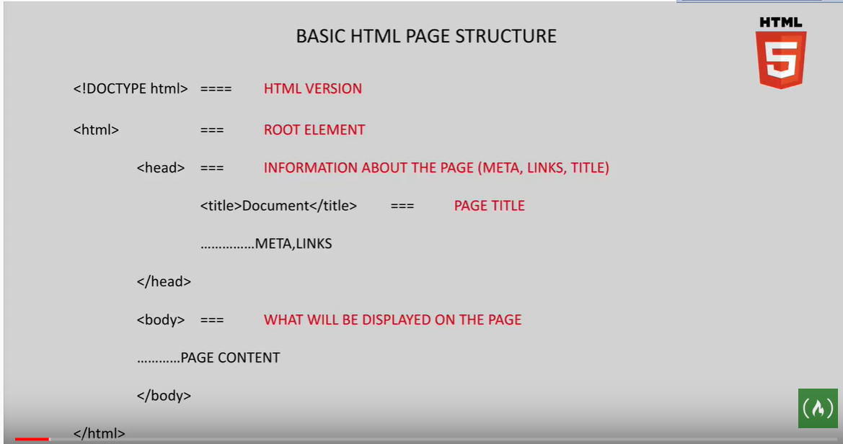

Install extension : Live Server

https://www.udemy.com/course/html5-fundamentals-for-beginners/learn/lecture/3518498#overview
https://www.way2tutorial.com/html/tag/index.php
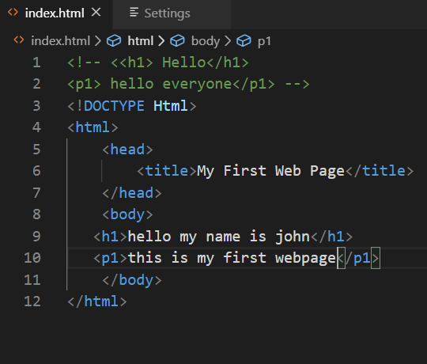

Note: install Emment Extension

