Multi-Agent AI Day Planner
Technical Specification & Project Definition
June 2026

1. Overview

1.1 Project type
Dimension | Value
Project category | Multi-agent AI system + RAG knowledge assistant
Primary interface | Streamlit web UI + REST API (FastAPI)
Deployment target | Azure Container Apps (Bicep IaC + GitHub Actions CI/CD)
Cost model | Cost-aware agent routing — sub-$0.01 per user per day
Agents | OpenAI gpt-4o (paid) · Groq llama-3.1-8b-instant (free) · Ollama mistral (local, free)

1.2 Problem statement
Professionals lack a unified AI system that intelligently plans their entire day — from wake-up to sleep — incorporating personalised diet plans, structured workout and yoga sessions, BMI-based weight management, and proactive reminders via SMS and app notifications.
Existing wellness tools are either too generic to be actionable, prohibitively expensive, or require stitching together multiple disconnected applications with no unified intelligence layer. There is no single system that orchestrates planning, nutrition, fitness, and health analytics through a cost-aware multi-agent architecture.

1.3 Target users
- Working professionals who need structured daily planning across health, nutrition, and fitness
- Fitness-conscious individuals seeking weight management, macro tracking, and consistent workout scheduling

1.4 Tech stack
Layer | Technologies
Backend & AI | FastAPI · LangGraph · OpenAI gpt-4o · Groq llama-3.1-8b-instant · Ollama mistral
Frontend | Streamlit 1.41 — 5-page web UI with sidebar navigation
Vector store | Pinecone (Azure eastus, 1536 dims, cosine) · FAISS local fallback
State & scheduling | Redis 7 · APScheduler (AsyncIOScheduler) · RedisJobStore
Observability | Prometheus · Grafana 10.2 · Loki 2.9 · Promtail
Infrastructure | Docker Compose · Azure Container Apps · ACR · Bicep IaC
CI/CD | GitHub Actions — test → build → push ACR → deploy Bicep on every push to main
Notifications | Twilio (primary) · Fast2SMS (fallback)

2. Goals
G1 — Cost-aware multi-agent orchestration via LangGraph
Builds a state machine with five nodes routing each task to the cheapest capable agent. A static routing table maps 10 task types to OpenAI, Groq, or Ollama. Any unknown task type defaults to the free local Ollama agent.

G2 — Personalised daily schedule generation
Generates a full 24-hour timeline from configurable wake and sleep times. Each scheduled event carries a time, category, duration, and a ready-to-send SMS reminder message within 160 characters.

G3 — Meal planning with automatic cheat meal detection
Generates breakfast, lunch, and dinner for any given date. Automatically switches to cheat-meal mode on Saturdays and Sundays. Each meal includes name, calories, prep time, and ingredients.

G4 — Proactive SMS reminders via APScheduler and Redis
Registers one reminder job per plan event in a Redis-backed job store. Each job fires 10 minutes before the event. Jobs survive API restarts. Past events are silently skipped.

G5 — Dual SMS provider with automatic failover
Checks for a Twilio key first; falls back to Fast2SMS if not configured. If neither is set, logs a warning and continues without crashing. Provider selection is fully automatic from environment variables.

G6 — BMI calculation and AI 4-week weight plan
Instant BMI calculation using the WHO formula with no AI call. Based on the result, categorises the user as Underweight, Normal, Overweight, or Obese and sets the appropriate goal. An AI-generated 4-week plan then provides calorie targets, macros, a weekly workout schedule, food guidance, and week-by-week milestones.

G7 — RAG knowledge assistant: 4-stage pipeline
A complete retrieve-rerank-generate-verify pipeline. The query is embedded and matched against a Pinecone vector store, top results are re-ranked by a fast Groq model, OpenAI generates the final answer, and a second Groq call checks every claim against the source chunks for hallucinations.

G8 — Plan history with 90-day rolling retention
Every generated plan is automatically saved to Redis per user. Retention is capped at 90 entries per plan type with a 90-day TTL. No client action is required — saving happens inside every generate endpoint before returning the response.

3. Non-Goals
NG1 — No wearable or biometric integration
Integrating smartwatch or fitness tracker APIs requires per-user OAuth2 credential storage, real-time event streaming infrastructure, and a secrets management layer that conflicts with the stateless Azure Container Apps scaling model. Deferred to v2 as a separate microservice.

NG2 — No native mobile application
Streamlit serves via a web server and is not compiled to a mobile binary. Building a native app would require a separate build pipeline, app store deployments, and push notification infrastructure. The existing SMS reminder system covers mobile notification needs for v1 without requiring device installation.

NG3 — No multi-user social or collaboration features
The data model keys all history on a plain user_id string with no authentication layer. Adding friend graphs or leaderboards would require JWT/OAuth2, a relational database, and privacy controls — orthogonal to the AI orchestration architecture in scope for v1.

NG4 — No payment processing or subscription tiers
The entire cost model is sub-$0.01 per user per day through cost-aware routing. Adding billing would require Stripe integration, subscription state management, and feature-flag gating — deferred in favour of demonstrating the core multi-agent and RAG capabilities cleanly.

NG5 — No medical diagnosis or clinical decision support
The BMI calculator uses the standard WHO formula and produces wellness guidance only. The AI agent is positioned as a wellness coach, not a physician. Adding clinical output would require regulatory compliance and clinical validation — out of scope.

NG6 — No fully offline mode
Full feature coverage requires active connections to the OpenAI API, Groq API, Redis, and Pinecone. While the Ollama agent runs locally at zero cost, replacing all four external dependencies for a fully offline mode is architecturally feasible but not a v1 priority.

4. Success Metrics

Metric | Target
Plan generation latency p95 | < 10 seconds
Cost per user per day | < $0.01
SMS delivery rate | > 95 %
RAG hallucination flag rate | < 5 %
API uptime (Azure) | > 99.5 %
Scheduler reliability (jobs fired on time) | > 99 %
API request error rate | < 1 %
OpenAI share of total agent calls | ≤ 30 %

5. Feature Definitions

5.1 — Orchestrator
Agent / Component: LangGraph — routes to OpenAI · Groq · Ollama

How it works
A LangGraph state machine receives every API request and routes it to the cheapest capable agent based on a static routing table. The state object carries the task type, user input, context, and the result from whichever agent responds. All three agents — OpenAI, Groq, and Ollama — are wired as separate nodes. The graph aggregates whichever node produces a result and returns it.

Agent capabilities
OpenAI handles all high-quality generation tasks: schedules, meals, and weight plans. Groq handles speed-critical tasks: RAG re-ranking, hallucination verification, and book recommendations at no cost. Ollama handles summarisation, evaluation, and acts as the zero-cost fallback for any unrecognised task type.

Observability
Every agent call increments a Prometheus counter and records latency in a histogram. The middleware layer records every API request with method, path, status code, and elapsed time — all shipped to Loki for log querying in Grafana.

5.2 — Day Planner
Agent / Component: OpenAI gpt-4o

Schedule generation
Accepts configurable wake and sleep times plus optional freeform preferences. Calls OpenAI once per day to produce a structured timeline of events. Fixed rules are enforced in the prompt: 45-minute workout on Monday, Wednesday, and Friday; yoga or mobility on other days; 10-minute evening meditation daily; 30-minute book reading before bed.

Event structure
Each event in the timeline contains a 24-hour time, activity description, duration in minutes, a category tag (sleep, wake, workout, meditation, meal, reading, work, or break), and a pre-composed SMS reminder message within 160 characters.

Reminder registration
If a phone number is provided, the system automatically registers one APScheduler job per event at plan generation time. Each job fires 10 minutes before the event time. Jobs are stored in Redis so they survive server restarts. Past-time events are silently skipped. The response includes a count of reminders successfully scheduled.

5.3 — Meal Planner
Agent / Component: OpenAI gpt-4o

Daily meal plan
Generates breakfast, lunch, and dinner for a given date. Each meal includes a name, estimated calorie count, preparation time in minutes, and a full ingredient list. The prompt instructs the model to balance macros, minimise processed ingredients, and vary cuisine style across the week.

Cheat meal detection
Automatically detects Saturdays and Sundays and switches the prompt to cheat-meal mode, suggesting a popular street food or restaurant-style dish instead of a balanced meal. The response includes an is_cheat_day flag so the UI can display it distinctly.

History
Every meal plan is saved to the Redis history store immediately after generation under the meals plan type, scoped to the requesting user ID.

5.4 — BMI & Weight Management
Agent / Component: Pure math (BMI) · OpenAI gpt-4o (plan)

BMI calculation
An instant calculation endpoint that requires no AI call. Accepts weight in kilograms and height in centimetres, computes BMI using the standard WHO formula, and returns the value, category (Underweight / Normal weight / Overweight / Obese), recommended goal (lose, gain, or maintain), ideal weight, and kilograms to change.

4-week weight plan
A full user profile — name, age, gender, weight, height, and activity level — is sent to OpenAI. The model returns a daily calorie target, protein, carbohydrate, and fat targets in grams, a 7-day workout schedule with intensity levels, food guidance (what to favour and what to avoid), week-by-week milestone expectations, and a personalised motivational note.

Goal routing
BMI below 18.5 triggers a caloric-surplus gain plan focused on strength. BMI in the normal range triggers a body-recomposition maintenance plan. BMI of 25 or above triggers a caloric-deficit loss plan focused on cardio. The goal is set automatically based on the calculated BMI.

5.5 — RAG Knowledge Assistant
Agent / Component: Groq (query/rerank/verify) · OpenAI (answer)

Stage 1 — Retrieval
The user question is converted to a 1536-dimensional vector using the OpenAI text-embedding-3-small model. The vector is queried against a Pinecone index hosted on Azure (eastus, cosine similarity) or a local FAISS index as a fallback, returning the top 10 matching chunks.

Stage 2 — Re-ranking
Groq scores each of the 10 retrieved chunks for relevance to the original question. The top 5 highest-scoring chunks are selected and passed to the answer generator. If the re-ranking response cannot be parsed, the original retrieval order is preserved.

Stage 3 — Answer generation
OpenAI synthesises a final answer from the top-5 ranked chunks with a grounded prompt that prohibits going beyond the provided context. The response includes the answer text and a list of cited sources.

Stage 4 — Hallucination verification
A second Groq call independently checks every claim in the generated answer against the source chunks. It returns a boolean flag, a confidence score between 0 and 1, and a list of any unsupported claims. This result is always included in the API response so callers can decide how to handle flagged answers.

5.6 — SMS Reminder System
Agent / Component: APScheduler · Redis · Twilio / Fast2SMS

Scheduling
When a day plan is generated with a phone number, the system iterates every event in the plan, computes a reminder time 10 minutes before the event, and registers a date-triggered job in APScheduler backed by a Redis job store. Jobs are idempotent — re-generating a plan for the same date and phone replaces existing jobs rather than duplicating them.

Delivery
At firing time, the job calls the SMS delivery function which checks for a Twilio configuration first, then falls back to Fast2SMS. If neither provider is configured, the failure is logged without crashing the scheduler. Both providers return a boolean success flag; errors are caught and logged rather than raised.

5.7 — Plan History
Agent / Component: Redis — no agent

Automatic saving
Every successful plan generation endpoint — day plan, meals, and weight plan — saves the full response payload to Redis before returning it to the client. No explicit save action is needed from the UI or API caller.

Retention and retrieval
History is stored per user per plan type. A rolling window keeps the newest 90 entries per combination, and a 90-day TTL ensures automatic expiry. The history endpoint accepts an optional plan type filter and a configurable result limit between 1 and 50.

Deletion
A delete endpoint accepts an optional plan type. Without a plan type, it clears all history for that user. With a plan type, it clears only that category. The response returns the count of Redis keys deleted.

5.8 — Observability
Agent / Component: Prometheus · Grafana · Loki · Promtail

Prometheus metrics
Five metrics are collected: a counter for total agent calls labelled by agent name, a latency histogram per agent with seven buckets from 100ms to 30 seconds, a counter for API requests labelled by method, endpoint, and status code, a counter for SMS reminders sent labelled by provider, and a gauge for active users.

Structured log shipping
A custom Python logging handler batches log entries every 2 seconds and ships them as structured JSON to Grafana Loki via HTTP. The handler uses a bounded in-memory queue so log emit calls never block the async event loop. Network failures in the shipping thread are silently swallowed — logging never crashes the application.

Grafana dashboard
A pre-built dashboard with five panels is provisioned automatically at container startup: agent calls per minute by agent, agent latency p95 by agent, total SMS reminders sent, API requests per minute by endpoint, and a live Loki log stream filtered to the application label. Both Prometheus and Loki are registered as datasources via provisioning config mounted into the Grafana container.

Log collection
Promtail scrapes stdout from all Docker containers using the Docker socket, applies container name and Compose service labels, and pushes entries to Loki every 5 seconds. No application-level log files are written to disk.

6. UI Mock
The following screenshot shows the live Streamlit application running at localhost:8501. The Day Planner page is active, showing the sidebar navigation (Day Planner, Meal Plan, BMI & Weight, History, Analytics), the wake-up and sleep time pickers, a freeform preferences field, and the Generate My Day Plan action button. The User ID field is populated with user_001 and the Phone (SMS) field is visible below the sidebar.

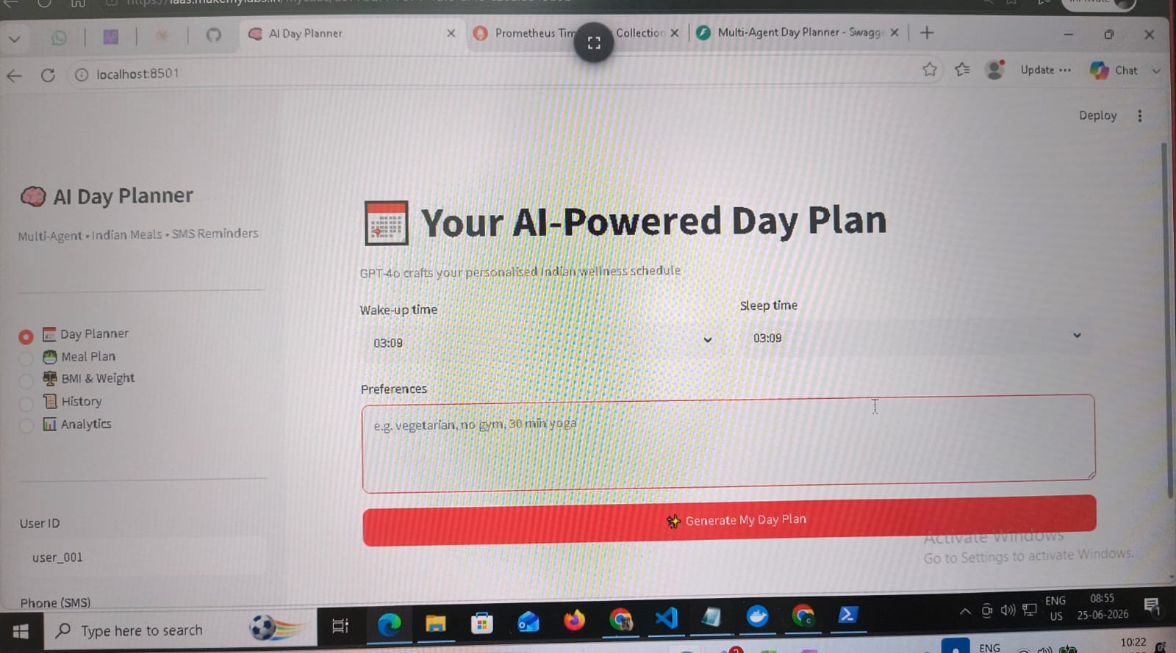
Figure 1 — Streamlit Day Planner UI running at localhost:8501 (25 June 2026)

7. Azure Deployment
The entire infrastructure is defined as code using Azure Bicep (azure/main.bicep) and deployed via a single GitHub Actions workflow on every push to the main branch. The workflow runs unit tests first, then provisions infrastructure, builds both Docker images in Azure Container Registry, and deploys them to Container Apps.

7.1 Infrastructure summary
Resource | Purpose
Azure Container Registry | Stores the FastAPI and Streamlit Docker images built by the CI pipeline
Azure Cache for Redis | Hosts the APScheduler job store and 90-day plan history; TLS-only, Basic C0 tier
Log Analytics Workspace | Receives container logs from the Container Apps environment; 30-day retention
Container Apps Environment | Shared managed environment for both application containers
FastAPI Container App | Runs the API — 0.5 vCPU, 1 GiB RAM, external HTTPS ingress, scales 1 to 5 replicas
Streamlit Container App | Runs the UI — 0.25 vCPU, 0.5 GiB RAM, external HTTPS ingress, scales 1 to 3 replicas

7.2 Secrets and configuration
API keys (OpenAI, Groq) are passed as secure Bicep parameters and stored as Container App secrets. They are never written to ARM output or environment files. The Redis connection string is constructed dynamically at deploy time from the Redis primary key and stored the same way. Each container references secrets by name rather than injecting values directly into environment variables.

7.3 CI/CD pipeline
- Trigger: push to the main branch
- Step 1: Run unit tests — pipeline stops on failure
- Step 2: Azure login and Bicep deployment — infrastructure is idempotent
- Step 3: Build and push FastAPI image to ACR tagged with the Git commit SHA
- Step 4: Build and push Streamlit image to ACR tagged with the Git commit SHA

Multi-Agent AI Day Planner | Technical Specification | June 2026

