A

Problem Analysis:

Question one has four main requirements:

(1) The four main indicators given in the topic and the indicators under the physical condition of concrete slabs are selected and ranked by importance.

(2) Sort the importance of the selected larger impact factor index to affect the repair order;

(3) Quantify all indicators in the two levels, and use mathematical methods to merge all indicators to obtain a comprehensive evaluation model about the order of repair. For data acquisition, we attach data samples and sources to the appendix. For the combination of indicators, in order to more directly reflect the degree of repair order, we adopt the fuzzy comprehensive evaluation method, that is, AHP and quantitative indicators, and find a combination method to solve the function model. Under the AHP level, the restoration order is the target layer, the personal evaluation degree and the public factor evaluation degree are the criterion layer, and the above-mentioned population density is used as the plan layer 1. The slabs should not be broken, etc. The five indicators are used as the second layer of the scheme, and the hierarchical analysis structure is established, and then the specific score value of each indicator is calculated through the function model, and finally a comprehensive evaluation model of the repair sequence is obtained through weighted summation. The higher the score, the more quickly it needs to be repaired.

Model Construction and Solution

The choice of indicators and the establishment of the model in question one

1. Selection of indicators

We searched related literature on Americans with Disabilities Act (ADA)* and found many indicators. After consulting related data and literature, we determined that the physical condition of concrete slabs has a larger impact factor as

* Sub-indicator 1: the [completeness](D:/Dict/8.9.3.0/resultui/html/index.html" \l "/javascript:;) of the slabs (Broken ones,ones with sides less than 4 inches are illegal);
* Sub-indicator 2: whether the vertical displacement at the interface between adjacent slabs exceeds ½ inch;
* Sub-indicator 3: whether the running slope is more than 2%;
* Sub-indicator 4: Whether the cross slope is at least 1% and at most 2%

2. The distinction of indicators

We distinguish four indicators such as population density between personal evaluation and public evaluation:

From the perspective of personal evaluation, we selected one indicator: number of complaints;

From the aspect of public evaluation, we selected the remaining 3 indicators: population density, the physical condition of concrete slabs and proximity to schools, bus stops, governmental buildings;

1. Fix the quantization function of order evaluation index:

First, we define  as the total number of slabs on the target street.

• Construction of population density index quantization function:

Considering that the higher the population density, the higher the average traffic of the street, and the higher the demand for road quality, so the quantitative function of this indicator should be positively correlated with the independent variable (population density); on the other hand, the greater the population density , The more severe the damage to this road section, the more it needs to be maintained and repaired, so a non-linear exponential function is constructed to score.

We take the average population density of the city as a reference indicator, which is the perfect score indicator. With the aid of the actual population density  and average population density of road sections and streets, the population density index quantization function can be constructed:



• Construction of the quantization function about the proximity to schools, bus stops, governmental buildings:

For this indicator, we find out all the schools, bus stops, governmental buildings within the city area, and define it as the reference value of the full marks under the indicator, passing the schools, bus stops, governmental buildings that exist in each road section The relationship between the number of buildings  and the total number , the index quantification function of proximity to schools, bus stops, and governmental buildings is:



• The construction of the number of complaints indicator quantitative function:

We believe that the number of complaints (defined as ) reaching 0 is the goal that each road section should pursue, so it is used as a reference score for 0 points. The number of complaints  that reaches the number of resident population (defined as ) is the full score of the reference score. The higher the score, the more repair the road section needs. Therefore, the quantitative function of constructing the number of complaints indicator is as follows:



•The construction of the physical condition of concrete slabs index quantification function:

Since this indicator has five sub-indices, it is necessary to construct a quantified function for the five sub-indices, and then use the relationship of their weights to find the function value of the physical condition of concrete slabs indicator



In which the  is the weight of the indicators, and is the value of each sub-indicator, =1,2,3,4.

We consider the correlation between the various indicators under the physical condition of concrete slabs, so we define a large scale for unified measurement, and define the total number of slabs that do not meet the ADA conditions as , and at the same time define the full score of the reference score, because The higher the score, the greater the number and the need for maintenance. Then the ratio between the number of plates that do not meet the respective conditions and the total  in the five conditions is defined as, where  represents each index.

①The construction of the quantization function for Sub-indicator 1:

For this indicator, we define the distance between it and the standard condition (or the degree of non-compliance) as , which is decided by the ratio of  to . We determine that the function is exponential. Function, the function is:



The construction of the quantization function Sub-indicator 2:

The construction of the quantization function Sub-indicator 2 is similar with Sub-indicator 1:



④The construction of the quantization function Sub-indicator 3:

The construction of the quantization function Sub-indicator 3 is similar with Sub-indicator 1:



④The construction of the quantization function Sub-indicator 4:

The construction of the quantization function Sub-indicator 4 is similar with Sub-indicator 1:



Establishment of a comprehensive evaluation model for repairing sequence:

Secondly , use AHP for 4 indicators such as population density: take the restoration sequence as the target layer, take the above-mentioned personal factors and public factors as the criterion layer, and use the 4 indicators such as population density as the plan layer to establish a hierarchy analysis result chart:

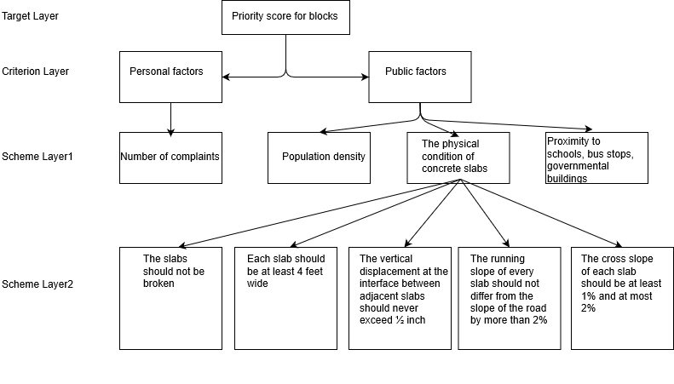

We sort the importance of each index from large to small, and construct a pairwise judgment matrix.

After calculating and checking the consistency of the judgment matrix, the final combination weight vector is:

The index score vector is:



Then the final comprehensive evaluation model of repair order is:



In which Z represents the scoring value of the repair order. The higher the score, the more priority repair is needed.

First, calculate A4 using 5 indicators selected from the physical condition of concrete slabs. The establishment of the hierarchy analysis result diagram is shown in the figure:

**图 Comprehensive evaluation hierarchy**

We sort the importance of each index from large to small, and construct a pairwise judgment matrix.

After calculating and checking the consistency of the judgment matrix, the final combination weight vector is:



The index score vector is:



Then the final comprehensive evaluation model of repair order is:



In which A4 represents the scoring value of the repair order, the higher the score, the more priority repair is needed.

Consistency check

Solved by the characteristic root method, the relative weight of each index is:

，

Calculate the consistency index of the two:

,

Calculate the agreement ratio:

,

It has been verified that the consistency of our judgment matrix is acceptable, for both are satisfied .