# C

### Problem analysis

Part C require us to construct an optimization algorithm for the fee of repairing the road. But in the previous part, we have not yet obtained any specific information about the road. So in this part, we are going to use the knowledge of projective geometry to analyze the street view photos in city of Ithaca in Google Map to find the width of the slab.

After that, we studied the general structure of the sidewalk in Ithaca and made the following schematic diagram. We assume that the structure of the road to be calculated is like this.

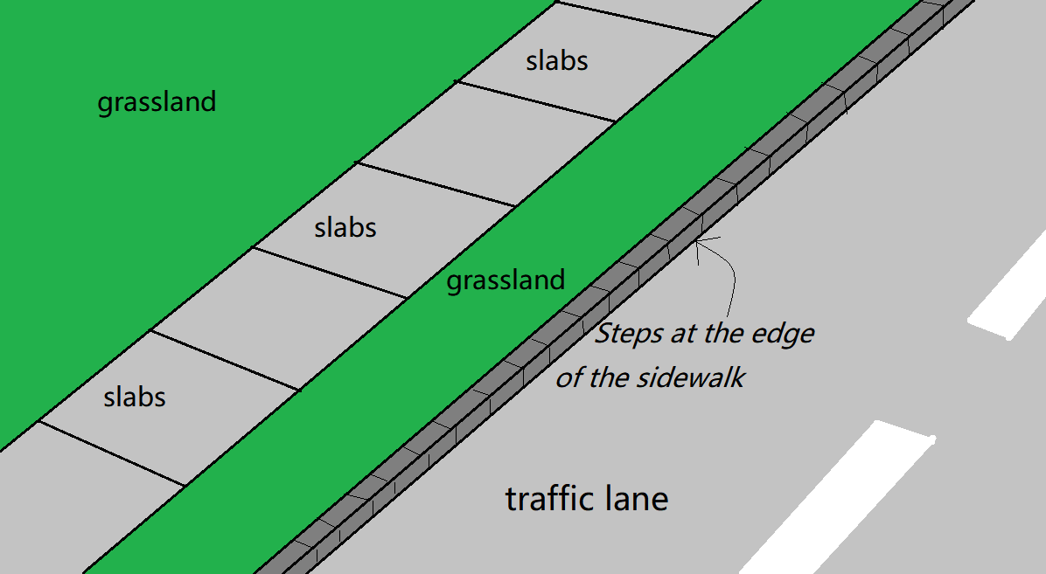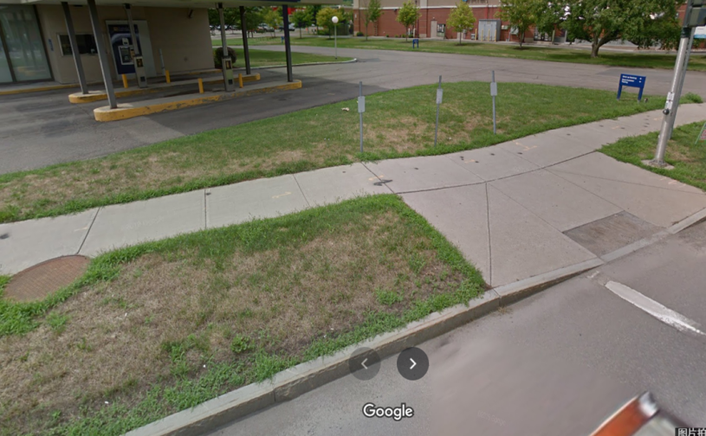

Figure : the simplification of the model

We simplify the angle and position of the stone brick to the position of the four vertices. If the coordinates of the four vertices cannot form a plane, then we will default the stone slab to be broken. By analyzing the coordinates of these four vertices, we can infer the running slope and the cross slope of the slab, as well as the vertical displacement.

Under normal circumstances, the slab will be broken or slightly inclined due to various reasons of weather and man-made. In this case, we will focus on the slate itself and the two adjacent slates, and perform a partial linear programming to determine whether to perform the above three operations on the slab. For convenience, we call it a smooth type. But in any case, we must also consider special circumstances, that is, due to special force majeure, such as a big tree growing on the roadside, or a large-scale traffic accident, many consecutive stone slabs have been raised or lowered as a whole. . This situation must be specially considered, because if we solve this situation by the method of solving the former situation, we may not be able to get the optimal solution. For convenience, we call it the undulating type. For the undulating section, we must first find out the specific range of the section, and then use the median method to solve it.

### The derivation process of the width of slab

Obviously, the shorter the side length of the slate, the more flexible the activities of repairing the slab can be carried out. But out of respect for the facts, we hope to obtain the true data of Slate as much as possible. Considering that the slabs used in different streets may not be the same size. Our test data will be based on W. Buffalo. St in Ithaca. W. Buffalo. St is a relatively wide and lively small street in the residential district of the city, which has a certain representativeness.

Using the relevant knowledge of projective geometry, we deduced the formula for finding the width of the road by using the ratio of the line segments in the photo and the data of the investigated cars. The formula is as follows:



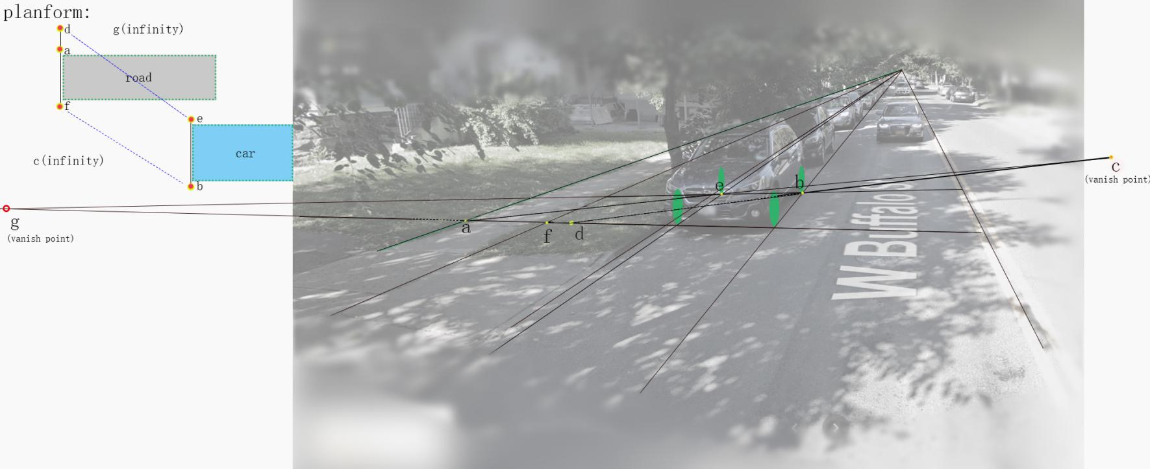In which 

Figure : the illustration of our algorithm

Finally we have w=58.242 inch.

Obviously, w satisfies the condition of "each slab should be at least 4 feet wide".

### Data generation

We first generated 6 slab roads with different conditions based on the data obtained in the data.The cross slope of each slab is measured from the inside of the road to the outside in order to allow for drainage. That is, the vertices of the flagstones near the two sides of the road are higher than the vertices of the flagstones near the center of the road when the road is built. Of course, the situation may be the opposite.

test1: Slabs were well protected.

test2: Slabs suffered mild harm because of temperature difference.

test3: After a term of lacks of maintaining slabs were uneven because of the growth of the trees along the road.

test4: Slabs suffered serious damage in extreme weather.

test5: The slabs were uneven for lacking maintaining for several years.

test6: Special case: Assuming a tree grows on the edge of a stone road, the root of the tree will form a cone

The slabs on these roads are broken and undulating.

We assume that the serial numbers of the slates on this street are from 1 to L, and we take L=200.

(---------- See the appendix for specific data --------------)

### Data review and preprocessing

At this stage, we first check the vertical inclination of the stone road, and make a qualitative judgment to facilitate subsequent calculations. If most of the slabs are inclined to the inside, then we think the road is inclined to the inside. vice versa.

In the second step, we inspect the broken slate. Broken slabs must be replaced, so their original height is invalid. We find the continuous broken slabs and use the height of the complete slabs at their ends to perform a linear function interpolation.

In the third step, we need to find the segments in this road that apply the first method and the segments that apply the second method.

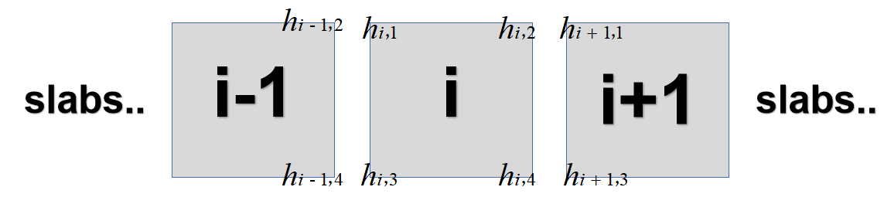

Figure : the illustration for the order of the slabs

If the following relationship is met:



Then we think this is a smooth road, otherwise it will be a bumpy road. It can be seen that this condition is very loose, because the second algorithm actually covers the first case, so we hope that the program will consider the overall situation as much as possible in order to arrive at the optimal solution.

In addition, we should first calculate the cost and effect of each operation:

Raising:changes the slope & position of the entire slab

it costs on average $5.13 per square foot of the slab.

Cost:

Cutting: Cutting involves removing a top slice of the slab, making its new surface have a different slope and elevation. This procedure costs on average $16 per linear foot of the slab, but it is only usable when removing at most 2 inches.

Cost: 

Replacing: Replacing a full slab costs on average $22 per square foot.

Cost: 

### Classification processing: smooth type

In the smooth type, we only need to consider adjacent slabs.We assume that the internal test of the road is higher than the outside (the situation where the internal test of the road is lower than the outside is similar, we will not repeat it here).

If a board has broken, then it must be replaced. We have solved this problem in preprocessing, so we won't repeat it here. Otherwise, we will use linear programming to solve the problem.

Conditions that need to be met:

1. the vertical displacement at the interface between adjacent slabs should never exceed ½ inch;
2. the running slope (i.e., in the direction parallel to the road) of every slab should not differ from the slope of the road by more than 2%;
3. the cross slope (i.e., in the direction perpendicular to the road) of each slab should be at least 1% (to allow for drainage) and at most 2% (to comply with the ADA).

Expressed by the formula:



When the above conditions are met, the value of the following formula should be minimized：



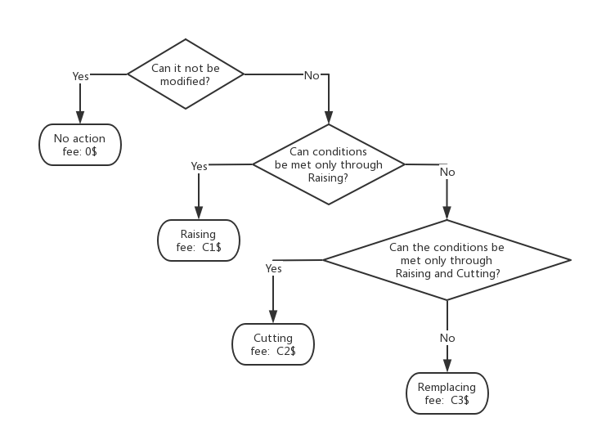

Figure : the flow chart of smooth type

It is worth noting that the above algorithms all need to consider the left and right slabs. Therefore, the first and last blocks do not conform to the above algorithm. But in this case, the first and last slabs do not need to be adjusted.

### Classification processing: the undulating type

In this case, we must first find the point where the rugged section deviates the farthest from the ideal smooth sidewalk (for example, if there is a pit in the road, then the center of the pit will become the farthest point). For convenience, we call it an evaluation point. Constantly adjust the final height of this point, and use this point as a benchmark to process it in the left and right directions (the processing method is the same as above), and calculate the cost of the entire rugged section at the current height of the evaluation point. Find the smallest cost, and the current plan is the best.

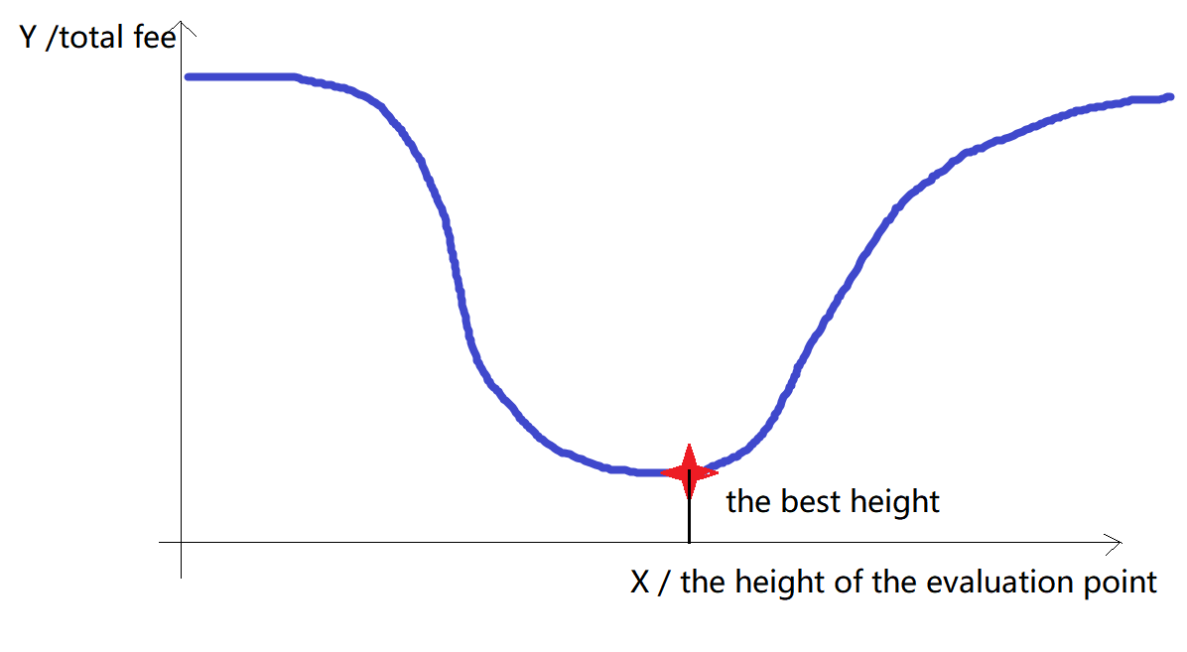

Figure : the unimodal function relationship

It is conceivable that if the evaluation point is too high or too low, the total price will be higher. If the height of the evaluation point is taken as the independent variable and the total price is taken as the dependent variable, their relationship will become a unimodal function. Therefore, we use the third-equal division method to solve the problem.

### Algorithm test

We used the above algorithm to calculate the maintenance cost of the small road we generated earlier, and the results are as follows:

|  |  |
| --- | --- |
| Test | Fee /$ |
| Test 1 | 2640 |
| Test 2 | 5797.68 |
| Test 3 | 12797.4 |
| Test 4 | 17239 |
| Test 5 | 31516.7 |
| Test 6 | 40543.3 |

It can be found that as the degree of road fragmentation increases, maintenance costs increase.