MethCoresProfiler– user documentation
MethCoresProfiler- Scripts for automatic identification of CIS-linked methylated CpG clusters in genomic loci.

Index
Description…………………………………………………………………………... 1
Pipeline steps: additional information
- Sampling and a significative 2-CIS-linked methylated CpG extraction…..…..2
- A significative CIS-linked methylated CpG extraction……………………….3
- MethCores extraction and comparative analysis…………..…….…………….5
- Example of usage………..…………………………………………………….9

Description
MethCoresProfiler is a pipeline composed of thirty R scripts for to trace and track cores shared by epiallele families in complex populations.
MethCoresProfiler requires three types of input files: i. a tab delimited text file of EpiHaplotypes in BINARY format; ii. a tab delimited text file containing information on the CpGs position in the sequence (or string), and; iii. a tab delimited text file containing metadata (information) associated with each sample with the following columns: #SampleID, Tissue, Description, Groups, Rep, id. The first two files can be obtained running AmpliMethProfiler (Scala et al. 2018). A local installation of different R packages is required.

The software is designed to work with tab delimited text file of EpiHaplotypes in BINARY format. Output from single and paired-end sequencing should be first converted to fasta format; aligned to reference to obtain the methylation status at each CpG locus in each input read as binary tab.

The tool performs a y repeated (default y = 1000) sampling (N = average of sample’s reads or smallest of them depending from operator) for each samples and extracts methylated cores in three steps: (i) identify significatively CpGs combinations based on x-square test (expected frequency vs observed frequency), (ii) extract epialleles containing significatively CpGs combinations (pvalue<0.0000000001) and (iiii) identify shared methylated cores.
For each region, a Random Control is generated with the same number of CpGs and the same size.

MethCoresProfiler is formed by three main components or R modules: the MethCores_Extractor, the MethCores_Combinator and the MethCores_Analyst.
1) The MethCores_Extractor, or Module 1, calculates the average depth of the samples reads (named b4), performs and summarises (y) repeated and iterative sampling (default y = 1000) of each experimental sample using b4 as a depth, and annotates the combination(s) of 2 two mCpGs with statistical significance, i.e., with a frequency higher than that expected frequency for independent events (x-square for independence statistics, p value -≤ 10⁻⁹). This module generates several tables reporting: i, All CpG methylation profiles (frequency of single mCpG); ii, The tetrachoric correlations of CpGs; iii, The co-occurrence of two mCpGs; iv, The taxonomic distribution of methylated species; v, The Shannon-Entropy index and the summary/sample, statistics and plots.
Significant combination(s) of mCpGs pairs are computed by comparing the frequency of each mCpG pairs with the expected frequency according to x-square statistics. The expected frequency of methylation of n CpGs, assuming two or more independent events, is:
p(mCpG1 ∩ mCpG2) = p(mCpG1) * p(mCpG2)
where p(mCpG1 ∩ mCpG2) represents the expected frequency of mCpG1-mCpG2. The expected frequency is computed in each sample and, depending on the methylation frequency of individual CpGs in the population of sequences, may vary for each combination.
The observed frequency is calculated as:
n(mCpG1-mCpG2) / N
where n(mCpG1-mCpG2) represents the number of EpiHaplotypes containing the specific mCpG1-mCpG2 combinations and N is the size of the sample.
The Shannon Entropy and the generalized entropy (Renyi entropy) were determined as follows:
Shannon: H(X) = -1 / n(CpGs) * Σ pi * log2 (pi)
Renyi: H_{α}(X) = -1 / n(CpGs) * 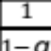 * log2 (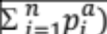
where n(CpGs) is the number of CpGs in the DNA string, pi is the frequency of each epiallele and S pi * log2(pi) and * log2 ( are the Shannon and Renyi entropies, respectively. The variable α in the Renyi entropy represents the weight of the events with α = 0.5 probability. This first multiplicative term in the formula is used to normalize the values in the interval [0,1] as reported in (13).
If significant 2-mCpGs combinations are not found, all epialleles in the population are brought to the next step.
2) The MethCores Combinator, or Module 2, analyses the complexity of the population by performing the following operations: i. All significant 2-mCpGs combinations, annotated by module 1, will be crossed; ii. The frequency of all mCpGs combinations (3 mCpGs or more) will be compared to the expected frequency for independent events (x-square for independence statistics, p value ≤ 10⁻⁹) and will be annotated; iii. The epialleles containing all significant mCpGs combinations will be extracted; iv. The structure and frequency of significant mCpGs combinations (cores) and individual epialleles will be reported (ComposCore and Tab_Epialleles, respectively). In the absence of significant mCpGs combinations, all epialleles will be brought to the next step.
3) The MethCores_Analyst, or Module 3, performs hierarchical cluster analysis of the epialleles annotated by Module 2 generating heatmaps of their structure and frequency. In this step, the frequency of each epiallele in the sample is compared (x-square test) to a random control (R), generated automatically by Module 1, with the same number of CpGs and depth (theoretical distribution). Individual significant epialleles are marked in a complex heatmap format (red = high frequency, blue = low frequency and white = neutral). Principal Component Analysis (PCA) of significant epialleles is also performed in this step. Finally, for each sample, the MethCores Analyst extracts the most frequent mCpGs shared by significant epialleles using a decreasing percentage scale (frequency of CpGs in only significant epialleles) starting from 0.9 (minimum 2-mCpGs). If significant epialleles were not found at this stage, the epiallele with the highest frequency will be annotated and its structure will be considered as a stable signature or core.
The MethCores_Analyst generates three types of indices: i. MethCores Index i.e., the frequency of the methylated cores in the population; ii. Clonality Index, i.e., the frequency of methylated cores normalized to the average methylation in the population; iii. in-phase CpGs Index or Stability Index or Entanglement Index, or E, which measures the rate of coupling or association of at least 2 mCpGs (mCpG1 and mCpG2) in the core according to:
∫p(mCpG1 _{core}) / p(mCpG1)∫
∫ p(mCpG2 _{core}) / p(mCpG2)∫

Where the p(mCpG1_{core})/(pmCpG1) and p(mCpG2 _{core})/(pmCpG2) are the frequencies of the first and the second (from the 5’end) CpG in the core normalised to the frequency of the same CpG in the population. Mono-methylated molecules can be excluded at this step. Note that the stability index is calculated only on extracted cores and not on the whole population. The index with a value 1 means that the mCpG1 and mCpG2 behave as a single unit and are “entangled”. The E index is higher when the cores maintain the mCpGs constitutive elements in the same configuration in different samples or time points. The normalisation step (mCpG in the core vs mCpG in the population) is essential in order to estimate the weight and the stability of the methylated core in the population, because it dissociates global methylation of the DNA in the population driven by genetic and epigenetic drift(s) from the methylation of specific sites subjected to selection pressure.
The minimum core contains at least two methylated cytosines with statistically significant frequency (x-square test adjusted p-value ≤ 10⁻⁹).

Pipeline steps: additional information
I. Sampling and a significative 2-CIS-linked methylated CpG extraction
Input
The module 1_MethCores_Extractor.R works on three types of inputs:
- Sequence files:
  - outFile: File containing the CpG methylation profile matrix. In this file, columns represent CpG sites and rows represent single molecules (reads). The methylation status of each CpG site in a molecule is coded as 0 if the site is recognized as unmethylated, 1 if the site is recognized as methylated, 2 if the methylation state cannot be assessed (i.e. other bases other than C or T or alignments gaps are found).
  - Gene.cgpos: CpG position from 5’ to 3’
  - Gene_meta.map: The sample ID on which the experiment is carried on

Output
1_MethCores_Extractor.R generates, for each sequenced region and for each sample:
- a file with CpGs co-occurrence (Meth_Meth, Meth_unMeth, unMeth_Meth)
- a file with CpGs tetrachoric correlation
- a file with methylated species taxonomy
- a file with list of all epialleles with relative frequency and CpGs structure
- a file with average methylation for CpG and average methylation for samples
- a file with Shannon-Entropy

II. A significative CIS-linked methylated CpG extraction
Input
The module MethCores_Combinator.R works on the output produced by preprocessFasta.py and uses three types of inputs:
- Sequence files:
  - clustFile: File containing the significative 2-linked CpGs combination
  - Gene.cgpos: CpG position from 5’ to 3’
  - Gene_meta.map: The sample ID on which the experiment is carried on

Output:
MethCores_Combinator.R generates, for each sequenced region and for each sample:
- ComposCoreFile: File with all significative core.
- tab_EpiallelesFile: File reporting all epialleles carrying the significative core.

III. MethCores extraction and comparative analysis
Input:
The module MethCores_Analyst.R works on the output produced by MethCores_Combinations.R and uses one input::
- Sequence files:
  - tab_EpiallelesFile: File reporting all epialleles carrying the significative core.
  - Gene.cgpos: CpG position from 5’ to 3’
  - Gene_meta.map: The sample ID on which the experiment is carried on

Output:
MethCores_Analyst.R generates, for each sequenced region and for each sample:
- a complex heatmap reporting structure of all significative epialleles, their frequency and selection respect to random sample.
- a file with core structure, its frequency respect with total population and respect with the methylated population.

Filtering parameters:
  - nProcessor1 (optional): assign number of processor
  - y1 (optional): number of sampling
  - B4 (optional): fix the number of reads to analyze (“default” or number)
  - pvalue1 (optional): pvalue for statistical analysis
  - Reads1 (optional): calculate size of sampling as average of reads or smallest of samples
  - min1 (optional): minimum number of reads
  - Remove1 (optional): remove samples with number of reads less to min
  - maxCG_pos1 (optional): max numbers of interval
  - Plot_all1 (optional): Put pictures for different samples in the same plot
  - Meth_unMeth_corr1 (optional): perform co-occurrence also for methylated-unmethylated CpGs
  - saveAs1 (optional): save as “pdf” or "png"
  - Modify_mono1 (optional): convert all mono-methyl epiallels in unmethylated epialleles.
  - splitForGene1 (optional): split the output files by gene name
  - population_weight1 (optional): if TRUE, it reports average weight of significant epialleles containing core. otherwise it reports the weight for each significant epiallels. Default is “FALSE”
  - Overtime1 (optional): create plot over time for each samples
  - type_Tissue1 (optional): if TRUE, it plots entanglement buy “Groups”, otherwise it plot by Tissue. Default is “same”

IV. Example of Usage
Data and input files used in this example is contained in the main MethCoresProfiler-master archive as well as on the github project page.
The typical MethCoresProfiler analysis starts from two main folders:
- one containing all MethCoresProfiler R scripts (in this example is named “MethCoresProfiler_scripts” and contains all the MethCoresProfiler scripts);
- another one containing analysis input files (in the example is called “testData”).

In particular, the testData folders contains:
- a folder containing a set of binary reads format files containing reads from a sequencing run (in this example the folder is named “out” );
- the cgpos file containing the CpG position (in this example the folder is named “DDO1.cgpos” );
- the metafile2 containing the sample annotations (in the example is called “DDO1_meta.map”).
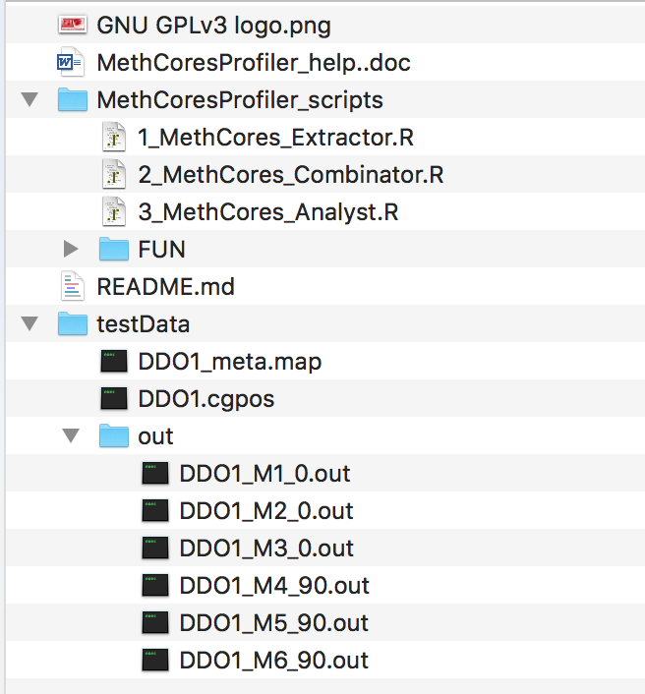

To obtain information on how to create, format and interpret input files, we remand to the instructions contained in the first part of this “README.md” file.

See the software manuscript for details on the quality filtering of the reads.
See the software documentation above for more details.

