100-student Stata lab perpetual license:

Serial number: 401506209499

Licensed to: 顾仪

. use "/Users/guyi/Desktop/大二下学期/金融计量学/课件数据/cons

> umption.dta", clear

#展示数据

. l

+------------------------+

| year y c |

|------------------------|

1. | 1978 381.23 184 |

2. | 1979 419.25 208 |

3. | 1980 463.25 238 |

4. | 1981 492.16 264 |

5. | 1982 527.78 288 |

|------------------------|

6. | 1983 582.68 316 |

7. | 1984 695.2 361 |

8. | 1985 857.82 446 |

9. | 1986 963.19 497 |

10. | 1987 1112.38 565 |

|------------------------|

11. | 1988 1365.51 714 |

12. | 1989 1519 788 |

13. | 1990 1644 833 |

14. | 1991 1892.76 932 |

15. | 1992 2311.09 1116 |

|------------------------|

16. | 1993 2998.36 1393 |

17. | 1994 4044 1833 |

18. | 1995 5045.73 2355 |

19. | 1996 5845.89 2789 |

20. | 1997 6420.18 3002 |

|------------------------|

21. | 1998 6796.03 3159 |

22. | 1999 7158.5 3346 |

23. | 2000 7857.68 3632 |

24. | 2001 8621.71 3887 |

25. | 2002 9398.05 4144 |

|------------------------|

26. | 2003 10542 4475 |

27. | 2004 12335.6 5032 |

28. | 2005 14185.4 5596 |

29. | 2006 16499.7 6299 |

30. | 2007 20169.5 7310 |

|------------------------|

31. | 2008 23707.7 8430 |

32. | 2009 25607.5 9283 |

33. | 2010 30015.1 10522 |

34. | 2011 35197.8 12570 |

35. | 2012 38459.5 14110 |

|------------------------|

36. | 2013 41907.6 15632 |

+------------------------+

. clear

#将数据按照y从小到达进行排序

. sort y

. l

+------------------------+

| year y c |

|------------------------|

1. | 1978 381.23 184 |

2. | 1979 419.25 208 |

3. | 1980 463.25 238 |

4. | 1981 492.16 264 |

5. | 1982 527.78 288 |

|------------------------|

6. | 1983 582.68 316 |

7. | 1984 695.2 361 |

8. | 1985 857.82 446 |

9. | 1986 963.19 497 |

10. | 1987 1112.38 565 |

|------------------------|

11. | 1988 1365.51 714 |

12. | 1989 1519 788 |

13. | 1990 1644 833 |

14. | 1991 1892.76 932 |

15. | 1992 2311.09 1116 |

|------------------------|

16. | 1993 2998.36 1393 |

17. | 1994 4044 1833 |

18. | 1995 5045.73 2355 |

19. | 1996 5845.89 2789 |

20. | 1997 6420.18 3002 |

|------------------------|

21. | 1998 6796.03 3159 |

22. | 1999 7158.5 3346 |

23. | 2000 7857.68 3632 |

24. | 2001 8621.71 3887 |

25. | 2002 9398.05 4144 |

|------------------------|

26. | 2003 10542 4475 |

27. | 2004 12335.6 5032 |

28. | 2005 14185.4 5596 |

29. | 2006 16499.7 6299 |

30. | 2007 20169.5 7310 |

|------------------------|

31. | 2008 23707.7 8430 |

32. | 2009 25607.5 9283 |

33. | 2010 30015.1 10522 |

34. | 2011 35197.8 12570 |

35. | 2012 38459.5 14110 |

|------------------------|

36. | 2013 41907.6 15632 |

+------------------------+

#求出y的各类数据特征

. sum y

Variable | Obs Mean Std. Dev. Min

> Max

-------------+------------------------------------------------

> ---------

y | 36 9667.796 11759.93 381.23

> 41907.59

. ta y

GDP per |

capita | Freq. Percent Cum.

------------+-----------------------------------

381.23 | 1 2.78 2.78

419.25 | 1 2.78 5.56

463.25 | 1 2.78 8.33

492.16 | 1 2.78 11.11

527.78 | 1 2.78 13.89

582.68 | 1 2.78 16.67

695.2 | 1 2.78 19.44

857.82 | 1 2.78 22.22

963.19 | 1 2.78 25.00

1112.38 | 1 2.78 27.78

1365.51 | 1 2.78 30.56

1519 | 1 2.78 33.33

1644 | 1 2.78 36.11

1892.76 | 1 2.78 38.89

2311.09 | 1 2.78 41.67

2998.36 | 1 2.78 44.44

4044 | 1 2.78 47.22

5045.73 | 1 2.78 50.00

5845.89 | 1 2.78 52.78

6420.18 | 1 2.78 55.56

6796.03 | 1 2.78 58.33

7158.5 | 1 2.78 61.11

7857.68 | 1 2.78 63.89

8621.71 | 1 2.78 66.67

9398.05 | 1 2.78 69.44

10541.97 | 1 2.78 72.22

12335.58 | 1 2.78 75.00

14185.36 | 1 2.78 77.78

16499.7 | 1 2.78 80.56

20169.46 | 1 2.78 83.33

23707.71 | 1 2.78 86.11

25607.53 | 1 2.78 88.89

30015.05 | 1 2.78 91.67

35197.79 | 1 2.78 94.44

38459.47 | 1 2.78 97.22

41907.59 | 1 2.78 100.00

------------+-----------------------------------

Total | 36 100.00

#对y和c进行相关性分析

. pwcorr y c,sig star(0.05)

| y c

-------------+------------------

y | 1.0000

|

|

c | 0.9976* 1.0000

| 0.0000

|

#作出y和c、logy和logc的散点图

. sc y c

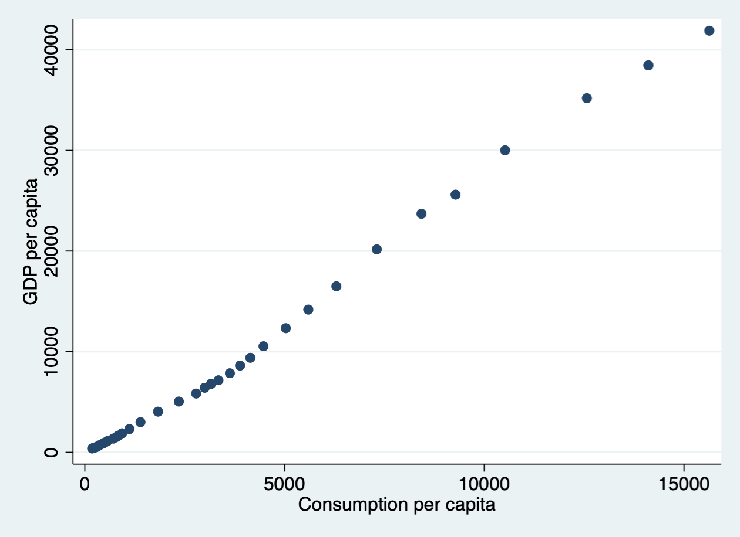

. sc lny lnc

variable lny not found

r(111);

. lny=log(y)

command lny is unrecognized

r(199);

. g lny=log(y)

. g lyc=log(c)

. sc lny lnc

variable lnc not found

r(111);

#更改命名

. rename lyc lnc

. sc lny lnc

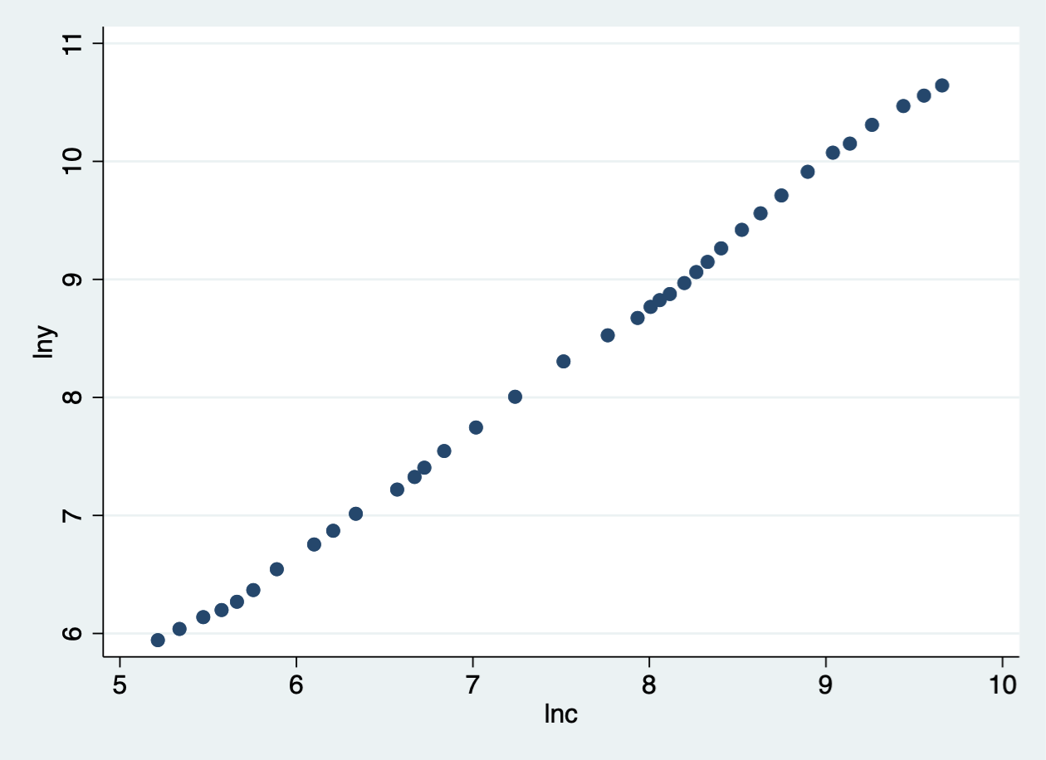

#求c相关数据特征

. sum c

Variable | Obs Mean Std. Dev. Min

> Max

-------------+------------------------------------------------

> ---------

c | 36 3793.028 4211.394 184

> 15632

. ta c

Consumption |

per capita | Freq. Percent Cum.

------------+-----------------------------------

184 | 1 2.78 2.78

208 | 1 2.78 5.56

238 | 1 2.78 8.33

264 | 1 2.78 11.11

288 | 1 2.78 13.89

316 | 1 2.78 16.67

361 | 1 2.78 19.44

446 | 1 2.78 22.22

497 | 1 2.78 25.00

565 | 1 2.78 27.78

714 | 1 2.78 30.56

788 | 1 2.78 33.33

833 | 1 2.78 36.11

932 | 1 2.78 38.89

1116 | 1 2.78 41.67

1393 | 1 2.78 44.44

1833 | 1 2.78 47.22

2355 | 1 2.78 50.00

2789 | 1 2.78 52.78

3002 | 1 2.78 55.56

3159 | 1 2.78 58.33

3346 | 1 2.78 61.11

3632 | 1 2.78 63.89

3887 | 1 2.78 66.67

4144 | 1 2.78 69.44

4475 | 1 2.78 72.22

5032 | 1 2.78 75.00

5596 | 1 2.78 77.78

6299 | 1 2.78 80.56

7310 | 1 2.78 83.33

8430 | 1 2.78 86.11

9283 | 1 2.78 88.89

10522 | 1 2.78 91.67

12570 | 1 2.78 94.44

14110 | 1 2.78 97.22

15632 | 1 2.78 100.00

------------+-----------------------------------

Total | 36 100.00

#删除变量lny lnc

. drop lny

. drop lnc

#条件筛选数据并展示

. l y if c>=3000

+---------+

| y |

|---------|

20. | 6420.18 |

21. | 6796.03 |

22. | 7158.5 |

23. | 7857.68 |

24. | 8621.71 |

|---------|

25. | 9398.05 |

26. | 10542 |

27. | 12335.6 |

28. | 14185.4 |

29. | 16499.7 |

|---------|

30. | 20169.5 |

31. | 23707.7 |

32. | 25607.5 |

33. | 30015.1 |

34. | 35197.8 |

|---------|

35. | 38459.5 |

36. | 41907.6 |

+---------+

. l y c if c>=3000

+-----------------+

| y c |

|-----------------|

20. | 6420.18 3002 |

21. | 6796.03 3159 |

22. | 7158.5 3346 |

23. | 7857.68 3632 |

24. | 8621.71 3887 |

|-----------------|

25. | 9398.05 4144 |

26. | 10542 4475 |

27. | 12335.6 5032 |

28. | 14185.4 5596 |

29. | 16499.7 6299 |

|-----------------|

30. | 20169.5 7310 |

31. | 23707.7 8430 |

32. | 25607.5 9283 |

33. | 30015.1 10522 |

34. | 35197.8 12570 |

|-----------------|

35. | 38459.5 14110 |

36. | 41907.6 15632 |

+-----------------+

.

.