**Assignment: JavaScript Basics**

**Question 1:**

Define a variable **age** and assign it the value 25. Also, declare a variable **name** and assign it the string "John Doe."

Ans:

 var age=21;

 var name="John Doe";

**Question 2:**

Explain the difference between the data types String and Number in JavaScript. Provide an example of each.

Ans:

var age=21;

var name="john doe";

console.log(typeof age);

console.log(typeof name);

output:

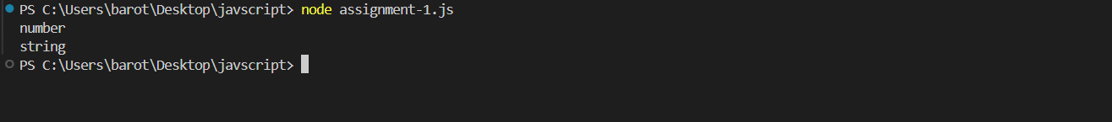

**Question 3:**

Write a JavaScript code snippet to check the type of the variable **temperature** and log it to the console. Assume **temperature** is a variable with the value 20.

Ans:

var temperature = 20;

console.log(typeof temperature);

output:



**Question 4:**

Given the following variables:

var x = 5, y = 3;

Calculate and store the result of the following operations in variables:

* Addition of **x** and **y**
* Multiplication of **x** and **y**
* Division of **x** by **y**
* Subtraction of **x** from **y**

Ans:

var x=5;

var y=3;

var add=x+y;

var mul=x*y;

var div=x/y;

var sub=x-y;

console.log(add,mul,div,sub);

output:

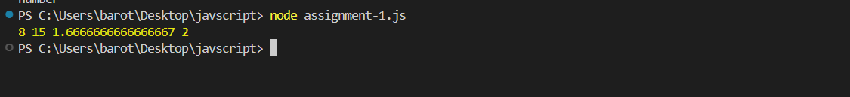

**Question 5:**

What is the purpose of the modulo operator (**%**) in JavaScript? Provide an example of its usage.

Ans:

var  A=11;

if(A % 2 ==0){

    console.log("given num is even");

}

else{

    console.log("given num is odd");

}

output:

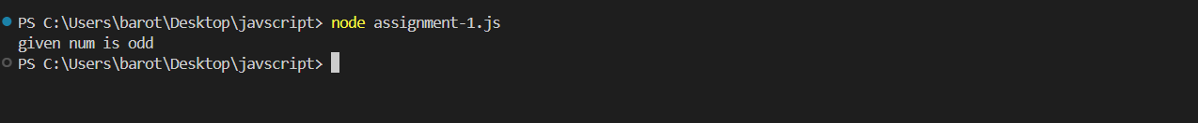

**Question 6:**

Concatenate the strings "Hello" and "World" and store the result in a variable named **greeting**. Log the value of **greeting** to the console.

Ans:

var a= "hello";

var b= "world";

var greeting =(a+b);

var greeting1 =(a+" "+b);

console.log(greeting);

console.log(greeting1);

output:

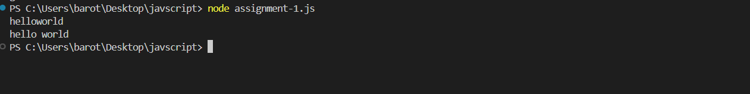

**Question 7:**

Write a JavaScript code snippet using relational operators to check if the variable **balance** is greater than or equal to 1000. Assume **balance** is a variable with a numeric value.

Ans:

var balance=200;

if(balance>=1000)

{

    console.log("balance sheet is clear");

}

else

{

     console.log("balance sheet is not clear");

}

Output:

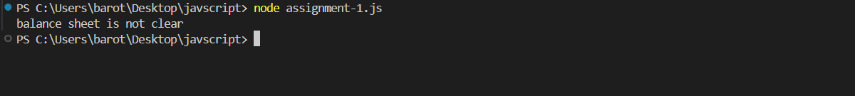

**Question 8:**

Explain the concept of the Boolean data type in JavaScript. Provide examples of variables with Boolean values.

Ans:

var a="10";

var b="20";

var c=(a>b);

console.log(c);

Output:



**Question 9:**

Calculate and store the result of the exponentiation operations:

* **4** raised to the power of **2**
* **2** raised to the power of **3**
* **10** raised to the power of **0.5**

Ans:

var x=4;

var y=2;

var z=x**y;

console.log(z);

Output:

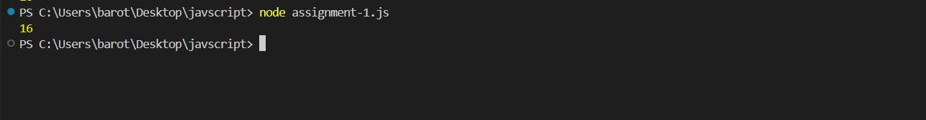

**Question 10:**

Given the variables:

Write a JavaScript code snippet using comparison operators to check if the number of apples is greater than the number of oranges.

var apples = 8, oranges = 5;

Ans:

var  apples=8;

var oranges=5;

if(apples>oranges){

    console.log("Apples are greater than oranges");

}

else{

    console.log("Apples are  not greater than oranges");

}

Output:

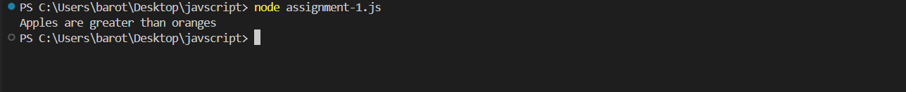

**Question 11:**

1) Declare two variables: admin and name.

Assign the value "John" to name.

Copy the value from name to admin.

Show the value of admin using alert (must output “John”).

Ans:

var admin="mahi";

var name="john";

admin=name;

// console.log(admin);

alert(admin);

Output:

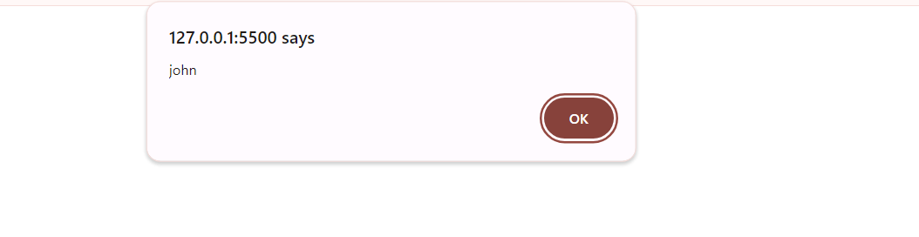

**Question 12:**

2) Declare variables to store the following information:

Your age (number)

Your name (string)

Are you a student? (boolean)

Print the values of these variables to the console.

Ans:

var age=21;

var name="Maithili";

var student=true;

console.log(age,name,student);

console.log( typeof age, typeof name, typeof student);

Output:

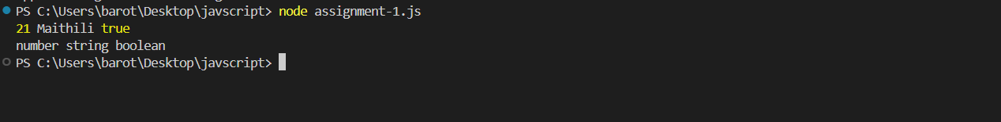

**Question 13:**

Create two variables, one using let to store a student's grade (which can change) and another using const to store their name (which shouldn't change). Modify the grade variable but attempt to modify the name variable. Observe the outcome.

Ans:

let grade="B";

const name="john";

console.log(grade);

console.log(name);

grade="A";

console.log(grade);

name="mahi";

console.log(name);

output:

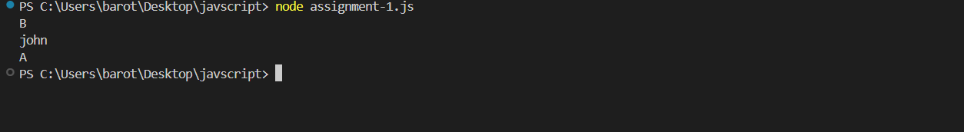

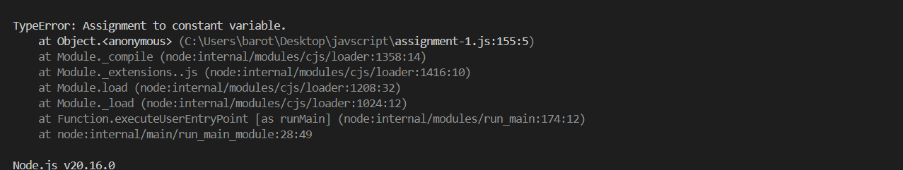

**Question 14:**

let name = "Arpit";

alert(helllo ${1});

alert(hello ${"name"});

alert(hello ${name});

Ans:

let name = "Maithili";

alert(`helllo ${1}`);

alert(`hello ${"name"}`);

alert(`hello ${name}`);

output:

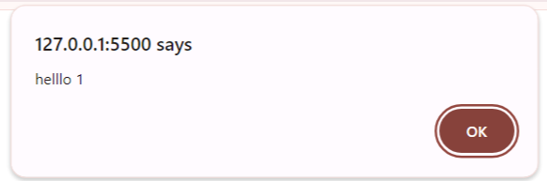

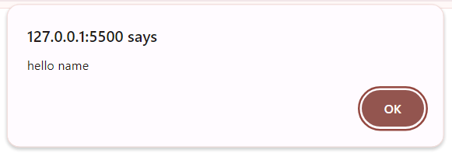

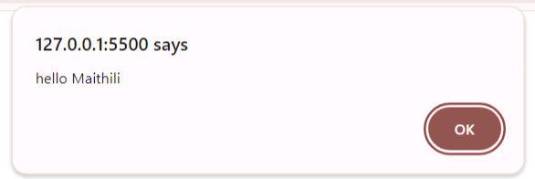

**Question 15:**

Write a script to declare a variable name and assign it your name. Display the value of the variable using console.log.

Ans:

var name="Maithili";

console.log(name);

output:

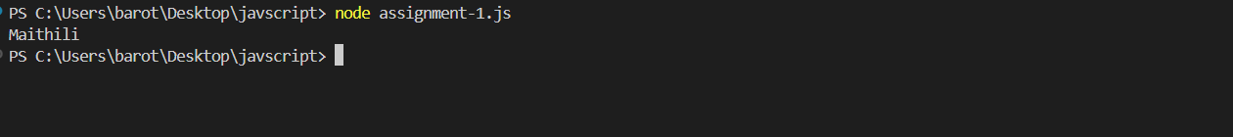

**Question 16:**

Declare a variable age and assign it your age. Then, change the value of age to 5 years older. Print both the original and updated values.

Ans:

var age=21;

var update=age+5;

console.log(age,update);

output:

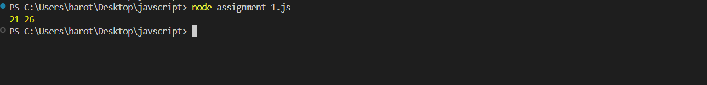

**Question 17:**

Declare two variables, firstName and lastName. Assign them your first and last name respectively. Concatenate them into a single variable fullName and print it.

Ans:

var firstname="Barot";

var lastname="Maithili";

var fullname=firstname+" "+lastname;

console.log(fullname);

output:

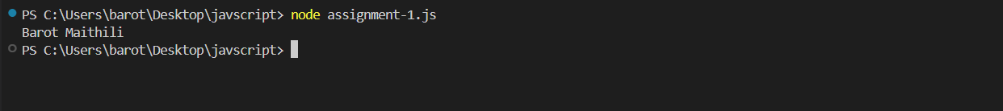

**Question 18:**

Declare a variable num and assign it the value 10. Multiply it by 5 and print the result.

Ans:

var num=10;

var mul=num*5;

console.log(mul);

output:

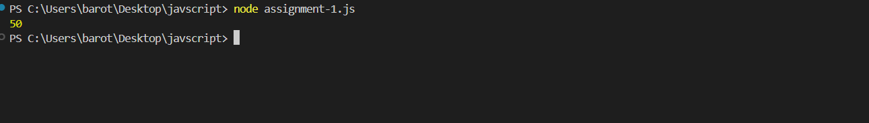

**Question 19:**

Declare two variables, x and y, and assign them the values 8 and 3 respectively. Compute and print the result of x + y, x - y, x * y, and x / y.

Ans:

var x=8;

var y=3;

var c=x+y;

var d=x-y;

var e=x*y;

var f=x/y;

console.log(c,d,e,f);

output:

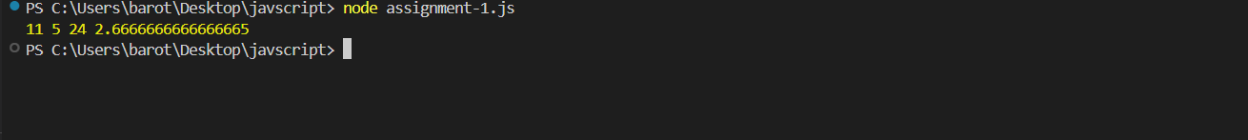

**Question 20:**

Declare a variable temperature with an initial value of 20. Reassign it to a string value "".twenty degrees Print the variable before and after reassignment to observe type coercion.

Ans:

 var temperature=20;

 var temperature1="20";

 console.log( typeof  temperature);

 console.log( typeof temperature1);

output:

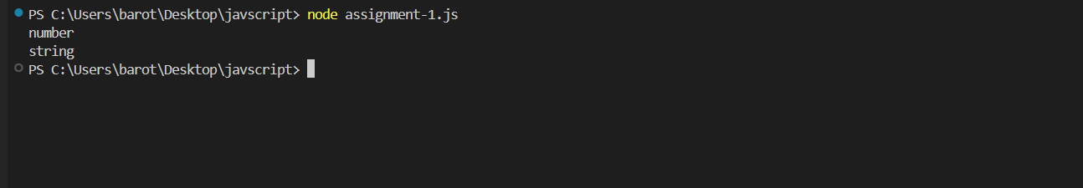

**Question 21**

Declare four variables, m, n, o, and p, and assign them the values 2, 4, 6, and 8 respectively. Evaluate and print the result of the expression ((m + n) * o) / (p - m).

Ans:

var m=2;

var n=4;

var o=6;

var p=8;

var ans=((m+n)*o/(p-m));

console.log(ans);

output:

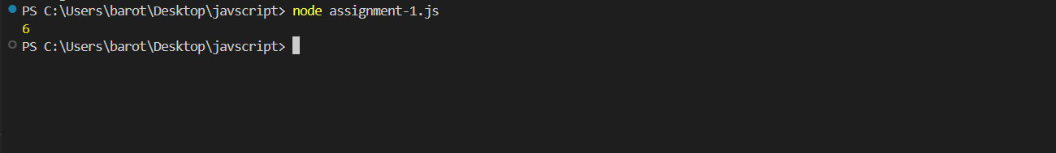

**Question 22**

Write a script that prompts the user to enter their name and age. Store these values in variables and display a greeting message like "Hello, [Name]. You are [Age] years old!".

Ans:

var name=prompt(("Name"))

var age=prompt(("Age"))

console.log("hello"+ "," +name+ " " +"your are"+" "+age+ " "+"years old!.")

output:





