10/14/2014

8.5:1 Entertainment

PROPRIETARY INFORMATION

Guardian Pets

Game Design Document

Version 1.0

Contents

1 Team Personnel 1

2 Game Overview 1

2.1 Game Description 1

2.2 Genre 1

2.3 Audience 2

2.4 Platform/Hardware 2

3 Core Gameplay 2

3.1 Upgrades 2

3.2 Energy 2

3.3 Shields 2

3.4 Pet Stats 2

3.5 Player Actions 2

4 Interface and Interface Usage 2

4.1 Main Menu Interface 2

4.2 Game Menu Interface 3

5 Menu and General Game Usage 3

5.1 Game Flow Diagram 3

6 Audio 3

7 Notes 3

8 Wish list 3

9 Micro-Transactions 4

# Team Personnel

Director and Programming Lead: Alexander Sanchez  
Visual Artist: Alexander Sanchez  
Lead Programmer: Andrew Best

# Game Overview

## Game Description

Guardian Pets is a single player experience, collecting and training multiple pets in order to conquer the player’s fears.

## Genre

Pet caretaking game

## Audience

* General Audience
* Ages 5 and up

## Platform/Hardware

The game will be developed using Unity’s free license. This means that there will be no costs for software used in developing the game. Since we are using Unity, we can target many platforms. However, to begin with, we will be submitting the game to the Android Play Store and the Apple App Store.

# Core Gameplay

## Upgrades

The player can purchase numerous “upgrades” for their pet using shields (see 3.3). These upgrades will increase the pet’s ability to conquer the player’s fears.

## Energy

Energy is the typical form of action tracking you will see in most games. Every 5 minutes the player will receive 1 energy, and each action the player takes will consume 1 energy.

## Shields

Shields are used as a currency to purchase upgrades for the pets. The player will receive 10 shields for every action performed after their current Pet has all three of their stats maxed out.

## Pet Stats

All of the pets have the same three stats: boredom, hunger and cleanliness. These stats will decay by 10 every 180 seconds (3 minutes) at random. The maximum for these stats is 100, and the minimum is 0. No matter how long the player goes without playing, the stat will never drop below 0, and no matter how often the player plays, they will not be able to increase a stat beyond 100.

## Player Actions

Players are able to do 3 basic functions when interacting with their pet: Feed, Wash and Play. Doing any of these 3 actions will cost 1 energy each, and increase the pet’s appropriate stat by 10.

Feed -> Hunger  
Wash -> Cleanliness  
Play -> Boredom

# Interface and Interface Usage

## Main Menu Interface

The main menu will contain normal, key elements that your average Main Menu has. It will contain a Start and Options button.

## Game Menu Interface

The game menu is the menu that appears when the player pauses the game. This menu should have Resume, Options and Quit buttons

# Menu and General Game Usage

## Game Flow Diagram

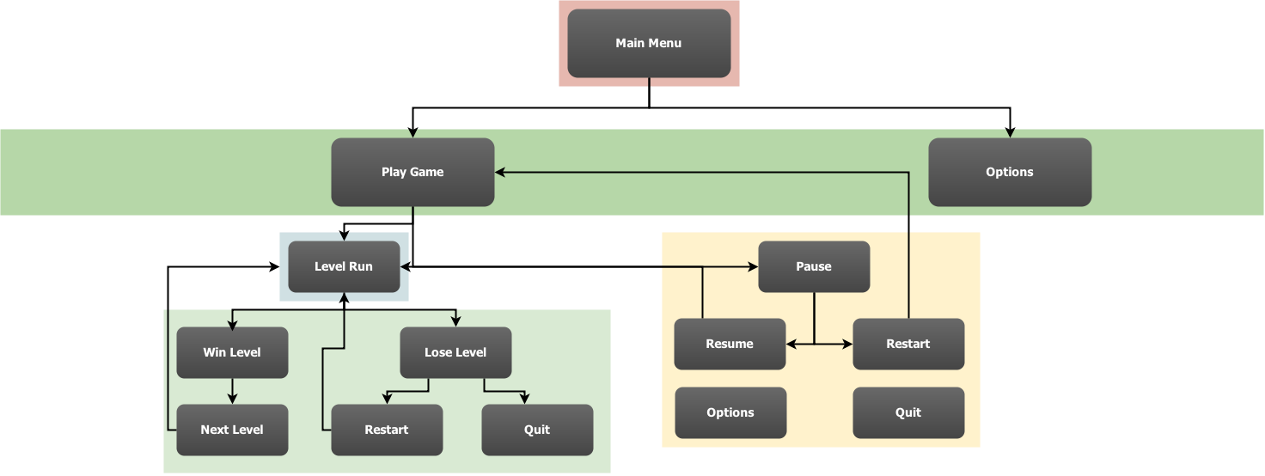

# Audio

This section will contain all audio information, in the following format:  
Song/Clip Name: 🡨 This will contain only the name of the song or the clip  
Artist (if applicable): 🡨 This will contain only the name of the artist, if not found, use **N/A**  
In Game Use: 🡨 This will contain where it is used in the game  
Credit: Yes/No 🡨 This is whether or not the artist wishes to be credited for their work, if Artist is **N/A** use **No**  
  
**Example:**  
Name: HappySound.mp3  
Artist: N/A  
In Game Use: On Play  
Credit: No

# Notes

This section will contain any important notes, such as copyright information for any art or audio that is not suited for other places in the document.

# Wish list

Here will be the list of features we would like to have in the game, but may not be able to fit into the timeline.

* Achievements

# Micro-Transactions

There will be a number of micro-transactions that the player can make to enhance their experience within the game. These include, but are not limited to:

* Instant Energy Refill
* 10 Energy
* 5 Energy
* X Shields
* Energy Cap + 1
* Energy Cap + 5
* Energy Cap + 10