Guardian Pets

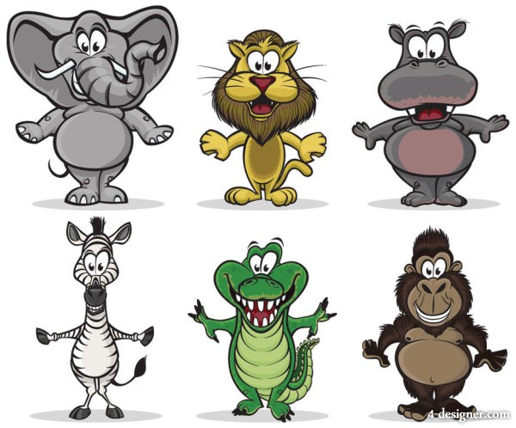

# Guardian Pets (Mobile App)

Side scrolling shooter game

Table of Contents

Table of Contents 1

2 Team Personnel

3 Target Audience

4 Visual Style and Game Platforms 5

5 Game Mechanics AI (Artificial Intelligence)……………………………………………………….………………………….. 6

6 Controls 7

7 User Interface ………………………………………………………………………………………………………………………………………8

8 Scalability and Mobile Awareness ……………………………………………………………………………………………………… 9

10 Creative Extras …………………………………………………………………………………………………….…………………………..11

# 2. Team Personnel

Director and Programming Lead: Alexander Sanchez

Visual Artist : Alexander Sanchez

Programming intern: Andrew Best

# 3. Target Audience

* General audience
* Video game fanatics
* Ages 5 and up

4. Visual Style and Game Platforms

The game will be developed using Unity. It will be viewable and playable fully functional on all major mobile devices (cellphones and tablets).

# 5. Game Mechanics

This game will be available as an app and playable on all mobile devices.

Points : Players are given an initial amount to use for care of their pet. The points are used to feed, love and bath their pet.

Shields: Shields are used to train pets to protect players from their fears. Players earn shields by caring for their pet. The better they care for the pet the more shields they receive.

Upgrades : Players are given an opportunity to upgrade their pet and their home.

***Game Play:***

The player is given the opportunity to adopt a guardian pet. They can choose from a selection of about 6. Players can only have 1 at a time. They can choose a name for their pet. Once the pet is chosen, they can now select a fear. The player will have a number of shields to start with and will be prompted to train their pet and use the free shields.

Based on a simple randomized timer, players will be prompted to feed, love and bath their pet. They will use points to care for the pet. Points replenish over time. The more they care for the pet, the more shields they can use. Players can purchase points and shields through our paypal account.

Players can purchase additional pets.

The app will also have a simple scanner that searches the room. It should flash and beep and make scanner noises (like a radar screen) and after a randomized amount of time give an all clear message.

# 8. Controls

The controls for the game utilize touch controls. Players would slide their finger up and down to pet their guardian, they would click on a bath icon and food icon to care for the pet. They would press the shield icon to train their pet.

# 

# 9. Creative Extras

Game Power-ups or incentives.

Multiplayer : Play with friends and online users.

Store multiple character slots (have a pet nap)

Love meter (happiness bar) Matters how you treat your pet in the game neglect lowers love meter and satisfying a pet with what he asks for increases,

Exercise (dumbbell) – increase pet strength (slow progression of leveling eventually exercise will increase energy bar.

Achievements

Vet medicine pack for a sick pet