鲁虹：“人为组构”的图像
——王庆松的艺术之路
按照艺术史家巫鸿先生的划分，中国当代摄影起始于1976年，至今可以分为4个阶段：第1个阶段为“民间摄影社团和展览的浮起”，此一阶段的特点是，不仅超越官方管理的摄影社团和展览逐渐出现，而且很多作品在艺术表现上已经完全偏离了官方原先规定的题材范围与表现手法，时间在1976年至1979年；第二阶段为“摄影新潮”，此一阶段的特点是，各种全新的艺术探索相继冒头，其主流当为纪实摄影，时间在1980~1989年；第3阶段为“实验摄影”，此一阶段的特点是，不少从事其他行当的当代艺术家转而以摄影为媒介进行创作，类似情况，人们只要看看当时出现的各类艺术大展与画册就能清楚感觉得到。正如巫鸿先生所言，“在这个潮流中，摄影家把概念和话语置入表现之上，通过艺术实验解构现实。他们不再致力于捕捉生活中的瞬间，而是更多关注艺术表现的方式并努力掌控对作品的观看，导致人为组构影像的流行。”【1】时间在1990~2006年。按我的理解，巫鸿先生的上述观点也意味着：所谓实验摄影与以往的纪实类摄影是有着很大区别的，即其并不以记录或呈现现场为目的，而是在运用“虚拟美学”的前提下，更强调以再造与重组图像的超现实手法去表达观念或各种奇思妙想。无数的创作足以证明，经过一些优秀艺术家的艰苦探索，实验摄影不仅大大溢出了传统摄影的边界，亦使两者成了既互为独立又有一定联系的领域。相比起来，前者对于后者，在本质上是一种建构与重构的关系，其中涉及到了新观念、新视角、新实验与新探索的介入。而接下来至今无疑是实验摄影不断深入发展的更新阶段。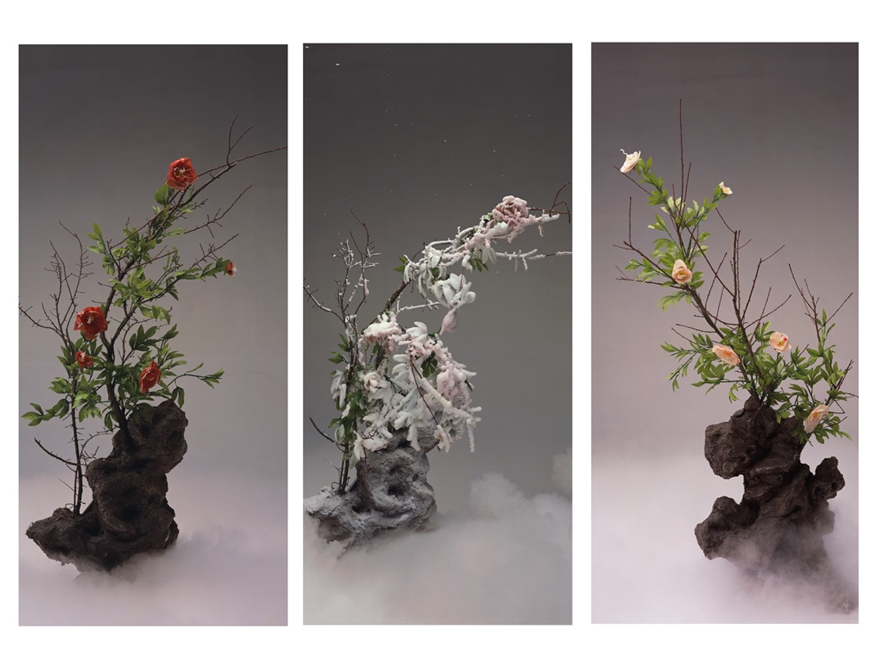
2003 红牡丹、白牡丹和霜牡丹-霜牡丹
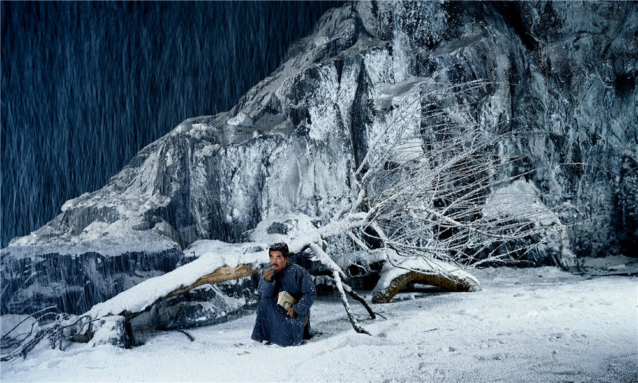
鲁迅-2004
从艺术家王庆松的艺术履历来看，他于1993年从四川美术学院毕业后，作为一位北漂艺术家，一直在从事油画创作，不少作品也曾参加过重要的艺术展览。只是到1996年，他才改以摄影媒介进行艺术创作，其内在原因是感到利用摄影作为创作媒介，更能深入表达他个人对于当下现实的深刻感受。虽然王庆松曾经在一次访谈中明确指出摄影的优势在于记录，否认自己的作品是“观念摄影”，并强调他不过是一名“记者”而已。【2】但我觉得巫鸿先生的上述评论显然十分适合于他。事实上，他并没有像传统记者一样以抓拍生活瞬间的方式去记录现实生活，反倒是以一些自编的荒诞故事来表明他对生活的态度。德国哲学家康德曾经说过，现实或自然仅仅只是一种表象或幻象而已，往往离生活的本质相去甚远，如果被其迷惑，就很容易得出既表面又浮浅的看法，弄得不好，还会成为各种流行说法或谎言的被动图解。我并不知道王庆松看过康德的相关言论没有，可我感到他肯定深有同感。否则，他绝不会以有异于传统纪实摄影的手法去制造一些超现实画面。我还注意到，在同一次访谈中，王庆松特别声明，他一直是在做“纪实性摄影”。如果结合他的一系列作品来看问题，我认为，他显然已经赋予“纪实性摄影”以全新的文化内含。其具体做法是：首先，他会在摄影棚或一些场所内制造出一些特殊的场景来，然后邀请众多模特出演角色，用以编排出一种直指生活本质的非现实场面，这就像拍电影的过程一样；其次，他才进入实质性的拍摄阶段。在此过程中，他既巧妙融合了行为艺术、装置艺术等诸多元素，也经常要在其中客串一个角色。于是，他本人的形象不但成了一个目击当下文化的见证人，也成了一个特殊的文化符号。而联系摄影史看问题，我们还会发现，他所使用的这种拍摄方法叫做“摆拍”。不过，熟悉摄影史的人都知道，传统纪实摄影中的“摆拍”更多是请人在主观搭建的背景前按照需要摆出“冒充”现实的场面来，这与王庆松故意要制造非现实的画面来表达他对人生、对社会的文化态度绝对不一样。由此可以认为，那些仅仅从宣传效果出发而运用“摆拍”手法的摄影家不过是为了以“冒充”现实的场面让人得出一种虚假的看法，而王庆松运用的另类“摆拍”手法却是希望以非现实的场面让人得出与生活本质相一致的看法。在我看来，这与王庆松时常会从社会学、文化学、历史学等角度观察现实生活，并在此基础上予以认真琢磨、研究、分析不无关系！也因为如此，那些带着他的体温或体现独特价值观的作品远比简单记录生活的所谓“纪实作品”、一味赶时髦而玩形式的作品，或用“摆拍”手法而做出的虚假作品要好得多！
以上主要谈的是王庆松的美学追求，即他对生活现实与艺术表现之间关系的理解，其实这也自然涉及到了他对重组图像的处理方式。应该说，落实到具体的创作中，他特别注重通过对传统文化、红色经典文化、当下现实与大众文化的借鉴或转换来调侃时下价值混乱的现状。其结果亦使他自始至终都没有做过转移西方当代影像的工作，即简单按照一些西方当代影像名家的手法和观念去进行创作。倘要说他的一系列影像作品不仅和当下中国文化、传统文化建立起了非常紧密的联系，也与西方当代影像艺术有效拉开了距离，那么应该说，其原因就在如此。下面拟分三个方面来谈：
1 、对传统文化的学习借鉴与转换
最近因写本文，我较为系统而仔细的阅读了王庆松的一系列作品，我深深感到，由于他曾经致力于“艳俗艺术”方面的创作，所以，在他最初的若干摄影作品中，仍然带有与“艳俗艺术”表现方式有关的痕迹，那就是向美国波普艺术学习，想办法将中国当下大众文化中的一些元素转换到创作中。十分难得的是，与此同时，他亦十分注重向传统艺术寻求借鉴——这当中自然也包括对传统年画与佛教艺术等等的借鉴。不过，艺术家在此过程中还智慧的增加了“挪用”“搞笑”和“反讽”等后现代艺术的表现元素。比如在他于1999年做的作品《拿来千手系列之一》中，（图一，《拿来千手系列之一》，180x110cm,1999年）便有意借用了佛教艺术中千手观音打坐的姿态。此外，他还别出新意的让由自己扮演的当代“千手观音”手中拿着各种消费品，如电话、香烟、金钱、VCD等等。于是，艺术家也对当下现实社会中一些人物欲至上的价值追求清楚表达了批判的立场。应该说，相关特点后来更好的体现在了他于2000年创作的《老栗夜宴图》之中。（图二，《老栗夜宴图》，120x960cm, 2000年）据知，为了创作此一著名作品，他当时把自己所有的近20张油画统统打包卖了1万元，再加上他母亲去世单位所补发的10个月工资，一共凑了2万元。随后，他请来艺术评论家栗宪庭、一些当代艺术家与群众演员，拍出了《老栗载宴图》。自此以后，王庆松的摄影作品便获得了国内外的广泛关注。在与艺术家的交流中我还得知，该创作灵感一者是来自于对生活的具体感受，另一者则是来自于对十世纪画家顾闳中名作《韩熙载夜宴图》的阅读体会。史料记载，后者的产生是因为后主李煜欲重用由北方逃至南唐的韩熙载，但又心存疑虑，故在得知其拟在家中设宴邀约亲朋好友之后，立即派出了画院的待诏顾闳中和周文矩到其家里去探听虚实，并命这两人要把所看到的一切画下来给他看。大智若愚且心知肚明的韩熙载为了保全自己，于是将计就计的安排了一出醉生梦死、载歌行乐、腐化糜烂的生活场景，其目的是为了让李后主不再怀疑自己是个有政治野心的人。本来，顾闳中与周文矩都作有《韩熙载夜宴图》，但周的作品不幸遗失，后世仅存顾闳中的作品。《老栗夜宴图》是在一座大型工作室中摆拍出来的，整个场景几乎按真实比例制作。按照顾闳中原画卷的构图与各段的处理方式，王庆松在作品中不仅将人物分为了好几组，而且以现代精英阶层的享乐方式替代了古代精英阶层的享乐方式。具体的说，作品以象征现代文化精英的“老栗”形象取代了身着长袍大褂的韩熙载、以妖艳时髦的现代女子乐器演奏者和舞蹈者取代了古代的女乐伎和歌舞伎、以现代的按摩女和洗脚女取代了古代的按摩女和洗脚女等等，于是既呈现出了远比现实生活更加夸张的艳俗场面，也巧妙审视了历史上的那些精英阶层与当代精英阶层在追求糜烂生活方式上的某种相似性。相信那些但凡了解《韩熙载夜宴图》产生背景与当下文化背景的人，都会与作品产生一种良性互动的关系。有趣的是，当此作品在国外展出时，一些西方艺评家与艺术家还对打破了焦点透视的平铺式摄影画面甚感兴趣，因为其像用连续性的电影画面在讲故事，这在西方摄影家用中是从来没有过的，故显得非常新颖。我很同意批评家王端廷的说法，即“正是从这件作品开始，王庆松开始充当导演的角色，通过邀请他人表演的方式表达自己的思想，完成自己的观念摄影作品。也是从这幅作品开始，王庆松的摄影作品，越来越显示出人物众多、场面宏大的特征。”【3】其实，王庆松的很多作品，如《卖货郎》（120x400cm， 2002年）《渡口》（120x380cm， 2002年）、《哨卡》（120x680cm， 2002年）《罗曼蒂克》（120x650cm，2003年）、《中国之家》（120x1200cm，2003年）《国色天香》, 120x 280cm, 2003）《瑞雪丰年》（120x280cm，2003年）等等都很好的借用与转换了传统艺术的表现方式，进而表达了他的艺术观念与奇思妙想。限于篇幅，在此就不一一评介了。
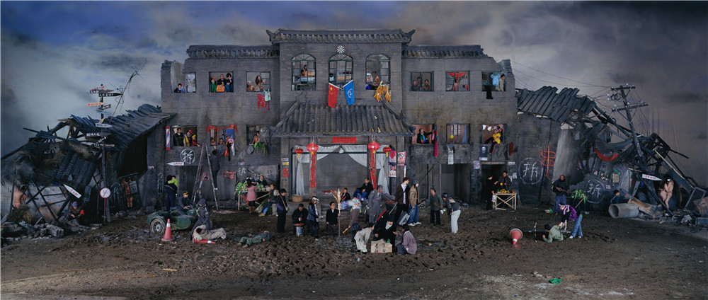
2005 盲流梦
2、对“红色经典”的转换与挪用
认真研究过王庆松艺术创作的人都知道，在具体创作方法的运用上，他并不限于对辛亥革命之前老文化传统的有效借鉴。事实上，他还有一些创作亦成功地对“红色经典”进行了转换与挪用。我认为，他的这一做法应该与上个世纪90年代的大背景有关，即当时在反思80年代对于西方现、当代艺术学习的得与失后，一些思想敏锐的中国当代艺术家由于强调从中国本位出发，一方面有意从辛亥革命之前老文化传统中借用了一些元素，另一方面还从“红色经典”中借用了一些元素。是以相继出现了一大批突显当下文化现实和改革开放前历史相联系的艺术创作。曾有批评家称其做法为“社会主义经验”在当代艺术创作的巧妙运用，也有批评家称其为当代艺术中的“红色记忆”。而属于这一范畴的艺术创作，大致有着如下两个特点：第一、特别强调用艺术作品来表达集体记忆与当下现实的内在联系。也因为这样，艺术与社会、艺术与历史、艺术与生活之间的边界也坍塌了，当代艺术创作也随之出现了全新的走势；第二、极为有效地借鉴了“后现代”的艺术策略，即常常对中国改革开放以前的历史图像加以翻新式的使用——其手法是或并置之、或戏仿之、或征引之、或影射之，正是随着一种话语方式向另一种话语方式的转换，也就是说，由先前的图像符号序列向新的图像符号序列转换，故当年曾经流行一时的图像符号内含完全被超越，被突出的则是艺术家个人的深刻反思。当然，这也意味着，相关的历史图像只是艺术家们使用的基本元素而已，艺术家们最终会以自己的方式改变原有的意向，从而传达出全新的意旨。由于新的文化信息是在特定的历史条件下回响，所以会让有相关背景的人与作品产生一种积极的互动关系。
《拿起战笔，战斗到底》，（图三，（《拿起战笔，战斗到底》，180x95cm， 1997年）是王庆松于 1997年根据“文革”期间的一幅著名政治宣传画创作的。在这幅作品中，原作的构图、人物的造型、背景上的鲁迅画像与其手书“横眉冷对千夫指，俯首甘为孺子牛”仍然保留着，但艺术家在前景不但换上了自己的头像，还在桌子上放置了金元宝、美元和《高考系列》丛书等等。这就将原作号召广大青少年要关心政治、进而批判一切反动思想的旨意改变成了鼓励广大青少年要好好准备高考或努力挣钱的旨意！由此也可看到在不同时代里，两代青少年所处的不同文化情境。
图片《又一次战争系列》是王庆松根据当年反映“自卫反击战”的图片改制的。在这幅超现实的作品中，（图四，《又一次战争系列之四》, 180x120cm, 2001年）他智慧的虚构了一些“中国军人”与西方商品文化作战的场景。具体做法是，将自己和一些年轻人装扮成了“解放军”战士，并正在充满硝烟的战火中冲锋陷阵，而前面的铁丝网上则挂满了可口可乐等国外商品。此一场面分明暗示：那些外来的商品文化在通过合法贸易方式对中国大举入侵时，已取得当年侵略战争也没有达到的效果。因此，反抗其入侵等同于“又一次战争”。此外，作品也强调了，外来的商品文化其实反映着特殊的意识形态，人们必须有所警惕。我注意到，他还有一些作品也很好运用了“红色经典”的元素，如《新兵和老兵》（ 180x120cm，1997年）就运用了当年反映“自卫反击战”图片的表现元素、《过去、现在和将来》（175x800cm， 2001年）中的“过去”与“现在”两个部分就借用了天安门“纪念堂”中的红色雕塑的表现元素、《血衣》（180x300cm, 2018年）则运用了反映土改内容的红色油画作品《血衣》的表现元素……限于篇幅，在此就不加以详尽评介了。
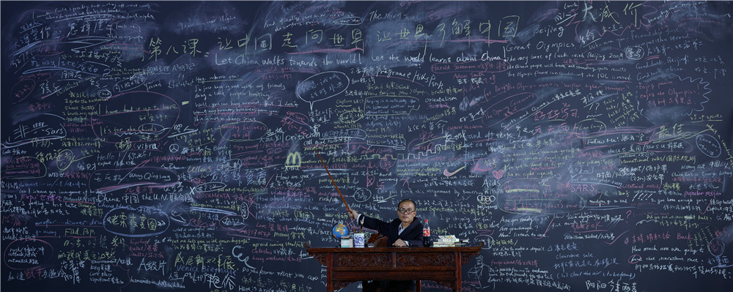
2003 跟我学
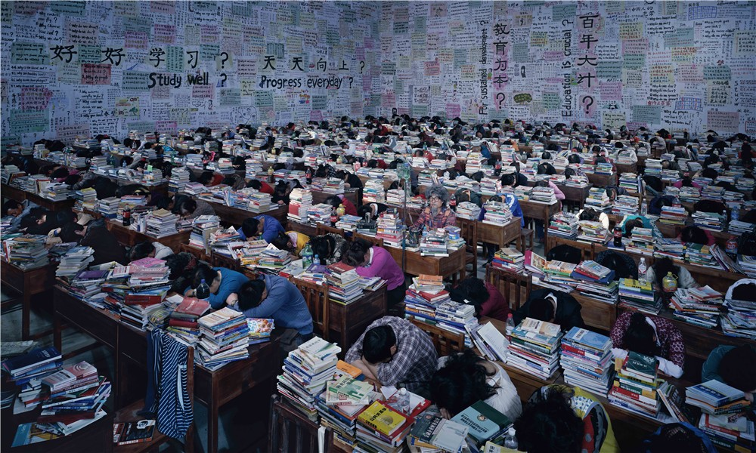
2013 跟你学
3、从现实生活与大众文化中升华出新的手法
很明显，在上面评介王庆松对辛亥革命以前的文化传统和“红色经典”予以借鉴的文字中，我已经涉及了他对当下现实积极介入的问题，只是从表述的角度出发，侧重点有所不同。其实，通过对王庆松创作的整体把握，人们肯定能体会到：强调艺术创作与社会现实的联姻，进而以深沉而鲜活的生活经验来体现他的艺术观念，乃是他的核心价值观。而其中包括对教育问题、医疗问题、房屋拆迁问题、消费问题与各种异化现象的深层质疑。另一方面，由于他的一些影像作品的题材就根植于当下现实的情境之中，故使他将若干新的图像与表现手法吸收到了自己的创作之中。因为相关作品比较多，下面仅选择性的介绍少数作品。
《跟我学》、《跟他学》与《跟你学》的创作时间跨度超过了十年，是对国内近些年出现的教育问题的深刻反思。但不同于传统的“纪实摄影”，即场景与人物都是在王庆松主观设计后才拍摄出来的。比如，在作品 《跟我学》中，（图五，《跟我学》 120x300cm， 2003年）由他所扮演的“教授”正戴着眼镜，手执教鞭在讲课，而背景的黑板上则写有非常多的文字，既有汉语，也有英语，这就以一种十分混乱的感觉暗示了当下教育的无序状态。该作品的名字借用了改革开放初期在国内热播的英语教学片名，标题中的“我”在作品中无疑指的是象征着混乱教学秩序的“教授”，但是，让年轻的学生向“他”学习的严重后果却是不言而喻的！而在《跟他学》中，由王庆松所扮演的“学生”处在了四周全是书籍、地上全是纸团的巨大房间里，因为桌子上也满是书籍，所以人们只能看到他的大半个头部。很明显，标题中的“他”在作品中显然指的是为了考试却身陷无尽书海的“书呆子”，可因为向“他”学习死读书的精神只会培养出大批缺乏创造力的“考试机器”，故对中国长远发展是极为不利的。（图六，《跟他学》（130x300cm，2010年）与以上两幅作品都是强调单个人物与环境的关系不同，作品《跟你学》中表现了许多学生在课堂上打瞌睡的场景，这当中显得特别突出的是由王庆松所扮演的一个“老学生”，只见他头发已经花白，胡子也很长了，而且是“戴着吊瓶”在坚持上课。无疑，作品借助很是夸张的手法，辛辣讽刺了一直在中国推行的“应试教育”对广大学生的异化。（图七，《跟你学》（180x300cm，2013年）当然，王庆松还有许多作品的题材与表现方式也是从现实升华出来的，特别有创意。因文字有限，在此就不多加评介了。比如《大广告》 （170x300cm, 2004年）就以虚拟的大广告反思了以华丽而虚假的文字欺骗顾客的商业模式、《宿舍》（170x400cm，2005年 》就以异常的方式表现了农民工住居拥挤或生活条件艰难的现实状况、而《大澡堂》120x150cm， 2000年》与《 找乐》（120x150cm， 2000年 ） 则表现了上个世纪90 年代在各个城市出现的色情服务问题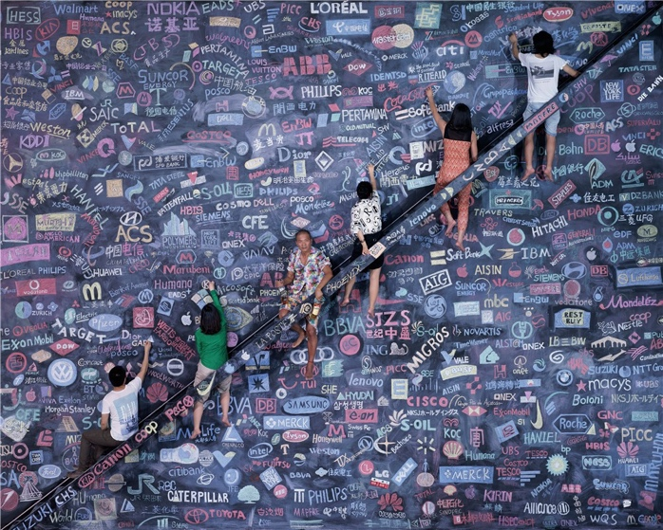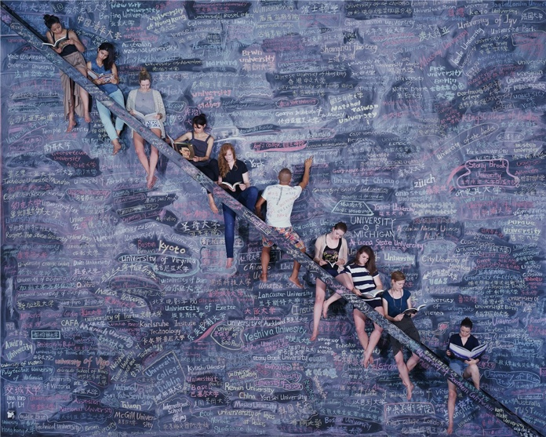
2014 同一个世界同一个梦想

在一次访谈中，记者凡哥问王庆松：有没有一点诀窍介绍给初学摄影的人？王庆松回答说：“摄影人应该更多地去了解摄影以外的知识，多了解社会，因摄影只有在观察中不停地磨练，你才会有一种经验，你的观察能力才可能有所提高，尤其数码时代不能去抓着拍，毫无思考地拍，要珍惜你每一次按快门的机会。”【4】我认为，这段话与陆游对儿子说“汝欲果学诗，功夫在诗外”的内涵完全一样，亦是我们理解王庆松作品的关键之处。相信由于王庆松随着综合能力的不断提升，并按此创作逻辑推进下去，一定会有更多、更好的作品出现。最近听说王庆松因感到摄影言之未尽，故想用自有的资金投资拍一部电影，内容是讲述一对兄弟从小城荆州来到大城市后的命运起伏，并会用更多对话的形式去谈及社会上的一些问题，名字叫《烂兄滥弟》。所以，我谨迫切的期待着，同时祝他取得更高的艺术成就！
2019年4月6日于武汉合美术馆

Constructed Images: The Art Odyssey of Wang Qingsong

Lu Hong

Professor Wu Hung, an art historian, theorizes the periodization of Chinese contemporary photography into four stages starting from 1976. Stage One covers 1976 to 1979, represented by “the rise of amateur photography societies and exhibitions beyond official administration.” Many of such works deviated from subject scopes and expressive methodologies regulated by the government. Stage Two, from 1980 to 1989, is called “New Wave of Photography”, characterized by new artistic explorations coming to the fore. The mainstream was documentary photography. Stage Three, from 1990 to 2006, is called “Experimental Photography”, featuring many contemporary artists switching from other genres towards making art works with photography as a medium. This rising tide could be authenticated by the varieties of art exhibitions and catalogues around that time. Like what was stated by Professor Wu Hung, “In the midst of this tide, photographers put concepts and discourses before expression modes and deconstructed realities through artistic experimentation. These artists stopped capturing significant moments in their life. Instead, they concentrated a lot more on the methodologies of artistic expressions and dived into sharpening perspectives in their works, resulting in the popularity of constructed images.”

My comprehension about this statement elicited by Professor Wu Hung is that there is a great distinction between experimental photography and documentary photography, meaning documentation or presentation of happenings along with sites is not the purpose any more for experimental artists. In the context of “virtual aesthetics”, artists tend to focus on reconstructing and fabricating images in a surrealistic way to convey their concepts and indulge in all sorts of fantasies. Numerous art works have proved that through a network of extraordinary artists’ hard work and ingenuity, experimental photography has gone far beyond the domain of traditional photography, which makes the two mutually-independent but co-related at some point. In comparison, the former constructs and reconstructs the latter, involving new concepts, new perspectives, new experiments and new interventions. Then following the earlier stages of development in photography, one will find the fourth stage with experimental photography delving more in depth and width.

From the biography of Wang Qingsong, one can find that he has been engaged in oil painting production since he graduated from Sichuan Academy of Fine Arts in 1993 and moved to Beijing right after. His oil works had been exhibited in many important art shows. In 1996, he switched to producing photo-based art works. The inner propeller was that Wang Qingsong felt like he could apply photography as a creative medium to further express this astounding impact from current realities in the turmoil of globalization. Even if he mentioned repetitively that his art works were not “conceptual photography” but “documentary photography”, adhering to the origin of photography that its advantage of faithful documentation still prevails, stressing he was just a photo journalist, I still feel like that the comments by Professor Wu Hung captures Wang Qingsong’s creative strategy very pointedly. In fact, Wang Qingsong has never documented the realities in snapshots like what a photo journalist does. Instead, he creates a multi-faceted storyline of frenetic and funny scenarios to demonstrate his attitude towards life.

Kant, a German philosopher, said that “all realities in life or nature are nothing but superficial fantasies, so distant from the essence of life itself. If one is screwed up, he might come up with very superficial and superfluous expressions. If one is hallucinated, his vision might become popular statements or negative illustrations of lies.” I did not know if Wang Qingsong has ever read about Kant and his related theories, but I bet he must share with Kant’s perspectives to some extent. Otherwise, he would not fabricate surrealistic imageries so different from the traditional documentary photography. Moreover, I noticed that in the same interview, he specifically stated that he has been making “documentary photography.” Toward his statement, I believe he has enriched this notion of documentary photography with a new cultural connotation.

Let us analyze his creative process step by step. First, he fabricates some deliberate scenarios inside photo studios or certain locations. Then he invites many actors and movie extras to act out some roles, producing surrealistic compositions that are constructed but inspired by real life. This whole process is exactly like producing a film. Secondly, he instruments the real shoots. During this whole procedure, he adroitly merges performance, installation and other arts forms including role play himself. Therefore, his presence makes him not only an eyewitness of the current culture, but also a special cultural icon. To some extent, the production of Wang Qingsong photography quite resonates that of Shi Chong, an artist who produces installation first and then applies hyper-realistic painting technique to finish his work. These two artists work in the most amazing and identical way. Relating to the history of photography, we can find Wang Qingsong has been using “Staged Photography”. Many people who are familiar with the history of photography will identify staged photos by looking whether the artist invites people to perform a “faked” reality in front of some set scenarios or not. But Qingsong’s staged sets intends to express his personal attitude toward human life, pose cultural critique and make social commentaries through unrealistic pictorials.

Some photographers apply staged sets to target at making huge propaganda impact by creating a “fake” reality and a “fabricated” perspective. In contrast, the method of staged photography by Wang Qingsong intends to create sur-realistic stage sets fabricated to relate to the realities in sync with life, highlighting this coherence and potency. From my own perspective, I think Wang Qingsong has taken a holistic method combining sociology, cultural studies, and historical analysis to contend with real-time reality, and give much deliberation into researching, analyzing, and pondering at the similarities between the real and the surreal in real life. These art works carry along with his warmth and representations of his unique world views and value standards, much more accurate and powerful than any other “so-called” documentary photographs which pursue nothing but popular taste and formalistic study through “staged photography”.

So far, Wang Qingsong’s works have been discussed a lot related to his aesthetics, namely, his understanding of life realities and artistic expressions, which also resonates in his processing procedure of imageries. He focuses on borrowing imageries from traditional cultures, red classics, contemporary social realities and pop culture, and converts them into critiques on value chaos at the current times. As a result, he has not done much work to transcribe contemporary western photography and image-making. His video and photographic works are so much closely connected with both Chinese contemporary and traditional culture, which distances himself remarkably from western contemporary photographers and video artists. This will be further discussed in three parts.

- Learning from traditional culture and transforming into contemporary twists
Recently I have read through quite a lot of essays on Wang Qingsong’s art works systematically and thoroughly. I deeply feel that as he committed himself early on to making works of “Gaudy Art”, he kept certain traits of similar expressions from this genre, which was to learn from American pop art, and transformed some elements of Chinese contemporary pop culture into his newer photographic creation. What is rare is he also concentrated on looking for breakthroughs from Chinese traditional arts, such as Chinese vernacular folk art and Buddhist art. The contemporary twist is that he incorporates expressive post-modern elements such as appropriation and satire into his own works. In “Requesting Buddha Series No.1” (photo 1, 180x110cm, 1999), he adopted intentionally the posture of Buddha sitting for meditation. He acted out this contemporary “Thousand-hand Buddha” holding all sorts of consumer goods, such as mobile phone, cigarettes, money, VCD and etc. In this reincarnation, the artist poses a strong criticism against the pursuit of satisfaction with materials richness. In 2000, he made “Night Revels of Lao Li” (photo 2, 120x960cm, 2000), funded from the money of selling his two dozen of oil paintings at 12,000 yuan and reconciling about 8,000 yuan with his mother’s former working unit after she passed away. Later, he invited art critic Li Xianting, several contemporary artist friends, and movie extras, to finish this photo shoot. From this photo work onwards, Wang Qingsong has achieved extensive attention at home and abroad.

Through conversations with the artist, I learnt that his creative inspirations came from his deep sensibilities towards modern life and his deliberate reading of the original, “Night Revels of Han Xizai”. He made a relatable comparison to the contemporary world. According to the historical analects, the original painting was commissioned by Emperor Li Yu in post-Tang Dynasty who wanted to invite Han Xizai to work in the imperial court, but he was so suspicious of Han Xizai’s loyalty. Hence the Emperor dispatched Gu Hongzhong and Zhou Wenju, the in-house painters, to paint an exact imagery of what was happening at Han Xizai’s mansion. Han Xizai, a super intelligent scholar, pretended to know nothing about this distrust and dispatch of spies into his house. Instead, he arranged a frivolous party with his friends at his mansion, dancing, singing, making fun, indulging in decadent life, aiming only to dispel the Emperor’s suspicion of his political ambition. Originally, both Gu Hongzhong and Zhou Wenju finished their paintings, but the work by Zhou Wenju was lost, leaving only the scroll painting by Gu Hongzhong.

“Night Revels of Lao Li” was staged at a huge photo studio in Beijing, produced in the same proportion as the original painting. Based on the five sections in the original composition, Wang Qingsong arranged his actors into five clusters, replacing the old fun-making party for elites with modern twists of having fun. “Lao Li” in western-style suit, representing erudite scholars in modern culture, replaced Han Xizai dressed in traditional robe. Some contemporary female musicians and dancers replaced ancient courtesans. Modern foot-massage girls replaced antiquated servants. This contemporary rendition presents a far more exaggerated kitschy scenario and creates a replica of elites in contemporary life of decadence and revelry. Everyone that understands the background of “Night Revels of Han Xizai” and contemporary cultural context will have an interesting interaction with this new version.

It is very interesting that when this photo work was exhibited overseas, western art critics and artists expressed super interest in this horizontal delineation of stories, breaking through focal perspectives in the western art. This linear rendition seems to narrate stories in a series of film sets. It is such an unusual and fresh experience for many western photographers that this photo work is appreciated as a rarity. I agree a lot with what critic Wang Duanting said that “From this work onwards, Wang Qingsong started to play the role of a film director, inviting other people to perform his thoughts and finish his conceptual expressions. From this work, his oeuvre has presented distinctive features of larger crowds and huge massive sets” . Actually many other photo works by Wang Qingsong, such as “knickknack Pedder” (120x240cm, 2002), “Port”(120x380cm, 2002), “Sentry Post” ( 120x680cm, 120x680cm), “Romantique” (120x650cm), “China Mansion” (120x1200cm, 2003), as well as “Ethereal Beauty” and “Auspicious Snow” (120x280cm x 2 pieces, 2003) carry forward a visual vocabulary of appropriation and conversion of traditional art forms into contemporary backdrops that unfold his artistic creativity and materialistic fantasia.

2. Translation and appropriation of “Red Classics”.
Most people who know Wang Qingsong’s artistic creativity agree that in terms of how to make impressive art works, he never ceases to apply traditional cultures into contemporary discussions. Actually, his several pieces translate well “Red Classics” in a meaningful fashion. Such connection with both the traditional and the contemporary has a lot to do with the grand social background in the 1990s. After people reflected upon the successes and failures of learning from the western modern and contemporary art, some acute-thinking Chinese artists stressed starting from China perspective and adopted elements from cultural traditions and “Red Classics”. Hence, a great number of works popped up highlighting historical association with contemporary cultural realities and economic opening-up. Some documents prove that during interviews, several contemporary artists reiterated the relationship between the past and the present and reaffirmed their use of icons and symbols represented from collective memories. Some critics entitle such lineage as “Socialist Experience” speaking of this application of past experiences in contemporary art making. Other critics call this trend as “Red Memories” of contemporary art. Related art works within this genre have the following two characteristics. Firstly, artists stress the inner connection between collective memories and contemporary realities. The boundaries between art and society, art and history, and art and life have been broken down, taking contemporary art and its creative production on a brand-new stage. Secondly, they adopt very successfully the strategies of “post-modernism”, namely, historical imageries before China’s economic reform has been renewed, applied with twists of parallel, critique, satire, quotation, or insinuation. Along with one visual language transcribed into another one, former imageries and icons are translated into new meanings. The once popular iconography and its connotations have been transcended. What is highlighted is only the deep reflections of artists who apply historical iconography as foundational elements and deliver fresh messages. As new cultural messages evoke resonances within specific historical contexts, works that have relevant contextual background will engage a lot more positively with the audience.

“Pick up the Pen, Fight till the End” (photo 3, 180x95cm, 1997) was created based on a very famous political poser during the Cultural Revolution. Appropriating the original composition, Lu Xun’s portraiture and posture, and his autograph of famous sentence, “Frowning upon bad deeds and bad people, I’d bow down to serve the people”, Wang Qingsong, in the foreground, featured himself at Lu Xun’s position, and put golden ingots, U$ dollars, and series of books on entrance exams to colleagues at the spotlight. Moving away from promoting young generation to care politics and criticize anti-revolutionary thoughts, this new rendering encourages young generations to prepare for the entrance exam to colleges so as to make money in the future. It is visible here that different generations of youth at different times are faced with different cultural contexts.

“Another Battle Series” were adaptions from snapshots of movies celebrating heroism and patriotism. Such a surrealistic photograph, “Another Battle Series No.4” (photo 4, 180x120cm, 2001) constructs an interface of “Chinese soldiers” confronted with western consumer culture. A detailed reading of this scene discovers that both the artist and some youth acting out like “PLA” soldiers were proceeding daringly in the midst of smoke, while upfront on the barbed wires were nothing but Coca-Cola cans and containers of soft drinks. This staged scene hints that foreign consumer culture is intruding into China through legal trade and business strategies, achieving an impact higher than previous invasions. Such confrontation against this consumer culture invasion is a justifiable war, hence the title, “Another Battle”. Moreover, his works stress the fact that we should be on alert against any specific ideological infiltration. I also notice that other works of Wang Qingsong select acerbic perspectives from “Red Classics”. For example, “Old and New Soldier” (180x120cm, 1997) carries the representation of the glory for heroism. In “Past, Present and Future” (175x800cm, 2001), the artist borrows the red sculptures in front of Mao’s Mausoleum at Tian’an’men Square. “The Blood-stained Shirt” (180x300cm, 2018) appropriates the scenario from a red classical painting, “the Blood-stained Shirt”, depicting land reform in the 1950s.

3. New style arisen from real life and pop culture
In the introduction to Wang Qingsong’s works inspired by cultural traditions from earlier revolutions and “Red Classics”, I talk about his critical interventions into current social realities. Due to different analysis, I focus on different sets of issues and works. After an overall comprehension of Wang Qingsong’s art works, we will understand that his main focus has been connecting artistic creativity with social reality to illustrate his artistic concepts through personal and shared experiences in which his suspicion about education, medicare, demolition, migration, consumption and other weird abnormalities are revealed. His art works are so different from other artists who pursue popular and hot issues just to create eye-catching commentaries. Furthermore, as the topics of his photography and video works are rooted in current social contexts, his imageries and expressions are merged seamlessly into his own vocabulary. There are quite astounding numbers of works. Here I am going to introduce just a few.

The three works, “Follow Me”, “Follow Him” and “Follow You” have been created over ten years which demonstrate his deep reflection upon multi-faceted issues arising from education. Different from the traditional “documentary photography”, Wang Qingsong created his own scenarios and invited actors to collaborate with him. For example, in “Follow Me” (photo 5, 120x300cm, 2003), he became a “professor” with a pair of glasses, giving a lesson and holding his teaching stick. The blackboard behind him was scribbled with lots of words in Chinese and English. This chaotic scene reminds us of disillusion and confusion of contemporary education. The name of the work, “Follow Me”, replicates the title of a celebrated TV educational program at the beginning of the economic reform. “Me” here is symbolized by the “professor” immersed in this chaotic teaching order. It is clear how ridiculous it will be to learn from this professor. In “Follow Him”, the bookworm reenacted by Wang Qingsong was surrounded by piles of books and discarded papers in a huge dirty room. Buried into the stacks of books on his table, only half of his head was visible. It is apparent that Him refers to this “bookworm”. Follow Him (photo 6, 180x300cm, 2013) can only produce “Exam Copycats” who know nothing but read and recite from static books. It will not be conducive and productive to the long-term development in China. The above two works talk about individuals in larger social contexts. Different from this, “Follow You” (photo 7, 180x300cm, 2013) sees packed students dozing off in the classroom, while one “senior student”, Wang Qingsong, turning old with white hair and long moustache, still listens attentively with IV bottles on. Such an exaggeration is so satirical that it highlights the awkward orientation of “education” for the purpose of examinations ONLY. Some other works by Wang Qingsong are inspired by social realities with hindsight into contested social issues. For example, “Billboard” (170x300cm, 2004), a fabricated huge billboard with its fantasy to misguide customers, allures viewer’s participation. “Dormitory” (170x400cm, 2005) unveils the crowed living situation and hardships of migrant workers in a very haphazard way. “Bath House” (120x150cm, 2000) and “Finding Fun” (120x150cm, 2000) usher in social vices related to sex industry erupting in different cities in the 1990s.

During an interview, the journalist Brother Fan asked Wang Qingsong, “Do you have any tricks to recommend to the beginners of photography?” Wang Qingsong answered, “Photographers need to learn anything beyond photography, to know about the society. Only through knowing more about this society, your photography can bear some warmth of humanity. Your photo works can be inspired from daily observations. After you accumulate experiences, you can sharpen your observation a great deal. Most importantly, don’t go ahead to take photos without thoughts and purposes. In particular, at this epoch of digital media, one must cherish each opportunity to click the shutter.” I think this statement by Wang Qingsong resonates cohesively what Lu You, a great literati in Song Dynasty, talked to his son that “If you really want to learn how to write poems, you must proceed from beyond, far away from poetry itself.” This is the essence of understanding Wang Qingsong. We believe that as Wang Qingsong’s overall presence increases and continues his shrewd logarithms of staged photography, he will produce more and better art works. Recently I learn from Wang Qingsong that he does not feel like photography is all powerful any more. He wants to invest in making a film, a story about two brothers. They come from a small town, Jingzhou, but experience very different ways of life. There will be a lot of dialogues about social issues. It will be entitled “Bloody Buddies”. I cannot help waiting for this upcoming film. I wish him another hike of success.

April 04, 2019, in United Art Museum, Wuhan, Hubei Province, China.

Notes:

Wu Hung, “Forty Decades of Chinese Contemporary Photography”, Issue 7, 2017, Pictorial.
Picture Worm, “To learn photography, you need to see more masterpieces”, WeChat public channel of “Secretes of Photography Masters”, 02/28/2018/.
Wang Duanting, “A Blink of Eye --- Introduction to Chinese Contemporary Photography, Image-making and Digital Art as Conceptual Art”, printed during “Sudden Enlightenment: Comparative Research Exhibition of Sino-German Conceptual Art”, published in February 2016, by Hebei Fine Arts Publishing House.

