The Artist Statement of Wang Qingsong
(Composed of three parts, photography works, video works and sculpture works.)

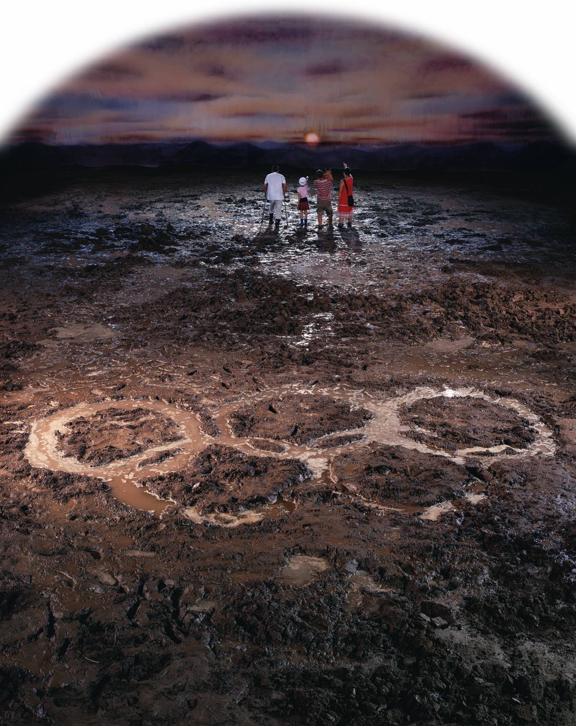

Part One

The Glorious Life --- Wang Qingsong’s Photography (1997-2012)

As economic development takes top priority in China’s national policies, the country has changed, and its people have changed even more. Everyone appears full of aspiration and seems satisfied with the achievements of reform and rapid development, which are expressed in the Chinese slogan, “One change a year, one big change in three years, and one unidentifiable transformation in five years.” Capitalism has "modernized" our formerly agricultural country. This rich contemporary China provides me with a huge resource for artistic inspiration. To sing highly of this new, sweeter-than-honey life of glory, I use theatrical techniques and let the camera narrate true and understandable contemporary stories.

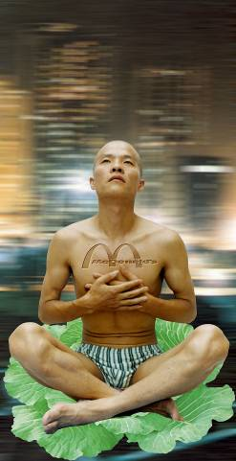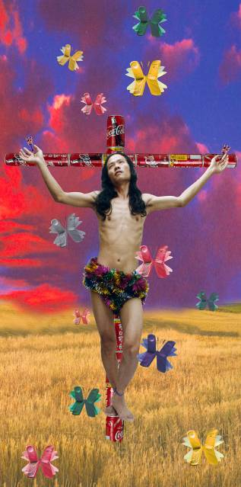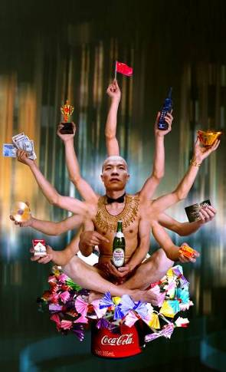
Thinker, 180x90cm,1998 Catcher, 180x90cm, 1998 Requesting Buddha No.1, 180x110cm, 1999

China, with 1/5 of the population in the world, has to resolve problems of clothing, food, housing and transportation. In housing, developers of real estate have created such terms as “Chinese Manhattan”, “Oriental Versailles”, “Park Avenue Apartments”, “Palm Beach Springs”, “Roman Garden”, “Modern SOHO”, and “European Classics”. In food, it is well known that McDonald's and Pizza Hut are just fast-food stores in Europe and America, nothing more than convenience. However, when they came into China, they became the top cuisine and hot rendezvous for people to have parties, invite friends, celebrate birthdays and meet lovers. On the surface, this phenomenon of going after what is western style represents an ideal for Euro-American materialistic life. But in such an era of globalization, does this ideal also represent worship that can create a lot of ridiculous contradictions? With this thinking, I created many photographic works including “Thinker” (1998), “Prisoner” (1998), “Catcher” (1998), “Requesting Buddha series” (1999), “Can I Cooperate with You?” (2000), “Look Up! Look Up!” (2000), “Bath House” (2000), “Forum” (2001), and “Beggar” (2001).

As the quintessence of Chinese traditional culture, Buddhism has accompanied Chinese civilization for thousands of years. It brings comfort and fortune to the people, inspires their soul and enlightens a responsibility for having good relations with the others. This Buddha used to set its goal to save the suffering through self-devotion. However, in the current commercial society, the respectable Buddha has also been changed. It reaches out its hands insatiably for money and material goods towards every troubled person. The “Requesting Buddha” Series （1999）is the faithful representation of such a phenomenon, overflowing with desires, hypocrisy and exaggeration.
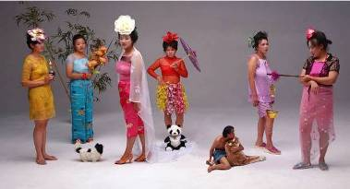 New Women, 120x220cm, 2000
“Court Ladies with Flowers”, a classical piece in Tang dynasty, described the decadent life in the imperial court. However, such desperate and dissolute lifestyle was not exciting, since it was separated from the then social realities. Such ecstasy was only playful fun scenarios designed by the noble rich people. That is the reason I revisit this painting. With the rampant consumerism going on that promulgate pop culture, we see a lot of fake nouveau-riche who dress themselves with jewelries and fashion brands. They look fabulous, confident and happy. But inside their heart, they must feel very timid that their hard-earned business and treasures shall end in bankruptcy. It is very obvious why I entitle this work as “New Women”. When women were liberated, they are confronted with harsh requirements. They need to have a fantastic outlook, sustainable heart, engaging in all tough positions and confronting with varieties of difficulties. In fact, these exterior appearances are fake and fabricated. Loads of sufferings hide behind. Are they really the contemporary modern women?
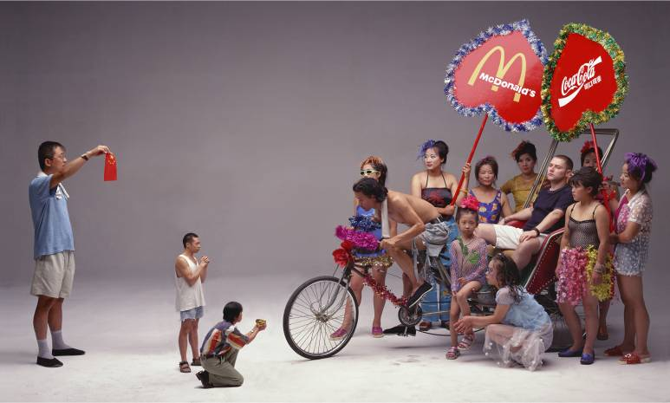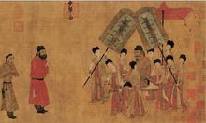
Can I cooperate with you, 120x200cm, 2000 Court Reception, Tang Dynasty, by Yan Li Ben

“Can I Cooperate with You” was influenced by the Tang-Dynasty painting by Yan Li Ben entitled “Sedan Chair”. The original painting described the historical event when the Tang-Dynasty Emperor married Princess Wencheng to Song Zan Gan Bu, the past Tibet, for building relationship. This is the only painting so far depicting the ancient Chinese foreign diplomacy. The power dominance and commercial success in the Tang Dynasty in Chinese history was known worldwide. Chinese people are proud of that ancient moment. I applied this ancient painting in the current reality. What is different is that important figures are placed in opposite places. In the original, the Chinese emperor (enlarged to show his supremacy) was sitting on the sedan while the foreign envoys came to pay tribute to the emperor (minimized to show less importance). In the new piece, a foreigner (British diplomat) representing commercial and political power sits on the tricycle while the Chinese people come to show collaboration and friendship. In some way, this is a catch-picture describing modern Chinese foreign diplomacy.
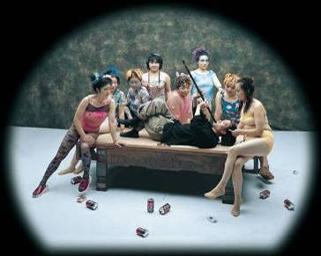 Finding Fun, 120x150cm, 2000

“Finding Fun” looks like inspired from an old painting. In fact, it was created based on my observations of both the past and present social and life experiences. It is a concentrated reflection on the empty-mindedness I feel about contemporary people who work to make more money. But money never can buy happiness. Nowadays the most popular term is finding fun. In order to tint this work with sentiments and indifference similar to that of the old literati, I change the color of the photo into cold tones in order to stress the hypocritical and disillusioned psychology in peoples’ mind.

I remembered that when I was a child, I often went to public baths together with other boys because most families did not have such facilities back in home. A “bathroom” was the place where children played and had fun. I even swam in the bathtub. When I grow up, China has experienced dramatic changes through opening-up and modernization. People’s lives are improved. Many rich families install bathroom and electric or gas water heater at home. The public bathhouses have gradually disappeared from our life. However, they are reconstructed and decorated by people who have an eye to their commercial value. The past public bathhouses reappear as fancy “Bathing Centers” where services of all varieties are offered, such as bath, footnail-clipping, massage and dining as well as Karaoke, and other forms of entertainment. They become a new spot for consumption. Rich guys even go there for discussing negotiations, signing contracts and having parties. Of course bathhouses are abused as places for illicit sexual trade since it is the easiest way to make huge amounts of money. Such businesses got very faddish not only in the entertainment industry, but also in fields such as urban construction, culture, etc. These phenomena seem to be very common which are so weird and abnormal, yet exist in contemporary China. This is the reason and significance that I set up a spa setting and invite female models to shoot Bath House.

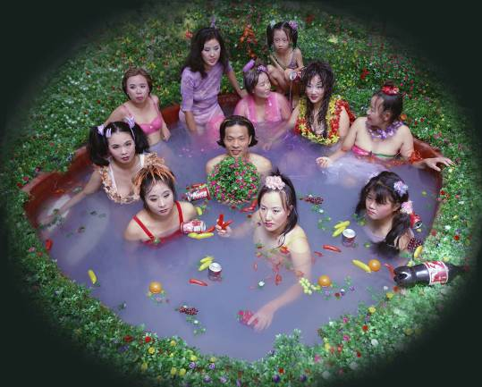 Bath House, 120x150cm, 2000
What haunts my mind is the status and fate of Chinese intellectuals, their life experience through Chinese history. In the modern era, that lacks ideals, people have cast doubt on the heroes and ideals of the past. I wanted to catch some scenes that describe such loss of hopes replaced with hoarding desire for money and power. To compare the past and present, I appropriated the old and known masterpiece “Night Revel of Han Xizai” which was the best piece of Chinese traditional figure painting. This old art piece reflected the then social life in the torrents of transformation, and depicted the life of a worried intellectual and high official in Post-Tang Dynasty, Han Xizai. He was powerless to fulfill his ideals of reconstructing the country. To “cleanse” himself, he chose to evade and “indulge in” comfort. After several centuries, even though the Chinese dynasties have changed frequently, the status of intellectuals in society has remained the same. With some thoughts on this question, I created “Night Revel of Lao Li”. It is a portrait of contemporary Chinese reality in this new century, portraying the situation of contemporary Chinese people, and of intellectuals in particular.
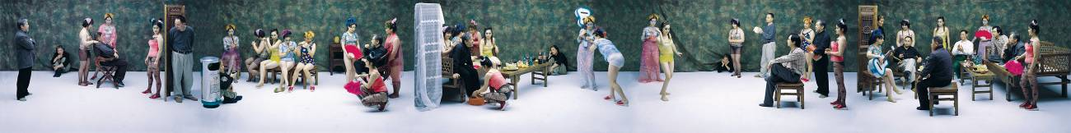

Night Revels of Lao Li, 120x960cm, 2000

“Another Battle” Series (2001) is influenced by the snapshots of patriotism and heroism extolled in the old movies talking about safeguarding the motherland that I watched in childhood. The heroes gave their lives for the liberation of New China in movies like “Landmine War”, “Guerrilla War”, “Three Liberation Wars”, etc. I used to dream about becoming a soldier, too. Up until now, this dream has not been realized. Nowadays economic reconstruction is like a war that progresses so rapidly and intensely. In this war, we have to face contradictions from both Chinese ancient civilization and modern western civilization. I call these contradictions “Another Battle”. In this battle of “defending our country”, without fire and gunshots, I portray myself as a defeated commander. It looks there is no winner at all in this battle.

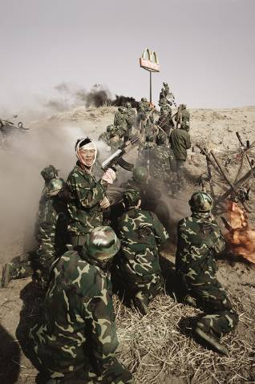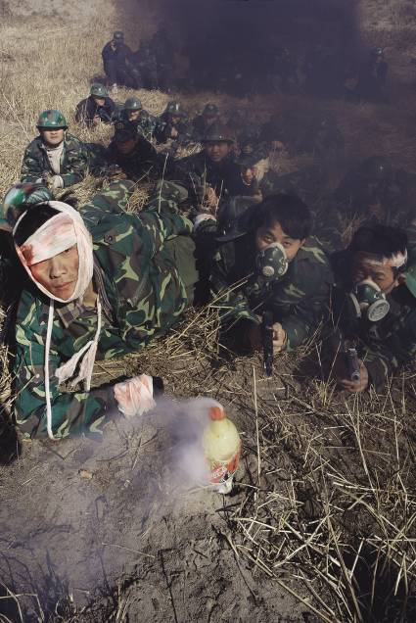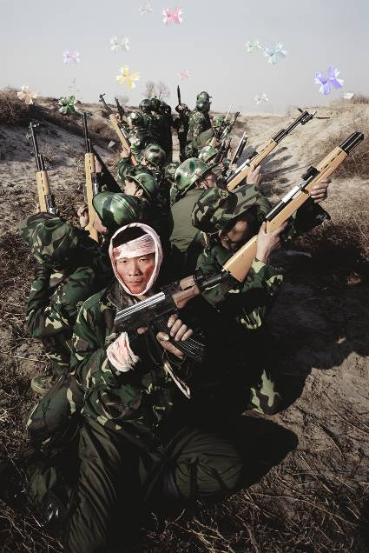
Another Battle Series, 2001

The most striking thing in the streets of Beijing is that we often see beggars loiter around foreign embassies and consulates where rich people of Chinese or foreign descent, come and go. The beggars ask for small change. When I came to Beijing and saw such a weird thing in 1993, I felt very depressing. So I did a performance, called Beggar (1993-1994). For three days, I walked on the street in Sanlitun, where foreign embassies and bars were located, and asked for money from foreigners only and did not give any reasons when they asked. However, I failed. I did not get any money. I did not get any sympathy either. In 2001, I reshot this memory through the shutter of camera and called it Beggar. However, by 2001, my perspective was different. Besides the value significance we give to paper currencies, I also want also to satirize the pompous attitude the rich give to the poor. This is the situation occurring with China’s growing gaps between the rich and poor.

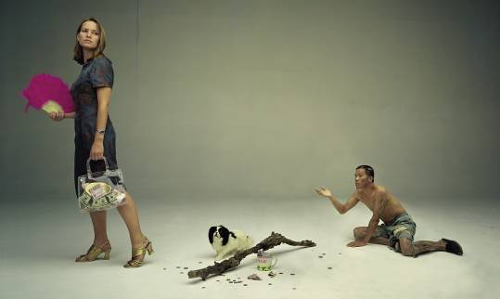 Beggar, 120x200cm, 2001

Forum was triggered by the “achievements” China made in 2001. All people were so happy because first, we entered WTO; second, we were granted with the right to host Olympics 2008; third, Chinese national football team got into the top 32 team for the World Cup. All these achievements seem to give us more confidence that we are becoming much stronger. Therefore many cosmopolitan cities organize international forums on the environment, population, economic growth, etc etc. The “Forum” work aims at express my skeptical attitude towards the mainly superficial devices that define our need to make our actions appear always bigger and better than actual reality.
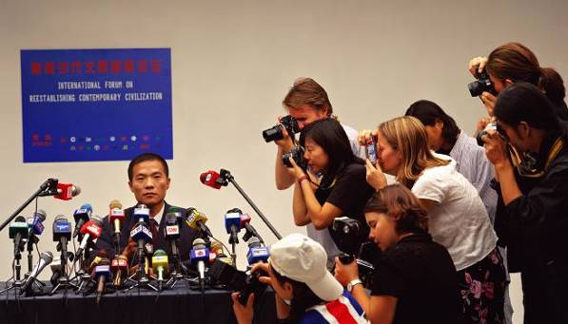 Forum, 120x210cm, 2001

To keep track of my reflection on our past, my consideration of our present, and my depiction of future, I find the urban state sculpture iconography can often best reveal our history and our ideals in China. However, I alter the sculptures, posing implicit doubt on what we have achieved and what we are expecting. With such “doubt”, I portray myself as a bystander in the photograph as a bystander in the triptych work entitled “Past, Present, and Future” (2001). Models are smeared with mud, silver and golden powder hinting at the changes in time from the revolutionary times to the modernization age, and on to the future toward which we aspire. The poses of the models imitate those on the monumental Communist state sculptures still found in some cities in China. I hope this work achieves the effect of reflecting upon the history of the past, reconstruction of the present and the beauty of the future.

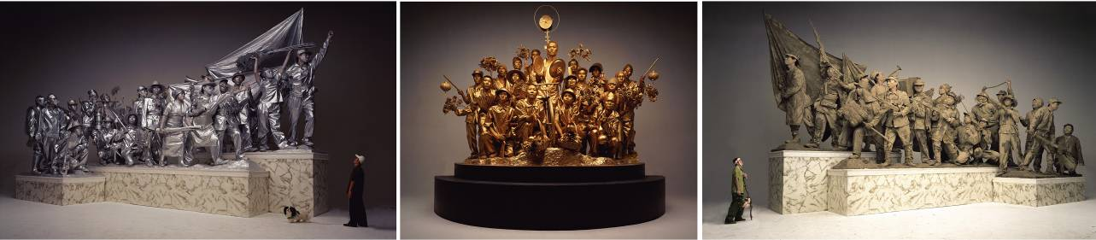

Past, Present and Future, 175x800cm, 2001

In 2002, I photographed two triptychs called "PreIncarnation" and "Incarnation". Continuing the idea of reflection upon our destruction of traditional culture, the gigantic models portrayed by three live person sculptures tell humorously our ludicrous behavior of praising our precious past though unconsciously damaging our history. Such skewed beliefs can be also found in present education in China.
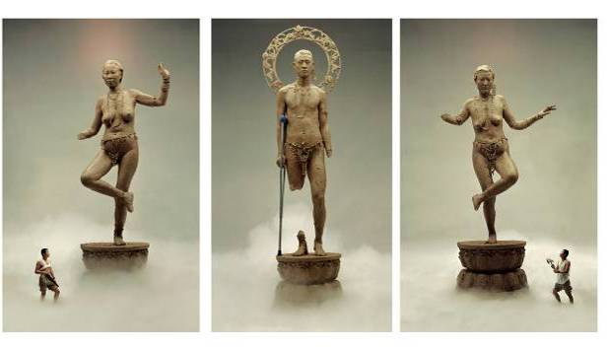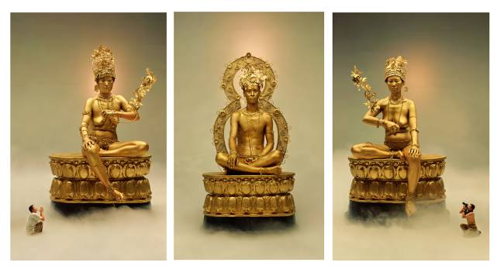
Preincarnation, 190x(120+110+120)cm, 2002 Incarnation, 190x(120+115+120)cm,2002
Nowadays children are excessively focused on obtaining popular consumer goods and fashionable merchandise. So in my scroll-photos of "Knickknack Peddler" (2002) and "Preschool" (2002) as well as “Follow me” in 2003 I make parodies of the ridiculous and self-contradictory beliefs and actions in the Chinese educational system. In these photos, I portrayed as a peddler selling all sorts of foreign goods, as an old man that nurtures new beliefs in the minds of children, and as a village teacher that teaches popular slogans and beliefs in both Chinese and English.
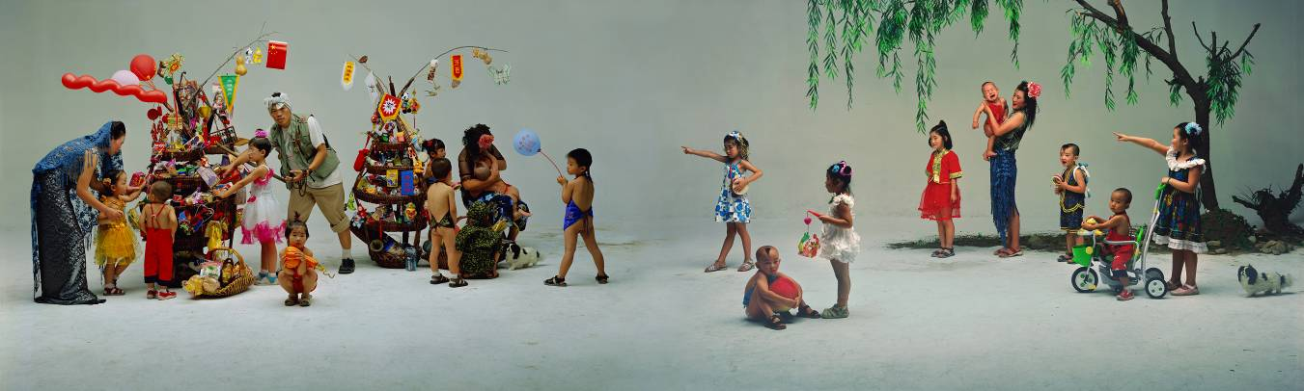
Knickknack Peddler,120x400cm, 2002

The folk history of “knickknack peddlers” is a very long one in China. Itinerant peddlers selling their wares even today often go around neighborhoods in cities and villages. In the past, they served as an avenue of information for locals to learn about the outside world, as they spread information to the far countryside when there was no telephone, cable or email. At the same time, “Peddlers” could act as spies in Chinese revolutionary periods. There are many historical references in the ancient painting depicting a “Knickknack Peddler” on which my photo is based. Many ancient painters have expressed their feelings towards life through comparisons to the life of the “Peddlers”. For example, the painting that inspired my work is from the Song Dynasty, wherein the painter aimed at expressing the joys of childhood. I replaced the ancient items with modern popular food, brands, etc etc. Perhaps in the future, “Peddlers” will disappear from our society, despite the important role they play as a symbol of societal reconstruction. Personally, I predict “Peddlers” will one day be replaced by “Super Markets”.

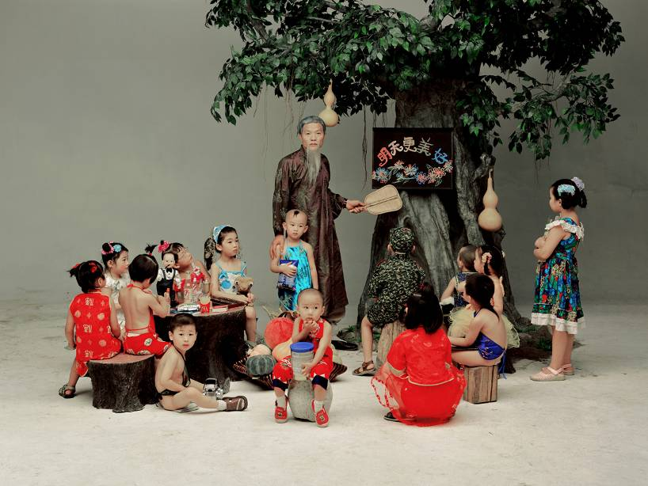 Preschool,120x160cm, 2002
Continuing the idea of reflection upon our destruction of traditional culture, the gigantic models portrayed by three live persons in “Three Graces” shows humorously our ludicrous behavior of praising our precious past though unconsciously damaging our history. Such skewed beliefs can be also found in present education in China. Nowadays children are mainly focused on acquiring popular consumer goods and fashionable merchandise. So in my "Preschool" which makes a parody of the ridiculous and self-contradictory beliefs and actions of the Chinese educational system, I am reconsidering what lasting effect if any comes from the well-known Chinese slogan “Education Should Start off from Children”.

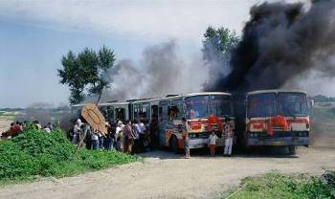 Art Express,120x200cm, 2002

In both art and economic fields, we see so much impact from foreign culture and residual influence from our own traditions. In "Art Express ", under the direction of so many famous international art biennales, people are so eager to get onto this “Art Express” bus. Clearly visible on the signposts are Venice Biennale, Documenta, Sao Paulo Biennale, Istanbul Biennial etc etc destination signs. I also add “Qingsong Biennale”, “Songzhuang Biennale (Songzhuang is an artist colony in east Beijing), a “Biennale of Hell” and a “Biennale of Heaven”.

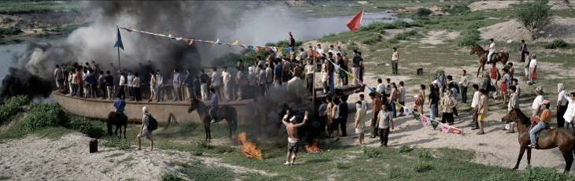
Port, 120x380cm, 2002
In "Port ", I shot the photo with many people standing on top of and alongside this huge boat. There are a red flag, as well as a banner of the United Nations, hanging from poles, along with many triangular banners with famous international commercial brands hinting at the victory of conquest. The gaze of the people in “Port” is forward-looking, despite being surrounded by heavy dark smoke portending an unpredictable future. Another possible scenario is portrayed in "Sentry Post" where "refugees" try to push through the sentry post comprised entirely of famous foreign brand name tin cans, where I stand as a border guard on high alert, and I am holding a Coca-Cola can as a grenade. In “Sentry Post’, I also built a barbed-wire border line fence strewn with foreign products, where the products look like grenades, then I set them on fire, preventing outsiders from entering the city.

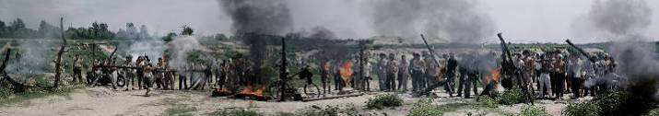Sentry Post, 120x680cm, 2002

I took the name of my work “Follow Me” from the first and most popular English language-teaching program introduced by CCTV (China State Television) in 1982, during the early years of economic reconstruction in China. This English-training series had sixty programs, which were repeatedly broadcast for twelve years. It had 10 million viewers and sold over 30 million textbooks, setting a Guinness record for foreigners learning English. Many Chinese people got a glimpse of the western lifestyle from “Follow Me.” Farmers, workers, soldiers and students, even monks at Lama Temple, enjoyed watching the program which provided a window to learn what foreigners eat and wear and how they live. Many people in Mainland China consider “Follow Me” as the Bible for learning oral English. For example, one young soldier in Shenyang, Liaoning Province, was featured on CCTV Headline News as a national hero because he studied English so well. In the 1980s, “Follow Me” helped many Chinese people make real their dreams of going overseas to further their studies. The English teaching TV program’s significance went far beyond learning English. It helped Chinese people to learn about the west and the world, just after China emerged from its closed-door policy.
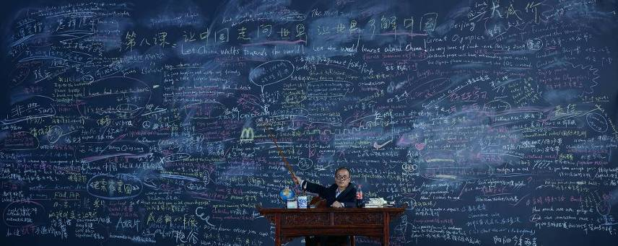
Follow Me, 120x300cm, 2003

In the 1980s, I also enjoyed watching “Follow Me” while studying in high school. However, I could never keep up with the program. Twenty years later, Chinese economic reform has brought many dramatic changes. China now has a myriad of exchanges with global industries from around the world. China hosted the 2008 Olympics in Beijing and the 2010 World Expo in Shanghai. At least on the surface, China is communicating well with the rest of the world. However, when I look at myself, I see a “backward” guy, still failing to speak English. Such thoughts inspired me to create my photograph “Follow Me”. For the shoot, I constructed a huge four-meter wide and eight-meter long blackboard in Beijing Film Studio in 2003, and we scribbled many Chinese and English slogans and terminology referencing changes in Chinese history and culture, words mainly taken from China-based English-training textbooks and manuals. From the early TV series of “Follow Me” to my photograph “Follow Me”, it has been my dream to see to realize the well-known slogan “China Walks towards the World, and World Learns about China”.

In the winter of 2003, I created a series of “fake flowers” series. The main flower I chose is the peony, popular symbol in China of national brilliance and prosperity, and therefore our national flower. I made the petals of my “peonies” out of fresh vegetables, and raw slices of mutton and beef. I shot one set when they were all nice and fresh. I later reshot the same “flowers” after putting the peonies in a deep freezer for a week. This work records a literal depiction of the transition from prosperity to decay, along with my hope of freezing such materialistic decadence made from fleshy desires.

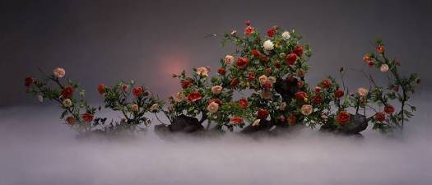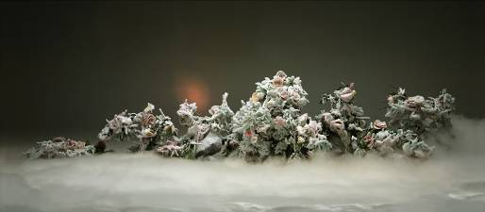

Ethereal Beauty and Auspicious Snow, 120x280cm, diptych, 2003
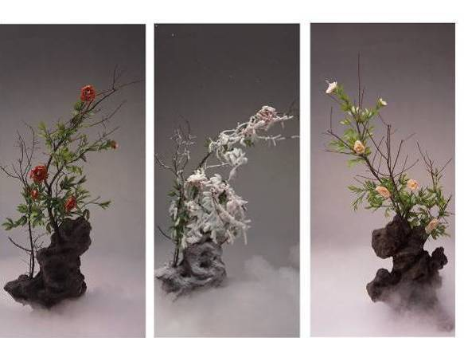

Red Peony, White Peony and Frosted Peony, 240x110cm x 3 pieces, 2003

In summer 2003, I created China Mansion (120x1200cm) and Romantique (120x650cm). Both of these works were shot in Beijing Film Studio of more than 19,000 square feet. This studio formerly hosted important movie crews, including those for the model revolutionary operas during the period of the Cultural Revolution and, recently played host to the Kill Bill (Quentin Tarentino) film crew. Today, the largest film studio in China is regrettably torn down, to make room for commercially ambitious real-estate development projects.

China Mansion, 120x1200cm, 2003

China Mansion summarizes my perception of Chinese social reality during the current stage of globalization. China has been very enthusiastic about inviting foreign experts in economy, technology, architecture, and culture to give support and guidance to its modernization programs. These foreign specialists help to create economic opportunities and introduce alternative systems of thought to China. However, the cultural clash creates social contradictions. This phenomenon triggered me to shoot and direct China Mansion. In the staging of China Mansion, I invited models to play the parts of foreign guests, mimicking postures in paintings by Ingres, Courbet, Manet, Gauguin, Klein, Boucher, Rembrandt, Rubens, Man Ray, and several other artists. I wanted my models to communicate with each other across centuries and at the same time dialoguing with Chinese culture so as to create certain amiable relationships. It seems my hope was in vain. It’s easy to see my visible confusion as I stand at the door greeting guests, as they enter China Mansion, filled with both Chinese and western imagery from antiquity. Obviously the host is a conservative, but also a fashionista. On the left of the photograph, the host wears a banner of welcome. But on the right, the armed guard—like a terra-cotta soldier—looks like a robber, preventing the honorable guests from freely circulating and instead forcing them to leave something valuable behind in the host’s China Mansion.

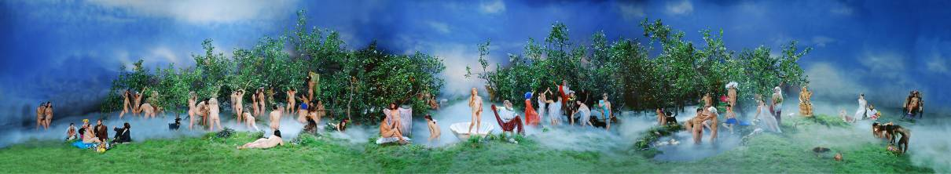

Romantique, 120x650cm, 2003

In Romantique, one seems to walk into a land that is half the heaven of western religion and half a pastoral Chinese garden. There are cheap plastic leaves, fruits, flowers, and decorations. The little ponds in this paradise emit a light smoke created from dry ice. Viewers can imagine false happiness in this fabricated beautiful paradise. Models act out the poses of figures in western masterpieces by Masaccio, Velasquez, Botticelli, Raphael, and Matisse. There’s a Chinese golden Buddha, beautiful princesses, and livestock. There’s a western girl and a Chinese man and his little girl, highlighting the potential conflicts of this complicated international dialogue. These people are very happy, peaceful, and without desire. Like “China Mansion”, the imagery and relations between subjects in “Romantique” are forced, manufactured, chaotic and confusing within this fabricated happiness of man-made utopia. For me such fabricated ideals are like a daydream, a bubble of momentary fantasy.
“Follow Me” is inspired by the English-studying Program in 1982 that lasted for five years. It is the first-ever English-teaching program in CCTV after the downfall of Gang of Four. Nationwide, young and old people studied English. However, I could not learn to speak and write English. In my course “Follow Me”, I wrote on the huge blackboard (4x8m) all fancy words that touch upon current significant issues, such as SARS, Olympics, tycoons of business and art world in both Chinese and English. But overall, one cannot figure out what this course is about even though it is titled “Let China walks toward the world, let the world know about China”.
“Competition” focuses on the power of ads and the misconceptions that advertising can create. For this photo work, I constructed a chaotic backdrop where over 20 people are depicted in a frenzy of competition with some even fist fighting while jostling for ad positioning on a huge billboard advertisement; this struggle for the most optimal outdoor ad placement is perceived as inevitably bringing power and influence. The struggle for ad placement in public space in China is not unlike a battlefield strewn with casualties after a pitched battle for power. Today one brand wins. The next day, its competitor will replace it with better positioning on public spaces. Every day, new ads go up, and old ones fall down, scattered in pieces, and discarded on the ground under newly erected billboard advertisements.
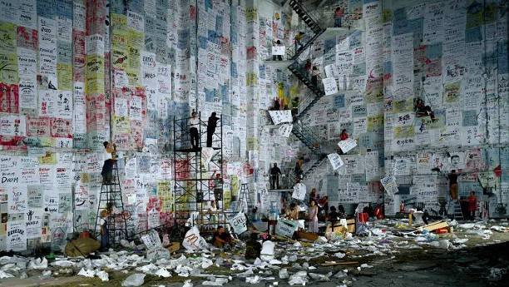
Competition,170x300cm, 2004
In “Competition”, I constructed a huge wall, that stood about 14 meters high and 40 meters across, and then we posted over 600 pieces of paper (110x90cm each) on which I wrote in traditional Chinese ink brush style in some instances and in felt tip pen and magic marker in others, a random selection of slogans and phrases from the advertisements that bombard us here every day. These ads include both domestic and international information about companies and famous brands, such as the lease of houses, education programs, restaurants, foot massage, etc. Everything is advertised, from items as big as airplanes (e.g. BOEING) or as small as vinegar and condoms. On my gigantic wall, I make the fight for advertising as fierce as a struggle for military power, with inevitable casualties on the battlefield. I have also included some of the famous brands that proliferate in China, such as Shell, McDonald's, Durex, Starbuck's, along with a few of the anecdotes behind them and the misunderstandings that arise in translating these into Chinese for a foreign audience. Altogether, I’ve used around 3000 varieties of products and services on my wall to show off the allure of this mass advertising campaign that surrounds us.
In terms of visual form and content, this outdoor advertising onslaught is not unlike the big character posters (“Da zi bao”) posted by competing factions and littering city streets in China during the Cultural Revolution. In the past the streets were hung with posters in fights over political beliefs. Now the struggle is over financial power and business gain. Ads for items are like a rash growing out of control everywhere on our city streets.
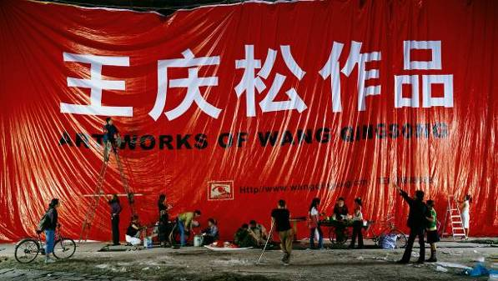 Billboard, 170x300cm, 2004
In “Billboard” (170x300cm, 2004), I continue my investigation of the power of ads and commercial images. I reproduce a huge billboard that reads "Art Works of Wang Qingsong" in gigantic bold letters, in homage to the huge advertising signboards that line the second and third ring roads around Beijing. Life goes on, under the shadow of these huge billboards. We can see some passers-by reading these gigantic ads while others pay no attention at all. Instead, they play chess, buy vegetables, or otherwise carry on with their day-to-day activities. Do we recreate our lives to follow the images depicted in the ads? How much power do these words exert on our mind and eye? I am interested in this physical and mental space that lies somewhere in between advertisements and reality.

"Archaeologist" (2004) was shot inside a 3 meter and 8 meter pit like cave where 30 nude models were covered with mud. In the photo work, they look like corpses, human remains from a long time ago. I pose as the archaeologist conducting research on human remains, in order to express my on-going reflections on what is real and what is false in present-day times. For my personal perspective, I sometimes think present-day human beings are deadened in mind and soul, and their remains need to be reexamined in order to understand the reasons for their early demise, as a means of better understanding how we arrived at this moment of desire-obsessed contemporary society.
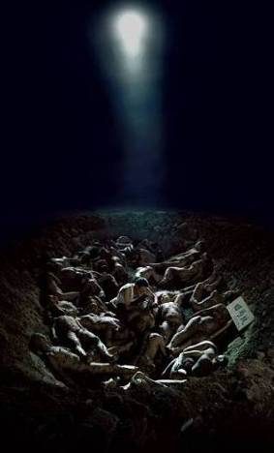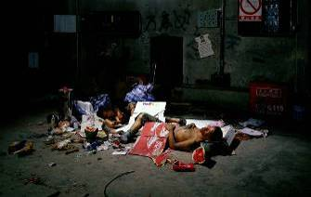
Archaeologist, 2004 Tramp, 120x190cm, 2004

“Tramp” created in 2004 described a couple, homeless and living on the street. They seem to be full of aspirations for a wonderful future. Loitering around them are many redundant things, such as coins, discarded food and garbage. Of course one finds Saddam Hussein’s capture reported in the headline of the New York Times. These minute but sensitive portrait stories are my way of demonstrating the horrible life of the poor who wander on the street.

In the summer of 2005, I made “Come! Come!” (170x200cm x 3 pieces). It involved 800 models, 5 trucks moving props, 8 passenger buses, 5 trucks of garbage of all kinds, and nearly 40 assistants to finish. I chose a location for the shooting on the outskirts of Beijing, at the Hebei Province border, in a remote area where permitting and security issues could be avoided. The weather was perfect for the photo shoot since there was little sunlight. But the temperature was quite hot.

“Come! Come!” is a triptych color photo work shot from the same vantage point with the 8 by 10 large-format camera placed on a scaffolding nearly five meters above the ground. The triptych’s left panel comprises a frontal portrait of 800 “demonstrators” holding a sampling of historically significant slogans and banners, beginning with the Opium War of the 1840’s, (one of China’s first large-scale confrontations with the outside world) from the far off history, all the way up to the present. These slogans and banners from recent events were chosen from a variety of historic books and records I’ve been reading over the last several months.
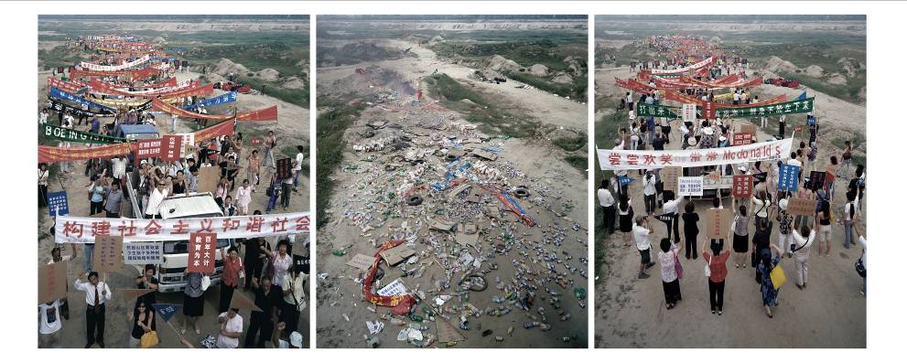 Come, Come, (170x200cm x 3 pieces).2005

On the triptych’s right panel, the “demonstrators” hold slogans and banners from many of the best-known advertisements seen during the course of the Economic Reform period (1980’s to present). These include both local Chinese brands as well as many foreign brands. Together, the banners cover an interesting array of advertising concepts and slogans as well as a poignant record of the changing aspirations of a people over a course of time. The middle image in the triptych is one of a pile of debris scattered across an otherwise untouched landscape. The debris is comprised of the historical slogans, ads, banners, and daily garbage remaining after a large-scale event, a demonstration, or an act of historic significance.

The triptych gives the viewer three very different images of the same road and landscape. In this work, I use this outdoor landscape setting polluted by “demonstrators” to pose questions such as “What Is Coming?” “Who Is Coming?”, “How Does It Come?”, and “Why Is It Coming?”. “Why Is It Happening On The Same Road?” Are the crowds generating slogans, garbage, or commercial advertisements? Historic changes of diverse impact often take place simultaneously, while seemingly going down one and the same path. But one thing is certain: The middle road, littered with garbage rather than people, appears silent, but one can see smoke and fire in the distance, hinting at some struggle, chaos, uncertainty or disputes either having come just before or portending to come just after the people disperse.

Each of the images is shot using a wide-angle lens. I have deliberately cropped the people standing closest to the camera on the left hand panel without omitting them from the frame. On the right, I’ve let those tiny figures in the distance remain in the far corners of the shot. I mean to place history in the forefront and hint at the danger of allowing commercialism to get closer. My fear is that as commercialism (consumerism) moves ever closer, the risk of it overwhelming us and over-powering all that has gone before us gets bigger and bigger.

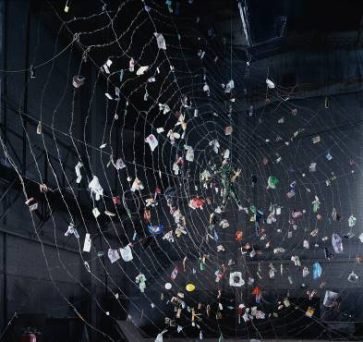 Poisonous Spider,170x180cm, 2005

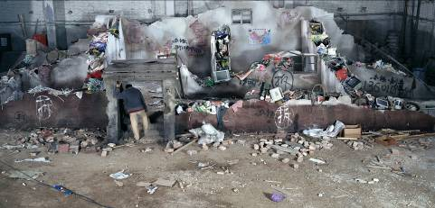 Home,120x250cm, 2005

In November 2005, I rented Being Film Studio for almost a month and created some new works including “Home” and “Poisonous Spider”. I built up a demolished home and a poisonous web made out of barbed wires. These two works include imagery that intrigued me and stuck in my childhood memories. “Home” comes from my earlier memories as a child, of whether our old family house could be hiding some treasures. I threw in a lot of garbage, including daily waste, electrical trash, chemicals, and etc. Until now, I do not completely understand if the demolished houses strewn around China’s city streets once excavated will indeed reveal hidden treasures. Probably bigger profits can be created from this wide spread demolition. Spiders made out of barbed wires hint at the simultaneous feeling of danger and attraction. The barbed-wire web has stuck on its web a variety of worms and insects for food. In today’s commercial world, everyone is like a spider feeing off of a variety of daily merchandise, and refuse I collected over several months.

My photo shoot sets often grow into full-blown installations, such as in “Dream of Migrants” (2005). This term “Migrants” is very derogatory in China. It means aimlessly drifting population from one place to another, mostly from countryside to big cities to look for jobs. This group of people is called an “unauthorized population flow”. The term hints at the risk of social instability. This “floating population” has special terms and is marked with demeaning characteristics such as bad personal hygiene, instability, and threats of dangers to others. In Beijing alone, there are nearly 3 million such people. They all hold a dear dream and look for opportunities when they flow from their hometown into big cities. They bring stimulus by way of human labor for urban development but they also bring forth a lot of unstable social factors, such as the plight of their children without papers to study in the city and lacking stable housing. This population is accustomed to being shepherded from one city to the other, helpless with little money and bad reputations. Some people recognize them as vibrant force, but most people regard them as human signs of social sickness. The array of derogatory terms to such population is often associated with “Tramp, loafers, gangsters, rascals…” Now they are considered a little more important since they are the city builders and supporters. Their interests are now taken more seriously, including welfare, salary, insurance and etc.
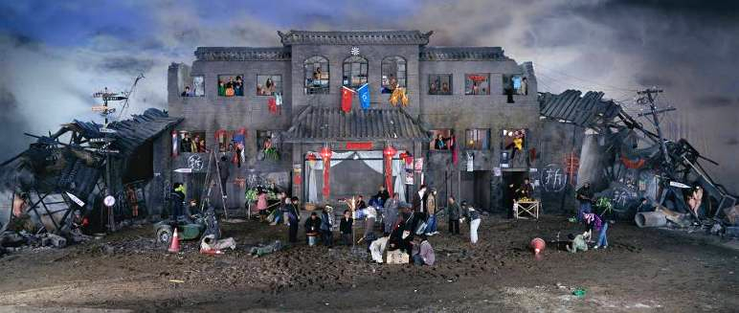
Dream of Migrants, 170x400cm, 2005
I am empathetic to this “Migrant” population. I think they hold on dearly to their dreams and like to be recognized for their contribution to the constructions of China’s cities as they attempt to fulfill their dreams of improving their lives. In reality, their dreams are often hard to realize, as their early dreams of moving to cities are in conflict with their harsh realities discovered only later after they arrive.

In 1993, I moved to Beijing, also from a far away place, from Jinzhou, in Hubei Province. Jinzhou is a very small city. I also had my big dreams despite being surprised by the huge scale of the city of Beijing, a capital city with a population 100 times larger than the population of my hometown, so I witnessed first hand the dramatic social changes in China’s urban areas. I survived because of the realization that my situation was not special and there were tens of thousands of people just like me pouring into China’s cities hoping and trying to realize their dreams.

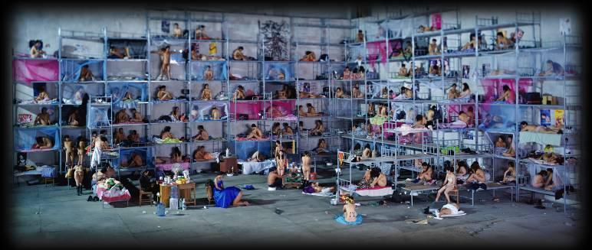 Dormitory, 170x400cm, 2005
Like “Dream of Migrants”, (and also in another work “Dormitory”) (2005), I like to depict the pursuit of personal dreams and work opportunities in this big capital city of Beijing. In the Beijing Film Studios, we constructed inside the studio a “Dream of Migrants” structure, the height of a three-storey building. At first glance, this structure is like Chinese-style architecture. But upon a closer look, one finds it combines the former Soviet Union architecture as well as European architecture in addition to the Chinese traditional civil house making. We can see the past brilliance and the potential danger of this hybrid architecture. I also depict a dirty moist land in front of the building to make hints at the hardships of living in cities and fulfilling dreams. I tone down the colors to create a very disappointing scenario. The general feeling of this work will aim to reflect the inherent conflict the floating population experiences when their dreams are in conflict with reality. I insert various details so the viewers can discover from this photograph the array of unsettled and conflicting feelings of the migrant populations.

“Dormitory” (2005) depicts the pursuit of personal dreams and work opportunities in this big capital city of Beijing. In the Beijing Film Studios, I constructed inside the studio a “huge dorm” composed of 160 models, with about 30 couples playing husbands and wives on the beds. In this structure, the height of a nine-storey bunk beds, one finds so many chaotic scenes, with lots of art history references. On the walls, I put up many popular posters just like where you see in many poor people's living quarters. You seem to walk into a place where you discover the dreams, expectations as well as hardships for the migrating population who leave their dear hometown and familiar settings to seek for a living in big cities.

In 2007, I made “The Glory of Hope” and “UN Party”. “The Glory of Hope” goes back to the difficult past years of China when it went through winning the right to host the Olympic Games. However, I think the uncertain future under the canopy of the euphoric rainbow of happiness is not that promising. The muddy ground represents the reality of China being an agricultural country. The five figures looking out at the horizon in this photo are all my family members. Chinese people are so dear of future dreams. Their life ethic is more forward-looking and hard-working. So even if the road is murky, they still step forward.

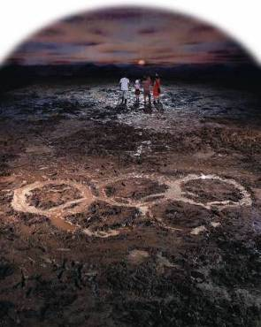 The Glory of Hope, 240x180cm, 2007

“UN Party” refers to the globally popular international gatherings, forums, conferences and dinners… In the left panel of this work, over 1300 people sat around U and N shaped tables and enjoyed cheap fast-food while entertaining heated discussions and expecting a bright future. However, in the right panel, all that remains are leftovers and a scene of chaos. The clouds of smoke overshadowing the black secretive place represent gloomy fantasy.
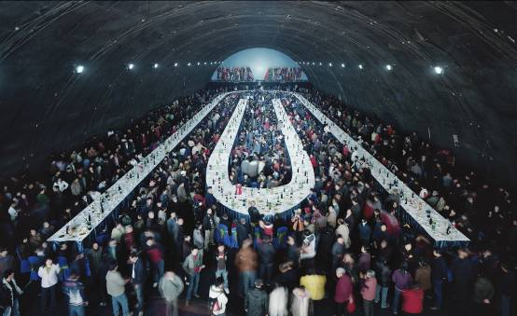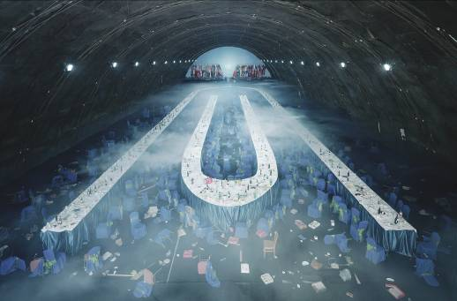

UN Party, diptych,170x280cm, diptych, 2007

In May, 2008, I built a site-specific installation at the PKM Gallery Beijing space. The interior was completely wrapped up with the ubiquitous red, white and blue striped plastic tarpelain material that blankets much of China’s evolving urban landscape, transforming the gallery into a circus-like construction site with a market economy inspired sense of impermanence.
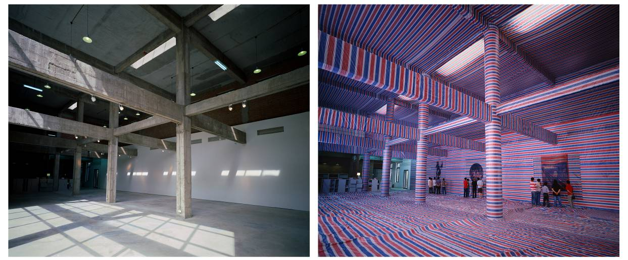

Gallery, 160x190cmx2 pieces, 2008.

“Hard-seat Compartment” (2008) a photo triptych comprised of the three images: the first portrays a completely empty train carriage; the second is a train carriage with luggage and a man, myself, sitting in front of a bowl of instant noodles, the third is the same train carriage crowded and filled up with passengers, luggage and bags. This mood is imbued with all the gloomy feelings one feels in a busy and messy place. I hope the viewers feel the same frustrating and claustrophobic impressions. A cheap “Hard-seat compartment” ticket is a very common choice of train passengers in China. These hard-seat unreserved carriage are often crowded with passengers and luggage piled up in the most messy and unsafe ways. Many people travel long distances in hard-seat, and when they stop somewhere and finally disembark their unsettled and depressing feelings from the hard ride stay in their hearts. The artist experienced many times these crazy trips when people were sprawled everywhere and the chaos and annoyances of hard-seat travel left him with bad feelings and breathlessness. This work reflects those journeys and movements from city to city and what people are willing to do and to tolerate in order to move and to improve their lives.

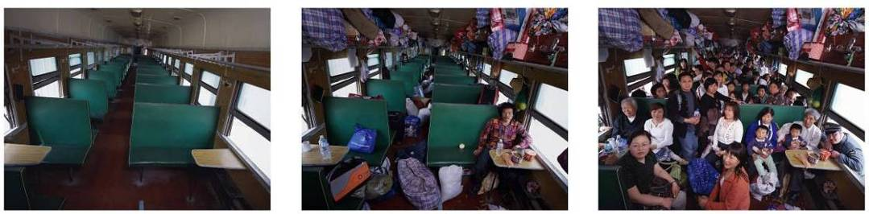

Hard-seat Compartment, 160x210cm x 3 pieces, 2008
I have observed the scenes in hospitals for many years. These experiences come from the experiences of family members, me, and other friends. There are only a very small percentage of people who hold government or corporation positions can get reimbursed from the cost of hospitalization. However, a large majority of the people in China have to pay money ahead of time due to lack of wide-spread social medical care. My son went to hospital for a check-up. The doctor told him to be quiet when he was only three years old and terrified of doctors. My mother died of cancer and was refused an extended stay in the hospital for treatment due to lack of money. I was also maltreated while staying in a ward with an old man who died next to me and his relatives cried for a whole day in front of the dead body. Many friends had similar experiences. We call on the conscience and conscientiousness of the entire hospital staff, and more often than not, there is no nice response to our pleas. In “Nutrients” (2008), I was invited by the world brand of fashion leader Christian Dior to make a photo work. Nowadays, fashion intrudes into our life. We must heed what the fashion leader takes us. Otherwise, we are labeled as old fashioned. But CD represents only large corporation deals. I am not against fashion, but I want people to take a cautious attitude. Therefore, in a large dilapidated house, I built a last -supper scene, decorated with bottled IV’s to show the nonsensical nature of our health care services. Hinting that over-reliance on both fashion and bottled IV’s exposes our exaggerated effect from consumerism, I doubt maybe they are just blank water.
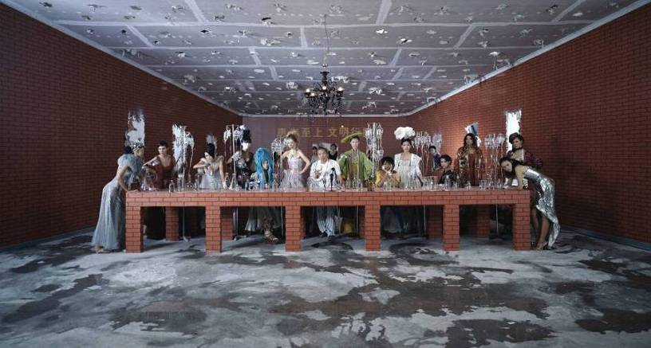
Nutrients, 160x300cm, 2008

I have been thinking about making a photo about hospitals and patient treatment for quite some time. When I was invited to the Northern Stage, New Castle, UK, to do a theatre project, I found out people came to theatres for psychological well-being, similar to seeking physical health improvements when patients go to the hospital. Do they get any real treatment and satisfaction, either from theatres or hospitals? With this question in mind, I come to the idea of transforming the UK’s Northern Theatre into a hospital ward. The Stage One theatre seemed to be as a fitting place to house 300 patients, medical staff and other participant models. On September 13, 2008, with the full support of Northern Stage staff and 300 volunteers, this project was successfully realized in a large-scale photograph titled “Temporary Ward”.
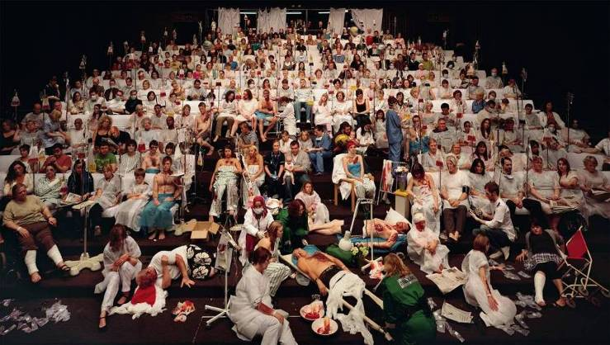Temporary Ward, 180x320cm, light-box, 2008

888,888 Darts and 666,666 Darts consist of 2 real objects with repeat layers of broken paper pieces from the dabbing action for over two months. The two underlying objects are two dartboards semi-destroyed after being hit repeatedly by darts (supposedly 888,888 and 666,666 times referring also to numerology that has an important good omen in Chinese folk belief). I want to demonstrate that a game of chance such as darts is potentially dangerous and irrational if not controlled. The human mind can lose touch with sanity if persons fall into obsessive psychotic loops of behaviour. Sometimes violence and madness can be born from apparently safe situations and apparently neutral emotions, engendered from the vacuity and boredom of repetitive games and actions.
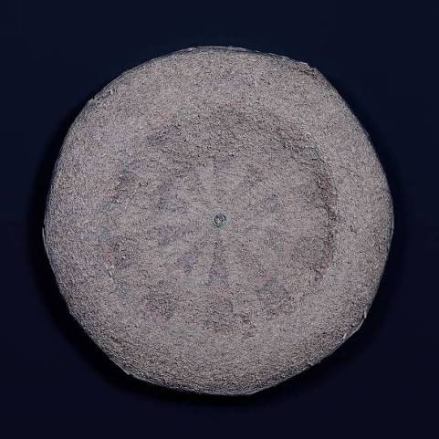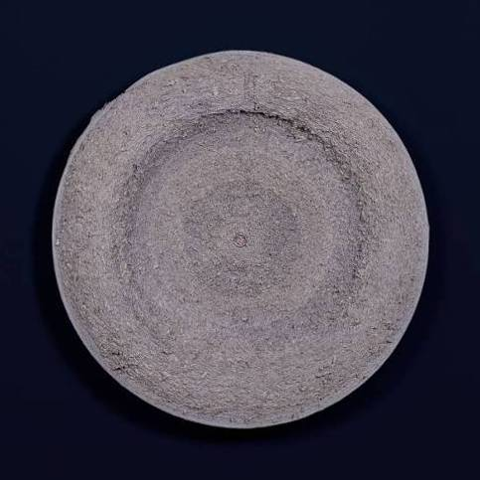
888,888 Darts and 666,666 Darts, each 150x120cm, 2008

In February 2009, I was invited by a French magazine to France to shoot some photo works. At that time, I decided to make another work for myself, “Safe Milk”. In an old castle in France, I invited western fashion models to work with me in staging a newer version of the “Last Supper”. Around 2008-2009, there was a nation-wide consumer scandal in China, involving tainted infant formula, milk and milk powder, contaminated with melamine, endangering the health of infants and small children. So I made this photograph. On a large table about 9 meters long, I placed yoghurt, and milk, asking models to bear their breasts. It was such a valuable experience that an American pregnant women volunteered to work with me on this photograph before giving birth a few days later.
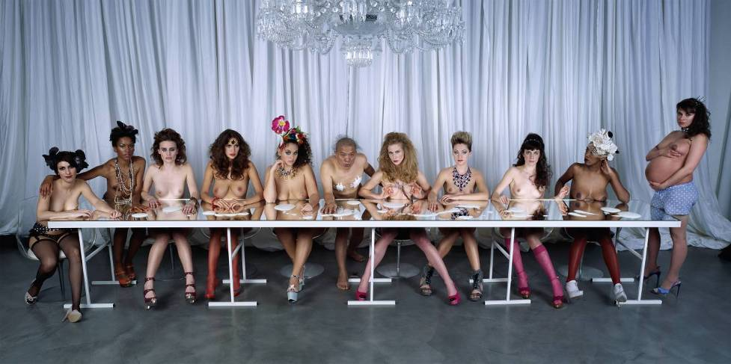Safe Milk, 160x300cm, 2009

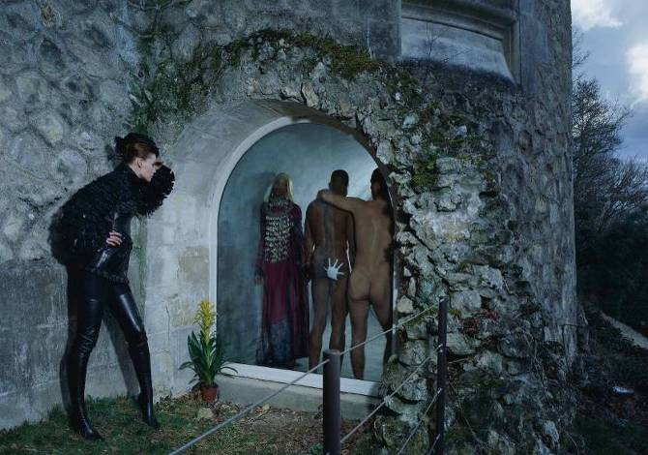 Romeo and Juliet, 120x170cm, c-print, 2009
At the same time, I also made "Romeo and Juliet", shooting two models dressed in Dior dresses, presenting a well-known romantic love story. One black girl acts out Juliet standing inside a cave cell while another white girl acts out Romeo coming to meet each other. This scene in this photograph is idyllic, and was shot in Da Vinci's museum in a small town 2 hours outside Paris.

Recently I have been thinking about how both commerce and humankind fail in their attempt to coexist, despite the fact that humankind produces merchandise, the merchandise comes back like a boomerang to dominate humankind adversely. The dilemma posed by humanity vs. merchandise is a long philosophical inquiry with no solution. What we do know is that the world is what we make or we are what the world makes.
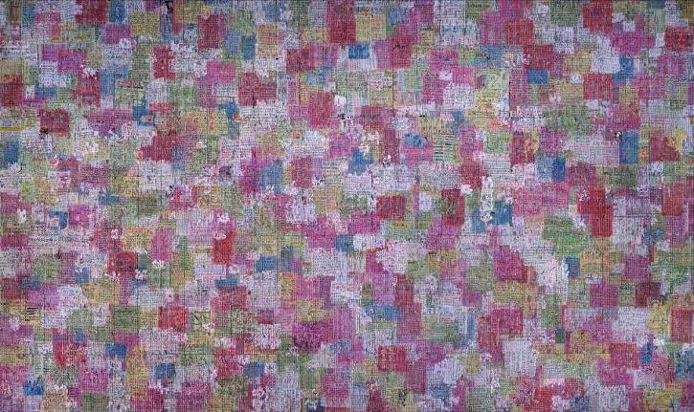

Debacle, 170x300cm, 2009
From October 2008 to January 2009, I returned to the multiple meanings and connotations imbued in terms such as “international famous brand names” which we fabricate for commercial promotion and marketing purposes. I collected all sorts of advertisements from real objects such as soft drink bottles, boxes and product packaging, medicine, as well as paper advertisements from newspapers, magazines, and invitations worldwide. Then I reproduced them in hand-written notes and posters, into 3,000 pieces of paper, each sized 85x110cm, then glued them onto a massive moveable wall made of corrugated asbestos tiles, sized 75x200cm, fixing hand-made ads layer by layer . Within seven days, we scratched off the layers of original commercials and mounted them onto a 12 meter high and 25 meter long setting of broken, worn-out, dilapidated-looking abandoned wall.

Together, this gigantic mosaic of broken strips from advertising materials makes an eye-catching semi-abstract painting. This process of production and destruction is like a game of building blocks. We enjoyed building up something new and then destroying it in order to create a brand-new style, and this production process will no doubt continue in the art world over and over again. I choose to name this work “Debacle” in reference to “Competition” (2004), and the similarities between the two works are obvious, with the fiercer competition going on continuously. “Debacle”, more pessimistic, depicts the utter failure of all commercials and corporate marketing schemes, and the contradictions inherent in “Competition” and “Debacle” within market economy forces.

From August 2009, I started to work with 200 models over 15 days in shooting the 42 meter long “The History of Monuments”. This work is my reflection on what is told about civilizations, beauties, virtues, standards and norms…. The models are smeared with mud and placed into the carved out contours of the photo backdrop. Chinese traditions are handed down from generation to generation with many documents on the historical figures, poetries, literature, dramas, etc. Often the leaderships like to summarize their achievements during their reign times. So each dynasty has its interpretations of its dynasty and the former dynasties. It is undeniable that many such versions are misguided. I am interested in why history is distorted by one flick of temporary persons who somehow has the power to rule out the brilliance of the others. I am not interested in who will be selected and remembered by the history. I am more interested in how I can interpret my part of the history with the maximal length of the paper since one roll of Kodak paper is as long as 45 meters. I simply juxtapose all the images, icons, figures, objects along this wall and put them together across the different times.
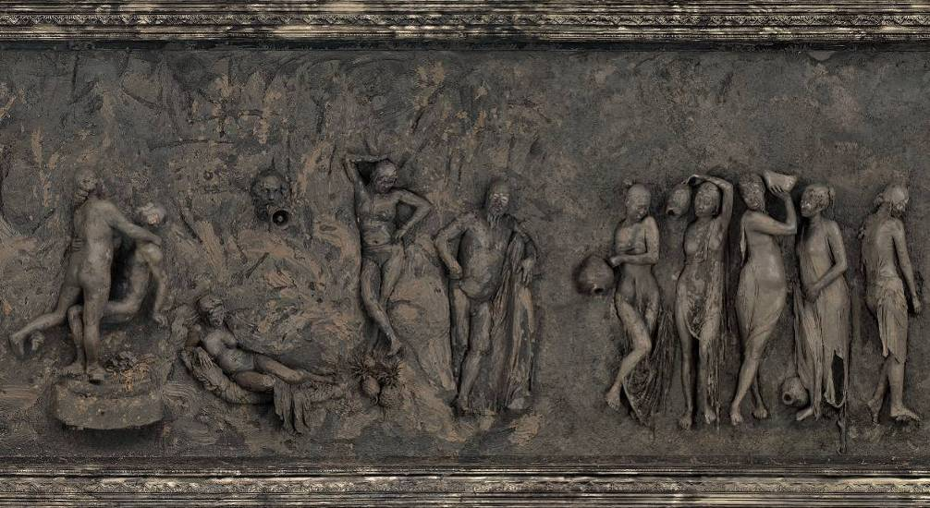

Detail of “The History of Monuments”, 125x4200cm. 2009-2010, c-print

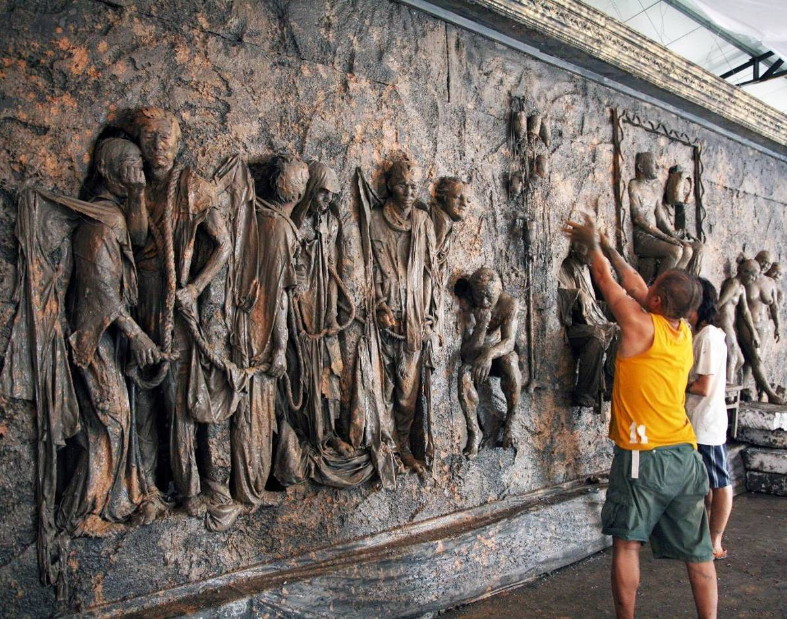

Around the time I shot “The History of Monuments” in 2009-2010 (120x4200cm, c-print), I started to prepare for shooting “Follow Him”. During the whole year until 2010, I collected and bought a lot of used books, magazines, dictionaries and etc of literature, poetry, law, college preparatory materials and put them onto stacks of shelves. Then let all these books got rotten and dirty. Like a real scholar who reads so many books, “I” still fail to write any decent paper even if loads of blank papers were trashed all over the ground.

In “Follow Him”, one finds a huge library with 20 tons of collected books. It took me a year to set this up since I must leave the book in the air to receive dust and dirt. In this image, I am talking about the education problem in China. Knowledge is taught but not learnt by many people who fail to understand the real meanings. They don’t know the meaning of studies. They study for their parents, for their grandparents, but never for themselves, for the love of knowledge itself. Therefore we see so many students trash their books after examinations.
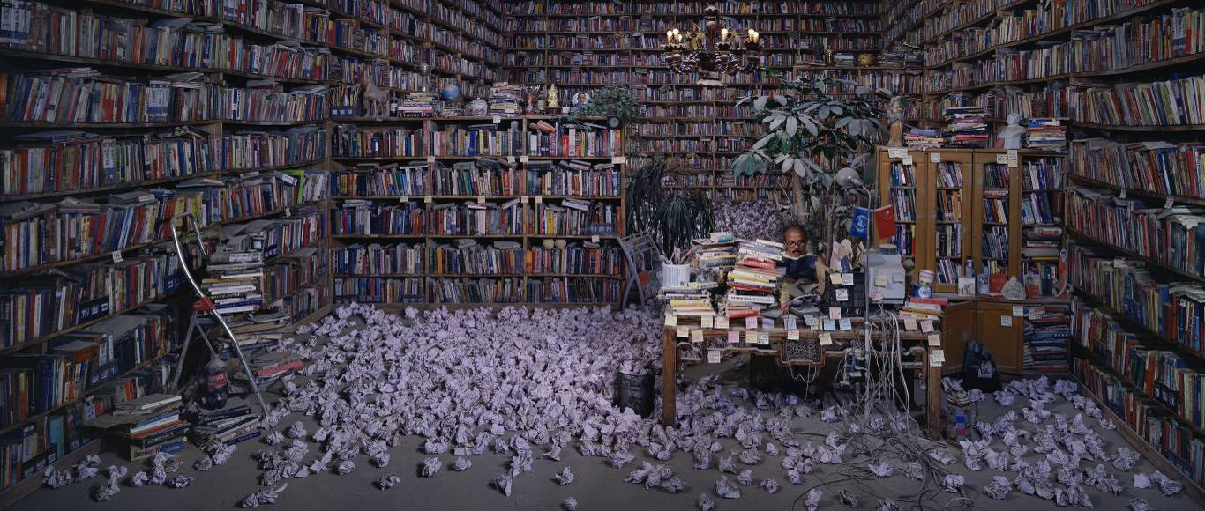
Follow Him, 130x300cm, 2010

In 2011, I made two art works related to faith, belief and ideas. They are called “Goddess” (180x250cm) and “Temple” (180x300cm). In the 500 square meters of my new studio in Songzhuang, I built with clay a Goddess on Mao suit imprisoned by the scaffoldings and green mash nets, surrounded by a lot of garbage and livestock. My inspiration came from a boat trip approaching the Statue of Liberty in 1999 in a foggy and rainy night. I found the Statue coming from the water like the Venus, pure and sacred. It is symbolic of freedom and democracy and also a yearning for self-independence. However, I found many people lose ideals and hopes dreaming only of how to make a nice and rich life. Some people might find these works are like negotiations between western civilization and Chinese traditions. But I think no matter which is better than the other, they both fail between the dear dreams are forgotten, either voluntarily or forcibly, by the drastic social, political and economic integration. So I make these two works to memorize the wishful past.
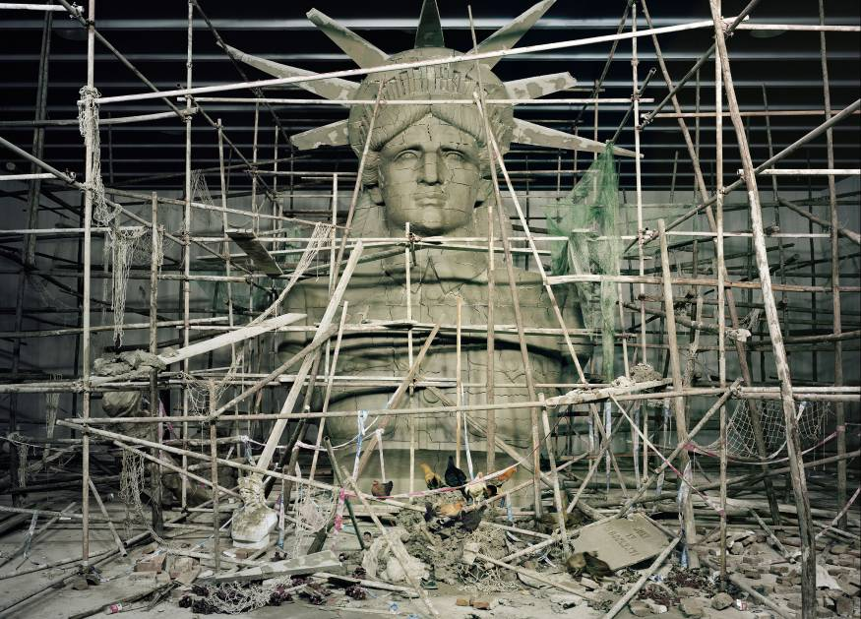
Goddess, 180x250cm, 2011
Approaching the Statue of Liberty by boat for the first time in 1999, Wang Qingsong had visions of Botticelli. ‘‘It was just a little bit like ‘The Birth of Venus,’ ’’ he said. ‘‘It was a goddess born from the water.’’ Twelve years later, he took that image as inspiration for ‘‘Goddess,’’ featuring a 26-by-19-foot clay sculpture built in his studio in Songzhuang, an artists’ village on the outskirts of Beijing. As with all of his work, Wang constructs elaborate tableaux, which he then photographs and dismantles. For ‘‘Goddess,’’ he imagined Lady Liberty in a Mao suit, a reflection of China’s struggle between two ideals: the beliefs of the chairman and the tenets of democracy. The scaffolding around the sculpture alludes to the vast unfinished construction sites in China; the chickens that wander through the rubble enjoy a freedom that he believes the Chinese people do not. Though he has had only a few direct confrontations with the authorities (usually over nudity), Wang expects ‘‘Goddess’’ to be controversial. ‘‘People have lost their dreams and their ideals,’’ he said. ‘‘As an artist, as a citizen, I am very puzzled about where we are going and why we are lost.’’ Julie Bosman ( http://www.nytimes.com/interactive/2011/10/16/magazine/LOOKchina.html?ref=magazine）

In 2011, after making “Goddess”, I created “Temple” which one can see a huge happy Buddha surrounded by 2000 some statue heads, given a big tribute by the bowing heads of 250 people. According the scripture, Buddha believes that people are born naked, and shall leave the world naked. That is why the people are naked smeared with mud. On the other hand, the prayers have different postures signifying the conflicts of different beliefs/religions in the world afflicted with all sorts of wars for economic benefits.
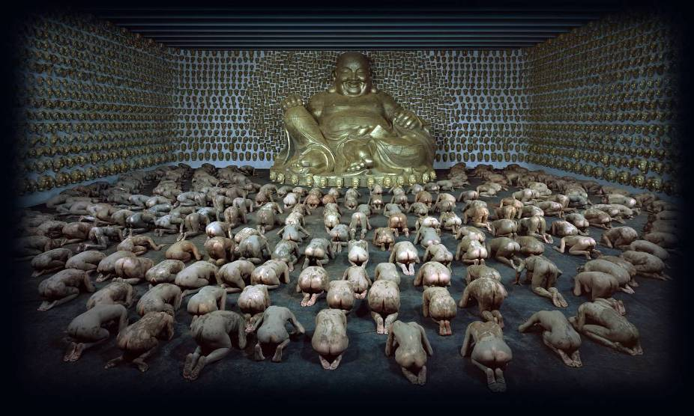
Temple, 180x300cm, c-print, 2011
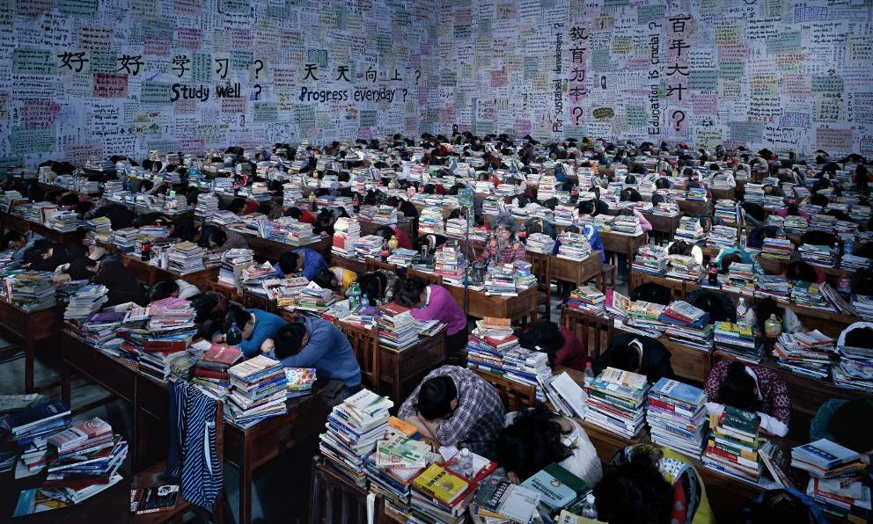 Follow Him, 2013
In 2013, I was invited for Venice Biennale China Pavilion. I wanted to do new shoots. The education issue in China as well as in the world has been the center of my creativity during the last years. So I made “Follow You” after “Follow Him” and “Follow Me”. In the large studio, I placed 120 school tables and 240 chairs in the huge background of blackboard walls, 240 people were invited only to doze off on the table. I was sitting in the middle and having IV drops while still watching upfront attentively to the teacher who was invisible. I want to talk about the huge waster of books and time for the students who were so tired of studies and could not stand one more the continuous examinations.

Around the same day, I shoot “ICU”. Like the previous discussion about fashion brands and consumerism and people’s fascination with foreign products in “Nutrients”, “Safe Milk”, “Preschool” and etc, I made a huge medical room decorated with all charts of what has been wrong with this patient who was sleeping on the operation table, spreading out, with lots of bloody tendons and used tubes around. If one notices clearly, he will find all the IV bottles are stuck with foreign drinks labels.
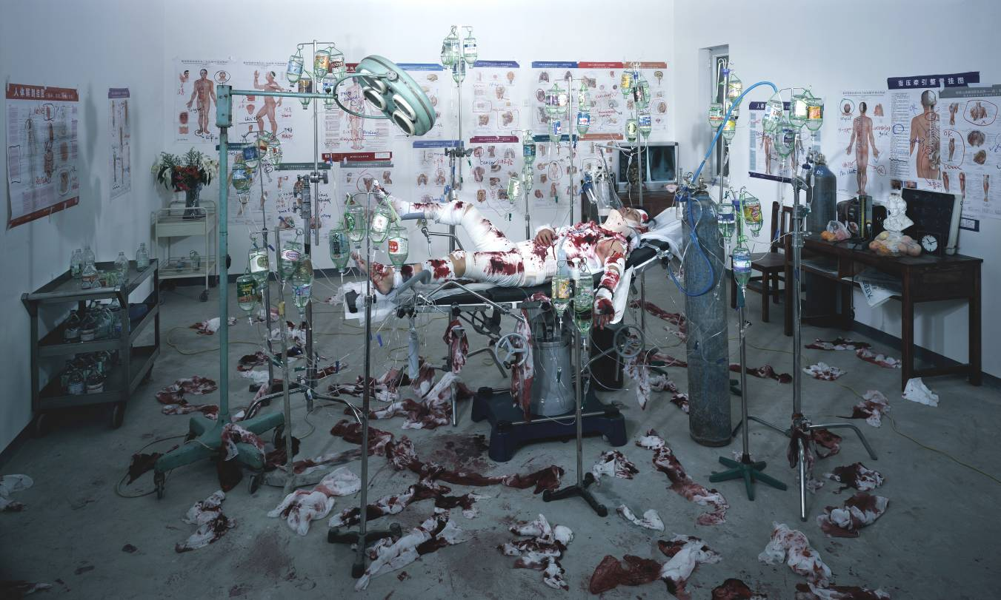

Overall, I hope my photographic works witness and emulate the hopes and frustrations of Chinese people in the modern reconstruction of socialism with Chinese characteristics. I came to Beijing in 1993. I experience all these significant social, historical and artistic developments. So by depicting these visual stories in my photographs, films and sculptures, I hope viewers will recognize clearly my attitude towards social phenomena in the current times. If my works can lead to further reflection for other people, I will be even happier.

Part Two

The Cruel Life: Wang Qingsong’s Video Works

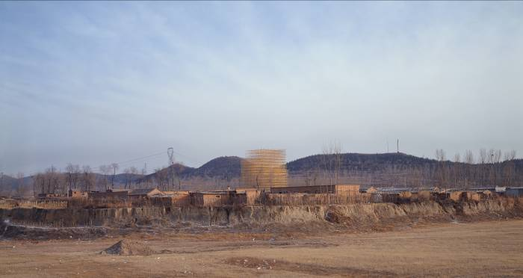Skyscraper, 5 minutes, 35 mm film, 2008

The video “Skyscraper” depicts the construction of a fantastic installation of about 35 meters high, with a diameter of 45 meters, built by 40 workers within a month or so in Changping County, 30 miles north of Beijing. The scaffolding iron bars are painted with gold color to make them look shiny and golden under the sunshine. This golden scaffolding signifies the glory/wonder of drastic changes in urbanization drive to urbanize. The soundtrack dubbed at the end of video plays “Silent Night” together with images of colorful fireworks celebrating the Chinese New Year, hinting at a very peaceful while melancholy world.

Through this video piece, I want to analyze how dramatic social changes, in particular, in terms of sky-scraper construction, occur in China and how such construction projects have little to do with happiness of humanity. I chose this location and accidentally found this poor village has been contaminated with pollution resulting in deformities of children. My photo works consistently depict my skepticism in the face of such dramatic transformations, involving human intervention in less-than humanistic methods and attitudes. This “Skyscraper” is like a Greek god growing magically from a smoky ground and looming high above the earth. The whole process of this scaffolding construction emulates the processes we witness of beginning and finally ending construction of high rises all around us.
Working of the film
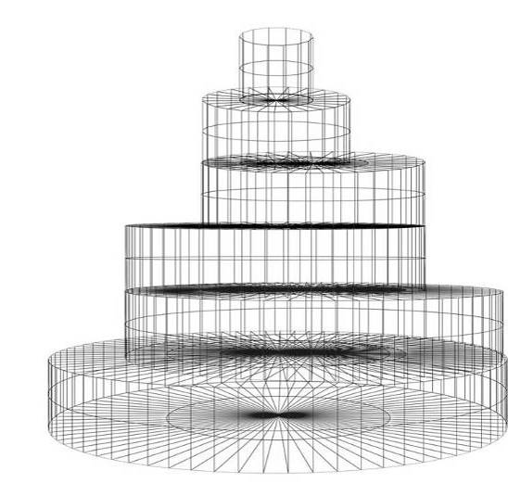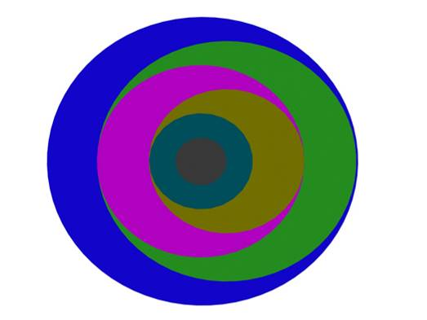
“Skyscraper” – sketch 01 Upper view

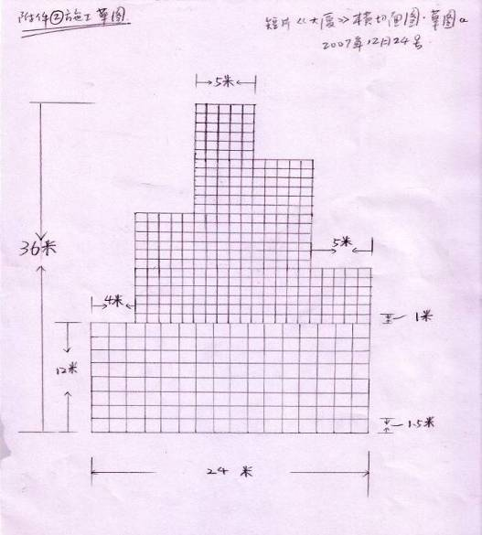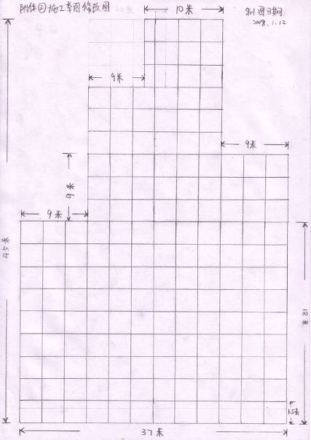
Draft 1: 30m in diameter, 36m in height Draft 2: 37m in diameter, 45m in height
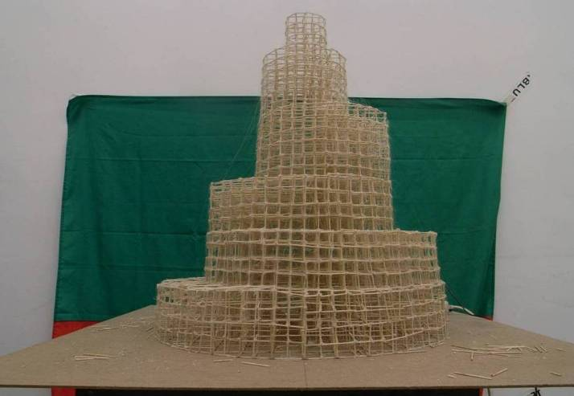

Marquette with tooth-picks, December 2007

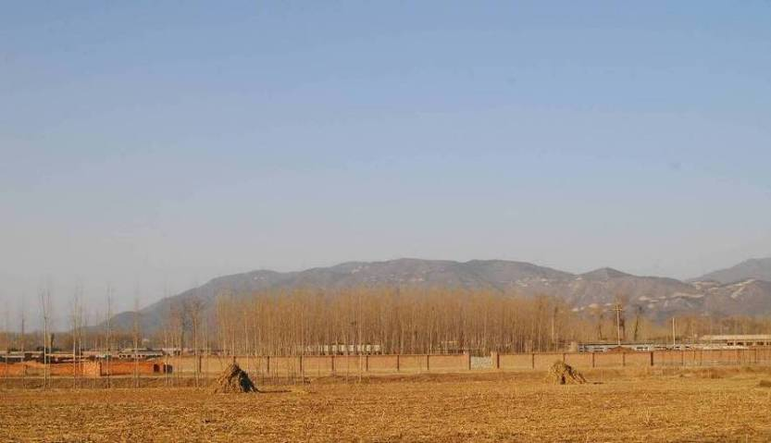

Shooting location, village in Changping District, Beijing. January 2008

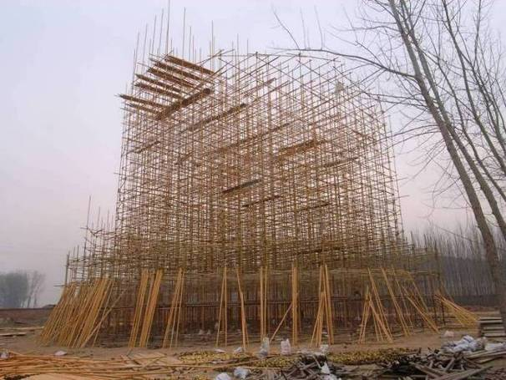 Front view of 24 meter high

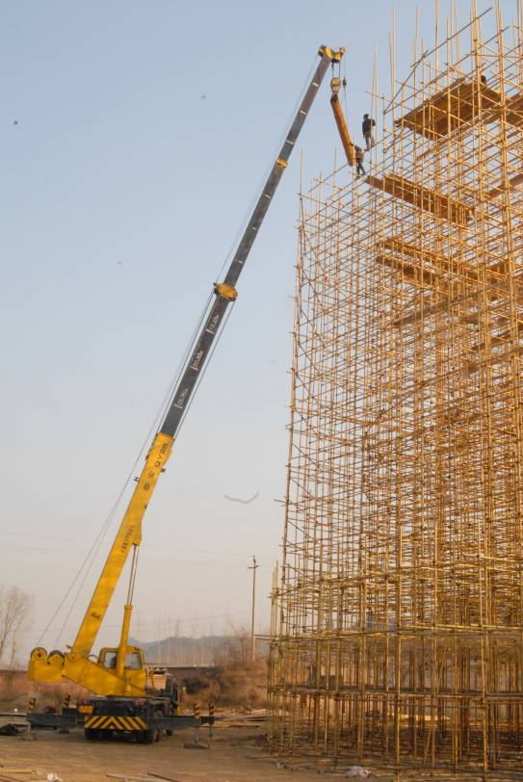 Construction site, Changping County, Beijing

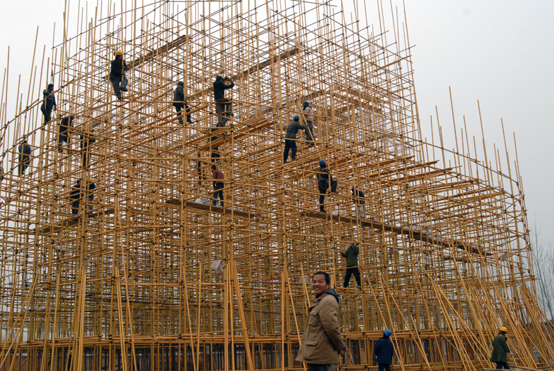

“Iron Man”, 4 minutes, 35 mm film, 2008

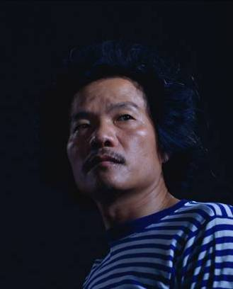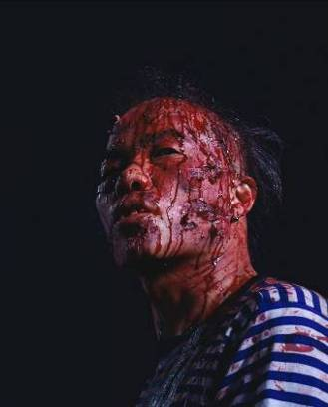
Iron Man, 150x120cm x 2 pieces, 2008

A poster from the Cultural Revolution entitled “To Live Like Such A Person” refers to the appreciation of being a brave, honest, and heroic person. In our childhood, we have been taught how to live and why to live in politic classes. These heroes were taught to as great models to emulate and to live up to as we grew up.

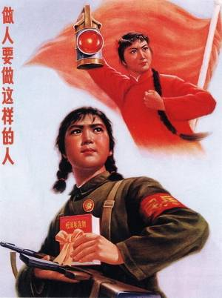
However, the real world is very tough, stifled with conflict, war, violence, strife, controversy, fight, combat… People have to face up to all these severe situations. To be a hero means a lot of suffering, bravery, insistence, all sorts of skills of stamina to combat against the unexpected disasters.

In “Iron Man”, Wang Qingsong created a hero in his own image affectionately referred to as “Iron Man”. This term “Iron Man” refers to an oil worker hero (Qingsong worked in the oil-fields for over eight years) who dedicated his life to developing Chinese oil industry in the early 1960s. In this video this strong-minded hero has been beaten up by a lot of fists but always straightens up his head facing sideways as if “Taking Death As Merely Going Back Home”. He avoids the fist by playing Chinese “Tai Chi” (a Chinese body-exercise system of slow meditative physical exercise designed for relaxation, balance and health). Finally, though losing hair and teeth in the course of the beating, he still smiles at his opponents. Is it a fact of life or an absurdist satire against all forms of violence? Or what is “Iron Man”?

123456 Chops, 4 minutes, video, 2008

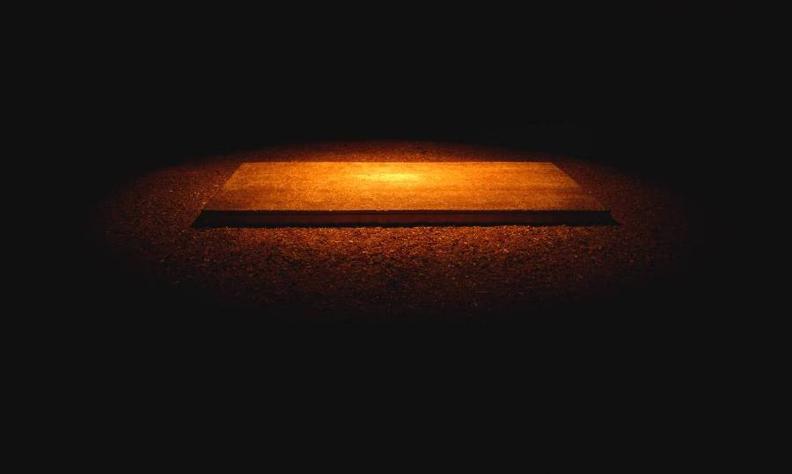123,456 Chops, 120x200cm, 2008

In dark light, a man dressed in the clothes of a lunatic or an institutionalized patient approaches a huge chopping block and throws the carcass of a goat onto the block. Then he begins coldly and wildly cutting the carcass into pieces hour-by-hour, day-in-and-day-out. The lone actor’s anger, violence, suffocation, sadness, disappointment, are all depicted in this methodical cutting action, in a disturbing piece that any one who has felt the need to vent anger can relate to. Perhaps this venting is the best means available to deal with unresolved feelings of anger, hatred, self-defense, or other negative feelings, to relieve one of far worse mental diseases.

During the production of this video, the artist tried to buy a pair of big-bladed machetes from kitchenware shops. The knife vendors all looked at the artist with suspicion and watched carefully as he exited the stores. Either they told him there were no such hacking knives, or three or four people came together to be on guard against him. He was assumed to be a sick person or potentially dangerous and crazy guy. In this exercise, the artist quickly realized life is full of dangers, terrors, violence, insecurities, suspicions, and etc…

Part Three

Close-to-Life: Wang Qingsong’s Sculptures

WELCOME PANEL is a bronze panel of banning (forbidden) signs that are engraved onto bronze. I collected a variety of public signage “don’ts” and then used them to create my own prohibition signs from my daily experience. It is like recording the evidence that taboos of all sorts, enforcing social conventions, creating rituals of behaviour, cultural protocols, restricting and moving our minds. In fact boundaries, rules and constrictions are the factors that tempt and encourage human beings to do exactly the opposite, secretly wishing to indulge in all that is forbidden.

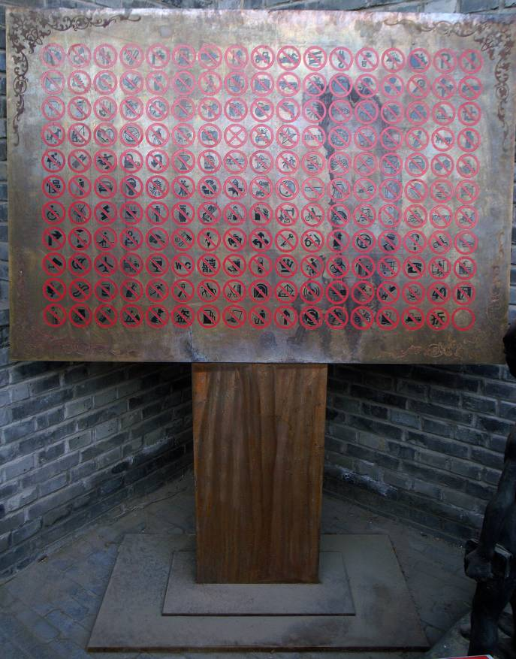

Welcome Panel, 146x100x180cm, bronze, 2008

“Luggage” is a selection of suitcases from our times I’ve collected starting with luggage of the 1920s. People move around and carry their belongings in suitcases. So the style and design of the luggage also represent the times when people are situated. I’ve collected luggage from the early war-time traditional Chinese bundles, 1920s Shanghai colonial-time suitcases, and the current style of backpacks, trolley-wheel suitcases nowadays and memorialized all of these in life-size bronze sculptures. Then I hand paint the original colors, flowers, patterns and designs onto the bronze bags and suitcases. The monuments to travel and human movement reflect a flow of time, also a flow of social change, a flow of people’s tastes….To date, I have made 30 bronze suitcase sculptures, and my plan is to make 200 with each a unique piece. When they are put together, one finds the traces of history.
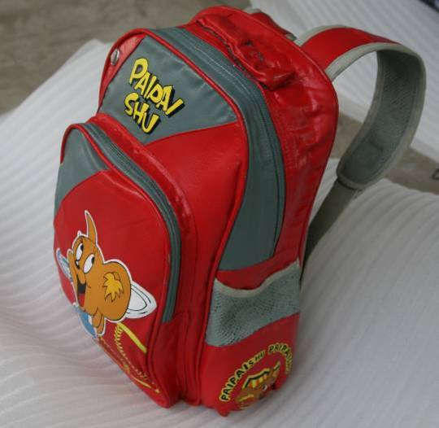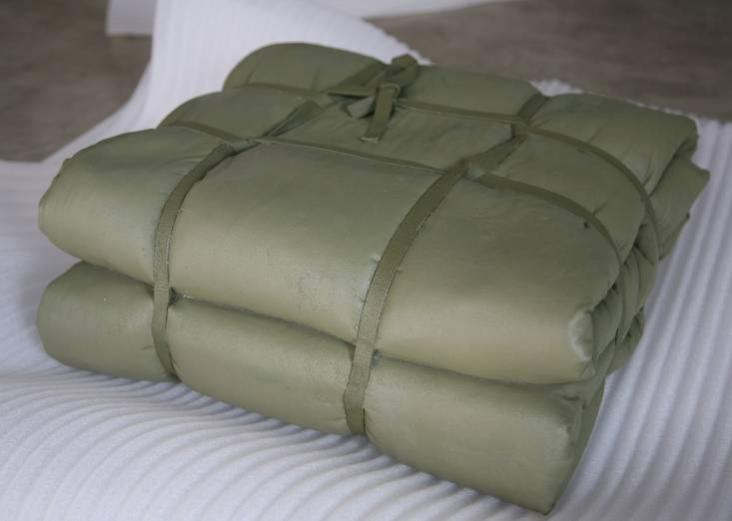

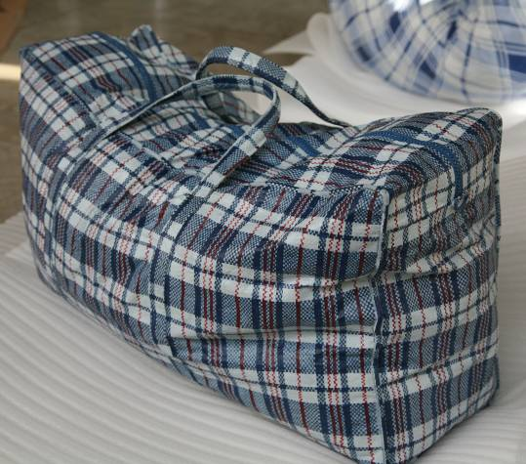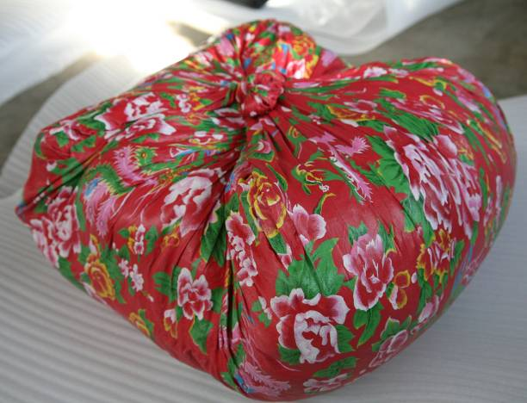

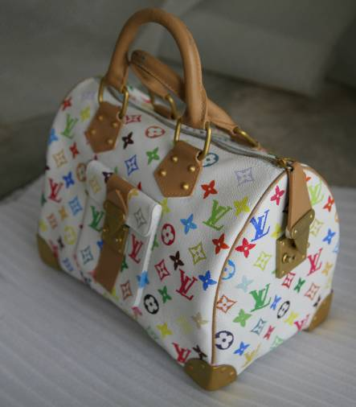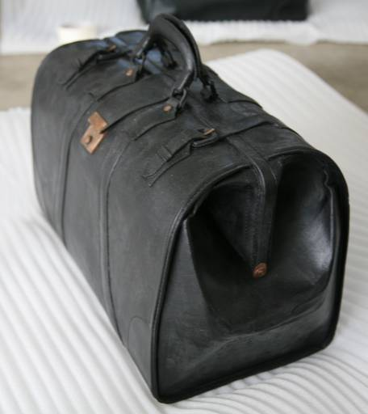

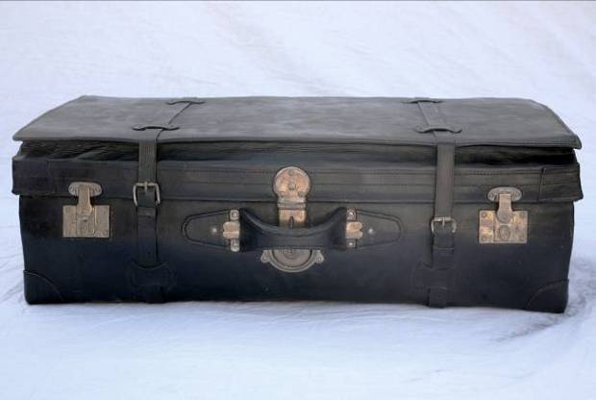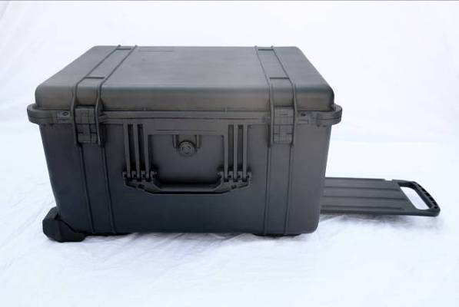
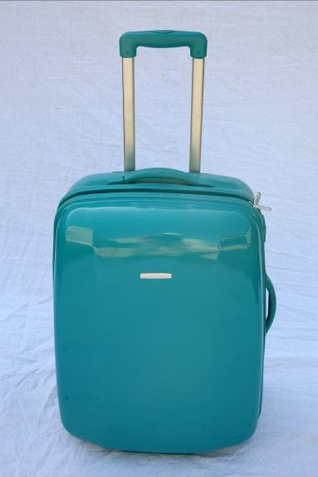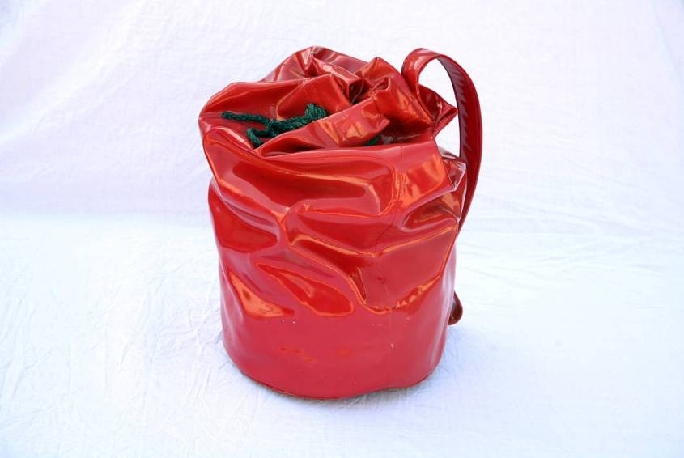

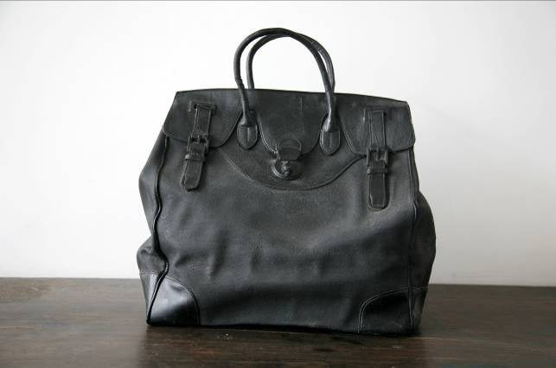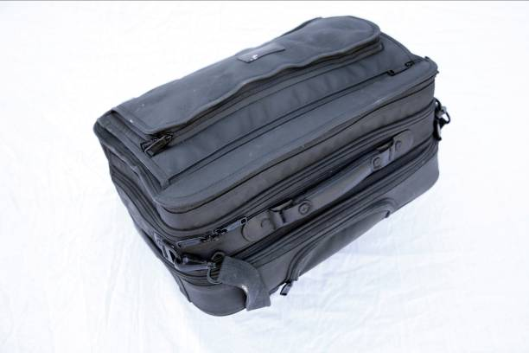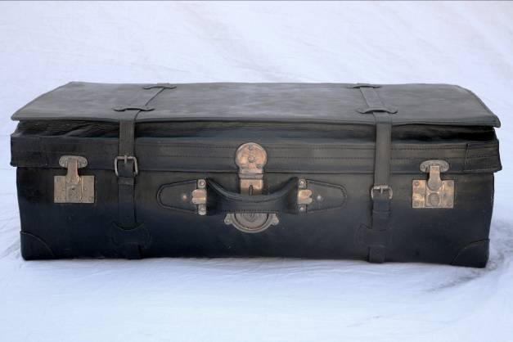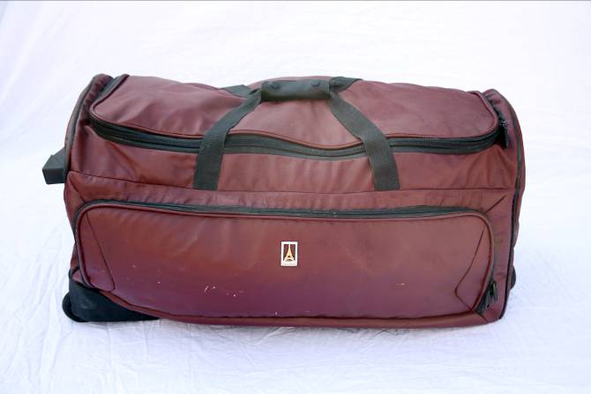
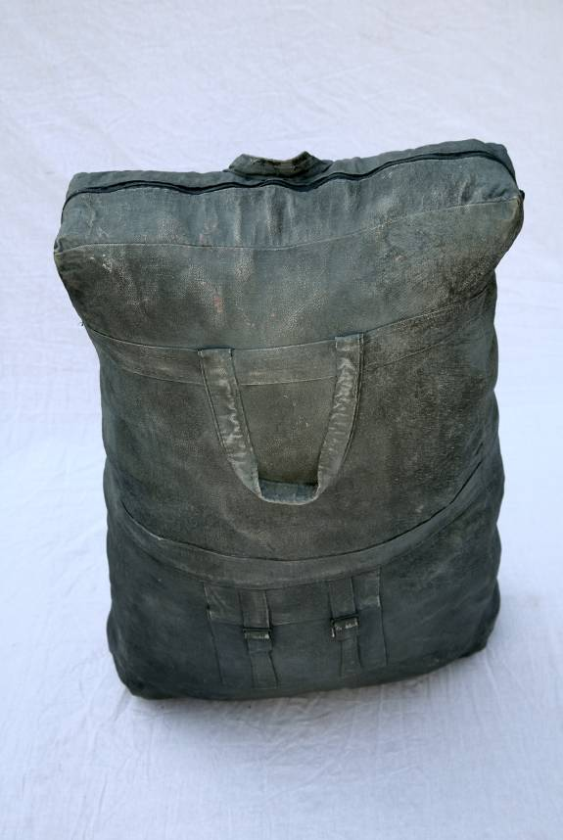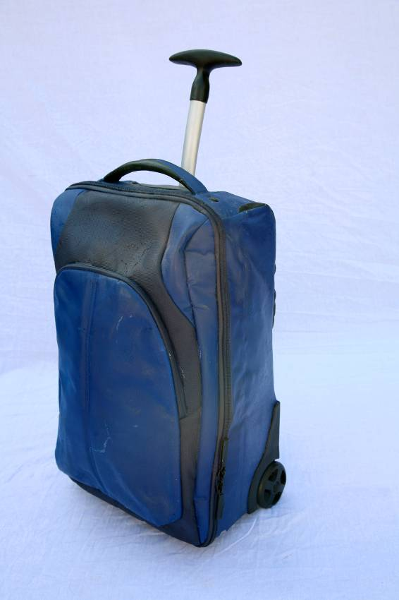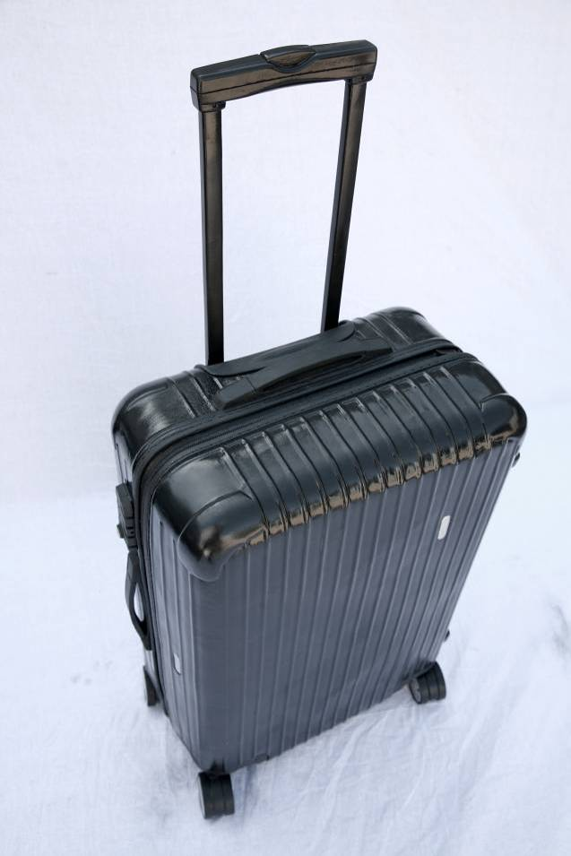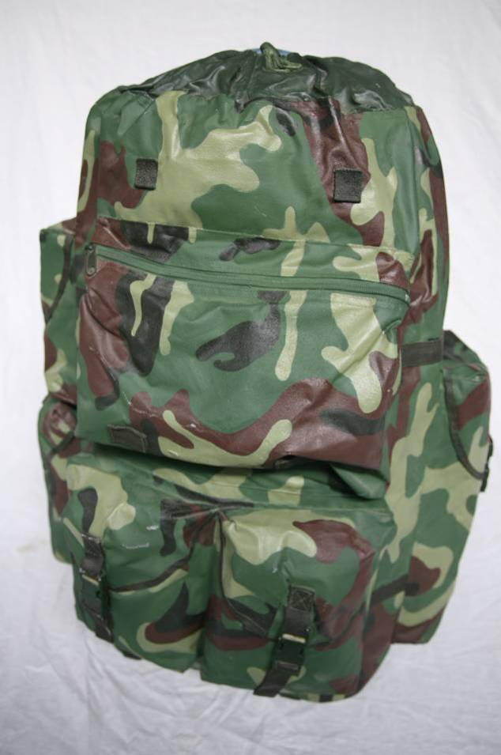
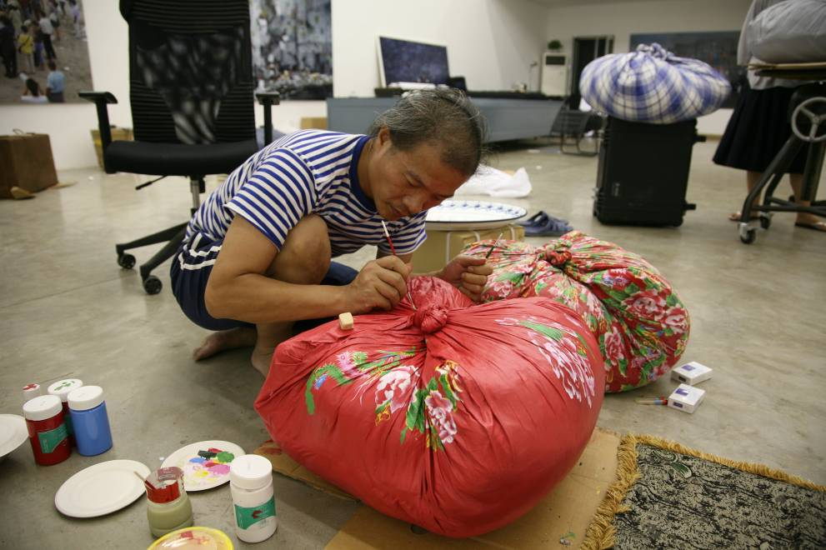
Wang Qingsong paints on bronze sculptures, 2009

