Social change and art, Wang Qingsong’s way – Artnet video interview
Posted on 02/05/2014

Artnet provides insights into the life of Wang Qingsong, who combines contemporary art with the keen social observation skills of a journalist.
In a video produced by Artnet, Heather Russell, the company’s senior specialist in Asian Modern and Contemporary Art, interviews Chinese new media artist Wang Qingsong. The conversation captures the personal, professional and conceptual motivations behind the artist’s photography and video artworks.
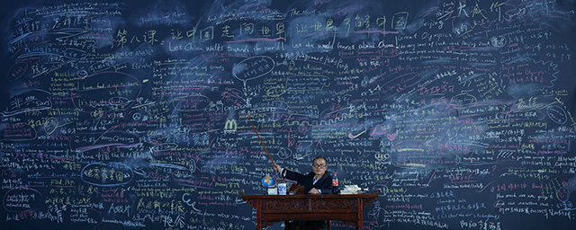
Wang Qingsong, ‘Follow Me’, 2003, photograph, 120 x 300 cm. Image courtesy the artist.
This article was written by a participant in our art writing diploma programme. Do you want to write for Art Radar, too? Click here to find out more about our Diploma in Art Journalism & Writing.
Sitting in the Artnet offices in New York, Wang Qingsong explains his artistic outlook: “I always say I am a journalist instead of artist,” he says. “I try to record changes of the entire society as a journalist. I believe that only journalists can observe the rapid change in China.”

(请插入YouTube的采访)
https://www.youtube.com/watch?v=6JViVi0Tx8o " target="_blank">Try watching this video on www.youtube.com</a>, or enable JavaScript if it is disabled in your browser.</div></div>
Watch the Artnet video interview with Wang Qingsong on youtube.com

Society staged
As interviewer Heather Russell notes in the video, Wang Qingsong’s signature layering of staged sets projects an underlying strain. “Your photographs […] are known the world over for being incredibly colourful, visually intricate [and] visually seductive,” she says, “but they carry an undercurrent of tension and subversiveness that, underneath this beautiful dream vision you give us, there is a deep message.”
Wang Qingsong, as the director of these elaborate sets, is often nestled between the various objects and colours that make up the large scale images; the artist poses as a subject in many of his photographic series. “I think I can represent the people who live at the bottom of society,” he says. “So people can relate [to the artwork] when they see my image in the works.”
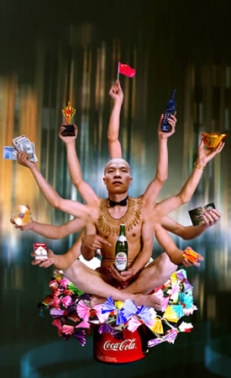
Wang Qingsong, ‘Requesting Buddha Series No.1’, 1999, photograph, 180 x 110 cm. Image courtesy the artist.
Growing up in a rapidly changing China
By the 1990s, China’s open door policy, brought in by Deng Xiaoping in December 1978, had changed the face of Chinese contemporary culture. “The generation of artists that emerged in the mid-1990s grew up in a mostly rural nation, under Mao, and experiencing the decade-long Cultural Revolution that started in 1966,” writes Barbara Pollack, a contributing editor for ARTnews, “their art […] reflected not only conditions at the time, but also a Chinese identity formed when the country was isolated from the rest of the world.”
Wang talks about his firsthand experience working at that time: “In the middle of the 1990s, Chinese contemporary art became more and more diversified,” he says. “Other art forms like performance, installation and photography began to flourish.” According to the artist, “Photography started being considered as a serious form of art” and this influenced his transition from painting to photography.
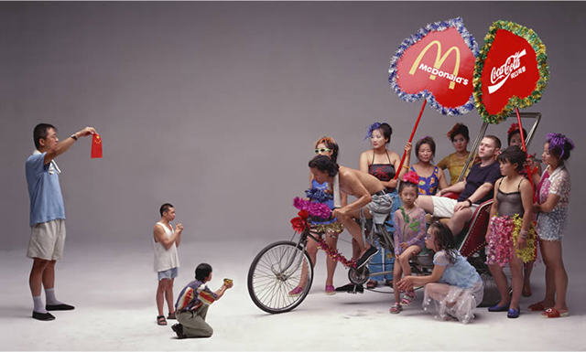
Wang Qingsong, ‘Can I cooperate with you’, 2000, photograph, 120 x 200 cm. Image courtesy the artist.
Wang’s education framed his perception and helped him to develop into a keen social observer. “We still had impressions of the revolution through education. All the teaching materials throughout elementary school were derived from the Cultural Revolution,” he explains. “I could still feel the responsibility to society which Mao emphasised as a part of social nature.” These Maoist elements in the school curricula and textbooks of Wang’s generation encouraged a strong social awareness. “Slogans such as the ‘SERVE THE PEOPLE WITH HEART AND SOUL’ made me concerned about the changes in society,” he explains.
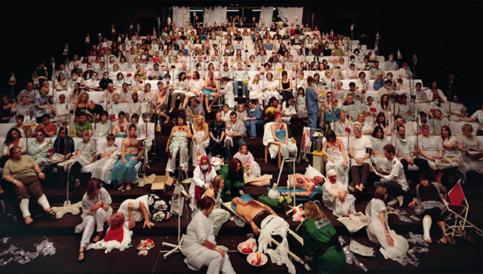
Wang Qingsong, ‘Temporary Ward’, 2008, photograph, lightbox, 180 x 320 cm. Image courtesy the artist.
International exhibition, future ventures
“Transfiguration”, the exhibition of the Chinese Pavilion at the 55th Venice Biennale, included the artworks of renowned Chinese artists, Wang Qingsong among them. To Wang, the process of coordinating with other artists to represent China’s transformation in an international forum was akin to a “cooperative fight”. Anticipating censorship by the Chinese Ministry of Culture, it was easy to select works for the exhibition, because “there were no naked bodies or obvious political elements,” he says. According to Wang, the Chinese Pavilion “had its relative limitations.”
In 2013, Wang Qingsong participated in the thirteenth edition of the Istanbul Biennial – themed “Mom, am I a barbarian?” – where he displayed his infamous “Follow Series”. Wang describes the system of opportunities and relationships in the international art world as net-like. “I also enjoy the uncertainty and the organic way in which exhibition concepts develop,” he adds.
Wang is now venturing into filmmaking. The artist does not disclose much information about this film venture, but he does note in the interview that filming is underway and that the production will be released within the next three to five years. In the meantime, the artist is working on a photographic series called “Blood Cloth” that aims to examine China’s role as a manufacturing nation and enterprise.
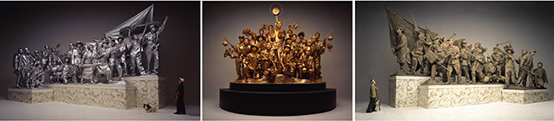
Wang Qingsong, ‘Past, Present and Future’, 2001, photograph, 170 x 283 cm, 170 x 212 cm, 170 x 283 cm. Image courtesy the artist.
More on Wang Qingsong
Wang Qingsong was born in 1966, in the wake of the Cultural Revolution in China. Born in Heilongjiang Province, Wang was trained as a painter in the Sichuan Academy. His migration from his rural hometown to Beijing inspired his outlook as well as his transition into photography in 1996.
He is represented by galleries Albion (London, UK), Dolores de Sierra (Madrid, Spain) and Pékin Fine Arts (Beijing, China) and has exhibited across the United States and Europe, including in exhibition venues such as the International Center of Photography ( New York, USA), the Asia Society (New York, USA), the J. Paul Getty Museum (Los Angeles, USA) and Stadtmuseum (Siegburg, Germany).
In 2006, he received the Outreach Award from Rencontres de le Photographie in Arles, France. His work is held in important international collections, including the Philadelphia Museum of Art (USA), the Hammer Museum (USA), the Victoria and Albert Museum (UK), the Moscow House of Photography (Russia), Mori Art Museum (Japan) and the National Gallery of Victoria (Australia).
This article was written by a participant in our art writing diploma programme. Do you want to write for Art Radar, too? Click here to find out more about our Diploma in Art Journalism & Writing.
Umber Majeed

