INTERVIEW | 02.10.15
https://www.jocksandnerds.com/articles/wang-qingsong
- 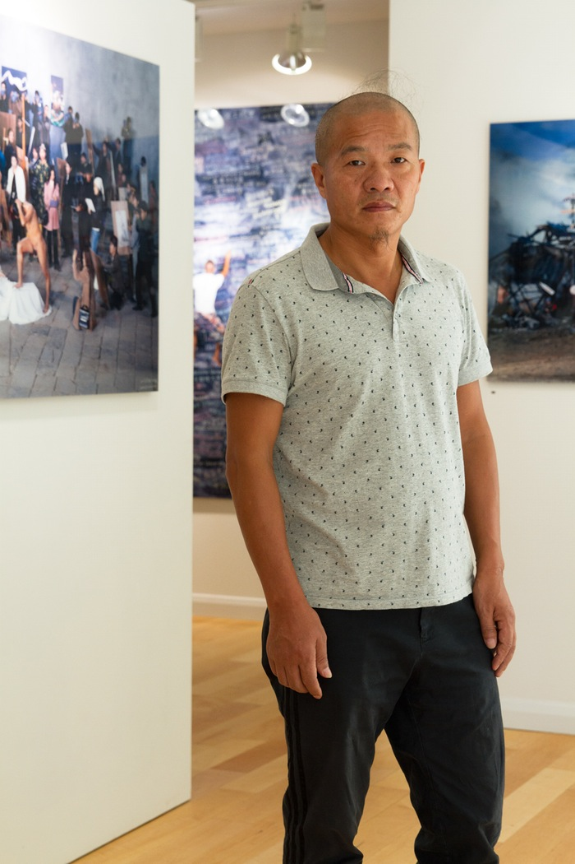

- 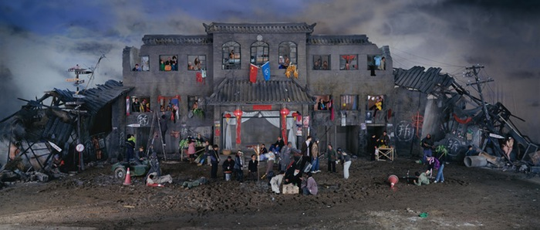

- 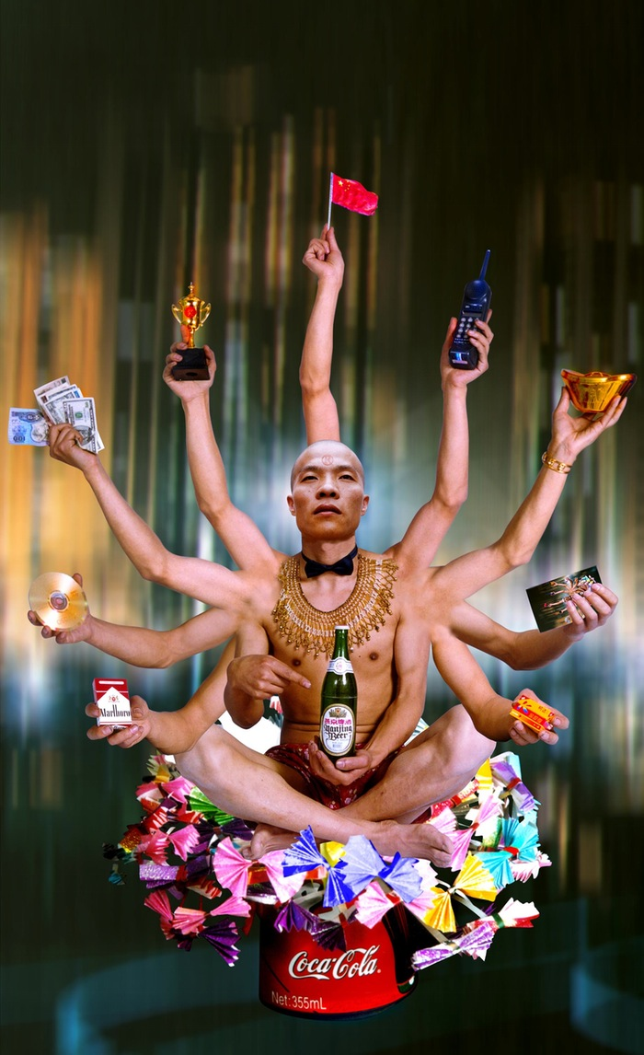 Requesting Buddha, 1999

- 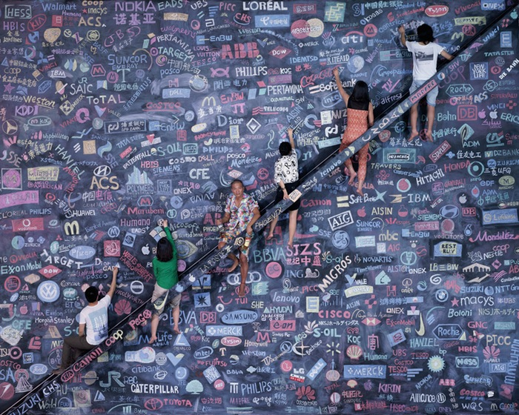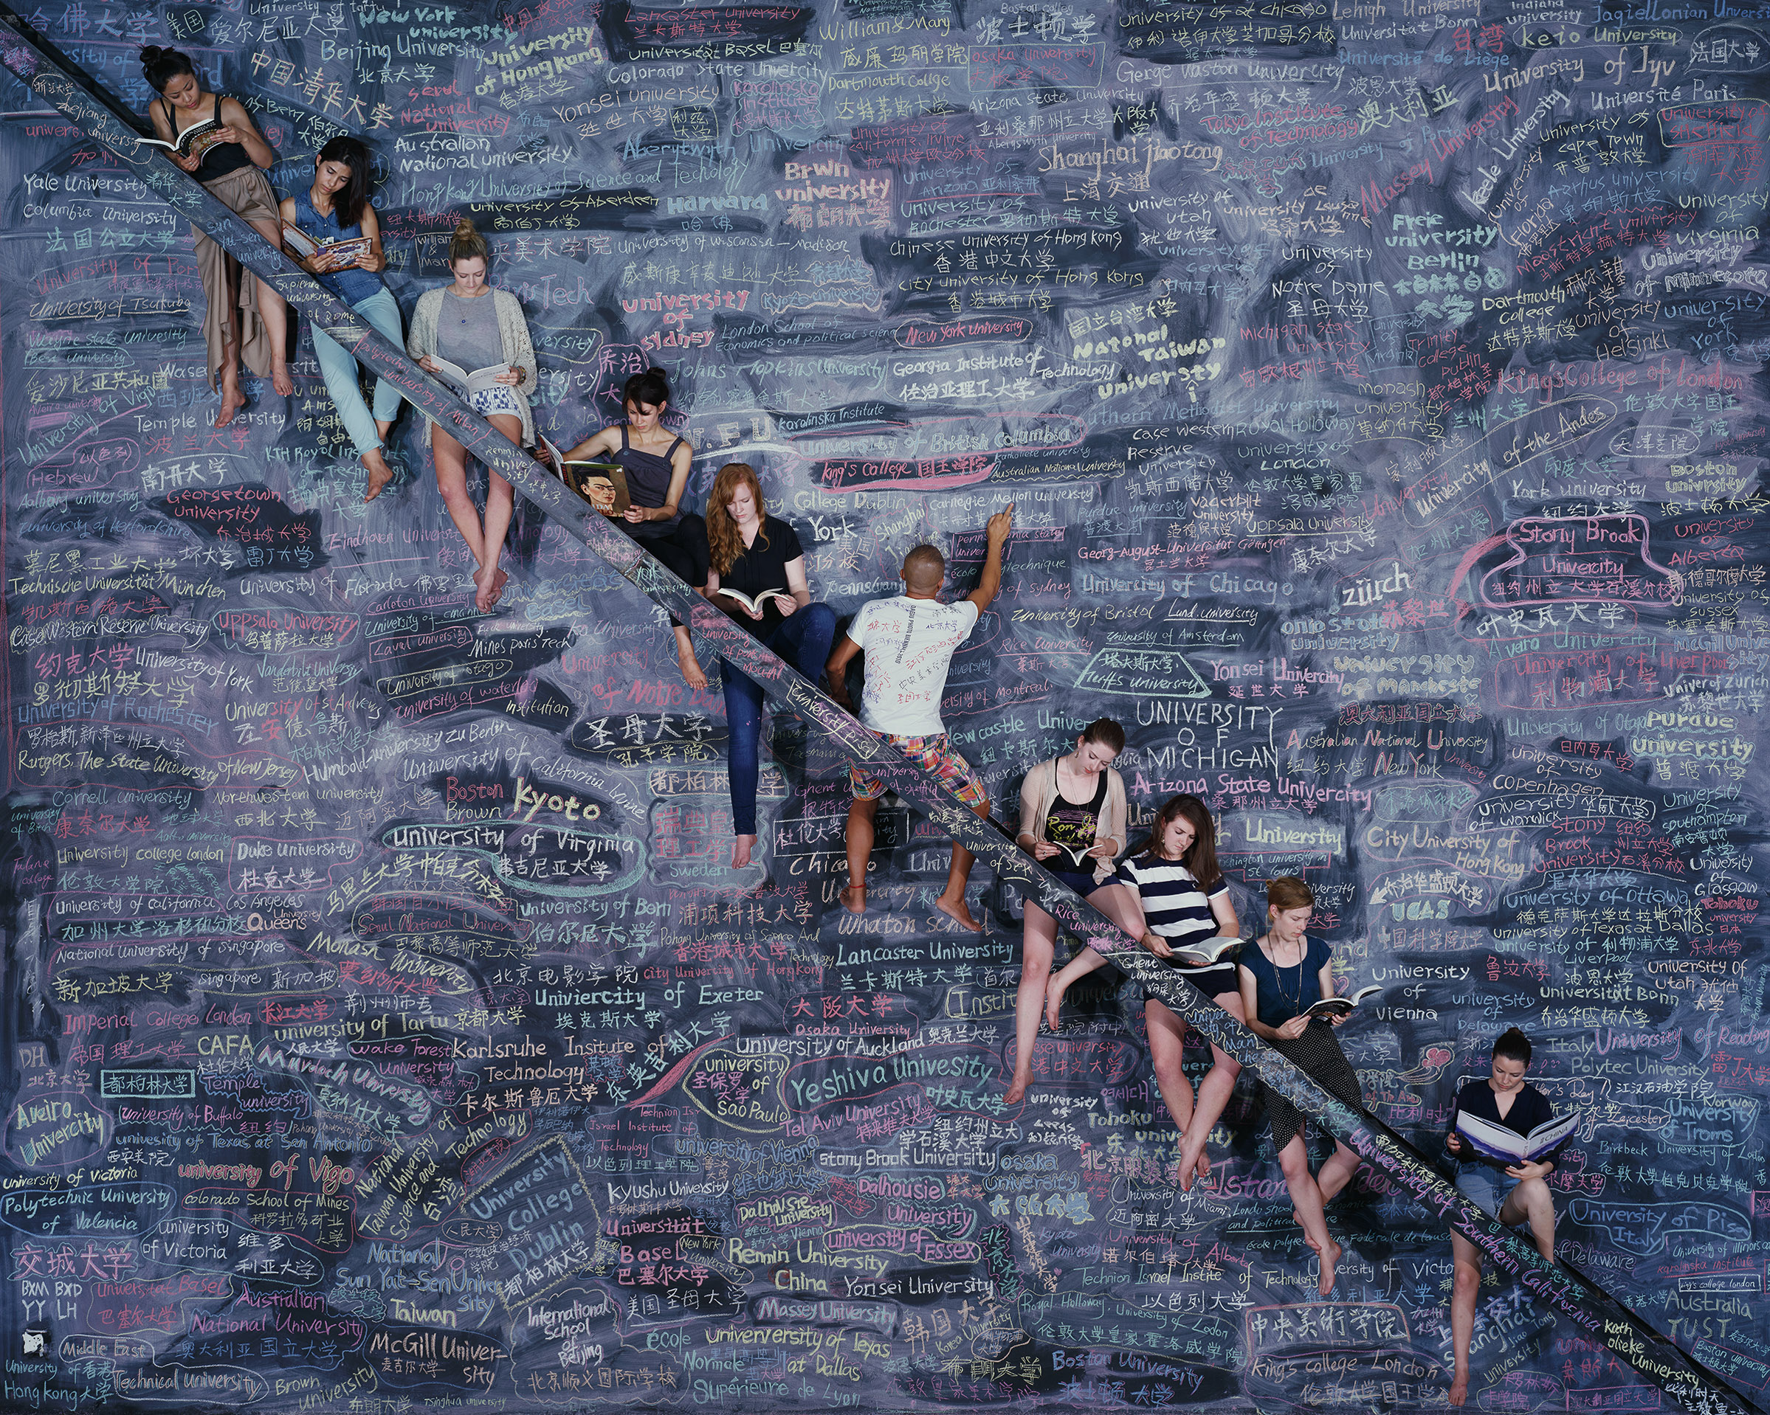
- One world, one dream, 2014 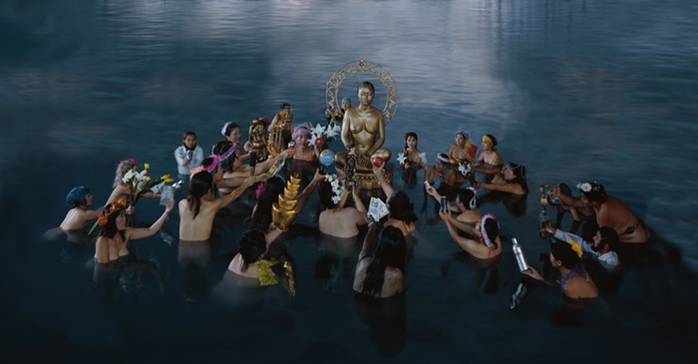
- Offering, 2003

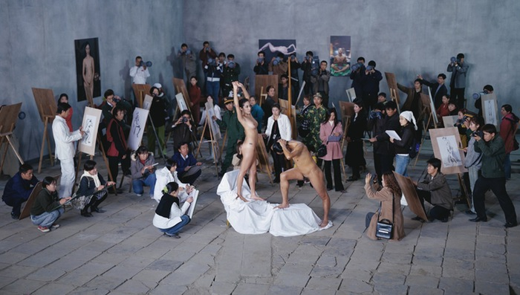
- Moma Studio, 2005

- 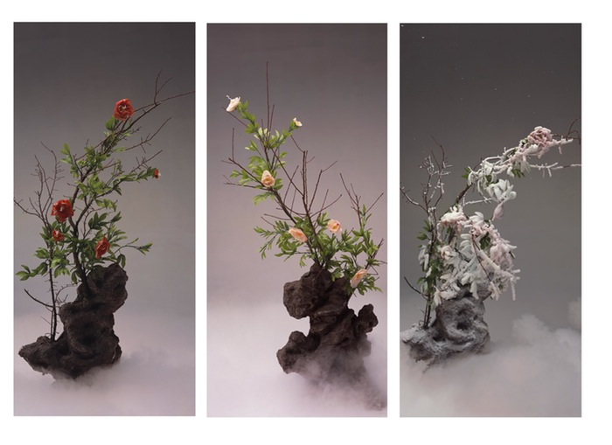
- Red Peony, White Peony and Frosted Peony, 2003

- Wang Qingsong
We spoke to Chinese contemporary artist Wang Qingsong for the launch of his first UK retrospective at Beetles+Huxley, London. Wang creates staged photographs as a means to observe various problems in contemporary China
- PHOTOGRAPH Chris Tang
- WORDS Edward Moore
- LOCATION Beetles+Huxley, 3-5 Swallow St, London W1B 4DE

When I met Wang Qingsong and his wife, the art writer and academic Zhang Fang for the first time, it was in a glossy chain-brand café in central London. A suitable location for an artist so critical of western consumerism. I asked him whether he felt disconnected when he was away from his home in China.

“As an international artist, I've travelled a lot but I am not that serious about developments in other countries,” he says. “I care about what is happening inside of China, the suffering and frustration, the good and bad.”

Wang’s concerns with China’s rapid transformation stem from his own life experiences. Born in 1966, he lived through Chairman Mao’s Cultural Revolution and Deng Xiaoping’s economic reforms.
There is not a system in place; where is the backbone?
As an artist, he observes these changes through staged photographs. Many of them are large-scale productions with detailed symbolism, characters and narratives – tools to mirror Chinese society.

“In this globalised culture, many nations merge with each other. So sometimes, Chinese people cannot differentiate what is new and what is old; what is western and what is Chinese. They are confused and that is the reality. This is the reason why I use photography and shoot these new stories happening in old China.
"In this old culture, many new things pop up that are influenced from the outside. The foreign things have become inside elements already. It's a strange newborn baby. Maybe the genes are Chinese but the body is something else.”

Could you speak about where you grew up and what daily life was like?
WQS: I was born in Daqing – where the Chinese oil industry began in the 1950s. It's still one of the largest oil fields in China. My parents worked there but because the Chinese government had to dispatch people to other reserves, they were moving around. That experience of travelling to different places made me begin to observe what was going on – looking into the realities of life in China.

Could you speak about your parents' background? I came across a story about your mother being persecuted for being a landlord's daughter.
WQS: Both my parents worked in the oil fields for most of their lives. Even I worked in the oil field for eight years before going to art academy. When my father passed away when I was like 13, I had to pick up his job.

I never knew my father to have a home – any family or relatives. My father was the only one. After he died, someone told me that he was a beggar. He was a homeless boy and someone to be pitied upon.
Even though there is a lot of humour in my photographs, I don't feel it’s that funny at all
My mother was the youngest from a landlord family. She was the youngest during the land reform in the 1950s, when all the landlords' properties had to be confiscated. Her family became so poor that the children had to quit studies.

In her family, the highest education any of the children received was in junior high school. My mother was the youngest so she studied only a couple of months in the school. She was only able to write her name and a couple of characters – from maybe one to 10.
When the family's property was confiscated, she pretended to be poor and went out to the street to ask for money and food. For a landlord's family, the kids didn't have this type of experience so she felt very embarrassed.

During the Cultural Revolution, my mother was discovered to have this landlord family background. She was persecuted. People were bringing the families of scholars, the educated and rich to platforms. They'd beat them up and ask them to hold some banners saying they were the bad element in society. My mother was on the stage being humiliated but somebody in there knew who her husband – my father – was. He was from the poorest family – even poorer than the peasants.

So, because my family was from the poorest to the richest, they somehow evened out and they gave my mother an easy way out.
How old were you at this time?
I was born in 1966, so not very old.
At school, was it difficult to suppress your own ideas?
In 1976, at the end of the Cultural Revolution, I was 10-years-old. So I was not in the Red Guard, beating up the people. I was the youngest generation of the Young Pioneers – we'd wear this red scarf.
Painting doesn't grab the whole picture of China's dramatic transformations; photography can
Because my family background was different, I was used to being a coward from childhood. Even though I had the thought to challenge something, I was always timid. My father passed away very early so my mother was always telling me, behave yourself.
So the rebellion was an internal experience?

I had many poor experiences in my childhood – in high school and working in the fields – so I developed a character that always feared authority. When I moved to Beijing when I was older, I had bad experiences with policeman because I was a migrant [from another province]. If you don't have the work certificate, you will have trouble.

When did the artistic influences start to come into your life?
WQS: Because of my character, being an introvert, I developed the skill to look around me. From childhood, I knew what was going on because I was quiet and observed a lot. You could say my childhood experiences gave me this career.

When did you start to practice art?
WQS: I was 13 for only a week when my father passed away. I was an adolescent and rebellious, arguing with my mom. She would be beating me up, saying that I'd only be excused when my dad got back. He never came back, so my adolescence was only a one-week rebellion.

I knew that I had to then be obedient and not a young man who could stand up and show off his capabilities. Other kids were proud to be growing up but I had to behave like a coward and show off my humility in front of others.

In China, without a father, the whole family would collapse. Before the economic reform in the 1990s, many families relied on the father to support the family. My mother was illiterate and had to raise four kids, so I had to pick up the job for the family.
I am not a Buddhist but maybe in my heart,
like many other Chinese people
All of this affected my character and led me to become a detailed observer. Even though there is a lot of humour in my photographs, I don't feel it’s that funny at all. I feel there is a lot of cold, misfortune and suffering.

When you were studying art, were you ever influenced by traditional Chinese painting?
WQS: After I finished in high school I went straight to work in the oil fields. I was never satisfied working as a labourer so I somehow tried to pick up drawing and painting by myself. Over a timespan of eight years I tried five times to get into art schools. It was so difficult in the 1990s. Maybe one of 200 got selected.
I picked up drawing when I was 17. Because of my childhood, it appeased me a little bit. It was something I could do that was enjoyable to do by myself. From my childhood, it was all the traditional drawings and sketches.

When did you discover photography?
WQS: After studying painting at college, I came to Beijing in 1993. I picked up photography three years after I moved.

Could you speak about the artists' communes you were living in?
WQS: An early one was the Yuanmingyuan artists’ village. Many universities were around there so intellectuals, artists and musicians liked to gather there. That was my first art community. Then there was the Songzhuang community.

Were these important environments to you?
WQS: I wasn't inspired by the other artists around because I was one of the earliest artists to pick up photography. I wasn't interested in painting anymore. Painting doesn't grab the whole picture of China's dramatic transformations; photography can.
In 2000, you had a self-titled exhibition which you've described as being the first moment when you felt like a photographer. In the same year, your mum died. We spoke about your childhood earlier; was this a significant year for you as an adult and artist?
In some way, yes. In China, we have this tradition that if you have parents that are alive, you feel like you still have roots. You have someone to rely upon. When you've lost your parents you somehow feel like you are able to be on your own.

Since my mother died, I didn't go back to my hometown that often. Unless there was a special time, like Chinese New Year when you need to go home to sweep the tombs to pay tribute to the people who have passed away.

Buddhism is a theme that appears quite regularly in your work. Could you speak about how you developed a critical perspective on this subject?

I am not a Buddhist but maybe in my heart, like many other Chinese people. You have to be a good person and do good things to others. You have to behave well. All these characteristics make you a Buddhist in some way.

All religions teach people to be nice to each other. They all tell you there's an after-life so you have to show respect, to be afraid of something – a power beyond you. In this way, I think it is good.
But in modern Chinese culture, you will find that Buddhism and many other small religions have been transformed. They became commercial products – consumer-like beliefs. I'm not interested in this type of Buddhism.

There's an emphasis on giving and receiving in Buddhist teachings. Do you think that on the surface these temples might have this tourism aspect but on the inside the monks are still practicing diligently?
This does not exist. There is no purity in most of these temples anymore. In the 1980s, we had a couple of very honourable temples. People would be really respectable and go there because of their beliefs.
Every Chinese person believes in the nation;
they don't believe in the individual
Now these temples have become bigger and grander. There are so many monks and so many believers, they all go to the temples to ask for forgiveness, for fortune – to receive rather than give. Temples ask for people to pay an entrance ticket. Also, we used to have small incense but now, because people have different requirements and requests, they've scaled up all these different-sized incense – you pay more for the bigger ones.

Inside the temples, you buy plastic flowers to offer to the Buddha. When you leave, the monks will take the flowers and re-sell them.
Every year, these monks can receive a lot of money from the tickets. The best difference to identify a good church or temple is whether you receive tickets. It's very bad.
The basis of every religion is that it teaches you how to live your life. If Buddhism in China can't provide this, do you feel there is a practical way to live in modern society?
Because of the general governmental propaganda – including all these big events, big parties, big receptions, and big military parades – every Chinese person believes in the nation. They don't believe in the individual.

They believe China needs to be developed bigger and greater, so that we will have a better life. Right now, we are suffering and unable to have social welfare because the nation isn't strong and powerful enough.

Many young generations believe in nobody. They believe in only having fun and satisfying their needs.

I myself am pessimistic. I'm in a bad mood and don't see any future that can brighten this young generation or peoples' hopes.
We all need entertainment, we all need freedom, we need all these things to satisfy our needs. That's not something to blame people for. The only ridiculous thing is that all this cheap media and entertainment comes from the lowest taste and is declining your capacity to enjoy yourself on a higher level.

The value system is collapsing and people have lost confidence in everything – in themselves, the nation, the system etc. Even though they can mobilise to some extent, everyone is not juvenile anymore. Its like everyone is getting older.

People have lost trust with each other. For example, there are many incidents in China where old people are pretending to be knocked over or be hurt and ask for money. When some old people are actually hurt, no one cares – no one dare to help him out. They can only watch people drowning. This is a vicious cycle that is going on.

There is not a system in place, so where is the backbone?

