LOMOGRAPHYMAGAZINECHINA'S SOCIAL ISSUES IN PHOTOGRAPHS: AN INTEVIEW WITH WANG QINGSONG
China's Social Issues in Photographs: An Inteview with Wang Qingsong
2014-03-20 2 SHARE TWEET
The Fine Arts graduate shifted to photography in the 1990s and has had a prolific career ever since. Wang Qingsong has participated in solo and group exhibitions not only in mainland China, but has also showcased his work in other parts of Asia, Europe, and the United States. His work transcends photography as an art; his portfolio proves that photographs aren’t only meant to be visually compelling, but socially relevant as well. Through this interview, he shares his life and beginnings as an artist.
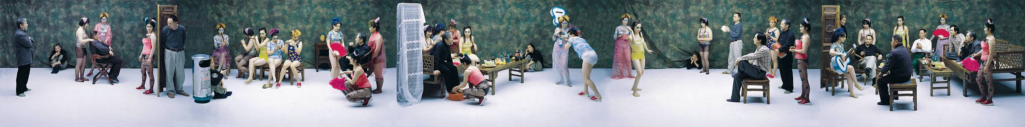
“Night Revels of Lao Li” (2000)
Tell us a bit about yourself?
WQS: I was born in 1966 in Heilongjiang Province, China. In 1993, I graduated from the Sichuan Academy of Fine Arts and since then I have lived and worked in Beijing.
Since turning from painting to photography in the late 1990s, I have created compelling works that convey an ironic vision of 21st-century China’s encounter with global consumer culture. Working in the manner of a motion-picture director, I conceive elaborate scenarios involving dozens of models that are staged in film studio sets. The resulting colour photographs, such as “Night Revels of Lao Li”, “Can I Cooperate with You?”, employ knowing references to classic Chinese artworks to throw an unexpected light on today’s China, emphasizing its new material wealth, its uninhabited embrace of commercial values, and the social tensions arising from the massive influx of migrant workers to its cities in “Sentry Post”, Dormitory” and “Dream of Migrants”. My celebrated photo-works extensively discuss the problems of education, which are “Follow Me”, “Follow Him” and “Follow You”. Other works touch widely upon social evils, like lack of healthcare, hospital overcharge, and patience, negligence.
Starting 2008, I engaged in sculpture and video making. My three short videos “123456 Chops”, “Skyscraper” and “Iron Man” take time-lapse mode to record the passage of time, objects and humanity.
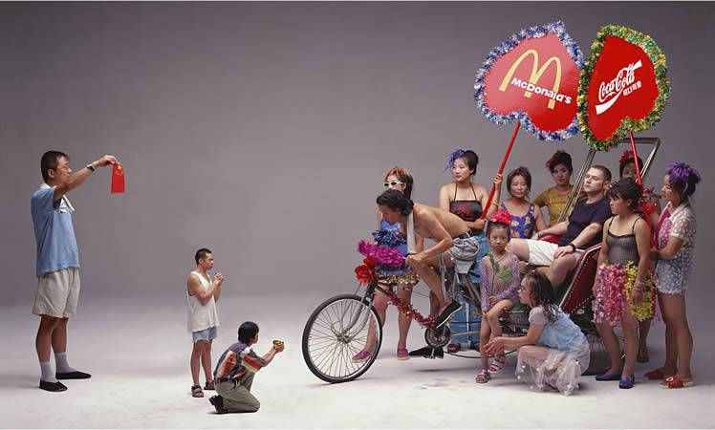
“Can I Cooperate with You?” (2000)

You were born when the Cultural Revolution had just started, and grew up experiencing the transformation of China with rapid urbanization. How was it to grow up in such an environment?
WQS: It was like taking a roller coaster every day. The changes have been so dramatic that we cannot catch up with the epoch. Something popular today will fade away tomorrow. Today’s truth might be faked tomorrow. So this diversity, drama and dilemma that China has is very enriching for me to make new and inspiring art works.

It’s very impressive to see your photographs addressing problems in China caused by the quick but overwhelming development and urbanization. How did you first start this project?
WQS: Around 1996, I became interested in image making works. I used to work on paintings applying a lot of Chinese folk art subjects and traditional iconography. But the collage-like oil works were so difficult to describe my strong feelings towards the drastic social changes. At the very beginning, I switched my heads onto the iconic powerful and influential people like movies stars, later onto vulgar images like beautiful ladies on Chinese magazines. This ornate and sweet computer-generated head-changes made me to move onto to rather complicated creations like “Requesting Buddha”, “Thinker”… From 2000 onwards, I started to use large-format cameras, crowds of movie extras, lighting, sound stage.

What changes do you think does China need to make to solve the problems you expressed through your powerful photographs?
WQS: There are many things to change, for example, education, healthcare, legal system…Sometimes I think we need to slow down a bit to keep up with the latest developments worldwide. We need to relax and reflect upon what we do and what we need to do. But first, we must reinstall our traditional values and virtues, like disdain for money and fame……We should value knowledge to make progress rather than GDP figures.
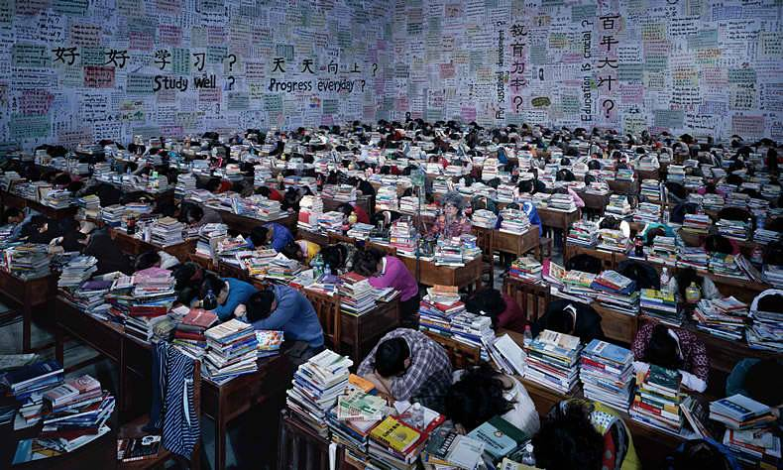
“Follow You” (2003)

I’ve heard that there is no freedom of expression in China, but apparently your photographs very clearly address the current issues in your country. You’ve exhibited around China and we wonder how your work and messages can be publicly available so given their controversial context?
WQS: Yes, my works carry difficult messages touching upon every sensitive detail of the controversies. But different people read different messages. Some think my works are pro-capitalism while others think completely the opposite. What I am doing is just throwing upon questions and do not provide exact answers. I also try to evade confrontations with the politics, though the works speak for themselves. Some works are never possible to be exhibited domestically.
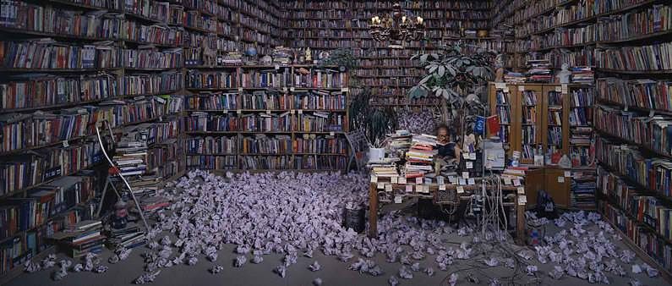
“Follow Him” (2010)

Is there any particular issue in China that you would like to portray in a future project?
WQS: I am going to address an important issue, the clothing production industry. This will be in my next project. Many menial workers laboriously work for a whole year to produce millions of shirts to exchange for one Boeing airplane.

What are you currently working on? Are there any upcoming projects or future projects you’re planning and if so can you give us an idea of what’s next?

WQS: I am thinking of moving on to film. I will have two solo exhibitions, one is in Daegu Art Museum, Korea, in September and the other will be in Frost Art Museum, Florida in October.

How did you first get into photography? What was your first camera?
WQS: Like I answered previously. I did not think painting brushes and colors can capture the fast speed of Chinese modernization. So I chose photography in late 1996. My first camera was a Minota 35mm.
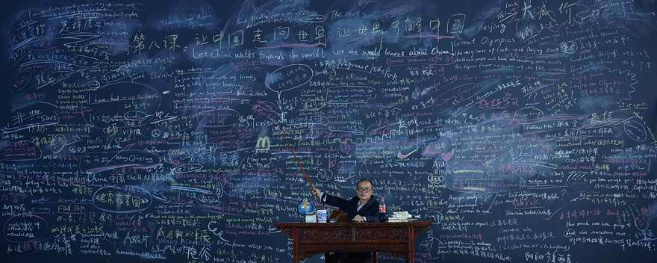
“Follow Me” (2013)

What was the most defining moment in your career as a photographer?
WQS: In 2000 when I was invited for a solo show in a gallery nearby Tian An Men, I decided to change the title of the show into Wang Qingsong Photography Exhibition. That was the first time I believed my works belonged to photography. 2000 also marked the beginning of Of the exploration of Chinese contemporary art at home and abroad by many art museums.

What advice can you give our community of budding photographers?
WQS: I would say, to think more, to do less. Get the hint from the back of your mind. Don’t work on intuition. Work on what’s left in your mind.
All photos were sourced from the artist’s website.

Special thanks to soundfoodaround for conducting the interview.

