Wang Qingsong @ Intersections
January 15, 2011 by Travis

Speaking of Chinese contemporary art, Wang Qingsong came and spoke on campus today.

Epic thanks to Prof. Jaimey Hamilton and the Intersections program here at the University of Hawaii which brings a good number of contemporary artists here each term not just to speak and present their work, but also to visit student studios and classes, and interact and engage directly with students. It’s a really special opportunity, I would imagine, for the students; I don’t know how common this is at other schools, but it’s pretty awesome here. And thanks, too, of course, to the incredible sponsors, since Intersections is not funded by the Art Dept or anyone else regularly/permanently on campus.

I don’t quite have my finger on the pulse of Chinese contemporary art enough to say really quite how big he is, but putting that aside, what matters is, his art is absolutely incredible.
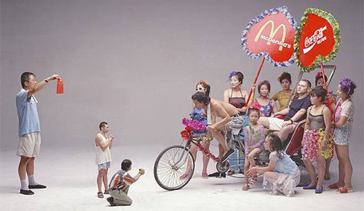
In “Can I Cooperate With You?” (2000), Wang references a classic Chinese painting depicting a Tang emperor receiving a foreign ambassador. Here, the foreigner and the Chinese switch places, with the foreigner surrounded with adulation, power, and wealth, and China, with its tiny flag, seeking, begging, for corporate collaboration.
A photographer, Wang choreographs amazingly elaborate and artificial scenes, with bold, colorful costumes, props, and backgrounds, the artificiality being part of the appealing aesthetic. His works speak to a great many subjects, questioning the benefits of commercialism and criticizing the impacts of Westernization. He seems particularly interested, or should I say frustrated, with the idea that China is such a major economic powerhouse, but in fact has no big name brands overseas (or even domestically? I wonder. I don’t know.) – when Chinese companies merge with foreign companies, yes, they benefit, and the nation benefits, but in the end, you still see Nike, McDonalds, and Sony everywhere in China, and no big name Chinese brand names in the rest of the world (there may be big major exceptions that are just slipping my mind at the moment… but anyway, that’s his argument).

There are basically two things, well, four, that really impress me about his work. One, the effort and materials put into each work is amazingly impressive. One would assume that he could do a lot in post, so to speak, that is, in digital editing. It’s obvious he must edit his photos considerably anyway, dialing up the color and smoothing out the roughness of reality. Yet, from costumes to props to backdrops, he does so much to actually create the scenes he photographs. One of his newest works, which hasn’t even been debuted yet, is a 42-meter-long piece, like a huge long frieze running along the ceiling of a building, in which a great many figures are seen in various poses and costumes meant to recreate various famous statues and monuments throughout history (mainly Chinese history). All is made to look like stone relief. But while I am sure there are plenty of ways he could have done this digitally, he actually built a giant wall with styrofoam impressions, covered entirely in mud, into which his models, also covered in mud, stepped, so that it would look like they were carved in relief from the stone.
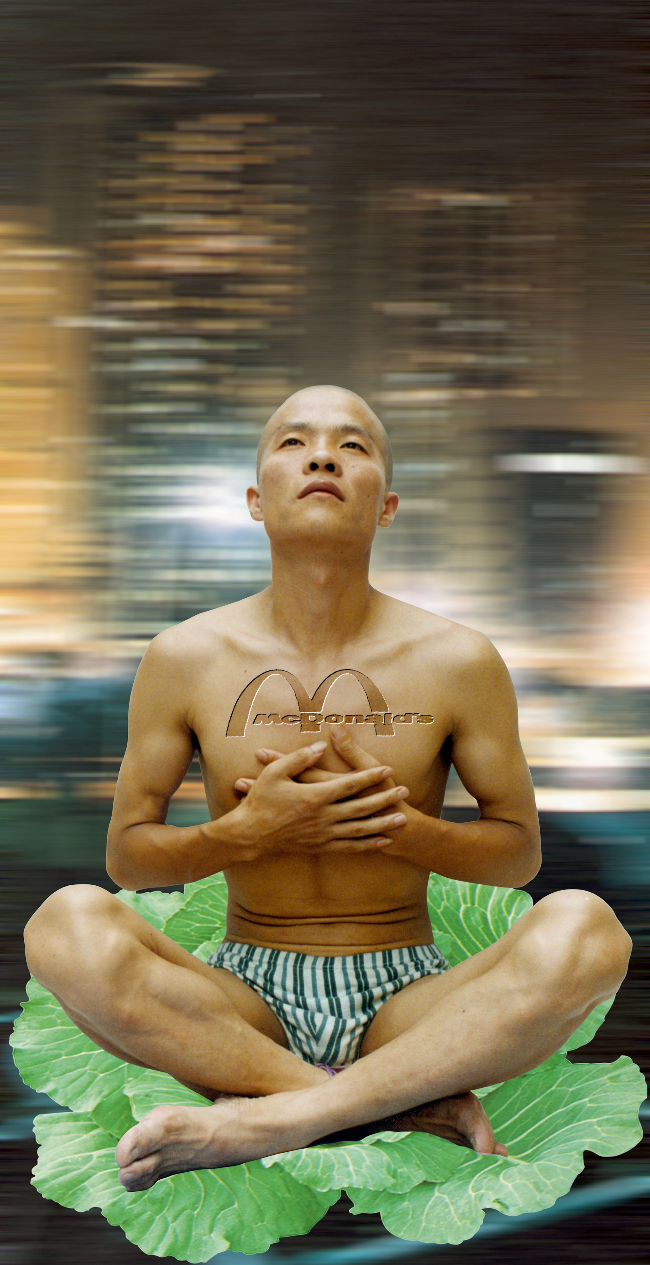
Left: “The Thinker” (1998) obviously speaks to spirituality and religion in these modern times. A man irrevocably imprinted with the cultural impact of McDonald’s attempts to meditate, to practice religion or seek spirituality, atop a cabbage leaf (symbolic, I am told, of the Chinese nation, or national pride), while the busy busy busy-ness of the city rushes past behind (or all around) him.

Secondly, his artwork functions on just about precisely the level I like and appreciate and enjoy in contemporary art. They are not abstract forms – they are very clearly images of people in certain costumes, in certain settings and situations, and very often the title gives a further hint as to the meaning of a work. I love works where you don’t need to struggle or get frustrated to figure out what it is. It’s very clear what his works are, what they depict. Whether it’s a crowd of people all crowded around a few naked women dancing, the crowd all pointing huge cameras at the women, or whether it is a professor sitting at a desk in front of a massive giant blackboard covered completely in English and Chinese words and Western corporate logos, you can tell immediately upon looking at it what it is. This frees you up to then get to the meat of the matter – what it all means. And while the meanings may be somewhat obvious – in one piece, he shows men in camo fatigues struggling up a hill as if towards battle, with a McDonald’s sign rising high above, obviously something belonging to the enemy – the aesthetic beauty of the works, the incredible detail (and I mean really incredible detail, every single word on that blackboard being legible at high enough magnification, and having relevance), and just some intangible quality about his work makes you want to look longer, look closer, and really think about it. There’s meaning right there, clear as day in front of you, that makes you laugh or nod, his social criticism obvious, saving you from the frustration most associate with modern art, but then, he makes you look deeper.
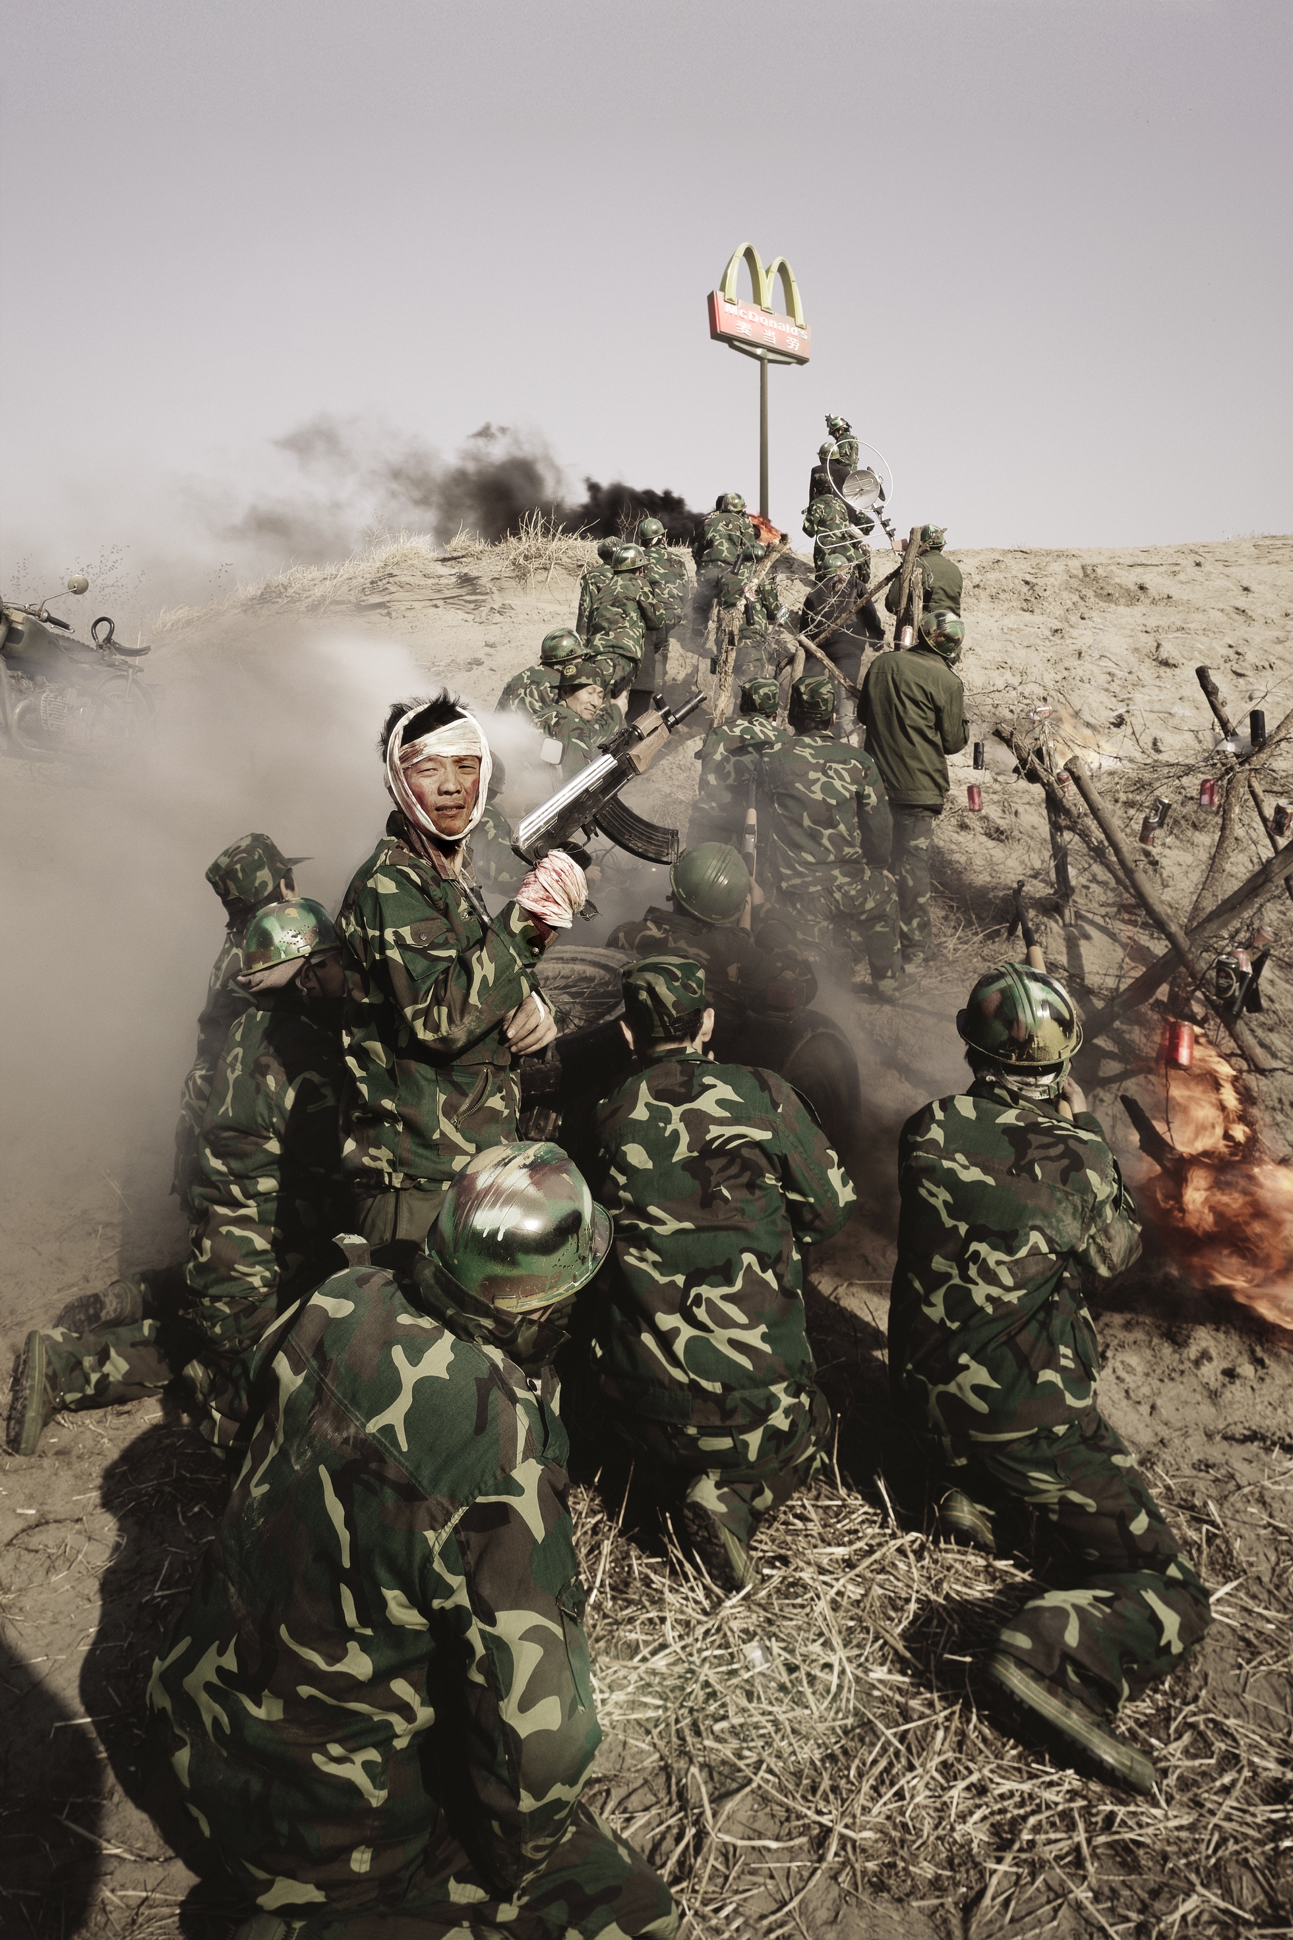
Third, these works are simply beautiful. They are appealing and attractive. Who says art has to be ugly? That is has to be disturbing? In a way, it’s kind of ironic, since historically it’s the Chinese painting critics, far moreso than anyone in the West so far as I know prior to the 20th century, who always said that color and realism were cheap tricks, that making a painting attractive and appealing in such a surface manner cheapened it, and that the best paintings were those that were not blatantly appealing on the surface, but which needed to be appreciated on a deeper level.

Wang Qingsong’s works absolutely work on a deeper level, I believe. But they are beautiful as well. Very clear, clean forms, like “airbrushed” magazine cover models, and bright colors, like an idealized version of reality, though the actual content of the scenes is more dream or fantasy, highly symbolic and extremely staged, hardly realistic at all.
And fourth, he does do a number of works that very directly reference classic Chinese artworks. And you know I love that.

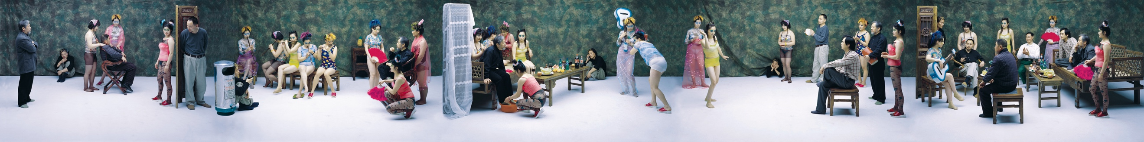

When his “Night Revels of Luo Li” came on the screen, I nearly leapt out of my seat. (Click image to embiggen.) I am not sure that I can really articulate the meanings and implications of this image – the social criticisms embedded in it – but the way in which he has reproduced the overall composition of the exceedingly famous “Night Revels of Han Xizai” (Gu Hongzhong, c. 970 CE) while replacing each element with something contemporary, and often something outlandishly colorful and gaudy, and for lack of a better word, slutty and crass, is really just incredible.

(I’m genuinely sorry that none of these are big enough to see here properly. Please do click to embiggenate.)
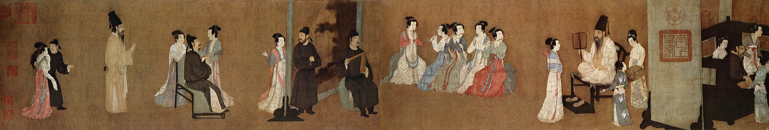
There are various stories behind the Han Xizai painting. One states that the emperor wished to grant Han Xizai a ministerial post, but had heard rumor of depraved and debauched activity in Han Xizai’s mansions, so he sent two painters to act as spies, who produced this work depicting an inappropriate mixing of social classes at a most raucous and immoral party. Another interpretation says that the previous story was created, along with the painting, in order to sully the reputations of both Han Xizai and that emperor, as dynastic change leads to such negative portrayals of the previous regime.

In any case, Wang Qingsong says his work is meant to speak to the situation of intellectuals in China today. What does that mean? Perhaps that the powers that be seek to portray intellectuals as debased, raucous, and immoral; that today, as during the Cultural Revolution, and in accord with Communist ideology overall, intellectuals are seen as the elite, as the bourgeois enemy of the good, hardworking proletariat worker or peasant. Or maybe I’m misreading it – Chinese ideology isn’t exactly my strong suit. But, in any case, the size of the work and the details allow for it to be very engaging and involving. Notice how the biwa player has been replaced by a woman with blue hair and a wonderfully blue guitar, while figures sit or stand opposite her in just about exactly the places and positions people sit or stand in the original work.

Note the very traditional elements of the setting – particularly the furniture, and the fans a few girls hold – but then, the very modern Sprite bottles, not to mention the very modern, and in some cases outlandish, clothing. Notice also the repetition of figures or characters. Starting from the right – as traditional Chinese paintings are traditionally read – the tall furniture element behind the girl with the guitar serves as a sort of narrative break, marking a break between scenes. On the other side, we see the same figures over again, doing something different. This is not one single scene, one giant panoramic party, but rather a series of sequences, a narrative over time, as in a traditional handscroll.

So much more can be said… I could run through all the pieces he spoke of and showed tonight. But I think I need to leave it there. His work is surprisingly easy to find online – just Google his name: there is tons out there.

A show of Wang Qingsong’s work, entitled “When Worlds Collide“, opens next Friday (Jan 21) at the International Center of Photography in New York, and runs through May 18. I look very much forward to seeing it myself when I am in New York for the College Art Association conference next month.

