INTERVIEW: Chinese artist Wang Qingsong plays "Ca bian qiu"

By Serene Fu
(http://www.artworldnow.com/2014/12/interview-chinese-artist-wang-qingsong.html)

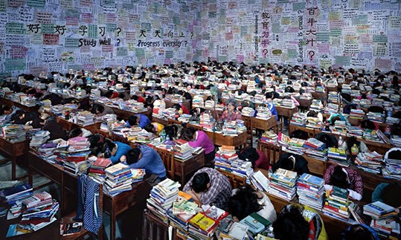
Follow You, 2013, C-print, 180 x 300cm. Courtesy of the artist

Wang Qingsong (b. Helongjiang, China, 1966) is renowned for his meticulously staged large-format photographs reflecting the dramatic socio-economic changes China has undergone in the past 30 years.

Since moving to Beijing in 1993, Wang has evolved from a struggling painter to a celebrated artist who has received international critical acclaim for his photography. Following exhibitions at the V&A Museum, London (2005) and the International Center of Photography, New York (2006), his provocative imagery has become a hallmark of Chinese avant-garde photography.

I met up with Wang on my recent trip from Hong Kong to Beijing as he was preparing the set for a new work. We spoke about his practice, society and how he handles China’s constraints on artistic freedoms.

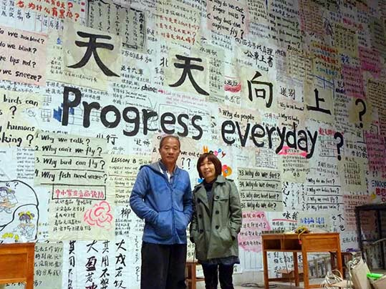
Wang Qingsong and Serene Fu

China joined the WTO in 2000. Is this also a watershed year in your photography as you abandoned low-budget self-portraits and digital retouching?

That’s true indeed. In 2000, I began to use models to perform in a studio and sometimes in outdoor settings. Several works were produced to critique China’s overly materialistic society and I also began to allude to old classics.

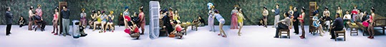
Night Revels of Lao Li, 2000, C-print, 120 x 960cm. Courtesy of the artist

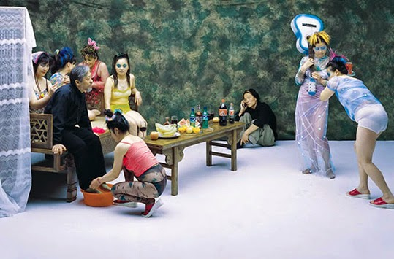
Night Revels of Lao Li (detail). Courtesy of the artist

One such piece is Night Revels with Lao Li (2000), a photograph that parodies a 10th century handscroll painting with 5 episodes and narratives. My friend and independent curator Li Xianting (Lao Li), did me a favour by playing the role of Han Xizai, a scholar-official who faked a wealthy lifestyle in order to win the trust of the emperor. As such, the work is a critique of China given the massive influx of western culture and consumerism since 2000.

The format of my work and settings have also expanded. I employ crowds and use many props and debris to magnify chaos within in society.

What is the the appeal of your work?

Perhaps my work charts the changes China has undergone and I leave space for viewers to judge it themselves. There is a sense of instant involvement in my work even though it may take a while for people to grasp the meanings behind it. It is also true that my works involve a painstaking process of production and creation. They render a unique aesthetic and visual point of view one recognises immediately.

I saw a recent work of yours with a focus on education at a 798 art district gallery. Is this issue something you are particularly concerned about?

I am very drawn to reveal the social conflicts and cultural clashes resulting from China’s economic reforms. I frown upon the education system because it suffocates the mind and trains students only to memorise. In One World, One Dream (2014) at White Box Museum of Art in the 798 art district, I created the set but allowed for participants to improvise. One World is represented by Fortune magazine’s Global 500 (the world’s 500 largest companies ranked by revenue) whereas One Dream is marked with names of 500 dream universities, all of which are drawn up by the participating teenagers.

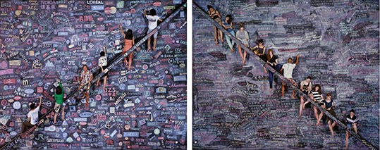
One World, 2014, C-print, 180 x 225cm (left). One Dream, 2014, C-print, 180 x 225cm (right). Courtesy of the artist

When the two parts of this photographic work come together, a pyramidal shape appears, thus mocking a pragmatic society that favours elitism and fame. The irony is that the current exodus of children sent to study abroad at an early age means that many will return to China with little knowledge of Chinese culture. This blind goal to succeed at all costs is rather pathetic. As a father of three young sons, I cannot say this trend does not worry me.

The words on One Dream, One World scribbled on a chalkboard remind me of Follow Me (2003) which set a record of £433,250 (ca. USD 865,200) at Christie’s London in 2008. Can you tell me more about this work and the price of your work?

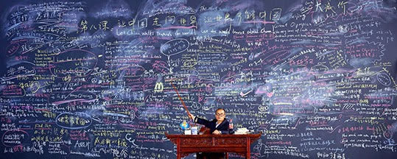
Follow Me, 2003, C-print, 120 x 300cm. Courtesy of the artist

Follow Me (2003) is inspired by an all time favourite 60-episode English learning programme on CCTV broadcast between 1982 -1994. The series was replayed a few times and had over 10 million viewers. Workers, peasants, liberation army soldiers, students and even monks watched it so I built a mural-like chalkboard to reflect the aspirations and dreams of people who moved abroad at the time and my role was that of a professor whose English was bad. When the work was shown in 2004, I sold all of the 10 larger editions at USD 1,800. Actually, I am not concerned with the price my work may fetch at auction and in my case it is mostly museums and foreign collectors who acquire my art.

You want to produce more videos alongside photography. What is your new video work about?

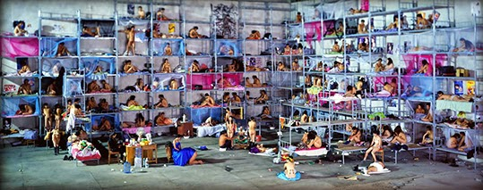
Dormitory, 2005, C-print, 170 x 400cm. Courtesy of the artist

I am installing a set for a 5 minute long video about sex in China. In terms of setting, it is a replica of Dormitory (2005), whereby men and women are jam-packed in bunk beds and under surveillance. This time 35 couples will be recruited to fill the rows of bunk beds.

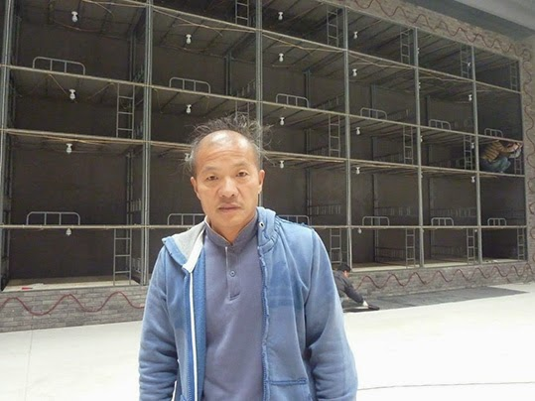
Wang Qinsong preparing the set of his new video work in his Songzhuang studio

I want models to feel at ease about performing love scenes so real couples will hopefully be taking part. My theatrical approach is combined with documentary realism: I will give some direction and employ a long shot as participants perform in a natural way. My intention is for Chinese viewers to be confronted with the taboo subject of sex.

Being a migrant yourself, you are aware of many issues the floating population faces in Beijing. Would you say Beijing is a good place for an artist to live in and make art?

If you are looking for a bigger studio space, the outskirts of Beijing has a lot to offer - particularly in the 90s. When I first moved to Beijing, I was in Yuanmingyuan (the Old Summer Palace) where I could mingle with other free-spirited artists. When this artist village was closed down in 1995, I moved to Songzhuang and its nearby villages until I settled down in Caochangdi in 2006.

In 2011, I bought this 50-year lease studio space of 2300 m2 to implement my grand scheme. This couldn’t be dreamt of in Hong Kong or some other places. However, rent hikes have made these art districts less affordable for young artists. But in terms of production costs, it is still very affordable despite rising inflation. I can finance my own works and am therefore free from sponsors’ demands.

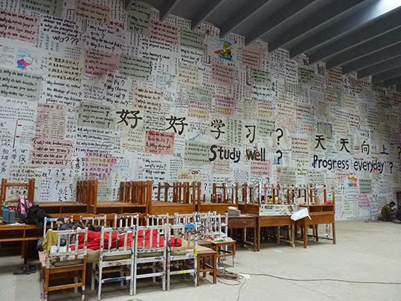
Wang Qingsong's studio - set of Follow You

Of course we have to cope with other limitations. There is no genuine freedom of expression in China, though you can consider there is freedom of speech because you can criticise every bit of the government in private. The catch is that you are forbidden to express such criticism in the public arena.

What’s more, there is censorship – like screening of catalogues – before any exhibition goes public. We have the "National Security People", the so-called "Guobao" from the 798 Art Zone Administration & Development Office to administer every move of 798’s galleries and museums. They also put those blacklisted artists under surveillance. I’m glad that I’m not on the blacklist although I’m being closely monitored.

Has your approach changed since Blood of the World (2006) was banned?

I have become extremely cautious and I ensure I won’t repeat the terrible blunders I made during the shooting of Blood of the World (2006). I was caught two days after shooting the work’s war scenes which incorporated nude crowds, explosions and fake blood. I was detained for three days and interrogated continuously for a whole week. I had to give up the film to stay away from trouble. Causing my wife and family to worry about my safety is the last thing I want to do. That’s why I can only play “ca bian qiu” .

“Ca bian qiu” literally means hitting the edge of the table in a ping-pong match. How do you play it in art?

On the one hand, I do what I can within the confines of the law. If I want to feature crowd scenes but don’t want to risk challenging the state’s rule, I need to acquire a permit if the number of people exceeds 50 and just recently it was 200. The authorities keep changing the rules without clarity. I had no choice but to cut down the number of performers in Follow You (2013) for instance.

On the other hand, I attempt to smudge the issues and leave more room for interpretation. I feel good being an artist and I’m treated respectfully. I witness friends (businessmen and artists) being kept under house arrest. For me, I don’t want to risk my personal freedom. At 48, I am wiser and I know my limits. Leaving many things unsaid whilst trying to make my point is my strategy now.

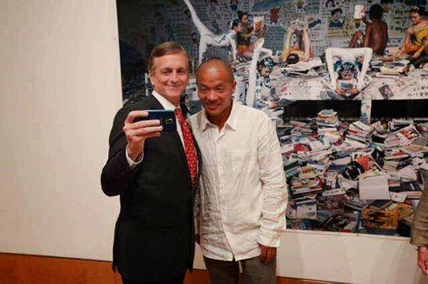
Wang Qingsong at the Frost Art Museum, 2014. Courtesy of the artist.

* Wang’s solo show ADinfinitum at the Frost Art Museum, Miami, USA is on view until 18 January 2015. The two-man exhibition Asian Contemporary Photography: Wang Qingsong and Jung Yeondoo is showing at the Daegu Art Museum, South Korea until 1 February, 2015.

www.wangqingsong.com

