http://www.jingdaily.com/en/culture/jing-daily-exclusive-interview-wang-qingsong-top-chinese-photographer/

Jing Daily Exclusive Interview: Wang Qingsong, Contemporary Chinese Photographer
Friday, January 28th, 2011 In Arts / Culture / Featured / Interview

Wang Discusses Solo Exhibition At New York’s International Center Of Photography, Future Plans
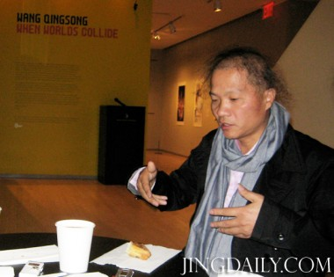
Wang Qingsong (王庆松)
Last week, the artist Wang Qingsong, one of China’s top contemporary photographers,had a very busy week in New York. Launching his first New York solo exhibition, “When World Collide” at the International Center of Photography and taking part in an Art Salon at the China Institute, Wang received a warm welcome during a very China-centric week in which Chinese artists Hai Bo and Cui Xiuwenwere respectively feted at Pace/MacGill and Eli Klein Fine Arts. Prior to the opening of “When Worlds Collide,” the Jing Daily team sat down with Wang to discuss his recent work, his new exhibition, and his future plans. Conducted in Mandarin, our interview shed light into the societal changes shaping Wang’s work, his thoughts on younger artists, and his observations on the Chinese art market as it climbs back towards a “second boom.”
Jing Daily (JD): Your artwork is often focused on describing and critiquing “Today’s China,” looking at commercial wealth and consumption, as well as the migration towards cities. How do you define Chinese consumer culture? Has it evolved since you first began your work?
Wang Qingsong (WQS): China is a big consumer market. My work is not really critical towards “China today,” but rather takes a skeptical attitude toward exaggerated consumption. A lot of things are not actually that good, but their worth is amplified by propaganda, and people believe that they must have these things in order to reflect their social identities. This kind of logic has caused a lot of exaggerated consumption and blind waste. Early on, my work reflected more on China’s national culture, and changes in the modern cultural context.
JD: How do you see this theme manifesting in Chinese culture these days, and what impact is it having on your work?
WQS: At the beginning, I thought this cultural change was happening because of our intentions to improve our lives, but I gradually realized that the invasion of new Western culture was changing our values as well. This kind of change had a big influence on my work. However, the change does not only affect me, but it also impacts all Chinese people. Perhaps many years ago, people would treat this kind of culture negatively, but they got used to it later. We can boil down this change in attitude to China’s basic national policy, basically, economic development.
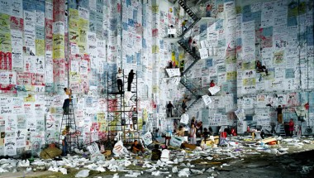
"Competition" (2004)
JD: How would you characterize the art scene in China in 2011? How has it changed over the past five years? What has improved? What hasn’t?
WQS: From 2005 up to the economic crisis, China’s art scene developed too quickly. During that period, many things weren’t thoroughly thought out, due to the rapid growth. Many works had to be done repeatedly because of the large volume of market demand. At that time, many artists were very productive. Now, the market has eased a little, and people will look at Chinese art more calmly. Artists should also think more rationally about their work. Since last year, I have not produced much new work, probably only two pieces. I started to think more about my work. Thinking is more important than doing.
JD: And how do you see your own position in the Chinese art scene today? Do you see yourself as someone who is part of the establishment? Critiquing the system as an outsider? An educator for new generations of artists?
WQS: I don’t think I am very successful. In fact, I mostly hear about it from other people. The first time I discovered that I was somewhat famous was in 1999. At that time, I went home to see my sick mother. I first arrived in Wuhan, but the train was late, so I had to spend a night there. Then I called a friend who I’d only met once before, and he arranged a car to pick me up and a decent hotel for me to stay in. He also asked some of his artist friends to come meet me. As it turned out, those people who came to meet me that night were artists I admired a lot. Also, before that point, I’d never stayed in such a nice hotel. I asked my friend why he treated me so well, and he told me that I was already famous at that point. Another time, I went to Germany. I was a friend over there who told me that I was very well-known in Germany. In fact, many times, you don’t even know that you’re famous. During that period, it wasn’t only me who doubted it. Even my mother did not believe that I was famous, and she thought I was lying when I told her that I was about to go abroad. I think we should not put ourselves in a position of feeling successful. We have to stop and reflect when we feel good about ourselves, so we can go further and do more meaningful work in our fields. I think the art system should develop slowly, as China’s economy needs to slow down. If it develops too fast, people may not absorb things correctly, and it could bring negative influences into the system as a whole. Therefore, everyone in this system needs to constantly look back, or take a break and really think about their next step. In terms of nurturing emerging artists in China, I feel it’s a tough question. In terms of art education, the Chinese system has kept a hereditary tradition, more or less, even decades after the establishment of the PRC. A veteran artist, for example, may want his or her art philosophy to be inherited by his or her students. Also, different art regions often form different factions, while these factions may have very little communication among each other. It is difficult for individuals to disrupt the system in a short amount of time. I give lectures sometimes, but these talks are all extra-curricular activities, and have little impact on the education system.
JD: In your earlier work, non-Chinese (Westerners) show up only incidentally, if at all. Yet in your newer work they have a more central position. Can you tell us a little about how these individuals fit into your work, thematically or metaphorically?
WQS: When you constantly look at one thing, you may want to turn to something fresh. One time, at an exhibition in South Korea, a friend of mine told me that he was not able to find my work as all the characters in the pieces were foreigners. In fact, he had never seen Westerners appear in my work in the past. I think this kind of otherness is very important, both for me and for the audience. I like to put different things together because this would transmit new feelings and emotions to me. However, in order to find the best balance, this “strangeness” requires constant adjustments.
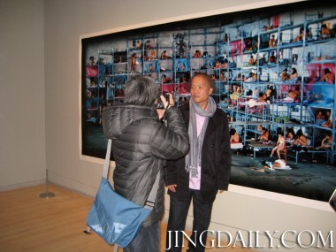
Wang Qingsong at ICP
JD: From your perspective, has the role of the collector in the Chinese art scene changed in the past five years? What are the contributing factors?
WQS: I think the role of collectors has been exaggerated recently. Although the role of collectors should be positive, some domestic collectors may need to improve their roles. The collector community also needs more communication. I think the culture of collecting cannot be too commercialized. The auction market in China, for example, emerged from many so-called “dark horses” last year. Some artists may have not created any work for 20 years, but suddenly they created a new piece, and the work went sky-high because of market speculation. I am not comfortable of making friends with this kind of marketer.
JD: And how about the role of museums and galleries, art fairs, and auction houses?
WQS: I believe that museums, art galleries, art fairs and auction houses are eager to do their best, but it is not easy. Some museums, for example, open an exhibition for only three or four days at a time, and the longest is half a month. Except for the opening ceremony and holidays, there is little time for people to visit, and the number of visitors is not enough. Sometimes, you may feel the exhibition is just something to go on your résumé. It is rare to see an exhibition lasting several months, like my [new] exhibition here at ICP and my former exhibition in Germany. The longer the exhibition lasts, the more chances you have to communicate with your audience. The exhibition should not just be a brief opening ceremony and a delicate album. Art museums in China need more time to adjust and calm down. I think auction houses play a bigger role than before. Before 2005, curators played a more important role. Some curators try to organize as many exhibitions as possible in order to cater to market demands. I believe it was hard for them to digest every single exhibition thoroughly. Since 2005, the role of curators has gradually faded, and the role of auction houses has increased. Auction houses have great eyes. At the same time, the influx of capital has had an effect, as some institutions started to invest in China’s booming art market. I think this kind of capital infusion has both positive and passive effects. Last year, for example, an artist exhibited 16 works in Shanghai, and in the end all these works were sold out, just like stocks. Now the art market [in China] is just like the stock exchange, and the effect of all this money coming in is even bigger than that of the stock market. A single piece of artwork might be owned by thousands of investors. I think this kind of art market may have certain risks, more or less.
JD: Do you find that younger Chinese photographers are taking a fundamentally different approach to their work than you and your contemporaries?
WQS: Now, the use of digital technology in photography is very common. Recently, there was an exhibition called “A Decade Long Exposure” celebrating the tenth anniversary of the Department of Photography at the Central Academy of Fine Arts. In that exhibition, there was a unit which included artwork from outstanding students who had graduated over the past ten years. I was surprised to see that 99 percent of these works used digital technology. I think today’s young people rely too much on digital technology. Too much reliance on digital manipulation is not good, because the image is device controlled and a similar work made by a computer would look pretty much the same. If you like a style, for example, you may want to use two or more computers to produce a piece. It ends up looking like a company’s mass produced products. In many cases, a piece of work can be replicated many times over, which ends up just looking like an advertisement. Digital technologies change rapidly, meaning that you can never catch up the speed of changes. For example, early in my career, I spent two days to make the “Thousand-Hand Bodhisattva” using digital technology, with the help of a friend. Now, with the latest technology on the market, it takes a computer only about half an hour to do the same work. The processing speed of computers is much faster than before. Also, the price of using digital technology is much cheaper. As a result, people’s artistic skills are actually inferior to computer technology. Maybe you can create very complex work now, but this work might look like child’s play after a few years, as technology is upgraded. Don’t rely too much on digital technology unless you have a really deep knowledge about it. Regarding to my new exhibition, “When Worlds Collide,” which encapsulates a decade of work, if all of my work was made with digital technology, I think the educational aspect of the exhibition would fail, because it would deviate too much from the nature of photography. Photography has its own advantages which do not always emphasize digital elements. Digital technology is merely a tool, and one cannot be too obsessed by it.
JD: Are there any emerging Chinese artists or photographers you’re keeping an eye on?
WQS: It is hard to say, because there are too many art spaces now. A new artist or photographer who just emerged would be quickly snapped up by exhibition spaces. This artist or photographer may feel some sense of success because he or she already has a market. Unlike in the past, when it was not easy for some artists to sell their work, so they had to continue to create new work and hold new exhibitions. I think artists need to constantly be suspicious of themselves and adjust their status, putting themselves in a position of feeling “unsuccessful.” Now, some students who have not yet graduated are represented by art galleries. If a person gets many good opportunities just after graduation, I think this might not be a good for his or her future career development. A person may simply be too young to fully grasp the opportunity. I myself had no good opportunities for several years after I graduated. In this regard, I think Ai Weiwei is a good example. Ai Weiwei had nothing to do when he just graduated. Suddenly, when the opportunity came, he would never give up a chance, no matter how large or small. Many good artists could not have good opportunities at the beginning. When an opportunity comes, they can unleash all of their accumulated energy out, and find great success. We cannot merely owe one’s success to chance. One’s success has a great deal to do with his or her accumulated experience and efforts. For me, I also need to accumulate experience and make adjustments to achieve my “optimal state” as an artist.
JD: What would you say is your “optimal status”?
WQS: It is a state in which “nothing matters.” I can create whatever I want. I can do whatever I want. I think this is the goal.
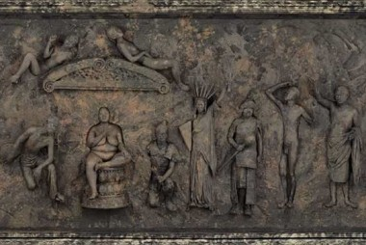
"The History of Monuments" - Detail (2010)
JD: Could you give us a brief description of “The History of Monuments,” the enormously long photographic frieze you completed last year? What prompted you to undertake such an ambitious and complicated work?
WQS: “The History of Monuments” was first shown in the “A Decade Long Exposure” at CAFA in Beijing. Before creating this work, I was curious about the maximum length a picture could be produced on one a roll of film. I found out that a roll of Kodak film can print a picture 42 meters long at the most, so I started to make this work, which is also 42 meter long. The purpose of this piece is to summarize culture. In China, people always like to sum things up in the form of a frieze, such as the summary of a year, five years, or ten years. I want to summarize certain aspects of culture in my work, although this kind of culture might not be “appropriate” by some people’s standards. “The History of Monuments” will be displayed in France this year.
JD: Is there anything more you would like our readers to know? Do you have any plans for yourself in the near future?
WQS: I think the Chinese contemporary art scene will certainly be good, because we have a huge population of 1.3 billion people, and their needs for life, as well as their artistic needs, will have a huge impact on the world. No matter whether the impact is good or bad, it is worth of paying attention to. In addition to photography, I hope I am able to extend my work to some other art fields in the future, such as TV or film. I think at a certain point, one may have some new ideas and need some new input.
JD: Thank you for participating in our interview. Congratulations on the opening of your new exhibition, and we look forward to your lecture at the China Institute tomorrow night.

“Wang Qingsong: When Worlds Collide” will be on view at the International Center of Photography in New York through May 8, 2011. The Jing Daily team would like to thank David Appel of the International Center of Photography for arranging the interview, and Dr. Agnes Hsu of the China Institute for organizing Wang Qingsong’s Art Salon. Tweet

