“On the Field of Hope”
Cui Cancan (curator), July 5, 2020

Click here to see Cui Cancan’s Tour of the Exhibition:
(I)

In 2000, Wang Qingsong pioneered a new way of narration. With the opening and closing of a handscroll, the center of the story in “Night Revels of Lao Li” constantly moves, highlighting a flowing and fragmented narrative. Inspired by a historical allusion to a Chinese traditional painting, Wang converges multiple sets of intertwined scenes from different times and places without hierarchical order. As a result, a new vision and comprehension of viewing and understanding this world changes the history of Chinese photography and alters the perspective of traditional photography in the West in the last century.

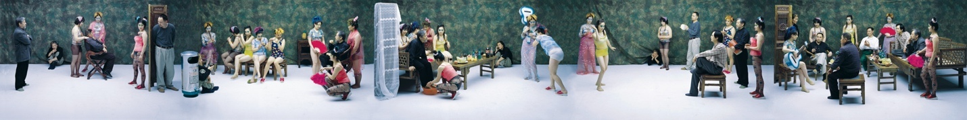
Night Revels of Lao Li, 120x960cm, 2000

For Western viewers, “Night Revels of Lao Li” has the historical charm of a distant China, while for Chinese viewers, it was the earliest representation of a post-modern vocabulary in photography. Beginning with “Night Revels of Lao Li”, Wang Qingsong brings together this mode of storytelling in his distinctive narratives and grandiose stage sets and embarks on a new historical journey. A single image becomes a triptych. A triptych develops into a handscroll. A handscroll evolves into a panoramic stage play. All these incessant adjustments activate and expand the functionality of photo narration. Since then, photography has no longer generated an isolated shadow of reality. It becomes a vast and confusing archeological site that has countless links to reality.

In Wang’s grand tableaux, the decisive moment featured in traditional photography becomes a continuous moment. He provides a continuous imagery to a certain moment and combines several dozen typological photographs into the same picture. Single pictures become multiple images which evolve into an album and further into a collection of images through interplays with stage sets. In “Romantique” and “China Mansion”, Wang re-engages with the narrative functionality of multi-point perspective, exerting the specific advantages of handscrolls which interpret complex historical stories. As nearly one hundred models are portrayed as classic figures in the Western art history from hundreds of years ago, the temporal sequence is broken, and the spatial structure is reconstructed.

Compared to traditional documentary photography, Wang Qingsong does not use a camera to record a moment in reality. Rather, he shows the real background that produces this moment. His method is additive, not subtractive. Beginning with a momentary feeling, he pursues to develop into a scene at a historical period. In “Dormitory”, Wang concentrates on producing one single image which will be produced by traditional photography over a couple of years. Dozens of metal-framed beds give metaphors to dozens of different real spaces, loaded with “real food for thoughts” like one big shipping container. They symbolize different families or stories. Here, space is condensed, and time is drawn closer. “Dreams of Migrants” brings different family dramas onto the same stage, where the ups and downs of these seventy-two “tenants” play out. This unique arrangement and composition offer a “God-like perspective.” Any acts in this play seems to denote everything under this world. However, Wang does not take on a “God-like perspective” in order to look down on these people; he directs our eyes and imaginations from less to more, from more to the infinite, then to broader and more expansive symbolism.

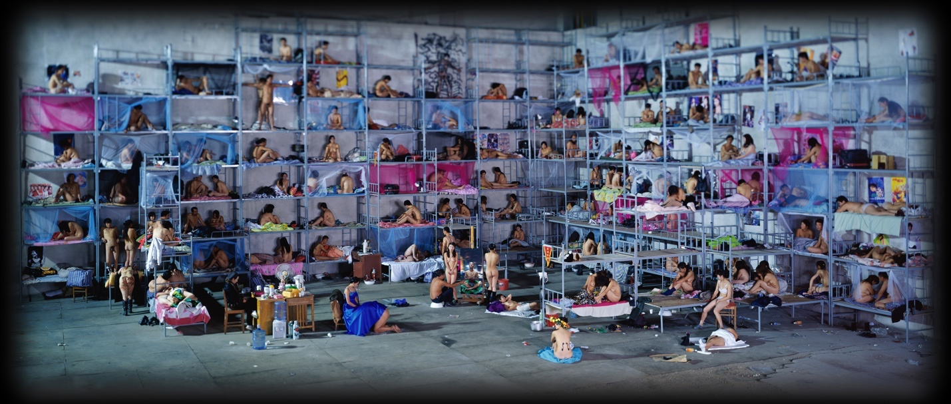
Dormitory, 170x400cm, 2005

Deviating from traditional photographers, Wang Qingsong plays different roles and identities at different stages in producing one single work. At the very beginning, he is like a playwright or author who conceives of a text and determines a rough story. Later, like a painter, he makes sketches and engages with further details. Sometimes he has to plan on postures, gestures, placement, and costume for several hundred figures. It might take him six months to meticulously paint the logos stroke by stroke that need to be photographed. All of these seemingly repetitive and boring tasks must be completed before the real thing, from locating a suitable setting, building stage sets, dispatching actors and large numbers of props and etc. He is just like a film director. He has to make one adjustment after another to the sets, shifting focus from the whole to the parts and from the parts to the whole. In this process, these source materials from the reality will be transformed into specific figures and scenes of varying magnitudes. At every step, he has to confront mistakes, reconfigure loss of control, forecast unforeseen changes and calculate constant increasing expenses and appropriate times/places.

It takes quite a lot of time to ensure that all of the pieces are in place in the puzzle. Then he sets up his camera and waits to take the picture. The poses and expressions of the actors must be captured before they fleet away. The light and shadow reveal all kinds of subtleties. He must take shot of the “decisive moment” which involves a huge production cost. Inside the black box of the camera, the light refracts information which turns into his artistic reality and realistic history.

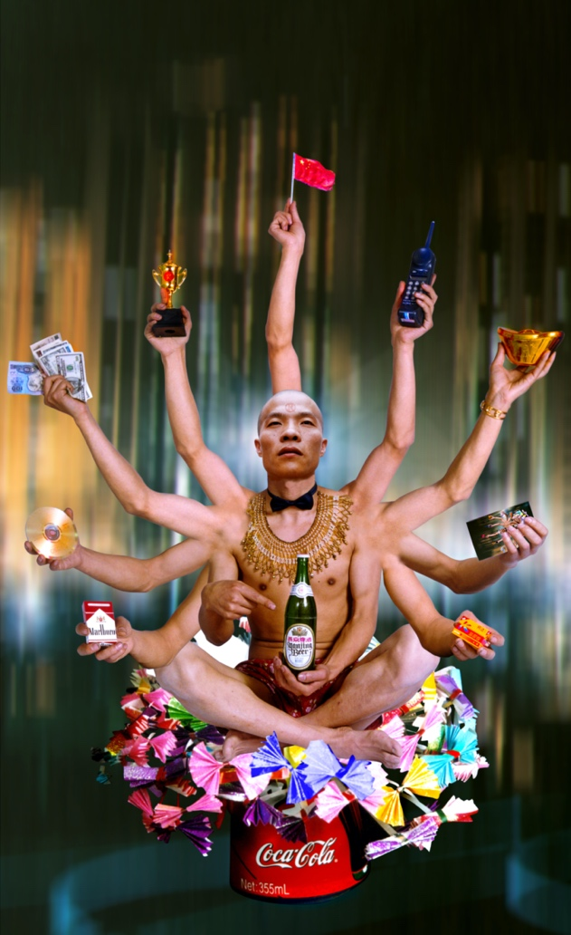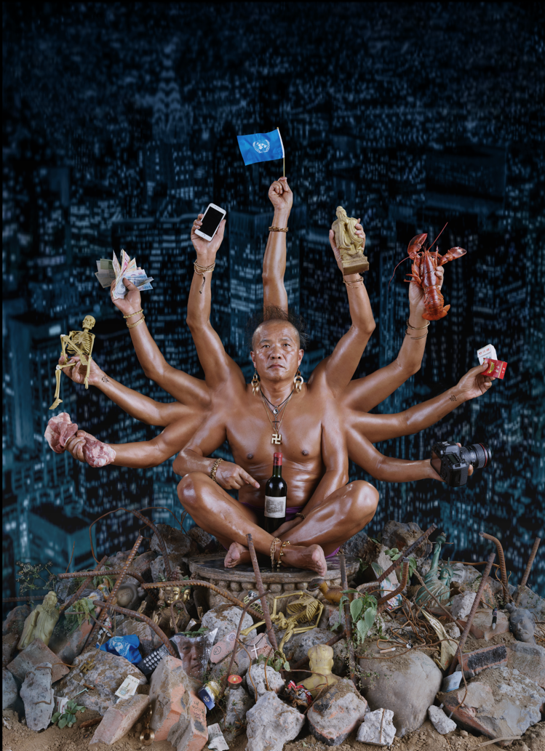
Requesting Buddha, 180x110cm, 1999 Bequeathing Buddha, 180x130cm, 2019

Wang Qingsong is more like an artist in a Hollywood studio, managing a large team and countless details, and handling different kinds of tasks and processes. Sometimes he needs hundreds of people through teamwork on a set of several thousand square meters. Sometimes he prepares for one photograph in a number of years, waiting for the right moment. He constantly shifts between these different roles and times. Photography does not carry its own power through a separate medium. Rather it must work in concert with other media to convey more nuances.

Therefore, impactful visuals are connected with legible information in Wang Qingsong’s work. The forms no longer require explanation, and the mixture of text, theatrics, and cinematography brings out the best of these media. The imagery provides irrefutable evidence. The text provides clear information and possible direction. The stage provides the relationship between locations, backgrounds, and characters. Such cinematic vocabulary connects these shots in the same scroll and rehearses at the same time and space one drama after another.

This makes Wang Qingsong’s works easy to understand, giving it an independent presence that does not require further explanation. In the pictures, he reveals the times, places, major protagonists, and arranges interconnectedness between the temporal backgrounds and narratives.

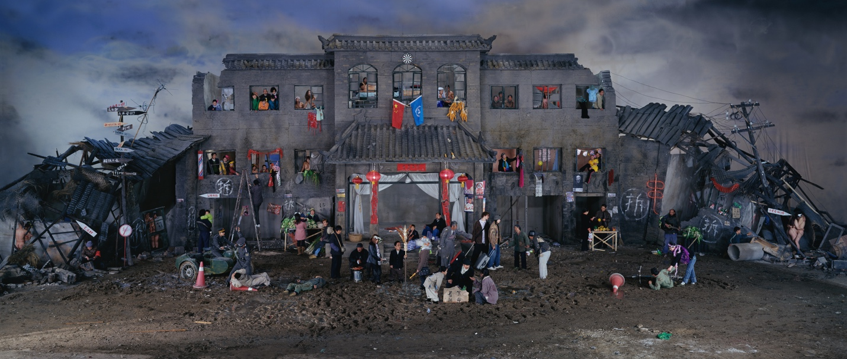
Dream of Migrants, 170x400cm, 2005

To analyze his work is like uncovering a film. One can decipher these steps. In his celebrated piece “Follow Me”, an immense visual impact attracts the eye, offering a magnificent visual spectacle.
Second, we are attracted to densely-packed forms, colors, and shadows, which start to activate our experience to recognize certain information. However, this information cannot be grasped at a glance, and its meaning cannot be comprehended immediately. This large volume of information transforms looking into a voyage of exploration and discovery. This new journey for the viewer gives viewers a delight in reading and discovering. At that point, viewing becomes a game compelling us to uncover the answers to these riddles that the artist has left in unobtrusive corners amidst numerous objects.

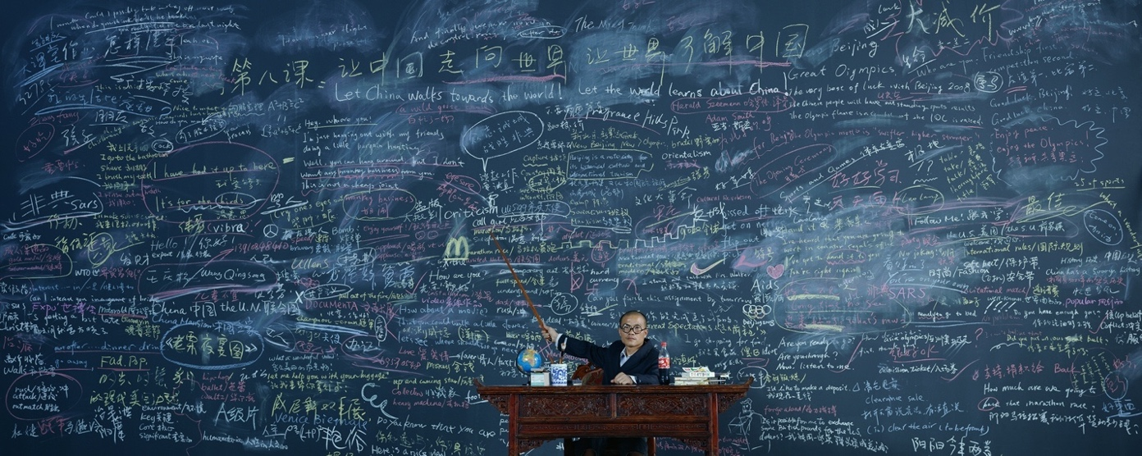
Follow Me, 120x300cm, 2003

Imitating a camera’s observation to the world, one first looks at the overall whole, then moves toward a visual center. Here one follows the artist’s eye. The lens constantly shifts, scanning its relationship to the surroundings. A row of large slogans, several obvious erased marks, and a few grammatically incorrect English sentences and seemingly familiar symbols pull us into relationships with complex storylines as he tries to identify similarities and differences from the reality. What are they saying? Who is the person in the middle of the image? Where is the pointer directing? What is written on the blackboard? What is the relationship between these texts and the final image? What is this work trying to say at last?

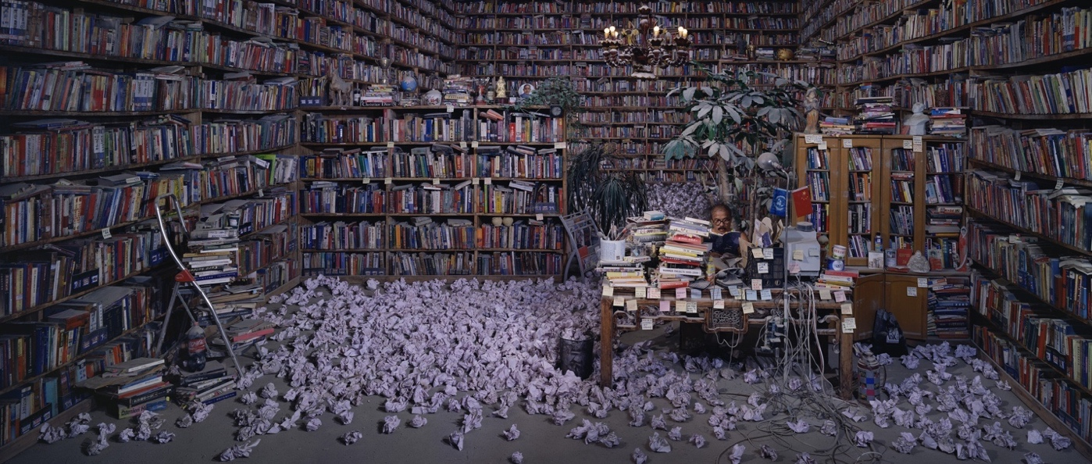
Follow Him 130x300cm, 2009

Confronted with so many Wang Qingsong’s photo works, we experience a process that John Berger described—from looking to seeing, from seeing to gazing and examining. Finally, we extract ourselves from the reading of visual information and the searching of meanings. In the face of a series of question marks, we begin to wonder, in this long trajectory of the artist’s career, why does the discussion of education reappear? Why are texts or slogans always prominently highlighted in his narratives? Or, none of this is important. What the heck the artist has such a miraculous hairstyle!

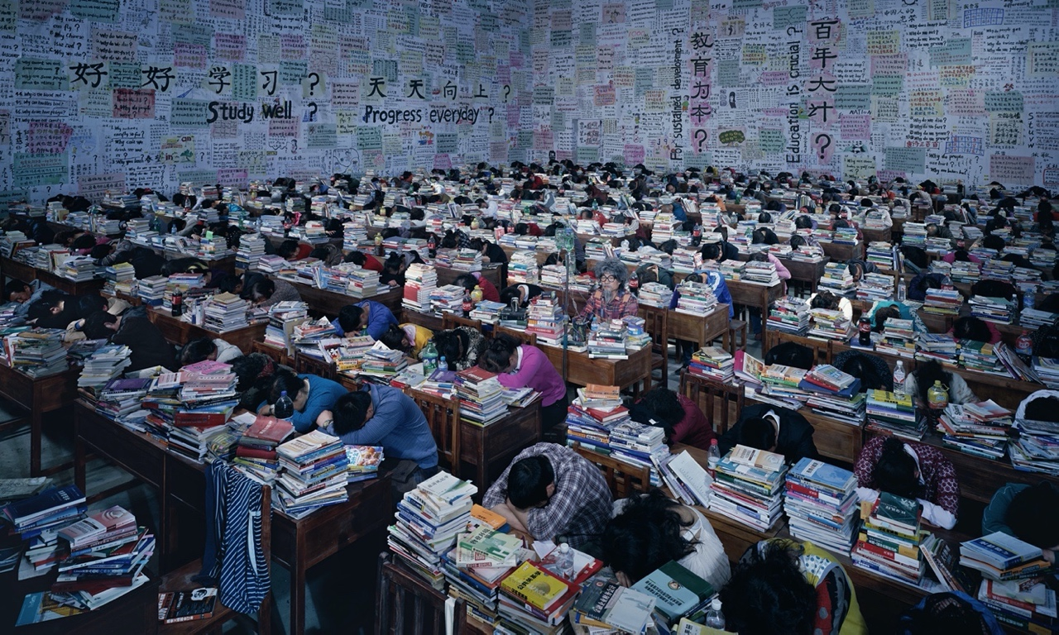
Follow You, 180x300cm, 2013
There is no riddle to unpack the story of “Follow Me”. He is not preaching, and he is certainly not following conventions. In Wang’s work, there is no final answer telling you that the world should be a certain way. He is simply consolidating his experiences and feelings, and constantly questioning reality, asking why something happens in this way or that way. In his later works such as “Follow Him” and “Follow You”, the trilogy pushed the story into a larger historical background or a larger reality. Wang develops one work into a series and then moves from that series into a richer message. The pieces echo one another, questioning and authenticating each other over the course of a decade. Exactly like a long series of novels, or an epic film, he keeps on exploring the myth.

Beginning in the late 1990s, Wang Qingsong embarked on a new path to creating “meanings”. He abandoned the grand tradition that photography once cherished, and reconnected photography to reality in order to present another charm that reality bears in photography.

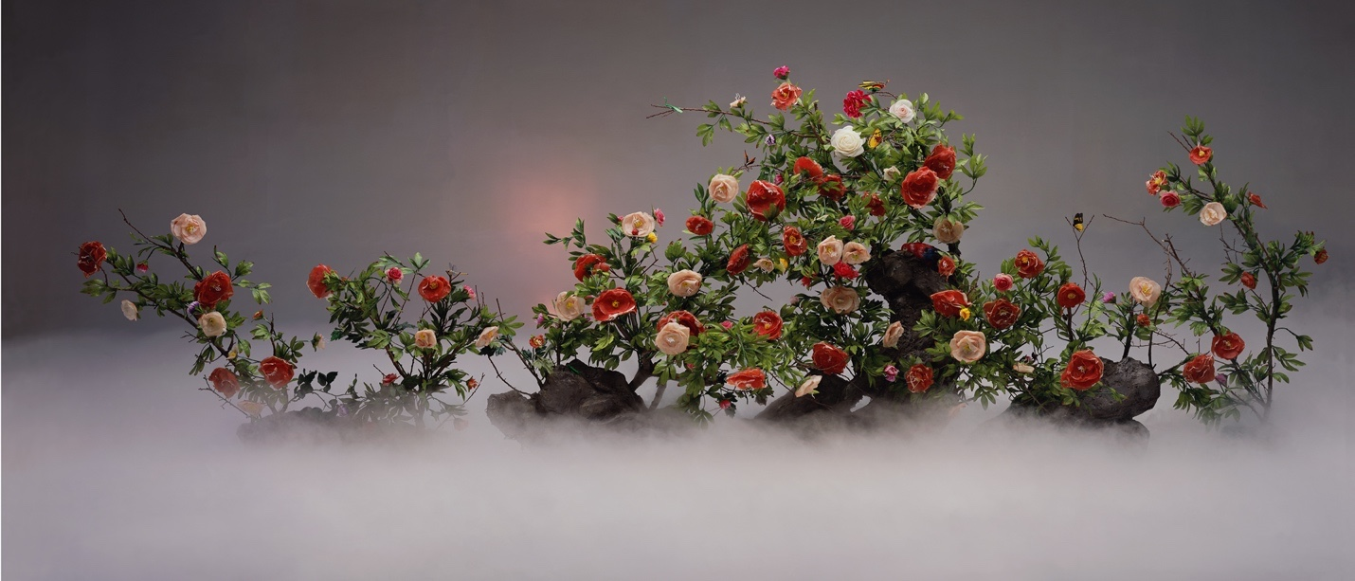
Ethereal Beauty, 120x280cm, 2003

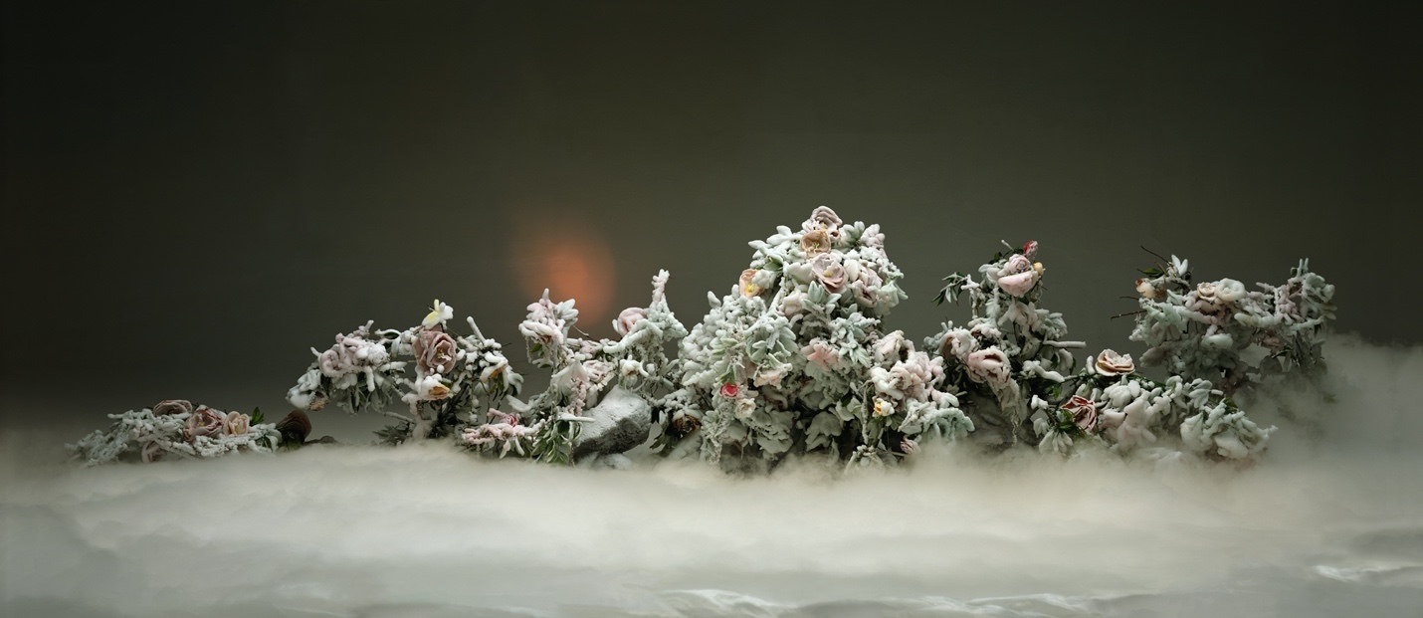
Auspicious Snow, 120x280cm, 2003
Before the photographer presses the shutter, the world that he sees and understands is entirely different from the fragment that the viewer sees in the exhibition hall. Here one grasps everything while the other only sees a part stripped of its beginning and end. John Berger wrote, “here lies an insurmountable chasm or abyss between the moment that the photographer records and the moment that viewers see.” Although some aspects of this abyss are part of the self-discipline and advanced aesthetics of modern photography, this ambiguity has been appreciated by many traditional photographers. Deviating from the constraints of this genre, Wang Qingsong builds a bridge out of the multiple languages in painting, theatrics, and cinematography to remedy momentary deficiencies and add the threads of a beginning and end to the story.

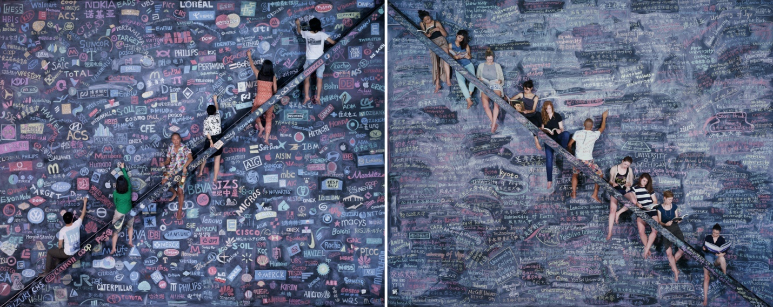
One World, One Dream, 180x225cm x 2 pieces, 2014

However, he does not stop at the functionality of documentary photography. His work situates doubt, criticism, and satire within those falsified yet real scenes. What we see seems to be real, but the absurdity of conflicting details and relationships is so incongruous. The models’ half-hearted performances and indefinable sense of isolation remind us that this is a drama play, which carries deeper visions and metaphors. Therefore, as reality becomes more distant, the image metaphors of reality becomes more prominent.

Wang has to keep some distance from documentary photography, which refers to captures reality directly. Temporally and spatially, he relies on a calmer and more rational state from which to observe and understand the overall social relationships before he can pronounce his comprehensive statement. He creates a concept at first, then fills in with minute details from complex reality. Therefore he is “creating” stories rather than describing them.

Reality is simply a source of materials and photography is just a means to an end. The objects he photographs are stylized (fabricated) yet typical events, existing in reality, but not completely. Wang photographs reality, e.g. a mark left by a drop of water or a ruin left by transformation. However, this reality does not provide proofs as it is. Rather, it comes from the artist’s individual reflection, or his stance in the face of such crude reality. His photographs come from reality, but are the products of cultural programming, creating a more fresh and refined “melodrama” or “sensation”. However, this “sensation” is more realistic than texts, enriched with more spices.

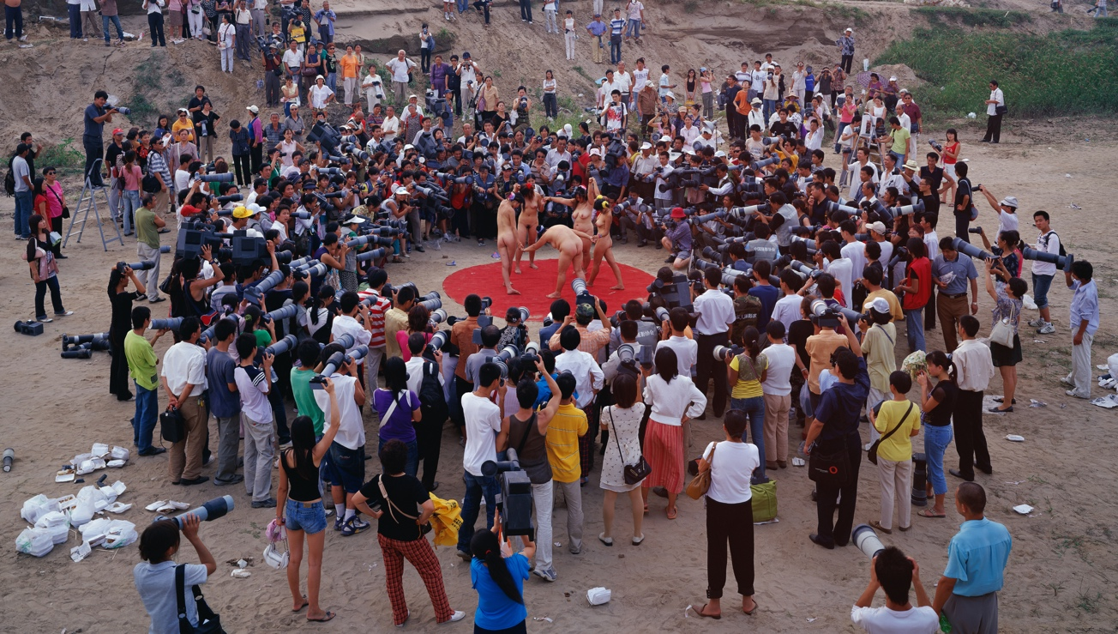
Fotofest, 170x300cm, 2005

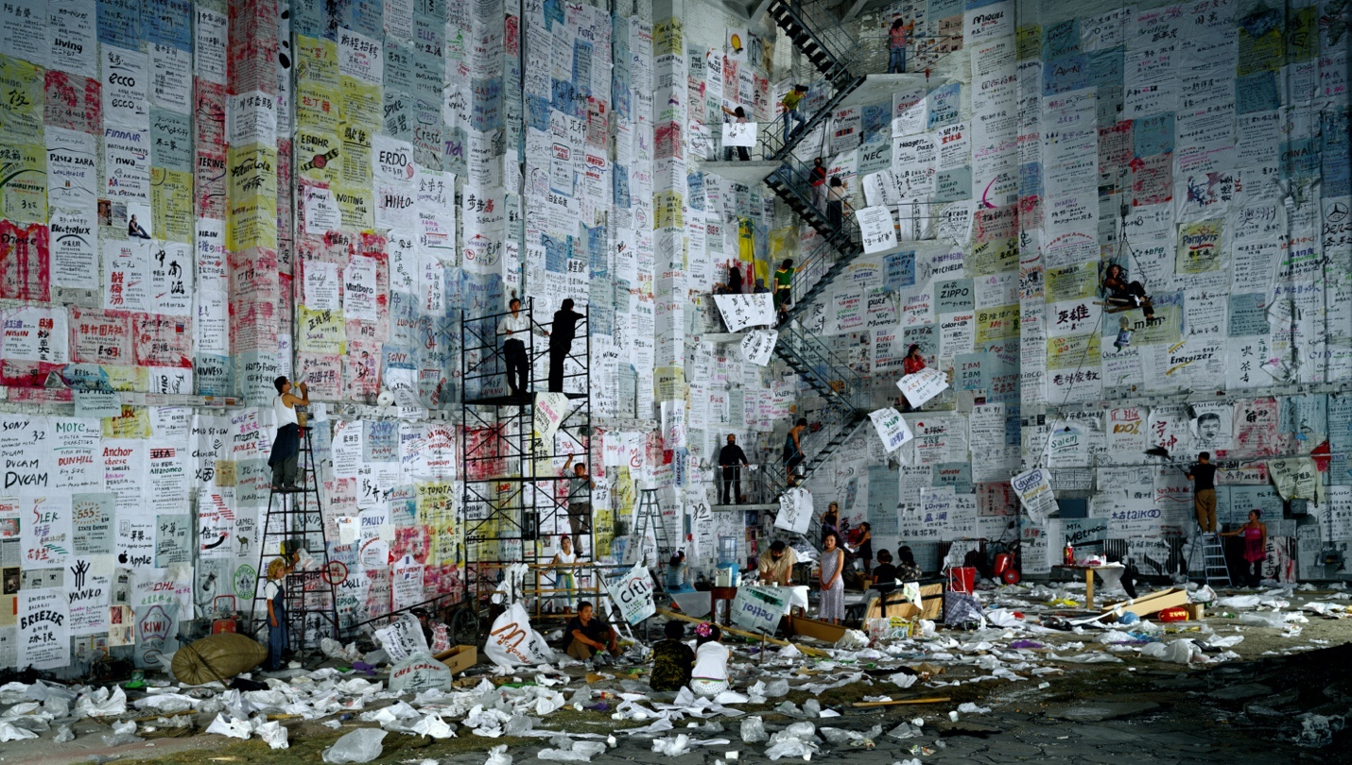
Competition, 170x300cm, 2004

(II)
Across this society, all have been changing, but not the concept of family. The living situations of these “petty people,” and many other facets of society, are ubiquitous in Wang’s work. His perspective is that of the commoners that examines keenly and empathetically, analyzes social psychology and portrays how these people see the world. They have their own ideals and hopes, their own joys and sense of beauty, even though this beauty may be hated by those with “good taste.” In the grand torrents of history, they float along, drifting from left to right, in ill-fitting clothes. They make great efforts to catch up, but they are always a few steps too late. They have a full load of doubts, attempting to make themselves look not so “messy”. But they always exude awkward hybrid features from this epoch. Regardless of how reality has changed or how irresistible globalization has been, there is always a group of people that has nearly caught up but always have been left far behind. Wang’s photographs are for these petty people, bearing witness to the strictures of human nature.

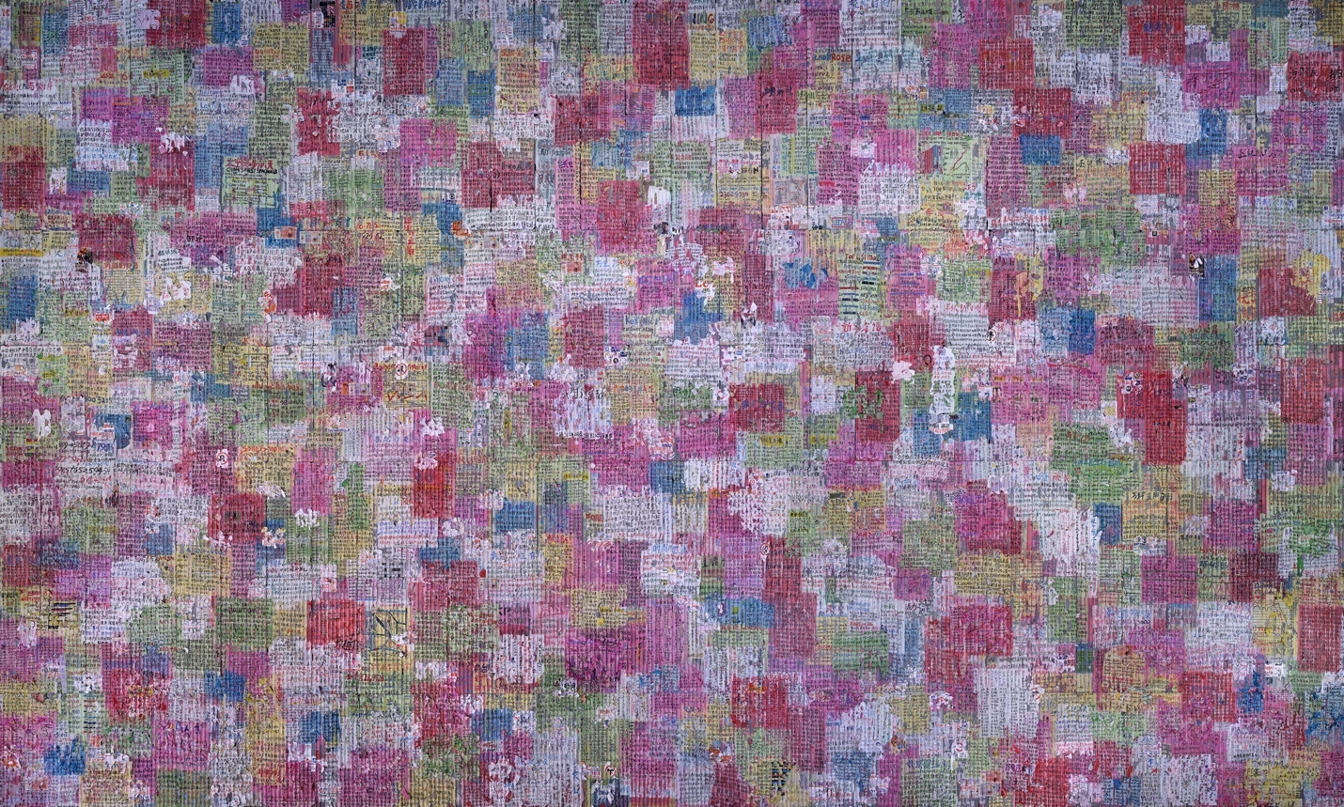
Debacle, 180x300cm, 2009

Wang Qingsong has captured a historical storyline at the most special locale, where cities and townships meet and produce its unique cultural traits for the social transformations in the last decades. In this world, he discovers a distinctive aesthetic, drawn from his hometown, an ancient city called Jingzhou, Hubei Province in 1980s to the construction workers’ sheds in Zhumadian, Henan Province in 1990s, onto the low-priced marketplace in Yiwu, Zhejiang Province in 2000s, continuing to the outskirts of Baoding, Hebei Province. Now all these forces come to the place where he has been living since 1993, a border land merging into a megacity. These relocations look like alternative utopias, including Yuanmingyuan Artists’ Village, Tongxian Township, and Victoria Bay in the dim light of Caochangdi Village. In these places, he saw rising franchises, KFC and Mr. Lee (formerly California Beef Noodle King), permeating all over small townships, enriching life for content and happiness. There one finds commoners’ life philosophy oriented towards power to survive and inextinguishable hope towards fragmented reality. It is full of grief and joy, typical of a life for the vast majority of people.

His work reflects a popular aesthetic with a post-modern perspective. Through a common person’s eye, it bids farewell to the glory of modernism, the God’s All-mighty glorious moments, or the sacred aura of light and shade. This not entirely “graceful” taste largely preserves the direct perception into reality itself. His aesthetics and methods are populist and democratic, and they are more in keeping with an era of ubiquitous advertising and internet connection, floating up and down with the times and populace’s tastes. In other words, only by reversing the power of advertising and consumerism with the same enforcement in the form of photographic “menace”, can he exert the full power of the social and historic function of photography in such a reality.

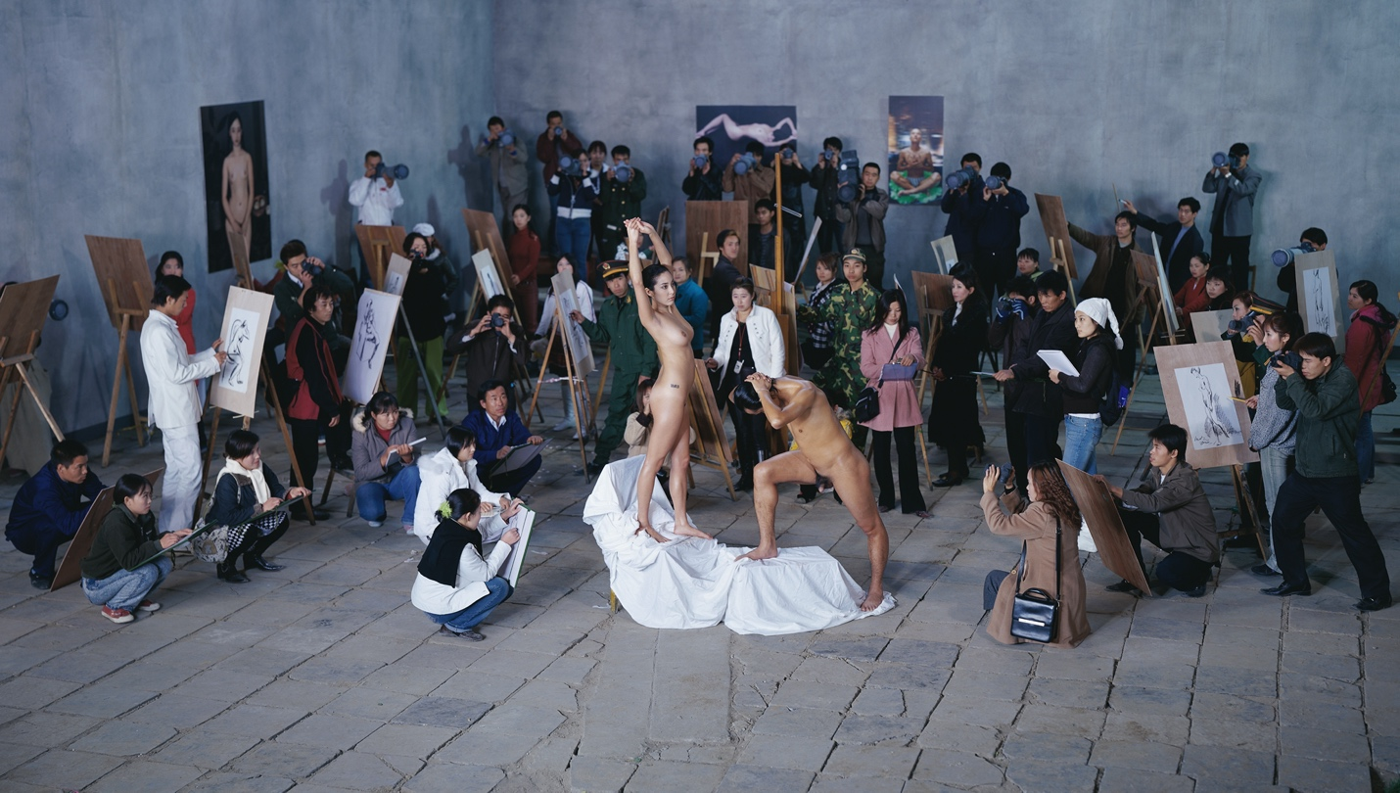
MOMA Studio, 170x300cm, 2005

This artistic nourishment might come from his earlier experiment with gaudy art, a methodology based on learning from popular culture and folk art. We can easily capture a historic aesthetic in his works, combining a grand collectivism, realist literary narratives, formalistic folk taste, as well as Chinese illustrations, storybooks, political propaganda images, and mass model plays from the 1970s and 1980s.

(III)

In 1981, the song “On the Field of Hope” spread all over China. Along with “Young People Meeting” and “Youth, Youth,” people enjoyed the changes in that era and looked for a beautiful prospect for the future.

Far away in the small town of Jingzhou, Wang Qingsong was living another life. His father died on a job mission. Gradually more depressed, he could not envision a future for himself. The song “On the Field of Hope” and the environment at that time were immensely meaningful for ending that dark period in his life. The joyful musical vitality and infectious lyrical power tell a simple yet attractive story, awakening the new generation of the 1980s and encouraging Wang to participate in these significant changes.

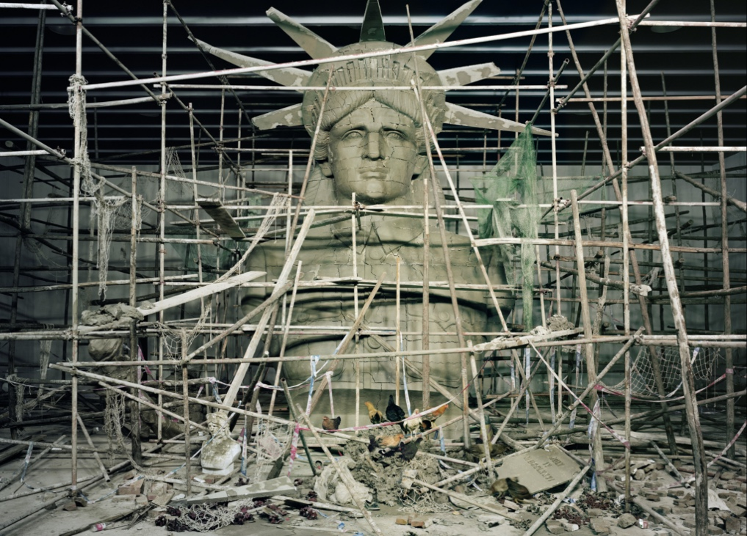
Goddess, 180x250cm, 2011

Wang Qingsong enrolled in an art college in the early 1990s. He arrived in Beijing in 1993 to begin his life as a “migrant” artist. In 1997, Wang shot his first series of photo works and gave them rather interesting titles such as “Take Up the Pen, Fight Until the End”, “Old and Young Soldiers”, and “Our Life is Sweeter Than Honey”. The frank and popular style and the stories of life alluded to in popular songs were echoed for the first time in his work. Later, Wang’s lens record the endless changes in Chinese society, and his artworks condense the histories, enlive the memories, and detail the transformations of reality and human desires. In between hope and field, his endless drama premieres.

The unprecedented 2020 pandemic suddenly stopped this accelerated social machine. Likewise, the questions that Wang Qingsong has been asking stop suddenly, as those models in his works freeze his attempt to untangle puzzles. The thread of the story is severed once again. The story about globalization and consumerism, connecting China to the world and helping the world to understand China which carries the sense of “life is as sweet as honey” and “tomorrow will be better” are temporarily brought to a close at the turning point of 2020. We don’t know when the pandemic will end, as we wonder into a river without coordinates and lose the orientation to comprehend these new changes. Old stories have collapsed, with new stories of hope yet to come.

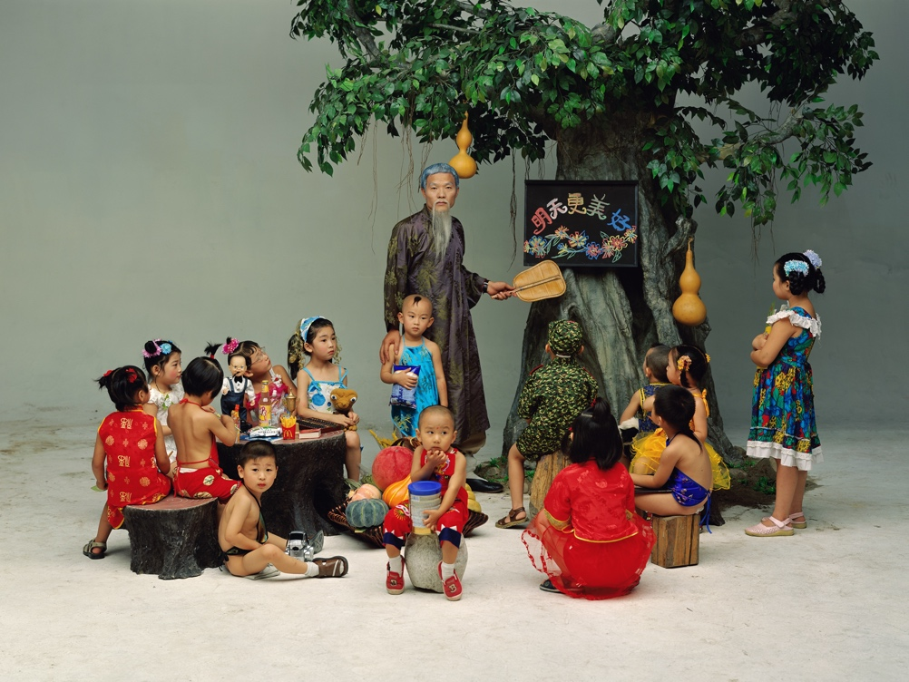
Preschool, 120x160cm, 2002

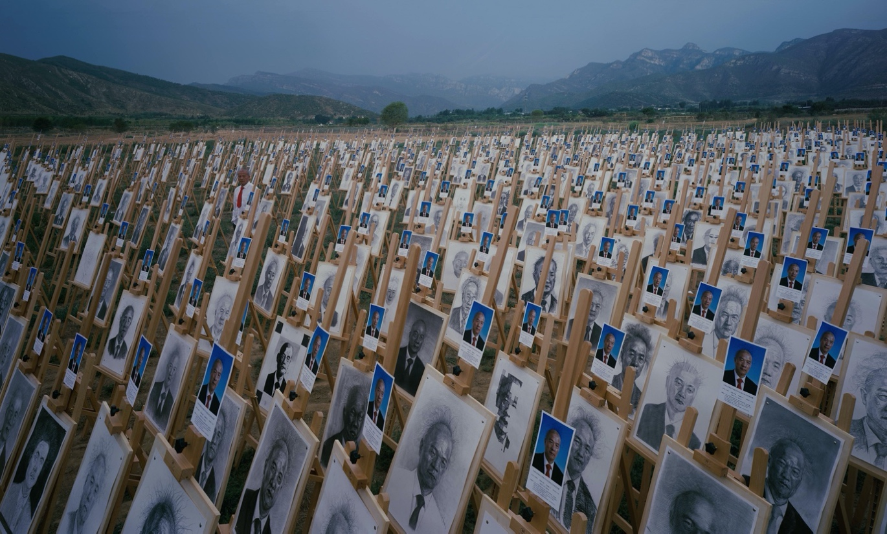
On the Field of Hope, 180x300cm, 2020
“Question a Brick Wall” is a new work in 2020 which summarizes the past puzzles and merges the previous two seminal works into a new force. In terms of form and content, this new work fuses “Competition” and “Debacle” from 2004 onwards and carries onwards the advertising and textual elements that repeatedly appear in “One World, One Dream” in 2014, thereby continuing the consumerist spectacle, a core theme in Wang’s work. Semantically, the large question mark reveals his vision that has been woven into the works made in the last two decades. Beginning with “Can We Cooperate with You?”, doubts and suspicions about the world permeate in every work. When it appears with a hefty scale of a monument in an exhibition space, the work asks a particularly important question at this moment, because all historical times and markings have started once again. We don’t know if the future will simply fall into the void, or if it will break through the dark abyss to welcome the entirety of stars.


Question a Brick Wall, 280x180cm, 2020
The title of the exhibition, “On the Field of Hope,” represents the past, the future, and a new hope. Where is our future? Where is our field? This question has started since the 1980s. After the massive changes in the last four decades, herein again we confront the past. If we have not experienced these decades, or if the temporal and spatial distances have not made the details of history ambiguous, those tears on the field of hope, drifting crowds, charming evenings, short-lived joys will not clarify the vision, or sharpen the dramas before they vanish into a vacuum. But at the very least, Wang Qingsong’s photography leaves us with a series of long shots. He believes that the human history is as simple and short as a long roll of photo paper.

That same young man who lost his life’s direction in Jingzhou in 1981 finds his answer on the field of hope. Forty years have passed as the song “young friends meet” goes on. Wang Qingsong’s interconnectedness with and temporal distance from those pop songs inspire recollections and hopes, as well as generate discussions of human destiny at such realities of different eras. As we look back on those memories and look forward into the future, we try to bridge the idealistic years of 1980s and the current pandemic in 2020. Sometimes we feel abrupt cutthroat pain out of the blue, but disasters seem to have been foretold, depressing though worth pondering for survival strategies .

