Some Thoughts on my Solo Show “On the Field of Hope”
--- Wang Qingsong, July 21, 2020
My solo exhibition "On the Field of Hope" opened smoothly on July 11, 2020 at Tang Contemporary. Surprisingly it succeeded out of my expectation at this time of pandemic. I think I should thank many artists around me and friends from my community. Of course, the success is also inseparable from the support of Tang Contemporary. Without its help, it would be difficult for this exhibition to open smoothly. Without its support, the new works might not have been completed successfully.
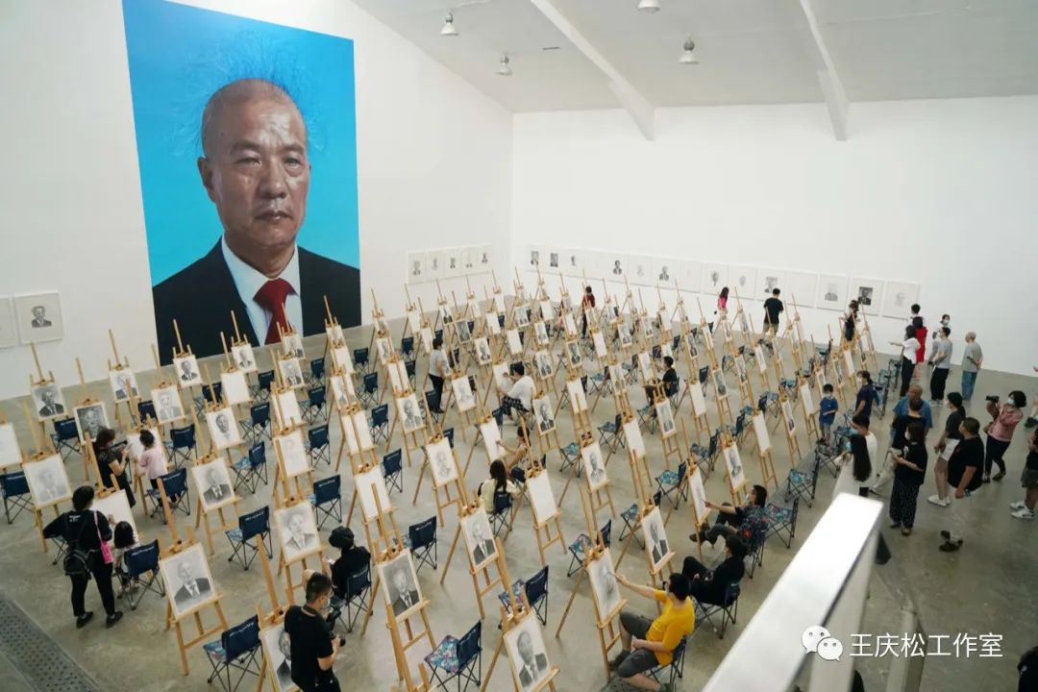
In fact, this exhibition was decided a year ago among myself, the curator Cui Cancan and Mr. Zheng, owner of Tang Contemporary. It was planned to open in early July 2020. I thought this time would be appropriate as school holidays fall in early July. My children studying abroad would be back then. I hope they all can come to the opening of my solo exhibition. But what I didn't expect was that the epidemic starting in Wuhan before 2020 Spring Festival ran rampant, and caused an outbreak across the world. At the beginning, I felt it would not be so serious and it would pass quickly, maybe end soon in a month or 40 days. However, it becomes a pandemic, much more serious, spreading into all corners of the world. What is gratifying now at least, is that the contagion is slowing down and our life is slowly returning to normal.
When I first talked to Cancan, the curator for this exhibition, we were not so sure of the theme yet. The original title would be "Wang Qingsong Solo Exhibition". During the making of “Question a Brick Wall", we decided that this title of the new work would be the theme of the exhibition. After I returned to China from the U.S. in late January 2020, the coronavirus caused serious disruption to my preparation. It last longer and prevented me from going out. I realized that a lot of things will be affected by this pandemic and nothing became predictable. Homebound, I started to prepare this new work "Question a Brick Wall".
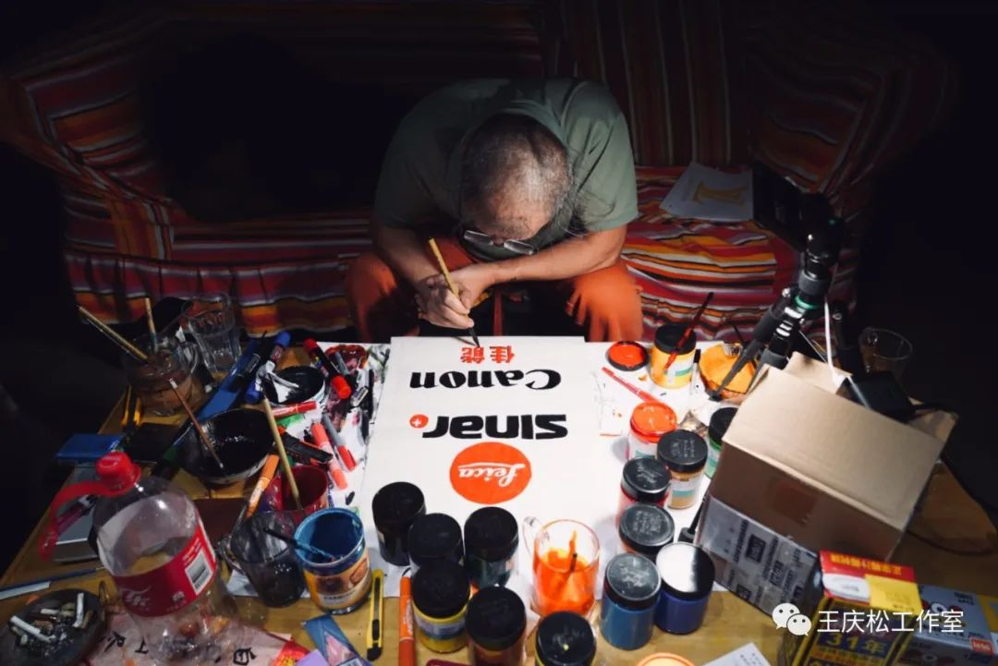Wang Qingsong working on the ads for the photo shoot
At the beginning, I just wanted to practice calligraphy. I chose some cheap advertising paper I used to write and scribbled some brands and their advertisements collected over these years. When I realized that this pandemic would not be over within a short period of time, I began to write in a neater manner, thinking of a new way to present this work in the exhibition that would open on July 11. As I said, the theme of the exhibition would be the title of the work "Question a Brick Wall”. This work was actually not as easy as making “Competition” in 2004 or “Debacle” in 2009. This time I was not writing calligraphy, but rather drawing and painting calligraphy and logos in more clarity and detail. I must draw each one over and over again, and paint many times one layer on top of another layer. In total, I did about 400 pieces of advertising paper within four months.
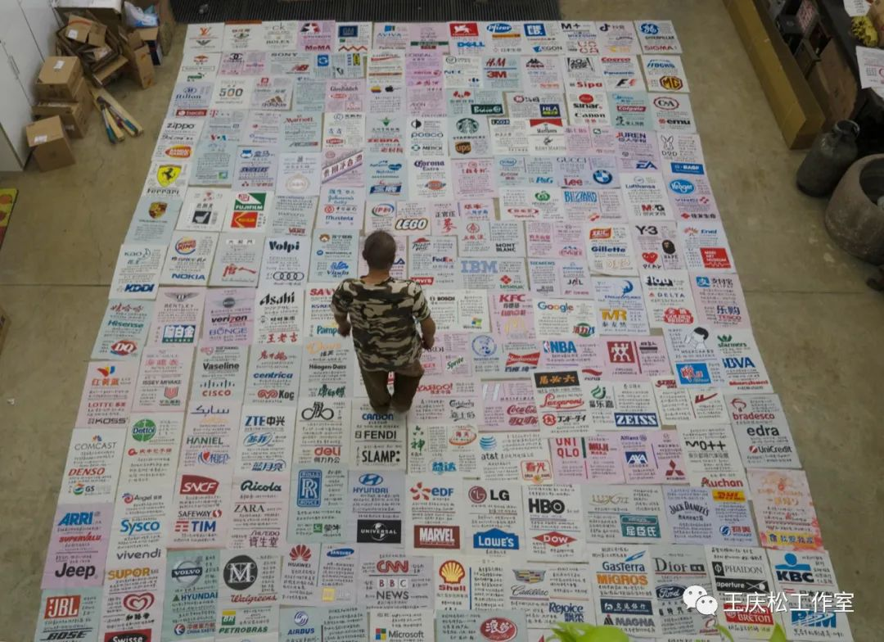
Mapping the ads in Wang’s studio
The height of the entire wall is set according to the height of the gallery space in Tang Contemporary. The installation is 8.3 meters and the width is almost 5.4 meters. On this huge poster wall, there are nearly 1,000 corporate brands, mainly those of Fortune 500 companies. The rest are some most recent popular product brands on the Internet, some common ones in our lives, including logos of art galleries and cultural institutions, and several brands from my hometown Jinzhou, Hubei Province. There are also my favorite and commonly used product brands. It took me more than four months to hand paint all these advertisements. Everyday I lay on the table for more than 10 hours. I sat on the sofa for so long that “carved” out a big hole into the sofa. My presbyopic glasses changed from 100 degrees to 300 degrees. So it is not exaggerating at all to say that I spent a great deal of time and energy into making this work.
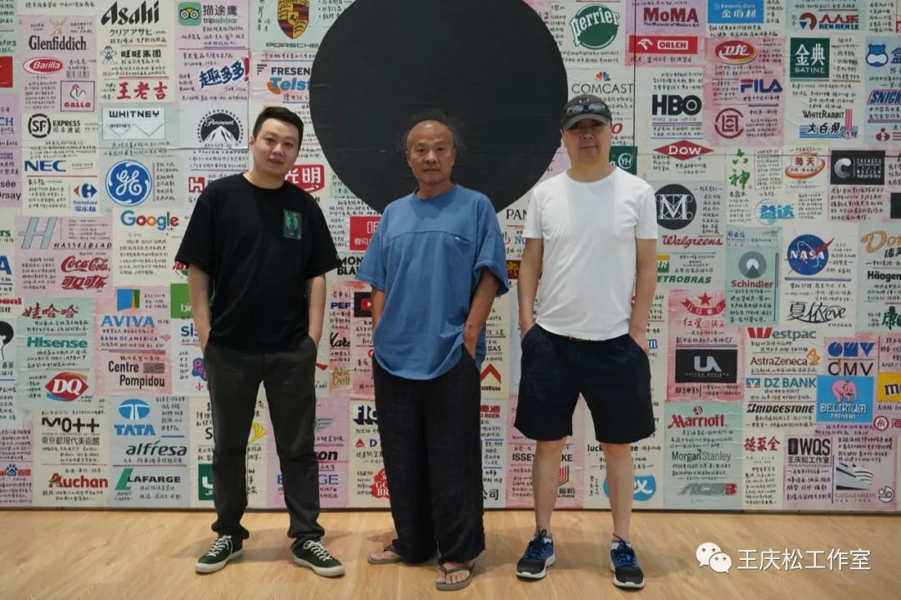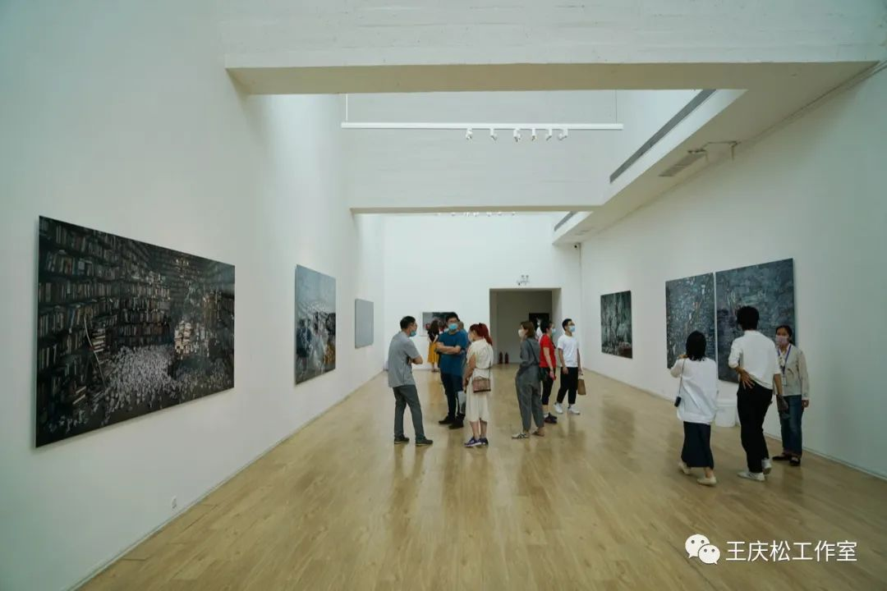
Cui Cancan, Wang Qingsong and Cui Jian
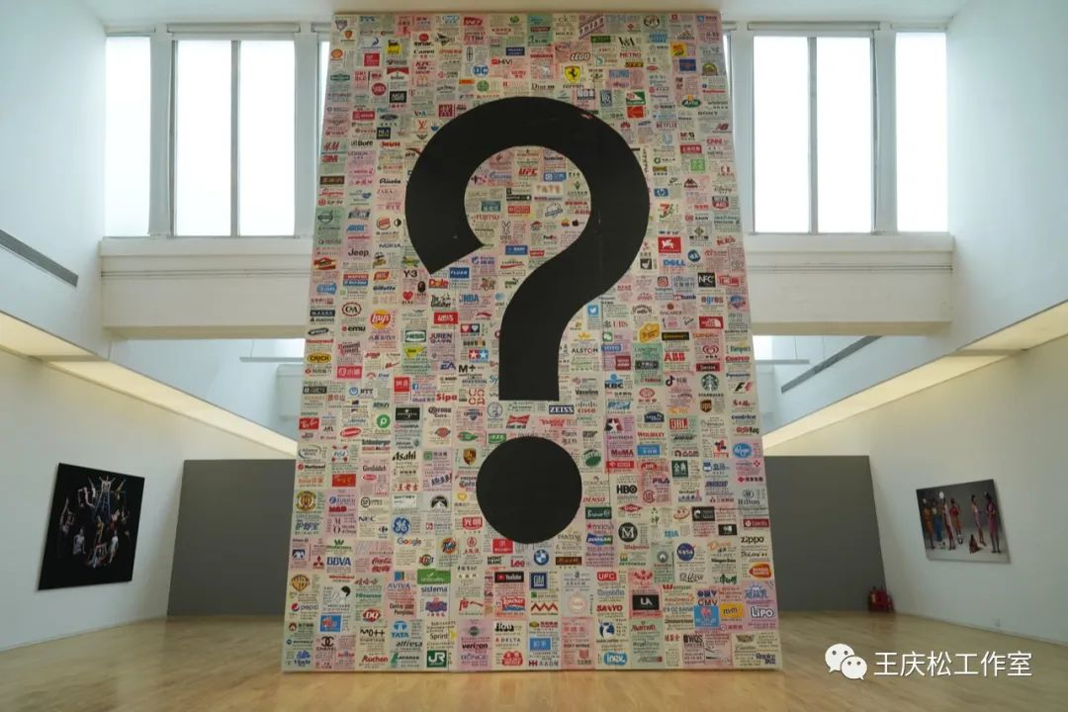
Here I want to address more briefly about the change of the title of the exhibition, which is from "Question a Brick Wall" to "On the field of Hope". This change occurred along with the outbreak and spread of the pandemic in 2020. In the meantime of preparing for “Question a Brick Wall”, I was working on shooting another new work. Originally, I wanted to make an installation in the old space of Tang Contemporary after I finished the shoot of this work. This second work talks about intense examinations to get into an art academy, or simply, it is a work critiquing about education in general. In the beginning, the title of this work was not "On the Field of Hope" at all. I could not finalize its name, probably I would call it “art exam class” or “rocket class”.
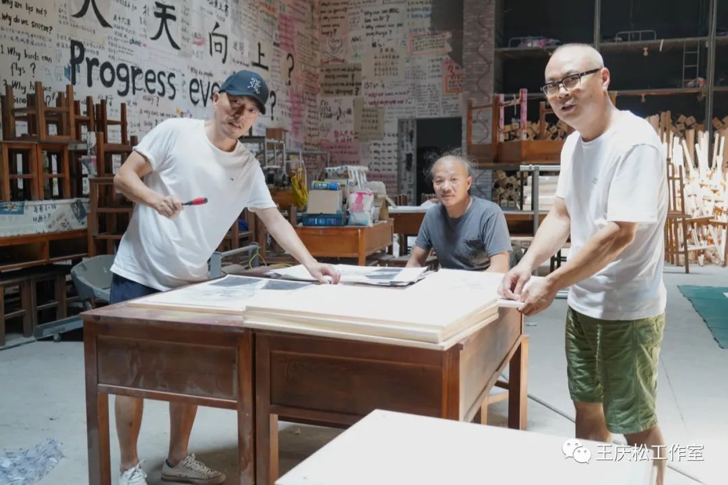 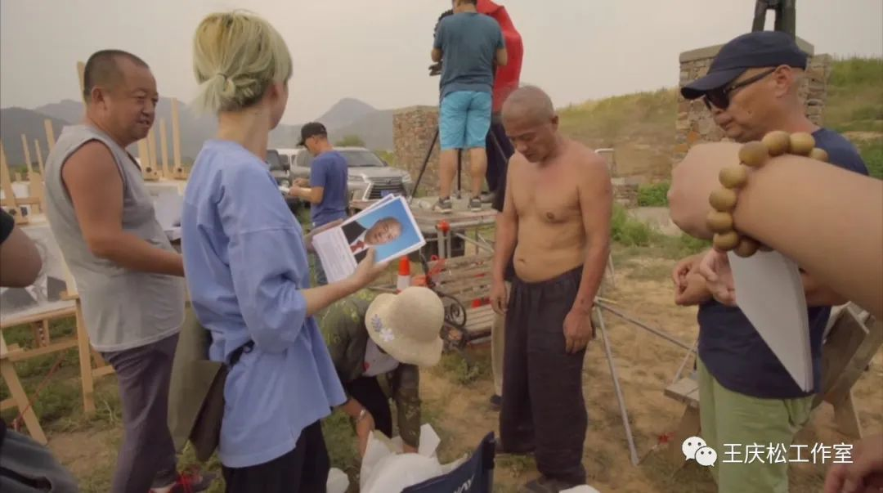Chen Weiqun, Wang Qingsong and Liu Haizhou
At the end of May 2020, there appeared a second spike of COVID-19 in Beijing. The return made me suddenly feel more concerned how I could finish this work, leaving me worried and suspended of whether this exhibition could proceed smoothly. As scheduled, in the old gallery space of Tang Contemporary, I would like to show this new work and a scene from shooting this work. But I doubted if this work could be finished on time due to the second spike of this severe virus. As the opening the exhibition approached, there was not much time left to shoot this new work. I must make a quick decision where to shoot this work as there was very little time, more than one month only, left to open the exhibition.
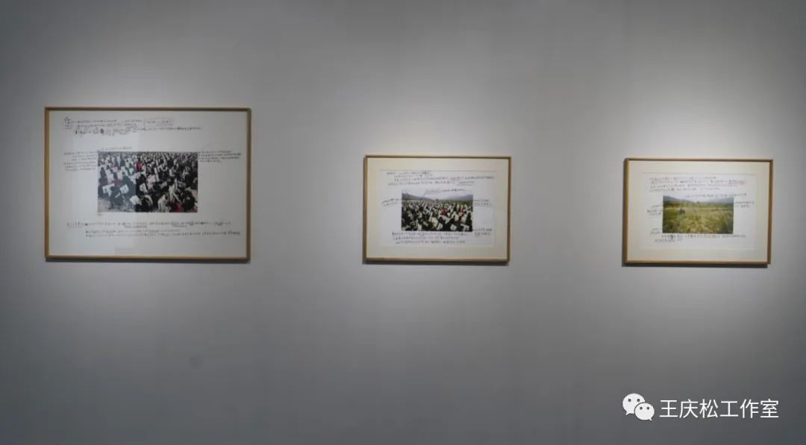Three drafts (Plan A, B and C) due to COVID-19
Originally, it was scheduled to be shot indoors, inside China National Film Corporation's film studios in Huairou Township. I planned to rent a studio there. But after I went there, I learned that it would be impossible to shoot indoors because this work would require 500 people to enter the scene. During the lockdown, organizing 50 people to shoot indoors would not be allowed. Being caught off guard, I must give up my indoor shooting plan. After discussing with the curator, I decided to shoot outdoors. After I made the decision, I drove around to find a suitable shooting location. In the end, when I saw an outdoor scene, I found it not so bad at all. However, I didn’t give up. I still wanted to find other indoor venues. So, I asked private studios in Daxing Township if they allow for 500 people to shoot indoors. Finally, after rounds of communicating with so many people, I learned that no one in charge dared to approve so many humans doing indoor activities during the pandemic. So, I aborted the original ideas.
In the end, I could only choose to shoot outdoors, hoping to complete this work successfully as this work would be the highlight for this solo exhibition. Then I went to Fangshan Township again to see this outdoor venue. That day I went, it was overcast and grayish, just like the gloomy mood of people under the second wave of epidemic in Beijing. The sky gradually turned orange when driving back to the studio. At sunset, I looked outside the window and "On the Field of Hope" resonated in my mind. I switched on the phone and played this song. Along with the melody, I imagined the outdoor shooting scene, and decided to name the work "On the Field of Hope". Firstly, I hoped that this work could be completed smoothly. Secondly, I wish the exhibition would be opened successfully.
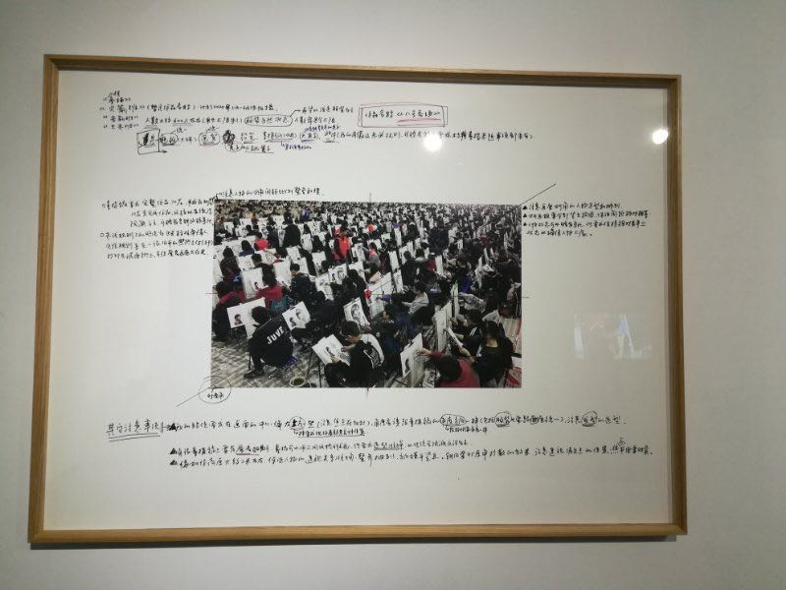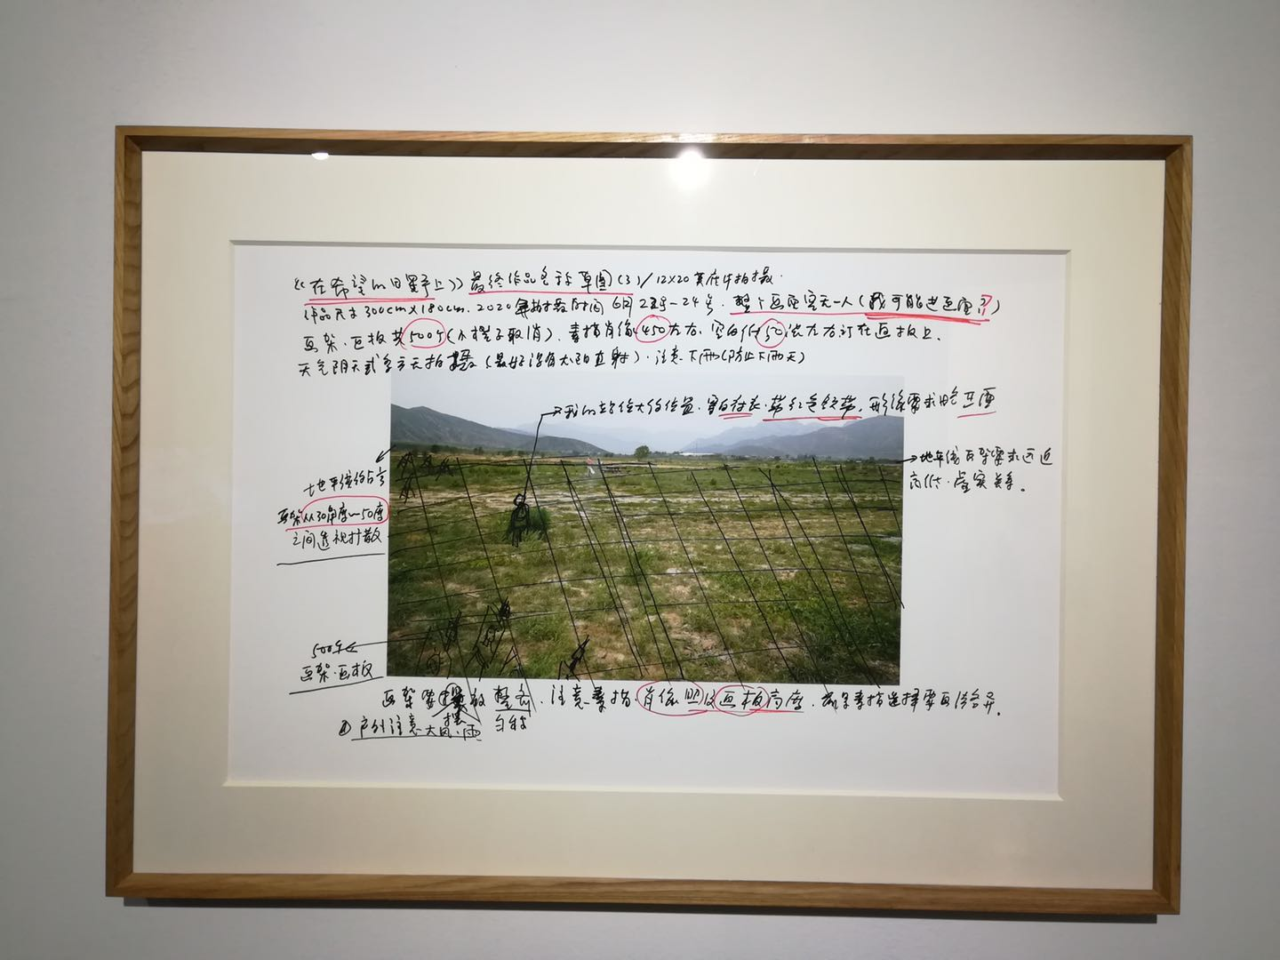Details of Plan B and C for shooting “On the Field of Hope”
(YouTube) Click to see the Making of “On the Field of Hope

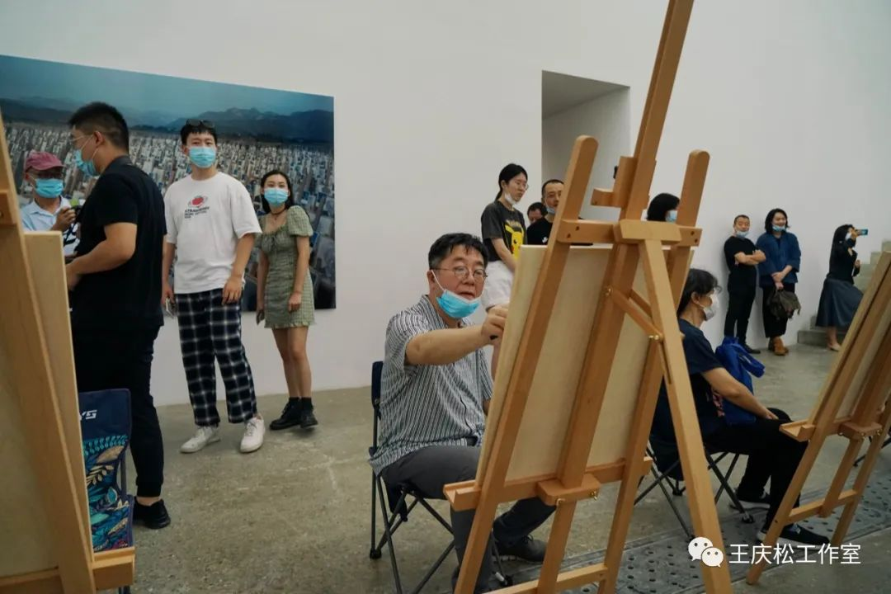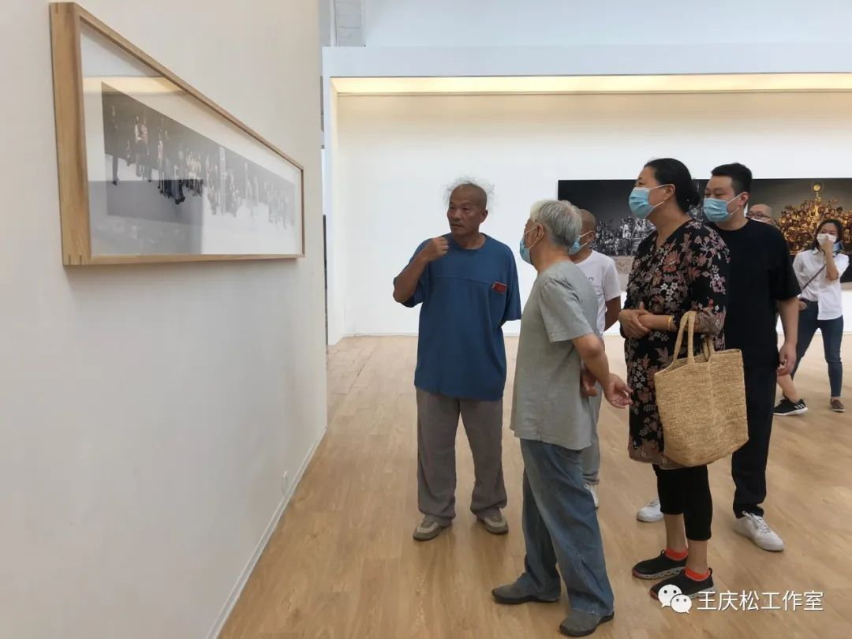
Wang Huangsheng is sketching a portrait Wang Qingsong/Cui Cancan/Liao Wen/Li Xianting
I went back to discuss with the curator, Cancan, telling him that the theme of this exhibition needed to be changed. During this long period of lockdown, each of us has experienced such a complicated and conflicted mood of disturbance. I wondered if we ccould give the audience a sense of hope. Such a hope reminds us of the popular song “On the Field of Hope” that I often listened to after I graduated from my middle school and entered a high school in the 1980s. This song with its lyrics and melody encouraged me in the 1980s when I was a youth.
I remembered the parallels in the lyrics very clearly, “My hometown is on the field of hope; my ideal is on the field of hope; my future is on the field of hope”. These three hopes gave youngsters so much encouragement at that time. In the midst of this pandemic, we all need a tiny bit of hope too, even if it is a hope with some doubt and controversy. Talking with Cancan, he also felt the same. Therefore, we finalized the theme of the exhibition, "On the Field of Hope", which reflects the history awaiting a better future at this abrupt crossroad. Under such hardship, we must ask about where the future holds for us. So it was almost before I shot this work that we determined the title of the exhibition and also that of this work as "On the Field of Hope".
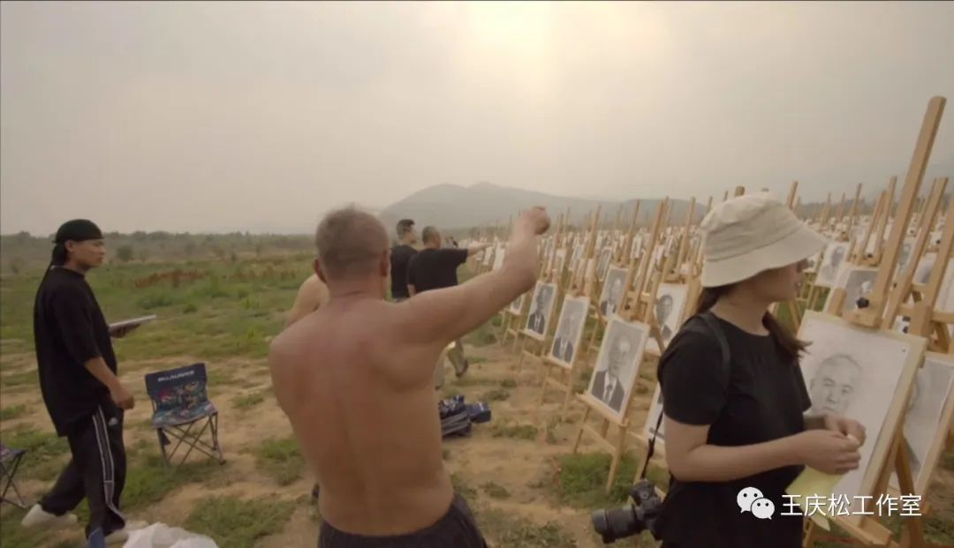
Speaking of the work itself, from the onset of shooting indoors to outdoors, I always wished that 500 people participate in the work. Even if it would be an outdoor shooting, I still hoped that 500 people would stand still in the picture, as it was conceived from the very beginning. But once coming to terms with the reality of shooting outdoors, I found it impossible for people to appear in the composition. On second thoughts, I felt that no one appearing in the photo shoot might have another unexpected effect and achieve a much better impact. Just like what we see in the exhibition now, there are only 500 easels and nearly 500 sketches. None but I appeared in the photograph. The shooting day was again overcast which created a special atmosphere for the work "On the Field of Hope", exactly the kind of feeling I needed.
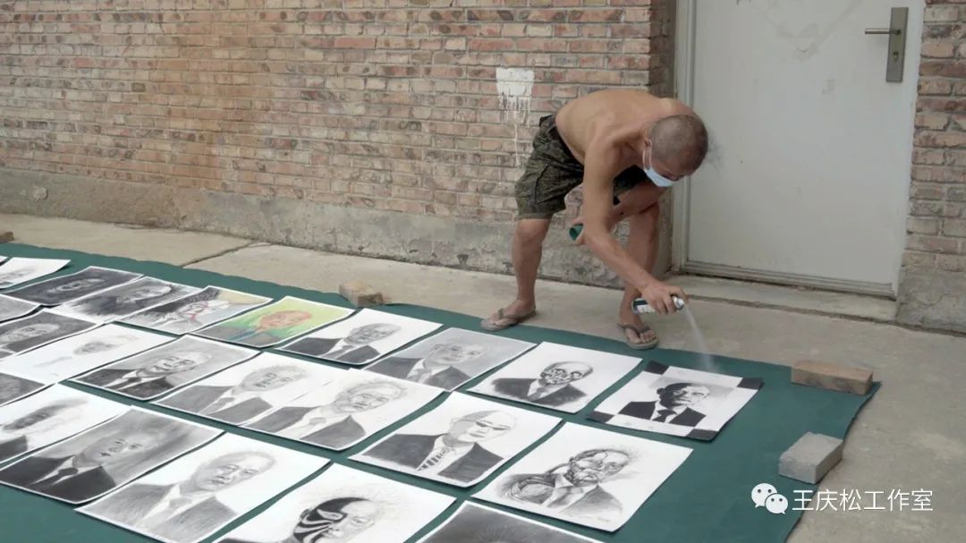 Wang Qingsong is processing the portraits
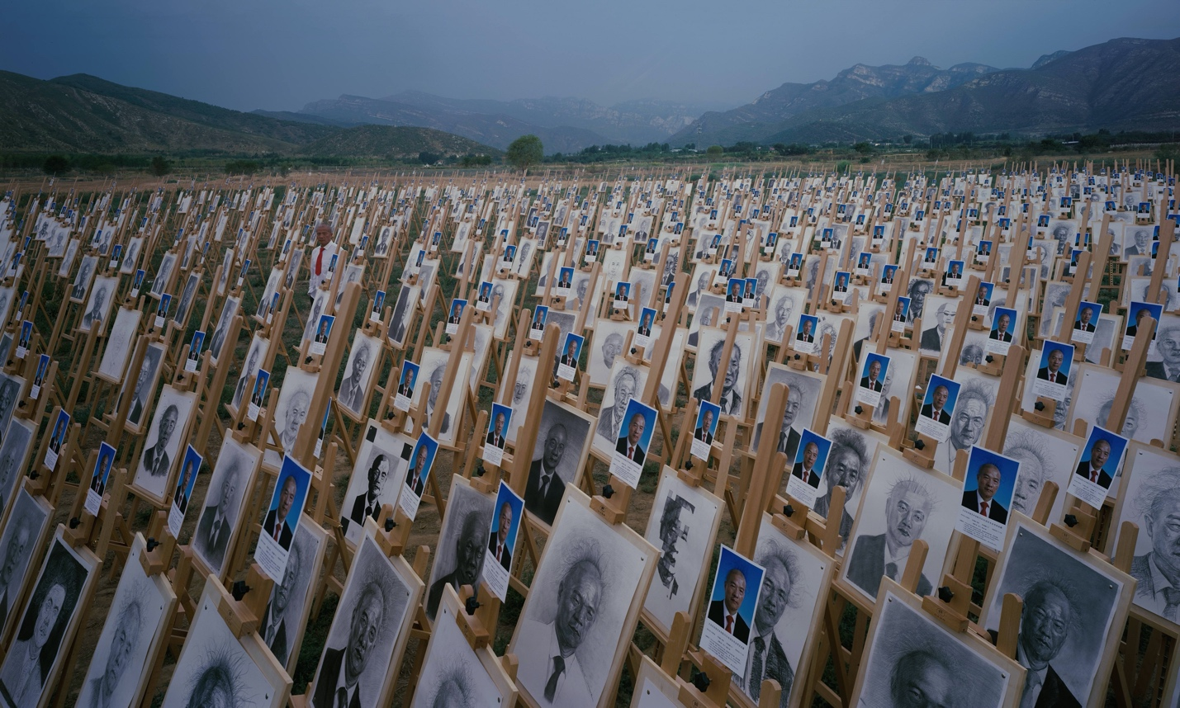On the Field of Hope, 180x300cm, 2020
It would be super difficult to finish the shoot without the help of my friends. During the epidemic, I could only shoot in the mountains on the outskirts of Beijing, more than 100 kilometers away from Beijing. I’d need a lot of people to help set up the easels on the scene. The accommodation, food and drink, and the transportation of people were very cumbersome. Especially Fangshan Township was relatively close to the place where the second wave of epidemic broke out. Only friends, trusting me, not much concerned about coronavirus, would join me as they risk being infected by the virus through working outside with many people.

Chen Weiqun/Wang Qingsong/Liu Haizhou
After three days of hard work, the shoot went smoothly from its onset to completion. Although working outdoors was super hard and many people got sunburned, everyone was as happy as going for an outing. It is worth mentioning that I was so afraid of rain, rain, and rain before and during the shooting. If it rained, all my sketches would be ruined. However, there was no rain at all during these three days. Right after returning to my studio, a sudden downpour overshadowed Beijing for a long time. I thought I was very lucky. At that time, I believed that my exhibition will be opened in good luck.
Of course, I am very grateful to all the friends who helped me complete the shoot so smoothly. In addition to the support from friends helping with the shooting, I also have to thank all the students and teachers, artists/friends who sketched my portraits, especially Xi'an August 1st Art School, Lanzhou Zhengshang Studio, the Attached School to Qinghua Art Academy. Thanks should also be extended to people from 798 street painters, Taobao salespersons, and Weibo fans, which increased the styles of the sketches.
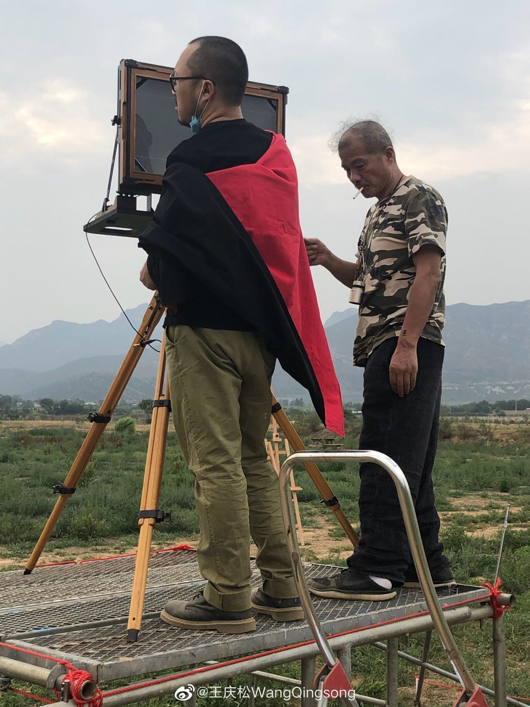 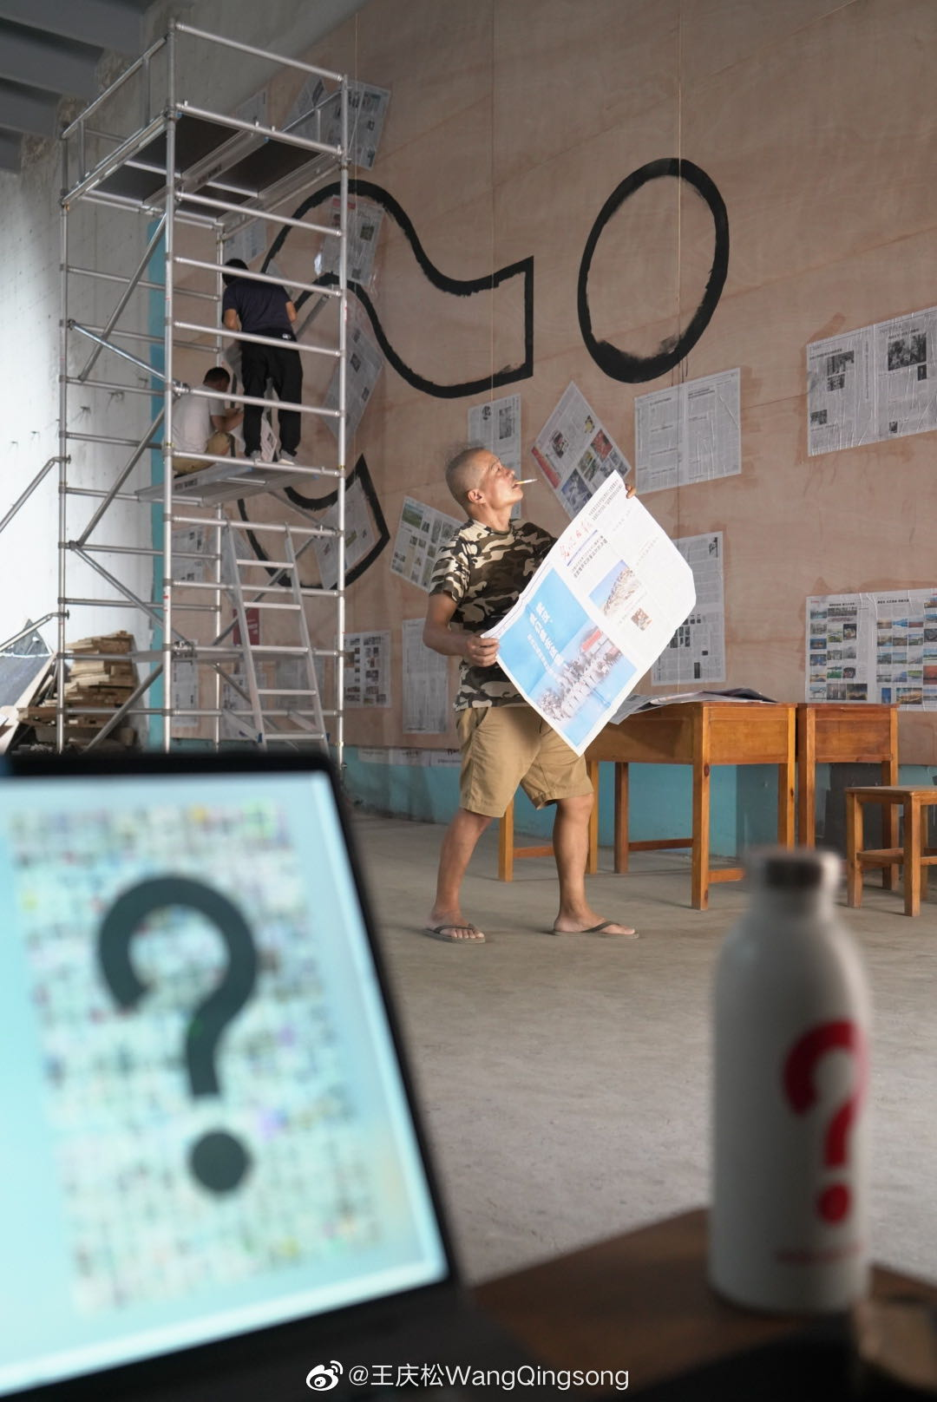Zong Ning and Wang Qingsong Wang Qingsong prepares for “Question a Brick Wall”

After shooting the photowork "On the Field of Hope", the hand-painted project of "Question a Brick Wall" was finished by working around the clock. After completing these two new works, it was June 28th. There were about ten days left before the exhibition opened. The entire process from post-production, printing photo works, and framing/mounting dragged along. In fact, at noontime before the opening day of the exhibition, some of the first framed works were delivered to the gallery and the installation started to be in place. It was not until the second set of works arrived at 6pm later that all the works were successfully placed on the wall. I have to thank for the contribution by all the staff who worked overtime for the framing and installing the show at the two gallery spaces of Tang Contemporary.
The preface of this exhibition was also finalized after communicating the overall exhibition layout with the curator Cui Cancan, which included my art works made from 1999 to 2020. We decided to present the preface in the form of handwritten blackboard written with colored chalks. I invited a great artist friend Lei Tong to hand write the entire preface. The two spaces have two walls, and the writing was so time-consuming. I tried out a little bit of writing but felt so painful on my shoulders hanging there. Therefore, a special gratitude should be given to Lei Tong for his great help in the process of setting up the exhibition prefaces.
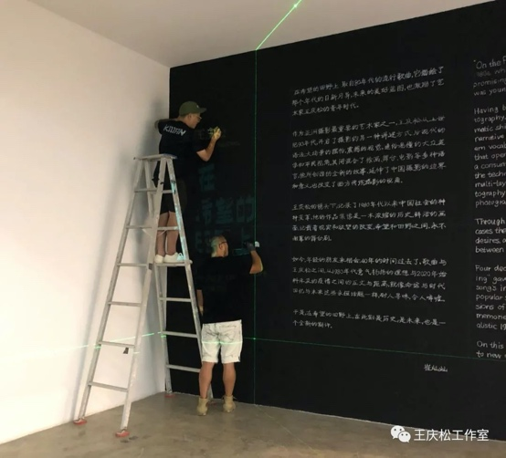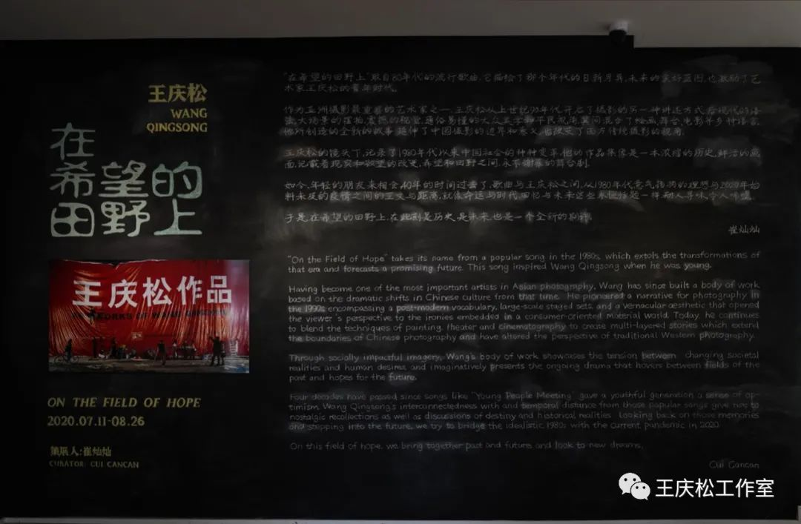
Lei Tong is using chalks to write the preface.

After the exhibition was installed, I had new worries again. Before the second spike of the epidemics, 798 art districts had slowly begun to return to its former bustle. Upon its return, people suddenly became vigilant. During the first few days of setting up the exhibition, I found little traffic in the entire 798 Art District. Less than ten people visited the gallery space a day. Throughout the evening, I was worried about the opening of the next day. Will there be anyone showing up the next day? Will the opening go smoothly? Everything was unknown as I expected a very difficult opening, without reception or a dinner party after the opening. Due to the special situation of the pandemic, I did not send out any personal invitations to my relatives and friends. I just posted a simple message about the exhibition on Weibo and WeChat before the opening.
The next day, I went to the gallery after lunch and waited for the opening in the afternoon. When I arrived at the gallery, I found that all these worries were actually unnecessary. The opening was far better than my imagination. Many friends living in Beijing came to the exhibition one after another. Even some old friends who have not seen each other in the past ten years showed up. Many of them told me that this was the first time they came to 798 to see an exhibition this year. I was very happy for this result, full of thanks for these friends to visit my exhibition during this extraordinary moment. It is my great honor. This was an opening ceremony of an unusual exhibition, the one without an opening ceremony, without food and drinks during the reception. However, it was the most memorable opening for me during the epidemic. The only regret is that my children could not come back to see my solo exhibition as they were stuck overseas.
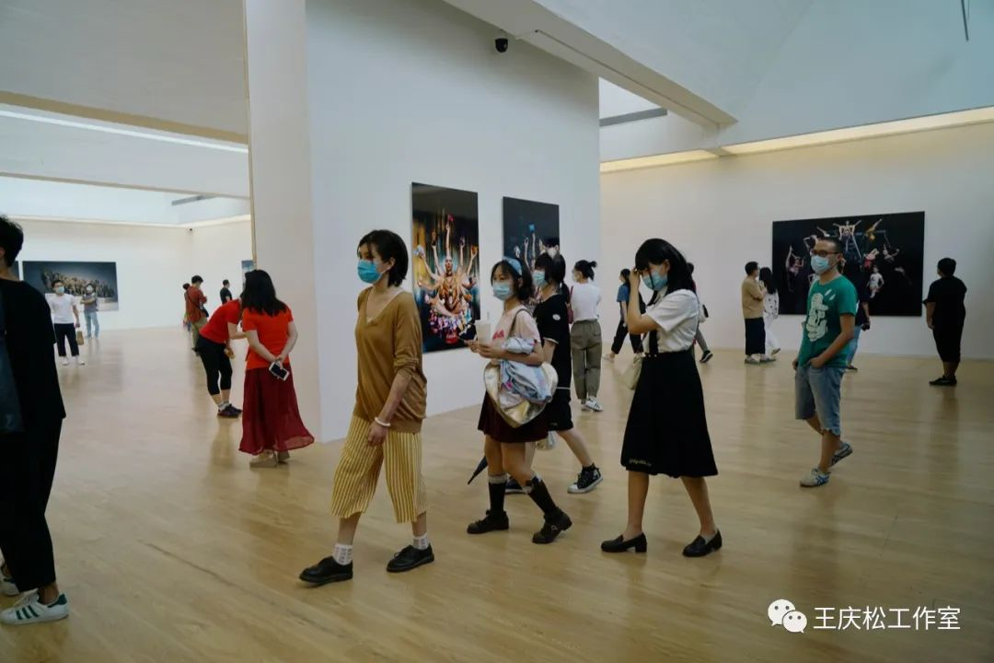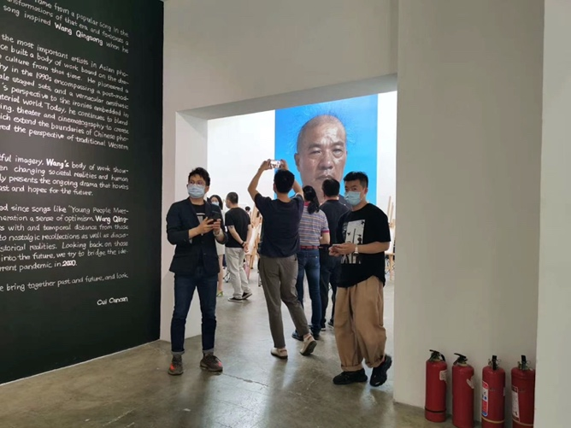
It has been ten days since the opening of the exhibition. During this period, friends come to see the exhibition constantly. Of course, I will occasionally introduce this exhibition to my friends. The exhibition "On the Field of Hope" has also attracted a lot of attention and report by some media. I am also very grateful to these media interviews and reports, as well as the spread of news by my friends on Weibo and WeChat. I personally posted the exhibition information on Weibo, which received a lot of attention and reposts from fans. After ten days, the number of readings of the exhibition information on Weibo has exceeded 500,000. It is beyond my expectation to be able to receive such immense attention. Thank all my fans for their long-term support. Thanks again to all the friends who helped this exhibition. My sincere appreciation goes to a lot of people.
What is gratifying is that two days ago, Beijing officially announced that the emergency response has been reduced from level two to level three. Nationwide, cinemas have officially opened up again. Just like the theme of this exhibition "On the Field of Hope", I think our future is still full of hopes. I myself still hold dear hopes for the future.
Finally, I would like to thank Cui Cancan, curator of this exhibition, "On the Field of Hope". He is also a great neighbor.
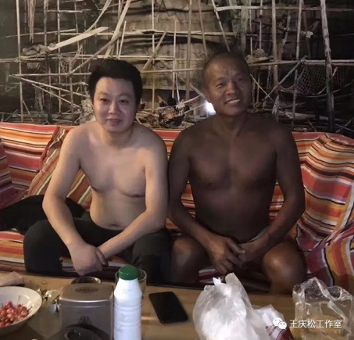  Logo of Wang Qingsong Studio

