**Higher Diploma in Software Engineering (IT114105)**

**ITE3006 Information Technology Essentials – EA**

|  |  |  |  |  |  |
| --- | --- | --- | --- | --- | --- |
| **Name:** | **POON Ngai Kuen** | **StudentID:** | **180091780** | **Class:** | **SE-1D** |

# Website Theme

The theme of this assignment is Chinese Fiction that is recommended to read.

All fiction information refers to 起點中文網 (<https://www.qidian.com/>)

# Webpage capture (1024 x 760)

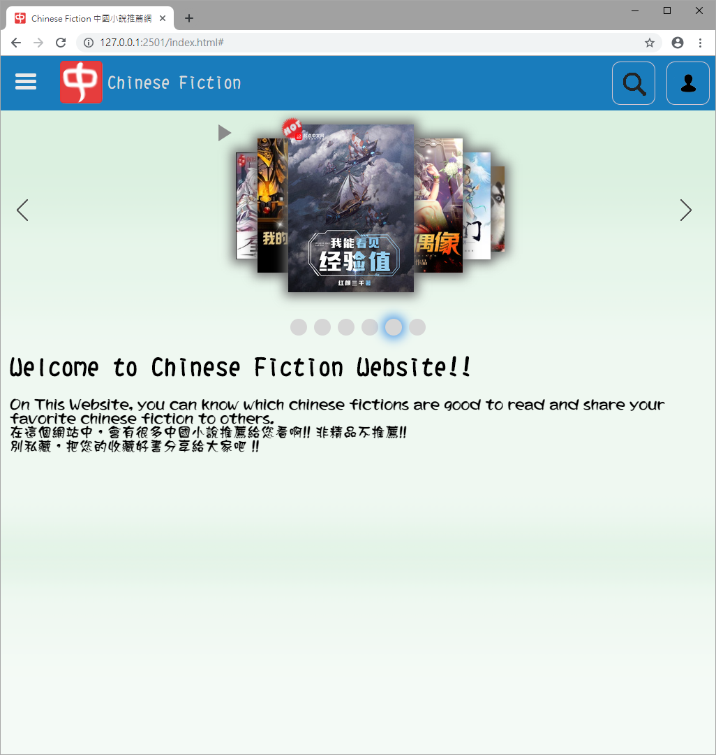

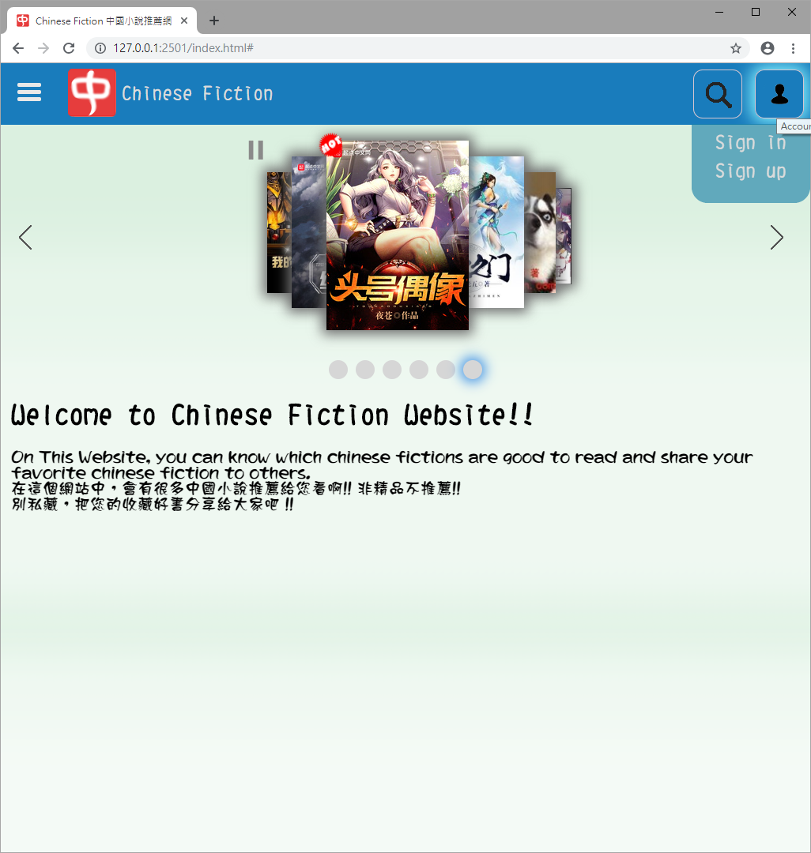

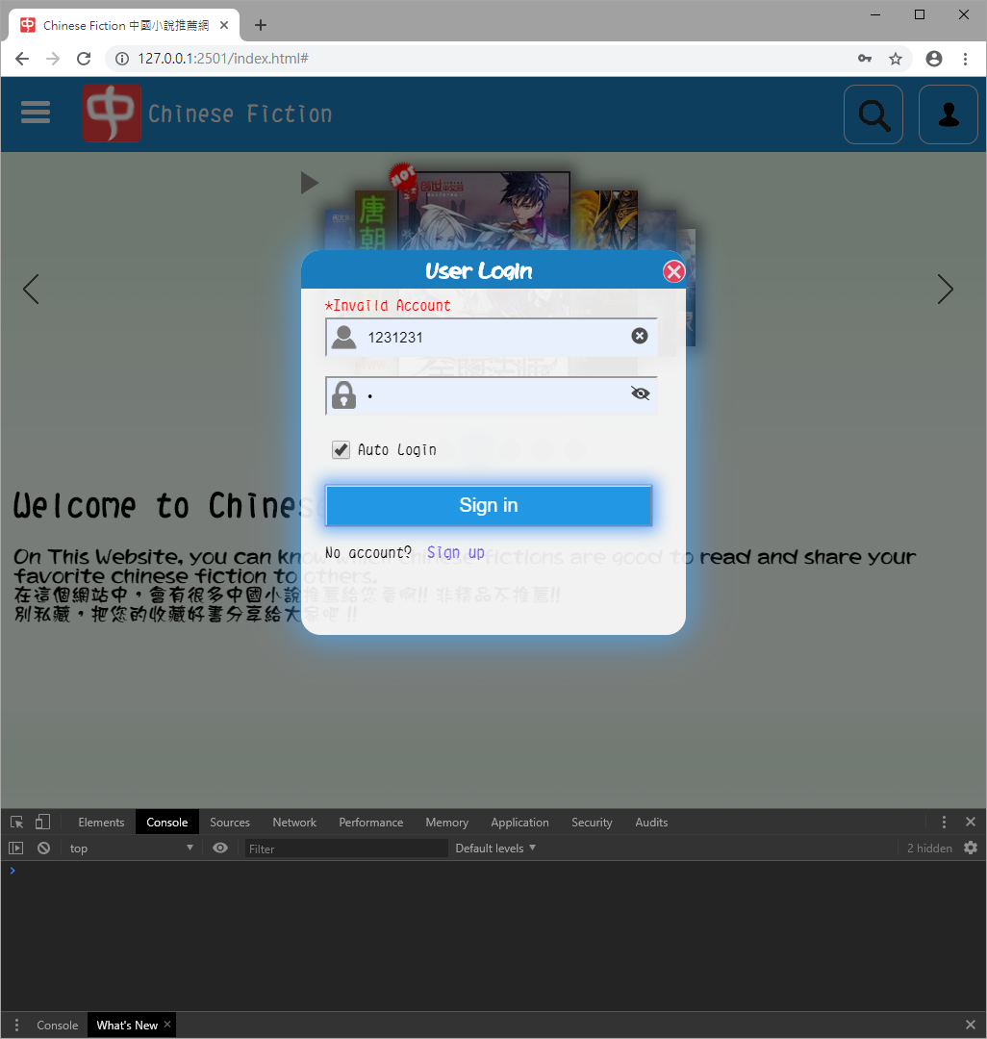

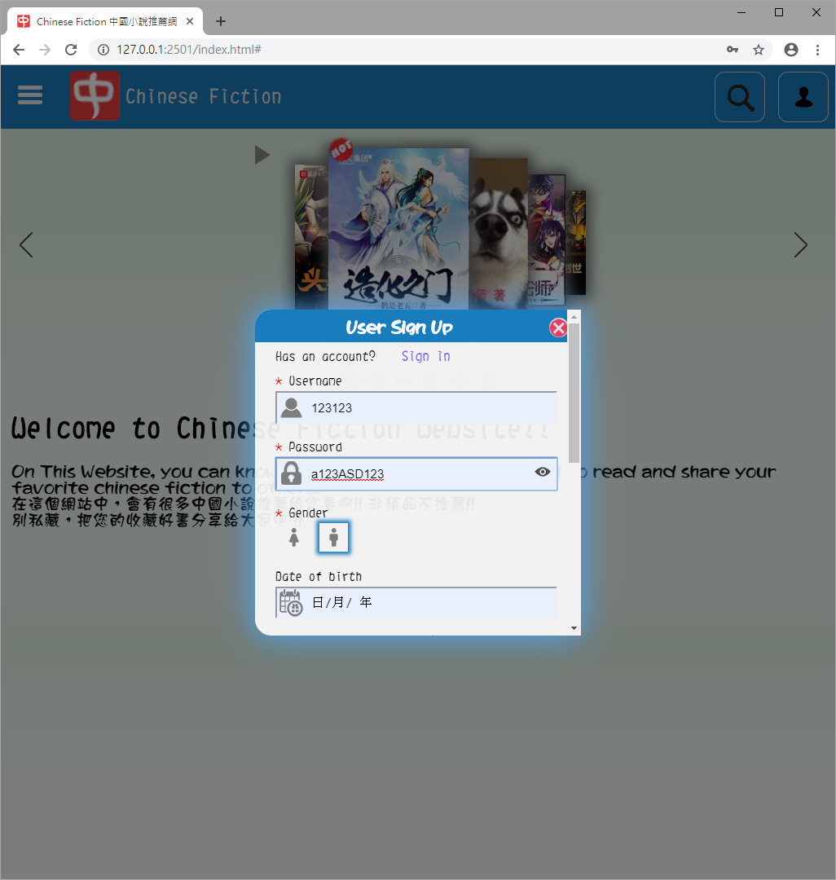

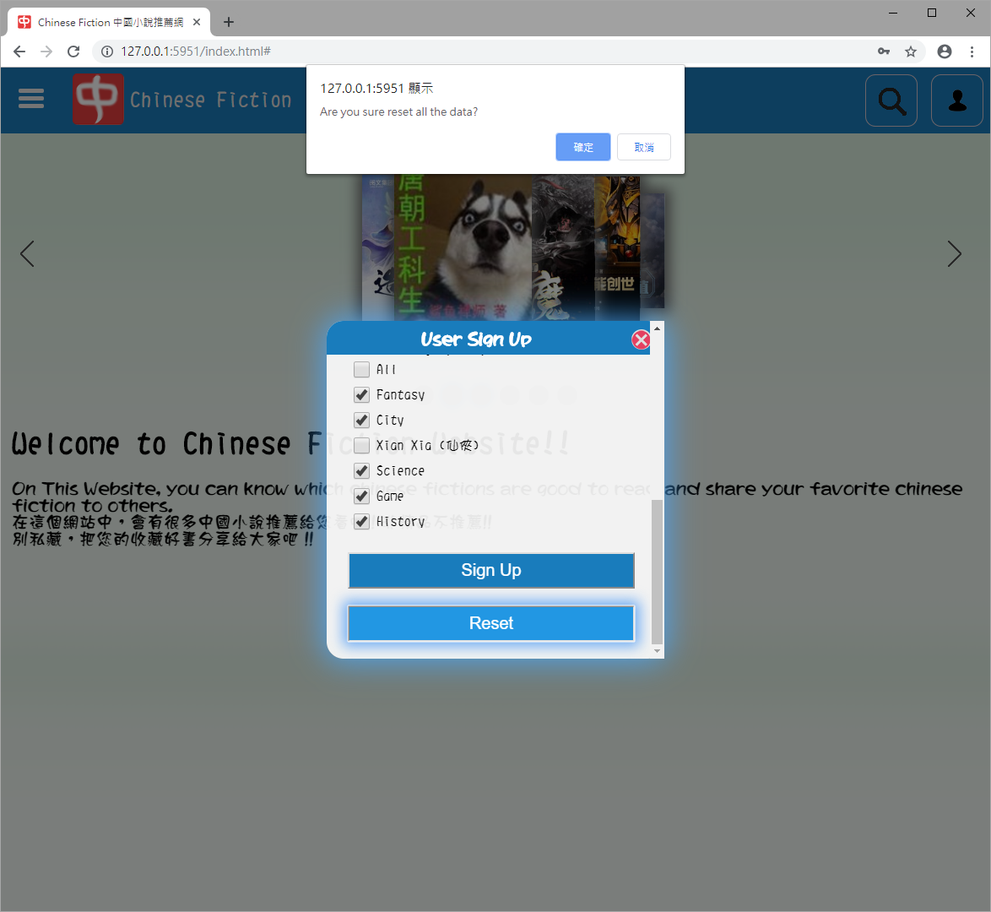

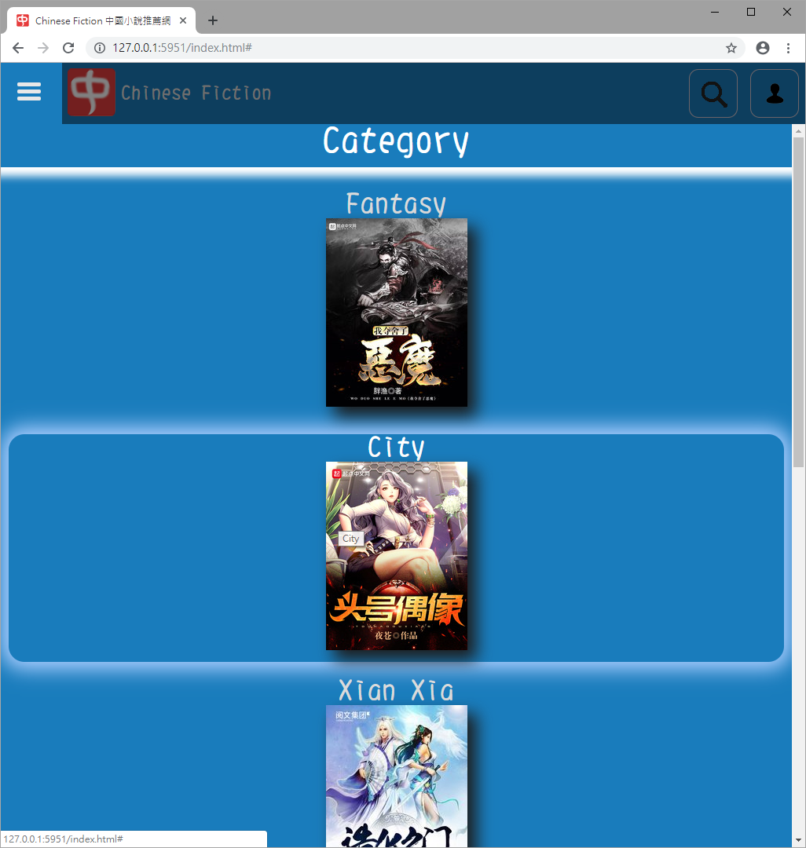

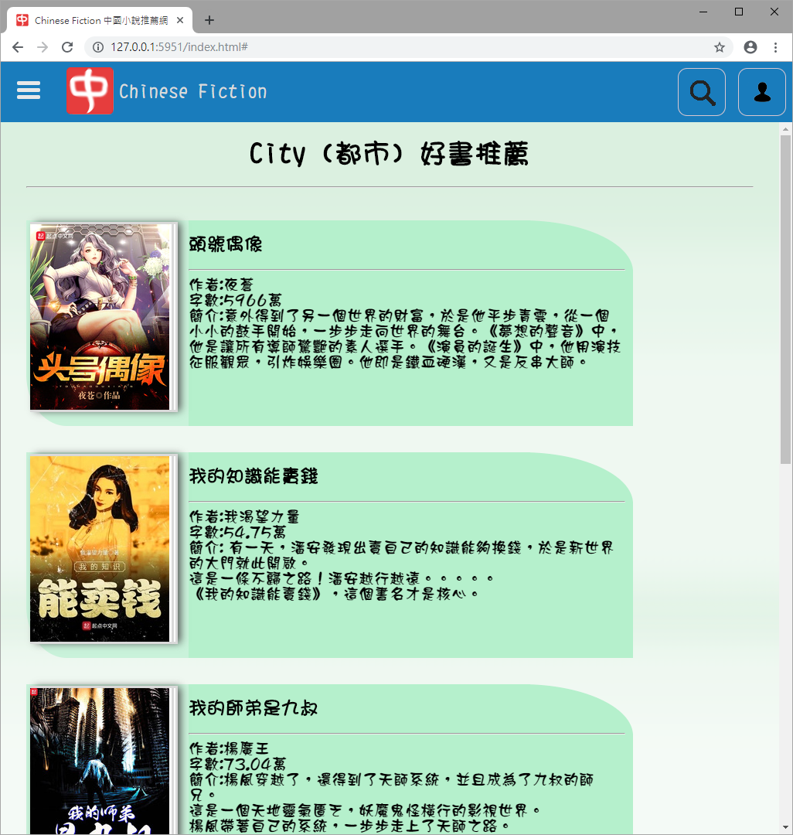

# Webpage capture (1280 x 760)

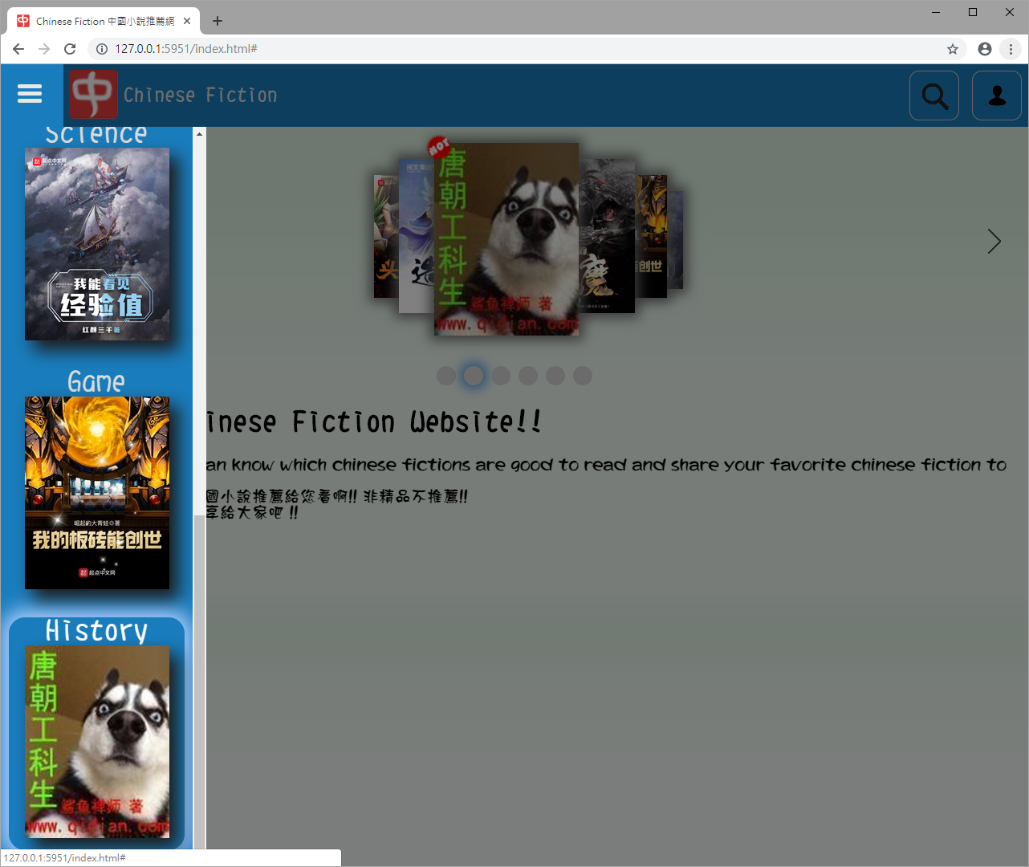

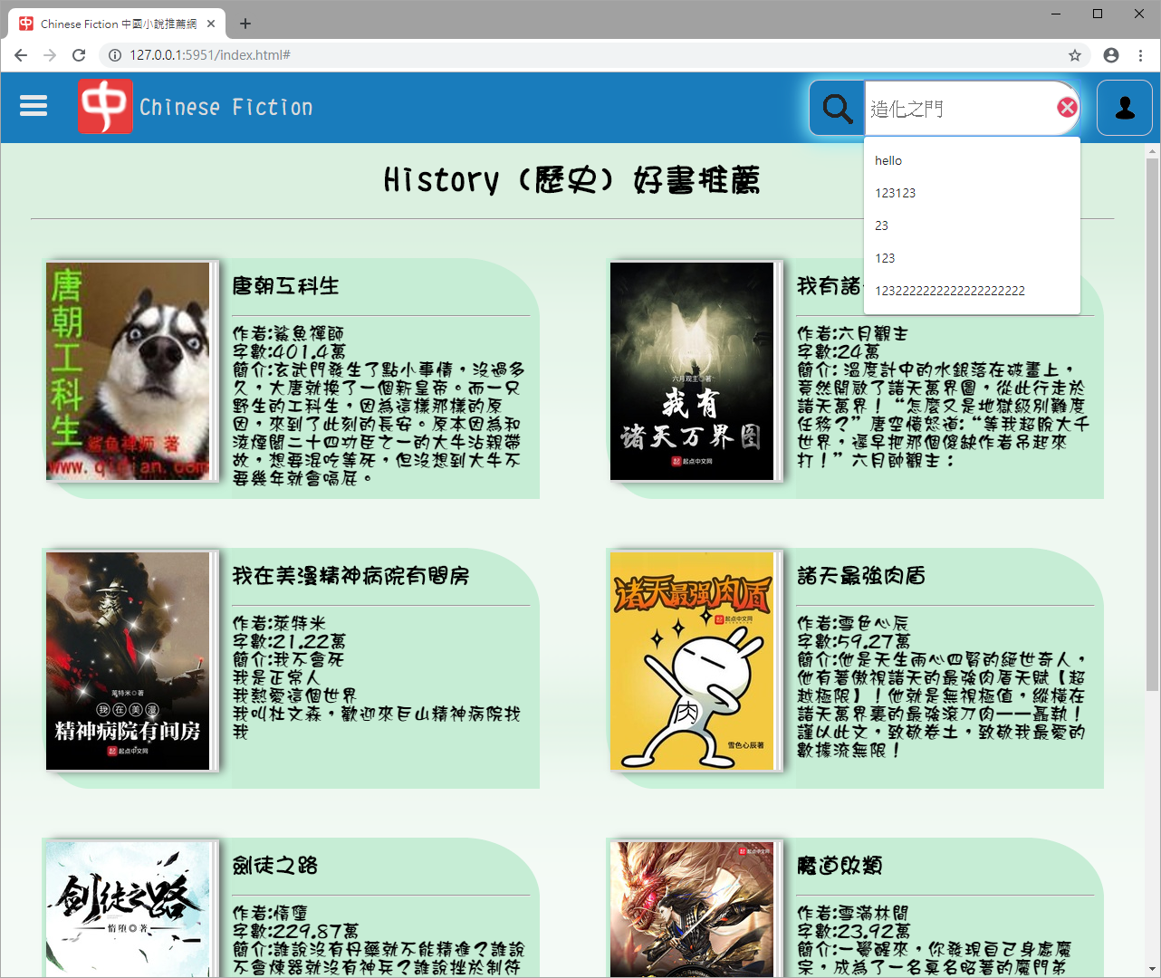

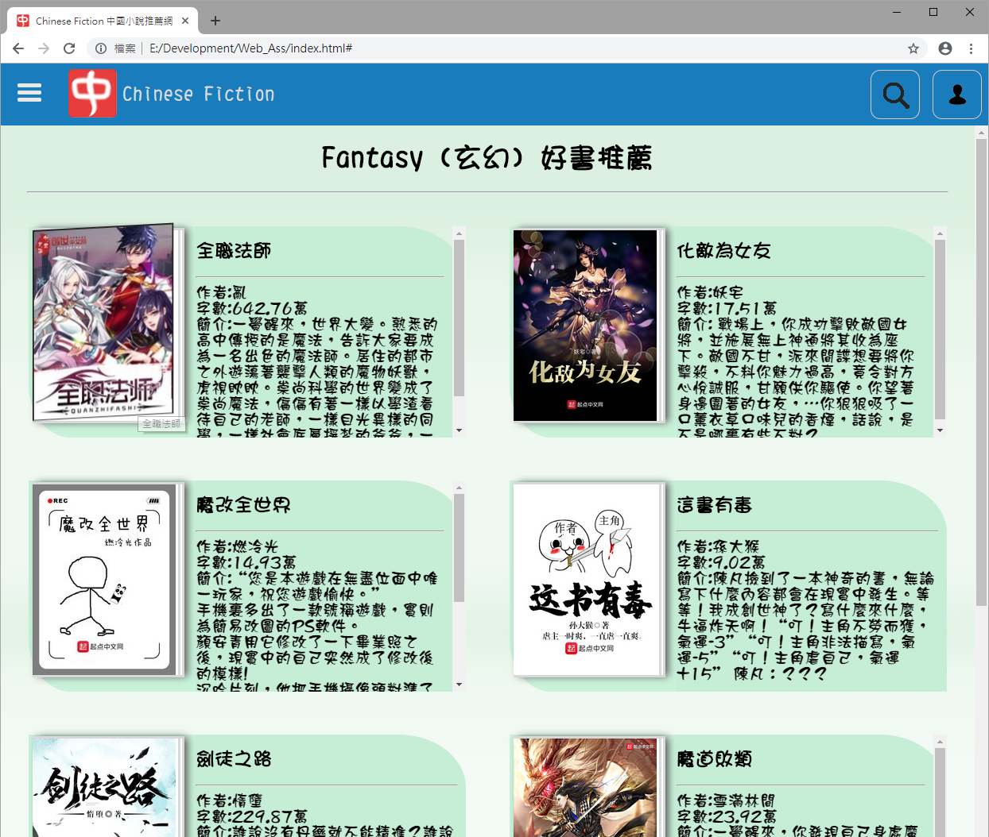

# Icon Reference

<https://material.io/tools/icons/?icon=contact_support&style=outline>