Hong Kong Institute of Vocational Education Department of Information and Communications Technology

HD in Software Engineering

Enterprise Systems Development (ITP4511) - Report

Poon Ngai Kuen (180091780)

Wan Tung Ling (180374534)

|  |  |  |
| --- | --- | --- |
| Work break down | POON Ngai Kuen | Wan Tung Ling |
|  | 50% | 50% |

# Assumption

1. The use will input the data correctly.

# User Requirements

Functional requirements

Teacher

Mark attendance (Roll call)

Edit/View the attendance record

Generate attendance sheet of each class (reduce inaccuracy)

Schedule (Setup class data/edit school day schedule/view schedule)

Student

View his/her attendance record (<60% failed)

View class schedule

IT administrator

Manage account

Non-functional requirements

Accuracy of the records

Operational:

The system will be a web-based system that run on any web browser.

~~Show statistic in graphical format~~

~~Show top search keywords~~

~~Export the attendance report to excel file~~

Performance:

The reports will be generated in real-time.

Security

# System Requirements

Class Management Functions

* Setup class data
* Schedule school day

Attendance Functions

* Show class schedule
* Record attendance for students per class
* Edit/view attendance history
* Generate attendance sheet for each class

Analytic and Report Functions

* Calculate/Count the attendance rate automatically (for each student by class)
* Generate real-time statistic reports
* Generate Report for attendance rate < 60%
* Generate Report for class schedule

Account Management

* Create different account/user
* Register student according to class
* Modify account information

# Site Map

# System Structure (MVC Model)

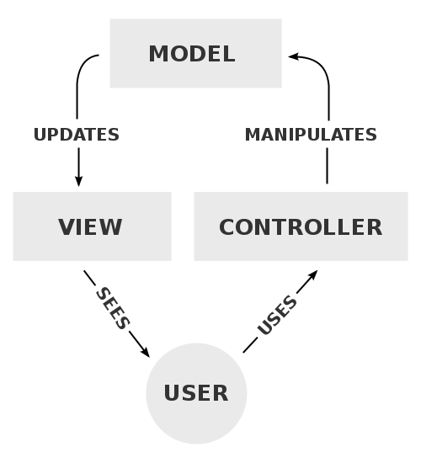

To implementing MVC, the first step is define beans to represent the data. Next use a servlet to handle requests and populate the beans. Then the servlet calls setAttribute on the request, session, or servlet context objects to store a reference to the beans that represent the results of the request. After that use the forwardMethod of RequestDispatcher to transfer control to the page. Finally, extract the data from the beans.

1. Controller: LoginController, RollCallController, AttendanceController
2. Bean: User, Teacher, Student, Course, Classes, Attendance
3. JSP

The system includes servlet(controller), bean and jsp.

Regarding Controller, the servlet serves as controller to handles initial request and process the data, for example the LoginController handle the login request, populate the user bean and then forward to the welcome.jsp.

Regarding Model, Java Bean class serves as a model to interact between the view and jsp. For instance, the user bean is populated to store the information of the user for interaction.

Regarding View, JSP pages are used for presentation. The populated bean and other data are displayed in the jsp.

# Database Structure

1. The **attendance** table is used for saving the student attendance of each course that they have enrolled.
2. The c**lass** table is used for saving the student enrolled course.
3. The **course** table is used for
4. The **teach_class** table is used for saving which courses are taught by the teacher.
5. The **user** table is used for saving information of user account that will be used for login the system.
6. The **student** table is used for saving information of students.
7. The **teacher** table is used for saving information of teacher.

# Characteristics of the System

## User friendly design

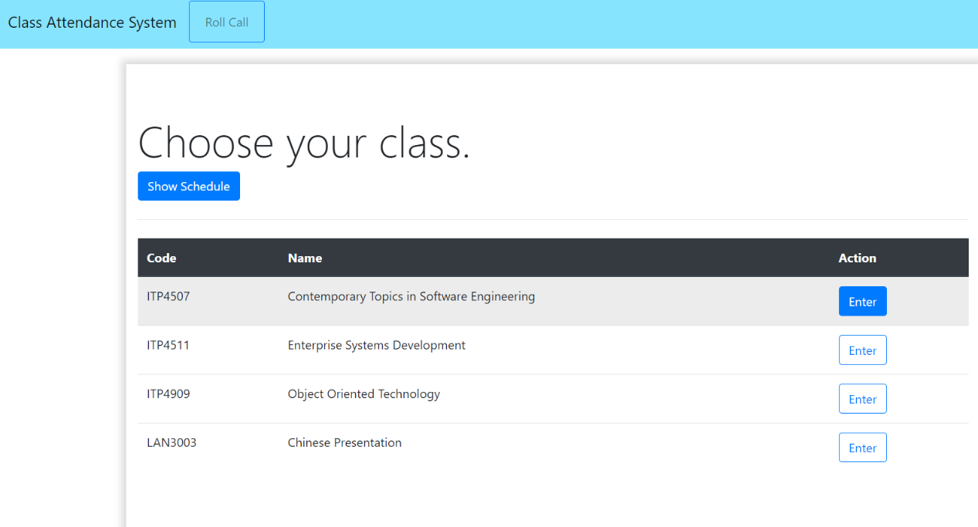

The navigation bar is on the top of the website, it allows users changing pages more easily. Also, the color of the button will be changed when the mouse is on it. Moreover, there are some tables for showing the data, it can help users viewing information more clearly.

# Conclusion

All in all, the system can help teachers take a roll call of their class and they can view and edit the history of the attendance of students in their class. For the students, they can view their attendance of each course. For the IT administrators, they can manage the user of the system and arrange the course for the teacher to teach.

# Skills requirements

## ✓Use JSP/servlets to dynamically generate HTML pages

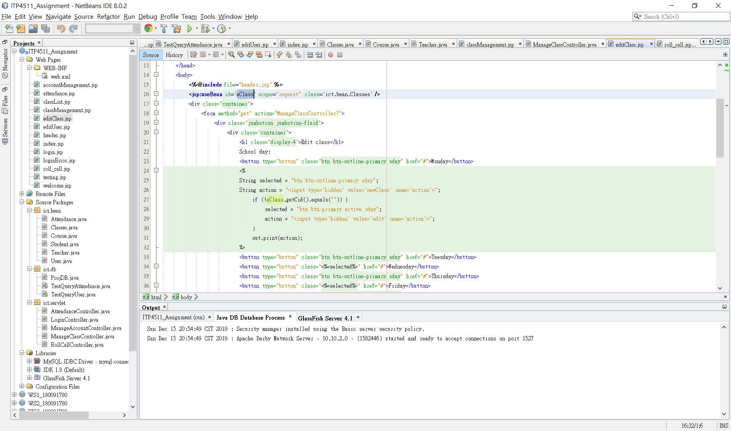

<jse:useBean> is used for dynamically generate HTML pages

## ✓Use JSP/servlets to accept user inputs from browser

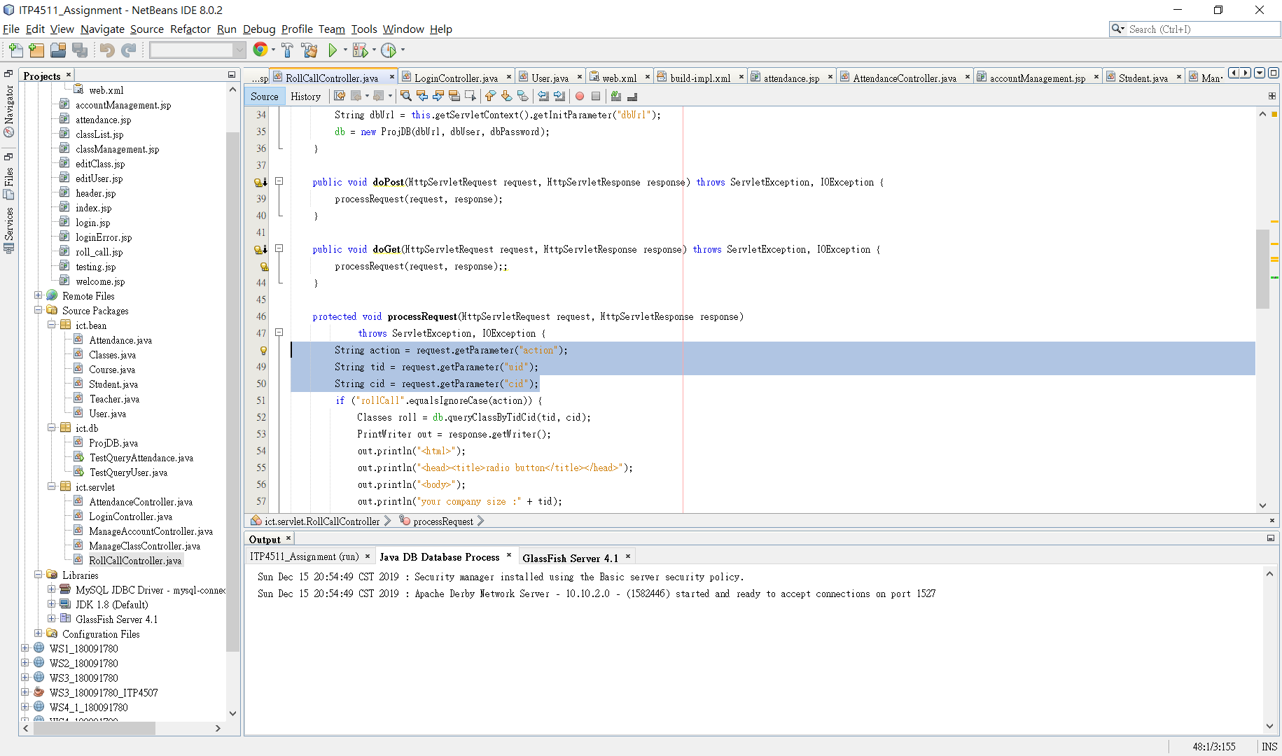

The controller servlets are used to receive the inputs from browser.

## ✓Use JSP Action

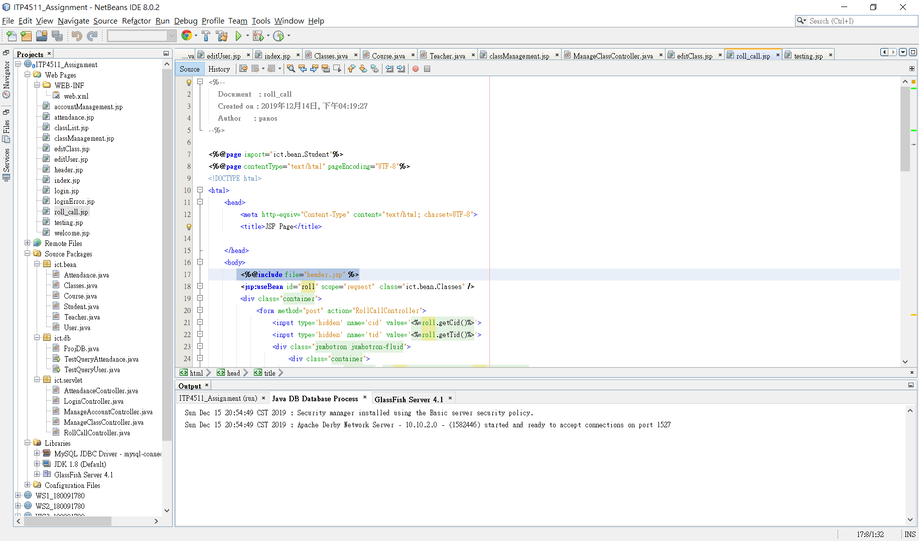

<% @include file %>The header(navigation bar) is included by all of jsp webpages.

## ✓Use JavaBean

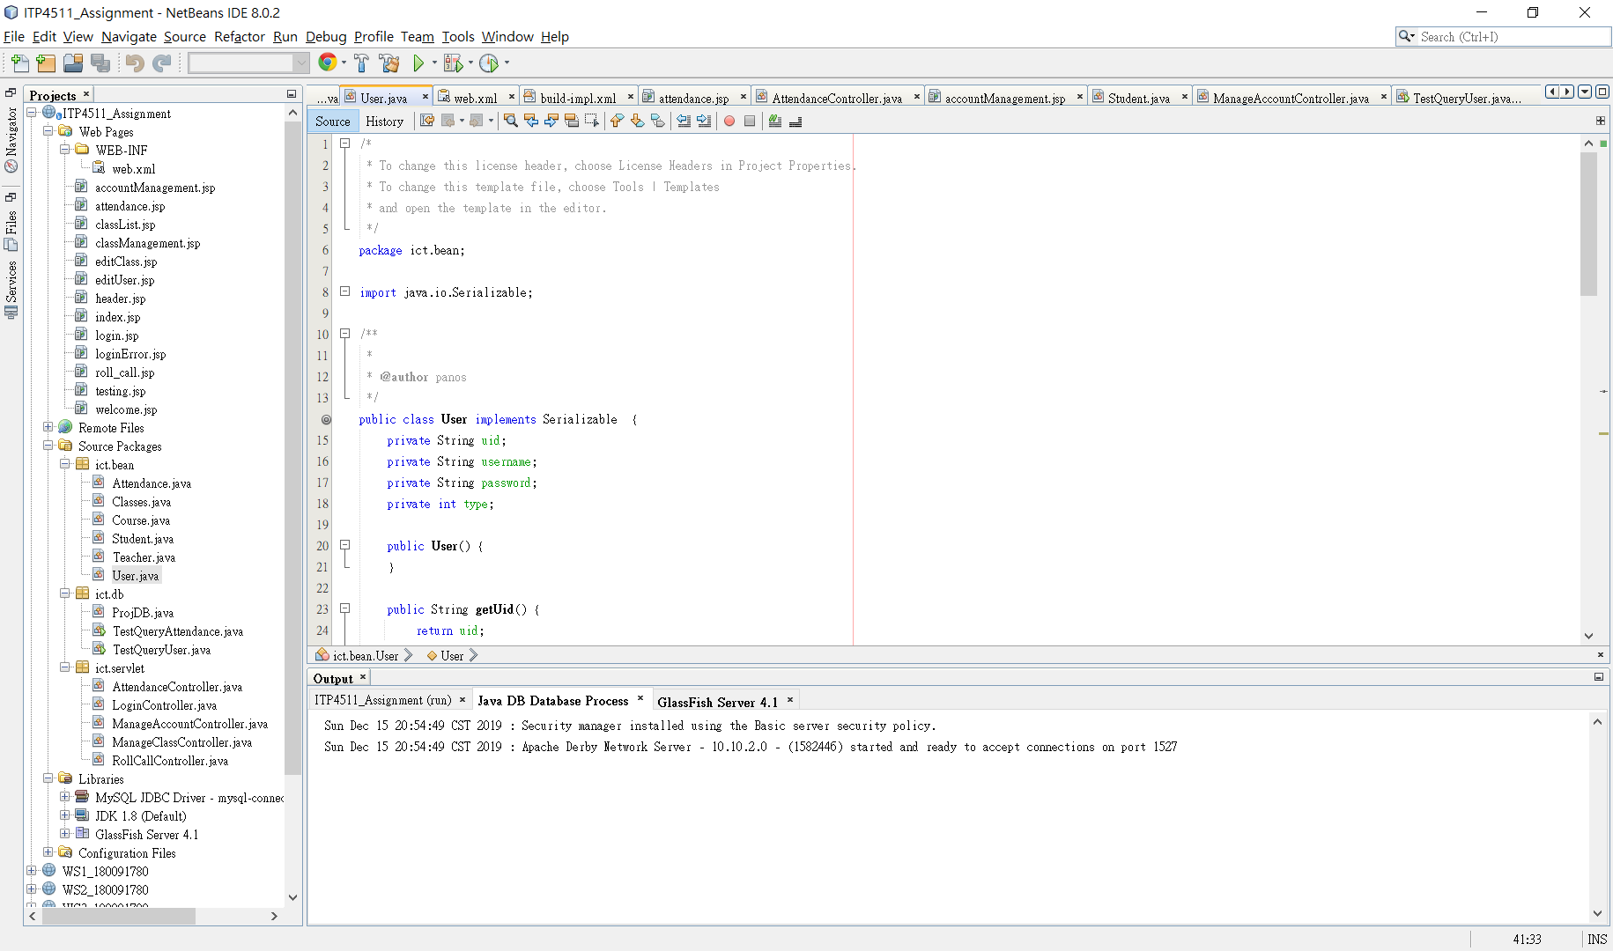

## ✓Use JDBC for database connection

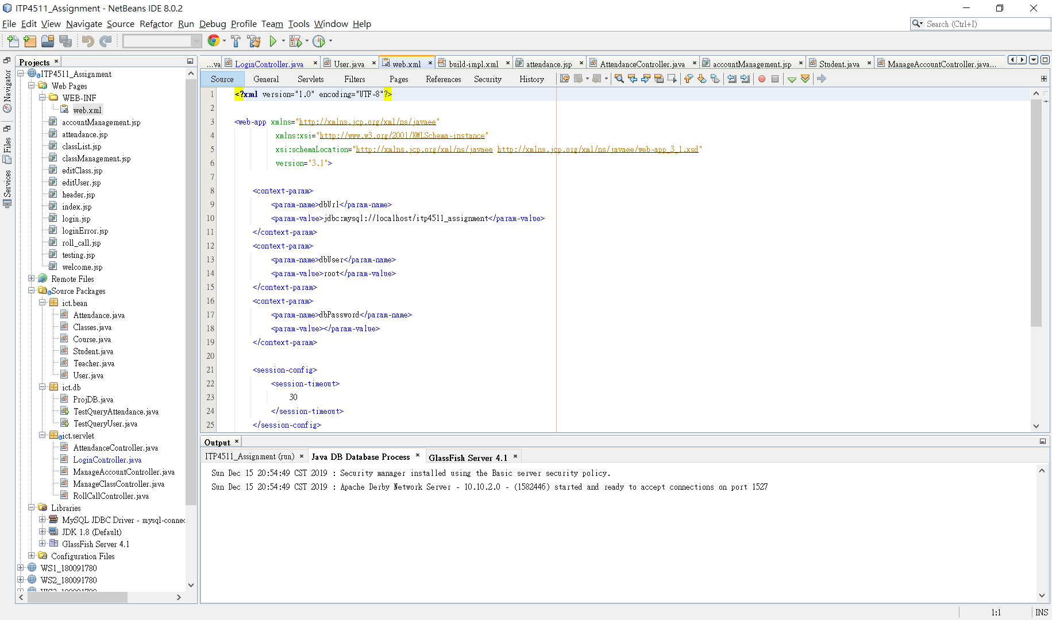

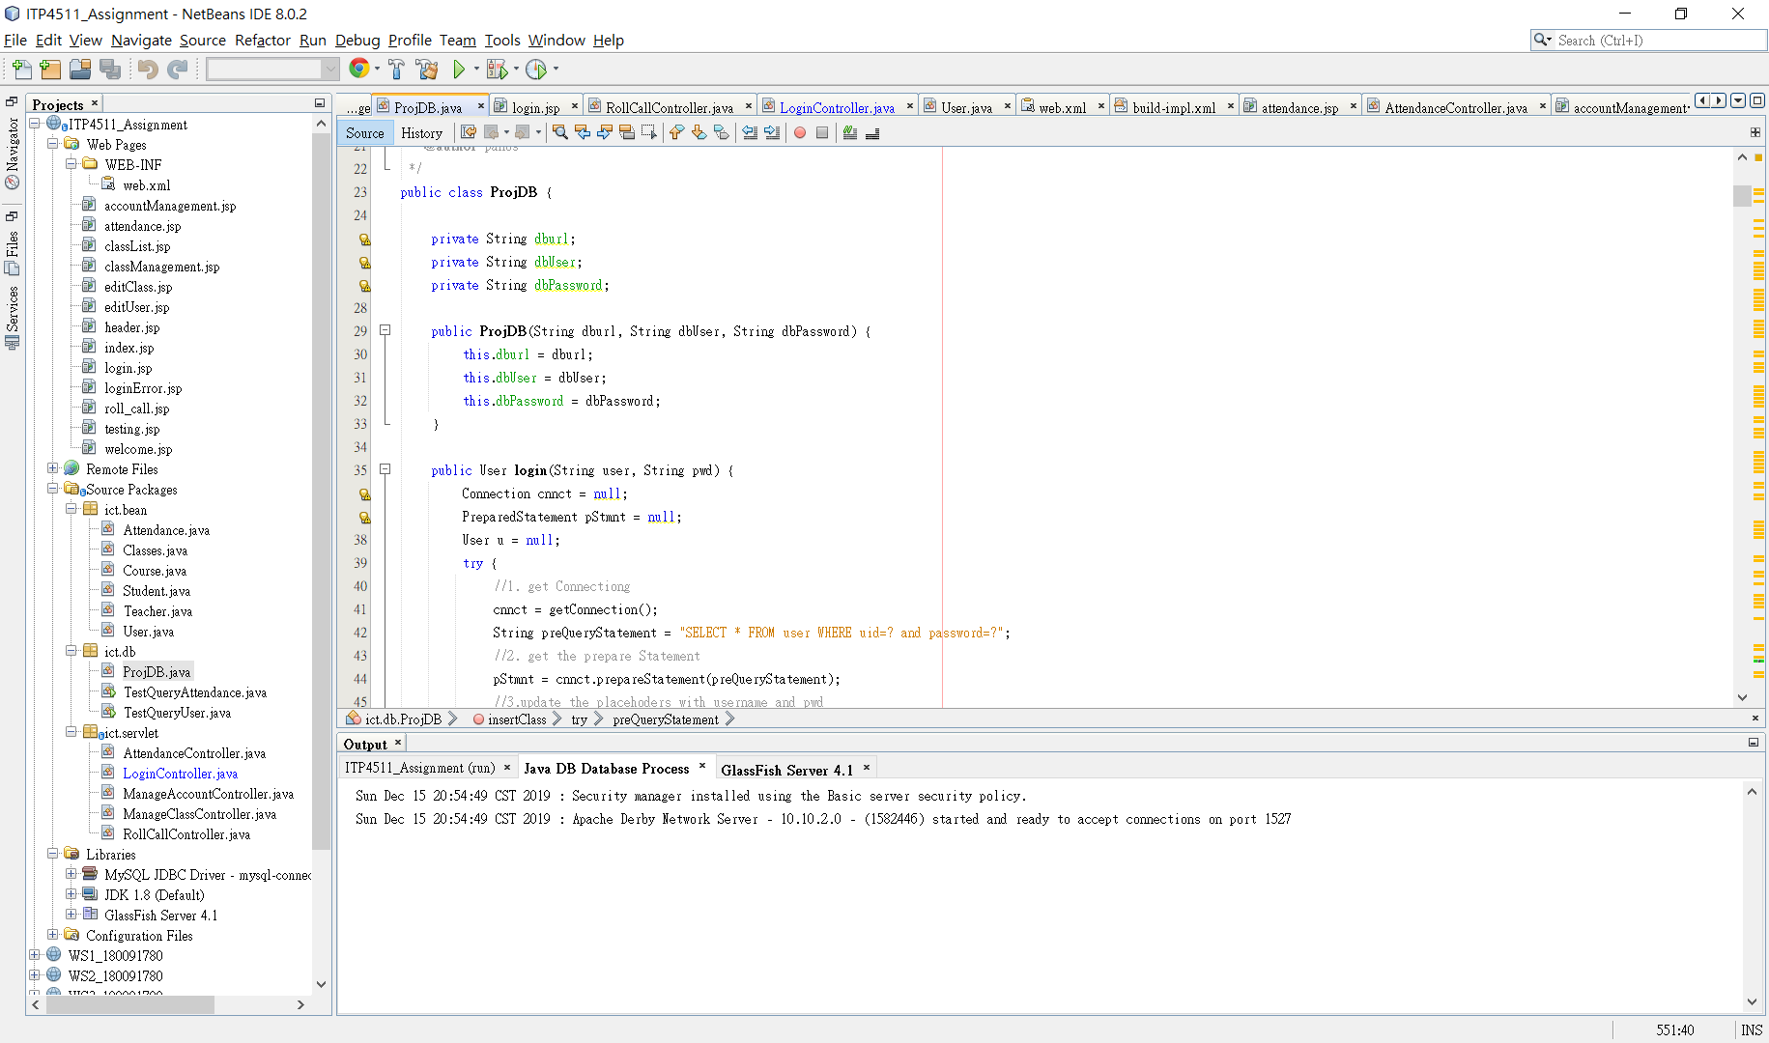

The data will be stored to the mysql by using JDBC.

## ✓Use session checking

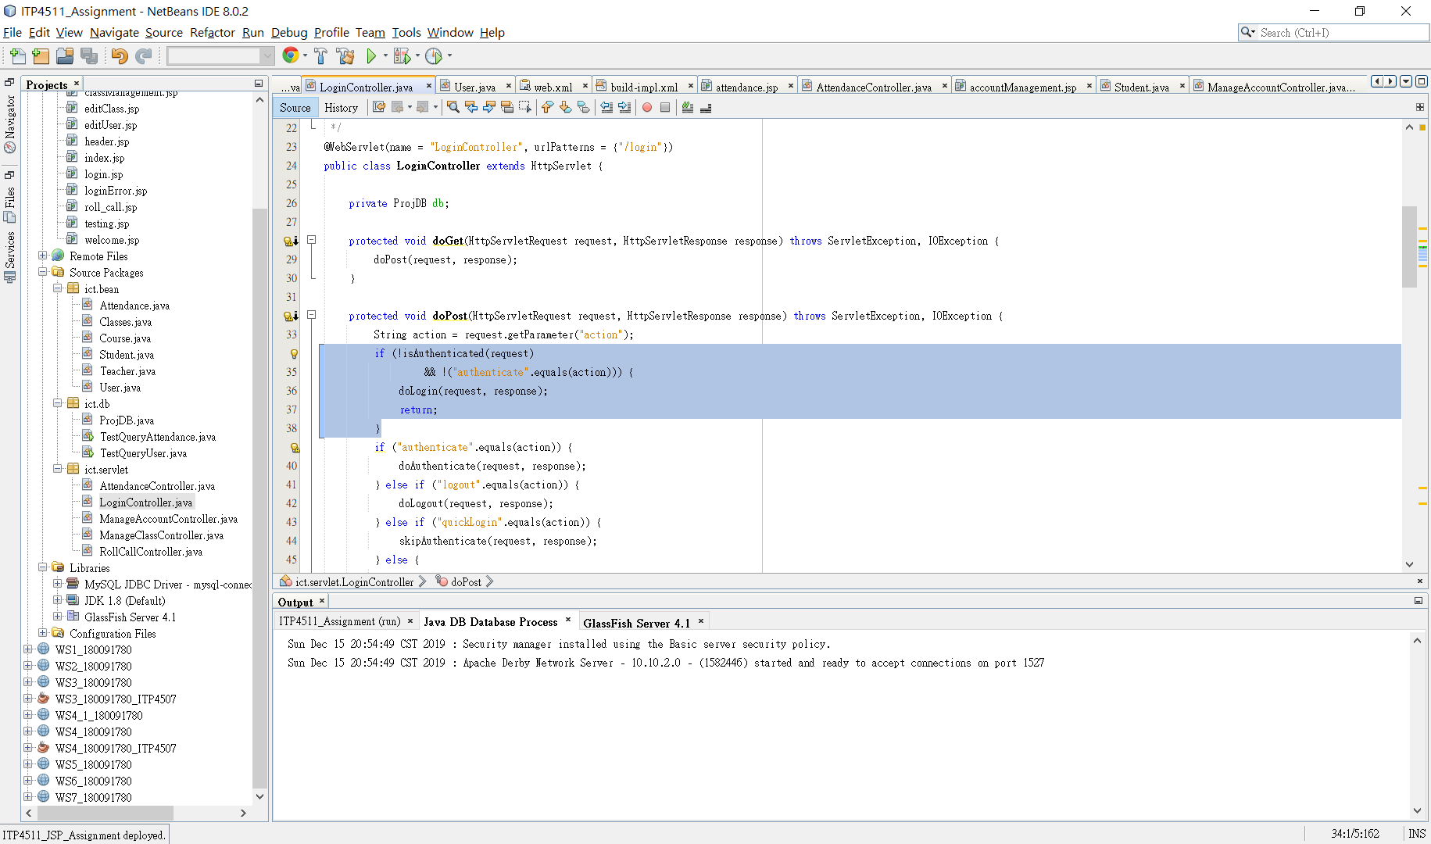

The login will be saved to the session, when the user closes the page but he/she does not close the browser, the login will be done automatically.

## ✓Use login control

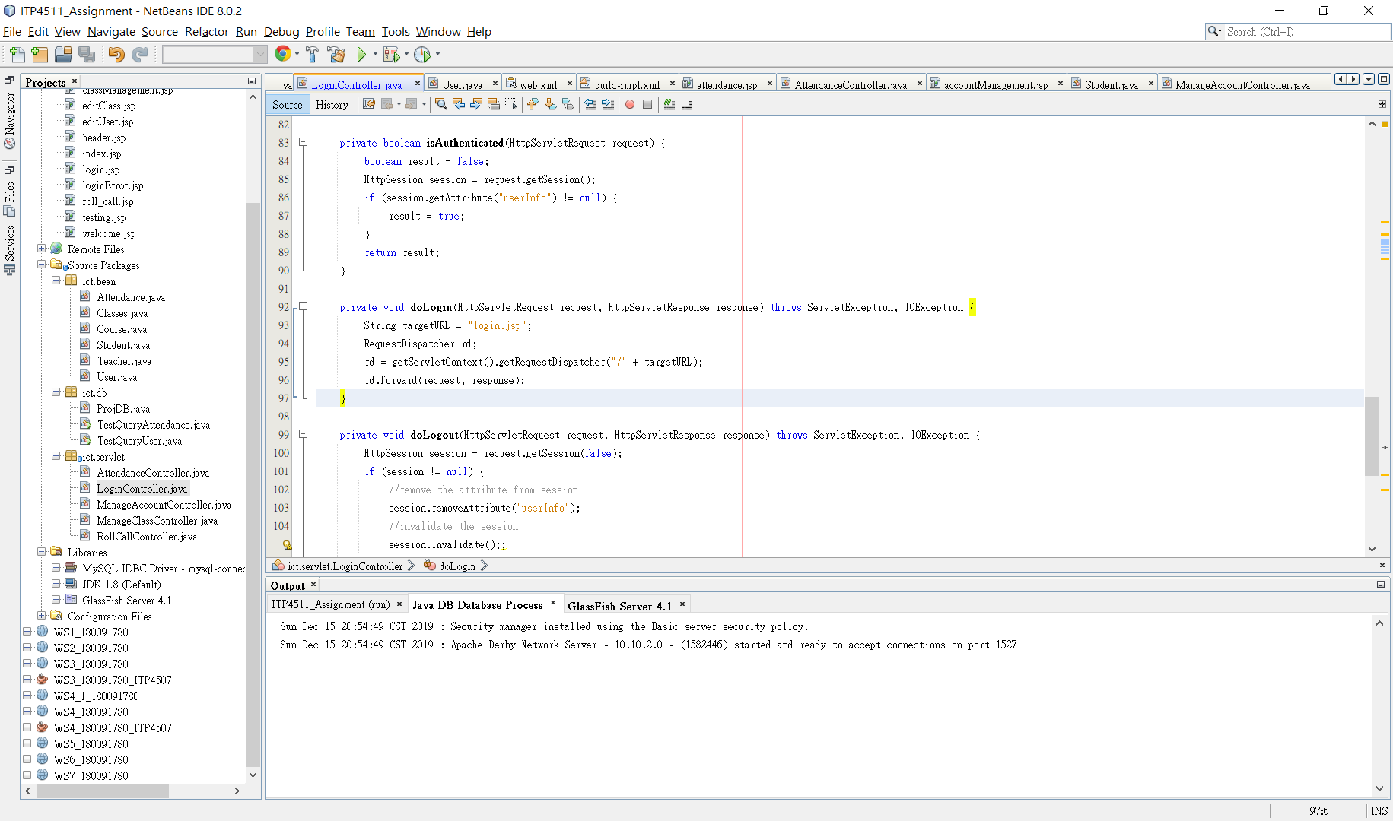

The login control is used for login.

## ✓Apply MVC model

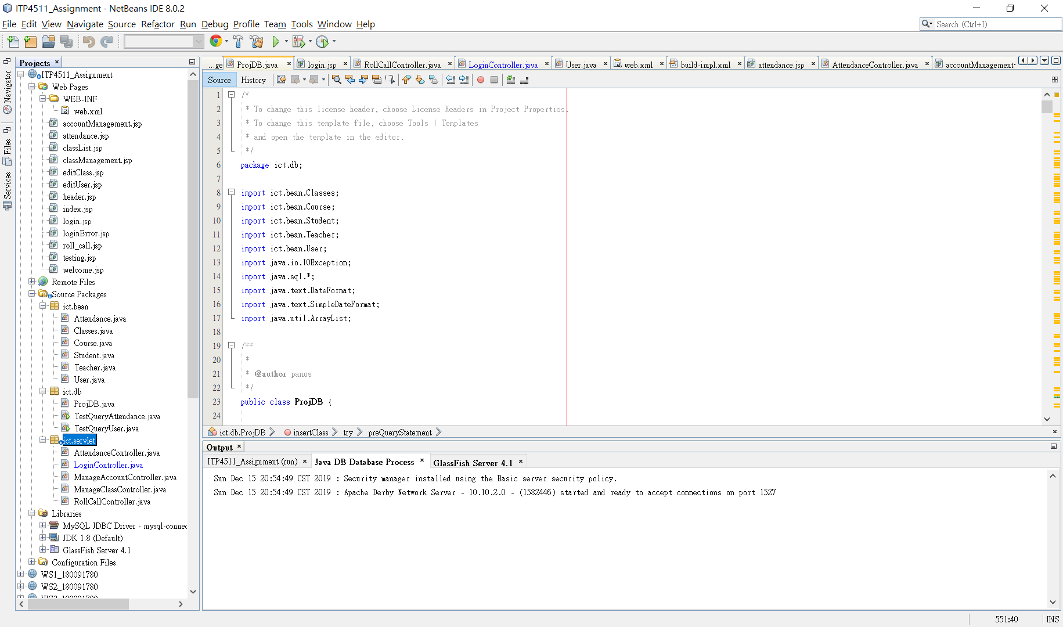

Users will send the request to the controller, and the controller will call the ict.bean or ict.db to get the data. Finally, the data will be sent back to the user, and display to the jsp page by using the function **forward** of **RequestDispatcher**.