**Higher Diploma in Software Engineering (IT114105)**

**ITP4909 Object-Oriented Technology Assignment**

|  |  |  |  |  |  |
| --- | --- | --- | --- | --- | --- |
| **Name:** | **POON Ngai Kuen** | **StudentID:** | **180091780** | **Class:** | **SE-1D** |

# Identify Actors

Public Passenger (Primary Actor)

Public Volunteer Driver (Primary Actor)

Registered Volunteer Driver (Primary Actor)

Registered Passenger (Primary Actor)

GPS (Primary Actor)

Google Map API (Secondary Actor)

# Identify use cases

Register Passenger Account

Register Driver Account

Book Car

Cancel Order

View Order History

Give Rating

Give Comment

Complete Book Order

Secure HCS service

Monitor HCS service

# Initial Use Case Diagram

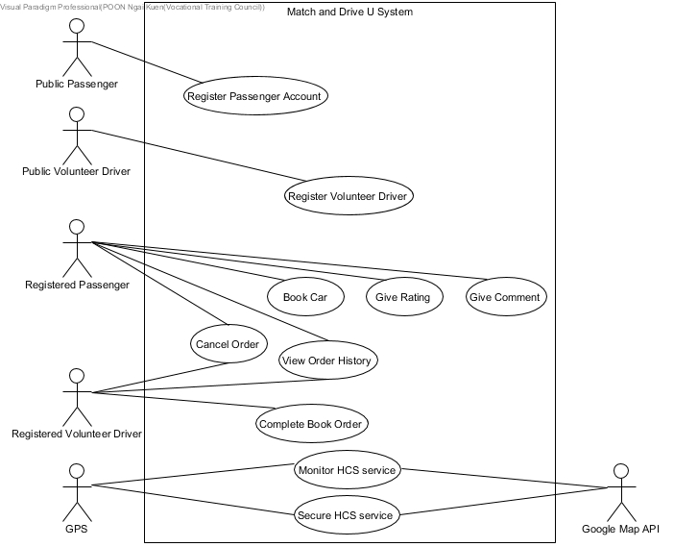

# Actor Description

|  |  |
| --- | --- |
| **Actor specification** | |
| **Actor name**: | Public Passenger (P) |
| **Description:** | A passenger, who is an elderly or disabled person, wants to get free transport and he/she does not have a passenger account on the MnDU system. |

|  |  |
| --- | --- |
| **Actor specification** | |
| **Actor name**: | Public Volunteer Driver (P) |
| **Description:** | A driver, who wants to use his/her car to help people to go to the destination without charging and he/she does not have a driver account on the MnDU system. |

|  |  |
| --- | --- |
| **Actor specification** | |
| **Actor name**: | Registered Volunteer Driver (P) |
| **Description:** | The driver, who uses his/her car transports a passenger to the destination without charging, has a volunteer driver account and he/she can use HCS to receive the book car order. |

|  |  |
| --- | --- |
| **Actor specification** | |
| **Actor name**: | Registered Passenger (P) |
| **Description:** | The passenger, who is an elderly or disabled person, wants to book a car for getting free transport and he/she has a passenger account on the MnDU |

|  |  |
| --- | --- |
| **Actor specification** | |
| **Actor name**: | GPS (P) |
| **Description:** | GPS is an object that helps to secure and monitor the HCS service. |

|  |  |
| --- | --- |
| **Actor specification** | |
| **Actor name**: | Google Map API (S) |
| **Description:** | It is another system function; it can locate the volunteer drivers when the drivers start a book order. |

|  |  |
| --- | --- |
| **Actor specification** | |
| **Actor name**: | User |
| **Description:** | A user is a passenger or volunteer driver who has an account of the MnDU system. |

# Use case Description

|  |  |
| --- | --- |
| **Use Case:** | Register Passenger Account |
| **Use Case ID:** | UC-100 |
| **Actor:** | Public Passenger |
| **Description:** | A public passenger must register a passenger account before using the functions of MnDU. |

|  |  |
| --- | --- |
| **Use Case:** | Register Driver Account |
| **Use Case ID:** | UC-200 |
| **Actor:** | Public Volunteer Driver |
| **Description:** | A public driver must register a driver account before using the functions of MnDU. |

|  |  |
| --- | --- |
| **Use Case:** | Login |
| **Use Case ID:** | UC-300 |
| **Actor:** | Registered Passenger, Registered Volunteer Driver |
| **Description:** | When a registered passenger or a registered volunteer driver wants to use the functions of MnDU, they must log in first. |

|  |  |
| --- | --- |
| **Use Case:** | Book Car |
| **Use Case ID:** | UC-400 |
| **Actor:** | Registered Passenger |
| **Description:** | A registered passenger can use the MnDU system to book a car. The volunteer driver will receive the book order, and then he/she will drive the passenger to the destination where the passenger wants to go. |

|  |  |
| --- | --- |
| **Use Case:** | Cancel Order |
| **Use Case ID:** | UC-500 |
| **Actor:** | Registered Passenger, Registered Volunteer Driver |
| **Description:** | Both of Registered passenger and registered volunteer driver can cancel their order if the passenger has not got on the car. |

|  |  |
| --- | --- |
| **Use Case:** | View Order History |
| **Use Case ID:** | UC-600 |
| **Actor:** | Registered Passenger, Registered Volunteer Driver |
| **Description:** | Both of Registered passenger and registered volunteer driver can view the book order history. The passenger views order call cars (book cars) history whereas the driver views completed orders history. |

|  |  |
| --- | --- |
| **Use Case:** | Give Rating |
| **Use Case ID:** | UC-700 |
| **Actor:** | Registered Passenger |
| **Description:** | When the registered passenger is driven to the destination by the volunteer driver, he/she can give a rating to the driver. |

|  |  |
| --- | --- |
| **Use Case:** | Give Comment |
| **Use Case ID:** | UC-800 |
| **Actor:** | Registered Passenger |
| **Description:** | When the registered passenger gives a rating to the driver, he/she can leave a comment to the driver (optional). |

|  |  |
| --- | --- |
| **Use Case:** | Complete Book Order |
| **Use Case ID:** | UC-900 |
| **Actor:** | Registered Volunteer Driver |
| **Description:** | When a registered volunteer driver wants to use his/her car to help people who book a car on the MnDU system, he/she can receive a book order through the system and complete the order. |

|  |  |
| --- | --- |
| **Use Case:** | Secure HCS service |
| **Use Case ID:** | UC-1000 |
| **Primary Actor:** | Organization |
| **Secondary Actor:** | Google Map API |
| **Description:** | The GPS uses the MnDU system to secure the HCS service. |

|  |  |
| --- | --- |
| **Use Case:** | Monitor HCS service |
| **Use Case ID:** | UC-1100 |
| **Primary Actor:** | Organization |
| **Secondary Actor:** | Google Map API |
| **Description:** | GPS uses the MnDU system to monitor the HCS service. |

# Base Use Case Descriptions

|  |  |
| --- | --- |
| **Use Case:** | Book car |
| **Use Case ID:** | UC-400 |
| **Primary actor:** | Registered Passenger |
| **Secondary actor(s):** | n/a |
| **Brief description:** | A registered passenger can use the MnDU system to book a car. The volunteer driver will receive the book order, and then he/she will drive the passenger to the destination where the passenger wants to go. |
| **Preconditions:** | The passenger has a valid passenger account. |
| **Flow of events** | 1. The passenger logs in the system. 2. The system requests the passenger to enter his/her username and password. 3. The passenger enters username and password. 4. The system displays a successful login message. 5. The passenger chooses ‘Book Car.’ 6. The system requests the passenger to enter necessary information about booking a car. 7. The passenger enters the necessary information. 8. The system searches for volunteer drivers. 9. The system gets a list of available drivers from volunteer drivers. 10. The system displays the list. 11. The passenger selects a driver from the list. 12. The system creates outstanding book order. 13. The system sends the order information to the driver. 14. The system changes the status of the car. 15. The system displays the order information to the passenger. |
| **Postconditions:** | The volunteer drive knows how to go to the destination. |
| **Alternative flows and exceptions:** | * In step 3, if the passenger forgets the password, it occurs an exception. * In step 7, if the passenger cannot fill in all the necessary information to the system, it occurs an exception. * In step 9, if the system cannot find the drive (no available drive at the moment), it occurs an exception. |
| **Non-behavior requirements:** | The volunteer driver can receive the book order in 5 minutes when a passenger places the order. |

# Refine Use Case Diagram

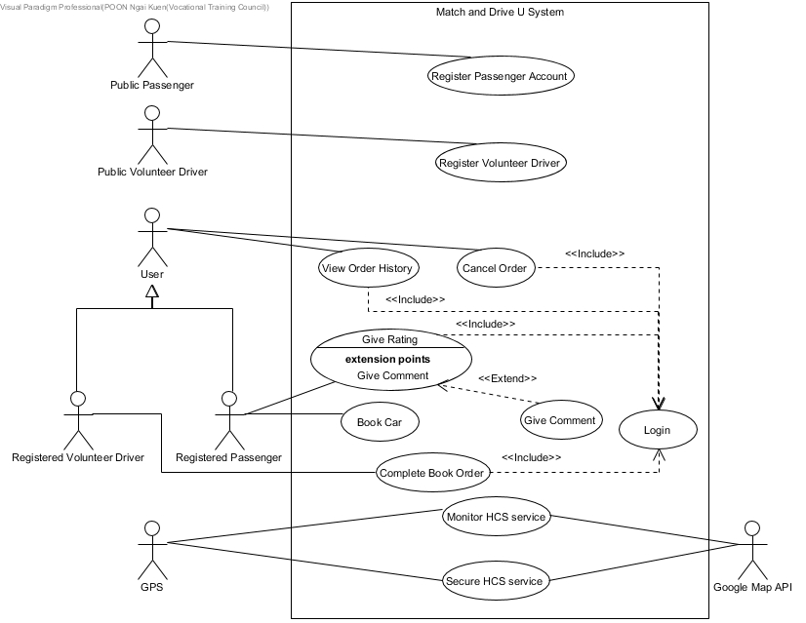

# Identify Candidate Classes and State the Nature

**Candidate objects**:

Elderly (Role plated)

Disable people (Role plated)

Passenger (Role plated)

Volunteer Driver (Role plated)

Username (Attribute)

Password (Attribute)

Car (Tangible things)

User (Role plated)

Phone number (Attribute)

Date of transport (Attribute)

Time of transport (Attribute)

Destination (Attribute)

Pickup location (Attribute)

Book Order (Event)

Rating (Event)

Comment (Event)

Car model (Attribute)

Walking aids (Conceptual things)

Folding wheelchairs (Tangible things)

Status (Attribute)

Car license plate number (Attribute)

Area (Attribute)

Google Map API (System)

GPS (Event)

**Revised list of candidate objects:**

Rating (Event)

Comment (Event)

Passenger (Role plated)

Volunteer Driver (Role plated)

Car (Conceptual things)

Book Order (Event)

GPS (Event)

|  |  |
| --- | --- |
| **Verb phrase** | **Association** |
| After taking a car, the **passenger** can also give **rating** and **comments** to the **driver**. | Gives |
| After his/her **book order** is completed, the **driver** will press a stop servicebutton, and the MnDU will again mark the car status from *driveToOrder* to *stopService*. | Completed by |
| after the driver gets on his/her car and logs in the MnDU driver app to start his/her book order, the app will send the **GPS** location to the MnDU every 10 minutes on the background for the MnDU to keep track of the general locations of the **car**. | Tracks |
| HCS also recruits **volunteer drivers**, who use their own cars without being paid | Uses |

# Data Dictionary

|  |  |
| --- | --- |
| **Class** | **Definition** |
| Rating | A rating is for passengers to determine the driver is good or not; the passenger gives it, and he/she can check when he/she wants to book a car. |
| Comment | Acomment holds the passenger comment; it is given by the passenger when he/she gives a rating. Other passengers can know more about the driver through the comments. |
| Passenger | A Passenger can register to be a user on the MnDU system.  The passenger can log in to use the service of the system. |
| Volunteer driver | A volunteer driver can register to be a user on the MnDU system. He/she also needs to provide the car license plate number when he/she sign up to a user. |
| User | A user can be a passenger or a volunteer driver. When he/she wants to be a user, he/she need to provide username and password as well as phone number. |
| Car | A volunteer driver uses his/her car to transport the passenger to the destination. The car holds the status, the car model, the available walking aids, car license plate number that is input by the driver. |
| Book order | A passenger can place a book order (call car) whereas the driver can complete the order. Book order holds the passenger who placed it and the driver who receives it. It also holds date and time of transport, destination as well as the pickup location. |
| GPS | A GPS will use GoogleMapAPI to achieve its function. It tracks the car to secure and monitor the HCS service. |

# Class Diagram

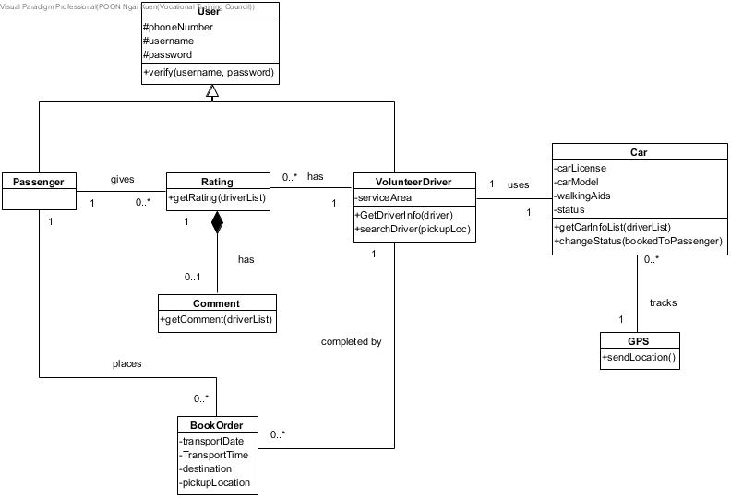

# System-Sequence-Diagram

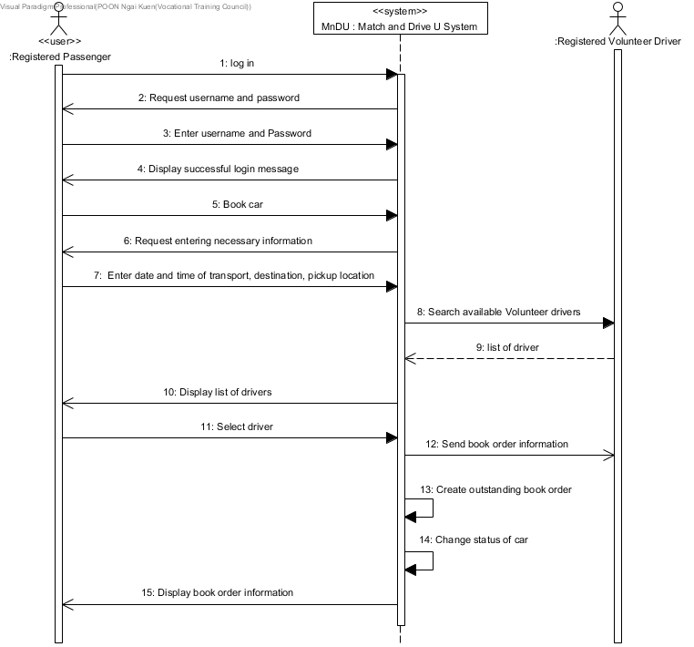

# Three-Tiers Sequence Diagram (Normal Scenario)

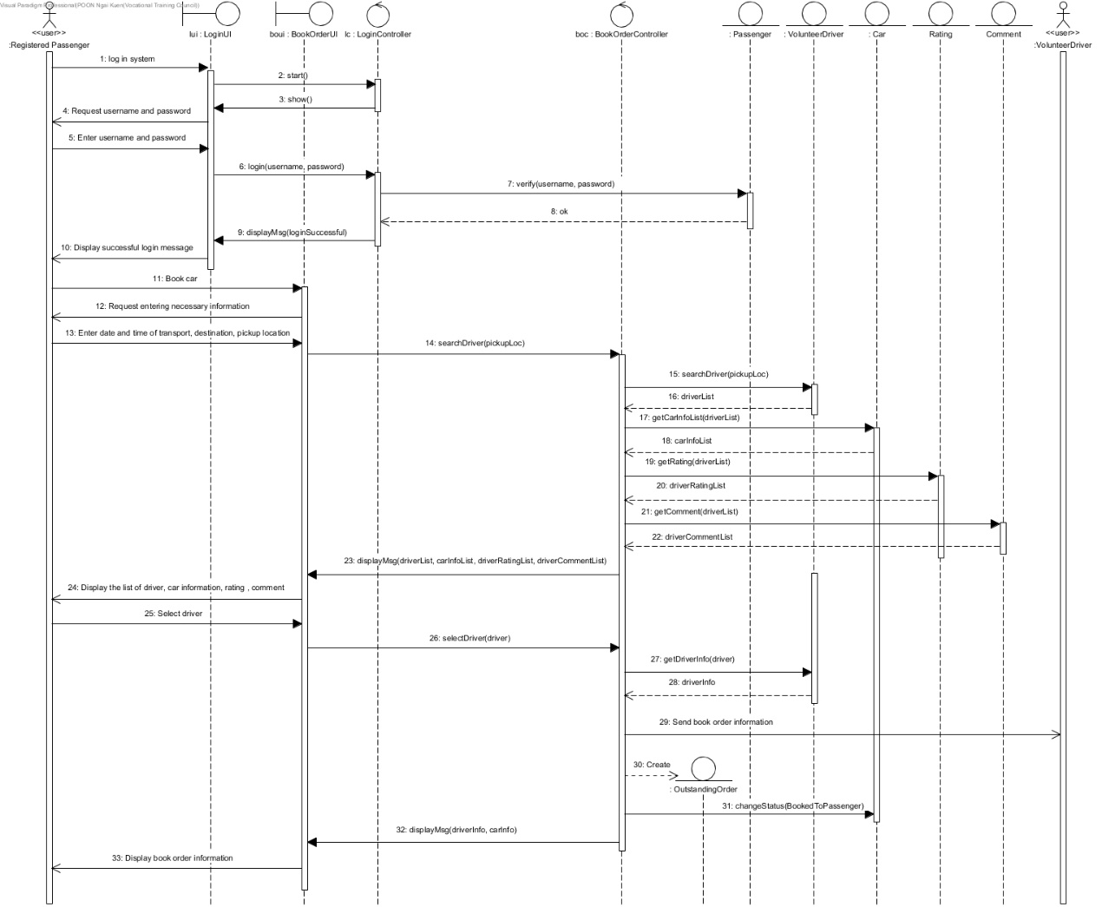

# Three-Tiers Sequence Diagram (Exception Scenario)

Exception scenario: No available driver for the passenger

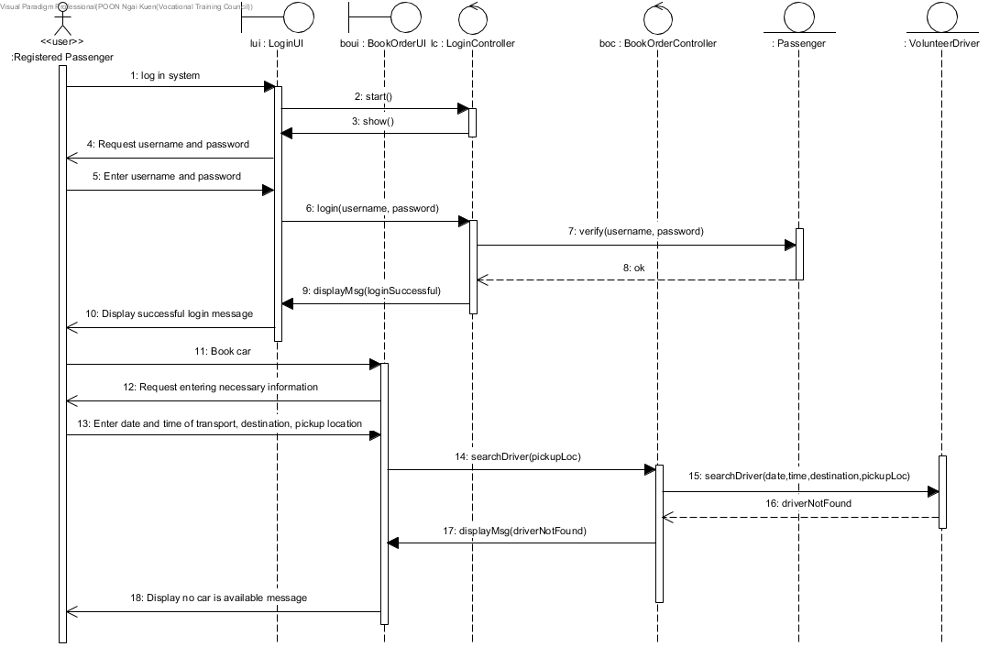

Exception scenario: Passenger does not fill in all the necessary information

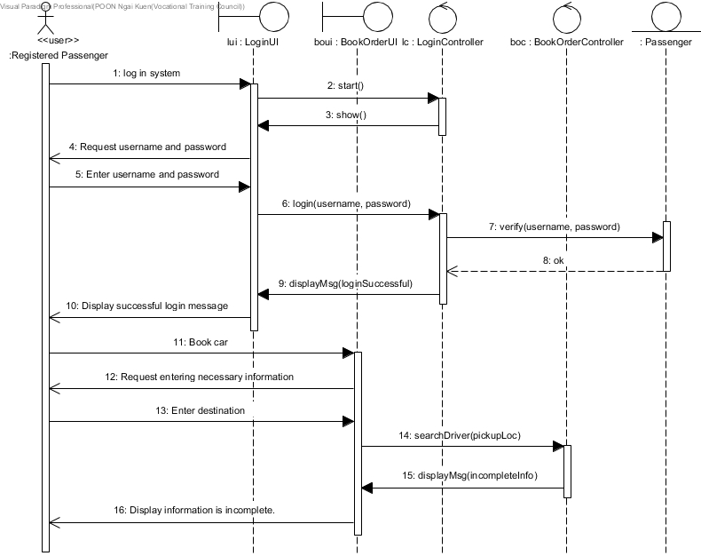

Exception scenario: Passenger enters an invalid password or username.

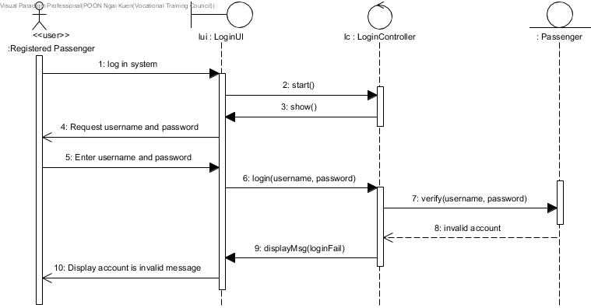

# State Machine Diagram

Login Controller

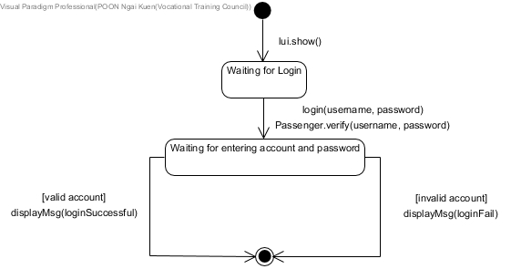

BookCar Controller

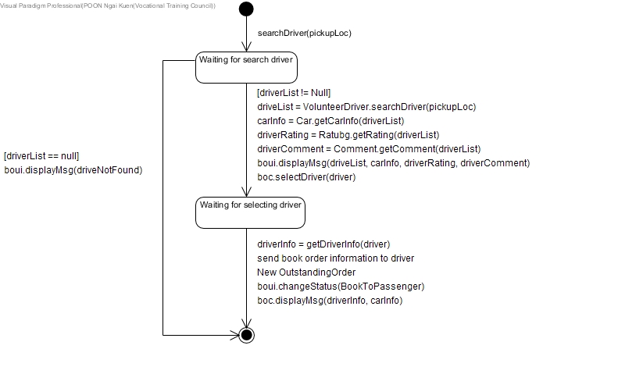

# Refine Class Diagram

