|  |
| --- |
|  |
| The Specification |
| [Type the document subtitle] |
|  |
| **[Your Name]** |
| **[Pick the date]** |

[Type the abstract of the document here. The abstract is typically a short summary of the contents of the document. Type the abstract of the document here. The abstract is typically a short summary of the contents of the document.]

Table of Contents

[To update the table of contents, right click the message below and select Update Field (F9 on PC, ⌥⌘U on Mac).]

**No table of contents entries found.**

1. Pages
   1. Page Tree

Welcome  
 Home  
 Admin

* 1. Welcome
     1. User Interface

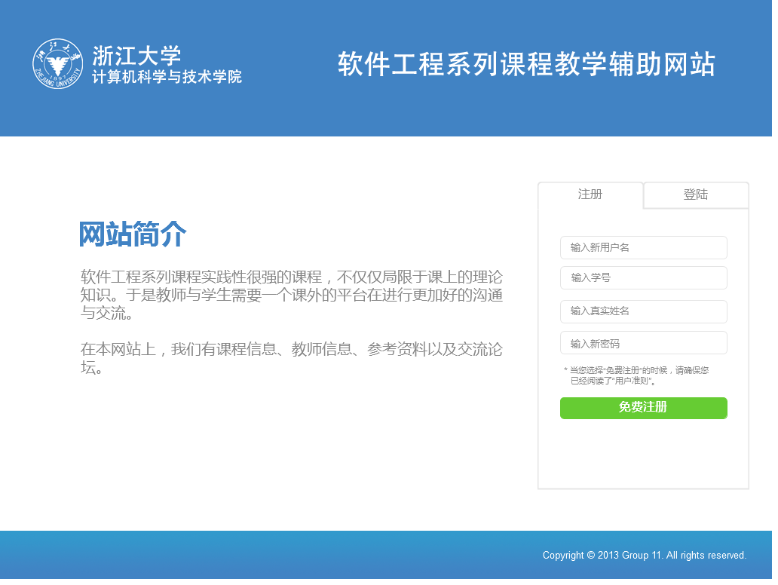

* + 1. Title
       1. State1
       2. User Interface



* + 1. Bottom
       1. State1
       2. User Interface



* + 1. Text
       1. State1
       2. User Interface

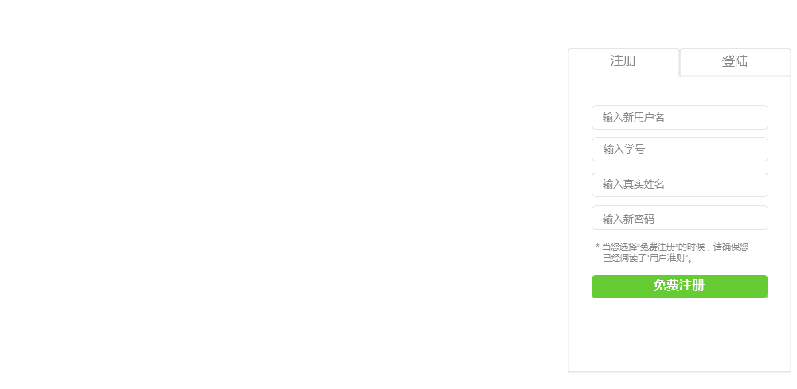

* + 1. LoginRegister
       1. Register
       2. User Interface

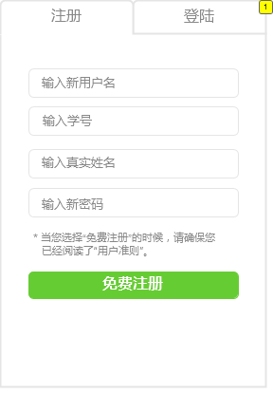

* + - 1. Widget Table

| Footnote | Interactions |
| --- | --- |
| 1 | OnClick:  Case 1:  Set LoginRegister state to Login |

* + - 1. Login
      2. User Interface

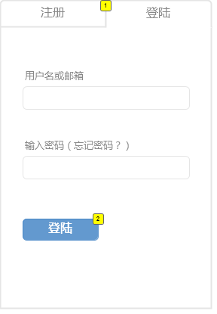

* + - 1. Widget Table

| Footnote | Interactions |
| --- | --- |
| 1 | OnClick:  Case 1:  Set LoginRegister state to Register |
| 2 | OnClick:  Case 1:  Open Home in Current Window |

* + 1. TextField
       1. Introduction
       2. User Interface

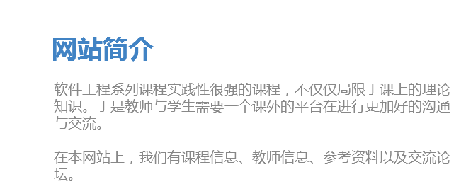

* 1. Home

OnPageLoad:  
 Case 1:  
 Set Main state to 杨  
 Set text on widget Present equal to "[[LVAR1]]"  
 Set Course state to Announce

* + 1. User Interface

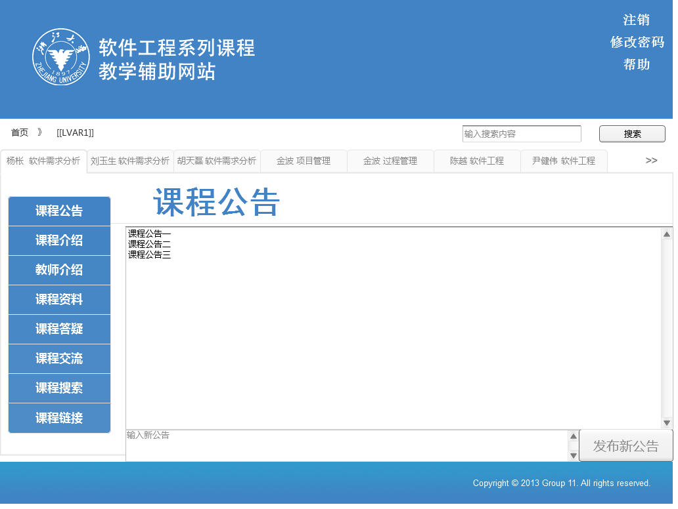

* + 1. Title
       1. State1
       2. User Interface



* + 1. Main
       1. 杨
       2. User Interface

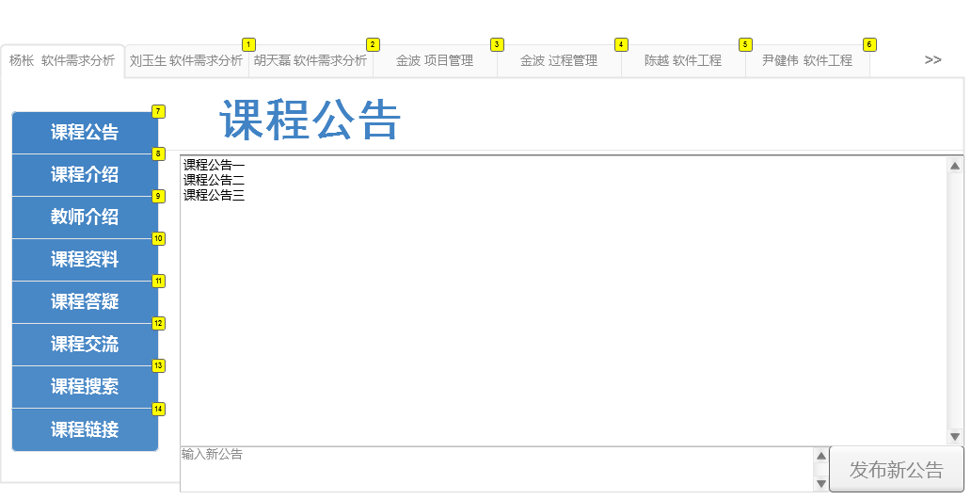

* + - 1. Widget Table

| Footnote | Label | Interactions |
| --- | --- | --- |
| 1 | liu | OnClick:  Case 1:  Set text on widget Present equal to "[[LVAR1]]"  Set Main state to 刘 |
| 2 | hu | OnClick:  Case 1:  Set Main state to 胡 |
| 3 |  | OnClick:  Case 1:  Set Main state to 金1 |
| 4 |  | OnClick:  Case 1:  Set Main state to 金2 |
| 5 |  | OnClick:  Case 1:  Set Main state to 陈 |
| 6 |  | OnClick:  Case 1:  Set Main state to 尹 |
| 7 |  | OnClick:  Announce:  Set Course state to Announce |
| 8 |  | OnClick:  Case 1:  Set Course state to Intro |
| 9 |  | OnClick:  Case 1:  Set Course state to Teacher |
| 10 |  | OnClick:  Case 1:  Set Course state to Material |
| 11 |  | OnClick:  Case 1:  Set Course state to Question |
| 12 |  | OnClick:  Case 1:  Set Course state to Communication |
| 13 |  | OnClick:  Case 1:  Set Course state to Search |
| 14 |  | OnClick:  Case 1:  Set Course state to Links |

* + - 1. 刘
      2. User Interface

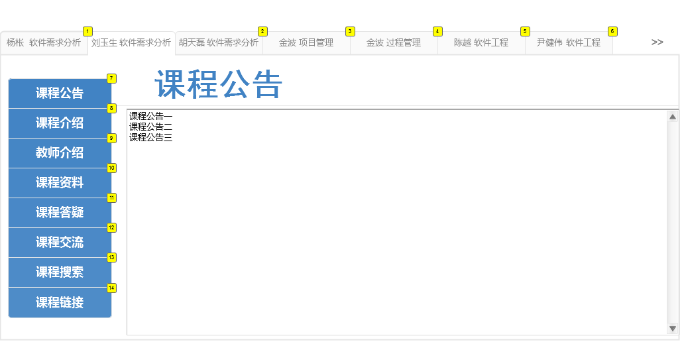

* + - 1. Widget Table

| Footnote | Label | Interactions |
| --- | --- | --- |
| 1 |  | OnClick:  Case 1:  Set Main state to 杨  Set text on widget Present equal to "[[LVAR1]]" |
| 2 |  | OnClick:  Case 1:  Set Main state to 胡 |
| 3 |  | OnClick:  Case 1:  Set Main state to 金1 |
| 4 |  | OnClick:  Case 1:  Set Main state to 金2 |
| 5 |  | OnClick:  Case 1:  Set Main state to 陈 |
| 6 |  | OnClick:  Case 1:  Set Main state to 尹 |
| 7 |  | OnClick:  Case 1:  Set Student state to Announce |
| 8 |  | OnClick:  Case 1:  Set Student state to Intro |
| 9 |  | OnClick:  Case 1:  Set Student state to teacher |
| 10 |  | OnClick:  Case 1:  Set Student state to material |
| 11 |  | OnClick:  Case 1:  Set Student state to question |
| 12 |  | OnClick:  Case 1:  Set Student state to comm |
| 13 |  | OnClick:  Case 1:  Set Student state to search |
| 14 |  | OnClick:  Case 1:  Set Student state to links |

* + - 1. 胡
      2. User Interface

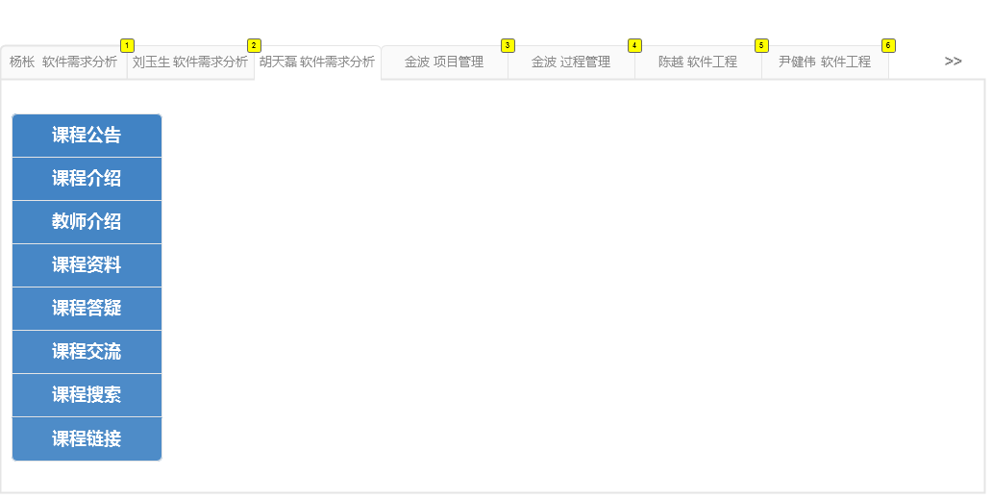

* + - 1. Widget Table

| Footnote | Interactions |
| --- | --- |
| 1 | OnClick:  Case 1:  Set Main state to 杨 |
| 2 | OnClick:  Case 1:  Set Main state to 刘 |
| 3 | OnClick:  Case 1:  Set Main state to 金1 |
| 4 | OnClick:  Case 1:  Set Main state to 金2 |
| 5 | OnClick:  Case 1:  Set Main state to 陈 |
| 6 | OnClick:  Case 1:  Set Main state to 尹 |

* + - 1. 金1
      2. User Interface

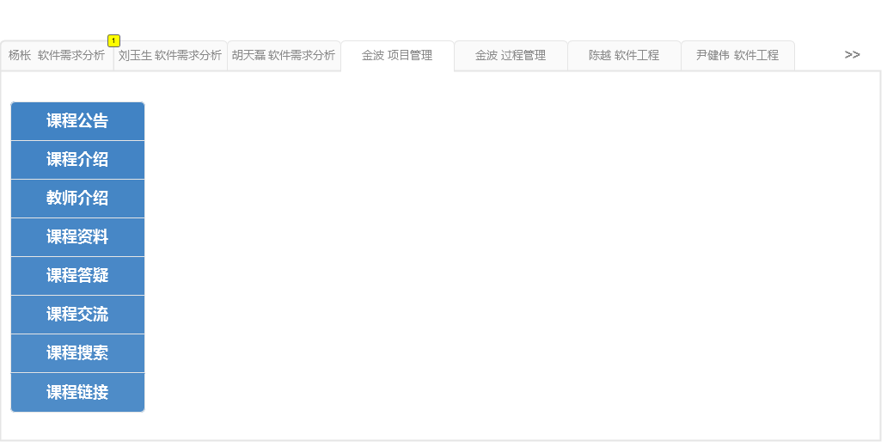

* + - 1. Widget Table

| Footnote | Interactions |
| --- | --- |
| 1 | OnClick:  Case 1:  Set Main state to 杨 |

* + - 1. 金2
      2. User Interface

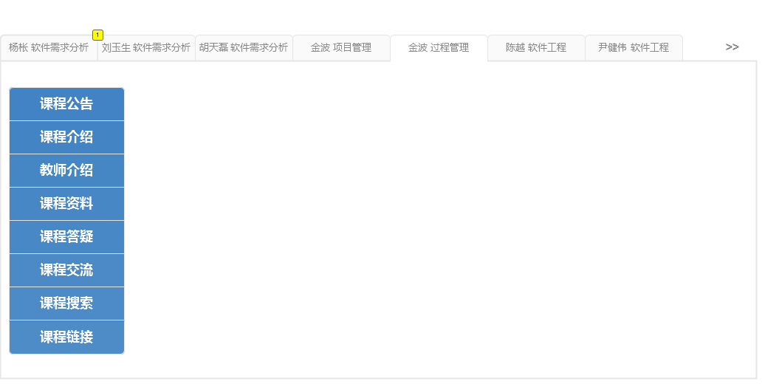

* + - 1. Widget Table

| Footnote | Interactions |
| --- | --- |
| 1 | OnClick:  Case 1:  Set Main state to 杨 |

* + - 1. 陈
      2. User Interface

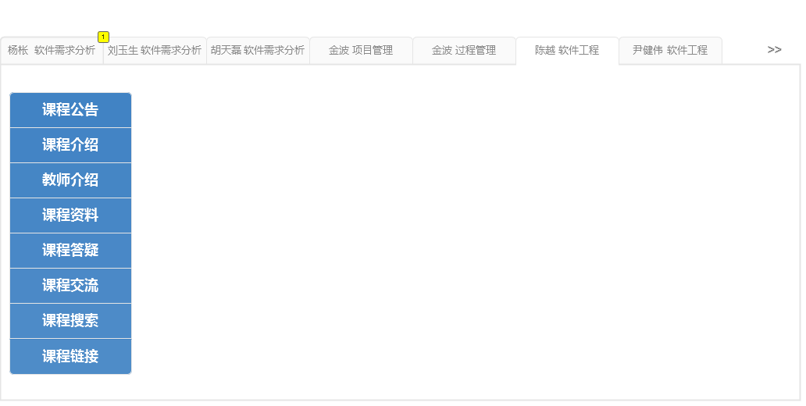

* + - 1. Widget Table

| Footnote | Interactions |
| --- | --- |
| 1 | OnClick:  Case 1:  Set Main state to 杨 |

* + - 1. 尹
      2. User Interface

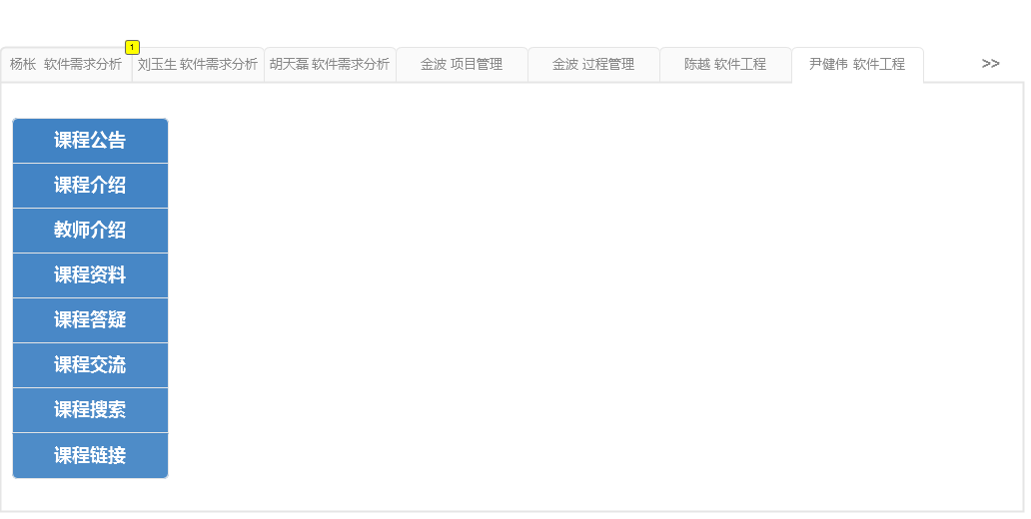

* + - 1. Widget Table

| Footnote | Interactions |
| --- | --- |
| 1 | OnClick:  Case 1:  Set Main state to 杨 |

* + 1. Course
       1. Announce
       2. User Interface

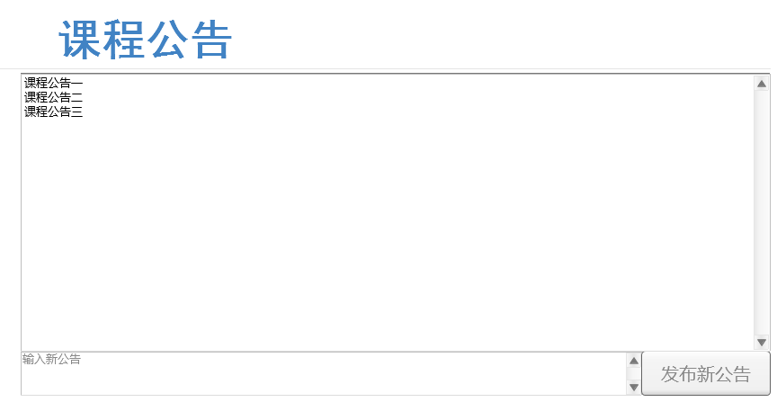

* + - 1. Intro
      2. User Interface

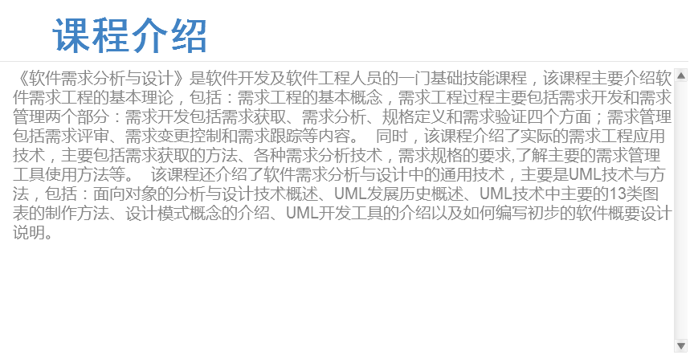

* + - 1. Teacher
      2. User Interface

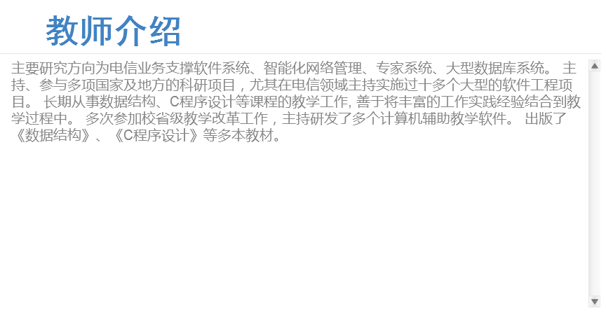

* + - 1. Material
      2. User Interface

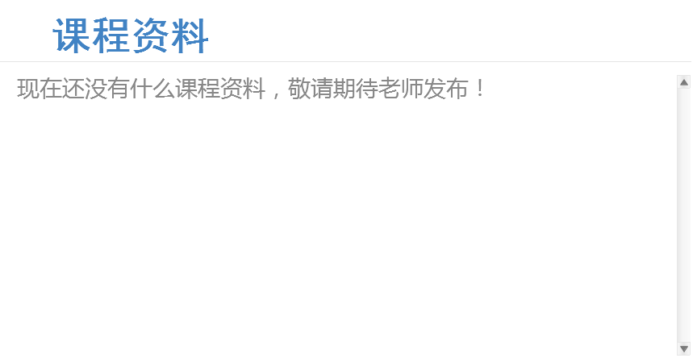

* + - 1. Question
      2. User Interface

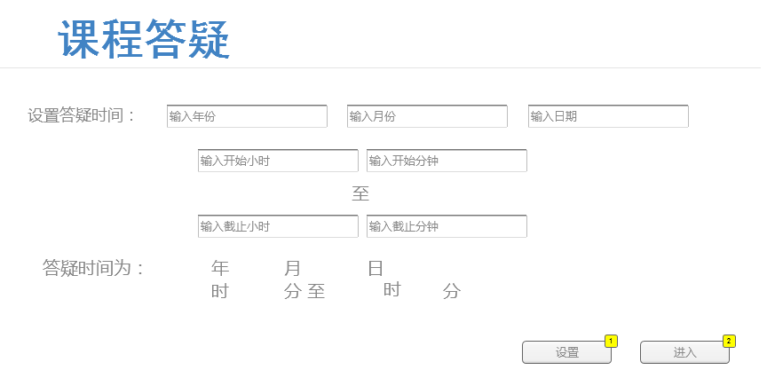

* + - 1. Widget Table

| Footnote | Label | Interactions |
| --- | --- | --- |
| 1 |  | OnClick:  Case 1:  Set text on widget year equal to "[[LVAR1]]", and  text on widget month equal to "[[LVAR1]]", and  text on widget day equal to "[[LVAR1]]", and  text on widget hour equal to "[[LVAR1]]", and  text on widget minute equal to "[[LVAR1]]", and  text on widget hour2 equal to "[[LVAR1]]", and  text on widget minute2 equal to "[[LVAR1]]" |
| 2 |  | OnClick:  Case 1:  Set Course state to questionstart |

* + - 1. Communication
      2. User Interface

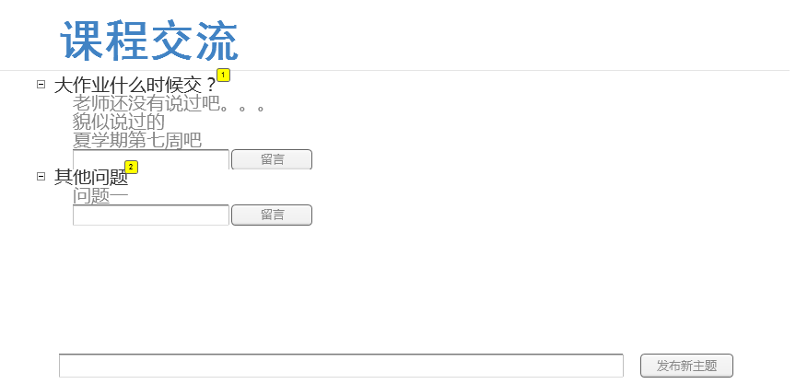

* + - 1. Widget Table

| Footnote | Label | Interactions |
| --- | --- | --- |
| 1 | CourseQuestion | OnClick:  Case 1:  Hide ask1 |
| 2 |  | OnClick:  Case 1:  Hide ask2 |

* + - 1. Search
      2. User Interface

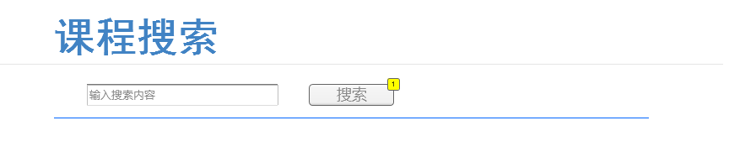

* + - 1. Widget Table

| Footnote | Label | Interactions |
| --- | --- | --- |
| 1 |  | OnClick:  Case 1:  Set text on widget search equal to "“[[LVAR1]]”", and  text on widget res equal to "没有符合的结果" |

* + - 1. Links
      2. User Interface

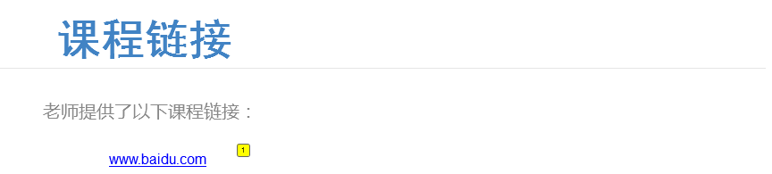

* + - 1. Widget Table

| Footnote | Interactions |
| --- | --- |
| 1 | OnClick:  Case 1:  Open www.baidu.com in Current Window |

* + - 1. questionstart
      2. User Interface

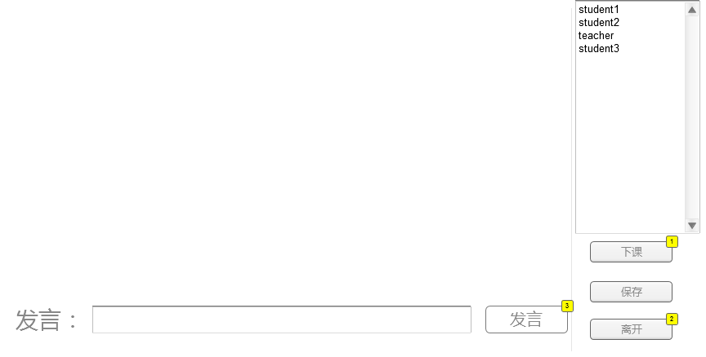

* + - 1. Widget Table

| Footnote | Label | Interactions |
| --- | --- | --- |
| 1 |  | OnClick:  Case 1:  Set Course state to Question |
| 2 |  | OnClick:  Case 1:  Set Course state to Question |
| 3 |  | OnClick:  Case 1:  Set text on widget date equal to "[[Year]]-[[Month]]-[[Day]]-14:00:", and  text on widget user equal to "Teacher Says:", and  text on widget content equal to "[[LVAR1]]" |

* + 1. ask1
       1. State1
       2. User Interface



* + 1. ask2
       1. State1
       2. User Interface



* + 1. Student
       1. Announce
       2. User Interface

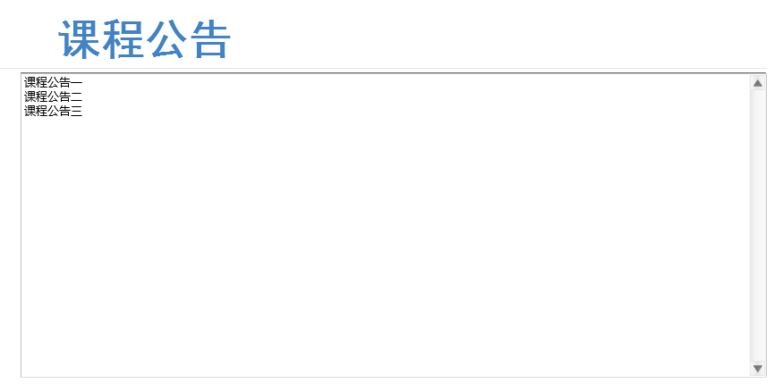

* + - 1. Intro
      2. User Interface



* + - 1. teacher
      2. User Interface



* + - 1. material
      2. User Interface



* + - 1. question
      2. User Interface

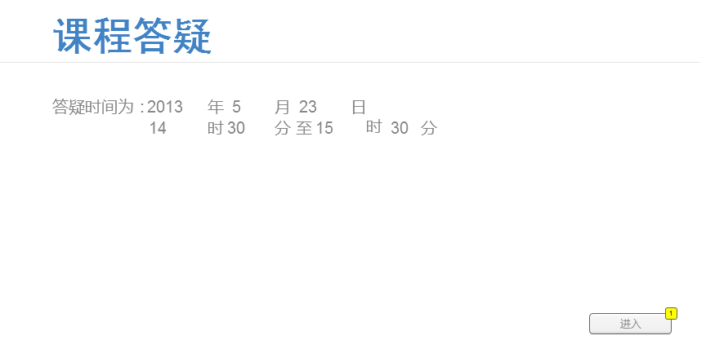

* + - 1. Widget Table

| Footnote | Label | Interactions |
| --- | --- | --- |
| 1 |  | OnClick:  Case 1:  Set Student state to questionstart |

* + - 1. comm
      2. User Interface

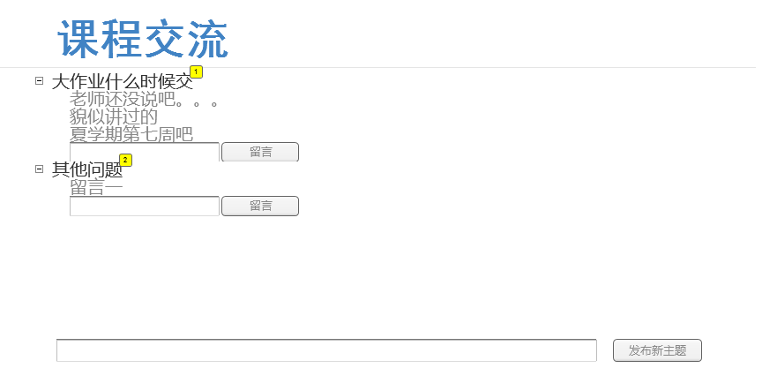

* + - 1. Widget Table

| Footnote | Label | Interactions |
| --- | --- | --- |
| 1 | CourseQuestion | OnClick:  Case 1:  Hide ask1 |
| 2 |  | OnClick:  Case 1:  Hide ask2 |

* + - 1. search
      2. User Interface



* + - 1. Widget Table

| Footnote | Label | Interactions |
| --- | --- | --- |
| 1 |  | OnClick:  Case 1:  Set text on widget search equal to "“[[LVAR1]]”", and  text on widget res equal to "没有符合的结果" |

* + - 1. links
      2. User Interface



* + - 1. Widget Table

| Footnote | Interactions |
| --- | --- |
| 1 | OnClick:  Case 1:  Open www.baidu.com in Current Window |

* + - 1. questionstart
      2. User Interface

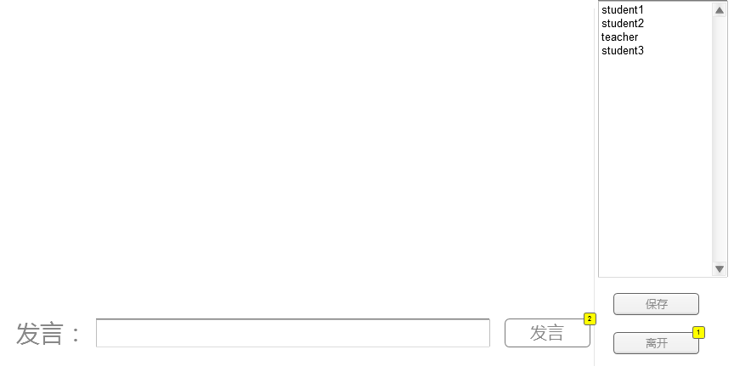

* + - 1. Widget Table

| Footnote | Label | Interactions |
| --- | --- | --- |
| 1 |  | OnClick:  Case 1:  Set Course state to Question |
| 2 |  | OnClick:  Case 1:  Set text on widget date equal to "[[Year]]-[[Month]]-[[Day]]-14:00:", and  text on widget user equal to "Student1 Says:", and  text on widget content equal to "[[LVAR1]]" |

* + 1. ask1
       1. State1
       2. User Interface



* + 1. ask2
       1. State1
       2. User Interface



* + 1. Bottom
       1. State1
       2. User Interface



* 1. Admin
     1. User Interface

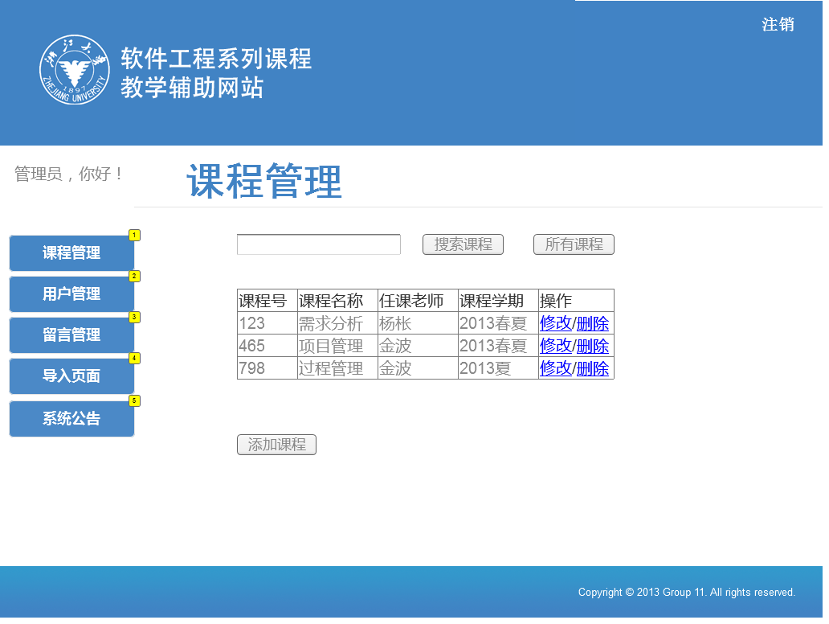

* + 1. Widget Table

| Footnote | Label | Interactions |
| --- | --- | --- |
| 1 |  | OnClick:  Case 1:  Set main state to course |
| 2 |  | OnClick:  Case 1:  Set main state to user |
| 3 |  | OnClick:  Case 1:  Set main state to comment |
| 4 |  | OnClick:  Case 1:  Set main state to input |
| 5 |  | OnClick:  Case 1:  Set main state to announce |

* + 1. Title
       1. State1
       2. User Interface



* + 1. main
       1. course
       2. User Interface

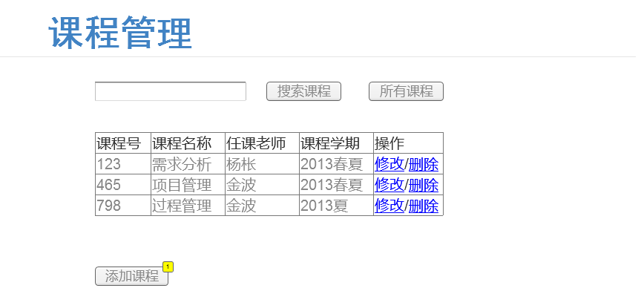

* + - 1. Widget Table

| Footnote | Interactions |
| --- | --- |
| 1 | OnClick:  Case 1:  Set main state to Add |

* + - 1. user
      2. User Interface

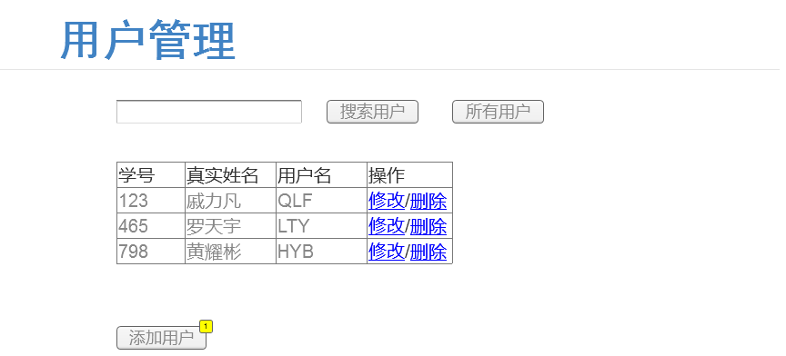

* + - 1. Widget Table

| Footnote | Interactions |
| --- | --- |
| 1 | OnClick:  Case 1:  Set main state to adduser |

* + - 1. comment
      2. User Interface

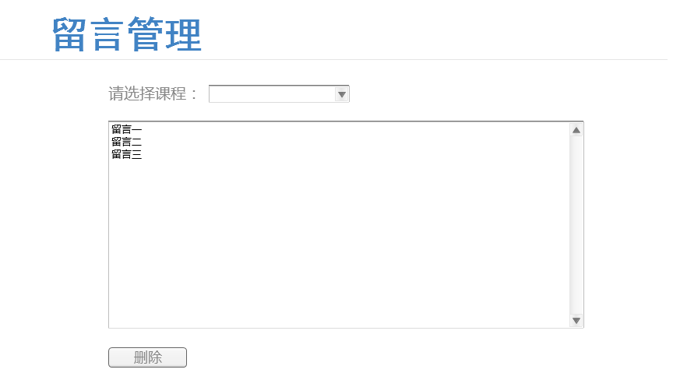

* + - 1. input
      2. User Interface

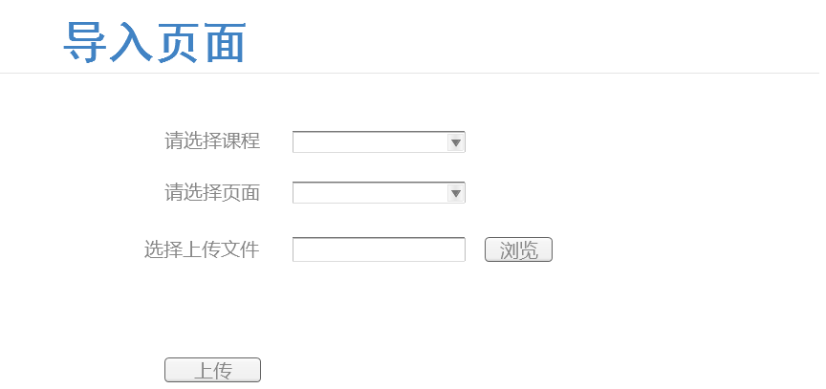

* + - 1. Add
      2. User Interface

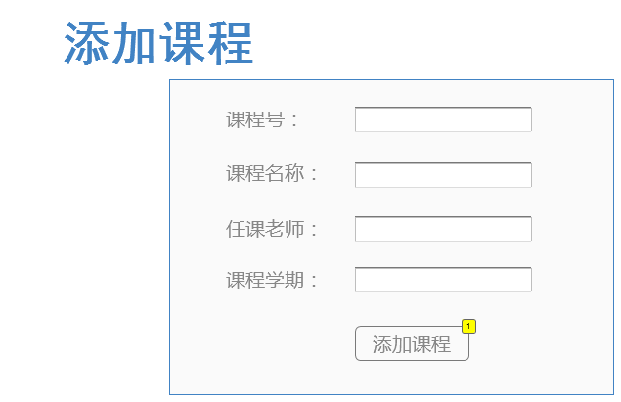

* + - 1. Widget Table

| Footnote | Interactions |
| --- | --- |
| 1 | OnClick:  Case 1:  Set main state to course |

* + - 1. adduser
      2. User Interface

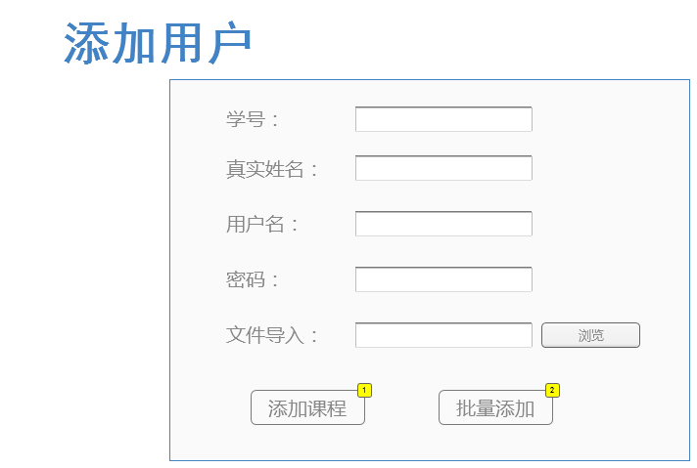

* + - 1. Widget Table

| Footnote | Interactions |
| --- | --- |
| 1 | OnClick:  Case 1:  Set main state to user |
| 2 | OnClick:  Case 1:  Set main state to user |

* + - 1. announce
      2. User Interface

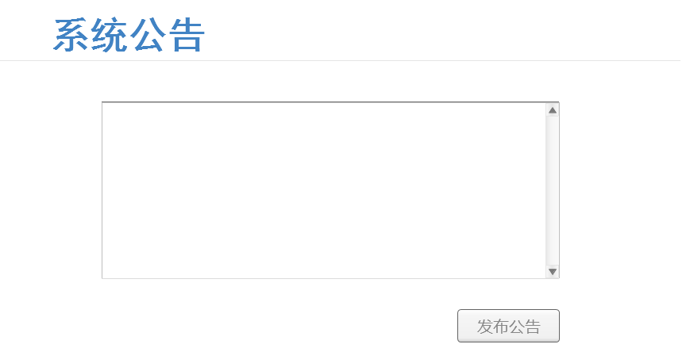

* + 1. Bottom
       1. State1
       2. User Interface

