JOP APPLICATION TRACKING SYSTEM
1 INTRODUCTION
1.1 Overview
applicant tracking system is software that manages the recruiting and hiring process, including job postings and job applications. It organizes information about job seekers and makes it searchable. As its name implies ,an ATS tracks candidates through the hiring process. It helps with interview scheduling, issues notifications and alerts, and sends automated emails to candidates and employees , such as recruiters and hiring managers.

But these system are far more than organizers. An ATS is also used to cull applicants and recommend the top candidates. It may conduct a preliminary analysis of the applicants it find the best first for a job. It may also look for keywords or use Al-type algorithms that run a deeper analysis of the job applicant. The goal is to speed HR’s review of a job applications and resumes.

1.2 Purpose
      - The job requisition is created and, if necessary, approved within the system.
      - The job posted in one or more locations , including internally for employees, on the organization’s website and on external jobs boards.

      - Candidates apply for the position on organizations website or directly on the job board if such functionality is available. The may have to answer questions related to the position, such as their work experience.

2. problem Definitions & Design Thinking
2.1 Empathy Map
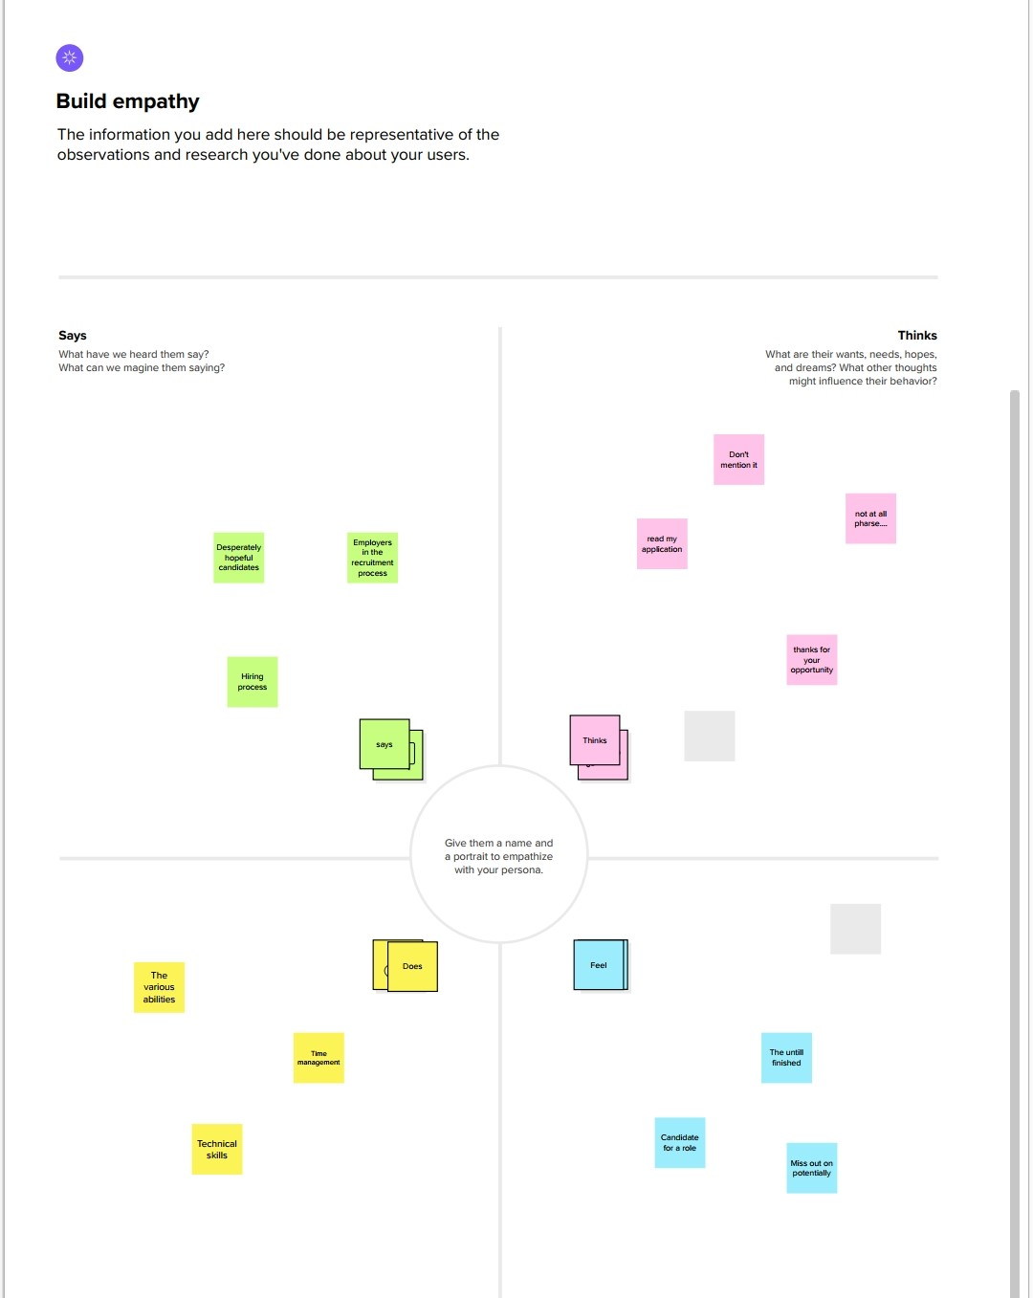

2.2 Ideation & Brainstorming Map

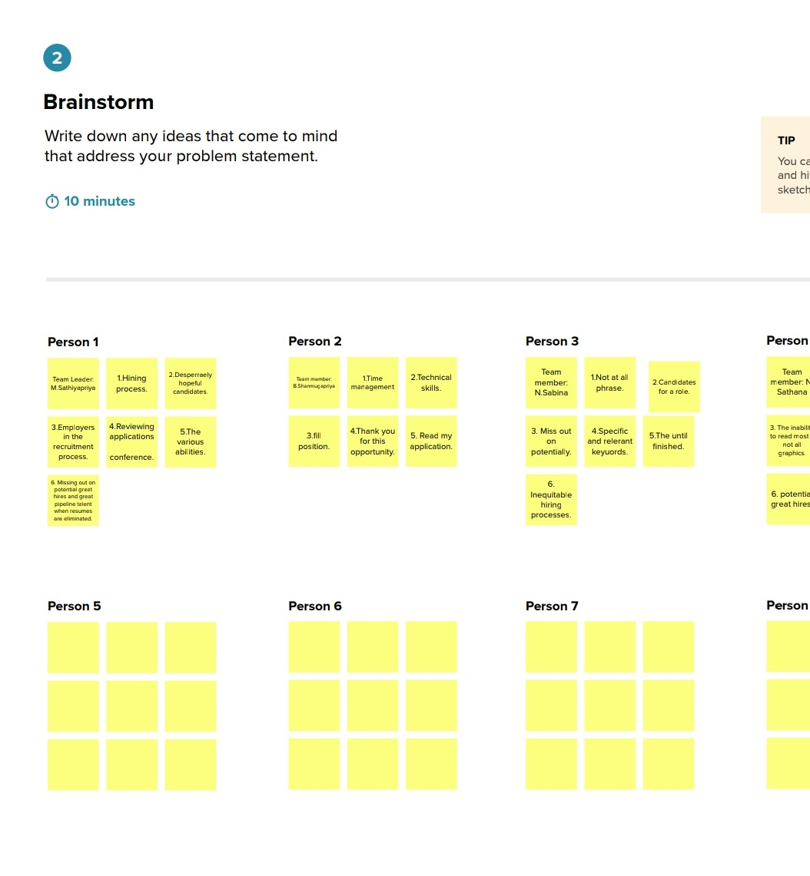

3. RESULT
3.1 DATA MODEL
Object name | Field in the object
Job Application
  Field label | Data type
  Job application name | Auto number
  candidate | Look up(candidate)
  total review score | Roll up summary
Job posting site
  Field label | Data type
  Description | Text area(255)
  Site Name | Text (80)
  Status | Picklist
Review
  Field label | Data type
  Interviewer | Look up(interviewer)
  Job application | Master-Detail(Job application )
  Overall Review score | Formula(Number)

3.2.Activity and screenshot
1.Object:
Create a custom object for Recruiter:

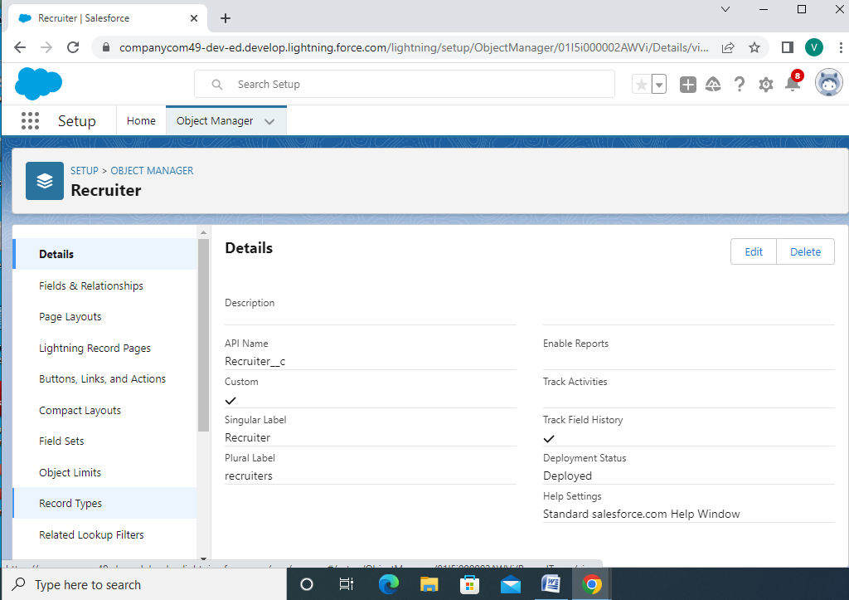

2. Create a jobs , candidate, job application object and tap:
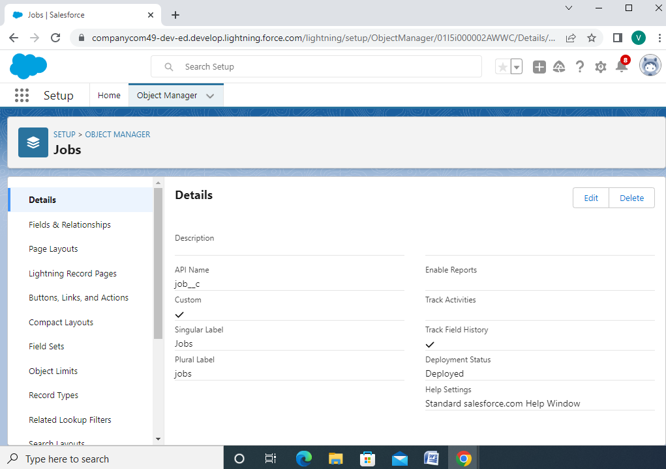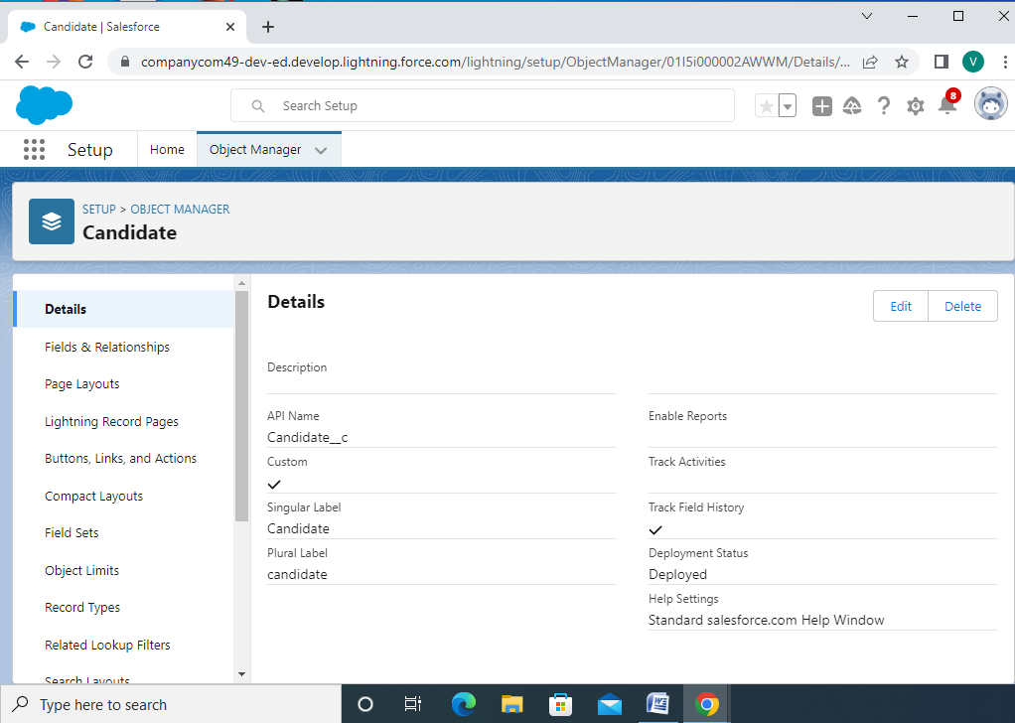

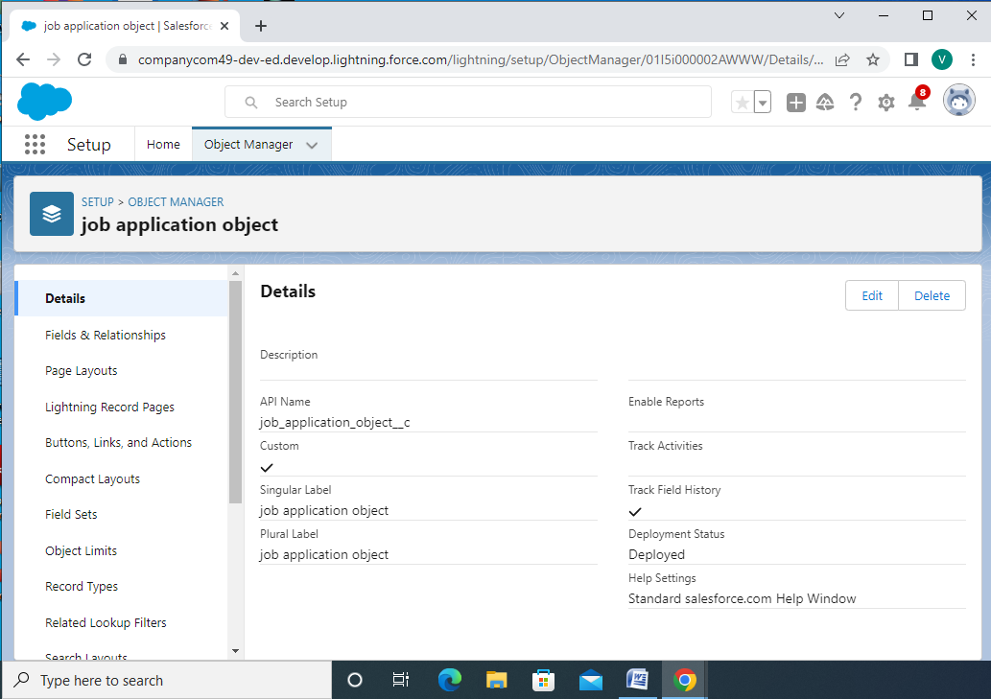

3. Create a custom profile
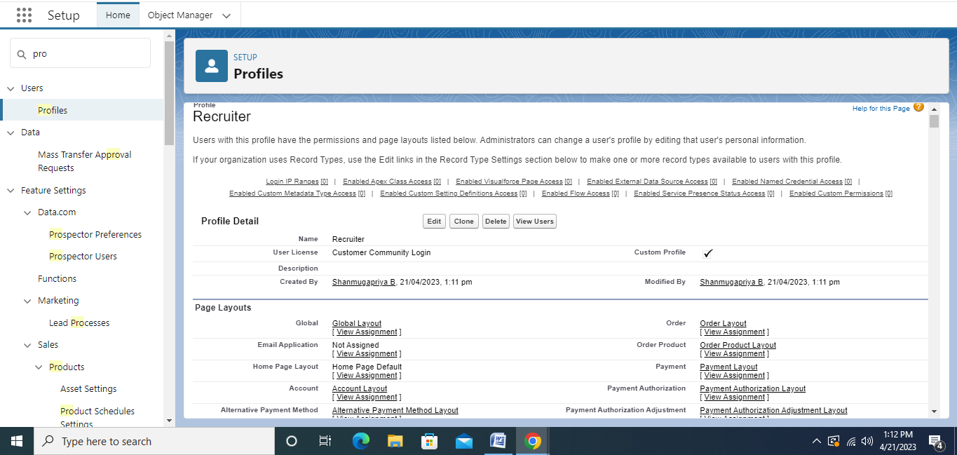

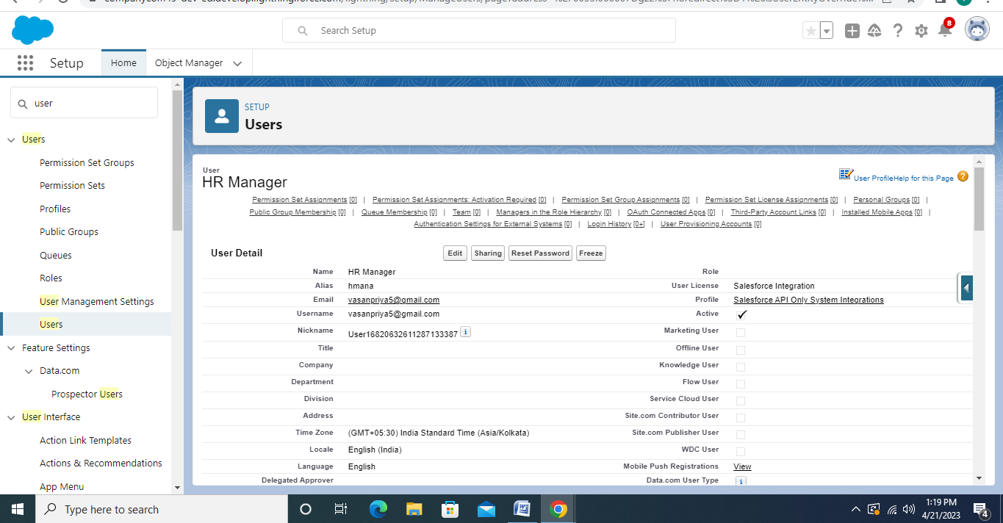
4. Sharing settings
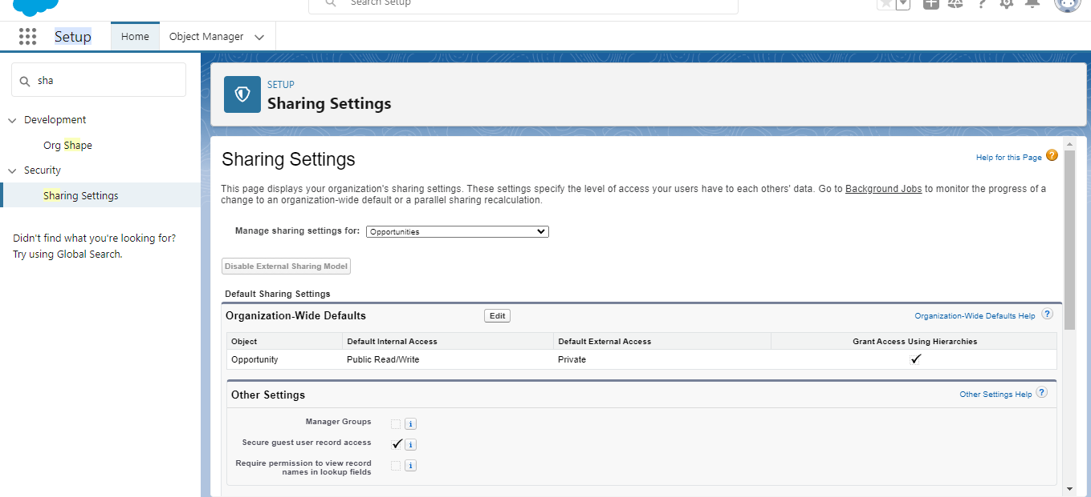

4. Trailhead Profile public URL
Team leader- https://trailblazer.me/id/mmurugaiyan

Team Member1-https://login.salesforce.com/

Team Member2-https://trailblazer.me/id/sathananatarajan69

Team Member3-https://trailblazer.mr/id/sabinanatarajan69

5. ADVANTAGES & DISADVANDAGES
ADVANTAGES

- Reduces time spent on time tasks:
ATS software allows you to automate various tasks of the hiring process that can save you a lot of time and free up your recruiting personal for other high- value tasks.
- Resume and CV screening:
With recruiters receiving 100s of resumes per role, even scanning can take a lot of time. ATS software can be utilized to review applications and filter out candidates that don’t meet the minimum requirements of the role.
- Speed up the recruitment cycle:
Having candidates information centralized on a single platform gives recruiters access to organized information allowing them to review and compare candidates more easily and quickly.

- Improves the quality of hire:
Not only do ATS create more efficient workflows, as previously discussed , they can also improve the quality of your hire.

- Enhances reporting and compliance:
Lack of compliance in the recruiting process can devastate your business and brand.

DISADVANTAGE

- When programming your recruiting software to recognize common keywords around roles and responsibilities you could end filtering out good candidates experience or lack looking for.

- It also much better to send a less personalized communication at all.

- Taking additional time to construct good communication can help make it feel more personalized.

6. APPLICATIONS
- Many jobseekers attest that looking for job online lacks a personal touch.
- This is has been so far the biggest complaint. Outdated job posting it’s the biggest drawback of online recruitment job applications detest.

- Had the aspirant known the position was filled she/he would have never applied it. This is simply a worker.

7. CONCLUSION
The end result of the recruitment process is essential a pool of applicants. Next to recruitment the logical step in the HR process is the selection of qualifies and complement people. As such this process concentrates of differentiating between applications in order to organization recruitments ultimately fulfilling the goal organization.

8. FUTURE SCOPE
Applicant tracking system in recruitment will continue to provide an opportunity to boost the quality of the new hires that you bring into your corporation. Now and into the future, you will be able to use applicant tracking system in your recruiting procedure to comply with local, state and federal hiring recruitments. For Ex. If your organization were to receive a complaint about the recruitment of hiring practices ,you applicant tracking system to back up your practices and provide key details about the number of applicants and their demographic information.

