Marketing Funnel Analysis Report
Task 18 – Data Analytics Track
Prepared by: [Your Name] | Data period: 9 Dec 2025 – 8 Jan 2026 | Tools: Python, SQL, Excel/Power BI
10,000  Visitors | 1,004  Purchases | 10.04%  Overall conversion | $277,323  Revenue

1. Executive Summary
Of 10,000 visitors, 1,004 purchased, an overall conversion rate of 10.04% and $277,323 in revenue (average order value $276.22). The funnel loses users at every stage, but two steps matter most:
- Checkout → Purchase has the highest drop-off rate: 70.95% of users who start checkout do not pay.
- Add to Cart → Checkout loses the most users: 3,493 (50.27% of carts).
Differences across channel, device, region and product category are small and not statistically significant, so the issue is funnel-wide. The biggest opportunity is improving the cart and checkout experience for everyone rather than targeting one segment.

2. Objective and Scope
Identify major funnel drop-offs, calculate stage conversion rates and compare segments. The funnel analyzed is Browse → Add to Cart → Checkout → Purchase.

3. Data and Cleaning
Item | Detail
Rows | 21,409 events
Users / sessions | 10,000 / 10,000 (one session per user)
Missing values | None
Duplicates | None
Sequence integrity | No checkout without a cart; no purchase without checkout
Attribute consistency | Each user has one device, region and channel

Note: Bonus Flag is "Yes" on every non-purchase event and "No" on every purchase, so it duplicates the event type and carries no independent information. It was excluded from the analysis.

4. Methodology
Metric | Formula
Stage conversion | Users at stage ÷ users at previous stage
Drop-off rate | 100% − stage conversion
Overall conversion | Purchases ÷ visitors
Significance test | Chi-square on conversion by segment (p < 0.05)

Supporting code: funnel_analysis.ipynb (Python) and sql/funnel_analysis.sql.

5. Funnel Table
Stage | Users | Stage Conv. | Drop-off | Users Lost | % of Visitors
Browse | 10,000 | – | – | – | 100.00%
Add to Cart | 6,949 | 69.49% | 30.51% | 3,051 | 69.49%
Checkout | 3,456 | 49.73% | 50.27% | 3,493 | 34.56%
Purchase | 1,004 | 29.05% | 70.95% | 2,452 | 10.04%
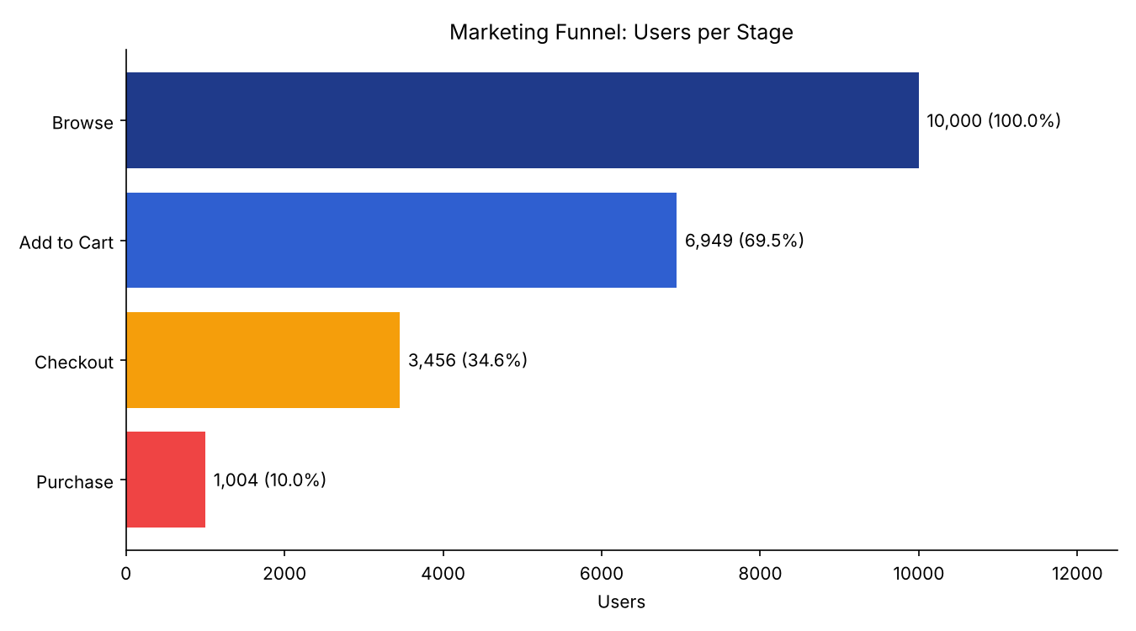
Figure 1: Users reaching each funnel stage
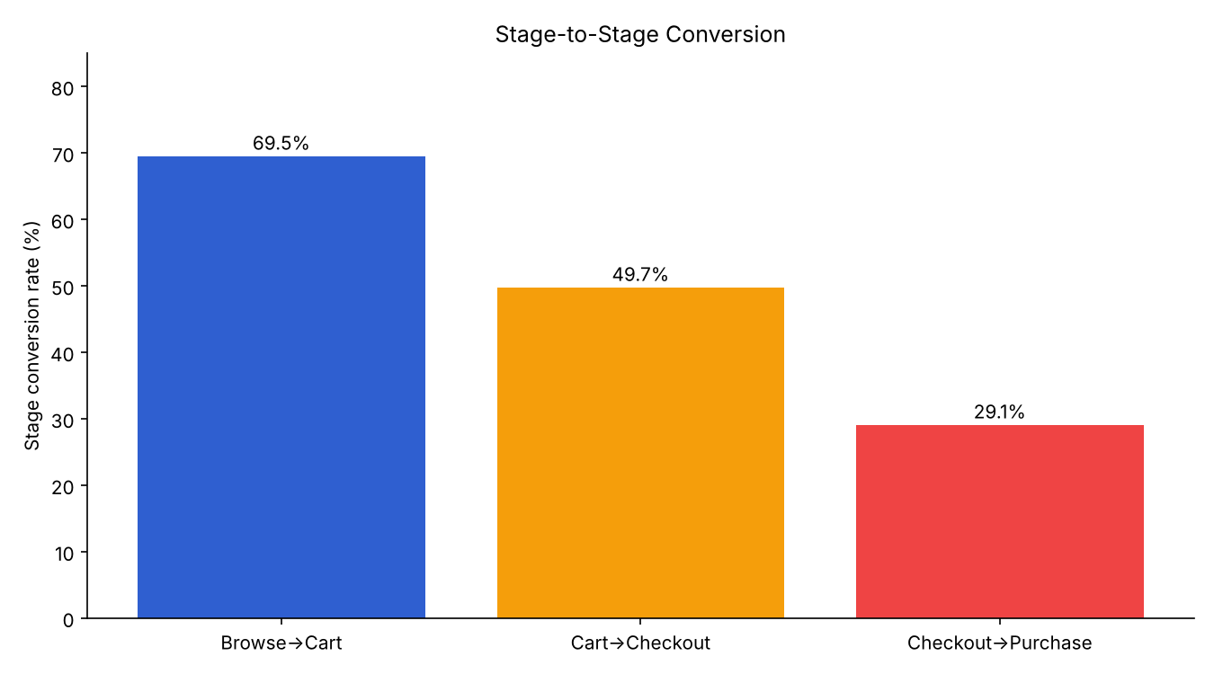
Figure 2: Stage-to-stage conversion rates

6. Segment Comparison

By Channel
Channel | Visitors | Cart→Checkout | Checkout→Purchase | Overall | Rev/Visitor
Google Ads | 2,520 | 51.15% | 30.01% | 10.63% | $29.31
Social Media | 2,437 | 48.23% | 30.44% | 10.22% | $28.05
Email | 2,515 | 49.89% | 28.21% | 9.86% | $27.49
Organic | 2,528 | 49.63% | 27.60% | 9.45% | $26.10

By Device
Device | Visitors | Cart→Checkout | Checkout→Purchase | Overall | Rev/Visitor
Desktop | 3,366 | 49.94% | 30.12% | 10.58% | $29.25
Tablet | 3,371 | 49.42% | 29.45% | 10.06% | $28.07
Mobile | 3,263 | 49.84% | 27.52% | 9.47% | $25.81

By Region
Region | Visitors | Cart→Checkout | Checkout→Purchase | Overall | Avg Order
South | 2,543 | 48.99% | 30.70% | 10.54% | $288.89
North | 2,463 | 49.41% | 29.98% | 10.27% | $271.32
West | 2,446 | 51.25% | 27.08% | 9.73% | $273.70
East | 2,548 | 49.31% | 28.49% | 9.62% | $269.86

By Product Category
Category | Visitors | Overall Conv. | Rev/Visitor
Electronics | 2,052 | 11.16% | $30.67
Fashion | 2,001 | 10.54% | $29.02
Sports | 1,948 | 9.70% | $28.67
Beauty | 2,021 | 9.45% | $24.92
Home | 1,978 | 9.30% | $25.33
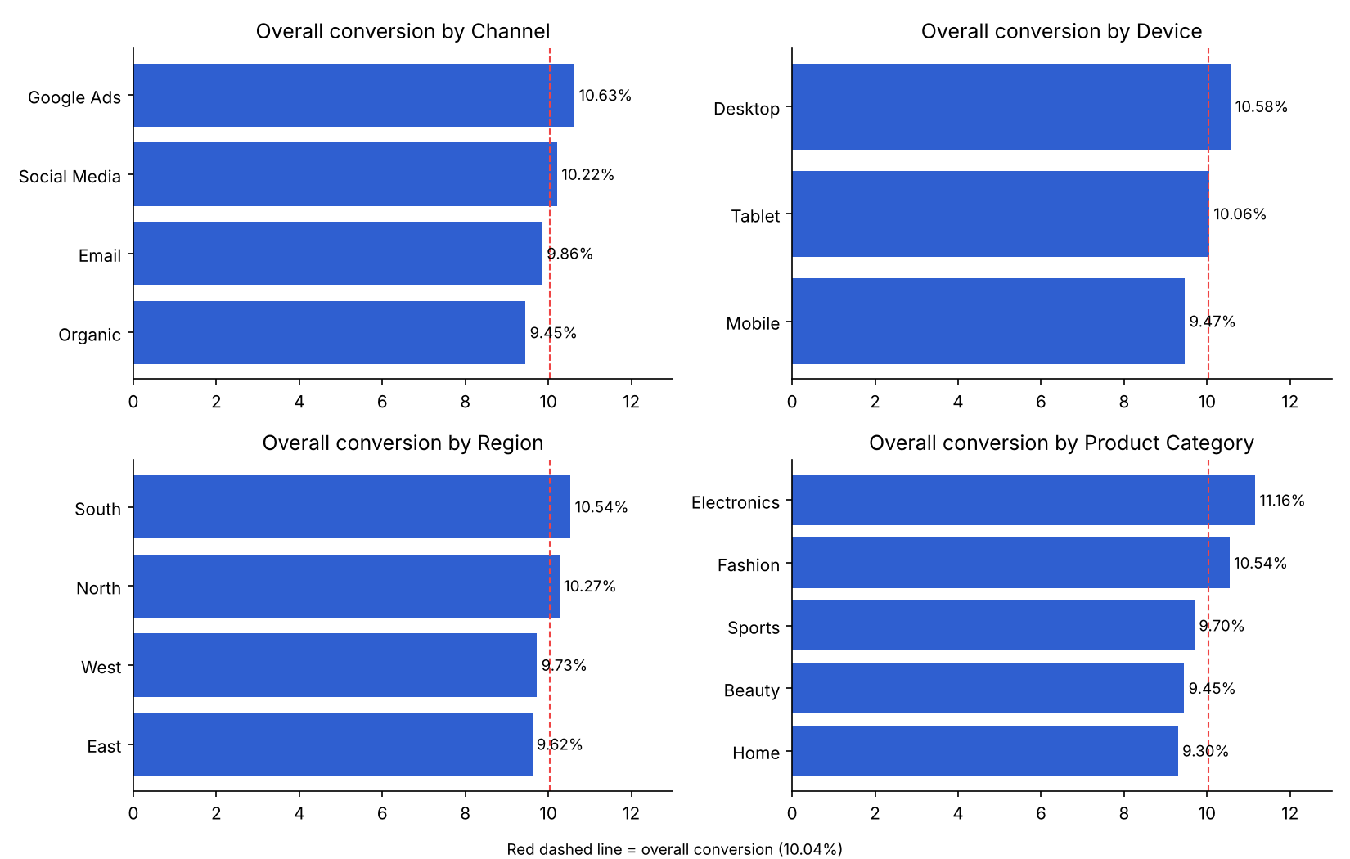
Figure 3: Overall conversion by segment (red line = 10.04% average)
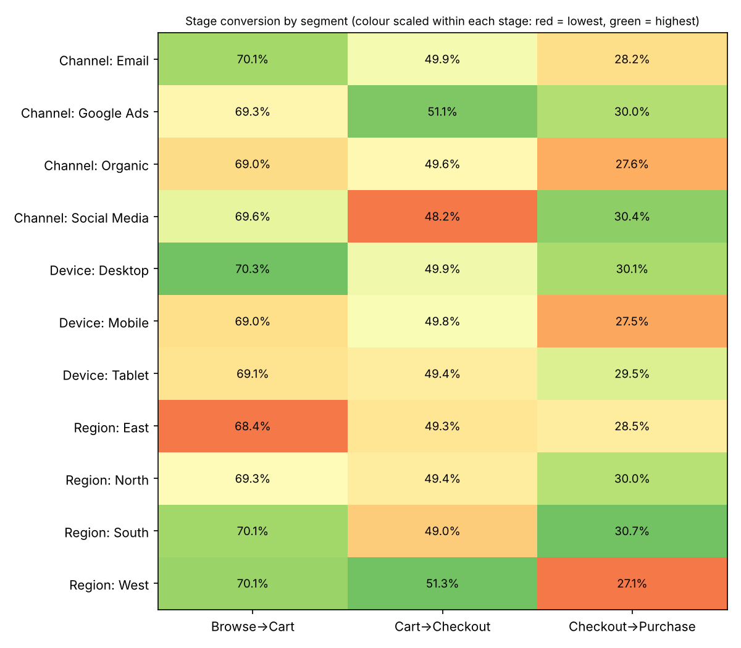
Figure 4: Stage conversion (%) by segment

Statistical Significance
Chi-square tests on Browse → Purchase returned p-values of 0.55 (channel), 0.33 (device), 0.66 (region) and 0.23 (category); Checkout → Purchase p-values ranged from 0.14 to 0.50. No segment is statistically different from the others, so gaps such as Mobile (9.47%) versus Desktop (10.58%) are directional signals, not proven differences.

7. Key Insights
- The funnel is leaky everywhere, but worst at the bottom. Only 29% of checkout starters complete payment.
- Half of all carts never reach checkout, the largest absolute loss at 3,493 users.
- Segments behave alike, so one funnel-wide fix will outperform segment-specific campaigns.
- Mobile is the weakest device at checkout (27.5% vs 30.1% on desktop) and has the lowest revenue per visitor, though the gap is not significant.
- Buyers decide quickly: checkout to purchase takes 2–5 minutes (mean 3.4), so recovery messaging must be timely.

8. Recommendations
Priority | Recommendation | Rationale
1 | Simplify checkout: guest checkout, fewer fields, more payment methods, trust badges, upfront shipping cost | Highest drop-off rate (70.95%)
2 | Reduce cart-to-checkout friction: show total cost early, persistent cart, clear call to action | Largest absolute loss (3,493 users)
3 | Abandoned-cart recovery via email or retargeting within hours | Buyers convert within minutes; intent fades fast
4 | Audit and optimize the mobile checkout | Lowest checkout→purchase rate (27.5%)
5 | A/B test each change and track stage conversion weekly | No segment clearly underperforms, so test funnel-wide changes

Illustrative impact (assumption, not a forecast): lifting Checkout → Purchase from 29.05% to 35% would add about 206 purchases (roughly $57,000 at the current $276 average order value) on the same traffic.

9. Limitations
- One month of data, so seasonality cannot be assessed.
- Segment gaps are not statistically significant; conclusions about them are directional.
- No cost or behavioral data (page speed, errors, abandonment reasons), so causes of drop-off need qualitative follow-up.
- The final week (5–8 Jan) is partial.

10. Next Steps
- Run A/B tests on checkout and cart changes.
- Collect abandonment reasons through exit surveys and session recordings.
- Add marketing cost data to compare channel ROI.
- Build a Power BI dashboard to monitor weekly stage conversion.

11. Conclusion
Conversion is 10.04%, with the biggest losses at Add to Cart → Checkout (by volume) and Checkout → Purchase (by rate). Because all segments perform similarly, improving the cart and checkout experience for all users is the clearest route to higher revenue.

