Inventory Turnover Analysis Report
Task 19 · Data Analytics Track · Dataset: Inventory_SupplyChain_Dataset.csv

1. Executive Summary
We analyzed 1200 inventory records (2020–2024) to measure how efficiently stock converts into sales. Overall turnover is 23.5 (COGS ÷ Average Inventory). Efficiency is fairly even across categories, but a clear slow-moving tail exists: 300 records (25%) turn below 9.1.
- Best category: Electronics (24.3). Weakest: Furniture (22.6), which also has the highest backorder rate (12.4%).
- Slowest segment: Accessories / Warehouse 3 / South (17.6), with 44% of its records in the slow bucket.
- Main driver: slow records hold about 27% more inventory (3,017 vs 2,367 units) while selling less than half the volume (293 vs 614 units).
- Action: cut replenishment on the slow segments and rebalance stock before buying more.

2. Turnover Formula
Inventory Turnover = Cost of Goods Sold ÷ Average Inventory
A higher ratio means stock is sold and replaced more often. For groups, total COGS is divided by total Average Inventory so large-inventory records carry proportionate weight. As a cross-check, sell-through (Units Sold ÷ Average Inventory) gives the same ranking.
Note: Average Inventory is in units and COGS is in currency, so the ratio shows COGS per average unit held. It is valid for comparing groups but is not an annualized times-per-year figure.

3. Turnover Table by Category
Category | Records | Total COGS | Avg Inventory | Turnover | Median | Sell-through | Slow %
Electronics | 314 | 19,207,239 | 2,520 | 24.3 | 22.2 | 0.21 | 22.0%
Accessories | 269 | 16,020,440 | 2,479 | 24.0 | 19.4 | 0.22 | 26.4%
Clothing | 311 | 18,789,437 | 2,617 | 23.1 | 18.9 | 0.21 | 23.8%
Furniture | 306 | 17,227,460 | 2,495 | 22.6 | 17.1 | 0.21 | 28.1%
All categories | 1200 | 71,244,576 | 2,530 | 23.5 | 19.6 | 0.21 | 25.0%

Median is the middle record-level turnover; it is lower than the weighted figure because a few very fast records pull the average up. Slow % is the share of records in the overall bottom quartile.
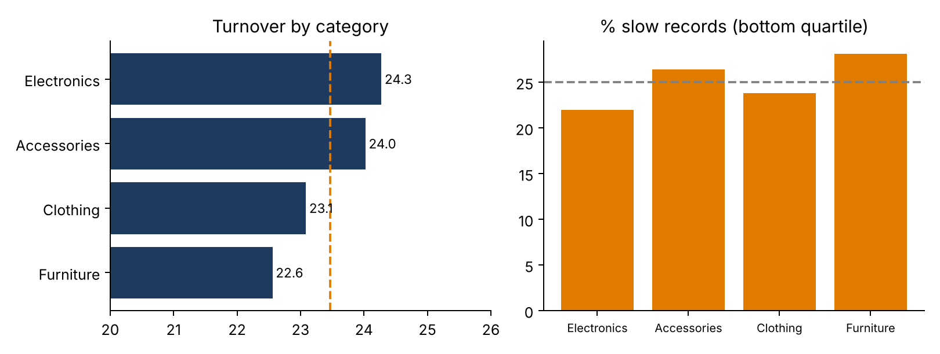

Category comparison
- Electronics (24.3) and Accessories (24.0) lead; Clothing (23.1) and Furniture (22.6) trail. The gap is about 1.7 points, or 7%.
- Furniture has the lowest median (17.1) and the highest backorder rate (12.4%), suggesting stock is mismatched to demand: too much of some items and shortages of others.
- Furniture has the largest share of slow records (28.1%), followed by Accessories (26.4%). Accessories has a strong overall ratio, so its average hides a weak tail.

4. Turnover by Warehouse, Region and Supplier
Group | Records | Turnover | Median | Slow % | Backorder %
Warehouse 1 | 403 | 25.0 | 21.8 | 23.6% | 10.9%
Warehouse 2 | 394 | 22.1 | 18.2 | 26.9% | 9.6%
Warehouse 3 | 403 | 23.3 | 19.5 | 24.6% | 8.4%
East | 284 | 23.2 | 20.0 | 22.5% | 8.1%
North | 317 | 25.1 | 22.8 | 24.3% | 11.0%
South | 282 | 22.0 | 17.1 | 28.0% | 10.3%
West | 317 | 23.3 | 18.7 | 25.2% | 9.1%
Supplier A | 312 | 23.9 | 20.2 | 23.1% | 7.1%
Supplier B | 310 | 23.2 | 20.0 | 30.0% | 10.3%
Supplier C | 275 | 23.2 | 19.4 | 24.4% | 9.1%
Supplier D | 303 | 23.6 | 18.7 | 22.4% | 12.2%

- Warehouse 1 is most efficient (25.0) and Warehouse 2 least (22.1).
- North leads regions (25.1); South is lowest (22.0).
- Suppliers differ little (23.2–23.9). Supplier D has the highest backorder rate (12.2%).

5. Slow-Mover List
A record is slow-moving when its turnover is below 9.1 (bottom quartile). The table ranks Category × Warehouse × Region segments with at least 15 records, lowest turnover first.

5.1 Ten slowest segments
# | Category | Warehouse | Region | Records | Turnover | Slow % | Backorder %
1 | Accessories | Warehouse 3 | South | 25 | 17.6 | 44.0% | 0.0%
2 | Clothing | Warehouse 3 | South | 34 | 18.4 | 32.4% | 8.8%
3 | Clothing | Warehouse 2 | South | 27 | 18.8 | 25.9% | 22.2%
4 | Accessories | Warehouse 2 | North | 29 | 18.8 | 41.4% | 0.0%
5 | Furniture | Warehouse 1 | West | 33 | 18.9 | 27.3% | 12.1%
6 | Accessories | Warehouse 2 | East | 27 | 19.0 | 29.6% | 3.7%
7 | Accessories | Warehouse 1 | West | 21 | 19.2 | 42.9% | 19.0%
8 | Clothing | Warehouse 3 | North | 25 | 19.4 | 28.0% | 8.0%
9 | Clothing | Warehouse 2 | West | 21 | 19.5 | 33.3% | 14.3%
10 | Furniture | Warehouse 3 | South | 27 | 20.1 | 25.9% | 18.5%

Accessories in Warehouse 3 (South), Warehouse 2 (North) and Warehouse 1 (West) combine low turnover with 41–44% of records in the slow bucket and low backorder rates. That points to overstock, not shortage, and these are the first candidates for reduced reordering. Clothing in Warehouse 2 / South and Furniture in Warehouse 1 / West also show elevated backorders, a sign of imbalance across items.

5.2 Ten slowest individual records
Date | Category | Warehouse | Region | Units Sold | COGS | Avg Inventory | Turnover
2023-03-17 | Accessories | Warehouse 3 | South | 62 | 1,416 | 2,852.5 | 0.50
2024-03-29 | Furniture | Warehouse 1 | South | 53 | 1,981 | 3,927 | 0.50
2022-05-28 | Electronics | Warehouse 3 | West | 93 | 2,109 | 4,132 | 0.51
2023-01-24 | Furniture | Warehouse 1 | West | 57 | 1,957 | 3,535 | 0.55
2020-07-24 | Furniture | Warehouse 2 | South | 61 | 1,877 | 3,182 | 0.59
2020-04-24 | Clothing | Warehouse 3 | West | 125 | 2,727 | 3,947.5 | 0.69
2023-12-19 | Furniture | Warehouse 1 | North | 70 | 1,613 | 2,185.5 | 0.74
2023-08-19 | Electronics | Warehouse 3 | South | 118 | 2,364 | 2,530 | 0.93
2022-10-19 | Accessories | Warehouse 2 | North | 124 | 2,551 | 2,399.5 | 1.06
2022-07-27 | Electronics | Warehouse 2 | South | 227 | 4,805 | 4,439.5 | 1.08

These records hold 2,000–4,000 units on average but sell fewer than 130 units. The full set of 300 slow records can be pulled with the SQL in the appendix.

5.3 Profile of slow records
Measure | Slow records | Other records
Average units sold | 293 | 614
Average inventory (units) | 3,017 | 2,367
Average inventory level (units) | 2,989 | 2,378
Average lead time (days) | 15.6 | 15.8
Backorder rate | 7.0% | 10.6%

Slow records are defined by high stock and low sales, not by lead time. Lead time is nearly identical across both groups, so slow movement comes from demand and ordering decisions rather than supplier delay.

6. Interview Questions

What is inventory turnover?
Inventory turnover measures how many times a business sells and replaces its stock in a period. It is calculated as COGS divided by average inventory. A higher ratio means products sell quickly and less cash is tied up in stock; a lower ratio means stock is sitting.

Why can high turnover be risky?
- Stockouts: very fast turnover can mean stock is too lean, leading to lost sales and backorders.
- Customer impact: unavailable products damage satisfaction and loyalty.
- Higher costs: frequent small reorders raise ordering and transport costs, and lose bulk discounts.
- Supply risk: little safety stock leaves no buffer against delays or demand spikes.
- Misleading signal: a high ratio may come from low inventory rather than strong sales. In this dataset the fastest records show this link: turnover correlates negatively with inventory held (r = −0.50).

7. Recommendations
- Cut replenishment for the slow segments in section 5.1, starting with Accessories in Warehouses 1, 2 and 3.
- Rebalance stock between warehouses rather than buying new stock, especially from Warehouse 2 where turnover is lowest.
- Review Furniture: low turnover plus the highest backorders suggests the wrong mix of items.
- Set a turnover alert (for example below 9, the bottom quartile) and a stockout alert for the fastest records.
- Add a period field and unit cost to the data so turnover can be annualized and days-of-inventory calculated.

8. Limitations
- Turnover uses COGS in currency over inventory in units, so use it for relative comparison.
- No period length per record, so figures are not annualized.
- Category and warehouse differences are small; the segment list is a watch list that needs confirmation with item-level data.

Appendix: SQL Queries
Table name: inventory. Column names are shown with quotes as in the CSV header.

A. Turnover by category
SELECT Category,
COUNT(*) AS records,
SUM(COGS) / SUM(AverageInventory) AS turnover,
SUM(UnitsSold) * 1.0 / SUM(AverageInventory) AS sell_through
FROM inventory
GROUP BY Category
ORDER BY turnover DESC;

B. Slow-moving records (bottom quartile)
WITH t AS (
SELECT *, COGS * 1.0 / AverageInventory AS turnover FROM inventory),
q AS (
SELECT turnover, NTILE(4) OVER (ORDER BY turnover) AS quartile FROM t)
SELECT t.* FROM t
WHERE t.turnover <= (SELECT MAX(turnover) FROM q WHERE quartile = 1)
ORDER BY t.turnover;

C. Slowest segments
SELECT Category, Warehouse, Region, COUNT(*) AS records,
SUM(COGS) / SUM(AverageInventory) AS turnover
FROM inventory
GROUP BY Category, Warehouse, Region
HAVING COUNT(*) >= 15
ORDER BY turnover ASC
LIMIT 10;

In Excel, create a helper column =COGS/Average Inventory and use a PivotTable, summing COGS and Average Inventory by group and dividing the totals.

