A/B Test Exploratory Analysis
Task 21 · Data Analytics Track · Report

1. Executive Summary
This report compares the conversion rates of two page variants, A (control) and B (variant), using data from 5,000 users. Variant B converted at 14.07% versus 5.40% for the control, an absolute lift of 8.67 percentage points (95% CI: 7.04 to 10.30 pp). The difference is highly statistically significant (z = 10.35, p < 0.001) and large in practical terms: B converts roughly 2.6 times as often as A.
Recommendation: roll out Variant B, while monitoring conversion after launch.

2. Objective and Hypotheses
The goal is to determine whether Variant B changes the conversion rate relative to the control, and to quantify the size and uncertainty of that change.
- Null hypothesis (H0): p_B = p_A. The two variants have the same conversion rate.
- Alternative hypothesis (H1): p_B ≠ p_A. The conversion rates differ (two-sided test).
Significance level: α = 0.05. Primary metric: conversion rate (share of users with Conversion = Yes).

3. Data Overview
The dataset (ab_testing.csv) contains 5,000 rows, one per user, with seven columns: User ID, Group (A/B), Page Views, Time Spent (seconds), Conversion (Yes/No), Device (Desktop/Mobile) and Location (England, Northern Ireland, Scotland, Wales).
- No missing values and no duplicate User IDs were found.
- Group sizes are 2,519 (A) and 2,481 (B). A sample ratio mismatch check gives χ² = 0.29, p = 0.59, so the split is consistent with a 50/50 allocation.
- Overall conversion is 9.7% (485 of 5,000 users).

4. Comparison Table
Metric | A (Control) | B (Variant) | Difference | Note
Users | 2,519 | 2,481 | -38
Conversions | 136 | 349 | +213
Conversion rate | 5.40% | 14.07% | +8.67 pp | Primary metric
Avg. page views | 7.58 | 7.49 | -0.09 | p = 0.44
Avg. time spent (s) | 241.7 | 243.3 | +1.6 | p = 0.64

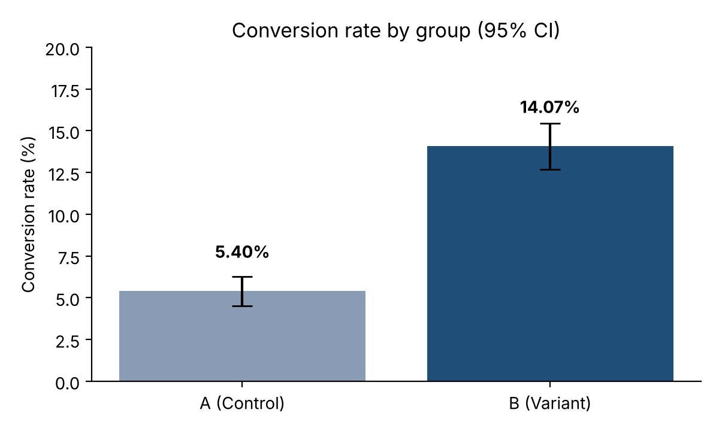

5. Test Result
Statistic | Value
Test | Two-proportion z-test (pooled); chi-square and Fisher's exact test agree
z-statistic | 10.35
p-value | < 0.001 (chi-square p ≈ 1e-25)
Absolute lift | +8.67 pp (95% CI: 7.04 to 10.30 pp)
Relative lift | +160.5% (95% CI: about +115% to +215%)
Risk ratio | 2.61
Odds ratio | 2.87
Cohen's h (effect size) | 0.30 (small to medium)
Statistical power | > 99.9% for the observed effect

We reject the null hypothesis. The confidence interval for the difference excludes zero by a wide margin, so even the most conservative end of the interval (about 7 pp) represents a substantial improvement.

6. Effect Size and Practical Significance
Statistical significance only says the difference is unlikely to be chance; effect size says whether it matters. Here the absolute lift is 8.67 pp, meaning roughly 9 additional conversions for every 100 users exposed to B. Cohen's h of 0.30 is conventionally small to medium, which is a reminder that h is a standardised measure and that low base rates compress it. In business terms, the relative lift of about 160% is very large. The lower bound of the interval is still far above any plausible minimum worthwhile effect, so the result is both statistically and practically significant.

7. Segment Analysis
Conversion by device and location shows that B outperforms A in every segment, so the effect is not driven by a single subgroup.
Segment | A rate | B rate | Lift (pp) | n (A / B)
Desktop | 5.87% | 13.91% | +8.04 | 1,244 / 1,294
Mobile | 4.94% | 14.24% | +9.30 | 1,275 / 1,187
England | 6.93% | 14.69% | +7.76 | 606 / 640
Northern Ireland | 5.05% | 11.47% | +6.42 | 614 / 628
Scotland | 4.93% | 15.06% | +10.13 | 670 / 611
Wales | 4.77% | 15.12% | +10.35 | 629 / 602

Segment results are exploratory. Each segment has a few hundred users per arm, so differences between segments (for example Northern Ireland versus Wales) should not be over-interpreted.

8. Secondary Metrics
Page views (Welch t-test p = 0.44) and time spent (p = 0.64) do not differ significantly between groups. Variant B therefore raises conversion without a measurable change in engagement depth, and without evidence that it harms those metrics.

9. Assumptions and Limitations
- Users are assumed to be independently and randomly assigned. The balanced group sizes and similar device and location mix support this, but the dataset does not document the assignment mechanism.
- The data has no timestamps, so novelty effects, day-of-week effects and test duration cannot be assessed.
- Conversion is a binary flag; revenue or value per conversion is not available.
- The size of the effect is unusually large for typical web experiments. It is worth confirming that tracking was implemented identically in both arms before acting on it.

10. Recommendation
Adopt Variant B. The evidence strongly favours B on the primary metric, the effect is consistent across devices and regions, and no secondary metric deteriorated.
- Roll out B to all users, ideally staged (for example 50% then 100%) with a small holdout to confirm the lift persists.
- Verify event tracking and randomisation for both arms, given the size of the effect.
- Monitor conversion, page views and time spent after launch, and review segment performance (especially Northern Ireland) for follow-up tests.

11. Interview Question Notes

Statistical vs practical significance?
Statistical significance asks whether an observed difference is unlikely under the null hypothesis; it depends heavily on sample size. Practical significance asks whether the difference is big enough to matter for the business. With very large samples, trivial differences can be significant; with small samples, important differences can be missed. Always report both the p-value and the effect size with a confidence interval. Here both are satisfied.

Why use a control group?
A control group provides the baseline needed to isolate the effect of the change. Without it, differences over time (seasonality, marketing, external events) could be mistaken for the effect of the variant. Random assignment to control and variant balances other factors on average, which supports a causal interpretation.

