Cohort Retention Analysis
Task 22 – Cohort Retention Basics · Online Retail II dataset · Data Analytics Track

1. Objective
Build a cohort retention table by signup month and use it to understand how customers return over time. This report covers the cohort definition, the cohort table, a heatmap, key insights, and answers to the interview questions.

2. Data and Method
The Online Retail II dataset contains transactions from a UK-based online gift retailer between December 2009 and December 2011. Both yearly sheets were combined and cleaned as follows:
Step | Rows removed | Rows left
Raw rows (both sheets) | – | 1,067,371
Exact duplicates (sheet overlap) | 34,335 | 1,033,036
Missing Customer ID | 235,151 | 797,885
Cancellations, Quantity ≤ 0, Price ≤ 0 | 18,460 | 779,425

The final dataset has 5,878 unique customers. Customers were assigned to a cohort by the month of their first purchase. The retention window is the number of months since that first purchase (Month 0 to Month 24), applied identically to every cohort. Retention for a cohort in Month N is the share of its customers who placed at least one order in that month.

Cohort definition
- Cohort: customers grouped by first-purchase month (25 cohorts, Dec 2009 – Dec 2011).
- Active: a customer with at least one valid invoice in the month.
- Retention %: active customers in Month N ÷ cohort size.

3. Cohort Table
The table below shows retention % for selected months. The full 25 × 25 tables (counts and percentages) are in the CSV files delivered with this report.
Cohort | Size | M1 | M2 | M3 | M6 | M9 | M12
2009-12 | 955 | 35 | 33 | 43 | 38 | 36 | 38
2010-01 | 383 | 21 | 31 | 31 | 26 | 32 | 22
2010-02 | 374 | 24 | 23 | 29 | 19 | 28 | 15
2010-03 | 443 | 19 | 23 | 24 | 25 | 11 | 20
2010-04 | 294 | 19 | 19 | 16 | 28 | 11 | 14
2010-05 | 254 | 16 | 17 | 17 | 21 | 8 | 15
2010-06 | 270 | 17 | 19 | 20 | 13 | 12 | 15
2010-07 | 186 | 16 | 18 | 30 | 11 | 11 | 13
2010-08 | 162 | 20 | 30 | 32 | 10 | 13 | 15
2010-09 | 243 | 23 | 24 | 12 | 14 | 13 | 22
2010-10 | 377 | 26 | 15 | 13 | 13 | 9 | 19
2010-11 | 325 | 18 | 9 | 10 | 13 | 9 | 26
2010-12 | 76 | 9 | 5 | 9 | 5 | 3 | 3
2011-01 | 71 | 17 | 21 | 20 | 16 | 21 | –
2011-02 | 124 | 16 | 15 | 19 | 15 | 18 | –
2011-03 | 179 | 18 | 22 | 20 | 21 | 10 | –
2011-04 | 106 | 26 | 20 | 20 | 18 | – | –
2011-05 | 111 | 23 | 24 | 16 | 26 | – | –
2011-06 | 108 | 23 | 21 | 27 | 8 | – | –
2011-07 | 102 | 22 | 30 | 28 | – | – | –
2011-08 | 106 | 27 | 31 | 26 | – | – | –
2011-09 | 189 | 27 | 38 | 15 | – | – | –
2011-10 | 221 | 32 | 16 | – | – | – | –
2011-11 | 191 | 14 | – | – | – | – | –
2011-12 | 28 | – | – | – | – | – | –
Table 1. Retention (%) by cohort at selected months since first purchase (– = not yet observable).

4. Retention Heatmap
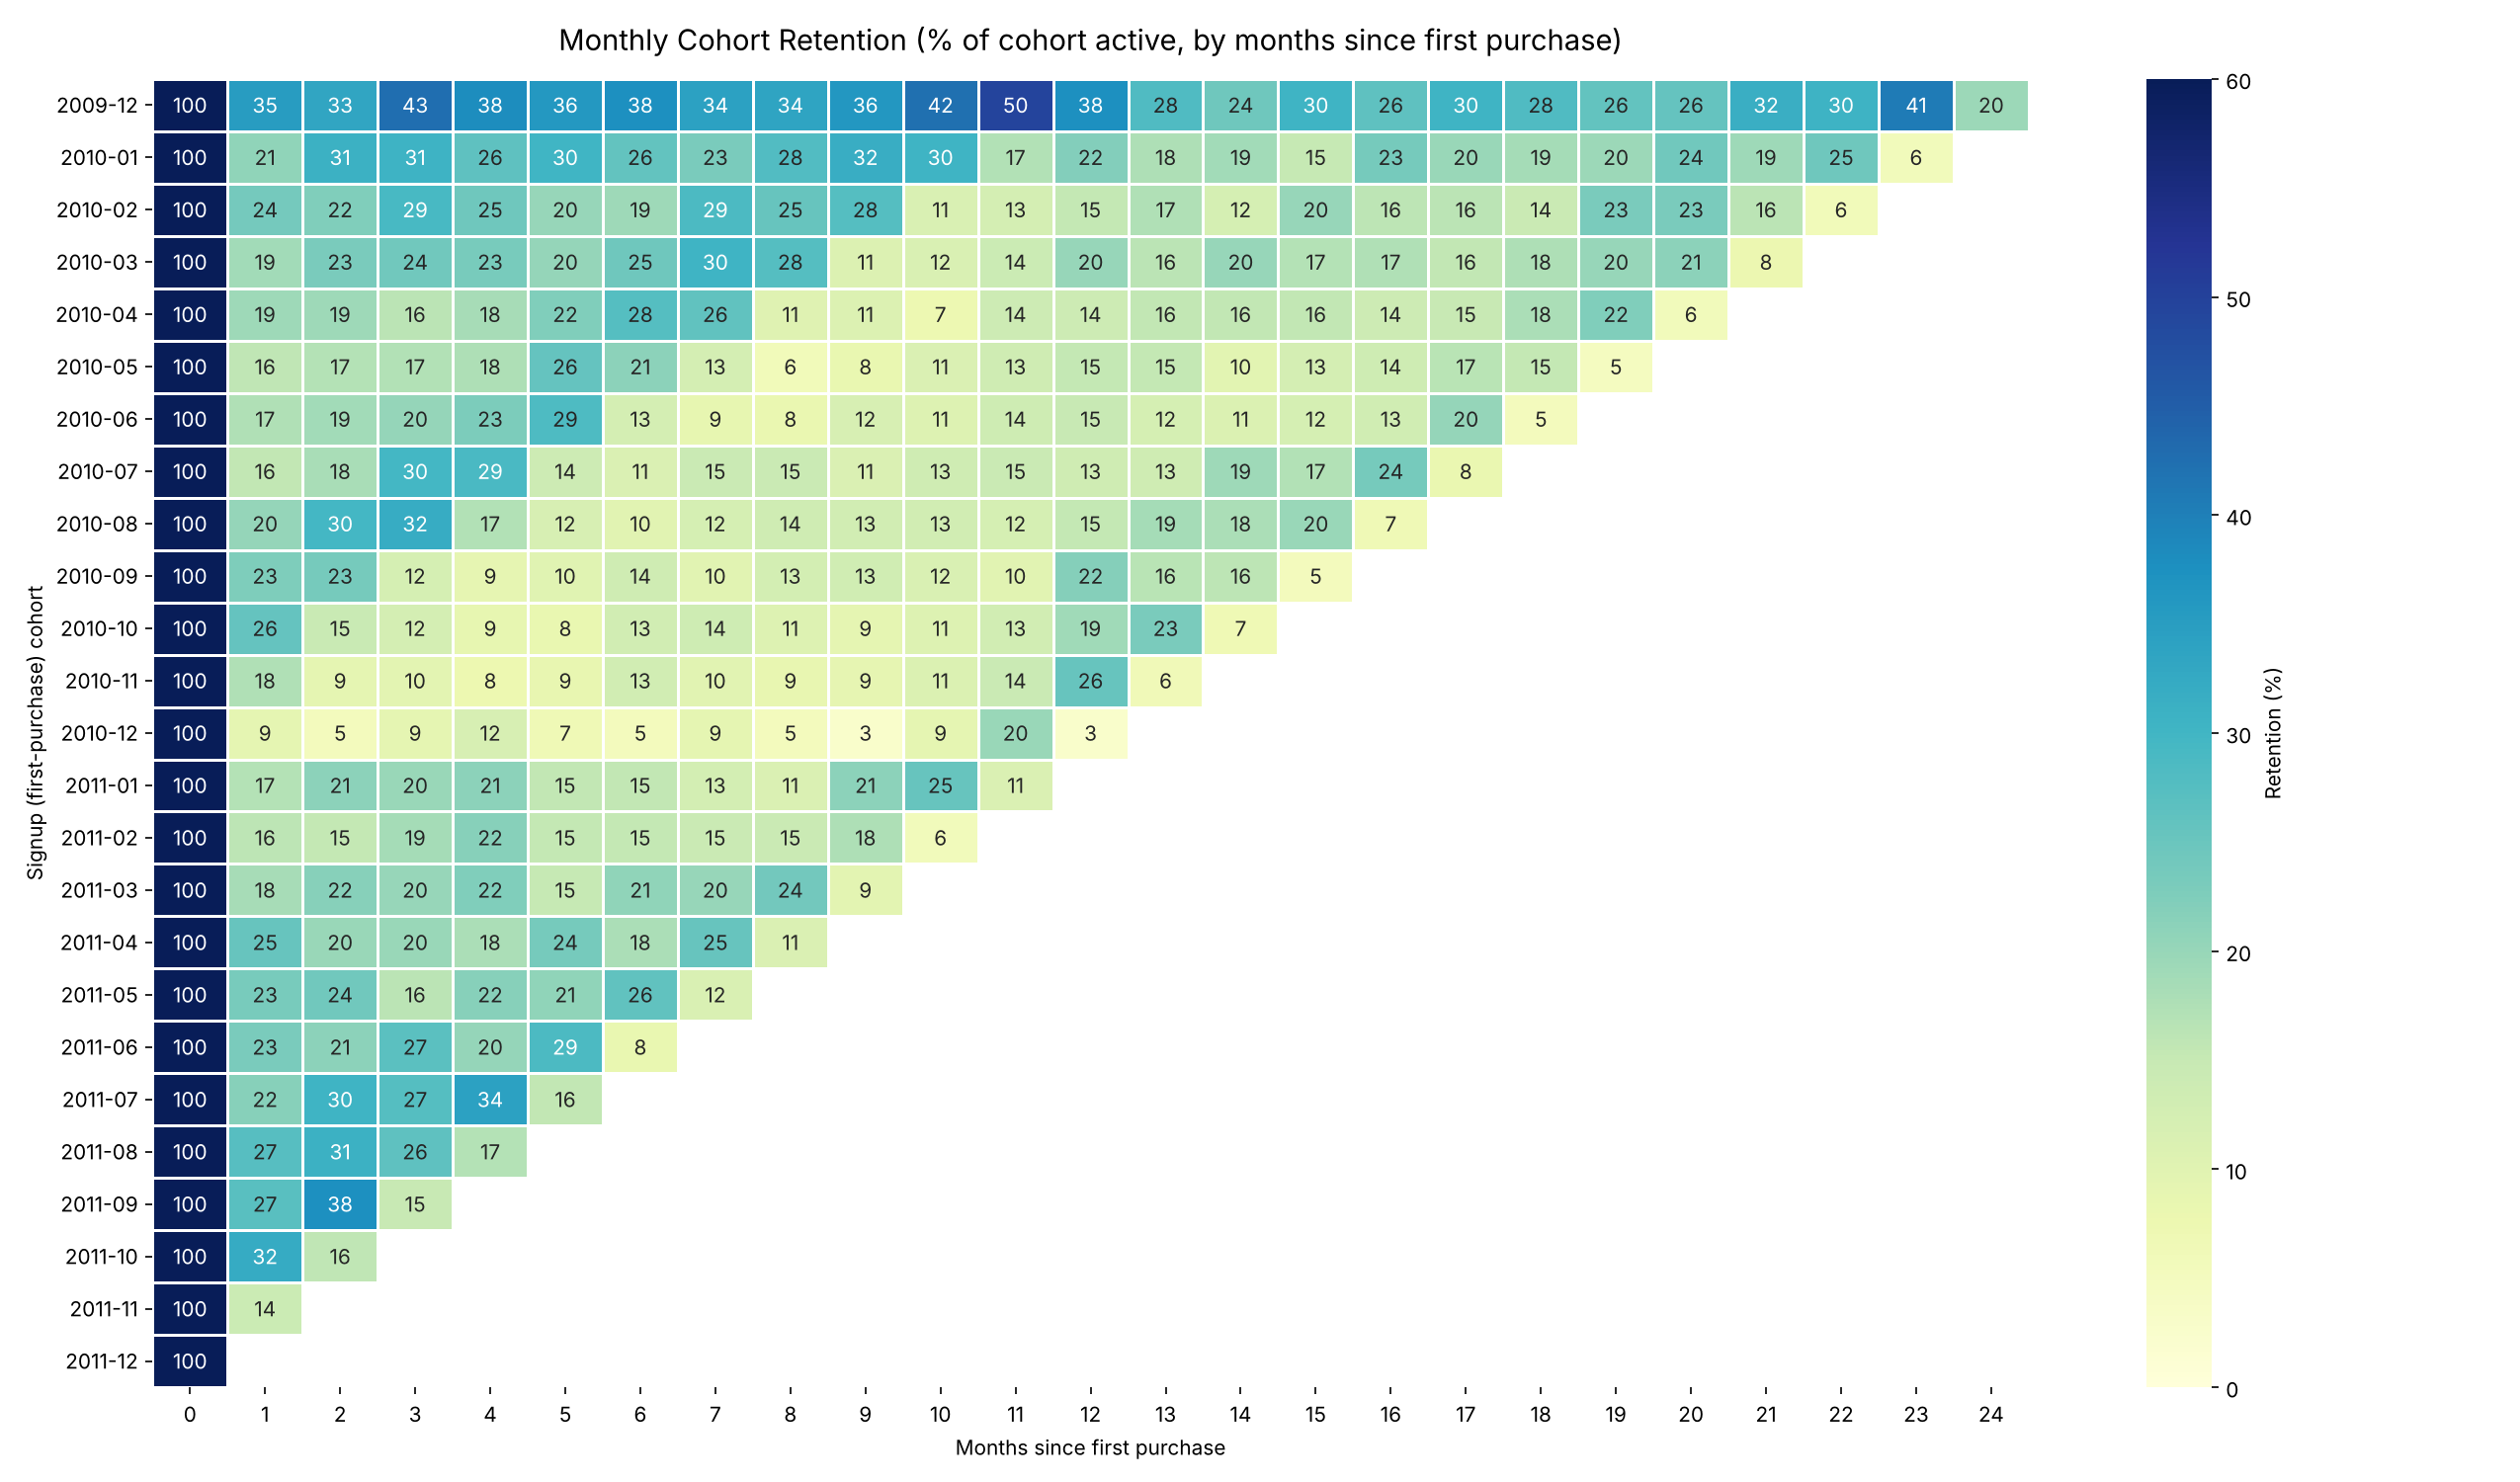
Figure 1. Monthly cohort retention heatmap (darker = higher retention).
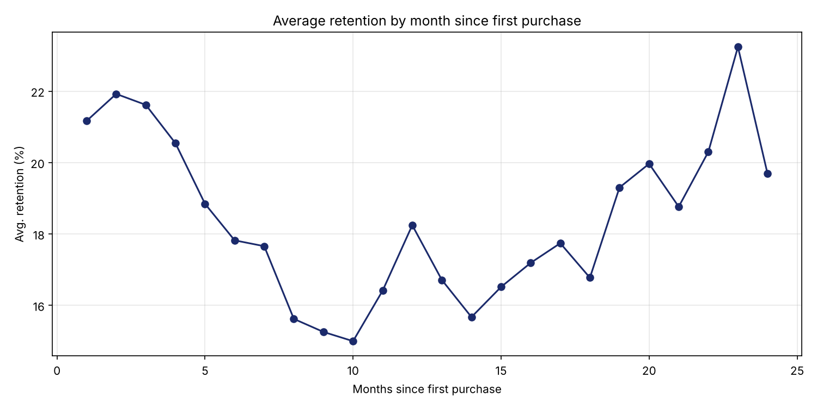
Figure 2. Average retention by month since first purchase (simple mean across cohorts).

5. Key Insights

5.1 Typical retention
Excluding the December 2009 cohort, an average new customer has about a 21% chance of buying again in Month 1, 21% in Month 3, 18% in Month 6 and 18% in Month 12. The drop is steep at first and then flattens: after the first couple of months, retention settles into a floor of roughly 15–20% rather than decaying to zero. This suggests a core group of repeat buyers, which fits a wholesale-style gift business.
Group (size-weighted) | M1 | M3 | M6 | M12 | Note
Dec 2009 cohort (955) | 35.3% | 42.5% | 37.7% | 37.6% | Includes existing customers
2010 cohorts, Jan–Dec | 19.9% | 20.7% | 18.1% | 18.4% | –
2011 cohorts, Jan–Oct | 24.0% | 21.7% | 19.5% | n/a | M12 not yet observable

5.2 The December 2009 cohort is not a true “new customer” cohort
The dataset starts in December 2009, so this cohort mixes genuinely new customers with long-standing ones whose earlier purchases are not visible. This explains its much higher retention (35–50%). It contains 955 customers (16% of all) and generates 49% of all revenue in the cleaned data. It should be treated as a baseline for existing customers and not compared directly with later cohorts.

5.3 Seasonality shapes retention
- Customers who joined in September–December 2010 (peak gift season) retained worst early on: the Nov 2010 cohort fell from 18% at Month 1 to 8–10% in Months 4–9, and the Dec 2010 cohort had only 9% at Month 1.
- The same cohorts rebound around Month 12 (Nov 2010: 25.5%, Oct 2010: 19.1%, Sep 2010: 21.8%), which is the following autumn. Many of these customers appear to be seasonal buyers who return for the next peak, not lost customers.
- Calendar-wide dips are visible too: nearly every 2010 cohort drops in the Dec 2010 column, reflecting a lower active base in that month. This shows up as a diagonal pattern in the heatmap.

5.4 Acquisition volume and quality varied
- New-customer volume was highest in Dec 2009 (955) and Jan–Mar 2010 (374–443), then fell to 162–294 per month in mid-2010, rose again in Oct–Nov 2010 (377 and 325), and was lower in 2011 (71–221 per month).
- Cohorts acquired in spring and summer 2011 (Apr–Sep) show better early retention (Month 1 of 22–27%) than those of mid-2010 (Month 1 of 16–20%), though they have shorter histories.
- The 2011-10 cohort has the best Month 1 retention (32%) and the 2010-07 cohort the lowest of the full-month cohorts (16%).

5.5 Repeat behaviour overall
72.4% of customers placed more than one order during the period, so one-time buyers are a minority. Monthly retention of about 20% is therefore not a sign that 80% of customers are lost: customers buy irregularly and many skip months before returning.

6. Recommendations
- Re-engage seasonal buyers: send reminders or early-access offers to customers acquired in autumn about 10–11 months later, ahead of their typical return window.
- Strengthen the first 90 days: Month 1–3 is where the largest drop-off occurs, so a follow-up offer or reorder prompt after the first purchase should have the largest effect.
- Study the high-retention cohorts (Dec 2009, spring/summer 2011, Oct 2011) to learn which acquisition channels or products produced loyal customers.
- Track retention with a consistent window: report Month 1, 3, 6 and 12 retention by cohort every month using the same definition.

7. Interview Questions

What is a cohort?
A cohort is a group of users or customers who share a common characteristic within a defined time period, most often the month in which they first signed up or purchased. Following each cohort separately over time lets us compare groups acquired at different times on equal terms. In this project, a cohort is all customers whose first purchase fell in the same calendar month.

Why is cohort retention useful?
- It separates the effect of customer age from calendar effects, so a growing customer base does not hide declining loyalty.
- It shows how quickly customers drop off and when retention levels off, which tells a team where to focus on onboarding or re-engagement.
- It allows fair comparison of different acquisition periods, campaigns or product changes (for example, whether 2011 customers behave better than 2010 customers).
- It supports forecasting of repeat revenue and customer lifetime value.

8. Limitations
- Signup is approximated by first purchase because the data has no registration date, and December 2009 includes existing customers.
- The dataset ends on 9 December 2011, so the last diagonal (and the 28-customer Dec 2011 cohort) covers a partial month and understates retention.
- About 20% of line items have no Customer ID and were excluded, so results describe identified customers only.
- Small cohorts (for example Dec 2010 with 76 customers and Dec 2011 with 28) produce volatile percentages.
- Retention here measures activity (any purchase), not revenue; a revenue or order-frequency cohort view would be a useful follow-up.

9. Appendix – Files
cohort_analysis.py – full pandas pipeline. cohort_retention.sql – SQL version (verified to match). cohort_active_customers.csv and cohort_retention_pct.csv – cohort tables. Charts: cohort_retention_heatmap.png, avg_retention_curve.png.

