Group 5 Written Report
Our project helps HR teams use Singapore IT job advertisements to plan salary budgets and hiring priorities. The salary analysis shows that pay differs across position levels, while overlapping salary distributions make job function an important part of a fair comparison.

Team workstreams
Topic | Owner | Data handling notebook | Dashboard/app code | Dashboard/app  Link
Written report | All | Group5_Project1_Report |  | /
Presentation Slide | All | Group5_Project1_Presentation |  | /
Github README | All | README | / | /
Cleaned_Master_Dataset | All | Team_Data_Cleaning_Final.ipynb  Jobs_clean.csv | / | /
Case1: Salary benchmark by seniority | Rachelle Congrui Liu (C) | Rachelle_salarycase_by_position_level.ipynb | Rachelle Streamlit _salarycase_by_position_level.py | https://group5-singapore-it-salary.streamlit.app/#salary-benchmark-by-position-level
Case2: Experience premium | Jen Ho | JCFileAnaysis.ipynb | JC_Streamlit.py | On localhost and Power BI
Case3: Contract vs permanent | Wong Siew Yin | SY_Bus_Qn_data_analysis_.ipynb | streamlit_dashboard.py | https://group5-singapore-it-salary-sy-qn3.streamlit.app/
Case4: Which IT job categories are high demand and hard to fill | Adelene Soh Puay Siam | Notebook4.ipynb | hard_to_fill_dashboard.py | https://group5-singapore-it-salary-sy-qn4.streamlit.app/

1.Business Case
- Business scenario. Talent Acquisition and Compensation and Benefits teams must compete for IT talent within limited hiring budgets. They need a consistent reference for reviewing offers and role requirements.
- Objective. Benchmark advertised salary by seniority, examine experience premiums, compare contract and permanent hiring patterns, and identify technology specialisms that are in high demand and hard to fill.
- Target users and value. Heads of Talent Acquisition, Compensation and Benefits leads and hiring managers can use the findings to review salary bands, calibrate experience requirements, consider employment mix and prioritise recruitment effort.
Success means that an HR user can select a relevant comparison group and explain a hiring decision using salary evidence and posting counts. The dashboard supports judgement; it does not establish actual employee pay or the availability of candidates.

2. Data Handling and Process
- Load and inspect. Python and Pandas load the full 1,048,585-row CSV. We inspect schema, missing values, numeric summaries, salary periods and duplicate job IDs. The final analysis uses the full selected dataset, not a sample.
- Clean the source. Remove 3,988 structurally empty records and the entirely missing occupationId column. Preserve raw salary fields, standardise whitespace and convert numeric values and dates. Duplicate checks require no additional row removal.
- Define the population to select source-labelled IT jobs. Parse the category JSON arrays and retain postings carrying the source Information Technology tag. This leaves 140,866 unique postings. Keep a separate job-to-category table because one posting can have multiple source categories.
- Engineer comparison fields. Calculate midpoint = (minimum + maximum) / 2, band width = maximum - minimum, and posting month. First-match title keywords assign seven inferred IT job functions, including Other IT, across nine position levels.
- Validate salary. Require Monthly pay, both bounds present, minimum > 0 and maximum >= minimum. All 140,866 IT records pass. Original posting dates span 6 October 2022 to 29 May 2024; the benchmark describes historical advertisements.
- Screen unusual values. Within IT function x position level, groups of at least five valid records use inclusive bounds Q1 - 1.5 x IQR to Q3 + 1.5 x IQR, where IQR = Q3 - Q1. Additional team rules require minimum >= SGD 1,000, maximum <= SGD 25,000, width <= SGD 10,000 and maximum/minimum <= 3. These thresholds were chosen to identify extreme or potentially miscoded salary records:
- Minimum ≥ SGD 1,000: excludes the lowest approximately 1% of reported salaries.
- Maximum ≤ SGD 25,000: retains approximately 99% of salary maximums while screening unusually high values.
- Width ≤ SGD 10,000: removes excessively broad salary ranges.
- Maximum/minimum ≤ 3: limits implausibly large gaps between the advertised minimum and maximum.
- Retain an audit trail. Set salary_analysis_ready=True only for valid records within the group bounds that pass all extra checks. Preserve every original salary value in the master file. EDA found extreme and broad advertised bands, motivating median-based comparisons, explicit review flags and visible sample sizes. Salary_analysis_ready = False means the record failed one or more salary-quality checks, such as invalid monthly salary, peer-group IQR screening, missing values, or the additional thresholds. These records should be excluded from the main salary analysis but retained for audit. Their exclusion reasons should be reviewed, as a flagged record is not necessarily incorrect.
Stage | Records
Original source | 1,048,585
After structurally empty records | 1,044,597
IT population and initial salary validity | 140,866
Salary analysis ready | 134,503
Retained for review | 6,363

3 Dashboard and App

3.1 Salary benchmark by position level
Owner: Rachelle Congrui Liu (C).
Business question: How do advertised salary benchmarks differ by position level

Dashboard：https://group5-singapore-it-salary.streamlit.app/
1) Data Selection and Calculation: Each posting’s monthly salary midpoint is calculated as (minimum + maximum salary) ÷ 2. Across 134,503 eligible postings, the overall median midpoint is SGD 6,500, and each bar shows the median midpoint for one of the nine position levels.
- Selected postings: Count eligible records = 134,503.
- Salary midpoint Formula : (Minimum + Maximum monthly salary) ÷ 2.
- Overall median: Median of all selected midpoints = SGD 6,500.
- Each bar: Median salary midpoint for that position level.
- Q1–Q3: 25th–75th percentiles, showing the middle 50%.

2) Dashboard view or screenshot

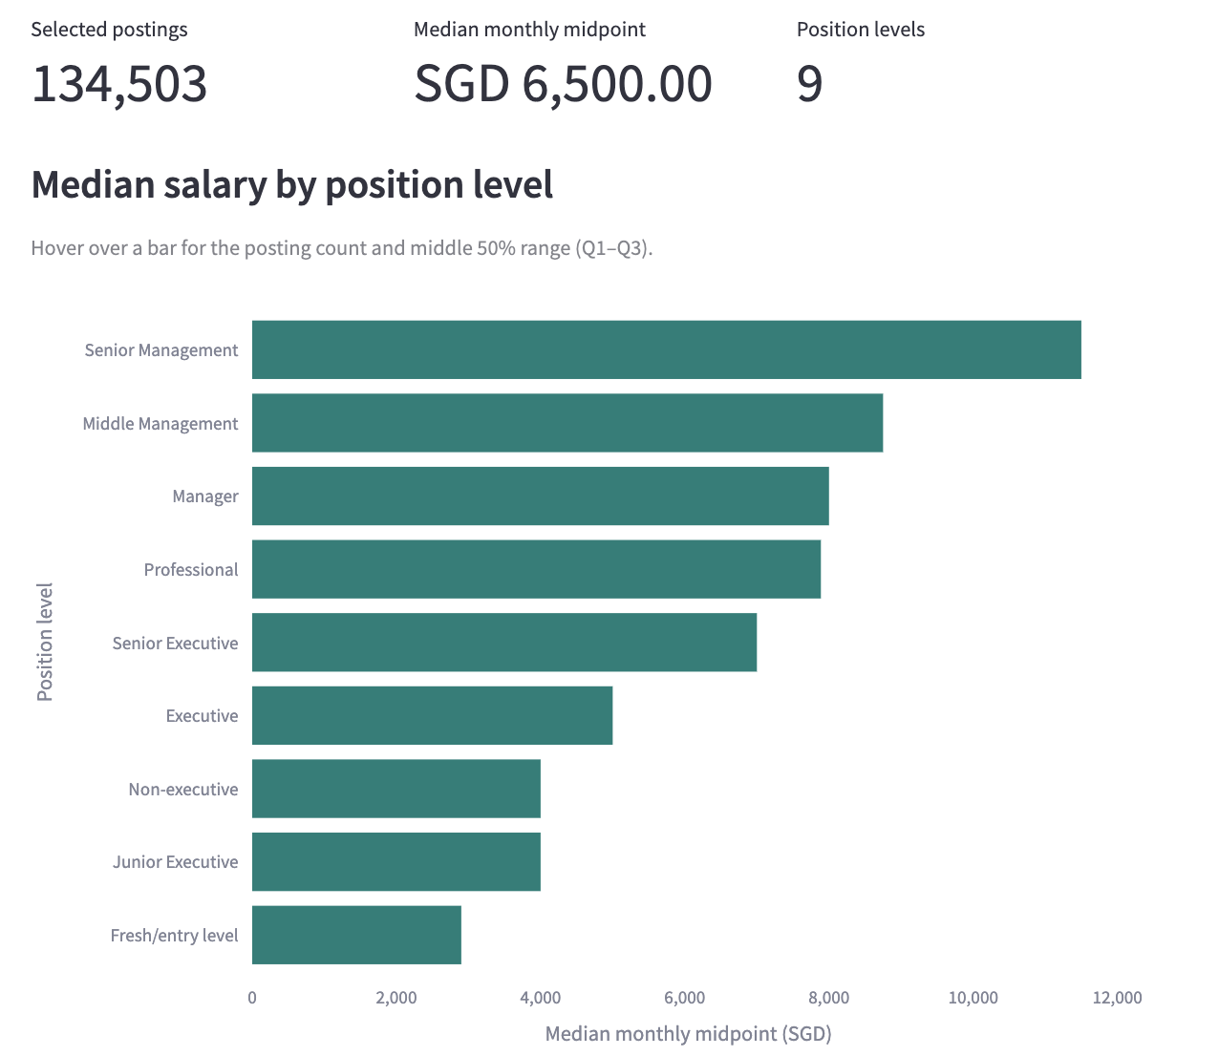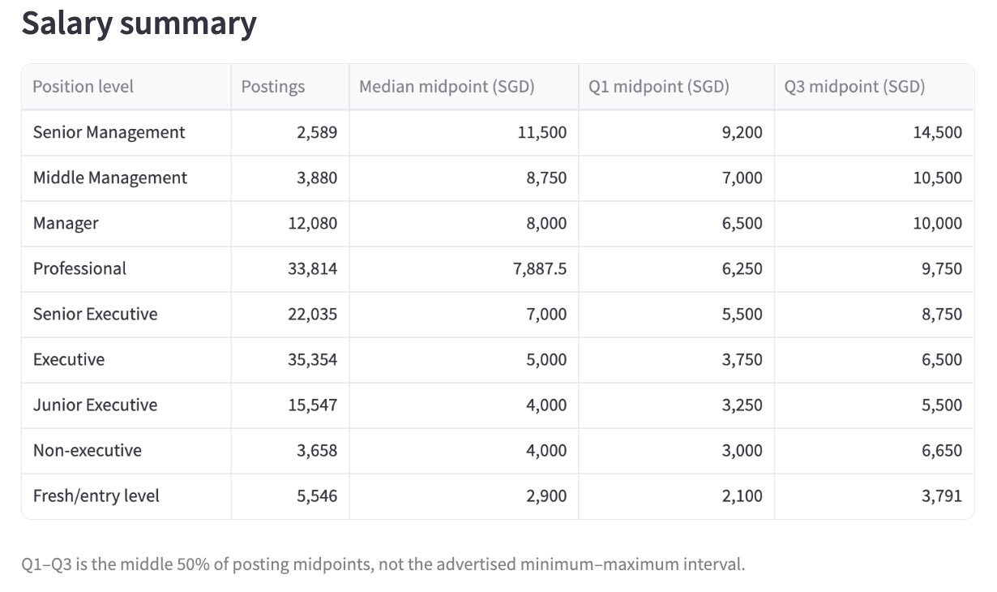
3) Key Findings and HR Recommendation
Key findings
- Overall median salary: SGD 6,500/month.
- Large pay gap by level: Senior Management has the highest median (SGD 11,500), while Fresh/Entry Level has the lowest (SGD 2,900).
- Management title ≠ higher pay: Manager (SGD 8,000) and Professional (SGD 7,887.50) differ by only SGD 112.50, with overlapping Q1–Q3 ranges.
HR recommendations:
- Pay for role scope, not title：Manager and Professional salaries are almost identical, so HR should benchmark based on responsibilities and skills, rather than assuming a management title deserves higher pay.
- Prioritise high-demand talent segments：Use posting volume + salary level together to identify roles where hiring demand is high and adjust recruitment budgets accordingly.
3.2 Experience premium
Owner: Jen Ho
Business question: How does advertised pay vary with required experience?
Dashboard：Streamlit and PowerBI desktop

1) Data selection and calculation

Data Used : minimumYearsExperience; average_salary; positionLevels
Formula:
% Change = (This year salary - previous previous salary) / previous year salary
Table plotted based on minimum years of experience - Sample of the data result (Top 6 records)
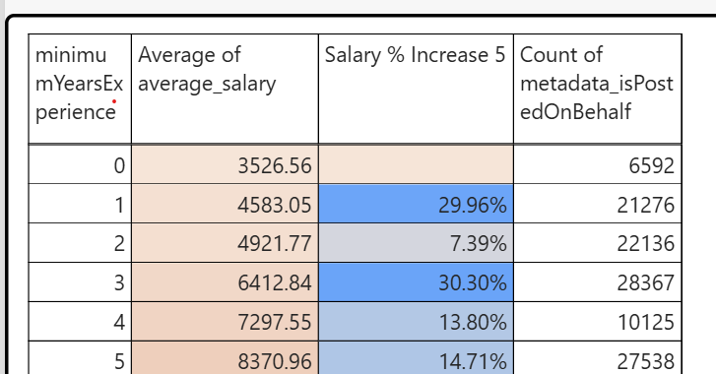

2) Dashboard view or screenshot
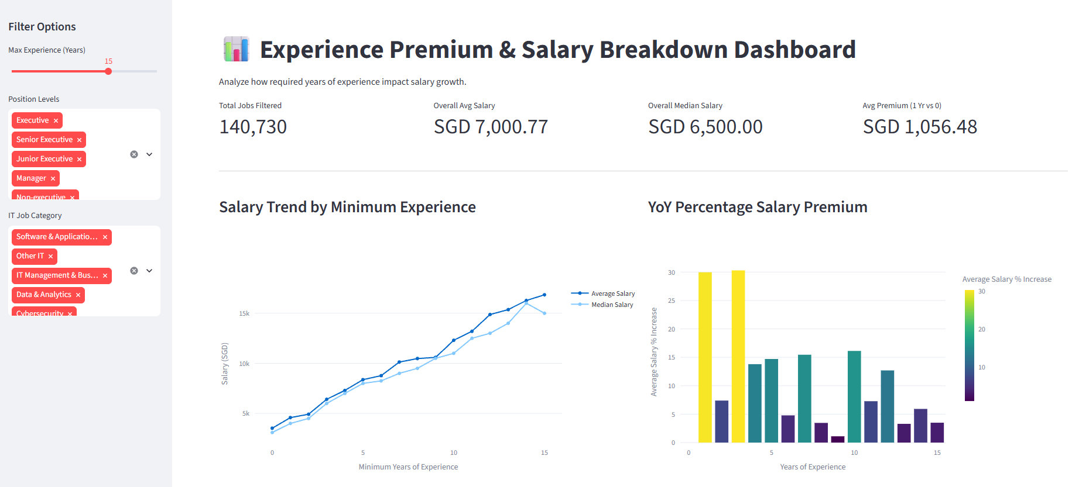

3) Key findings and HR recommendation
- Significant salary increase in these years (Years 1, 3, 5, 10): Salary growth peaks sharply at specific career inflection points. Year 1 (+29.96%) marks the transition out of fresh graduate tiers, Year 3 (+30.30%) reflects transition to independent executive roles, and Years 5, 7, and 10 represent standard management thresholds where compensation jumps by +SGD 1,000–1,700+.
- Plateau Years (Years 2, 6, 8, 9): Intermediate years show modest gains (+1.10% to +7.39%), indicating that incremental experience within the same responsibility bracket yields minimal salary adjustments compared to jumping across experience tiers.
- Early Career Multiplication: Between Year 0 and Year 5, median base pay more than doubles from SGD 3,100 to SGD 8,000, delivering average yearly gains of ~SGD 1,000.

3.3 Contract vs permanent
Owner: Wong Siew Yin
Business question: What employment mix appears in the market?
Dashboard：https://group5-singapore-it-salary-sy-qn3.streamlit.app/

1) Data selection and calculation
Two datasets were used for this analysis: all job postings across all industries, used as the market-wide baseline, and IT.
Calculation method
For each dataset, postings were grouped by employment type using pandas' value_counts(), and each type's share of postings was calculated as:
Percentage = (Number of postings in that employment type ÷ Total postings in the dataset) × 100
Employment types individually representing a small minority of a dataset's postings were combined into a single "Other" category. Counts and percentages were then recalculated on this regrouped set. The resulting charts show the distribution of employment types, by posting count and by percentage, for both the all-industries baseline and the IT dataset.

2) Dashboard view or screenshot
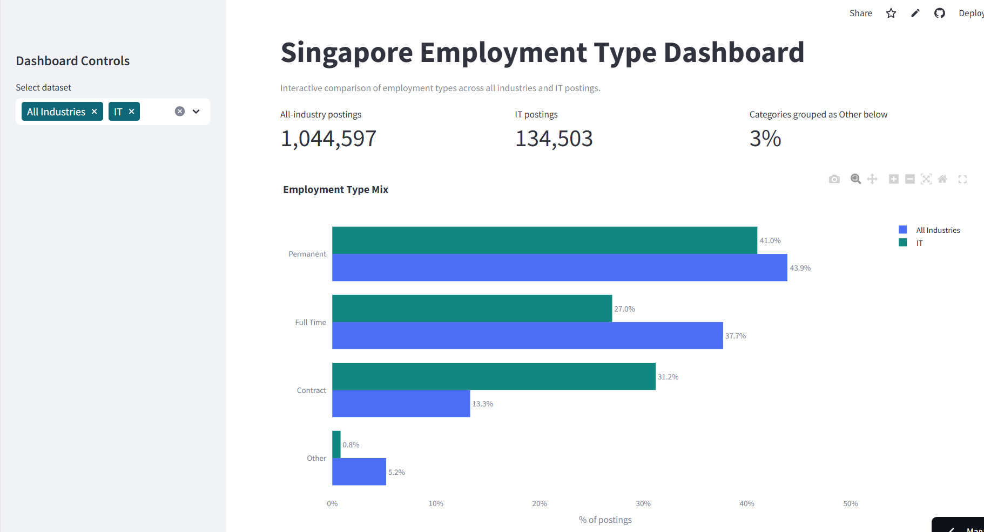
3) Key findings and HR recommendation
Key findings
Permanent hiring is still more common in both groups, but the gap is much smaller in IT. Market-wide, there are about 3.3 Permanent postings for every 1 Contract posting (43.9% vs 13.3%). In IT, that drops to about 1.3 to 1 (41.0% vs 31.2%). Contract hiring is more than twice as common in IT as in the rest of the market, and it's close to becoming as common as Permanent hiring, rather than being a small minority option.
HR recommendation
With contract roles making up 31.2% of IT postings compared to just 13.3% across the market, and Permanent still leading in both, HR and hiring teams need to plan for contract hiring as a standard part of recruiting for IT, not treat it as a one-off exception. Compensation should still be benchmarked separately for contract and permanent roles, since the two involve different hiring and budgeting decisions

3.4 Which IT job categories are high demand and hard to fill
Owner: Adelene Soh Puay Siam
Business question: Which IT Job categories are high demand and hard to fill
Dashboard：https://group5-singapore-it-salary-sy-qn4.streamlit.app/

1）Data selection and calculation
The IT postings are broken down into 7 ‘it_job_category’ buckets.
To flag a category as “hard to fill”, three signals are combined (each converted to a 0-100 rank score across the 7 categories, then averaged into a ‘hard_to_fill_index’):
- Demand : number of job postings (more postings = more hiring demand).
- Scarcity : applicants per vacancy (‘total_applications / total_vacancies’); the fewer applicants per open role, the scarcer the candidate pool.
- Backlog - % of postings still ‘open’ (not yet ‘Closed’/’Re-open’); a high proportion left open signals employers are struggling to close out the role.
“metadata_repostCount’ (reporting = a re-advertised, unfilled role) is reported alongside as a supporting signal, though it’s rare in this dataset (94% of postings were never reposted) so it’s not weighted into the index.

2）Dashboard view or screenshot
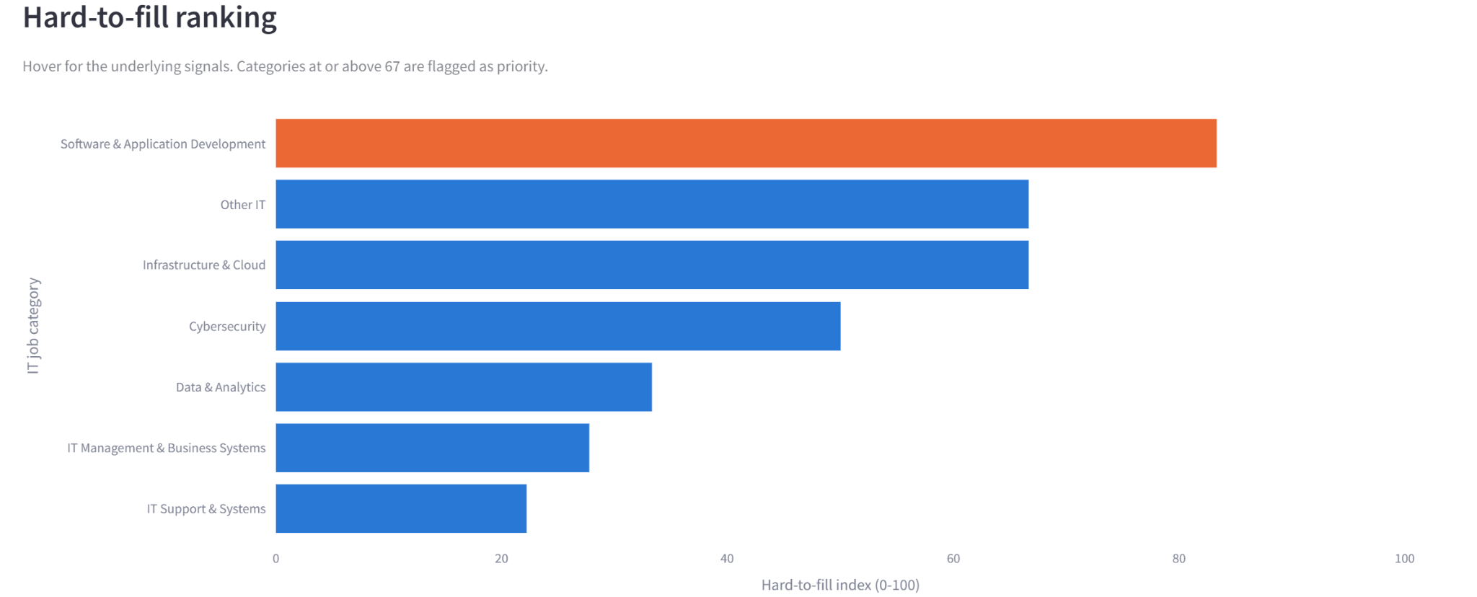
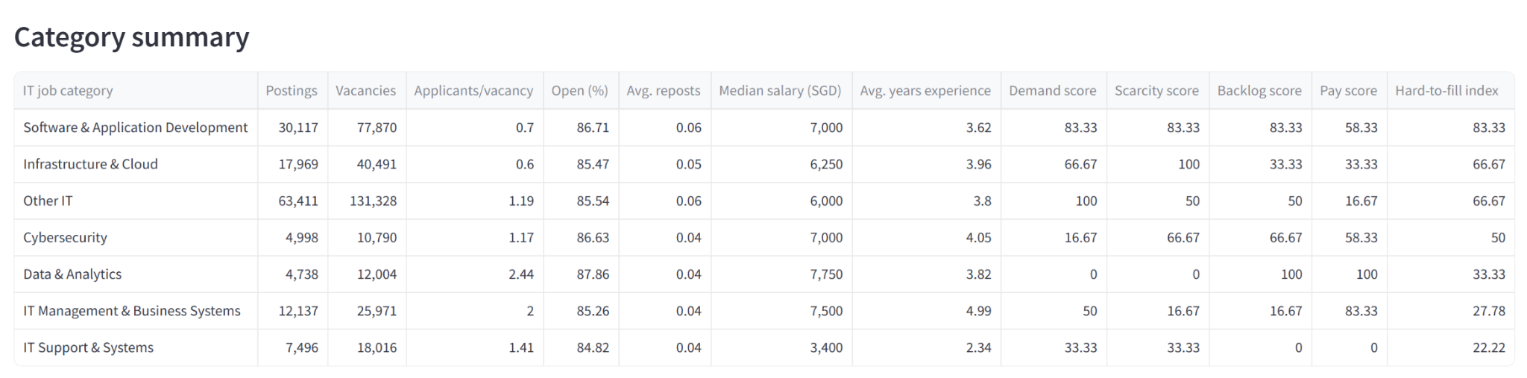

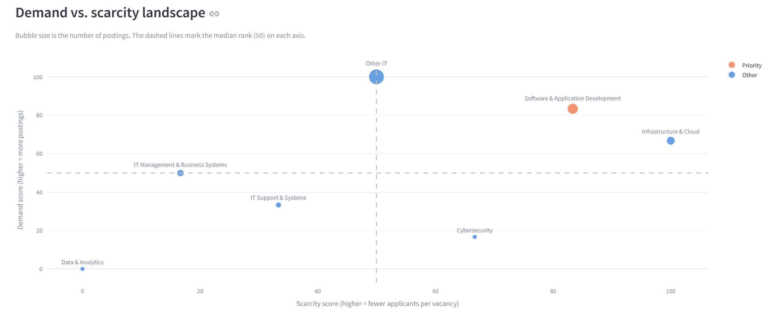

3）Key findings and HR recommendation
Key findings
Software & Application Development - is the clearest high-demand, hard-to-fill category, the most postings after the “Other IT” catch-all, one of the lowest applicants-per-vacancy (0.70) of any specific specialism, and 86.7% of its postings are still ‘Open’.
Infrastructure & Cloud - has the single scarcest candidate pool in the dataset (0.6 applicants-per- vacancy - the lowest of all 7 categories) combined with strong demand (2nd-highest posting volume), making it the #2 priority.
Data & Analytics - is a special case: it has the “best” applicant supply (2.44 applicant/vacancy) yet the highest share of postings still open (87.9&). That combination points to a qualification/skills mismatch, not a sourcing- volume problem.
IT Support & Systems - is the easiest category to fill (lowest ‘hard_to_fill_index’, lowest pay, fastest close-out).
Other IT - is the largest bucket by raw volume (65k postings) but is a catch-all label rather than a real specialisation - its applicants-per-vacancy (1.19) is healthier than Software & Application Development and IT Support & Systems, so raw volume alone overstates how “hard to fill” it really is. This is a data-labeling limitation and would need further review.

HR recommendation
- Software & Application Development - top priority, sourcing/pipeline problem
- Widest possible sourcing: expand beyond local applicant pools (0.70 applicants/vacancy is the tightest) - partner with universities/bootcamps, consider overseas/remote hires, employee referral bonuses.
- Review compensation competitiveness against market rate - 86.7% of postings stay open, suggesting offers aren’t converting.
- Shorten time-to-hire (streamline interview loops) since roles sit open a long time, every extra week increases risk of losing candidates to competitors.

- Infrastructure & Cloud - #2 priority, acute scarcity problem
  - This has the scariest talent pool overall (0.60 applicants/vacancy) - treat as a build-vs-buy problem: invest in upskilling/reskilling internal IT support staff into cloud roles rather than relying solely on external hiring.
  - Consider certifications-sponsorship programs (AWS/Azure/GCP) to grow the internal pipeline.
  - Explore contractor/managed-service partnerships to bridge gaps while internal capability is built.

- Data & Analytics - skills/qualification mismatch, not a sourcing problem
  - Applicant supply is healthy (2.44/vacancy) but 87.9% of postings stay open - the issue is candidates aren’t meeting the bar, not too few candidates.
  - Recommend to re-examine job requirements - are they overspecified or misaligned with what the role actually needs?

- “Other IT” - fix the data before acting on it
  - Don’t treat this as a single hiring priority - it’s a labeling artifact, not a real specialism.
  - Recommend working with the data/HRIS team to re-tag postings into proper specialisms so future hard-to-fill analysis is actionable.

- IT Support & Systems - deprioritize
  - Lowest hard-to-fill index and fastest close-out; no urgent action needed. Keep sourcing channels as-is.

4. Presentation Challenges and Learnings

Challenges and learnings
- Salary Data Requires Multiple Checks. Salary midpoint alone cannot determine whether a record is reasonable. Some postings may have an unusually low minimum salary, a very high maximum salary, or an excessively wide salary range. Therefore, both IQR screening and salary-band checks are used. Flagged records are not necessarily errors, so the original records and review reasons are retained.
- Labels need context. Source position levels represent different career tracks rather than a strict promotion ladder. Title-keyword classification depends on matching order and may misclassify ambiguous roles. Similar functions should be compared before attributing salary differences to seniority.
- Consistent denominators matter. A multi-category posting must not be counted repeatedly as distinct demand. Use unique posting IDs after category expansion. An all-industry comparator for the employment-mix topic requires the wider source population, not only the IT master dataset.
- Advertisements have limits. The data records offered salary ranges rather than accepted compensation. Posting counts show advertised demand and cannot establish candidate scarcity. Experience-pay differences can also reflect job function and seniority. The historical period limits application to current hiring.

Next steps
Review how results change under alternative salary thresholds, manually validate a sample of keyword classifications and refresh the dataset before current hiring decisions.

