PLSQL如何远程连接ORACLE

- |
- 浏览：6875
- |
- 更新：2014-03-19 18:24

1

2

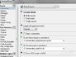3

分步阅读
如何在没有装ORACLE的电脑上用PLSQL远程连接ORACLE

方法/步骤

下载instantclient，我的是WIN7，下载的是instantclient-basiclite-nt-12.1.0.1.0.zip



解压到一个固定的目录如C:\instantclient_plsql

在解压的目录里创建文件network\admin\tnsnames.ora



3

编辑文件内容，注意IP和PROT要用远程ORACLE的

# tnsnames.ora Network Configuration File: C:\oracle\product\10.2.0\db_1\NETWORK\ADMIN\tnsnames.ora# Generated by Oracle configuration tools.

ORCL = (DESCRIPTION = (ADDRESS_LIST = (ADDRESS = (PROTOCOL = TCP)(HOST = 172.16.176.110)(PORT = 1521)) ) (CONNECT_DATA = (SERVER = DEDICATED) (SERVICE_NAME = orcl) ) )

EXTPROC_CONNECTION_DATA = (DESCRIPTION = (ADDRESS_LIST = (ADDRESS = (PROTOCOL = IPC)(KEY = EXTPROC1)) ) (CONNECT_DATA = (SID = PLSExtProc) (PRESENTATION = RO) ) )

4

设置PLSQL，菜单为Tools\Prefrence

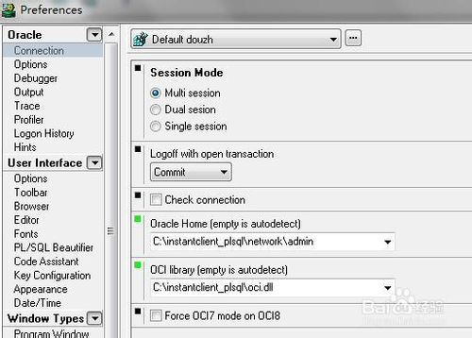

5

重新启动PLSQL，可以远程连接了

