Blended Interaction
- Introduction
Research Goal:
Paradigm for designing post-WIMP interactive spaces as a tool for HCI researchers, but also design practitioners

Research Questions:
  - Can we approach the design of post-WIMP DUIs more systematically?
  - What could be helpful design principles & tools?
  - Example prototypes
  - Design Approach: Blended Interaction

... blends user skills & objects from the real world with computational power of the digital world using blends to guide the users understanding.

    - Direct manipulation interfaces

Hutchins, Hollan, Normann (1985): Direct Manipulation Interfaces. (HCI)
- “In a system built on the model-world metaphor, the interface is itself a world where the user can act, and which changes state in response to user actions.”
- “The world of interest is explicitly represented and there is no intermediary between user and world.”
- “Appropriate use of the model-world metaphor can create the sensation in the user of acting upon the objects of the task domain themselves.”

Conclusion:
- Interface in which the users can directly act on objects instead of conversing about
- More real-world skills can be used, e.g.:
  - Visual skills for recognizing and rapidly perceiving changes of objects
  - Motor skills for manipulating objects and putting them to locations in space
  - Remembering locations of objects in space
  - Make use of commonalities between model-world and real world
- Direct manipulation makes user of mental and bodily skills for acting in the world
    - First steps towards embodied interaction!

    - Embodied Interaction & Reality-based Interaction

“Embodied” view of cognition:
- The body matters! → Tangible Computing: Make use of our motor & bodily skills and spatial awareness (bimanual multi-touch computing, tangible user interfaces, smart environments, …)
- The social environment matters! → Social Computing: Make use of our social skills, design for social interaction and collaboration…

Jacob at al., 2008:
“We believe that all of these new interaction styles draw strength by building on users’ pre-existing knowledge of the everyday, non-digital world to a much greater extent than before. They employ themes of reality such as users’ understanding of naïve physics, their own bodies, the surrounding environment, and other people. The thereby attempt to make computer interaction more like interacting with the real non-digital world.”
- Naïve Physics (NP): Peoples common sense knowledge about the physical world.
- Body Awareness & Skills (BAS): Familiarity and understanding that people have of their own bodies, independent of the environment.
- Environment Awareness & Skills (EAS): People have a physical presence in their spatial environment and develop many skills for navigating within altering their environment.
- Social Awareness & Skills (SAS): People are generally aware of the presence of others and develop skills for social interaction.

“By drawing upon these themes of reality, emerging interaction styles often reduce the gulf of execution, the gap between a user’s goal for action and the means to execute those goals.”

Question:
What part of the user interface should be based on reality-based interaction and what part should be provide computer-only functionality that is not realistic?

Answer:
Make the first part as large as possible and use the second only as necessary, highlighting the tradeoffs explicitly.

Tradeoffs:
- Reality vs. Expressive Power (expressive power is limited in order to maintain the clear virtual 3D, e.g. complex tree structures of folders)
- Reality vs. Efficiency (some systems are suited for novice users, than for experts, e.g. video clip puzzle)
- Reality vs. Plasticity (WIMP-based systems are able to provide a lot of functions, reality-based systems just providing a few tasks)
- Reality vs. Ergonomics (e.g. repetitive fatigue – Ermüdung)
- Reality vs. Accessibility (e.g. realistic actions may not be ideal for the disabled)
- Reality vs. Practicability (Cost, technological limitations, space, power consumption, etc. may be traded off against realism)

    - Conceptual Blending

Imaz & Benyon 2007, Fauconnier & Turner 2002:
“A blend is a “conceptual integration” or cross-domain mapping. Taking elements from the domain and applying them to another, then conceptual integration or blending is an operation that is applied to two input spaces, which results in a new, blended space. The blend receives a partial structure from both input spaces but has an emergent structure of its own.”

Metaphor: The Operating system is an office desktop.
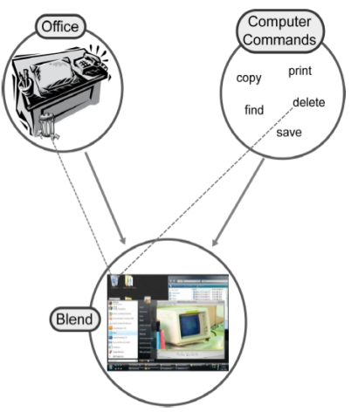
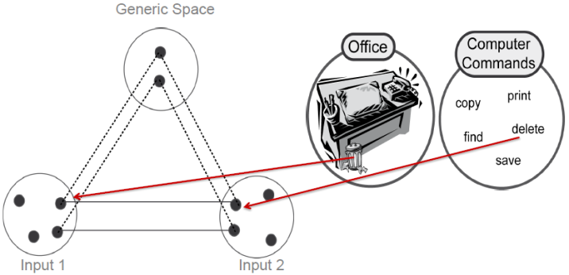
- Generic space contains what the input spaces have in common
- Blend receives a partial structure from both input spaces, but has an emergent structure of its own.

    - Domains of Design

Individual Interaction
Social Interaction & Communication

Physical Environment
Workflow

- Individual Interaction:
Blending real world interaction &objects (e.g. scribbling text, sketching objects, grasping tokens) with digital actions & representations (e.g. to move digital post-its or sketches, touch items of token pie-menus).
- Social Interaction & Communication:
Different user can interact at the same time on an equal manner considering real-world social conventions of communication (e.g. multi-touch display allows multi-user interaction; tokens could be grasped equally).
- Workflow:
Fluid change between real-world workflow and computer-supported workflow (e.g. virtual tour – real tour in a Museum; shift procedure in control rooms)
- Physical Environment:
Blending the power of real-world devices, furniture, rooms & buildings with the power of virtual means (e.g. combining tables, chairs, walls, … with multi-touch planar, spherical, … displays); new arrangements of place and space.

  - Design Tool: The ZOIL Paradigm

ZOIL = Zoomable Object-Oriented Information Landscape

    - Individual Interaction

- Semantic Zooming: Zoom from cover→ preview → detailed information → multimedia contents
- Visualization Tools: Pictures on a landscape (e.g. VISS)
- Blending physical and virtual ink with digital pen & paper
- Video of shift block

    - Social Interaction

- Design for “around the table” collaboration: Visual & tangible filter/flow metaphor for Boolean logic
- Integration of private and shared displays and spaces (e.g. DeskPiles)

    - Workflow

- Affinity Table for Creative Workgroup
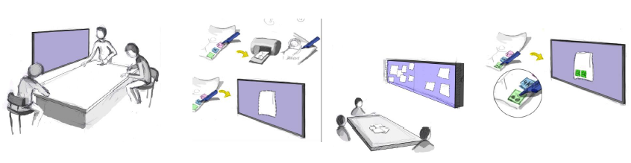
- “Brainsketching” by van der Lugt, 2002 implemented in IdeaVis
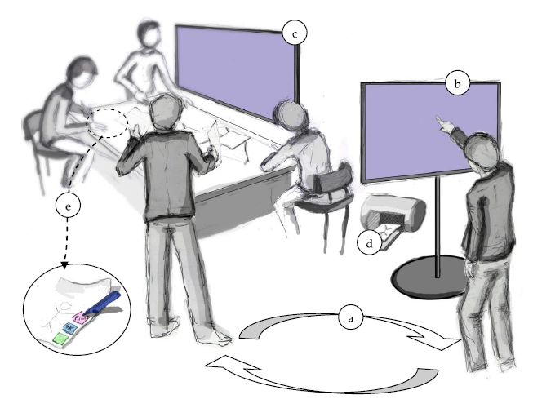
- ideas handled over between leaders touch-display and group touch-display
- project leader highlights design ideas/browses through ideas
- group browses through ideas/ discuss ideas/ choose some to work on
- ideas printed on special paper & pen (Drawn stuff automatic shown on group screen)
- Ranking and Marking of ideas

- TwisterSearch: Collaborative Search with Initial Context Framing based on Model of Social Search (Evans, Chi 2009)
    - Physical Environment

- Control Room Scenario with Siemens AG – Holistic Workspace
- Curved Display by LMU München – optimal way for visual & haptic feedback (one screen instead of 2, curve for smooth movement), mental model of ONE screen
- Room for blended library

  - Conclusion
- Design Principles

  - Provide post-WIMP functionality as objects not applications.
  - Provide a zoomable user interface for navigation with semantic zooming.
  - Provide enough space for sense making and annotation.
  - Provide enough space for mixed-focus collaboration.
  - Provide post-WIMP InfoVis Tools for fluid interaction.
  - Support Multi-User Collaboration with Visual Tangible Externalizations.

- User Cases & User Studies

- Search & Find, e.g. Libraries, e-Science
- Edutainment, e.g. Exhibitions
- Creative Work, e.g. Design
- Monitoring, Controlling, e.g. Control Rooms

Potential of tabletops:

- Closer face-to-face collaboration & more equitable working style (Rogers & Lindlay, 2004)
- Increase awareness and better group work experience (Amershi & Morris, 2008)
- Horizontal form-factor whose affordances are well-suited to follow-up activities (e.g. sorting, making a purchasing decision) (Morris et al. 2010)

- Unexplored potentials:
  - Hybrid interaction → Combining interaction with tangible interface elements and multi-touch interaction
  - Faceted search → iteratively filtering the whole information space based on metadata, instead of populating a result set based on keywords

- Facet streams:
  - Materializing the query:
    - Physical shape and material: Facet token
    - Direct touch interaction: facet wheel
    - Direct touch interaction: value wheel
    - Visual filter/flow metaphor for Boolean query (Redesign of Young & Shneiderman 1993, Hansaki et al 2006 for tabletops)
  - Facet-Streams equally effective as established Web designs for facet navigation (although it introduces novel and unfamiliar hybrid interaction techniques and visual metaphors)
  - User perceived Facet-Streams as a fun experience and design as innovative
  - Increased awareness and better mutual support among collaborators
  - Variety of different search strategies and collaboration styles possible
  - Seamless transitions between tightly coupled collaboration and loosely coupled parallel work
  - Users where able to quickly learn and apply visual metaphor for Boolean logic
  - Users succeeded in formulating complex Boolean queries based on natural language instructions

- Cognitive Models for HCI

  - Understanding & Modeling HCI

    - A very simplified overview of HCI areas

HCI is interested in “good” user interfaces. But “good” has been changing a lot over time…

- Human Factors of the 1960s:
  - Error prevention
  - Interface: control “displays” and hardware configuration switches
  - Usage of symbols for better understanding of tasks
- Usage Problems of the 1970s:
  - Cost-Effectiveness / Based on timesharing
  - Command line interfaces
- Office Work of the 1980s:
  - Usability for workers
  - First GUIs
- E-Commerce of the 1990s:
  - Usability for Customers
  - User interfaces for e-commerce (e.g. ebay, amazon, …)
- Interactive Products of the 2000s:
  - User Experience
  - Design of products to give the user innovative experiences with the product in his environment

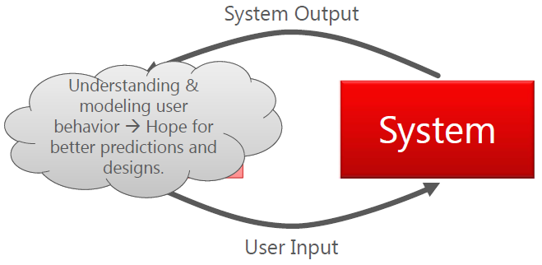
    - Shared approach in HCI
- Benett (1983): User/Terminal Interface
  - Cognitive processing from visual perception to reasoning & memory to motor & verbal skills (and many more, e.g. social behavior …).

  - Cognitive Science and Computer Science

- Cognitive Science helps to understand and model the human mind
- Subjects of Cognitive Science “are the information processes of natural or artificial agents’ interaction with the physical and social environment.” (Dahlbäck, 1999)
- Influences by: Philosophy, Computer Science, Psychology, Social Science, Linguistics, Neuroscience
- Examples:
  - Computing as metaphor e.g. Model Human Processor by Card, Moran, Newell 1980s
  - “Parallel Distributed Processing” as metaphor “The Brain is a neural network” (Neural networks, 1986 – Rumelhart, McClelland)
  - Categories of Objects (like class inheritance tree)
- No unified science of cognition and theory of mind
- Cultural out of formal methods from mathematics, logic, theory of computation (theories, only limited interest in empirical base)
- Quantitative & qualitative empirical culture from psychology and social science (tight connection between theory and empirical data)
- Constructive or modelbuilding culture of design or engineering science – HCI, AI (loose connection between theories and evaluation of designed artefacts)

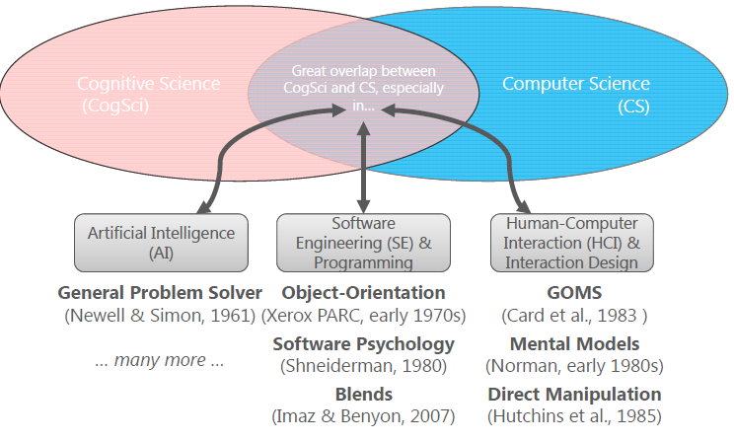
  - Behaviorism vs. Cognitivism

Steven Pinker: The Blank Slate Viking (2002):

      - The mental world can be grounded in the physical world by the concepts of information, computation, and feedback.
      - The mind cannot be a blank slate because blank slates don’t do anything.
      - An infinite range of behavior can be generated by finite combinatorial programs in the mind.
      - Universal mental mechanisms can underlie superficial variation across cultures.
      - The mind is a complex system composed of many interacting parts.

  - The Model Human Processor (MHP) (1983)

- Modeling based on Memories and Processors
- Memories and Processors are described by parameters
- Motor Skill (Fitt’s Law)
Speed-accuracy trade off associated with pointing whereby targets that are smaller and/or further away require more time to acquire.
- Choice Reaction Time (Hick’s Law)
Depends logarithmic on the number of items and a constant number

  - GOMS & KLM (1983)

- GOMS (goals, Operators, Methods, Selection Rules) uses MHP to model performance for user interfaces (e.g. to predict task times)
- KLM (Keystroke-Level Modeling) is the easiest form of GOMS
  - K: time to press key or button
  - P: time to point mouse to a target
  - M: time for mental preparation for task
- Does not consider fatigue, distraction, social environment or organizational factors
- Cognitivist approaches such as MHP and GOMS do not (and never intended to!) help with more essential high-level challenges of the 21st century interaction design:
  - How to create usability AND a positive user experience?
  - How to make things appear attractive?
  - How to model continuous bi-manual, multi-touch, or tangible interaction (e.g. pinching or zooming manipulations, moving tokens on a tabletop, connecting siftables, …)?
  - How to model body gestures or postures as input?
  - How to turn users into sociable collaborators?
  - How to make users feel safe and your product appear reliable?
  - …

  - Direct Manipulation (1982, 1985)

Ben Shneiderman observed a series of novel user interfaces and talked to their users 1982:

“In talking to users of interactive systems, I have become aware of a pattern of excitement. Certain systems generate a glowing enthusiasm among users which is in marked contrast with the more common reaction of grudging acceptance or outright hostility. The enthusiastic users’ reports are filled with the positive feelings of:
- Mastery of the system.
- Competence in performance of their task.
- Ease in learning to use the system originally and acquire new features.
- Confidence in their capacity to retain mastery over time.
- Enjoyment in using the system.
- Eagerness to show it off to novices.
- Desire to explore more powerful aspects of the system.”

“Understanding Direct Manipulation:
- Continuous representation of the object of interest.
- Physical actions or labeled button presses instead of complex syntax.
- Rapid incremental reversible operations whose impact on the object of interest is immediately visible.”

Hutchins, Hollan, Norman (1985): Direct Manipulation Interfaces:

- The goal: A cognitive account of Direct Manipulation “[…] the feeling of directness results from the commitment of fewer cognitive resources. […] the need to commit additional cognitive resources in the use of an interface leads to feeling of indirectness.”
- “There are two major metaphors for the nature of human-computer interaction, a conversational metaphor and a model-world metaphor.”

- “In a system build on the conversational metaphor, the interface is a language medium in which the user and the system have a conversation about an assumed, but not explicitly represented world.”
- “In this case, the interface is an implied intermediary between the user and the world about which things are said.”

- “In a system build on the model-world metaphor, the interface is itself a world where the user can act, and which changes state in response to user actions.”
- “The world of interest is explicitly represented and there is no intermediary between user and world. Appropriate use of the model-world metaphor can create the sensation in the user of acting upon the objects of the task domain themselves.”
- Input Devices in theory and praxis

The discipline of HCI (from HCM SIGCHI Curricula for HCI):
Human machine interface by Scott I. MacKenzie:

1968: Douglas Engelbart presents the “computer mouse” at the convention center in San Francisco on December 9th.

Definitions:
- “Basically, an input device is a transducer from the physical properties of the world into logical parameters of an application.” (Baecker, 1987)
- “Input devices sense physical properties of people, places, or things.” (Hinckley, 2008)
  - Properties

- “Properties are the qualities which distinguish among devices and determine how a device is used and what it can do.” (MacKenzie, 1995)
- “Input device properties help a designer understand a device and anticipate potential problems.” (Hinckley, 2008)

- Number of Dimension: (by Buxton, 1983)
  - Mouse: 2D
  - Slider wheel: 1D
  - Multi-channel device: e.g., Mouse with slider wheel (2D+1D)
  - 6 Degree of freedom (6DOF): Flystick (target tracking)
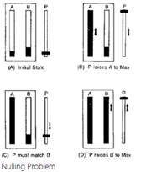
- Property sensed: (by Buxton, 1983)
  - position, motion, pressure
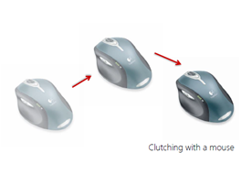
- Absolute input device: (by Buxton, 1983)
  - position sensing devices
  - nulling problem
- Relative input devices: (by Buxton, 1983)
  - motion sensing devices
  - time consuming clutching problem
- Continuous vs. Discrete:
  - Mouse vs. keyboard (Card, 1990)
- Direct vs. Indirect:
  - Touch vs. mouse
  - Direct: has unified display and motor space (e.g. lack of buttons for state transition and occlusion problem with direct touch)
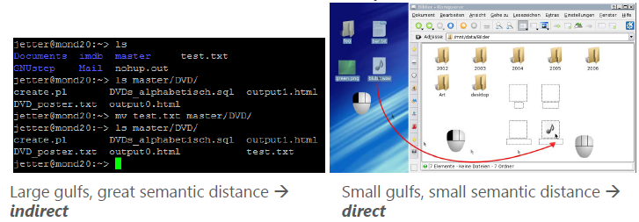
  - Indirect: separated physical input in motor space from display space
- Device acquisition time:
  - Time to move one’s hand to the device
- Homing time:
  - Time to move the hand back from input device to “home” position, e.g. return from mouse to keyboard
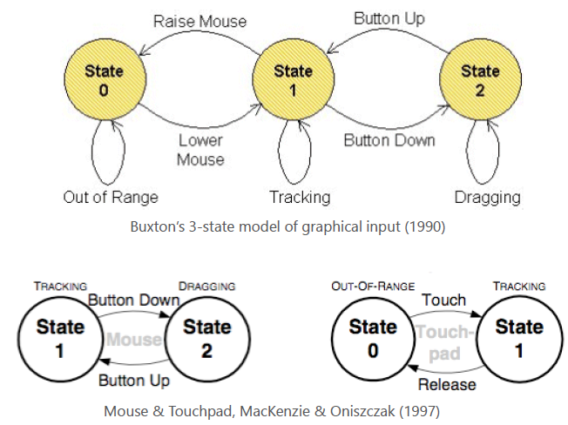
  - States

- Parameters

- “A parameter is any characteristic of a device or its interface which can be tuned or measured along a continuum of values.” (MacKanzie, 1995)
- Difference from Properties:
  - Properties cannot be adjusted or optimized, but parameters can be tuned

- Transfer functions:
  - mapping between motor space and display space
  - e.g. isometric joystick
- Movement parameters:
  - position, speed, velocity
  - Influence Performance & Learning time (Douglas, 1997)
- Kinesthetic correspondence:
  - Similarity of movements (Britton, Limpscomb & Pique, 1978)

- Examples:
  - Cursor sensibility (change parameters of (laser-)sensor transfer function)
  - 3D Calculation in games depends on resolution parameters

- Taxonomy

- Synonyms: classification, abstraction
- Taxonomy of Input devices:
  - Taxonomies make a clear and will-structured definition of the device in mind; and therefore make the evaluation of the device easier.

    - Semantics of primitive virtual devices (Wallace, 1976)
    - Human input to computer systems from the User’s perspective

Elementary Tasks (Foley, Wallace & Chan 1984):

- Select: an item in 1,2 or 3D
- Position: an item in 1, 2 or 3D
- Orient: (rotate) an item in 1,2 or 3D
- Path: specify a path, such as in inking in a paint program
- Quantify: specify a numerical value
- Text: enter text as in word processing
- More: location, images and identity (Hinckley, 2008)

Human-machine interaction (Card et al, 1991)

- It can be modeled as interaction within an artificial language among at least three agents:
  - A human
  - A user dialogue machine
  - An application
- Ideas in modeling the language of input device interaction:
  - A primitive movement vocabulary
  - A set of composition operators

- Selection

Effectiveness metrics (Card, 1991)

- Desk footprint:
  - Amount of area the device consumes
- Pointing Speed:
  - Device bandwidth
- Pointing precision:
  - Minimum convenient target size
- Error
- Time to learn
- User preferences
  - User satisfaction
- Cost

User characteristics & experiences
- Elderly, disabled, children
- Physical:
  - Anthropomorphic (height, left handed, etc.)
  - Age (mobility, dexterity, etc.)
- Cognitive/Perceptual
  - Sight, hearing, etc.
- Personality
  - Including cultural factors
Environment and Context
- On the move, loud

Application requirements
- Stressful, vital, interaction type

Device properties

- Summary

- We need properties and taxonomies for the input devices in order to understand the device, be able to compare it with other devices, and also continue to new designs for future input devices in the right direction.
- The existing taxonomies are useful, but not complete specially according to the new technologies, coming up in the field of input devices, e.g. Microsoft Kinect, 3D technology, …

- Multimodal and Proxemic Interactions

  - Definitions

- The focus is on multimodal perception and control – human input & output channel.
- Concept of modality is tightly coupled with human sense.
- Pay attention for interferences (using modalities)
  - E.g. reading/hearing and speaking simultaneously is awkward

- “Multimodal systems process two or more combined user input methods … in a coordinated manner with multimedia system output.”
“… a paradigm shift away from conventional WIMP interfaces.”
“This new class of interfaces aims to recognize naturally occurring forms of human language and behavior …” (Oviatt, 2008)

- Modality: a form of sensory perception

  - Speech and Gestures

    - “Put-That-There” Richard Bolt (1983)

- MIT Architecture Machine Group’s “Media Room”
- Spatial Data-Management System (SDMS)
  - “Dataland”
- “Speak-and-point”
- Choice of Speech Recognition Systems (at that time – 80’s)
  - Parsing speech signal word by word tokens
  - Speaker must talk in a “clipped” word-by-word style

    - Input modes

- Active input modes are ones that are deployed by the user intentionally as an explicit command to a computer system (e.g. speech). [explicit interaction]
- Passive input modes refer to naturally occurring user behavior or actions that are recognized by a computer (e.g. facial expressions, manual gestures). They involve user input that is unobtrusively and passively monitored, without requiring any explicit command to a computer. [implicit interaction]
- The most naive approach to using eye position as an input might be as a direct substitute for a mouse […]. (Robert J. K. Jacob, 1990)

    - Derivation

- Blended multimodal interfaces incorporate system recognition of at least one passive and one active input mode.
  - e.g. speech and lip movement systems
- Temporally-cascaded multimodal interfaces process two or more user modalities that tend to be sequenced in a particular temporal order (such that partial information supplied by recognition of an earlier mode is available to constrain interpretation of a later mode)
  - e.g. gaze, speech
  - may combine only active input modes, only passive ones or they may be blended

    - Disambiguation and classification

- Mutual disambiguation
  - Involves disambiguation of signal or semantic-level information
  - In one error-prone input mode from partial information supplied by another
  - Can occur in a multimodal architecture with two or more semantically rich recognition-based input modes
  - Leads to recovery from unimodal recognition errors (suppresses errors experienced by user)
- Visemes
  - Refers to detailed classification of visible lip movements (Correspond with constants and vowels during articulated speech)
  - Viseme-phoneme mapping refers to correspondence between visible lip movements and audible phonemes during continuous speech

    - Advantages

- System-centered advantages
  - A multimodal architecture with two semantically rich input modes can support mutual disambiguation
- Examples:
  - Haptic Tabletop Puck (tactile)
  - Blind man’s stick & Kinect (tactile and auditive)

    - Multimodal features

- Feature-level fusion
  - Method for fusing low-level feature information from parallel input signals
  - With multimodal architecture, applied to processing closely synchronized input
  - E.g. speech and lip movements
  - “early fusion”

- Semantic-level fusion
  - Method for integrating semantic information derived from parallel input modes in a multimodal architecture
  - used for processing speech an gesture input
  - “late fusion”

    - Multimodal interaction – goal and advantages

- Flexible use of input methods:
  - Choice of input device
  - Combined input modes (different than blended multimodal interaction)
  - Alternate between input modes
- Permits diverse user groups:
  - Different ages
  - Personal skills
  - Native language status
  - Cognitive styles
  - Sensory impairments
  - Temporary and permanent handicaps

    - Multimodal interaction – future directions (by Oviatt, 2002)

- Today most multimodal systems are bimodal
- Recognition technologies related to several humans senses have yet to be well represented or included at all within multimodal interfaces
- Successful design of multimodal systems will continue to require guidance from cognitive science on the coordinated human perception and production of natural modalities

  - Proxemics

In 1966 anthropologist Edward Hall coined the term “proxemics”, an area of study that identifies the culturally dependent ways in which people use interpersonal distance to understand and mediate their interactions with other people.
    - Door pedestrian interaction (Ju and Leifer, 2008)
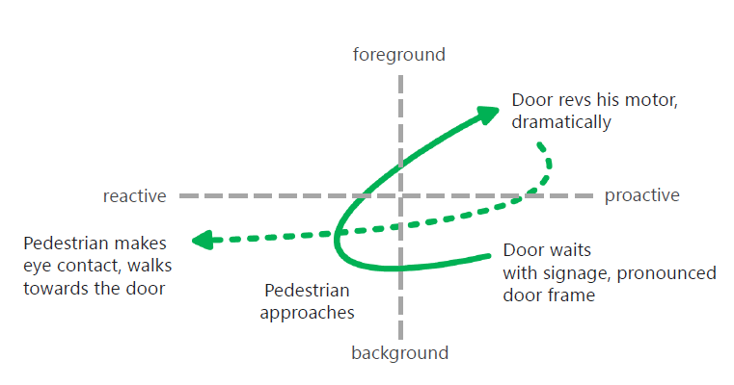
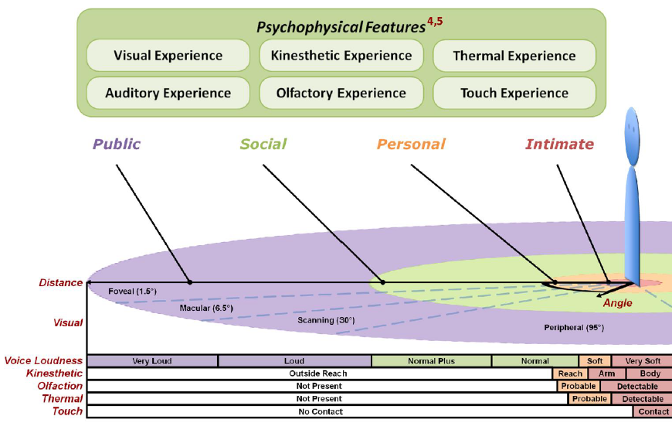
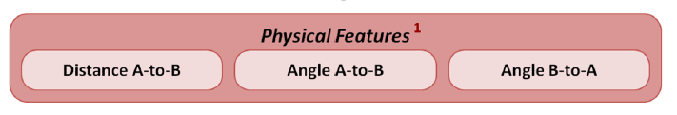
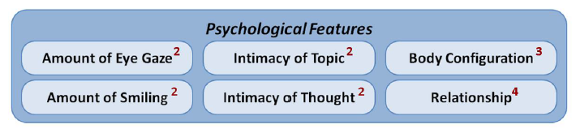
    - Proxemics features

- Tangible Interfaces & Physical Prototyping

  - Motivation for Tangible User Interfaces (TUI)

    - What is Tangible Computing?

- Origins in Ubiquitous Computing
- Computation moves into the environment
- Interface moves into the environment
- New set of design concerns
  - Managing attention
  - Incorporating context
  - Combining devices
  - New physical forms and affordances
  - New interactive styles

    - Human body perception

- Haptic | Related to the sense of touch
- Cutaneous | Pertaining to the skin itself or the skin as a sense organ (pressure, temperature, pain)
- Tactile | Pertaining to the cutaneous sense but more specifically the sensations of pressure rather than temperature and pain
- Proprioceptive | Relating to sensory information about the state of the body
- Vestibular | Pertaining to the perception of head position, acceleration and deceleration
- Kinaesthetic | The feeling of motion. Relating to sensations originating in muscles, tendons and joints.
- Force Feedback | Relating to the mechanical of information sensed by the human kinaesthetic system

    - How bodies matter

“The body is the ultimate instrument of all our external knowledge, whether intellectual practical… experience [is] always in terms of the world to which we are attending from our body.” (Polanyi, 1967)

Five Themes for Interaction Design

- Thinking through doing:
  - Direct physical interaction with the world is a key constituting factor of cognitive development during childhood
  - The importance of physical action as an active component of our cognition extends beyond early development stages
  - Theories and research of embodied cognition regard bodily activity as being essential to understanding human cognition
  - Learning though doing
  - The Role of gesture
  - Epistemic action
  - Thinking through prototyping

- Performance
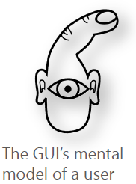
  - “When compared to other human operated machinery (such as the automobile) today’s computer systems make extremely poor use of the potential of the human sensory and motor systems. The controls on the average user’s shower are probably better human-engineered than those of the computer on which far more time is spent.” (Bill Buxton)
  - Action-centered skills
  - Hands
  - Motor memory

- Visibility
  - The fact that the paper [air traffic control flight] strips are physically laid out in the space and annotated directly (rather than indirectly through, for example a keyboard) means that the activities of co-workers interacting with the strips can be perceived, providing mutual awareness for collaboration.
  - Situated Learning
  - Visibility Facilitates Coordination

- Thick practice
  - System designers have often “paved paradise and put up a parking lot”
  - Design for “embodied virtuality” rather than virtual reality

  - Characteristics of Tangible User Interfaces

    - From GUI to TUI

Properties of the abacus:

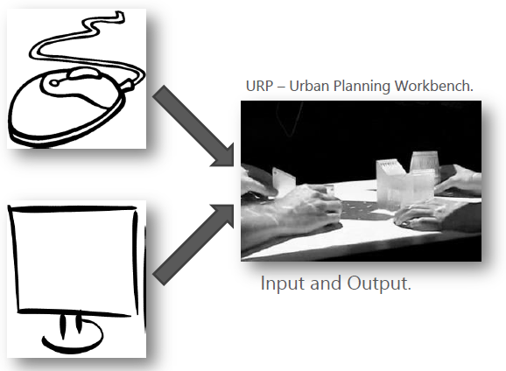
- No distinction between input and output
- Consisting of beads, rods and frame
- Directly manipulatable

Components

- Controls:
  - manipulation of information
- Representations:
  - Perception with the human senses
- TUIs combine control and representation

“Seamless Interface”

- “[…] TUIs will augment the real physical world by coupling digital information to everyday physical objects and environments. […]” (Ishii, 2008)
- Blurring the boundary between physical and digital!

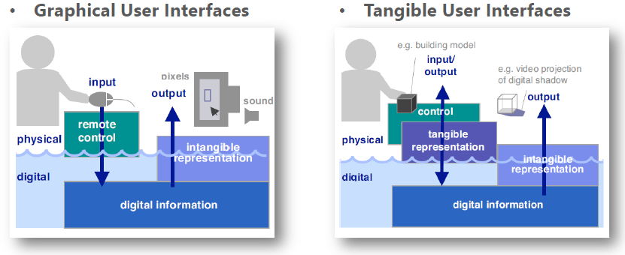
- The success of a TUI often relies on a balance and strong perceptual coupling between the tangible and intangible representations. […]

    - Key Properties of TUI

- Computational Coupling of tangible representations to underlying digital information and computation
- Embodiment of mechanisms for interactive control with tangible representations
- Perceptual Coupling of tangible representations to dynamic intangible representations

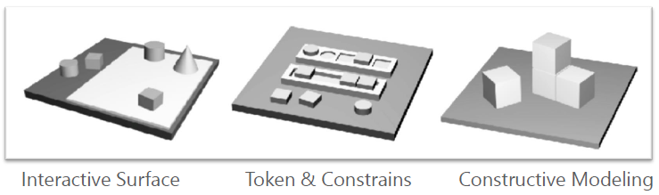
    - Different types of TUI

Token & Contrains

- […] tokens are descrete, spatially reconfigurable physical objects that typically represent digital information
- Physically emobied,
- Descrete,
- Regrid elements
- Each representing data
Tangible Query Interfaces (Ullmer, Ishii & Jacobs, 2003)
- Usage of phyisically constrained tokens
- To express, manipulate and visualize parameterized database queries

Interactive Surface

- Direct control of electronic or virtual objects through physical handles
- Combination between:
  - Outstandingly, expression and creativity – entertainment
  - Freedom – precision, rigor and efficiency
- Open but precise and rather complex control
- Social and collective experience which integrates collaboration and competition
- Examples:
  - Facet Stream (2010)
  - Reactable (2006) – Music performance

  - Multi-touch Technologies

- Resistive
  - Navigation Systems
  - Works over special substrate, dots and an flexible outer membrane
- Capacitive Systems
  - iPhone
  - works with electric conductivity/temperature
- Inductive Systems
  - Special Pen & Display (works over position and pressure of pen)
- Optical Systems
  - MS Surface 1
  - Integrated optical sensors /Beamer

  - Physical Prototyping

- Allow designers and users to get the “experience” of the product
- Very important for Interactive and “tangible” products

- Le Bricolage (die Bastelarbeit)
  - Gobling things together
  - Using existing items
  - Combination to new ideas
  - Surrogate for a futuristic technology
  - Physical prototypes
  - Roots in product-development
- Toolkits
  - “The tools and technologies that are available to us today are opening up new ways of approaching things.” (Bill Buxton)
  - Examples: Arduino, D. Tools, Voodooio, Lego Mindstorms, Phidgets, Raspberry Pi

