- Foundation of VISS

  - Creativity Support Tools
- Framework for Mega-Creativity (Shneiderman)
Collect | - Learning from other works (libraries, internet, …)  - Search and browsing in digital medias  - Visualize data and processes to understand and discover relationships
Relate | - Consult peers and mentors for support
Create | - Explore, compose and evaluate possible solutions  - Think by free association to make new combinations of ideas (brainstorming, lateral thinking, …)  - Explore solutions – what-if tools and simulation models  - Compose artifacts (e.g. UML-Diagrams) and performances (Requirement-analysis) step by step  - Review and replay session histories to support reflection
Donate | - Disseminate the results to gain recognition and contribute to libraries, the Web, etc.

- Example: GENEX http://www.cs.umd.edu/hcil/pubs/presentations/genex/index.shtml

- Knowledge Crystallization Operators
Acquire information | - Monitor, Search, Capture
Make sense of it | - Extract information  - Fuse different sources  - Find and recode information into schema
Create something new | - Organize for creation  - Author
Act on it | - Distribute, Apply, Act

- Knowledge Media Workbenches

= Couple of creativity support-tools for users of Digital Libraries:

- Visual information seeking with search, watch, bookmarks and news functions
- Information Workspace to store different spheres of interest and knowledge artifacts
- Media Warehouse that fuses different sources, offers integration of data support and sharing
- Media Editors to create and present new knowledge artifacts; offer integration of actions and consistent terminology; support higher level of actions like “collect-explore-visualize”
- History tool for reviewing and replaying session histories
- E-Mail, Website, CSCW functionality
- Zoomable User Interfaces
- …

Design Principles for a Knowledge Media Workbench:

- Comprehensive visual support for all activities of creative work
- Searching and browsing of digital libraries
- Rich representation of information (multimedia) from different information sources
- Keeping and managing information needs, search results, knowledge artifacts
- Support the creation of knowledge artifacts
- Support reflection based on the interaction history
- Variety possibilities to disseminate knowledge artifacts
- Smooth integration across windows/applications

  - Visual Information Seeking Systems

- VISS supports the task “searching and browsing”
- Key is the enormous capacity for human visual information processing
- Presenting information visually and allowing dynamic user control through direct manipulation UI
- Displays of textual and numeric information can be extended to incorporate spatial displays in which related information is clustered in 2-dimensional higher spaces
- Examples: Google (Miniaturansicht), grokker.com, kartoo.com, liveplasma.com

- Definition:

- Combines the functionality of retrieval systems with the possibilities of information visualization systems
- Important aspect is their possibility to visualize a great variety of document attributes allowing the user to choose the most appropriate for his task

- Examples: Slides 15-28 and INSYDER (32-49), INVISIP (50), VisMeB (51/52), ZUIScat (73-77), BEST, MedioVis (53-57), Blended Library

- Steps during Information Seeking

Formulation:  Expressing the search | Search form (simple, extended, visual); phrases; variants; size of result set
Initiation of action: Launching | Search button; dynamic queries
Review of results:  Reading messages and outcome | Overview, zoom and filter, details on demand; clustering; change sequencing; visualizations
Refinement:  Formulating the next steps | Meaningful messages; support changing of search parameters; relevance feedback
Use:  Compiling or disseminating insight | Saving and annotating of results; sending via e-mail; input other tools

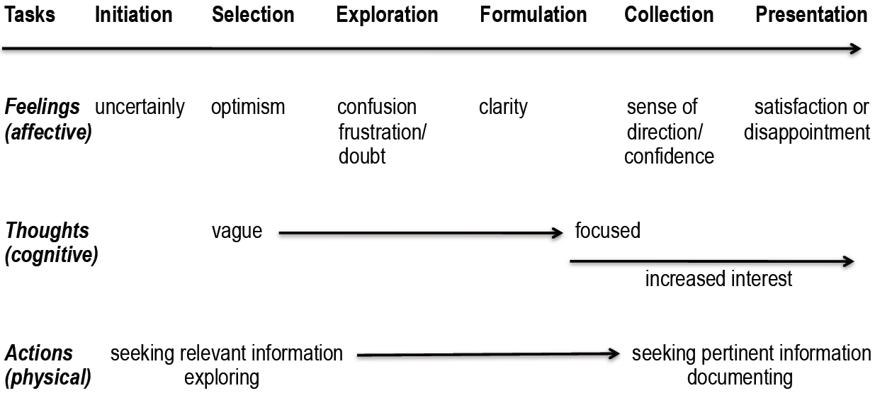
- Model of Information Search Process
- User Interface Design Principles for VISS

- Goals (by Ahlberg and Shneiderman):
- Reduce the user anxiety about the flood of information
- Find needles in haystacks
- Support exploratory browsing to develop intuition
- Find patterns and exceptions
- Even make browsing fun

- Easy to use system; supports the users work in an effective and efficient manner. UE
- Easy to learn system; shows the user its possibilities during the interaction with it. HCI
- Support by formulating the query; allow user to express the right information needs. IR + InfoVis
- Quick and insightful overview about all search-results; find needles in haystacks. InfoVis
- Right amount of information in the context, where it is needed. InfoVis
- Different aspects of interest at the same time; information comparing and/or to get more information. InfoVis
- Possibilities to restrict the amount of information; selecting of topics of interest. InfoVis
- Customize the system; reflecting the user’s personal needs. HCI
- Related Research Disciplines

- HCI and UE
- Design
- IR and Data Mining
- Business Intelligence and Data Warehouse
- Knowledge Management

- Information Visualization:
- Visualize nonphysical information
- Abstract data (no natural or obvious representation exists)
- Key problem: discover adequate (expressive and effective) visual metaphors to make information more accessible
- Example: FilmFinder (63/64)
- Uses References Models for raw data for example data tables, visual mapping and view transformations (Zoom, Detail pop-ups, Fisheye, Magic Lenses and movable filters)

- Context of Use influencing the Success of Visualizations (5T-Environment)

- Target user group: e.g. interpersonal differences in information perception and processing, which influences the way people think (spatial dimensions or abstraction)
- Task to be done: e.g. knowledge worker: monitor, detect, search, extract information, fuse different sources, find and recode information into schema, organize, compare, simulate, decide, distribute
- Type and number of data: e.g. text or numeric data; hierarchy in the data; number of documents or data items
- Technical possibilities: e.g. site of monitor, memory size, processor power, available input/output devices
- Training: find the right balance between learnability and efficiency or between simplicity vs. power; long term benefits must out weight the amount of training

- User-Centered Design makes use of the following Usability Engineering techniques:
- Factors of “5-T Environment” have to be considered during Requirements Engineering using techniques like contextual task analysis and user profiles
- Prototyping or different visualization ideas offer a rich design space
- Formative and summative evaluation techniques during the whole development process to “proof the concepts”
- Iterative process model (e.g. Usability Engineering Lifecycle) allows consideration of evaluation results

- Visual-information-seeking-mantra (by Shneiderman): “Overview first, zoom and filter, then details on demand.”
  - Scatterplot with zoom and filter functionality for overview
  - Table for details on demand
  - Zoomable User Interfaces offering semantic zooming (TableZoom, RowZoom, Cell Zoom)

- Post-WIMP-Search

  - User Interfaces

- 1st generation user interfaces

- Behind the screen is invisible world of business logic, data objects, relations, results, …
- Input and output language is very programming-like
- User has a conversation about an assumed, but not explicitly represented world
- Conversational Metaphor

- 2nd generation user interfaces

- Visual representation or simulation of a model-world, that contains business logic
- Direct manipulation of the model-world without languages as intermediary
- GUI with Model-World Metaphor

- 3rd generation user interfaces

- User is “off-the-desktop”
- Physical and social world becomes entirely augmented with information technology
- Users can switch between their real-world skills and their virtual superpowers
- Embodied or Reality-Based Interaction

  - WIMP vs. post-WIMP?

- WIMP = Windows Icon Menu Pointer
- Post-WIMP = novel interaction without WIMP

- Embodied Interaction

- The body matters!
Tangible Computing: Make use of our motor & bodily skills and spatial awareness (bimanual multi-touch computing, tangible user interfaces, smart environments, …)
- The social environment matters!
Social Computing: Make use of our social skills, design for social interaction and collaboration (Surface)

- Reality-Based Interaction

- Naïve Physics (NP): People common sense knowledge about the physical world
- Body Awareness & Skills (BAS): Familiarity and understanding that people have of their own bodies, independent of the environment
- Environment Awareness & Skills (EAS): People have a physical presence in their spatial environment and develop many skills for navigating within and altering their environment
- Social Awareness & Skills (SAS): People are aware of the presence of others and develop skills for social interaction
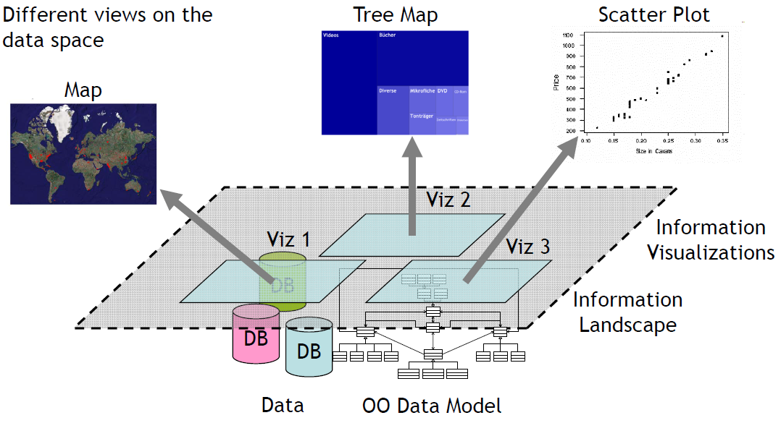
- Zoomable Object-Oriented Information Landscape (ZOIL)
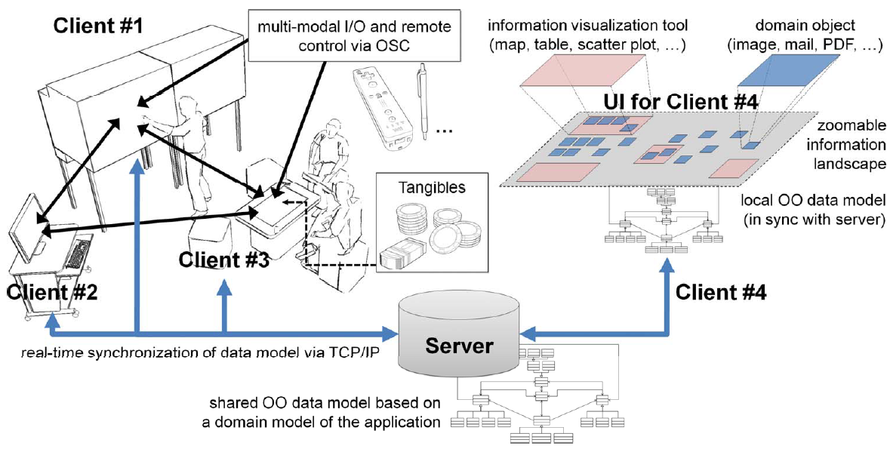
- Semantic Zoom:
  - Enables User to browse objects
  - Different visualizations serve as visual entry points
  - Exploration does not necessarily start with a keyword search
  - Entry points: media type, persons, floor-plan, country, town (MedioVis)
  - Magic lenses: flexible tool to define specific filter criterias
  - M3 Scatterplots
  - Search Tokens
  - Facet-Streams

- Potential of Tabletops for Co-Located Collaborative Search

- Closer face-to-face collaboration and more equitable working style
- Increased awareness and better group work experience
- Horizontal form-factor whose affordances are well-suited to follow up activities (e.g. sorting, making purchasing decision)
- Unexplored potentials:
  - Hybrid interaction: Combining interaction with tangible interface elements and multi-touch interaction
  - Faceted search: iteratively filtering the whole information space based on metadata, instead of populating a result set based on keywords
- Collaborative faceted product search:
  - More than a logical AND of all personal criteria
  - It is decision making or negotiation based on iterations of softening criteria
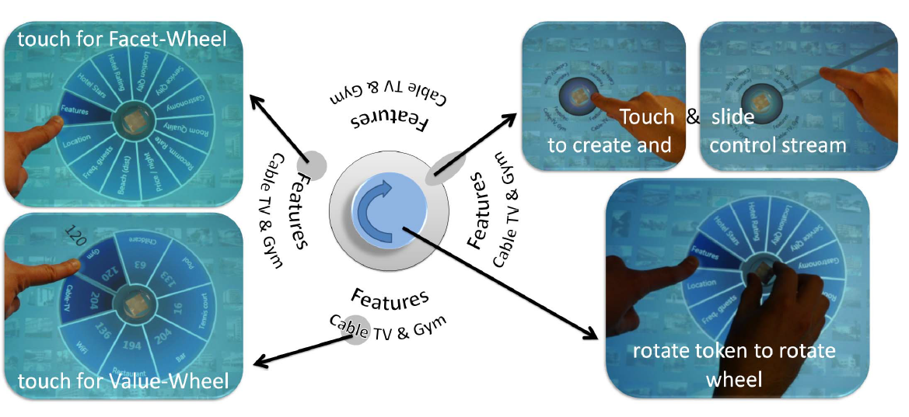
  - Criteria are equivalents of complex Boolean expression
- Conclusion of facet-stream studies:
  - Facet-streams are equally effective as established web designs for faceted navigation (although it introduces novel an unfamiliar hybrid interaction techniques and visual metaphors)
  - Users perceived using facet-streams as fun experience and considered its design as innovative
  - Increased awareness and better mutual support among collaborators was observed
  - Variety of different searching strategies and collaboration styles could be realized with our design
  - Seamless transitions between tightly-coupled collaboration and loosely-coupled parallel work
  - Users were able to quickly learn and apply our visual metaphor for Boolean logic
  - Users succeeded in formulating complex Boolean queries based in natural language instructions

- Theory of Social Search

- Definition

- Search acts, that make use of social interactions with others
- Utilize social and expertise networks
- Are done in shared social workspaces
- Or involve social data mining or collective intelligence processes to improve the search process
- Examples: del.icio.us, diigo

- An Elaborated model of social search

- Before Search:
  - Context Framing
    - External prompt (external request, motivated by external sources)
    - Internal prompt (self-initiated, to find information related to personal or work endeavors)
  - Requirement Refinement
    - Gathering requirements and formulating relevant search schemas

- During Search:
  - Informational search:
    - Exploratory process of searching for information that may or may not be familiar to the user
    - Completion of the task is not always clear, there is maybe no specific answer
    - Foraging: after a specific search, followed by skimming, reading, and extracting information, user may update and shift their search representations
    - In consequence, users update their “search schema”
    - Sense-making: after an initial pass at foraging, users my identify preliminary evidence files from which they can reflect and use them to further modify their search schema an query

  - Navigational search:
    - Users perform a series of actions to identify content from a particular, often familiar, location. The content is typically known in advance or will be easily recognized once it is (re)discovered
    - E.g. look up for treatment for a specific drug in database
    - Establish search guidelines, improve search schemas
    - Brainstorm, seek coworkers opinions

  - Transactional search:
    - Locate a source where they can subsequently perform a transaction or other “web-mediated activity”

- After Search – End product:

  - Examples:
    - Next week’s weather forecast
    - Latest news about autism
    - …
  - Organize:
    - Printing results
    - Bookmarking
    - Creating a presentation
  - Distribute:
    - … the search products to others
    - Users may serve as information filters for others
    - Trustwothiness??

- Systems supporting social search:

- Design principle: Users need access to resources while preparing for search tasks.
Aardvark: primarily searches for users in the friend list or the friend’s friend lists for a user, which is suitable to answer the question. This one will be contacted.
ChaCha Mobile: Search engine by sending a SMS to a number and get the answer.
- Design principle: User needs help evaluating and validating search results.
Google: “Did you mean”

