Create Table salespeople

->create table salespeople(Snum int(4),Sname varchar(10),city varchar(10),comm float(3,2));

->INSERT INTO salespeople (Snum, Sname, city, comm)

values (1001, 'peel', 'london', 0.12),

(1002, 'serres', 'san jose', 0.13),

(1004, 'motika', 'london', .11),

(1007, 'rifkin', 'barcelona', .15),

(1003, 'axelrod', 'new york', .10);

->select \* from salespeople;

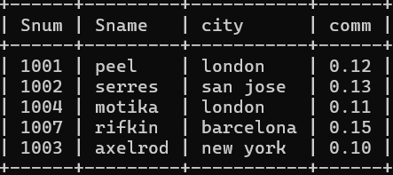

Create Table customers

->create table customers(Cnum int(4),Cname varchar(10),city varchar(10),Rating int(4),Snum int(4));

->INSERT INTO customers (Cnum, Cname, City, Rating, Snum)

VALUES (2001, 'hoffman','london',100,1001),

(2002,'giovanni','rome',200,1003),

(2003,'liu','san jose',200,1002),

(2004,'grass','berlin',300,1002),

(2006,'clemens','london',100,1001),

(2008,'cisneros','san jose',300,1007),

(2007,'pereira','rome',100,1004);

->select \* from customers;

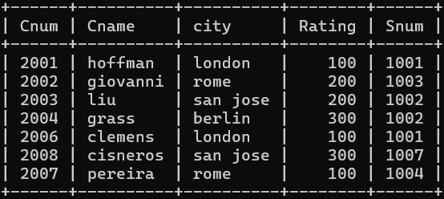

Create Table Order

->create table orders(onum int(4),amt float(7,2),odate date,cnum int(4),snum int(4));

->insert into orders(onum,amt,odate,cnum,snum)

values(3001,18.69,'1990-10-03',2008,1007),

(3003,767.19,'1990-10-03',2001,1001),

(3002,1900.10,'1990-10-03',2007,1004),

(3005,5160.45,'1990-10-03',2003,1002),

(3006,1098.16,'1990-10-03',2008,1007),

(3009,1713.23,'1990-10-04',2002,1003),

(3007,75.75,'1990-10-04',2004,1002),

(3008,4723.00,'1990-10-05',2006,1001),

(3010,1309.95,'1990-10-06',2004,1002),

(3011,9891.88,'1990-10-06',2006,1001);

->>select \* from orders;

