***Assignment –1***

**Creating sample tables and inserting values.**

Create the following tables with the given structures and insert sample data as specified: -

**A) *SALESPEOPLE***

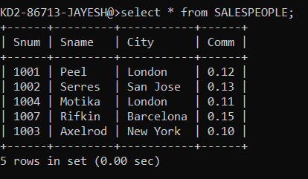

***CUSTOMERS***

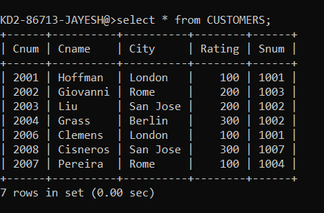

***ORDERS***

