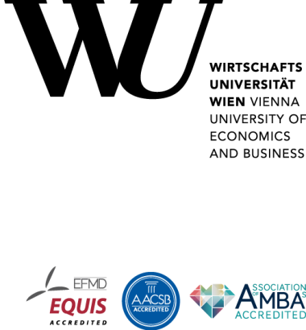
Internship Confirmation

To whom it may concern,

I confirm that Mr. Aaron Arsakajev worked as an intern on a supervised data science project conducted in collaboration with the University Library at the Vienna University of Economics and Business from October 2025 to February 2026. The project was part of the Data Science Specialization Lab in the Department of Information Systems and Operations at WU, and I supervised it as the data coach.
The project focused on designing and implementing an AI-assisted decision-support system for classifying business and economics literature according to the Regensburg Network Classification Scheme (RVK). Using over 80,000 historical bibliographic records, the team developed a leakage-safe data pipeline and evaluated seven lexical, semantic, retrieval-based, and hierarchy-aware model variants. The final system generated ranked classification suggestions to support subject librarians while leaving the final decision to a human expert.
Mr. Arsakajev's individual responsibilities and contributions included:
- Taking the technical and analytical lead for the project.
- Translating an open-ended problem into the overall system architecture.
- Setting priorities.
- Coordinating work packages and deadlines across the team.
- Leading the cleaning, harmonization, and preparation of historical library data, including interpreting duplicate structures, missing metadata, and invalid RVK entries, as well as coordinating delegated API-based enrichment tasks.
- Selecting, implementing, refining, and comparing most of the seven predictive model variants, ranging from TF-IDF/SVM baselines and hierarchy-aware routing to semantic, retrieval-based, and transformer approaches.
- Designing the metric-driven evaluation framework and the reproducible, two-stage experiment setup. This included the ranked suggestion, class imbalance, hierarchy, coverage, and manual review measures. He also documented the complete workflow in an integrated BEAM architecture.
- Using evidence from data and model results to redirect the solution from full automation to a realistic human-in-the-loop decision support system.
- Independently developing the complete Flask-based MVP interface to demonstrate model recommendations and enable the University Library and future students to continue the work.
- Defining the substantive structure of the final presentation, coordinating the speakers, and communicating the project's methodology, limitations, and results to an audience that included representatives from Bank Austria, IBM, KPMG, and Raiffeisen Bank.
Mr. Arsakajev distinguished himself through his exceptional analytical ability, rapid comprehension, and high degree of ownership. He developed a deep understanding of the library domain and used it to explain anomalies in the raw data that were not apparent from the datasets alone. He consistently approached complex and unfamiliar problems in a structured, evidence-based, and solution-oriented manner.
His initiative and level of responsibility far exceeded what would normally be expected of an intern. Through his technical expertise and commitment, he became the team's primary point of contact for technical matters. He provided the project with coherent direction and enabled his colleagues to contribute effectively by defining their work packages clearly. He worked independently with exceptional care and persistence, consistently producing excellent work.
Notably, he exercised sound professional judgment when the available data proved insufficient for reliable full automation. Rather than overstating the performance of the models, he correctly interpreted the evidence and developed a useful AI-assisted workflow. In this workflow, librarians could begin with ranked recommendations while maintaining complete control over the final classification. This demonstrated mature critical thinking, sound technical judgment, and a pronounced focus on practical value.
Mr. Arsakajev combined technical depth with the ability to clearly and convincingly communicate complex results. His structured and composed manner made him a highly effective contributor in technical discussions, progress meetings, and the final presentation.
He always conducted himself in an exemplary manner toward his supervisor and fellow team members. He was dependable, constructive, and supportive. His colleagues relied on his guidance and technical judgment throughout the project.
Mr. Arsakajev consistently exceeded expectations and performed all responsibilities entrusted to him to our full satisfaction. His contributions were crucial to the project's analytical quality, coherence, and successful completion.
I recommend Mr. Arsakajev without reservation for demanding academic or professional opportunities requiring analytical strength, technical initiative, leadership, and the ability to clearly communicate complex results. Thank you for your outstanding contribution, Mr. Arsakajev. Best wishes for your future academic and professional success.

Date:2026-05-31

Mag. Max Mustermann
University Library
Subject Librarians and Research Services
Vienna University of Economics and Business

