Application Form Bain
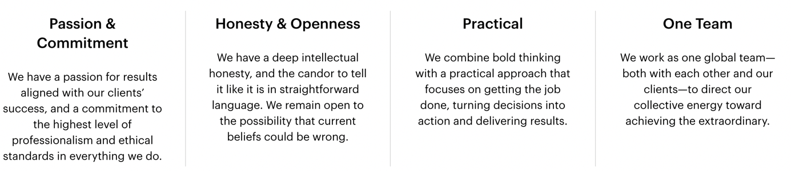
Everything we do at Bain & Company is guided by True North. True North is an unchanging and true point on a gyro-compass. It is constant, singular and unaffected by factors like magnetic forces or location. For us, True North is our unswerving commitment to always do the right thing by our clients, our people, and our communities. What does 'True North' mean to you? Tell us about an experience/story you've had regarding 'True North'.

For me, true north means setting a goal and moving towards that goal all the time, no matter the obstacles in your way.

Since I come from a family with non-academic background, I faced multiple challenges in pursuing an academic path requiring high commitment and passion, especially in challenging situations at university. I often felt like giving up – but I always remembered my “true north”. I wanted to be the first member in my family to have graduated from university. For example, when ….

When I entered my first lectures at university, I realized that an open-minded attitude is a premise for following higher education. Sometimes, this also involves rejecting old thinking patterns and problem-solving approaches. Doing so necessitates honesty with oneself as well as others. Therefore, a team with diverse backgrounds can maximize outcomes since many thinking approaches are combined. However, it is crucial that academic attitude results in actions and delivers excellent results. All these approaches enable one to be the best version of oneself and make well-considered decisions to take action, whether in terms of a business situation or an academic achievement.

At Bain, we often work in teams together with our clients, to tackle their most challenging problems. What is your favourite example of a team (e.g. extracurricular activities, part time work, university projects) you’ve worked in to solve a problem? *

In my first year of studies, I engaged in a volunteer project to familiarize primary school pupils with the topics of entrepreneurship and sustainability. Therefore, we organized different workshops and playfully founded a company with children.

Our team consisted of four people:
• Yuki, an art student who is very creative, passionate, and calm
• David, a motivated and humorous business student
• Sandra, a socioeconomics student that is open-minded, analytical, and reliable
• Me, Kathi, an international business student, very eager, detail-oriented, curious, and problem-solving

Since we all came from different backgrounds and had diverse character traits, we had different perceptions. Our different thinking approaches enabled us to create a program combining skills from various disciplines. Sandra educated the children on sustainable economics, Yuki designed creative and innovative products with the children and David, and I educated them on different entrepreneurial topics.

