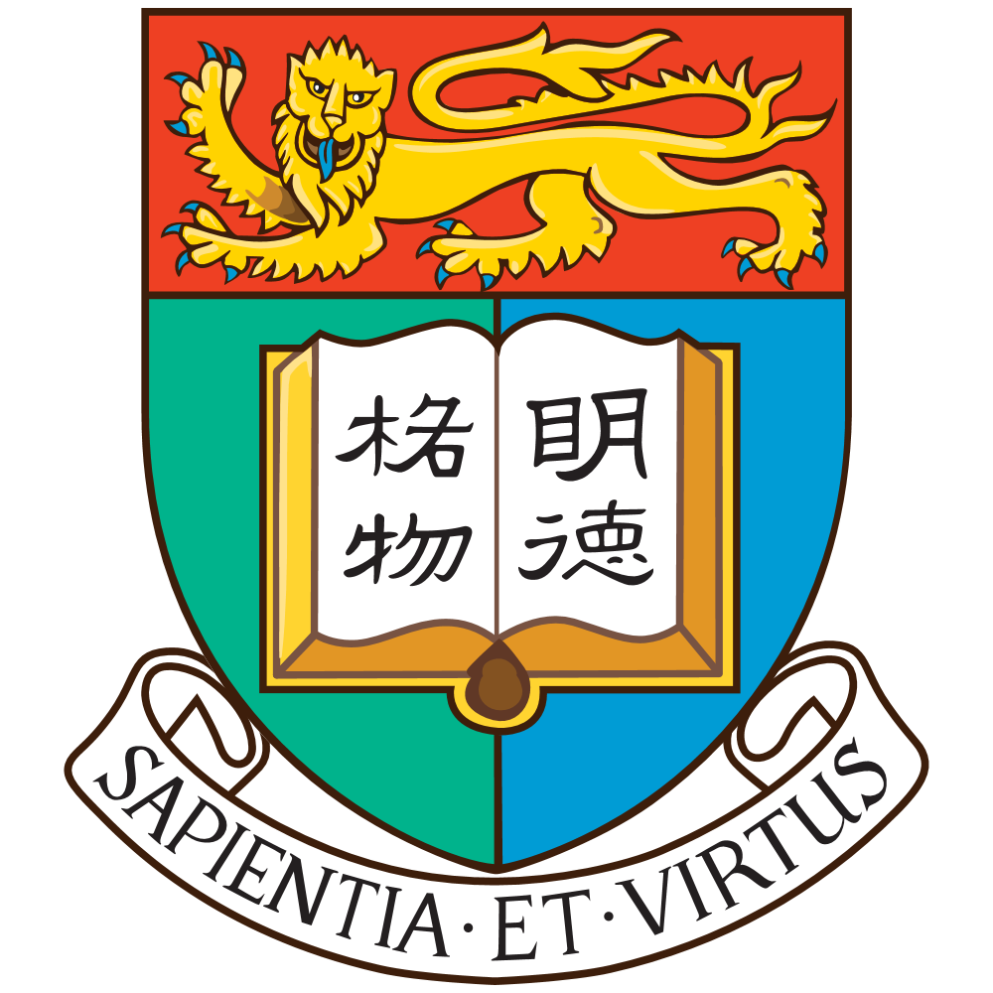
Motivation letter for an exchange semester at University of Hong Kong

Dear Members of the election committee,

with this motivation letter I apply for an exchange semester at the University of Hong Kong starting with first day of teaching on Sep 1, 2026. The following will make clear why I am tremendously motivated to enroll in this privileged and challenging university that perfectly assists me in obtaining my professional aspirations as an undergraduate student at University of Innsbruck.

My first work experience was gained very early as a sound-engineer, not only in planning technical productions in a high-pressure environment, but also in leading different technicians aiming to provide a fully immersive and memorable experience for visitors. This experience helped me to understand the immense potential of bringing like-minded individuals together and the remarkable results that can be achieved when guided by the right leadership. A lesson I have continued to apply ever since. Kitesurfing as my favorite sport brought me therefore not only to different countries and continents, it helped me also to understand the importance of international exchanges, not only to learn from new cultures, but also to find these like-minded people.
The establishment of a business plan for an real estate in western Africa during my first Internship in V&V Dabelstein Group helped me to develop (?) a deep understanding of an independent critical and strategic thinking.
While studying in University of Innsbruck, I immersed myself furthermore in the business world during my internship at BMC Strategy Consulting. Through working closely together with banks, insurances, and funds, I gained insight in the financial advisory industry and was fostered. It inspired me to focus my passion on the finance path and empowered me to engage myself in the Academic Stock Exchange Association for an interdisciplinary exchange on current finance and economics topics outside of university.

When I informed myself about an international exchange option, the University of Hong Kong stood out the most to me because of its high variety of courses, the diverse background of the students and close ties to the business world. With the business department’s motto “Inspire – Empower – Lead” it embodies the values I strive to uphold my past work experience and future academic career.
As I pursue an international career in the strategic and financial advisory industry the offered courses like “Venture Capital and Private Equity” or “Equity Investment and Valuation”, by professors having a deep background in various financial institutions, sound intriguing to me as my last and current semesters focused on the area of “Corporate and Behavioral Finance” and I am looking forward learning more about it. Furthermore, with more than 7000 students originating from outside Hong Kong, over 90 different nationalities and Hong Kong as China’s most vibrant technological city, it offers a unique environment of ambitious students striving to, address global challenges, advance humanity, and promote sustainability - an exceptional value proposition, that will help me to build a strong international network.
I am convinced that the University’s relationships to the financial advisory industry, with partner companies like Accenture, HSBC and J.P. Morgan, will be the ideal environment for me to help landing a highly engaging and challenging job in that branch after my graduation.

In inclusion I believe that my skills, experience, and cultural awareness will enable me to become a well-rounded international student.

Thank you for taking the time to consider my application.

Sincerely,
Ferdinand Seidl

