To whom it may concern
Berlin, 23 July 2025 / Reference: SH-FS-AR
Mr Florian Reidmann, born on 27 June 2001, worked for IEG – Investment Banking from
01 May January 2025 through to 31 August 2025 as a full-time Intern.
IEG – Investment Banking
IEG (Deutschland) GmbH
Bundesallee 205
D – 10719 Berlin

Phone +49 (30) 303016-30
Fax +49 (30) 303016-36

Info@Ieg-Banking.com
www.Ieg-Banking.com
http://twitter.com/IEGNews

Geschäftsführer:
Stefan C. Heilmann
Mirko Heide

Handelsregister:
AG Charlottenburg,
HRB 89021 B
Sitz: Berlin
USt-IDNr: DE230026389
Steuernummer: 27/261/00078

Bankverbindung:
Volksbank Oberberg
Kontonr. 701 602 9011
Bankleitzahl 384 621 35
Reference letter for Mr. FloriaN Reidmann
IEG - Investment Banking Group is one of the leading global independent investment banking boutiques focused on Mergers & Acquisitions, Financing & Principal Investments for Internet, Technology & Services. Locally present in the key international growth regions and emerging markets, IEG – Investment Banking Group is a unique, influential, and trusted partner for growth companies and larger global corporates. Founded in 1999 and owned by its partners, IEG now employs more than 50+ professionals worldwide.
During his term with IEG, Florian had close contact with various deal types and industries and had deep exposure to German and international transactions.
Florian had close interaction with experienced partners at IEG. He supported the execution teams in various investment banking transactions, especially M&A mandates, on both the buy- and sell-side.
His primary responsibilities included:
- Initiated and co-developed an AI-driven tech stack to streamline target screening and core M&A workflows
- Prepared cap table analysis, including exit waterfall models to illustrate the distribution of proceeds across shareholder classes under various deal scenarios
- Supported the development of IEG’s Defense Tech market coverage through research on dual-use technologies and early-stage disruptors
- Financial modeling: Supporting the creation of financial models for company valuations and business plan analyses
- Participation in internal strategy projects: Supporting the development and optimization of internal processes and business development initiatives
- Preparation of company valuation and analyses using CTA and CCA, as well as supported in DCF valuation
- Support in Due Diligence processes: Assisting in the coordination and review of data room documents
- Benchmarking analysis: Comparing key financial and operational metrics of relevant market players
- Expanded internal investor database by integration of deal rationales, sector expertise and recent transaction data to improve targeting accuracy in sell-side processes
- Research and identification of cross-border opportunities: Analyzing international buyers and target companies
- Analysis of annual financial statements and independent execution of company valuations
- Conduction of market, company and competition analysis utilising commercial databases such as MergerMarket, Pitchbook, Crunchbase, Bundesanzeiger, Inven, Markus and Capital IQ
- Creation of marketing materials such as company profiles, teasers, Information memoranda, process-timeline, status reports and management presentations
- Analysis of business models and creation of corresponding short profiles
- Target research (technology sector)
- Preparation of long lists and short lists
- Research and Identification of potential investors and continuous updating of internal investor lists
- Industry trend research: Identifying M&A trends and sector developments.
- Support in the maintenance and further development of internal databases
- Supported the drafting of an Engagement Letter Template
- Assisted in building a report for cybersecurity

Florian's high career motivation, diligent attitude, and strong work results earned him the regard of his colleagues. His capability to combine structured thinking, preliminary analytics and accuracy when completing his assigned tasks made him a precious and desirable member of any project. Florian always performed his tasks to our fullest satisfaction and has proven resilient and reliable in a high-pressure environment. His ability to prioritise multiple requests with a high workload and tight deadlines while efficiently communicating with colleagues and superiors has always been excellent.

We are very pleased that Florian was our Intern and are confident he will rise to future challenges. We wholeheartedly wish Florian all the best for his professional career and personal future.
Sincerely,
IEG (Deutschland) GmbH

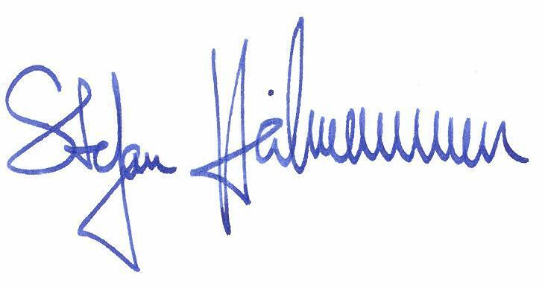
Stefan Heilmann Felix Specht Andreas Rösch
CEO Vice President Associate

