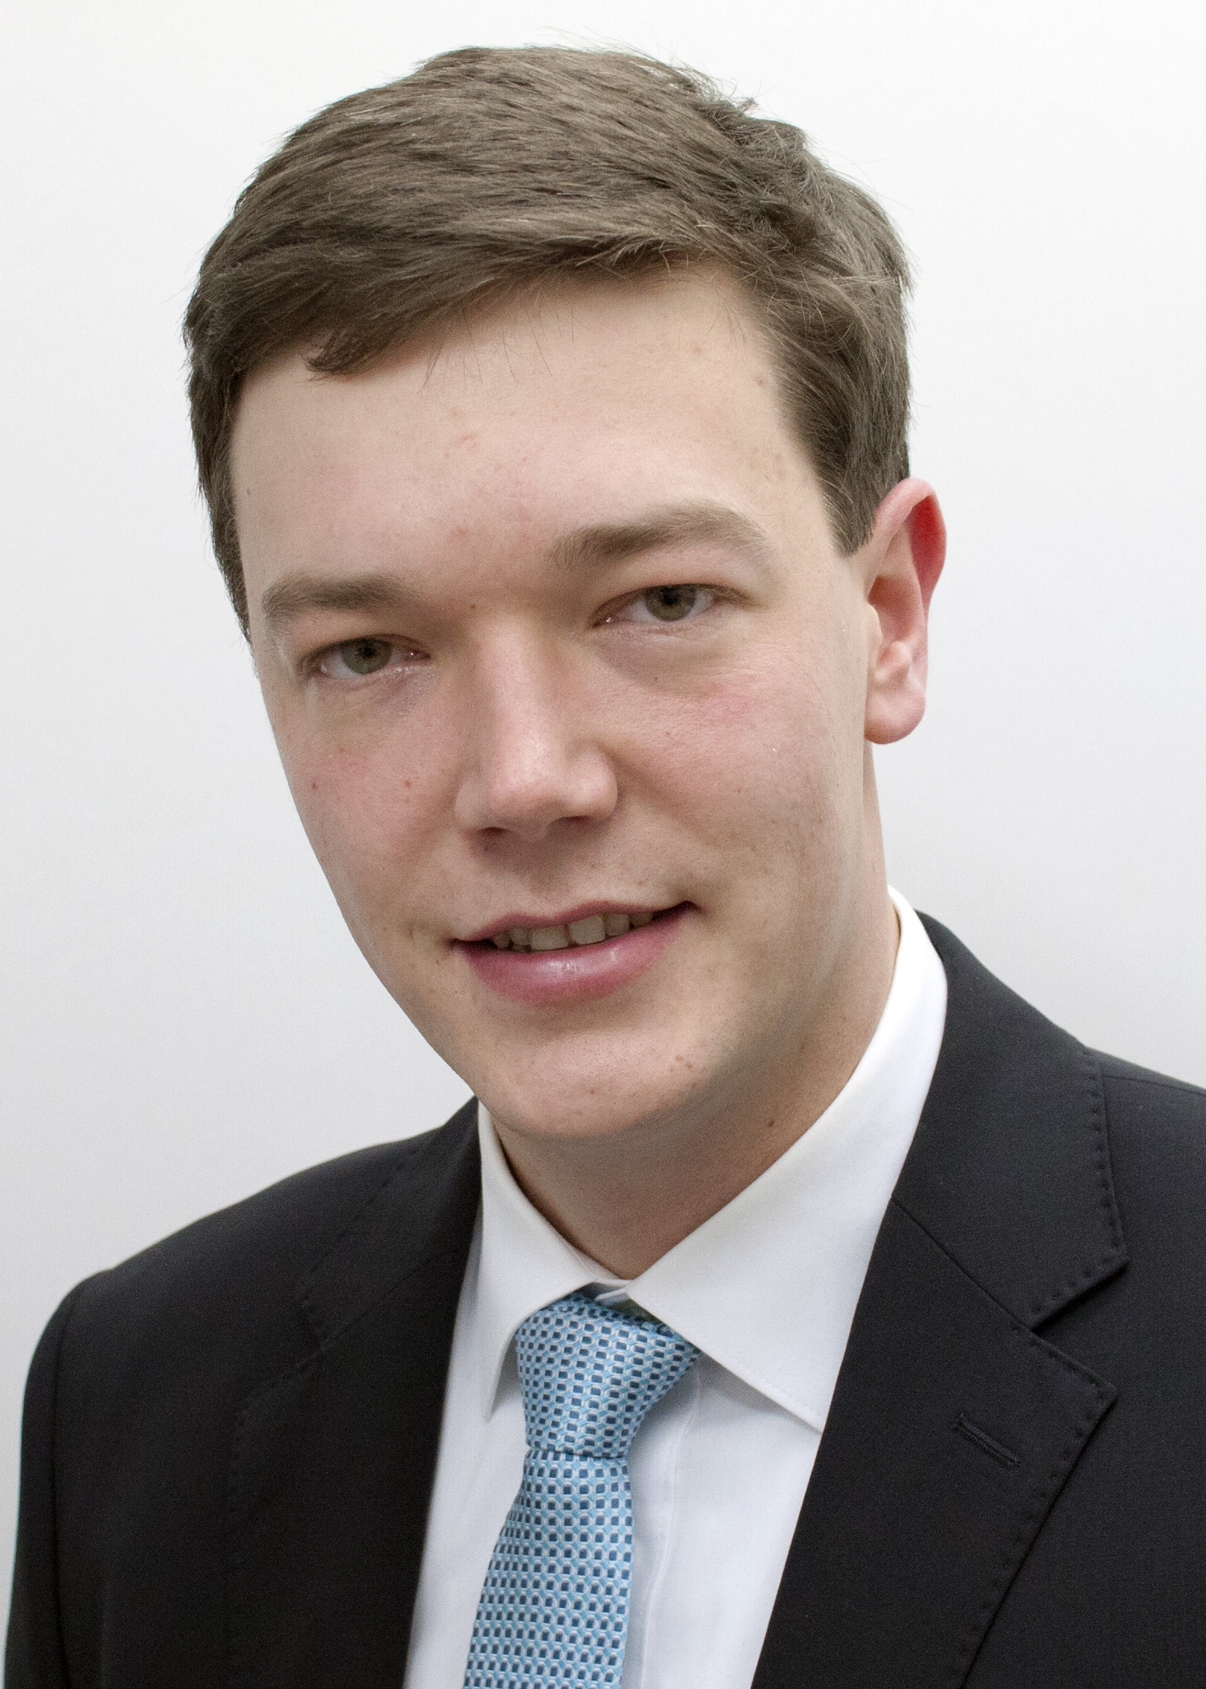
Eike-Christian Claußen
27th of September 1996 in Rendsburg, Germany

Citizenship German
Address Gorch-Fock-Weg 7,
24784 Westerrönfeld
Mobile +49 1525 5644332
E-Mail eikeclaussen2709@gmail.de

EDUCATION

Aug. 2022 – exp. Aug 2024 Frankfurt School of Finance and Management | Frankfurt, Germany
Master in Management, M.Sc

Oct. 2019 – exp. May 2022 Georg-August-Universität Göttingen | Göttingen, Germany
Bachelor of Agricultural Science, B.Sc.
Current grade: 2,3
Concentration: Agribusiness
Thesis: Barriers and challenges of implementing environmental support programs in German agriculture (in cooperation with the start-up Biodivers)

Aug. 2018 – Jun. 2019 Berufsbildungszentrum am Nord-Ostsee-Kanal | Osterrönfeld, Germany
Skilled famer
Final grade: 1,49
Apprenticeship school lessons for training as a farmer; one day per week

Aug. 2017 – Jul. 2018 Berufliche Schule des Kreises Ostholstein | Lensahn, Germany
Apprenticeship school lessons for training as a farmer; one day per week

Sept. 2007 – Jun. 2016 Herderschule Rendsburg | Rendsburg, Germany
University Entrance Qualification
Final grade: 1,8

Aug. 2003 – Jun. 2007 Schule am Ochsenweg | Westerrönfeld, Germany

WORK EXPERIENCE

Aug. 2021 – Sep. 2021 LV west-coast farming | Liepāja, Lativia

Employment in Agricultural Management and Practice

Coordinating the harvest with own machines and contractors

Aug. 2020 – Sep. 2020 / Rüdiger Wessel | Putbus, Germany

Jul. 2019 – Oct. 2019 Employment in Agricultural Management and Practice

Help with harvesting and sowing; quality control of the work steps

Jul. 2018 – Jul. 2019 BGA Söhrn GmbH & Co. KG | Beldorf, Germany

Agricultural Apprentice
Insight into all areas over one year; one school day per week

Jul. 2017 – Jul. 2018 Bauernmarkt & Geflügelhof Albert | Altgalendorf, Germany

Agricultural Apprentice
Insight into all areas over one year; one school day per week

Feb. 2017 – May 2017 Walling Contracting Southland | Invercargill, New Zealand
Employment in Agricultural Management, Strategy and Practice
Establishment of a new business area, a newly acquired dairy farm; Introduction to investments

Sep. 2016 – Dec 2016 Greg Roper | Goondiwindi, Australia
Employment in Agricultural Management and Practice
Maintenance and care of a machine over 3 months; combine harvesting work for various customers

Jul. 2015 – Aug. 2015 Nordsaat Salzau Landwirtschaftliche Betriebsgesellschaft mbH | Salzau, Germany
Employment in Agricultural Practice
First independent work with agricultural machinery and in seed processing

Oct. 2014 Blunk GmbH | Rendswühren, Germany
Internship at the Management Office
Introduction on strategy development for the new forestry sector in the company

Oct. 2012 – Dec. 2015 Holm & Laue GmbH & Co. KG | Westerrönfeld, Germany
Part-time employment besides school
Preparing orders in the warehouse

ADDITIONAL SKILLS AND QUALIFICATIONS

Languages German – native IT MS Office – advanced
English – fluent SPSS – advanced
French – basic

VOLUNTEERING AND EXTRACURRICULAR ACTIVITIES

Jan. 2021 – Jul. 2021 Chairman of a student lecture company | Göttingen, Germany

Sep. 2014 – Jun. 2016 Class representative | Rendsburg, Germany
Representative of my class in the last two years at Herderschule Rendsburg

Oct. 2011 – Jun. 2014 Handball Referee | Westerrönfeld, Germany
Referee for youth games in Schleswig-Holstein

Interests Handball, Ski, Cooking

Göttingen | 5th of March 2022


Eike-Christian Claußen

