Accenture GmbH
Campus Kronberg 1,
D-61476 Kronberg, Germany
+49 (0) 61 73 94-99
accenture.com

Letter of Recommendation
September 22, 2025

To Whom It May Concern,

It is my pleasure to recommend Ms. Mariana Lavrukhina, born on 11.11.2003 in Dnipro, who successfully completed her internship with our team at Accenture Strategy, M&A and Private Equity Practice, for three months between 1 July 2025 and 30 September 2025 working full-time 40 hours per week. During her time with us, Mariana consistently impressed with her outstanding analytical skills, reliability, and ability to adapt quickly to complex project settings.

Over the course of her internship, Mariana provided valuable support in a complex post-merger integration (PMI) project for a major global client in the agriculture and food processing industry, where she contributed to the Integration Management Office (IMO) and the Data, Technology, and Analytics workstream. She was supporting the carve-out of a business unit acquired from one of the world’s largest chemical companies.

Her responsibilities included assisting in the preparation of Steering Committee presentations, where she developed and continuously updated risk heat maps in Excel and PowerPoint and maintained risk descriptions on JIRA. In addition, she played a key role in the preparation of deliverables for leadership and employee meetings. She worked on an event planning template and slides for meetings with the Chief Transformation Officer, while also assisting in the preparation of an integration workshop.

Her contributions further extended to the development of a cutover period communication plan and drafting email templates to inform employees about post-merger integration activities. She also prepared an event roadmap displaying the timeline of management and workstream site visits, which proved highly valuable in coordinating the cross-stream forum during the post-merger integration phase.

Mariana also demonstrated strategic foresight in the conceptualization and development of Day-100 plans across key workstreams, focusing on ensuring business continuity, securing core operations, identifying quick wins and “low-hanging fruit,” and supporting synergy capture initiatives.

Finally, she supported the creation of end-to-end business process maps, capturing cross-functional information flows and interactions between divisions of the sold unit, and designed a governance structure chart showing the roles of the buyer, the seller, and Accenture across workstreams.

Beyond her technical contributions, Mariana stood out for her precise analytical ability, enabling her to quickly grasp complex situations and independently find efficient solutions. Already after a short period of familiarization, she was able to deliver excellent results even for challenging tasks. She consistently worked independently, carefully, and according to a well-thought-out plan, while also managing her time and responsibilities with great discipline.

She was exceptionally reliable, highly motivated, and demonstrated impressive dedication and willingness to learn. Her contributions were always of very high quality and quantity, and she fulfilled her responsibilities to our utmost satisfaction. Mariana was a valued member of the team, well-liked for her friendly, proactive, and cooperative attitude, which fostered effective collaboration both within the team and with stakeholders. Her communication was clear, thoughtful, and well adapted to the needs of both internal teams and the client. She also brought positive energy to the team, and she was a pleasure to work with.

I am confident that Mariana will bring value to any team she joins, and I recommend her without hesitation. Please do not hesitate to contact me if you have any questions or require further information.

Sincerely,
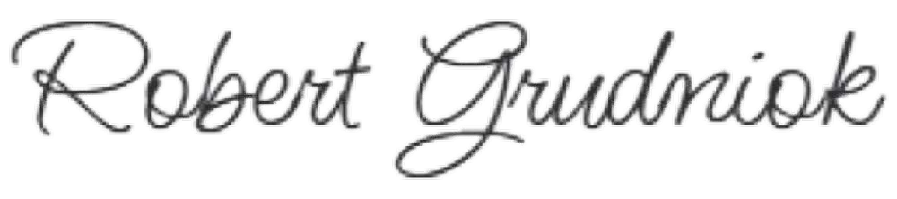

Robert Grudniok
Strategy Consultant
robert.grudniok@accenture.com

