Xinglin Academy: AI-Powered Traditional Chinese Medicine Diagnostic System Architecture

Fiona Cheng, Jimmy Yip, Marco Chung, Will Cheng
[Course Code]: [Course Name]
[Instructor Name]
[Date: August 26, 2026]
System Requirements Specification

1. Functional Requirements (FR)

1.1 Authentication & User Management
- User Registration: The system must provide a registration interface (/register) that validates input fields, checks for duplicate users, verifies password match/strength requirements, hashes passwords using bcrypt, and persists new user records in the MongoDB users collection.
- User Login: The system must authenticate users via /login, apply rate limiting checks (429 status code for excess attempts), verify credentials against stored bcrypt hashes, and issue a JWT token stored in a secure cookie upon successful login.
- Role-Based Access & Redirection: Upon login, the system must route users with an Admin role to /admin and standard users to /userInfo.
- Account & Profile Operations: Standard users can read their profile data (GET /userInfo) and update their credentials (e.g., POST /changePassword). Admins possess elevated permissions to perform user deletion operations (DELETE /admin/user/:id).

1.2 AI Medical Diagnosis & CRUD Operations
- Create (Medical Consultation Entry): System must capture user symptoms from the diagnostic view (doctor.ejs), process these inputs via an external AI service, and store the resulting consultation details (date, symptoms, diagnosis, prescription, ingredients, instructions, and image URLs) into the MongoDB history collection.
- Read (Consultation History & Details): Users can retrieve and display their historical consultation logs on a visual timeline (history.ejs). Selecting a record reloads the cached details back into the consultation interface.
- Update (System & Prescription State): System must maintain and update user session states (e.g., sessionStorage tokens, isLoggedIn, and reviewData flags). It must also allow database updates for system-wide health recipe data to automatically reflect updated prescription guidance across the application.
- Delete (History Management): Users can permanently delete individual diagnostic history records from the timeline via a dedicated interface action (DELETE request to backend).

2. Non-Functional Requirements (NFR)

2.1 Security Requirements
- Data Encryption & Hashing: All sensitive user credentials (passwords) must be hashed using bcrypt before storage in the database.
- Authentication Security: Secure API routes must be protected using JWT tokens passed via secure cookies and validated through authentication middleware.
- Rate Limiting: Protect registration/login endpoints against brute-force attacks using rate-limiting middleware (returning HTTP status 429 when limits are exceeded).
- Environment Protection: Sensitive environment configurations, system secrets, and external AI API keys must be isolated in environment variables (.env).

2.2 Performance & Reliability
- Stateless Session Validation: Use JWT tokens and client-side session storage (sessionStorage) to reduce backend database lookup overhead for active session states.
- API Integration: Ensure stable synchronous/asynchronous API communication between the Node.js backend server and external AI providers (Alibaba Qwen APIs) to return diagnosis data in structured JSON format.

3. Tech Stack & Environment Requirements
- Runtime & Framework: Node.js, Express.js (app.js)
- Database & ODM: MongoDB, Mongoose ODM (users, history, and sessions collections)
- View Engine & Assets: EJS templates (doctor.ejs, history.ejs), CSS stylesheets (doctor.css), and static images
- Security Dependencies: bcrypt, cookie-parser, custom rate limiter, input validator middleware
- External Services: Alibaba Qwen API

Section 3: System Architecture & Deployment Design

System Architecture
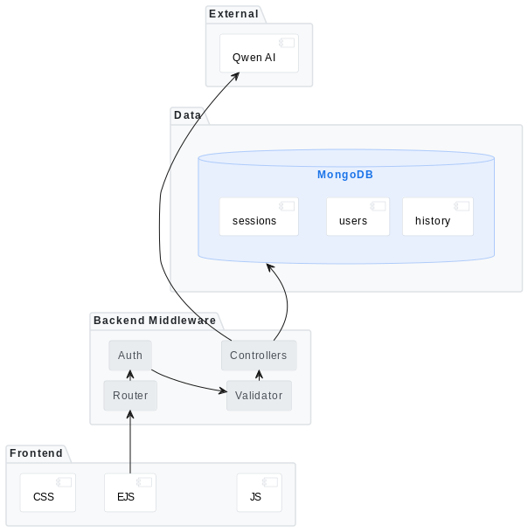
Figure 1. High-Level System Architecture Diagram.

Deployment Topology
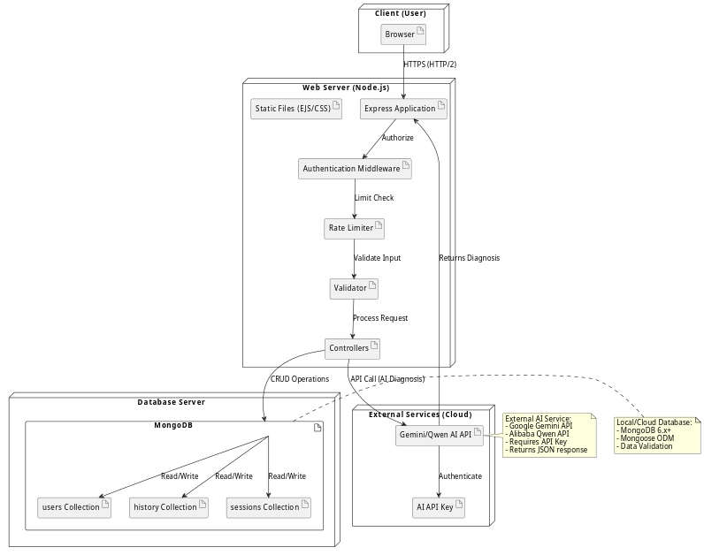
Figure 2. System Deployment Diagram.

Section 4: Data Modeling & Domain Design
Domain Class Architecture

