杏林院Xinglin Academy: AI-Powered Traditional Chinese Medicine Diagnostic System Architecture
Authors: Fiona Cheng, Jimmy Yip, Marco Chung, Will Cheng
Course: HK283DSFS5: 勵行會後端網站開發人員證書 (5)
Instructor: Fanny Hou
Date: August 26, 2026

1. System Requirements Specification

1.1 Functional Requirements (FR)

1.1.1 Authentication & User Management
- User Registration: The system must provide a registration interface (/register) that validates input fields, checks for duplicate users, verifies password match/strength requirements, hashes passwords using bcrypt, and persists new user records in the MongoDB users collection.
- User Login: The system must authenticate users via /login, verify credentials against stored bcrypt hashes, and issue a JWT token stored in a secure cookie upon successful login.
- Role-Based Access & Redirection: Upon login, the system must route users with an Admin role to /admin and standard users to /userInfo.
- Account & Profile Operations: Standard users can read their profile data (GET /userInfo) and update their credentials (e.g., POST /changePassword). Admins possess elevated permissions to perform user deletion operations (DELETE /admin/user/:id).

1.1.2 AI Medical Diagnosis & CRUD Operations
- Create (Medical Consultation Entry): System must capture user symptoms from the diagnostic view (doctor.ejs), process these inputs via an external AI service, and store the resulting consultation details (date, symptoms, diagnosis, prescription, ingredients, instructions, and image URLs) into the MongoDB history collection.
- Read (Consultation History & Details): Users can retrieve and display their historical consultation logs on a visual timeline (history.ejs). Selecting a record reloads the cached details back into the consultation interface.
- Update (System & Prescription State): System must maintain and update user session states (e.g., sessionStorage tokens, isLoggedIn, and reviewData flags). It must also allow database updates for system-wide health recipe data to automatically reflect updated prescription guidance across the application.
- Delete (History Management): Users can permanently delete individual diagnostic history records from the timeline via a dedicated interface action (DELETE request to backend).

1.2 Non-Functional Requirements (NFR)

1.2.1 Security Requirements
- Data Encryption & Hashing: All sensitive user credentials (passwords) must be hashed using bcrypt before storage in the database.
- Authentication Security: Secure API routes must be protected using JWT tokens passed via secure cookies and validated through authentication middleware.
- Environment Protection: Sensitive environment configurations, system secrets, and external AI API keys must be isolated in environment variables (.env).
- Male/Female AI interaction: The user could decide whether the interaction with the AI TCM responder uses a male/female picture as well as audio.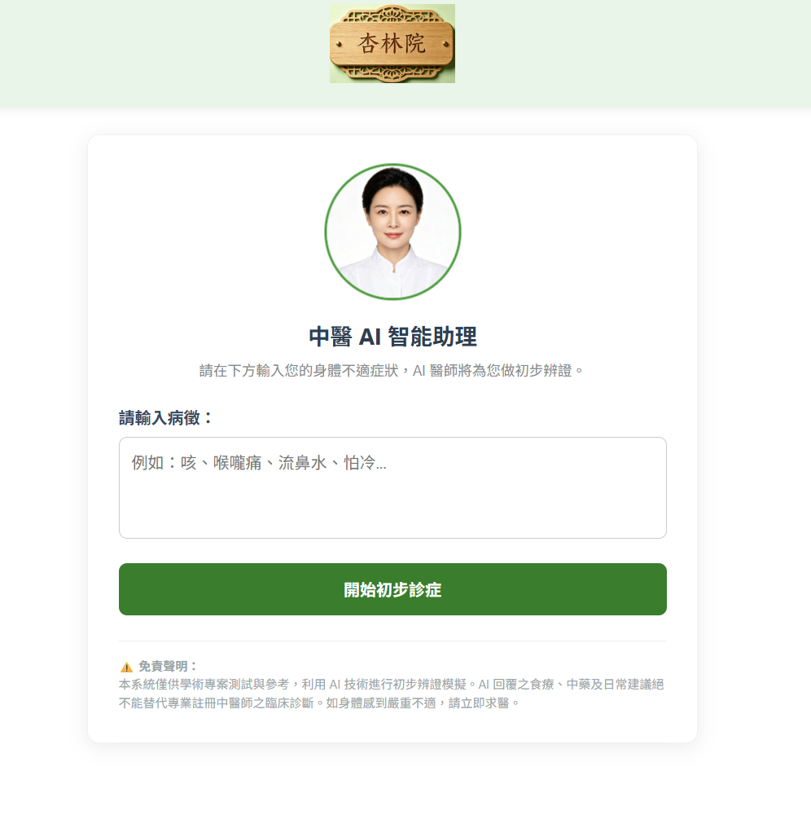

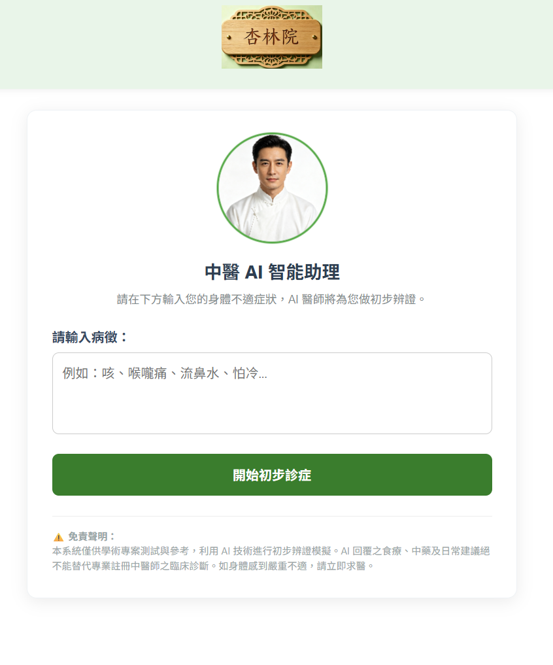

1.2.2 Performance & Reliability
- Stateless Session Validation: Use JWT tokens and client-side session storage (sessionStorage) to reduce backend database lookup overhead for active session states.
- API Integration: Ensure stable synchronous/asynchronous API communication between the Node.js backend server and external AI providers (Alibaba Qwen APIs) to return diagnosis data in structured JSON format.

1.3 Tech Stack & Environment Requirements
- Runtime & Framework: Node.js, Express.js (app.js)
- Database & ODM: MongoDB, Mongoose ODM (users, history, and sessions collections)
- View Engine & Assets: EJS templates (doctor.ejs, history.ejs), CSS stylesheets (doctor.css), and static images
- Security Dependencies: bcrypt, cookie-parser, input validator middleware
- External Services: Alibaba Qwen API

2. System Architecture & Deployment Design

2.1 System Architecture
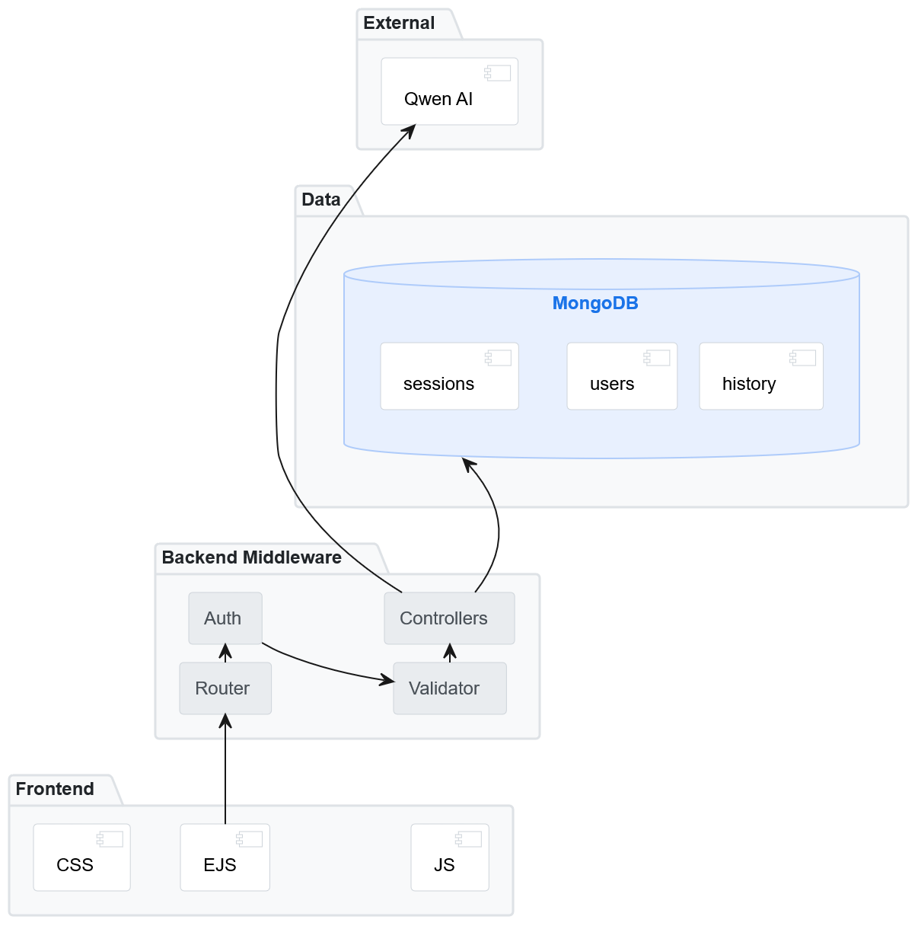
The application utilizes a modular system architecture separating Presentation, Backend Middleware, Data, and External AI Cloud Services.
Figure 1. High-Level System Architecture Diagram.

The Frontend Presentation Layer uses EJS templates, CSS styles, and client-side JavaScript. The Backend Middleware Layer routes requests through authentication and validation middleware into controllers. The Data Layer interfaces with MongoDB collections (users, history, sessions), while outbound requests process diagnostic prompts through the Alibaba Qwen AI service.

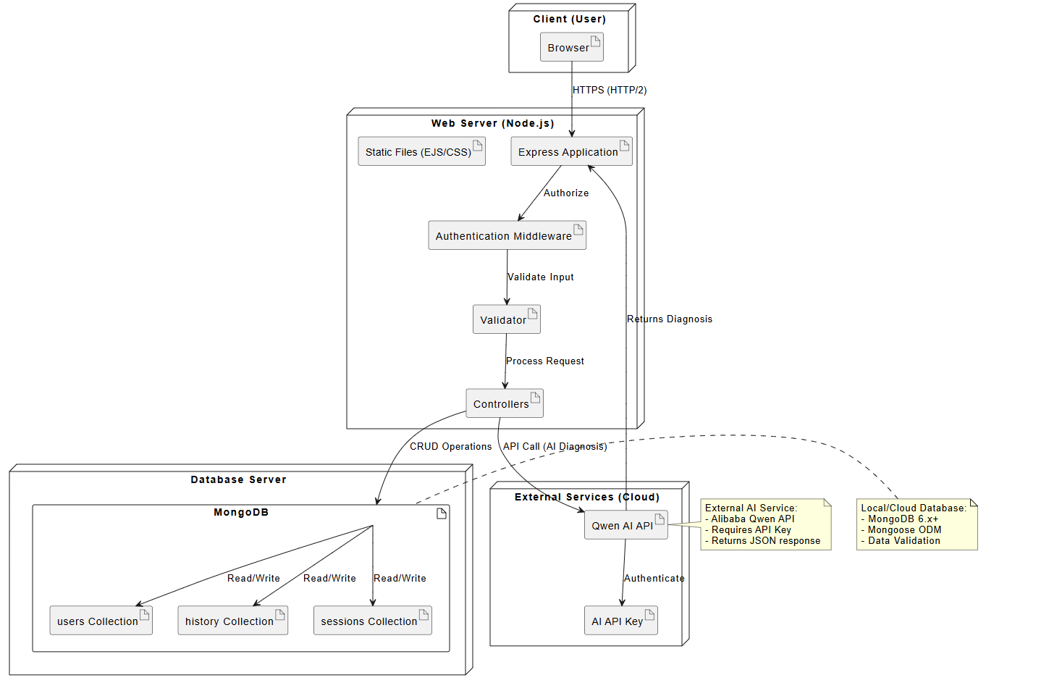Figure 2. System Deployment Diagram.
Clients connect via HTTPS. The Node.js Express server hosts application logic, static files, and security validation middleware. Database operations query MongoDB version 6.x+ via Mongoose ODM, and AI diagnostic requests authenticate through secure API keys to external cloud services.

3. Data Modeling & Domain Design

3.1 Domain Class Architecture
The domain model defines core business entities and their structural relationships.

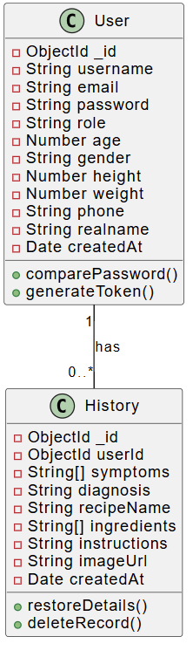
Figure 3. System Class Diagram and Entity Relationships.

3.1.1 Core Domain Classes
- User: Represents system accounts, encapsulating identity fields (_id, username, email, password, role), demographic traits (age, gender, height, weight, phone, realname), and creation timestamps. It defines business methods for password comparison (comparePassword()) and authentication token generation (generateToken()).
- History: Represents individual medical diagnostic records associated with a specific user. Attributes include _id, userId, symptoms, diagnosis, recipeName, ingredients, instructions, imageUrl, and createdAt. It provides operational methods for restoring prescription details (restoreDetails()) and deleting records (deleteRecord()).
- Session: Manages active state credentials and session validation. Attributes include token, userId, device, lastActive, and isLoggedIn. Methods include validate() and invalidate().

3.1.2 Entity Relationships
- User to History: One-to-Many (1 to 0..*). A single user can possess zero or multiple diagnosis history records.
- User to Session: One-to-Many (1 to 0..*). A single user can establish zero or multiple active sessions across different devices or logins.

3.2 Database Schema Design

1. users Collection
Stores user credentials, authorization roles, and personal profile information.
- _id (ObjectId, Primary Key)
- username (String, Required)
- email (String, Required, Unique)
- password (String, Hashed via bcrypt)
- role (String, Default: "user")
- age, gender, height, weight, phone, realname (Mixed Data Types)
- createdAt (Date, Timestamp)

2. history Collection
Stores diagnostic logs and herbal medicine prescriptions linked to individual user IDs.
- _id (ObjectId, Primary Key)
- userId (ObjectId, Foreign Key -> users._id)
- symptoms (Array of Strings)
- diagnosis (String)
- recipeName (String)
- ingredients (Array of Strings)
- instructions (String)
- imageUrl (String)
- createdAt (Date, Timestamp)

3. sessions Collection
Maintains active token metadata and session validity states.
- token (String, Unique)
- userId (ObjectId, Foreign Key -> users._id)
- device (String)
- lastActive (Date)
- isLoggedIn (Boolean)

4. Core Application Workflows & Behavior

4.1 User Authentication & Registration Workflows
The registration and login processes enforce structural validation, input sanitization, and hashed credential verification before issuing session tokens.

4.1.1 User Registration Flow
When a user accesses /register, the system presents a registration form. Upon submission (POST /register), the application executes validation checks:
- Field Validation: Ensures all required fields are filled and format constraints are satisfied.
- Password Verification: Validates password matching and strength requirements.
- Account Uniqueness: Queries MongoDB to confirm the email/user does not already exist.
- Account Creation: Hashes the password using bcrypt and writes the record to the users collection, returning a success response and redirecting to /login.

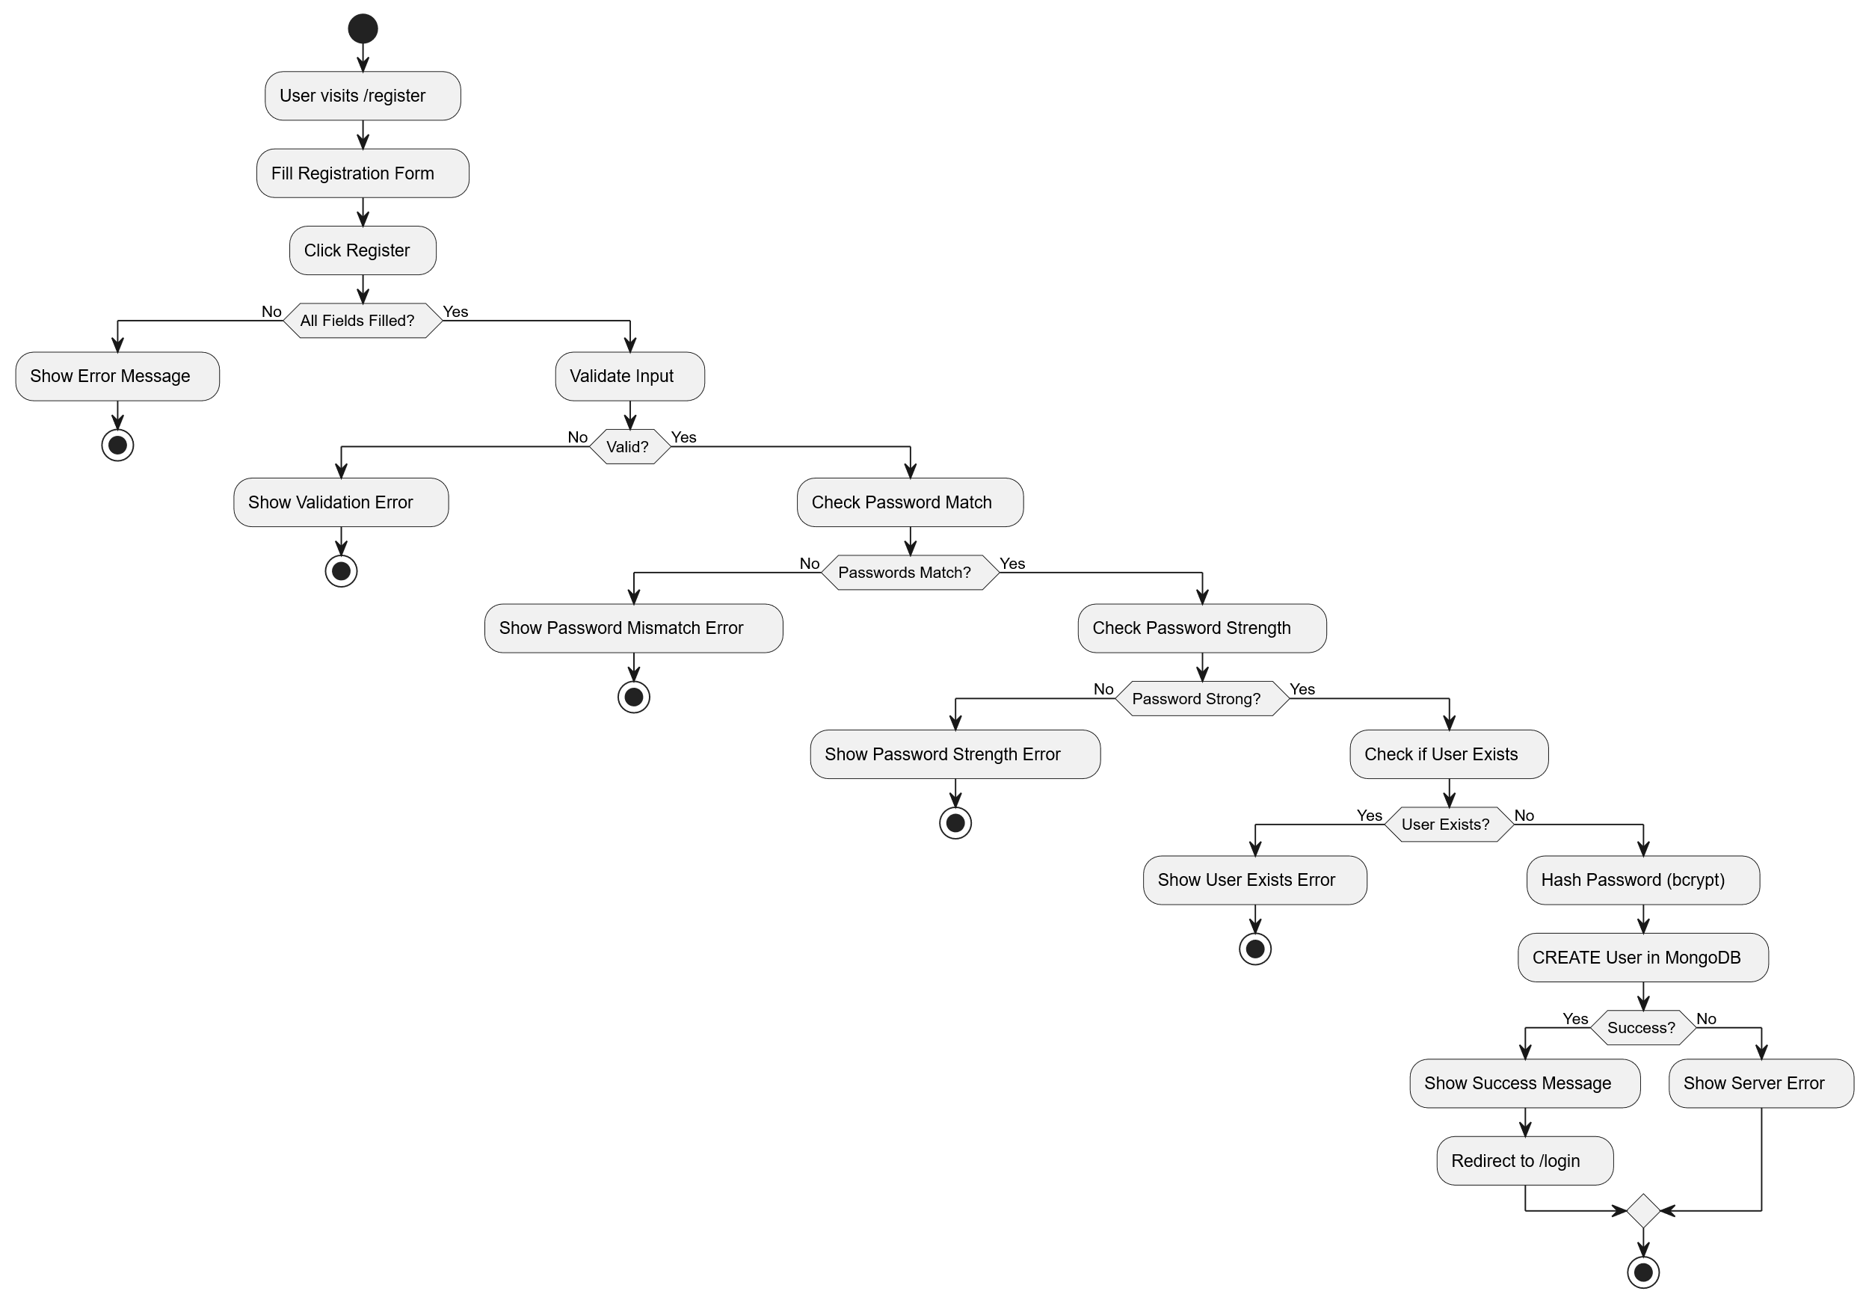
Figure 4. User Registration Activity Flow.

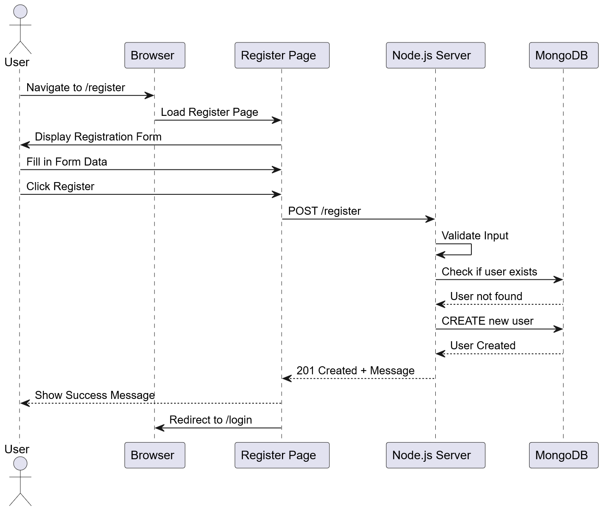
Figure 5. User Registration Sequence Diagram.

4.1.2 User Login & Access Control Flow
When submitting credentials at /login (POST /login), the system executes security checks before granting access:
- Credential Verification: Searches MongoDB for the user record and verifies the password against the stored bcrypt hash. If invalid, a generic 401 Unauthorized response is returned.
- Session Token Issuance: Upon successful verification, a JWT token is generated and stored in a secure cookie.
- Role-Based Redirection: Admin users are redirected to /admin, while standard users are routed to /userInfo.

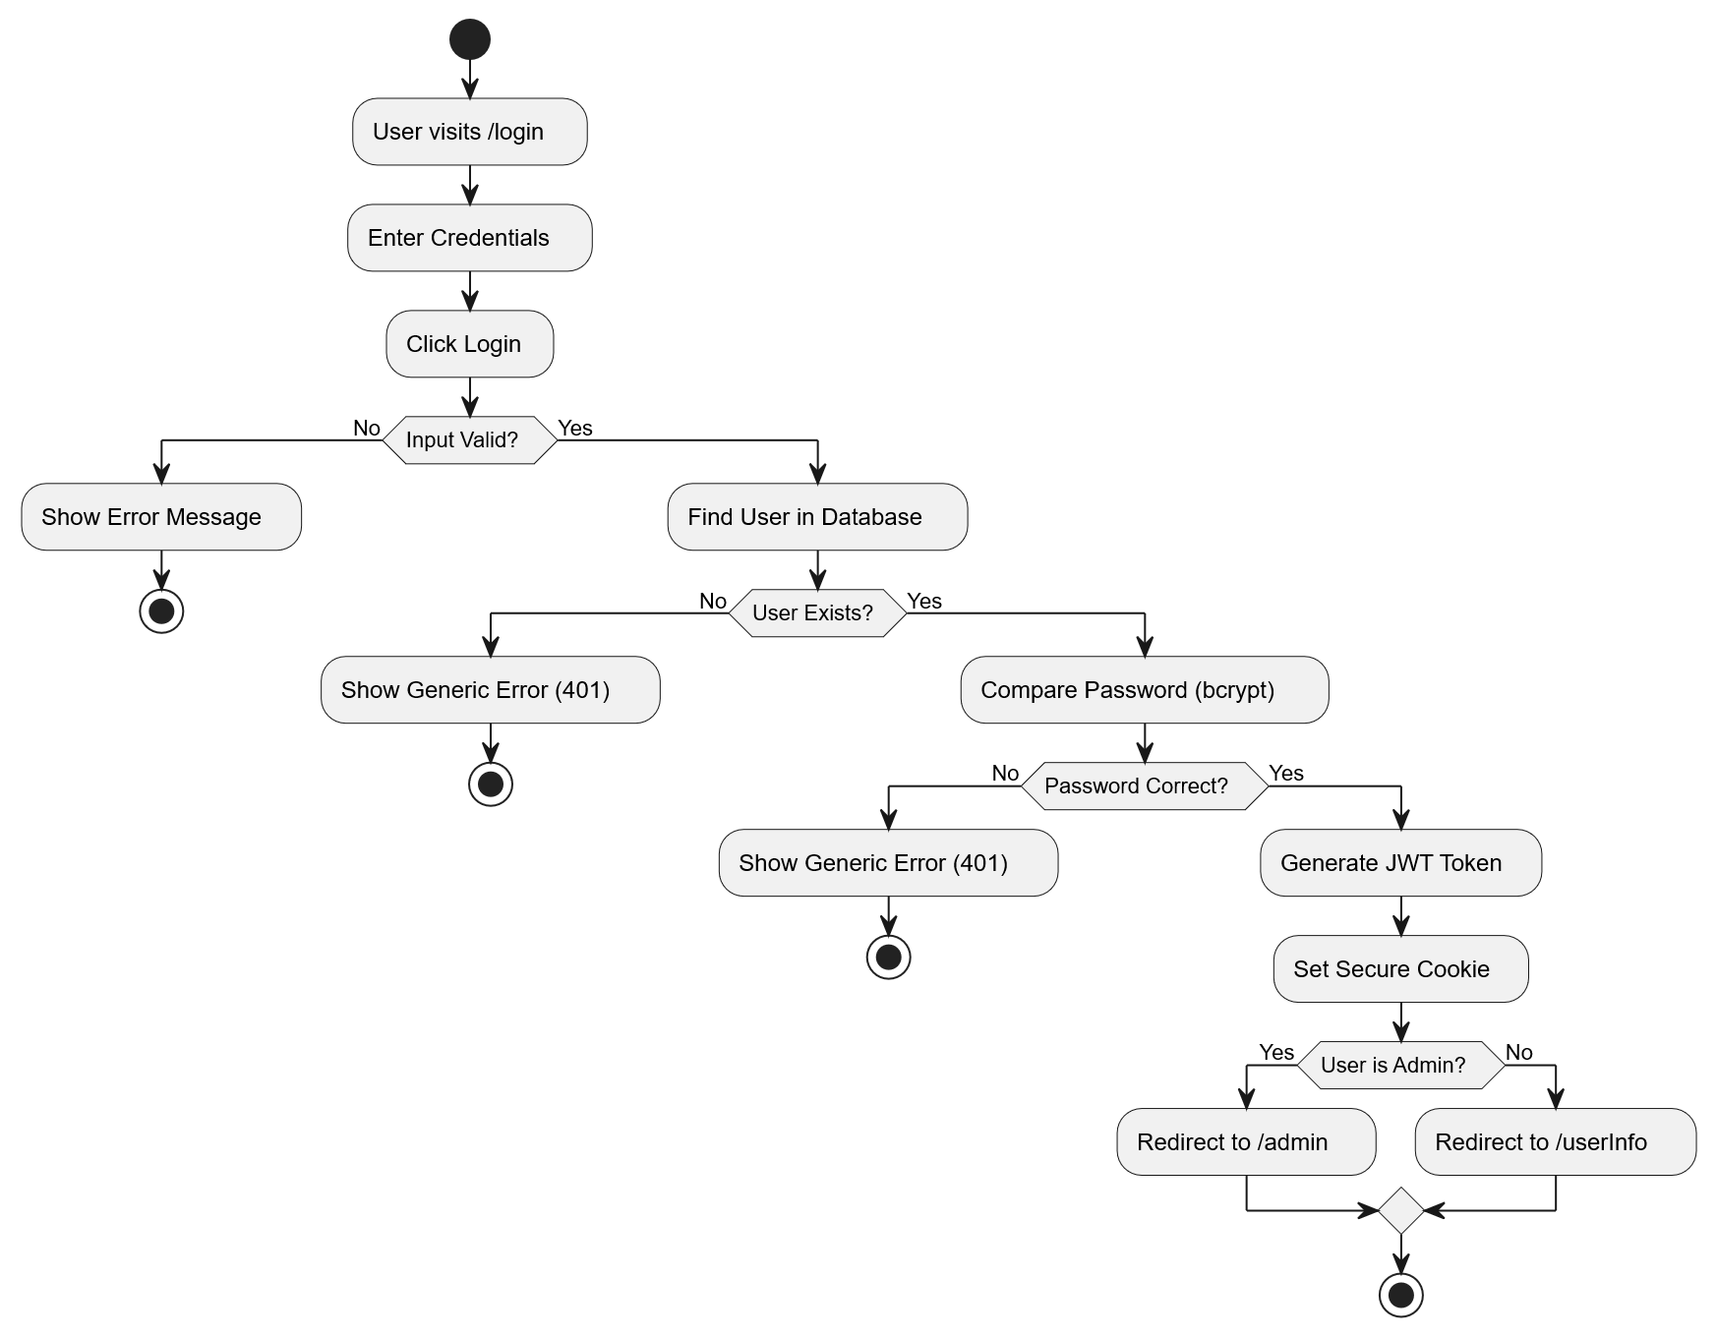
Figure 6. User Authentication Activity Flow.

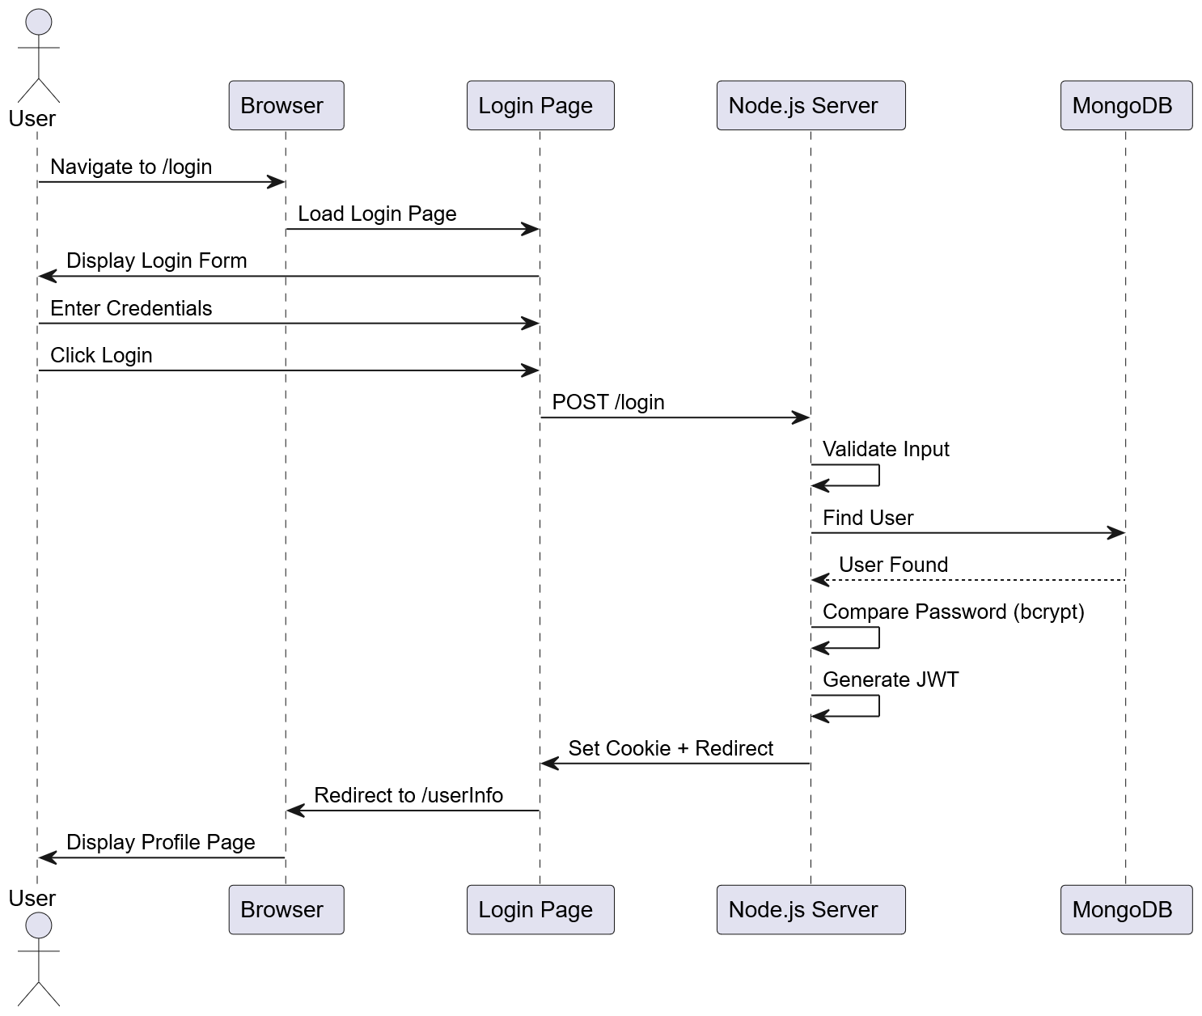
Figure 7. User Authentication Sequence Diagram.

4.2 CRUD Operations & System Integration
The application implements full CRUD capability, binding frontend user actions to backend controller logic and database mutations.
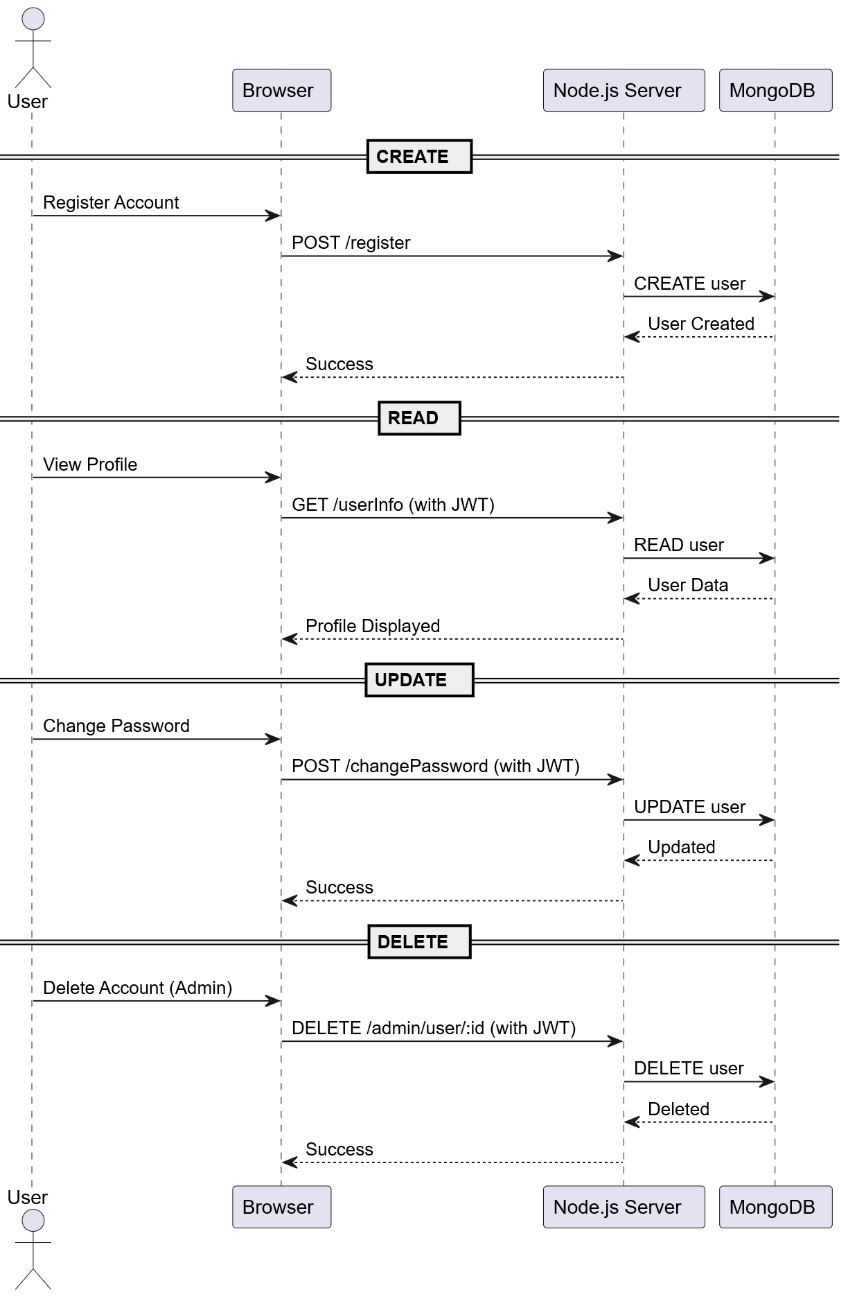
Figure 8. Core CRUD Operations Sequence Diagram.
- Create (Write Operations): User registration creates new user records in the users collection. Diagnostic sessions submitted via doctor.ejs automatically capture symptoms and AI-generated prescription guidance, storing complete diagnostic records in the history collection.
- Read (Query Operations): Navigating to history.ejs fetches historical consultation records associated with the user's account ID and renders them chronologically on a timeline interface. Restoring record details reloads cached prescription data back into the consultation view.
- Update (Modification Operations): Users can execute password updates (POST /changePassword), which modify the corresponding document in MongoDB. Session state flags (isLoggedIn, reviewData) and sessionStorage tokens are updated dynamically across requests. System-wide formulation changes update database records to automatically sync across frontend views.
- Delete (Removal Operations): Selecting individual record entries or executing administrative operations triggers target deletion requests (DELETE route), permanently removing corresponding records from MongoDB.

5. Directory Structure & System Implementation

5.1 Project Directory & Layout
The system follows a structured modular layout, separating server orchestration, static assets, rendering templates, and environment dependencies.

杏林院專案根目錄 (Root)
├── app.js
├── package.json
├── public/
│ ├── final_project_css/
│ │ └── doctor.css
│ └── erb_finalproject_photo/
│ ├── soup_master.png
│ └── herb_master.png
└── views/
├── doctor.ejs
└── history.ejs

5.1.1 Component Breakdown
- app.js (Core Server): Operates as the main Node.js application server. It initializes Express middleware, handles database connection setup via Mongoose, defines routing endpoints, and protects API keys using .env environment variables.
- package.json (Dependency Manifest): Manages project dependencies, including express (web server execution), mongoose (MongoDB ODM), and cookie-parser (JWT and cookie management).
- public/ (Static Assets): Stores static files served by Express.
  - final_project_css/: Contains custom CSS stylesheets (doctor.css) controlling UI layouts, UI components, navigation bars, and dynamic capsule tags.
  - erb_finalproject_photo/: Stores core image assets (soup_master.png, herb_master.png) rendered across consultation interfaces.
- views/ (Template Engine): Houses Server-Side Rendered (SSR) EJS templates.
  - doctor.ejs: Serves the real-time AI diagnostic interface, supporting interactive consultation options, speech integration capabilities, and session cache restoration.
  - history.ejs: Displays the user's historical diagnostic timeline, rendering stored records and providing deletion management controls.

5.2 Environment & Dependency Configuration
- Security & Environment Protection: Application secrets, database credentials, and external Cloud AI API keys (Alibaba Qwen) are kept out of source code and loaded dynamically from .env configuration files into app.js.
- Middleware Integration: Security middleware components (Authentication Middleware, Input Validator) are attached directly to Express routes to sanitize payloads and guard endpoints against unauthorized access.

