A case study of a manufacturing system producing jumper cables consists of six processes (workstations) and three rework paths is demonstrated in Figure 2. The manufacturing process begins with cutting the cable to the required length, followed by removing the outer protective jacket to expose the optical fibers. The exposed fibers are inserted into ceramic ferrules and secured using adhesive, which is subsequently cured through thermal baking. After connector assembly, the ferrule end faces are polished. End-face inspection and cleaning are then conducted prior to the final insertion loss measurement. Insertion loss is a KQC of jumper cables, as it represents the attenuation of optical power during signal transmission and directly affects product quality and transmission performance; it is measured in decibels (dB). Based on customer requirements, the manufactured jumper cables are categorized into two grades according to their insertion loss specifications: [0, 0.3] and [0, 0.35] dB, respectively. The mean and standard deviation of historical inspected data of insertion loss are 0.32 dB and 0.04 dB, respectively.
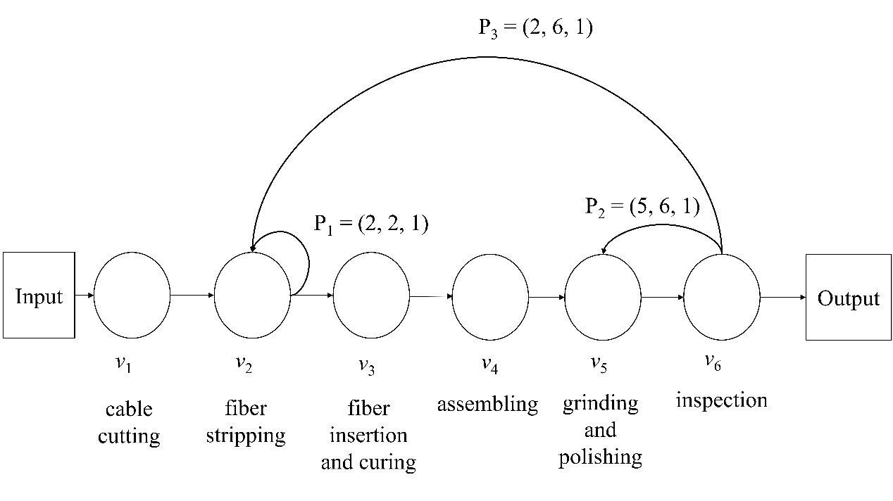
Figure 2. MFN modeled from a jumper cable manufacturing system.

Defective products generated during the jumper cable manufacturing process are undergo three rework paths. The first rework path is applied to defective WIPs generated at workstation v₂, where fiber breakage may occur during the stripping operation. When a fiber breakage occurs, the broken section is cut off, and the outer protective jacket is stripped again at workstation v₂ to expose an intact section of optical fiber. The second rework path is initiated after the jumper cable has undergone grinding and polishing at workstation v₅. The ferrule end face is then inspected, and the insertion loss is measured at workstation v₆. If the measured insertion loss exceeds 0.35 dB, the jumper cable is identified as defective and is returned to workstation v₅ for re-grinding and re-polishing. The third rework path, if the insertion loss remains above 0.35 dB after rework, the assembled connector components are disassembled and the product is returned to workstation 2 for reprocessing. For simplicity, the following example considers only one rework cycle, while multiple rework cycles are considered in Section 4.2. Therefore, the three rework paths are expressed as P₁ = (2, 2, 1), P₂ = (5, 6, 1), and P₃ = (2, 6, 1). The workstation parameters and the corresponding probabilities of each workstation providing a given capacity, calculated using the binomial distribution, are summarized in Table 1.

Table 1. Workstation parameters and corresponding probability.
Workstation  (v_{i}) | Number of identical machines  () | Machine yield rate  (π_{i}) | Machine availability  (r_{i}) | Workstation  capacity  (c_{i}) | Probability of providing given capacity  Pr(c_{i})
v₁ | 3 | 0.9997 | 0.9896 | 0 | 0.0000
 |  |  |  | 160 | 0.0003
 |  |  |  | 320 | 0.0306
 |  |  |  | 480 | 0.9691
v₂ | 4 | 0.9753 | 0.9725 | 0 | 0.0000
 |  |  |  | 115 | 0.0001
 |  |  |  | 230 | 0.0043
 |  |  |  | 345 | 0.1012
 |  |  |  | 460 | 0.8945
v₃ | 3 | 0.9982 | 0.9862 | 0 | 0.0000
 |  |  |  | 120 | 0.0006
 |  |  |  | 240 | 0.0403
 |  |  |  | 360 | 0.9592
v₄ | 4 | 0.9945 | 0.9723 | 0 | 0.0000
 |  |  |  | 125 | 0.0001
 |  |  |  | 250 | 0.0044
 |  |  |  | 375 | 0.1018
 |  |  |  | 500 | 0.8937
v₅ | 5 | 0.9218 | 0.9769 | 0 | 0.0000
 |  |  |  | 85 | 0.0000
 |  |  |  | 170 | 0.0001
 |  |  |  | 255 | 0.0050
 |  |  |  | 340 | 0.1052
 |  |  |  | 425 | 0.8897
v₆ | 3 | 0.7733 | 0.9831 | 0 | 0.0000
 |  |  |  | 135 | 0.0008
 |  |  |  | 270 | 0.0490
 |  |  |  | 405 | 0.9502

