目录

1283. Find the Smallest Divisor Given a Threshold 4

1284. Minimum Number of Flips to Convert Binary Matrix to Zero Matrix 6

1286. Iterator for Combination 10

1288. Remove Covered Intervals 12

1289. Minimum Falling Path Sum II 14

1292. Maximum Side Length of a Square with Sum Less than or Equal to Threshold 16

1293. Shortest Path in a Grid with Obstacles Elimination 19

1296. Divide Array in Sets of K Consecutive Numbers 22

1298. Maximum Candies You Can Get from Boxes 25

1300. Sum of Mutated Array Closest to Target 29

1301. Number of Paths with Max Score 32

1307. Verbal Arithmetic Puzzle 35

1312. Minimum Insertion Steps to Make a String Palindrome 40

1314. Matrix Block Sum 43

1315. Sum of Nodes with Even-Valued Grandparent 45

1316. Distinct Echo Substrings 47

1318. Minimum Flips to Make a OR b Equal to c 50

1319. Number of Operations to Make Network Connected 52

1320. Minimum Distance to Type a Word Using Two Fingers 56

1325. Delete Leaves With a Given Value 60

1326. Minimum Number of Taps to Open to Water a Garden 63

1330. Reverse Subarray To Maximize Array Value 66

1334. Find the City With the Smallest Number of Neighbors at a Threshold Distance 68

1335. Minimum Difficulty of a Job Schedule 71

1338. Reduce Array Size to The Half 74

1339. Maximum Product of Splitted Binary Tree 77

1340. Jump Game V 81

1345. Jump Game IV 86

1349. Maximum Students Taking Exam 89

1352. Product of the Last K Numbers 93

1353. Maximum Number of Events That Can Be Attended 96

1354. Construct Target Array With Multiple Sums 99

1362. Closest Divisors 102

1363. Largest Multiple of Three 104

1368. Minimum Cost to Make at Least One Valid Path in a Grid 106

1371. Find the Longest Substring Containing Vowels in Even Counts 111

1373. Maximum Sum BST in Binary Tree 113

1375. Bulb Switcher III 117

1383. Maximum Performance of a Team 120

1388. Pizza With 3n Slices 123

1395. Count Number of Teams 126

1397. Find All Good Strings 130

1402. Reducing Dishes 132

1405. Longest Happy String 134

1406. Stone Game III 137

1411. Number of Ways to Paint N × 3 Grid 140

1414. Find the Minimum Number of Fibonacci Numbers Whose Sum Is K 143

1415. The k-th Lexicographical String of All Happy Strings of Length n 145

1416. Restore The Array 149

1420. Build Array Where You Can Find The Maximum Exactly K Comparisons 153

1423. Maximum Points You Can Obtain from Cards 156

1425. Constrained Subsequence Sum 160

1434. Number of Ways to Wear Different Hats to Each Other 163

1438. Longest Continuous Subarray With Absolute Diff Less Than or Equal to Limit 166

1439. Find the Kth Smallest Sum of a Matrix With Sorted Rows 169

1442. Count Triplets That Can Form Two Arrays of Equal XOR 172

1444. Number of Ways of Cutting a Pizza 174

1449. Form Largest Integer With Digits That Add up to Target 177

1453. Maximum Number of Darts Inside of a Circular Dartboard 180

1458. Max Dot Product of Two Subsequences 184

1462. Course Schedule IV 186

1463. Cherry Pickup II 189

1467. Probability of a Two Boxes Having The Same Number of Distinct Balls 192

1477. Find Two Non-overlapping Sub-arrays Each With Target Sum 195

1478. Allocate Mailboxes 198

1482. Minimum Number of Days to Make m Bouquets 201

1483. Kth Ancestor of a Tree Node 204

1488. Avoid Flood in The City 207

1489. Find Critical and Pseudo-Critical Edges in Minimum Spanning Tree 210

1494. Parallel Courses II 213

1498. Number of Subsequences That Satisfy the Given Sum Condition 216

1499. Max Value of Equation 218

1504. Count Submatrices With All Ones 220

1505. Minimum Possible Integer After at Most K Adjacent Swaps On Digits 223

1514. Path with Maximum Probability 227

1515. Best Position for a Service Centre 230

1520. Maximum Number of Non-Overlapping Substrings 233

1521. Find a Value of a Mysterious Function Closest to Target 237

1526. Minimum Number of Increments on Subarrays to Form a Target Array 241

1531. String Compression II 243

1537. Get the Maximum Score 246

1541. Minimum Insertions to Balance a Parentheses String 249

1542. Find Longest Awesome Substring 252

1546. Maximum Number of NonOverlapping Subarrays With Sum Equals Target 254

1547. Minimum Cost to Cut a Stick 256

1553. Minimum Number of Days to Eat N Oranges 259

1559. Detect Cycles in 2D Grid 264

1562. Find Latest Group of Size M 268

1563. Stone Game V 272

1568. Minimum Number of Days to Disconnect Island 275

1569. Number of Ways to Reorder Array to Get Same BST 278

1574. Shortest Subarray to be Removed to Make Array Sorted 282

1575. Count All Possible Routes 284

1579. Remove Max Number of Edges to Keep Graph Fully Traversable 287

### 1283. Find the Smallest Divisor Given a Threshold

Medium

Given an array of integers nums and an integer threshold, we will choose a positive integer divisor and divide all the array by it and sum the result of the division. Find the **smallest** divisor such that the result mentioned above is less than or equal to threshold.

Each result of division is rounded to the nearest integer greater than or equal to that element. (For example: 7/3 = 3 and 10/2 = 5).

It is guaranteed that there will be an answer.

**Example 1:**

**Input:** nums = [1,2,5,9], threshold = 6

**Output:** 5

**Explanation:** We can get a sum to 17 (1+2+5+9) if the divisor is 1.

If the divisor is 4 we can get a sum to 7 (1+1+2+3) and if the divisor is 5 the sum will be 5 (1+1+1+2).

**Example 2:**

**Input:** nums = [2,3,5,7,11], threshold = 11

**Output:** 3

**Example 3:**

**Input:** nums = [19], threshold = 5

**Output:** 4

**Constraints:**

* 1 <= nums.length <= 5 * 10^4
* 1 <= nums[i] <= 10^6
* nums.length <= threshold <= 10^6

class Solution {

public:

    int smallestDivisor(vector<int>& nums, int threshold) {

        int l = 1, r = INT_MAX;

        while (l < r) {

            int mid = l + (r-l)/2, sum = 0;

            for (double i : nums) sum += ceil(i / mid);

            if (sum > threshold) l = mid+1;

            else r = mid;

        }

        return l;

    }

};

### 1284. Minimum Number of Flips to Convert Binary Matrix to Zero Matrix★★★

Hard

Given a m x n binary matrix mat. In one step, you can choose one cell and flip it and all the four neighbours of it if they exist (Flip is changing 1 to 0 and 0 to 1). A pair of cells are called neighboors if they share one edge.

Return the *minimum number of steps* required to convert mat to a zero matrix or **-1** if you cannot.

Binary matrix is a matrix with all cells equal to 0 or 1 only.

Zero matrix is a matrix with all cells equal to 0.

**Example 1:**

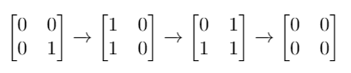

**Input:** mat = [[0,0],[0,1]]

**Output:** 3

**Explanation:** One possible solution is to flip (1, 0) then (0, 1) and finally (1, 1) as shown.

**Example 2:**

**Input:** mat = [[0]]

**Output:** 0

**Explanation:** Given matrix is a zero matrix. We don't need to change it.

**Example 3:**

**Input:** mat = [[1,1,1],[1,0,1],[0,0,0]]

**Output:** 6

**Example 4:**

**Input:** mat = [[1,0,0],[1,0,0]]

**Output:** -1

**Explanation:** Given matrix can't be a zero matrix

**Constraints:**

* m == mat.length
* n == mat[0].length
* 1 <= m <= 3
* 1 <= n <= 3
* mat[i][j] is 0 or 1.

class Solution {

public:

    int m, n;

    const vector<int> dirs{0,0,1,0,-1,0};

    int minFlips(vector<vector<int>>& mat) {

        n = mat.size(), m = mat[0].size();

        int bitvec = createBitVec(mat), cnt = 0;

        if (!bitvec) return 0;

        queue<int> q;

        unordered_set<int> vis;

        q.push(bitvec);

        while (!q.empty()) {

            int sz = q.size();

            ++cnt;

            while (sz--) {

                auto u = q.front();

                q.pop();

                for (int i = 0; i < n; i++) {

                    for (int j = 0; j < m; j++) {

                        int t = getFlip(i, j, u);

                        if (!t) return cnt;

                        if (!vis.count(t)) {

                            q.push(t);

                            vis.insert(t);

                        }

                    }

                }

            }

        }

        return -1;

}

int createBitVec(vector<vector<int>>& mat) {

        int bitvec = 0;

        for(int i = 0;i < n; i++) {

            for(int j = 0; j < m; j++) {

                bitvec <<= 1;

                bitvec |= mat[i][j];

            }

        }

        return bitvec;

    }

    int getFlip(int i, int j, int bitVec) {

        for (int d = 0; d < 5; d++) {

            int x = i+dirs[d], y = j+dirs[d+1];

            if (x >= 0 && y >= 0 && x < n && y < m) {

                bitVec ^= 1<<(x*m+y);

            }

        }

        return bitVec;

    }

};

### 1286. Iterator for Combination

Medium

Design an Iterator class, which has:

* A constructor that takes a string characters of **sorted distinct** lowercase English letters and a number combinationLength as arguments.
* A function *next()* that returns the next combination of length combinationLength in **lexicographical order**.
* A function *hasNext()* that returns True if and only if there exists a next combination.

**Example:**

CombinationIterator iterator = new CombinationIterator("abc", 2); // creates the iterator.

iterator.next(); // returns "ab"

iterator.hasNext(); // returns true

iterator.next(); // returns "ac"

iterator.hasNext(); // returns true

iterator.next(); // returns "bc"

iterator.hasNext(); // returns false

**Constraints:**

* 1 <= combinationLength <= characters.length <= 15
* There will be at most 10^4 function calls per test.
* It's guaranteed that all calls of the function next are valid.

class CombinationIterator {

public:

    int len, mask;

    string s;

    CombinationIterator(string characters, int combinationLength) {

        s=characters;

        len = combinationLength;

        mask = (1 << characters.length()) - 1;

    }

    string next() {

        while(mask && __builtin_popcount(mask) != len) mask--;

        string out;

        for(int i=0; i< s.length(); i++) {

            if (mask & (1 << (s.length() - i - 1)))

                out += s[i];

        }

        mask--;

        return out;

    }

    bool hasNext() {

        while(mask && __builtin_popcount(mask) != len) mask--;

        if (!mask)

            return false;

        return true;

    }

};

class CombinationIterator {

public:

    int len, mask;

    string s, characters;

    bool ok = true, end = false;

    CombinationIterator(string a, int n) {

        s = string(n, '1') + string(a.size() - n, '0');

        characters = a;

    }

    string next() {

        hasNext();

        ok = false;

        string res;

        for (int i = 0; i < s.length(); ++i) {

            if (s[i] == '1')

                res += characters[i];

        }

        return res;

    }

    bool hasNext() {

       if (end) return false;

       if (ok) return true;

       if (!prev_permutation(s.begin(), s.end())) {

           end = true;

           return false;

       }

       return ok = true;

    }

};

### 1288. Remove Covered Intervals

Medium

Given a list of intervals, remove all intervals that are covered by another interval in the list. Interval [a,b) is covered by interval [c,d) if and only if c <= a and b <= d.

After doing so, return the number of remaining intervals.

**Example 1:**

**Input:** intervals = [[1,4],[3,6],[2,8]]

**Output:** 2

**Explanation:** Interval [3,6] is covered by [2,8], therefore it is removed.

**Constraints:**

* 1 <= intervals.length <= 1000
* 0 <= intervals[i][0] < intervals[i][1] <= 10^5
* intervals[i] != intervals[j] for all i != j

class Solution {

public:

    int removeCoveredIntervals(vector<vector<int>>& intervals) {

        auto cmp = [](const vector<int> &lhs, const vector<int> &rhs) {

            if (lhs[0] != rhs[0]) return lhs[0] < rhs[0];

            else return lhs[1] > rhs[1];

        };

        sort(intervals.begin(), intervals.end(), cmp);

        int pre = intervals[0][0], res = intervals.size();

        for (auto &v : intervals) {

            if (pre >= v[1]) --res;

            else pre = v[1];

        }

        return res;

    }

};

### 1289. Minimum Falling Path Sum II

Hard

Given a square grid of integers arr, a *falling path with non-zero shifts* is a choice of exactly one element from each row of arr, such that no two elements chosen in adjacent rows are in the same column.

Return the minimum sum of a falling path with non-zero shifts.

**Example 1:**

**Input:** arr = [[1,2,3],[4,5,6],[7,8,9]]

**Output:** 13

**Explanation:**

The possible falling paths are:

[1,5,9], [1,5,7], [1,6,7], [1,6,8],

[2,4,8], [2,4,9], [2,6,7], [2,6,8],

[3,4,8], [3,4,9], [3,5,7], [3,5,9]

The falling path with the smallest sum is [1,5,7], so the answer is 13.

**Constraints:**

* 1 <= arr.length == arr[i].length <= 200
* -99 <= arr[i][j] <= 99

class Solution {

public:

    int minFallingPathSum(vector<vector<int>>& arr) {

        int fm = 0, sm = 0, pos = -1;

        for (auto i = 0; i < arr.size(); ++i) {

            auto fm2 = INT_MAX, sm2 = INT_MAX, pos2 = -1;

            for (auto j = 0; j < arr[i].size(); ++j) {

                auto mn = j != pos ? fm : sm;

                if (arr[i][j] + mn < fm2) {

                    sm2 = fm2;

                    fm2 = arr[i][j] + mn;

                    pos2 = j;

                } else sm2 = min(sm2, arr[i][j] + mn);

            }

            fm = fm2, sm = sm2, pos = pos2;

        }

        return fm;

    }

};

### 1292. Maximum Side Length of a Square with Sum Less than or Equal to Threshold

Medium

Given a m x n matrix mat and an integer threshold. Return the maximum side-length of a square with a sum less than or equal to threshold or return **0** if there is no such square.

**Example 1:**

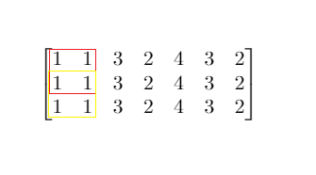

**Input:** mat = [[1,1,3,2,4,3,2],[1,1,3,2,4,3,2],[1,1,3,2,4,3,2]], threshold = 4

**Output:** 2

**Explanation:** The maximum side length of square with sum less than 4 is 2 as shown.

**Example 2:**

**Input:** mat = [[2,2,2,2,2],[2,2,2,2,2],[2,2,2,2,2],[2,2,2,2,2],[2,2,2,2,2]], threshold = 1

**Output:** 0

**Example 3:**

**Input:** mat = [[1,1,1,1],[1,0,0,0],[1,0,0,0],[1,0,0,0]], threshold = 6

**Output:** 3

**Example 4:**

**Input:** mat = [[18,70],[61,1],[25,85],[14,40],[11,96],[97,96],[63,45]], threshold = 40184

**Output:** 2

**Constraints:**

* 1 <= m, n <= 300
* m == mat.length
* n == mat[i].length
* 0 <= mat[i][j] <= 10000
* 0 <= threshold <= 10^5

class Solution {

    int squareSum(vector<vector<int>>&prefixSum, int x1, int y1, int x2, int y2) {

        return prefixSum[x2][y2] - prefixSum[x1][y2]

 - prefixSum[x2][y1] + prefixSum[x1][y1];

    }

public:

    int maxSideLength(vector<vector<int>>& mat, int threshold) {

        int m = mat.size(), n = mat[0].size();

        vector<vector<int>> prefixSum(m+1, vector<int>(n+1));

        for (int i = 1; i <= m; i++) {

            for (int j = 1; j <= n; j++) {

                prefixSum[i][j] = prefixSum[i-1][j]+prefixSum[i][j-1]

- prefixSum[i-1][j-1] + mat[i-1][j-1];

            }

        }

        int res = 0;

        for (int i = 0; i <= m; i++) {

            for (int j = 0; j <= n; j++) {

                int len = res+1;

                while (i+len <= m && j+len <= n

 && squareSum(prefixSum, i, j, i+len, j+len) <= threshold) {

                    res = len;

                    len++;

                }

            }

        }

        return res;

    }

};

### 1293. Shortest Path in a Grid with Obstacles Elimination

Hard

Given a m * n grid, where each cell is either 0 (empty) or 1 (obstacle). In one step, you can move up, down, left or right from and to an empty cell.

Return the minimum number of steps to walk from the upper left corner (0, 0) to the lower right corner (m-1, n-1) given that you can eliminate **at most** k obstacles. If it is not possible to find such walk return -1.

**Example 1:**

**Input:**

grid =

[[0,0,0],

 [1,1,0],

[0,0,0],

 [0,1,1],

[0,0,0]],

k = 1

**Output:** 6

**Explanation:**

The shortest path without eliminating any obstacle is 10.

The shortest path with one obstacle elimination at position (3,2) is 6. Such path is (0,0) -> (0,1) -> (0,2) -> (1,2) -> (2,2) -> **(3,2)** -> (4,2).

**Example 2:**

**Input:**

grid =

[[0,1,1],

 [1,1,1],

 [1,0,0]],

k = 1

**Output:** -1

**Explanation:**

We need to eliminate at least two obstacles to find such a walk.

**Constraints:**

* grid.length == m
* grid[0].length == n
* 1 <= m, n <= 40
* 1 <= k <= m*n
* grid[i][j] == 0 **or** 1
* grid[0][0] == grid[m-1][n-1] == 0

class Solution {

public:

    int shortestPath(vector<vector<int>>& grid, int k) {

        int rows=grid.size(), cols=grid[0].size();

        int minSteps = max(0,rows+cols-2), obstacles=minSteps-1, minStepsNextRound=minSteps;

        if(obstacles<=k) return minSteps;

// take a shortcut if we can afford it

        vector<vector<int>> dirs = {{1,0},{0,1},{-1,0},{0,-1}};

        list<vector<int>> togo; togo.push_back({0,0,k});

// BFS: {row, col, remaining k}

        vector<int> visited(rows*cols, -1);

// position -> k remaining

        visited[0]=k;

        int steps=0;

        while(togo.size()) {

           steps++;

           minSteps=minStepsNextRound;

           for(int sz=togo.size();sz>0;sz--) {

             int r=togo.front()[0],c=togo.front()[1],k=togo.front()[2];

                togo.pop_front();

                for(auto& d:dirs) {

                    int rr=r+d[0], cc=c+d[1];

                    if(rr<0 || rr>=rows || cc<0 || cc>=cols) continue;

                    int kk = k-grid[rr][cc];

                    if(visited[rr*cols+cc]>=kk) continue;

// have been here passing less obstacles

// maybe we can take a shortcut and go straight to the goal

// but jump only from the point closest to the target

                    int stepsToTarget = rows-rr-1+cols-cc-1;

                    if(stepsToTarget-1<=kk&&stepsToTarget==minSteps-1)

return steps+stepsToTarget;

                    togo.push_back({rr,cc,kk});

                    visited[rr*cols+cc]=kk;

                    minStepsNextRound=min(minStepsNextRound

,stepsToTarget);

                }

            }

        }

        return -1;

    }

};

### 1296. Divide Array in Sets of K Consecutive Numbers

Medium

Given an array of integers nums and a positive integer k, find whether it's possible to divide this array into sets of k consecutive numbers  
Return True if its possibleotherwise return False.

**Example 1:**

**Input:** nums = [1,2,3,3,4,4,5,6], k = 4

**Output:** true

**Explanation:** Array can be divided into [1,2,3,4] and [3,4,5,6].

**Example 2:**

**Input:** nums = [3,2,1,2,3,4,3,4,5,9,10,11], k = 3

**Output:** true

**Explanation:** Array can be divided into [1,2,3] , [2,3,4] , [3,4,5] and [9,10,11].

**Example 3:**

**Input:** nums = [3,3,2,2,1,1], k = 3

**Output:** true

**Example 4:**

**Input:** nums = [1,2,3,4], k = 3

**Output:** false

**Explanation:** Each array should be divided in subarrays of size 3.

**Constraints:**

* 1 <= nums.length <= 10^5
* 1 <= nums[i] <= 10^9
* 1 <= k <= nums.length

class Solution {

public:

    struct node {

        int val, sz;

        bool operator < (const node &rhs) const {

            if (val != rhs.val) return val > rhs.val;

            else return sz < rhs.sz;

        }

    };

    bool isPossibleDivide(vector<int>& nums, int k) {

        if (k == 1) return true;

        sort(nums.begin(), nums.end());

        priority_queue<node> pq;

        for (auto i : nums) {

            if (pq.empty()) pq.push({i, 1});

            else if (pq.top().val == i-1) {

                if (pq.top().sz == k-1) pq.pop();

                else {

                    node t = {pq.top().val+1, pq.top().sz+1};

                    pq.pop();

                    pq.push(t);

                }

            }

            else pq.push({i, 1});

            //cout << pq.size() << "\n";

        }

        return pq.empty();

    }

};

class Solution {

public:

    bool isPossibleDivide(vector<int>& nums, int k) {

        unordered_map<int, int> ctr;

        for (int num : nums)

            ctr[num]++;

        for (int num : nums) {

            int start = num;

            while (ctr[start - 1])

                start--;

            for (; start <= num; start++) {

                int times = ctr[start];

                if (times) {

                    for (int victim=start;victim < start+k;victim++) {

                        if (ctr[victim] < times)

                            return false;

                        ctr[victim] -= times;

                    }

                }

            }

        }

        return true;

    }

};

### 1298. Maximum Candies You Can Get from Boxes

Hard

Given n boxes, each box is given in the format [status, candies, keys, containedBoxes] where:

* status[i]: an integer which is **1** if box[i] is open and **0** if box[i] is closed.
* candies[i]: an integer representing the number of candies in box[i].
* keys[i]: an array contains the indices of the boxes you can open with the key in box[i].
* containedBoxes[i]: an array contains the indices of the boxes found in box[i].

You will start with some boxes given in initialBoxes array. You can take all the candies in any open box and you can use the keys in it to open new boxes and you also can use the boxes you find in it.

Return *the maximum number of candies* you can get following the rules above.

**Example 1:**

**Input:** status = [1,0,1,0], candies = [7,5,4,100], keys = [[],[],[1],[]], containedBoxes = [[1,2],[3],[],[]], initialBoxes = [0]

**Output:** 16

**Explanation:** You will be initially given box 0. You will find 7 candies in it and boxes 1 and 2. Box 1 is closed and you don't have a key for it so you will open box 2. You will find 4 candies and a key to box 1 in box 2.

In box 1, you will find 5 candies and box 3 but you will not find a key to box 3 so box 3 will remain closed.

Total number of candies collected = 7 + 4 + 5 = 16 candy.

**Example 2:**

**Input:** status = [1,0,0,0,0,0], candies = [1,1,1,1,1,1], keys = [[1,2,3,4,5],[],[],[],[],[]], containedBoxes = [[1,2,3,4,5],[],[],[],[],[]], initialBoxes = [0]

**Output:** 6

**Explanation:** You have initially box 0. Opening it you can find boxes 1,2,3,4 and 5 and their keys. The total number of candies will be 6.

**Example 3:**

**Input:** status = [1,1,1], candies = [100,1,100], keys = [[],[0,2],[]], containedBoxes = [[],[],[]], initialBoxes = [1]

**Output:** 1

**Example 4:**

**Input:** status = [1], candies = [100], keys = [[]], containedBoxes = [[]], initialBoxes = []

**Output:** 0

**Example 5:**

**Input:** status = [1,1,1], candies = [2,3,2], keys = [[],[],[]], containedBoxes = [[],[],[]], initialBoxes = [2,1,0]

**Output:** 7

**Constraints:**

* 1 <= status.length <= 1000
* status.length == candies.length == keys.length == containedBoxes.length == n
* status[i] is 0 or 1.
* 1 <= candies[i] <= 1000
* 0 <= keys[i].length <= status.length
* 0 <= keys[i][j] < status.length
* All values in keys[i] are unique.
* 0 <= containedBoxes[i].length <= status.length
* 0 <= containedBoxes[i][j] < status.length
* All values in containedBoxes[i] are unique.
* Each box is contained in one box at most.
* 0 <= initialBoxes.length <= status.length
* 0 <= initialBoxes[i] < status.length

class Solution {

public:

    int maxCandies(vector<int>& status, vector<int>& candies, vector<vector<int>>& keys, vector<vector<int>>& containedBoxes, vector<int>& boxes) {

        bool changed = true;

        int res = 0;

        while (!boxes.empty() && changed) {

            changed = false;

            vector<int> newBoxes;

            for (auto b : boxes) {

                if (status[b]) {

                    changed = true;

                    newBoxes.insert(end(newBoxes), begin(containedBoxes[b]), end(containedBoxes[b]));

                    for (auto k : keys[b]) status[k] = 1;

                    res += candies[b];

                }

                else newBoxes.push_back(b);

            }

            swap(boxes, newBoxes);

        }

        return res;

    }

};

class Solution {

public:

    int maxCandies(vector<int>& status, vector<int>& candies, vector<vector<int>>& keys, vector<vector<int>>& containedBoxes, vector<int>& initialBoxes) {

        int res = 0;

        for(auto i : initialBoxes) {

            res += dfs(i, status, candies, keys, containedBoxes);

        }

        return res;

    }

private:

    unordered_set<int> locked;

    int dfs(int i, vector<int>& status, vector<int>& candies, vector<vector<int>>& keys, vector<vector<int>>& containedBoxes) {

        if (status[i] == 0) locked.insert(i);

        if (status[i] <= 0) return 0;

        int res = candies[i];

        status[i] = -1;

        vector<int> &t = containedBoxes[i];

        for (auto j : keys[i]) {

            if (status[j] == 0) {

                status[j] = 1;

                if (locked.count(j)) {

                    locked.erase(j);

                    t.push_back(j);

                }

            }

        }

        return  res+maxCandies(status,candies, keys,containedBoxes,t);

    }

};

### 1300. Sum of Mutated Array Closest to Target

Medium

Given an integer array arr and a target value target, return the integer value such that when we change all the integers larger than value in the given array to be equal to value, the sum of the array gets as close as possible (in absolute difference) to target.

In case of a tie, return the minimum such integer.

Notice that the answer is not neccesarilly a number from arr.

**Example 1:**

**Input:** arr = [4,9,3], target = 10

**Output:** 3

**Explanation:** When using 3 arr converts to [3, 3, 3] which sums 9 and that's the optimal answer.

**Example 2:**

**Input:** arr = [2,3,5], target = 10

**Output:** 5

**Example 3:**

**Input:** arr = [60864,25176,27249,21296,20204], target = 56803

**Output:** 11361

**Constraints:**

* 1 <= arr.length <= 10^4
* 1 <= arr[i], target <= 10^5

class Solution {

public:

    int findBestValue(vector<int>& arr, int target) {

        int n = arr.size();

        sort(arr.begin(), arr.end());

        vector<int> v(n, 0);

        v[0] = arr[0];

        for (int i = 1; i < n; ++i) v[i] += v[i-1] + arr[i];

        int sum = v.back(), l = min(arr[0], target/n), r = arr.back();

        int sub = INT_MAX, res = INT_MAX;

        while (l <= r) {

            int mid = l + (r-l)/2;

            int pos = lower_bound(arr.begin(), arr.end(), mid)

- arr.begin();

            int cur_sum = (pos == 0 ? 0 : v[pos-1]) + (n-pos)*mid;

            if (abs(target-cur_sum) < sub

|| abs(target-cur_sum) == sub && mid < res) {

                res = mid;

                sub = abs(target-cur_sum);

            }

            if (cur_sum == target) return mid;

            else if (cur_sum > target) r = mid-1;

            else l = mid+1;

        }

        return res;

    }

};

class Solution {

public:

    int findBestValue(vector<int>& A, int target) {

        sort(A.begin(), A.end());

        int n = A.size(), i = 0;

        while (i < n && target > A[i] * (n - i))

            target -= A[i++];

        return i == n ? A[n - 1]

: int(round((target - 0.0001) / (n - i)));

    }

};

### 1301. Number of Paths with Max Score

Hard

You are given a square board of characters. You can move on the board starting at the bottom right square marked with the character 'S'.

You need to reach the top left square marked with the character 'E'. The rest of the squares are labeled either with a numeric character 1, 2, ..., 9 or with an obstacle 'X'. In one move you can go up, left or up-left (diagonally) only if there is no obstacle there.

Return a list of two integers: the first integer is the maximum sum of numeric characters you can collect, and the second is the number of such paths that you can take to get that maximum sum, **taken modulo 10^9 + 7**.

In case there is no path, return [0, 0].

**Example 1:**

**Input:** board = ["E23","2X2","12S"]

**Output:** [7,1]

**Example 2:**

**Input:** board = ["E12","1X1","21S"]

**Output:** [4,2]

**Example 3:**

**Input:** board = ["E11","XXX","11S"]

**Output:** [0,0]

**Constraints:**

* 2 <= board.length == board[i].length <= 100

class Solution {

public:

    vector<vector<int>> dirs {{1, 0}, {0, 1}, {1, 1}};

    vector<int> pathsWithMaxScore(vector<string>& board) {

        auto sz = board.size();

        vector<vector<int>> score(sz + 1, vector<int>(sz + 1)), paths(sz + 1, vector<int>(sz + 1));

        board[0][0] = board[sz - 1][sz - 1] = '0';

        paths[0][0] = 1;

        for (int i = 1; i <= sz; ++i) {

            for (int j = 1; j <= sz; ++j) {

                if (board[i - 1][j - 1] == 'X')

                    continue;

                for (auto d : dirs) {

                    auto i1 = i - d[0], j1 = j - d[1];

                    auto val = score[i1][j1]+(board[i - 1][j - 1]-'0');

                    if (score[i][j] <= val && paths[i1][j1] > 0) {

                        paths[i][j] = ((score[i][j]==val?paths[i][j]:0)  + paths[i1][j1]) % 1000000007;

                        score[i][j] = val;

                    }

                }

            }

        }

        return {paths[sz][sz] ? score[sz][sz] : 0, paths[sz][sz]};

    }

};

class Solution {

public:

    long MOD;

    pair<int, long> dp[101][101];

    pair<int, long> f(vector<string>& A, int i, int j) {

        int n = A.size(), m = A[0].size();

        if(i >= n || j >= m || A[i][j] == 'X')

            return { -1e5, 0 };

        int val = A[i][j] - '0';

        if(A[i][j] == 'E')

            val = 0;

        if(i == n - 1 && j == m - 1)

            return { 0, 1 };

        pair<int, long> p1 = { -1, -1ll };

        if(dp[i][j] != p1)

            return dp[i][j];

        auto op1 = f(A, i + 1, j);

        auto op2 = f(A, i, j + 1);

        auto op3 = f(A, i + 1, j + 1);

        int cnt = 0;

        int ans = val + max(op1.first, max(op2.first, op3.first));

        if(val + op1.first == ans) cnt += op1.second; cnt %= MOD;

        if(val + op2.first == ans) cnt += op2.second; cnt %= MOD;

        if(val + op3.first == ans) cnt += op3.second; cnt %= MOD;

        return dp[i][j] = { ans, cnt % MOD };

    }

    vector<int> pathsWithMaxScore(vector<string>& board) {

        MOD = 1e9 + 7;

        pair<int, int> p1 = { -1, -1ll };

        for(int i = 0; i <= 100; i++)

            for(int j = 0; j <= 100; j++)

                dp[i][j] = p1;

        auto p = f(board, 0, 0);

        if(p.first <= 0)

            p.first = 0;

        return { p.first, (int)p.second };

    }

};

### 1307. Verbal Arithmetic Puzzle

Hard

Given an equation, represented by words on left side and the result on right side.

You need to check if the equation is solvable under the following rules:

* Each character is decoded as one digit (0 - 9).
* Every pair of different characters they must map to different digits.
* Each words[i] and result are decoded as one number **without** leading zeros.
* Sum of numbers on left side (words) will equal to the number on right side (result).

Return True if the equation is solvable otherwise return False.

**Example 1:**

**Input:** words = ["SEND","MORE"], result = "MONEY"

**Output:** true

**Explanation:** Map 'S'-> 9, 'E'->5, 'N'->6, 'D'->7, 'M'->1, 'O'->0, 'R'->8, 'Y'->'2'

Such that: "SEND" + "MORE" = "MONEY" , 9567 + 1085 = 10652

**Example 2:**

**Input:** words = ["SIX","SEVEN","SEVEN"], result = "TWENTY"

**Output:** true

**Explanation:** Map 'S'-> 6, 'I'->5, 'X'->0, 'E'->8, 'V'->7, 'N'->2, 'T'->1, 'W'->'3', 'Y'->4

Such that: "SIX" + "SEVEN" + "SEVEN" = "TWENTY" , 650 + 68782 + 68782 = 138214

**Example 3:**

**Input:** words = ["THIS","IS","TOO"], result = "FUNNY"

**Output:** true

**Example 4:**

**Input:** words = ["LEET","CODE"], result = "POINT"

**Output:** false

**Constraints:**

* 2 <= words.length <= 5
* 1 <= words[i].length, result.length <= 7
* words[i], result contains only upper case English letters.
* Number of different characters used on the expression is at most 10.

class Solution

{

    public:

    int c2i[26];//把每個字母映射到數字 (確保每個字母只會映射到同1個數字)

    int i2c[10];//把每個數字映射到字母 (確保數字不會被重複使用)

    vector<string> w; //words的全域變數 (純粹為了方便)

    string r; //result的全域變數 (純粹為了方便)

    bool dfs(int index,int l,int s)

    {

        //遍歷順序是把當前的位數中的所有單字處理完後，才會進展到下一個位數，直到所有位數被處理完為止

        //index代表當前到了words中的哪1個單字

        //(eg. words[index], index從0~words.length()-1)

        //l代表當前走到了words中單字或result的哪1個位數(因為我們要統計完所有當前位數才能進位)

        //(eg. words[index][l], result[l], l從0~result.length()-1或是l從0~words[index].length()-1)

        //s是所有單字在當前的位數的總合;s%10是當前位數所有單字合的個位數, s/10就是我們傳遞的進位值

        if(l==r.length()) //如果已經遍歷完所有的位數，就抵達終止條件

            return s==0; //我們要確保當前的s進位值已經是0

        if(index==w.size()) //如果對於所有單字words[0]~words[end]，都已經遍歷完當前位數l，就遍歷下個位數

        {

            if(c2i[r[l]-'A']!=-1) //如果result當中，當前位數對應的字母已經被分配過數字

            {

                if(c2i[r[l]-'A']==s%10) //確認此字母映射到的數字是否為s的個位數 (s是所有的單字在當前位數的總合)

                    return dfs(0,l+1,s/10);//因為所有單字的當前位數都遍歷完了，所以我們從下個位數的words[0]開始遍歷，並且傳遞進位值(s/10)

            }

            else if(i2c[s%10]==-1) //如果字母還沒映射過，我們要確認我們該使用的數字(s%10)是否還沒被用過

            {

                if(l==(int)r.length()-1&&s%10==0) //最大位數不能為0

                    return false;

                c2i[r[l]-'A']=s%10; //把所有單字的當前位數的總和之個位數分配給result的當前位數對應的字母

                i2c[s%10]=r[l]-'A'; //確保所有單字當前位數的總和對應的個位數字已經被分配給字母r[l]，避免重複分配

                bool temp=dfs(0,l+1,s/10); //我們先把backtracking的結果存下來，因為此後還要把前面2個操作的結果復原, 而傳遞的index=0代表對於下個位數從words[0]開始遍歷, 把位數l增加1以前進到下個位數,傳遞進位值(s/10)

                c2i[r[l]-'A']=-1; //把前面的操作復原，這是回溯法backtracking的一部份

                i2c[s%10]=-1; //把前面的操作復原，這是回溯法backtracking的一部份

                return temp; //回傳結果

            }

            return false; //如果沒辦法符合以上的if或else if中的條件，代表此路不通，沒辦法形成正確等式

        }

        if(l>=w[index].length()) //如果當前處理的位數已經大於當前單字的長度，就直接跳過此單字

            return dfs(index+1,l,s); //直接跳過words[index]，從words[index+1]繼續遍歷當前的位數，s不會被改變，因為此單字已經被跳過了

        if(c2i[w[index][l]-'A']!=-1) //如果此字母已經分配過數字了

            if(l!=(int)w[index].length()-1||c2i[w[index][l]-'A']!=0) //避免首位數為0

                return dfs(index+1,l,s+c2i[w[index][l]-'A']); //把此字母對應的數字加到s，並且從下個單字words[index+1]繼續遍歷

        for(int i=0;i<10;i++) //如果此字母還沒被分配過任何數字

        {

            if(i2c[i]!=-1) //如果此數字已經被用過，就不能重複使用

                continue;

            if(i==0&&l==w[index].length()-1) //word[index]的首位數不能是0

                continue;

            i2c[i]=w[index][l]-'A'; //我們分配數字i給了字母w[index][l]，因此數字i不能再次被使用

            c2i[w[index][l]-'A']=i; //我們把字母w[index][l]映射的值設成數字i，因此該字母不能再被映射成其他數字

            bool temp=dfs(index+1,l,s+i); //我們先把backtracking的結果存下來，因為此後還要把前面2個操作的結果復原。並且從下個單字words[index+1]開始遍歷此位數(此位數被遍歷完才會再進位)，並且把s加上此操作所分配的數字

            i2c[i]=-1; //把前面的操作復原，這是回溯法backtracking的一部份

            c2i[w[index][l]-'A']=-1; //把前面的操作復原，這是回溯法backtracking的一部份(讓我們能開始嘗試下一種可能)

            if(temp) //如果任何一種單字分配的方式能形成正確等式，就回傳true

                return true;

        }

        return false; //如果所有的數字分配都嘗試過也不能成功，就回傳false

    }

    bool isSolvable(vector<string>& words, string result)

    {

        for(int i=0;i<words.size();i++)

            if((int)words[i].length()>(int)result.length()) //每個單字的長度都不能長於result的長度

                return false;

        memset(c2i,-1,sizeof(c2i)); //把所有的26個字母的映射初始成-1，代表我們還沒有為此字母分配過數字

        memset(i2c,-1,sizeof(i2c)); //把所有10的數字的映射初始成-1,代表我們還沒有分配過此數字給任何字母

        w=words; //words的全域變數是w

        r=result; //result的全域變數是r

        for(int i=0;i<words.size();i++) //把所有的單字反轉，以便我們能從個位、十位、百位遍歷到最大位數

            reverse(w[i].begin(),w[i].end());

        reverse(r.begin(),r.end()); //把結果對應的字串反轉，以便我們能從個位、十位、百位遍歷到最大位數

        return dfs(0,0,0); //我們從words[0]的最小位數(個位數)開始遍歷，個位數的總和初始為0

    }

};

### 1312. Minimum Insertion Steps to Make a String Palindrome

Hard

Given a string s. In one step you can insert any character at any index of the string.

Return *the minimum number of steps* to make s palindrome.

A **Palindrome String** is one that reads the same backward as well as forward.

**Example 1:**

**Input:** s = "zzazz"

**Output:** 0

**Explanation:** The string "zzazz" is already palindrome we don't need any insertions.

**Example 2:**

**Input:** s = "mbadm"

**Output:** 2

**Explanation:** String can be "mbdadbm" or "mdbabdm".

**Example 3:**

**Input:** s = "leetcode"

**Output:** 5

**Explanation:** Inserting 5 characters the string becomes "leetcodocteel".

**Example 4:**

**Input:** s = "g"

**Output:** 0

**Example 5:**

**Input:** s = "no"

**Output:** 1

**Constraints:**

* 1 <= s.length <= 500
* All characters of s are lower case English letters.

//time limit

class Solution {

public:

    int minInsertions(string s) {

        return dfs(0, s.length()-1, s);

    }

private:

    map<pair<int, int>, int> mp;

    int dfs(int i, int j, string &s) {

        if (i >= j) return 0;

        else if (mp.count({i, j})) return mp[{i, j}];

        int ret;

        if (s[i] == s[j]) ret = dfs(i+1, j-1, s);

        else ret = 1 + min(dfs(i+1, j, s), dfs(i, j-1, s));

        return mp[{i, j}] = ret;

    }

};

class Solution {

public:

    int minInsertions(string s) {

        int n = s.length();

        vector<vector<int>> dp(n + 1, vector<int>(n + 1));

        for (int i = 0; i < n; ++i)

            for (int j = 0; j < n; ++j)

                dp[i + 1][j + 1] = s[i] == s[n - 1 - j] ? dp[i][j] + 1 : max(dp[i][j + 1], dp[i + 1][j]);

        return n - dp[n][n];

    }

};

### 1314. Matrix Block Sum

Medium

Given a m * n matrix mat and an integer K, return a matrix answer where each answer[i][j] is the sum of all elements mat[r][c] for i - K <= r <= i + K, j - K <= c <= j + K, and (r, c) is a valid position in the matrix.

**Example 1:**

**Input:** mat = [[1,2,3],[4,5,6],[7,8,9]], K = 1

**Output:** [[12,21,16],[27,45,33],[24,39,28]]

**Example 2:**

**Input:** mat = [[1,2,3],[4,5,6],[7,8,9]], K = 2

**Output:** [[45,45,45],[45,45,45],[45,45,45]]

**Constraints:**

* m == mat.length
* n == mat[i].length
* 1 <= m, n, K <= 100
* 1 <= mat[i][j] <= 100

class Solution {

public:

    int sizeX, sizeY;

    int extractSum(int i, int j, const vector<vector<int> >& sum) {

        if (i < 0 || j < 0) return 0;

        if (i >= sizeX) i = sizeX - 1;

        if (j >= sizeY) j = sizeY - 1;

        return sum[i][j];

    }

    vector<vector<int>> matrixBlockSum(vector<vector<int>>& mat,int K){

        sizeX = mat.size();

        sizeY = mat[0].size();

        vector<vector<int>> sum(sizeX, vector<int>(sizeY, 0));

        // Calculate prefix matrix

        for (int i = 0; i < sizeX; i++) {

            for (int j = 0; j < sizeY; j++) {

                sum[i][j] = mat[i][j] + extractSum(i-1, j, sum)

+extractSum(i, j-1, sum)-extractSum(i-1, j-1, sum);

            }

        }

        // Use prefix matrix to calculate our sum

        vector<vector<int>> ans(sizeX, vector<int>(sizeY, 0));

        for (int i = 0; i < sizeX; i++) {

            for (int j = 0; j < sizeY; j++) {

                ans[i][j] = extractSum(i+K,j+K,sum)

-extractSum(i+K, j-K-1,sum)-extractSum (i-K-1, j+K, sum) + extractSum(i-K-1, j-K-1, sum);

            }

        }

        return ans;

    }

};

### 1315. Sum of Nodes with Even-Valued Grandparent

Medium

Given a binary tree, return the sum of values of nodes with even-valued grandparent.  (A *grandparent* of a node is the parent of its parent, if it exists.)

If there are no nodes with an even-valued grandparent, return 0.

**Example 1:**

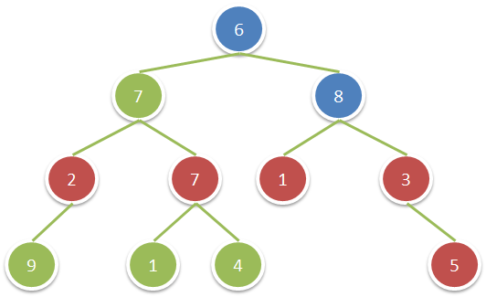

**Input:** root = [6,7,8,2,7,1,3,9,null,1,4,null,null,null,5]

**Output:** 18

**Explanation:** The red nodes are the nodes with even-value grandparent while the blue nodes are the even-value grandparents.

**Constraints:**

* The number of nodes in the tree is between 1 and 10^4.
* The value of nodes is between 1 and 100.

/**

 * Definition for a binary tree node.

 * struct TreeNode {

 *     int val;

 *     TreeNode *left;

 *     TreeNode *right;

 *     TreeNode(int x) : val(x), left(NULL), right(NULL) {}

 * };

 */

class Solution {

public:

    int sumEvenGrandparent(TreeNode* root) {

        dfs(root, false, false, 0);

        return res;

    }

private:

    int res = 0;

    void dfs(TreeNode *p, bool f0, bool f1, int depth) {

        bool f2 = p->val % 2 == 0;

        if (f0) res += p->val;

        if (p->left) dfs(p->left, f1, f2, depth+1);

        if (p->right) dfs(p->right, f1, f2, depth+1);

    }

};

class Solution {

public:

    int sumEvenGrandparent(TreeNode* root, int p = 1, int gp = 1) {

        return root ? sumEvenGrandparent(root->left, root->val, p)

               + sumEvenGrandparent(root->right, root->val, p)

               + (gp % 2 ? 0 : root->val)  : 0;

    }

};

### 1316. Distinct Echo Substrings

Hard

Return the number of **distinct** non-empty substrings of text that can be written as the concatenation of some string with itself (i.e. it can be written as a + a where a is some string).

**Example 1:**

**Input:** text = "abcabcabc"

**Output:** 3

**Explanation:** The 3 substrings are "abcabc", "bcabca" and "cabcab".

**Example 2:**

**Input:** text = "leetcodeleetcode"

**Output:** 2

**Explanation:** The 2 substrings are "ee" and "leetcodeleetcode".

**Constraints:**

* 1 <= text.length <= 2000
* text has only lowercase English letters.

class Solution {

public:

    int distinctEchoSubstrings(string text) {

        unordered_set<string_view> res;

        const char *p = text.c_str();

        for (int i=0; i<text.size(); ++i) {

            for (int len=1; i+len+len<=text.size(); ++len) {

                const string_view a(p+i    , len);

                const string_view b(p+i+len, len);

                if (a==b) {

                    res.insert(a);

                }

            }

        }

        return res.size();

    }

};

class Solution {

public:

    typedef long long ll;

    static constexpr int A = 1000000007, B = 1000000037;

    class Hash {

    public:

        Hash(const string &s) {

            h[0] = s[0] % B;

            p[0] = 1;

            for (int i=1; i<s.size(); ++i) {

                h[i] = (h[i-1]*A + s[i]) % B;

                p[i] = (p[i-1]*A) % B;

            }

        }

        // a and b are inclusive

        ll hash(const int a, const int b) {

            if (a) {

                const auto res = (h[b] - h[a-1] * p[b-a+1]) % B;

                return res < 0 ? B + res : res;

            }   else {

                return h[b];

            }

        }

    private:

        ll h[2000], p[2000];

    };

    int distinctEchoSubstrings(string text) {

        Hash h(text);

        unordered_set<string_view> res;

        const char *p = text.c_str();

        for (int i=0; i<text.size(); ++i) {

            for (int len=1; i+len+len<=text.size(); ++len) {

                if (h.hash(i, i+len-1) == h.hash(i+len, i+len+len-1)) {

                    res.insert(string_view(p+i, len));

                }

            }

        }

        return res.size();

    }

};

### 1318. Minimum Flips to Make a OR b Equal to c

Medium

Given 3 positives numbers a, b and c. Return the minimum flips required in some bits of a and b to make ( a OR b == c ). (bitwise OR operation).  
Flip operation consists of change **any** single bit 1 to 0 or change the bit 0 to 1 in their binary representation.

**Example 1:**

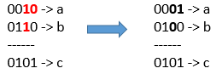

**Input:** a = 2, b = 6, c = 5

**Output:** 3

**Explanation:** After flips a = 1 , b = 4 , c = 5 such that (a OR b == c)

**Example 2:**

**Input:** a = 4, b = 2, c = 7

**Output:** 1

**Example 3:**

**Input:** a = 1, b = 2, c = 3

**Output:** 0

**Constraints:**

* 1 <= a <= 10^9
* 1 <= b <= 10^9
* 1 <= c <= 10^9

class Solution {

public:

    int minFlips(int a, int b, int c) {

        int res = 0;

        while (a || b || c) {

            int aa = (a & 1);

            int bb = (b & 1);

            int cc = (c & 1);

            //cout << aa << ' ' << bb << ' ' << cc << "\n";

            if ((aa | bb) == 1) {

                if (cc != 1) {

                    if (aa == 1 && bb == 1) res += 2;

                    else res += 1;

                }

            }

            else {

                if (cc == 1) res++;

            }

            a >>= 1;

            b >>= 1;

            c >>= 1;

            //cout << a << " " << b << " " << c << std::endl;

        }

        return res;

    }

};

//popcount c++20  == __builtin_popcount

class Solution {

public:

    int minFlips(int a, int b, int c) {

        return __builtin_popcount((a | b) ^ c) + popcount(a & b & ((a | b) ^ c));

    }

};

### 1319. Number of Operations to Make Network Connected

Medium

There are n computers numbered from 0 to n-1 connected by ethernet cables connections forming a network where connections[i] = [a, b] represents a connection between computers a and b. Any computer can reach any other computer directly or indirectly through the network.

Given an initial computer network connections. You can extract certain cables between two directly connected computers, and place them between any pair of disconnected computers to make them directly connected. Return the *minimum number of times* you need to do this in order to make all the computers connected. If it's not possible, return -1.

**Example 1:**

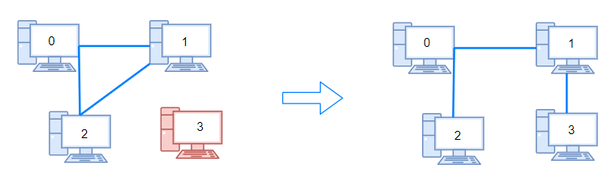

**Input:** n = 4, connections = [[0,1],[0,2],[1,2]]

**Output:** 1

**Explanation:** Remove cable between computer 1 and 2 and place between computers 1 and 3.

**Example 2:**

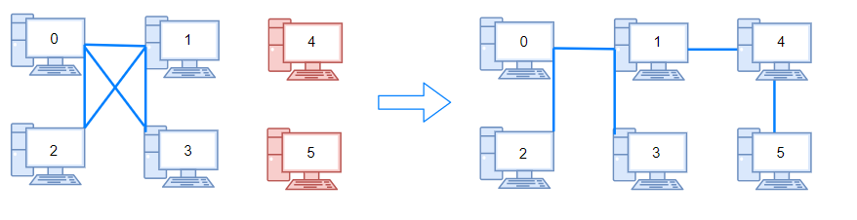

**Input:** n = 6, connections = [[0,1],[0,2],[0,3],[1,2],[1,3]]

**Output:** 2

**Example 3:**

**Input:** n = 6, connections = [[0,1],[0,2],[0,3],[1,2]]

**Output:** -1

**Explanation:** There are not enough cables.

**Example 4:**

**Input:** n = 5, connections = [[0,1],[0,2],[3,4],[2,3]]

**Output:** 0

**Constraints:**

* 1 <= n <= 10^5
* 1 <= connections.length <= min(n*(n-1)/2, 10^5)
* connections[i].length == 2
* 0 <= connections[i][0], connections[i][1] < n
* connections[i][0] != connections[i][1]
* There are no repeated connections.
* No two computers are connected by more than one cable.

class Solution {

public:

    int makeConnected(int n, vector<vector<int>>& connections) {

        if (connections.size() < n-1) return -1;

        for (int i = 0; i < n; ++i) fa.push_back(i);

        for (auto &v : connections) {

            Union(fa[v[0]], fa[v[1]]);

        }

        map<int, int> m0, m1;

        for (int i = 0; i < n; ++i) {

            int fa = findfa(i);

            m0[fa]++;

        }

        return m0.size() - 1;

    }

private:

    vector<int> fa;

    int findfa(int x) {

       return x == fa[x] ? x : (fa[x] = findfa(fa[x]));

    }

    void Union(int x, int y) {

        int fax = findfa(x);

        int fay = findfa(y);

        fa[fax] = fay;

    }

};

class Solution {

public:

    int find(vector<int> &ds, int i) {

        return ds[i] < 0 ? i : ds[i] = find(ds, ds[i]);

    }

    int makeConnected(int n, vector<vector<int>>& connections) {

        if (connections.size() < n - 1) return -1;

        vector<int> ds(n, -1);

        for (auto &c : connections) {

            auto i = find(ds, c[0]), j = find(ds, c[1]);

            if (i != j) {

                if (ds[j] < ds[i])

                    swap(i, j);

                ds[i] += ds[j];

                ds[j] = i;

                --n;

            }

        }

        return n - 1;

    }

};

### 1320. Minimum Distance to Type a Word Using Two Fingers

Hard

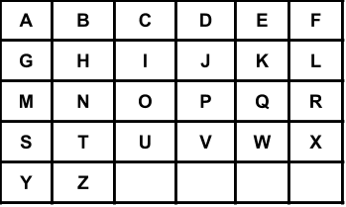

You have a keyboard layout as shown above in the XY plane, where each English uppercase letter is located at some coordinate, for example, the letter **A** is located at coordinate **(0,0)**, the letter **B** is located at coordinate **(0,1)**, the letter **P** is located at coordinate **(2,3)** and the letter **Z** is located at coordinate **(4,1)**.

Given the string word, return the minimum total distance to type such string using only two fingers. The distance between coordinates **(x1,y1)** and **(x2,y2)** is **|x1 - x2| + |y1 - y2|**.

Note that the initial positions of your two fingers are considered free so don't count towards your total distance, also your two fingers do not have to start at the first letter or the first two letters.

**Example 1:**

**Input:** word = "CAKE"

**Output:** 3

**Explanation:**

Using two fingers, one optimal way to type "CAKE" is:

Finger 1 on letter 'C' -> cost = 0

Finger 1 on letter 'A' -> cost = Distance from letter 'C' to letter 'A' = 2

Finger 2 on letter 'K' -> cost = 0

Finger 2 on letter 'E' -> cost = Distance from letter 'K' to letter 'E' = 1

Total distance = 3

**Example 2:**

**Input:** word = "HAPPY"

**Output:** 6

**Explanation:**

Using two fingers, one optimal way to type "HAPPY" is:

Finger 1 on letter 'H' -> cost = 0

Finger 1 on letter 'A' -> cost = Distance from letter 'H' to letter 'A' = 2

Finger 2 on letter 'P' -> cost = 0

Finger 2 on letter 'P' -> cost = Distance from letter 'P' to letter 'P' = 0

Finger 1 on letter 'Y' -> cost = Distance from letter 'A' to letter 'Y' = 4

Total distance = 6

**Example 3:**

**Input:** word = "NEW"

**Output:** 3

**Example 4:**

**Input:** word = "YEAR"

**Output:** 7

**Constraints:**

* 2 <= word.length <= 300
* Each word[i] is an English uppercase letter.

class Solution {

public:

    int minimumDistance(string word) {

        map<pair<char, char>, int> pre;

        pre.insert({make_pair(' ', ' '), 0});

        for (auto c : word) {

            map<pair<char, char>, int> cur;

            for (auto &it : pre) {

                auto pii = it.first;

                int d = it.second;

                pair<char, char> ss = pii.first < c ? make_pair(pii.first, c) : make_pair(c, pii.first);

                pair<char, char> tt = pii.second < c ? make_pair(pii.second, c) : make_pair(c, pii.second);

                if (cur.count(ss))

                    cur[ss] = min(cur[ss], d + dist(pii.second, c));

                else cur[ss] = d + dist(pii.second, c);

                if (cur.count(tt))

                    cur[tt] = min(cur[tt], d + dist(pii.first, c));

                else cur[tt] = d + dist(pii.first, c);

            }

            pre = cur;

        }

        int res = INT_MAX;

        for (auto &i : pre) {

            res = min(res, i.second);

        }

        return res;

    }

private:

    int dist(char a, char b) {

        if (a == ' ' || b == ' ') return 0;

        int x0 = (a-'A') % 6;

        int y0 = (a-'A') / 6;

        int x1 = (b-'A') % 6;

        int y1 = (b-'A') / 6;

        return abs(x0-x1) + abs(y0-y1);

    }

};

class Solution {

public:

    int minimumDistance(string word) {

        vector<int> dp(26);

        int res = 0, save = 0, n = word.size();

        for (int i = 0; i < n - 1; ++i) {

            int b = word[i] - 'A', c = word[i + 1] - 'A';

            for (int a = 0; a < 26; ++a)

                dp[b] = max(dp[b], dp[a] + d(b, c) - d(a, c));

            save = max(save, dp[b]);

            res += d(b, c);

        }

        return res - save;

    }

    int d(int a, int b) {

        return abs(a / 6 - b / 6) + abs(a % 6 - b % 6);

    }

};

### 1325. Delete Leaves With a Given Value

Medium

Given a binary tree root and an integer target, delete all the **leaf nodes** with value target.

Note that once you delete a leaf node with value target**,**if it's parent node becomes a leaf node and has the value target, it should also be deleted (you need to continue doing that until you can't).

**Example 1:**

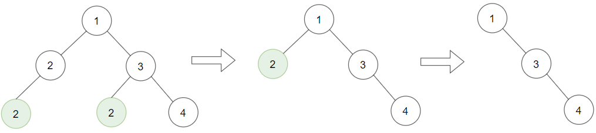

**Input:** root = [1,2,3,2,null,2,4], target = 2

**Output:** [1,null,3,null,4]

**Explanation:** Leaf nodes in green with value (target = 2) are removed (Picture in left).

After removing, new nodes become leaf nodes with value (target = 2) (Picture in center).

**Example 2:**

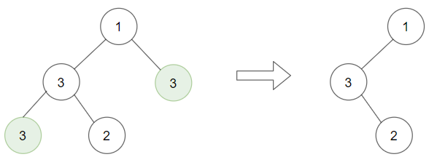

**Input:** root = [1,3,3,3,2], target = 3

**Output:** [1,3,null,null,2]

**Example 3:**

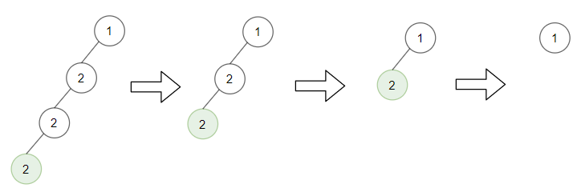

**Input:** root = [1,2,null,2,null,2], target = 2

**Output:** [1]

**Explanation:** Leaf nodes in green with value (target = 2) are removed at each step.

**Example 4:**

**Input:** root = [1,1,1], target = 1

**Output:** []

**Example 5:**

**Input:** root = [1,2,3], target = 1

**Output:** [1,2,3]

**Constraints:**

* 1 <= target <= 1000
* The given binary tree will have between 1 and 3000 nodes.
* Each node's value is between [1, 1000].

/**

 * Definition for a binary tree node.

 * struct TreeNode {

 *     int val;

 *     TreeNode *left;

 *     TreeNode *right;

 *     TreeNode(int x) : val(x), left(NULL), right(NULL) {}

 * };

 */

class Solution {

public:

    TreeNode* removeLeafNodes(TreeNode* root, int target) {

        if (root->left) root->left = removeLeafNodes(root->left, target);

        if (root->right) root->right = removeLeafNodes(root->right, target);

        if (!root->left && !root->right && root->val == target) return nullptr;

        else return root;

    }

};

### 1326. Minimum Number of Taps to Open to Water a Garden

Hard

There is a one-dimensional garden on the x-axis. The garden starts at the point 0 and ends at the point n. (i.e The length of the garden is n).

There are n + 1 taps located at points [0, 1, ..., n] in the garden.

Given an integer n and an integer array ranges of length n + 1 where ranges[i] (0-indexed) means the i-th tap can water the area [i - ranges[i], i + ranges[i]] if it was open.

Return *the minimum number of taps* that should be open to water the whole garden, If the garden cannot be watered return **-1**.

**Example 1:**

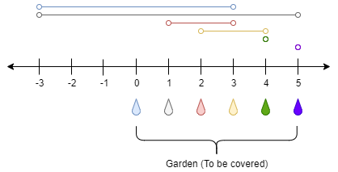

**Input:** n = 5, ranges = [3,4,1,1,0,0]

**Output:** 1

**Explanation:** The tap at point 0 can cover the interval [-3,3]

The tap at point 1 can cover the interval [-3,5]

The tap at point 2 can cover the interval [1,3]

The tap at point 3 can cover the interval [2,4]

The tap at point 4 can cover the interval [4,4]

The tap at point 5 can cover the interval [5,5]

Opening Only the second tap will water the whole garden [0,5]

**Example 2:**

**Input:** n = 3, ranges = [0,0,0,0]

**Output:** -1

**Explanation:** Even if you activate all the four taps you cannot water the whole garden.

**Example 3:**

**Input:** n = 7, ranges = [1,2,1,0,2,1,0,1]

**Output:** 3

**Example 4:**

**Input:** n = 8, ranges = [4,0,0,0,0,0,0,0,4]

**Output:** 2

**Example 5:**

**Input:** n = 8, ranges = [4,0,0,0,4,0,0,0,4]

**Output:** 1

**Constraints:**

* 1 <= n <= 10^4
* ranges.length == n + 1
* 0 <= ranges[i] <= 100

class Solution {

public:

    int minTaps(int n, vector<int>& A) {

        vector<int> dp(n + 1, n + 2);

        dp[0] = 0;

        for (int i = 0; i <= n; ++i)

            for (int j=max(i - A[i] + 1, 0);j <= min(i + A[i], n); ++j)

                dp[j] = min(dp[j], dp[max(0, i - A[i])] + 1);

        return dp[n]  < n + 2 ? dp[n] : -1;

    }

};

### 1330. Reverse Subarray To Maximize Array Value

Hard

You are given an integer array nums. The *value* of this array is defined as the sum of |nums[i]-nums[i+1]| for all 0 <= i < nums.length-1.

You are allowed to select any subarray of the given array and reverse it. You can perform this operation **only once**.

Find maximum possible value of the final array.

**Example 1:**

**Input:** nums = [2,3,1,5,4]

**Output:** 10

**Explanation:** By reversing the subarray [3,1,5] the array becomes [2,5,1,3,4] whose value is 10.

**Example 2:**

**Input:** nums = [2,4,9,24,2,1,10]

**Output:** 68

**Constraints:**

* 1 <= nums.length <= 3*10^4
* -10^5 <= nums[i] <= 10^5

class Solution {

public:

    int maxValueAfterReverse(vector<int>& A) {

        int total = 0, res = 0, min2 = 123456;

int max2 = -123456, n = A.size();

        for (int i = 0; i < n - 1; ++i) {

            int a = A[i], b = A[i + 1];

            total += abs(a - b);

            res = max(res, abs(A[0] - b) - abs(a - b));

            res = max(res, abs(A[n - 1] - a) - abs(a - b));

            min2 = min(min2, max(a, b));

            max2 = max(max2, min(a, b));

        }

        return total + max(res, (max2 - min2) * 2);

    }

};

### 1334. Find the City With the Smallest Number of Neighbors at a Threshold Distance

Medium

There are n cities numbered from 0 to n-1. Given the array edges where edges[i] = [fromi, toi, weighti] represents a bidirectional and weighted edge between cities fromi and toi, and given the integer distanceThreshold.

Return the city with the smallest numberof cities that are reachable through some path and whose distance is **at most** distanceThreshold, If there are multiple such cities, return the city with the greatest number.

Notice that the distance of a path connecting cities ***i*** and ***j*** is equal to the sum of the edges' weights along that path.

**Example 1:**

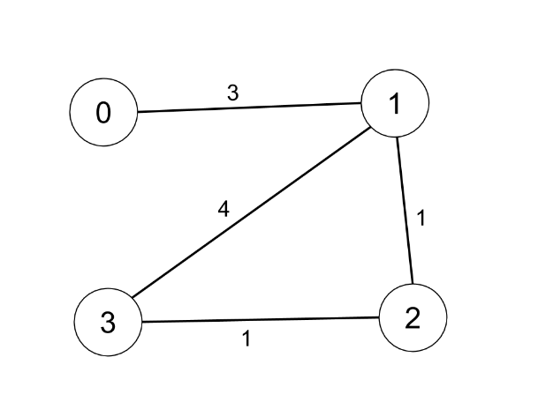

**Input:** n = 4, edges = [[0,1,3],[1,2,1],[1,3,4],[2,3,1]], distanceThreshold = 4

**Output:** 3

**Explanation:** The figure above describes the graph.

The neighboring cities at a distanceThreshold = 4 for each city are:

City 0 -> [City 1, City 2]

City 1 -> [City 0, City 2, City 3]

City 2 -> [City 0, City 1, City 3]

City 3 -> [City 1, City 2]

Cities 0 and 3 have 2 neighboring cities at a distanceThreshold = 4, but we have to return city 3 since it has the greatest number.

**Example 2:**

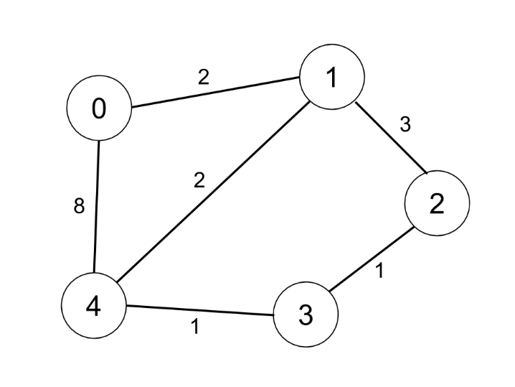

**Input:** n = 5, edges = [[0,1,2],[0,4,8],[1,2,3],[1,4,2],[2,3,1],[3,4,1]], distanceThreshold = 2

**Output:** 0

**Explanation:** The figure above describes the graph.

The neighboring cities at a distanceThreshold = 2 for each city are:

City 0 -> [City 1]

City 1 -> [City 0, City 4]

City 2 -> [City 3, City 4]

City 3 -> [City 2, City 4]

City 4 -> [City 1, City 2, City 3]

The city 0 has 1 neighboring city at a distanceThreshold = 2.

**Constraints:**

* 2 <= n <= 100
* 1 <= edges.length <= n * (n - 1) / 2
* edges[i].length == 3
* 0 <= fromi < toi < n
* 1 <= weighti, distanceThreshold <= 10^4
* All pairs (fromi, toi) are distinct.

class Solution {

public:

    int findTheCity(int n, vector<vector<int>>& edges, int distanceThreshold) {

        vector<vector<int>> dis(n, vector(n, 10001));

        int res = 0, smallest = n;

        for (auto& e : edges)

            dis[e[0]][e[1]] = dis[e[1]][e[0]] = e[2];

        for (int i = 0; i < n; ++i)

            dis[i][i] = 0;

        for (int k = 0; k < n; ++k)

            for (int i = 0; i < n; ++i)

                for (int j = 0; j < n; ++j)

                    dis[i][j] = min(dis[i][j], dis[i][k] + dis[k][j]);

        for (int i = 0; i < n; i++) {

            int count = 0;

            for (int j = 0; j < n; ++j)

                if (dis[i][j] <= distanceThreshold)

                    ++count;

            if (count <= smallest) {

                res = i;

                smallest = count;

            }

        }

        return res;

    }

};

### 1335. Minimum Difficulty of a Job Schedule

Hard

You want to schedule a list of jobs in d days. Jobs are dependent (i.e To work on the i-th job, you have to finish all the jobs j where 0 <= j < i).

You have to finish **at least** one task every day. The difficulty of a job schedule is the sum of difficulties of each day of the d days. The difficulty of a day is the maximum difficulty of a job done in that day.

Given an array of integers jobDifficulty and an integer d. The difficulty of the i-th job is jobDifficulty[i].

Return *the minimum difficulty* of a job schedule. If you cannot find a schedule for the jobs return **-1**.

**Example 1:**

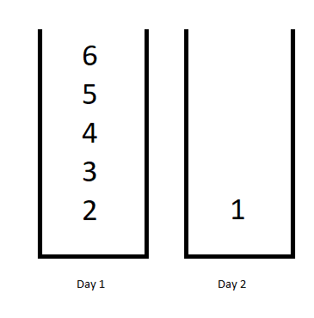

**Input:** jobDifficulty = [6,5,4,3,2,1], d = 2

**Output:** 7

**Explanation:** First day you can finish the first 5 jobs, total difficulty = 6.

Second day you can finish the last job, total difficulty = 1.

The difficulty of the schedule = 6 + 1 = 7

**Example 2:**

**Input:** jobDifficulty = [9,9,9], d = 4

**Output:** -1

**Explanation:** If you finish a job per day you will still have a free day. you cannot find a schedule for the given jobs.

**Example 3:**

**Input:** jobDifficulty = [1,1,1], d = 3

**Output:** 3

**Explanation:** The schedule is one job per day. total difficulty will be 3.

**Example 4:**

**Input:** jobDifficulty = [7,1,7,1,7,1], d = 3

**Output:** 15

**Example 5:**

**Input:** jobDifficulty = [11,111,22,222,33,333,44,444], d = 6

**Output:** 843

**Constraints:**

* 1 <= jobDifficulty.length <= 300
* 0 <= jobDifficulty[i] <= 1000
* 1 <= d <= 10

class Solution {

public:

    int minDifficulty(vector<int>& jobs, int days) {

        const int n = (int)jobs.size();

        if (n < days) return -1;

        vector<int> dp(n), old(n); // new and old dp

        // fill dp for d = 1

        dp[0] = jobs[0];

        for (int i = 1; i < n; i++)

            dp[i] = max(dp[i-1], jobs[i]);

        // fill dp for remaining days

        for (int d = 1; d < days; d++) {

            swap(dp, old);

            // monotonic and minimum stack {oldBest, curMax, bestSoFar}

            vector<array<int,3>> stk = {{1<<30,1<<30,1<<30}};

            for (int i = d; i < n; i++) {

                int oldBest = old[i-1];

                while (stk.back()[1] <= jobs[i]) {

                    oldBest = min(oldBest, stk.back()[0]);

                    stk.pop_back();

                }

                stk.push_back({oldBest, jobs[i], min(oldBest + jobs[i], stk.back()[2])});

                dp[i] = stk.back()[2];

            }

        }

        return dp[n-1];

    }

};

### 1338. Reduce Array Size to The Half

Medium

Given an array arr.  You can choose a set of integers and remove all the occurrences of these integers in the array.

Return *the minimum size of the set* so that **at least** half of the integers of the array are removed.

**Example 1:**

**Input:** arr = [3,3,3,3,5,5,5,2,2,7]

**Output:** 2

**Explanation:** Choosing {3,7} will make the new array [5,5,5,2,2] which has size 5 (i.e equal to half of the size of the old array).

Possible sets of size 2 are {3,5},{3,2},{5,2}.

Choosing set {2,7} is not possible as it will make the new array [3,3,3,3,5,5,5] which has size greater than half of the size of the old array.

**Example 2:**

**Input:** arr = [7,7,7,7,7,7]

**Output:** 1

**Explanation:** The only possible set you can choose is {7}. This will make the new array empty.

**Example 3:**

**Input:** arr = [1,9]

**Output:** 1

**Example 4:**

**Input:** arr = [1000,1000,3,7]

**Output:** 1

**Example 5:**

**Input:** arr = [1,2,3,4,5,6,7,8,9,10]

**Output:** 5

**Constraints:**

* 1 <= arr.length <= 10^5
* arr.length is even.
* 1 <= arr[i] <= 10^5

class Solution {

public:

    int minSetSize(vector<int>& arr) {

        int n = arr.size() / 2;

        unordered_map<int, int> mp;

        for (auto i : arr) ++mp[i];

        int sum = 0, cnt = 0;

        vector<int> temp;

        for (auto &pii : mp) temp.push_back(pii.second);

        sort (temp.begin(), temp.end(), greater<int>());

        for (auto i : temp) {

            sum += i;

            ++cnt;

            if (sum >= n) return cnt;

        }

        return -1;

    }

};

class Solution {

public:

    int minSetSize(vector<int>& arr) {

        unordered_map<int, int> m;

        priority_queue<int> pq;

        for (auto n : arr) ++m[n];

        for (auto &p : m) pq.push(p.second);

        int res = 0, cnt = 0;

        while (cnt * 2 < arr.size()) {

            ++res;

            cnt += pq.top(); pq.pop();

        }

        return res;

    }

};

### 1339. Maximum Product of Splitted Binary Tree

Medium

Given a binary tree root. Split the binary tree into two subtrees by removing 1 edge such that the product of the sums of the subtrees are maximized.

Since the answer may be too large, return it modulo 10^9 + 7.

**Example 1:**

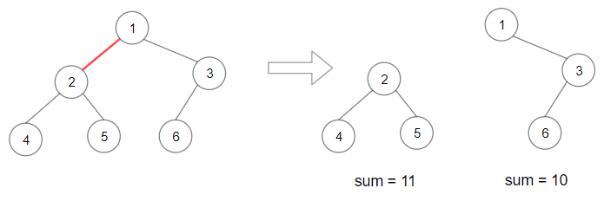

**Input:** root = [1,2,3,4,5,6]

**Output:** 110

**Explanation:** Remove the red edge and get 2 binary trees with sum 11 and 10. Their product is 110 (11*10)

**Example 2:**

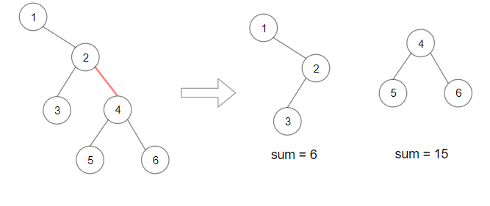

**Input:** root = [1,null,2,3,4,null,null,5,6]

**Output:** 90

**Explanation:** Remove the red edge and get 2 binary trees with sum 15 and 6.Their product is 90 (15*6)

**Example 3:**

**Input:** root = [2,3,9,10,7,8,6,5,4,11,1]

**Output:** 1025

**Example 4:**

**Input:** root = [1,1]

**Output:** 1

**Constraints:**

* Each tree has at most 50000 nodes and at least 2 nodes.
* Each node's value is between [1, 10000].

/**

 * Definition for a binary tree node.

 * struct TreeNode {

 *     int val;

 *     TreeNode *left;

 *     TreeNode *right;

 *     TreeNode(int x) : val(x), left(NULL), right(NULL) {}

 * };

 */

class Solution {

public:

    int maxProduct(TreeNode* root) {

        S = calSum(root);

        dfs(root);

        return res % MOD;

    }

private:

    long long MOD = 1e9 + 7;

    long long S;

    long long res = -1;

    long long calSum(TreeNode *p) {

        if (!p) return 0;

        return p->val + calSum(p->left) + calSum(p->right);

    }

    int dfs(TreeNode *p) {

        if (!p) return 0;

        long long left = dfs(p->left);

        long long right = dfs(p->right);

        res = max(res, left*(S-left));

        res = max(res, right*(S-right));

        return left + right + p->val;

    }

};

class Solution {

public:

    long res = 0, total = 0, sub;

    int maxProduct(TreeNode* root) {

        total = s(root), s(root);

        return res % (int)(1e9 + 7);

    }

    int s(TreeNode* root) {

        if (!root) return 0;

        sub = root->val + s(root->left) + s(root->right);

        res = max(res, sub * (total - sub));

        return sub;

    }

};

### 1340. Jump Game V

Hard

Given an array of integers arr and an integer d. In one step you can jump from index i to index:

* i + x where: i + x < arr.length and 0 < x <= d.
* i - x where: i - x >= 0 and 0 < x <= d.

In addition, you can only jump from index i to index j if arr[i] > arr[j] and arr[i] > arr[k] for all indices k between i and j (More formally min(i, j) < k < max(i, j)).

You can choose any index of the array and start jumping. Return *the maximum number of indices* you can visit.

Notice that you can not jump outside of the array at any time.

**Example 1:**

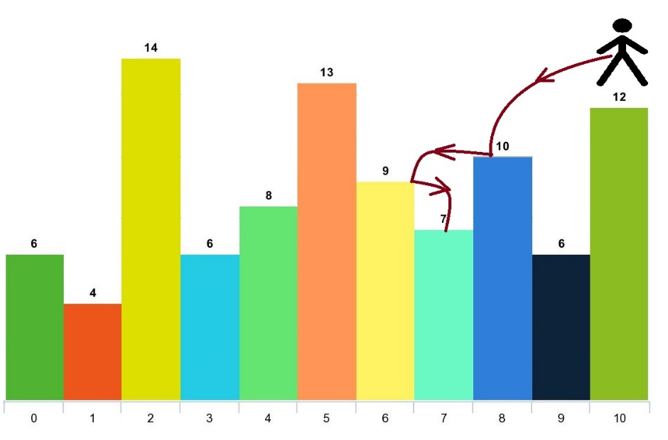

**Input:** arr = [6,4,14,6,8,13,9,7,10,6,12], d = 2

**Output:** 4

**Explanation:** You can start at index 10. You can jump 10 --> 8 --> 6 --> 7 as shown.

Note that if you start at index 6 you can only jump to index 7. You cannot jump to index 5 because 13 > 9. You cannot jump to index 4 because index 5 is between index 4 and 6 and 13 > 9.

Similarly You cannot jump from index 3 to index 2 or index 1.

**Example 2:**

**Input:** arr = [3,3,3,3,3], d = 3

**Output:** 1

**Explanation:** You can start at any index. You always cannot jump to any index.

**Example 3:**

**Input:** arr = [7,6,5,4,3,2,1], d = 1

**Output:** 7

**Explanation:** Start at index 0. You can visit all the indicies.

**Example 4:**

**Input:** arr = [7,1,7,1,7,1], d = 2

**Output:** 2

**Example 5:**

**Input:** arr = [66], d = 1

**Output:** 1

**Constraints:**

* 1 <= arr.length <= 1000
* 1 <= arr[i] <= 10^5
* 1 <= d <= arr.length

class Solution {

public:

        int dp[1001] = {};

    int dfs(vector<int>& arr, int i, int d, int res = 1) {

        if (dp[i]) return dp[i];

        for (auto j = i + 1; j <= min(i + d, (int)arr.size() - 1) && arr[j] < arr[i]; ++j)

            res = max(res, 1 + dfs(arr, j, d));

        for (auto j = i - 1; j >= max(0, i - d) && arr[j] < arr[i]; --j)

            res = max(res, 1 + dfs(arr, j, d));

        return dp[i] = res;

    }

    int maxJumps(vector<int>& arr, int d, int res = 1) {

        for (auto i = 0; i < arr.size(); ++i)

            res = max(res, dfs(arr, i, d));

        return res;

    }

};

class Solution {

public:

    struct A {

        int h, i, j = 1;

    };

    int maxJumps(vector<int>& arr, int d) {

        vector<A> V;

        int ret = 1, i, n = arr.size(), j, h, vsiz, k, l;

        for (i = 0; i < n; ++i) {

            h = arr[i];

            vsiz = V.size();

            if (V.empty() || V[vsiz-1].h >= h) {

                V.push_back({h, i, 1});

            } else {

                j = 1;

                while (!V.empty() && V[vsiz-1].h < h) {

                    for (k = vsiz-2; k >= 0 && V[k].h == V[vsiz-1].h; --k);

                    // populate V[l] to left and right

                    for (l = vsiz-1; l > k; --l) {

                        // populate left

                        if (k >= 0 && V[l].i - V[k].i <= d)

                            V[k].j = max(V[k].j, V[l].j + 1);

                        // populate right

                        if (i - V[l].i <= d)

                            j = max(j, V[l].j + 1);

                        // retire

                        ret = max(ret, V[l].j);

                        V.pop_back();

                    }

                    vsiz = V.size();

                }

                V.push_back({h, i, j});

            }

        }

        // retire the rest

        while (!V.empty()) {

            vsiz = V.size();

            for (k = vsiz-2; k >= 0 && V[k].h == V[vsiz-1].h; --k);

            // populate V[l] to left and right

            for (l = vsiz-1; l > k; --l) {

                // populate left

                if (k >= 0 && V[l].i - V[k].i <= d)

                    V[k].j = max(V[k].j, V[l].j + 1);

                // retire

                ret = max(ret, V[l].j);

                V.pop_back();

            }

        }

        return ret;

    }

};

### 1345. Jump Game IV

Hard

Given an array of integers arr, you are initially positioned at the first index of the array.

In one step you can jump from index i to index:

* i + 1 where: i + 1 < arr.length.
* i - 1 where: i - 1 >= 0.
* j where: arr[i] == arr[j] and i != j.

Return *the minimum number of steps* to reach the **last index** of the array.

Notice that you can not jump outside of the array at any time.

**Example 1:**

**Input:** arr = [100,-23,-23,404,100,23,23,23,3,404]

**Output:** 3

**Explanation:** You need three jumps from index 0 --> 4 --> 3 --> 9. Note that index 9 is the last index of the array.

**Example 2:**

**Input:** arr = [7]

**Output:** 0

**Explanation:** Start index is the last index. You don't need to jump.

**Example 3:**

**Input:** arr = [7,6,9,6,9,6,9,7]

**Output:** 1

**Explanation:** You can jump directly from index 0 to index 7 which is last index of the array.

**Example 4:**

**Input:** arr = [6,1,9]

**Output:** 2

**Example 5:**

**Input:** arr = [11,22,7,7,7,7,7,7,7,22,13]

**Output:** 3

**Constraints:**

* 1 <= arr.length <= 5 * 10^4
* -10^8 <= arr[i] <= 10^8

class Solution {

public:

    int minJumps(vector<int>& arr) {

        int n = arr.size();

        unordered_map<int, vector<int>> indicesOfValue;

        for (int i = 0; i < n; i++)

            indicesOfValue[arr[i]].push_back(i);

        vector<bool> visited(n); visited[0] = true;

        queue<int> q; q.push(0);

        int step = 0;

        while (!q.empty()) {

            for (int size = q.size(); size > 0; --size) {

                int i = q.front(); q.pop();

                if (i == n - 1) return step; // Reached to last index

                vector<int>& next = indicesOfValue[arr[i]];

                next.push_back(i - 1); next.push_back(i + 1);

                for (int j : next) {

                    if (j >= 0 && j < n && !visited[j]) {

                        visited[j] = true;

                        q.push(j);

                    }

                }

                next.clear();

// avoid later lookup indicesOfValue arr[i]

            }

            step++;

        }

        return 0;

    }

};

### 1349. Maximum Students Taking Exam

Hard

Given a m * n matrix seats  that represent seats distributions in a classroom. If a seat is broken, it is denoted by '#' character otherwise it is denoted by a '.' character.

Students can see the answers of those sitting next to the left, right, upper left and upper right, but he cannot see the answers of the student sitting directly in front or behind him. Return the **maximum**number of students that can take the exam together without any cheating being possible..

Students must be placed in seats in good condition.

**Example 1:**

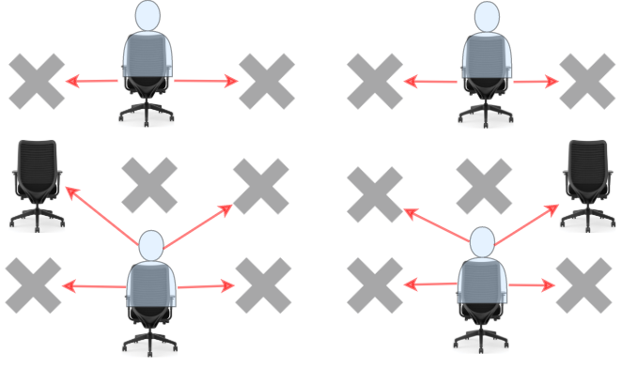

**Input:** seats = [["#",".","#","#",".","#"],

  [".","#","#","#","#","."],

  ["#",".","#","#",".","#"]]

**Output:** 4

**Explanation:** Teacher can place 4 students in available seats so they don't cheat on the exam.

**Example 2:**

**Input:** seats = [[".","#"],

  ["#","#"],

  ["#","."],

  ["#","#"],

  [".","#"]]

**Output:** 3

**Explanation:** Place all students in available seats.

**Example 3:**

**Input:** seats = [["#",".","**.**",".","#"],

  ["**.**","#","**.**","#","**.**"],

  ["**.**",".","#",".","**.**"],

  ["**.**","#","**.**","#","**.**"],

  ["#",".","**.**",".","#"]]

**Output:** 10

**Explanation:** Place students in available seats in column 1, 3 and 5.

**Constraints:**

* seats contains only characters '.' and'#'.
* m == seats.length
* n == seats[i].length
* 1 <= m <= 8
* 1 <= n <= 8

class Solution {

public:

    int maxStudents(vector<vector<char>>& seats) {

        int m = seats.size();

        int n = seats[0].size();

        vector<int> validity; // the validity of each row in the classroom

        for (int i = 0; i < m; ++i) {

            int cur = 0;

            for (int j = 0; j < n; ++j) {

                // the j-th bit is 1 if and only if the j-th seat is not broken

                // here the 0th bit is the most significant bit

                cur = cur * 2 + (seats[i][j] == '.');

            }

            validity.push_back(cur);

        }

        // all the f states are set -1 as invalid states in the beginning

        // here f[i][mask] represents the first i-1 rows to handle corner cases

        vector<vector<int>> f(m + 1, vector<int>(1 << n, -1));

        // f[0][0] is a valid state

        // think of a virtual row in the front and no students are sitting in that row

        f[0][0] = 0;

        for (int i = 1; i <= m; ++i) {

            int valid = validity[i - 1];

            // the interval [0, 1 << n) includes all the n-bit states for a row of students

            // please note that state 0 represents no student sitting in this row

            // which is always a valid state

            for (int j = 0; j < (1 << n); ++j) {

                // (j & valid) == j: check if j is a subset of valid

                // !(j & (j >> 1)): check if there is no adjancent students in the row

                if ((j & valid) == j && !(j & (j >> 1))) {

                    // f[i][j] may transit from f[i -1][k]

                    for (int k = 0; k < (1 << n); ++k) {

                        // !(j & (k >> 1)): no students in the upper left positions

                        // !((j >> 1) & k): no students in the upper right positions

                        // f[i - 1][k] != -1: the previous state is valid

                        if (!(j & (k >> 1)) && !((j >> 1) & k) && f[i - 1][k] != -1) {

                            f[i][j] = max(f[i][j], f[i - 1][k] + __builtin_popcount(j));

                        }

                    }

                }

            }

        }

        // the answer is the maximum among all f[m][mask]

        return *max_element(f[m].begin(), f[m].end());

    }

};

### 1352. Product of the Last K Numbers

Medium

Implement the class ProductOfNumbers that supports two methods:

1. add(int num)

* Adds the number num to the back of the current list of numbers.

2. getProduct(int k)

* Returns the product of the last k numbers in the current list.
* You can assume that always the current list has **at least** k numbers.

At any time, the product of any contiguous sequence of numbers will fit into a single 32-bit integer without overflowing.

**Example:**

**Input**

["ProductOfNumbers","add","add","add","add","add","getProduct","getProduct","getProduct","add","getProduct"]

[[],[3],[0],[2],[5],[4],[2],[3],[4],[8],[2]]

**Output**

[null,null,null,null,null,null,20,40,0,null,32]

**Explanation**

ProductOfNumbers productOfNumbers = new ProductOfNumbers();

productOfNumbers.add(3); // [3]

productOfNumbers.add(0); // [3,0]

productOfNumbers.add(2); // [3,0,2]

productOfNumbers.add(5); // [3,0,2,5]

productOfNumbers.add(4); // [3,0,2,5,4]

productOfNumbers.getProduct(2); // return 20. The product of the last 2 numbers is 5 * 4 = 20

productOfNumbers.getProduct(3); // return 40. The product of the last 3 numbers is 2 * 5 * 4 = 40

productOfNumbers.getProduct(4); // return 0. The product of the last 4 numbers is 0 * 2 * 5 * 4 = 0

productOfNumbers.add(8); // [3,0,2,5,4,8]

productOfNumbers.getProduct(2); // return 32. The product of the last 2 numbers is 4 * 8 = 32

**Constraints:**

* There will be at most 40000 operations considering both add and getProduct.
* 0 <= num <= 100
* 1 <= k <= 40000

class ProductOfNumbers {

public:

    ProductOfNumbers() {

    }

    vector<long long> pr = { 1 };

    void add(int num) {

        if (num == 0) pr = { 1 };

        else pr.push_back(pr.back() * num);

    }

    int getProduct(int k) {

        if (k >= pr.size()) return 0;

        return pr.back() / pr[pr.size() - k - 1];

    }

};

/**

 * Your ProductOfNumbers object will be instantiated and called as such:

 * ProductOfNumbers* obj = new ProductOfNumbers();

 * obj->add(num);

 * int param_2 = obj->getProduct(k);

 */

### 1353. Maximum Number of Events That Can Be Attended

Medium

Given an array of events where events[i] = [startDayi, endDayi]. Every event i starts at startDayiand ends at endDayi.

You can attend an event i at any day d where startTimei <= d <= endTimei. Notice that you can only attend one event at any time d.

Return *the maximum number of events*you can attend.

**Example 1:**

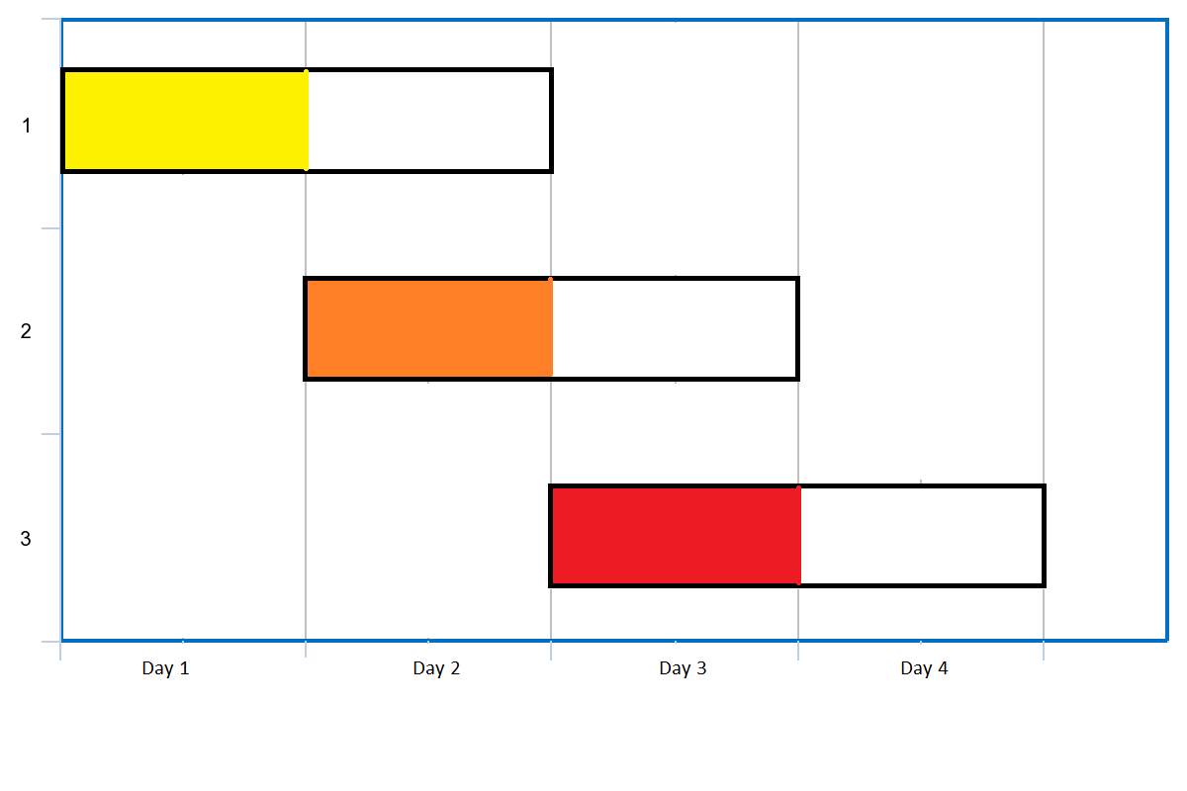

**Input:** events = [[1,2],[2,3],[3,4]]

**Output:** 3

**Explanation:** You can attend all the three events.

One way to attend them all is as shown.

Attend the first event on day 1.

Attend the second event on day 2.

Attend the third event on day 3.

**Example 2:**

**Input:** events= [[1,2],[2,3],[3,4],[1,2]]

**Output:** 4

**Example 3:**

**Input:** events = [[1,4],[4,4],[2,2],[3,4],[1,1]]

**Output:** 4

**Example 4:**

**Input:** events = [[1,100000]]

**Output:** 1

**Example 5:**

**Input:** events = [[1,1],[1,2],[1,3],[1,4],[1,5],[1,6],[1,7]]

**Output:** 7

**Constraints:**

* 1 <= events.length <= 10^5
* events[i].length == 2
* 1 <= events[i][0] <= events[i][1] <= 10^5

class Solution {

public:

    int maxEvents(vector<vector<int>>& A) {

        priority_queue <int, vector<int>, greater<int>> pq;

        sort(A.begin(), A.end());

        int i = 0, res = 0, d = 0, n = A.size();

        while (pq.size() > 0 || i < n) {

            if (pq.size() == 0)

                d = A[i][0];

            while (i < n && A[i][0] <= d)

                pq.push(A[i++][1]);

            pq.pop();

            ++res, ++d;

            while (pq.size() > 0 && pq.top() < d)

                pq.pop();

        }

        return res;

    }

};

### 1354. Construct Target Array With Multiple Sums

Hard

Given an array of integers target. From a starting array, A consisting of all 1's, you may perform the following procedure :

* let x be the sum of all elements currently in your array.
* choose index i, such that 0 <= i < target.size and set the value of A at index i to x.
* You may repeat this procedure as many times as needed.

Return True if it is possible to construct the target array from A otherwise return False.

**Example 1:**

**Input:** target = [9,3,5]

**Output:** true

**Explanation:** Start with [1, 1, 1]

[1, 1, 1], sum = 3 choose index 1

[1, 3, 1], sum = 5 choose index 2

[1, 3, 5], sum = 9 choose index 0

[9, 3, 5] Done

**Example 2:**

**Input:** target = [1,1,1,2]

**Output:** false

**Explanation:** Impossible to create target array from [1,1,1,1].

**Example 3:**

**Input:** target = [8,5]

**Output:** true

* N == target.length
* 1 <= target.length <= 5 * 10^4
* 1 <= target[i] <= 10^9

class Solution {

public:

    bool isPossible(vector<int>& A) {

        long total = 0;

        int n = A.size(), a;

        priority_queue<int> pq(A.begin(), A.end());

        for (int a : A)

            total += a;

        while (true) {

            a = pq.top(); pq.pop();

            total -= a;

            if (a == 1 || total == 1)

                return true;

            if (a < total || total == 0 || a % total == 0)

                return false;

            a %= total;

            total += a;

            pq.push(a);

        }

    }

};

class Solution {

public:

    bool isPossible(vector<int>& t) {

        auto s = accumulate(begin(t), end(t), (long long)0);

        auto i = max_element(begin(t), end(t)) - begin(t);

        while (s > 1 && t[i] > s / 2) {

            s -= t[i];

            if (s <= 1)

                return s;

            t[i] = t[i] % s;

            s += t[i];

            i = max_element(begin(t), end(t)) - begin(t);

        }

        return s == t.size();

    }

};

### 1362. Closest Divisors

Medium

Given an integer num, find the closest two integers in absolute difference whose product equals num + 1 or num + 2.

Return the two integers in any order.

**Example 1:**

**Input:** num = 8

**Output:** [3,3]

**Explanation:** For num + 1 = 9, the closest divisors are 3 & 3, for num + 2 = 10, the closest divisors are 2 & 5, hence 3 & 3 is chosen.

**Example 2:**

**Input:** num = 123

**Output:** [5,25]

**Example 3:**

**Input:** num = 999

**Output:** [40,25]

**Constraints:**

* 1 <= num <= 10^9

class Solution {

public:

    int largestDivisor(int num) {

        int d = sqrt(num);

        while (num % d != 0) --d;

        return d;

    }

    vector<int> closestDivisors(int num) {

        auto d1 = largestDivisor(num + 1), d2=largestDivisor(num + 2);

        if (abs(d1 - (num + 1) / d1) < abs(d2 - (num + 2) / d2))

            return {d1, (num + 1) / d1};

        return { d2, (num + 2) / d2 };

    }

};

### 1363. Largest Multiple of Three

Hard

Given an integer array of digits, return the largest multiple of **three** that can be formed by concatenating some of the given digits in any order.

Since the answer may not fit in an integer data type, return the answer as a string.

If there is no answer return an empty string.

**Example 1:**

**Input:** digits = [8,1,9]

**Output:** "981"

**Example 2:**

**Input:** digits = [8,6,7,1,0]

**Output:** "8760"

**Example 3:**

**Input:** digits = [1]

**Output:** ""

**Example 4:**

**Input:** digits = [0,0,0,0,0,0]

**Output:** "0"

**Constraints:**

* 1 <= digits.length <= 10^4
* 0 <= digits[i] <= 9
* The returning answer must not contain unnecessary leading zeros.

class Solution {

public:

    string largestMultipleOfThree(vector<int>& digits,string res = ""){

      int m1[] = {1, 4, 7, 2, 5, 8}, m2[] = {2, 5, 8, 1, 4, 7};

      int sum = 0, ds[10] = {};

      for (auto d : digits) {

          ++ds[d];

          sum += d;

      }

      while (sum % 3 != 0) {

        for (auto i : sum % 3 == 1 ? m1 : m2) {

          if (ds[i]) {

            --ds[i];

            sum -= i;

            break;

          }

        }

      }

      for (int i = 9; i >= 0; --i)

         res += string(ds[i], '0' + i);

      return res.size() && res[0] == '0' ? "0" : res;

    }

};

### 1368. Minimum Cost to Make at Least One Valid Path in a Grid

Hard

Given a *m* x *n* grid. Each cell of the grid has a sign pointing to the next cell you should visit if you are currently in this cell. The sign of grid[i][j] can be:

* **1** which means go to the cell to the right. (i.e go from grid[i][j] to grid[i][j + 1])
* **2** which means go to the cell to the left. (i.e go from grid[i][j] to grid[i][j - 1])
* **3** which means go to the lower cell. (i.e go from grid[i][j] to grid[i + 1][j])
* **4** which means go to the upper cell. (i.e go from grid[i][j] to grid[i - 1][j])

Notice that there could be some **invalid signs** on the cells of the grid which points outside the grid.

You will initially start at the upper left cell (0,0). A valid path in the grid is a path which starts from the upper left cell (0,0) and ends at the bottom-right cell (m - 1, n - 1) following the signs on the grid. The valid path **doesn't have to be the shortest**.

You can modify the sign on a cell with cost = 1. You can modify the sign on a cell **one time only**.

Return *the minimum cost* to make the grid have at least one valid path.

**Example 1:**

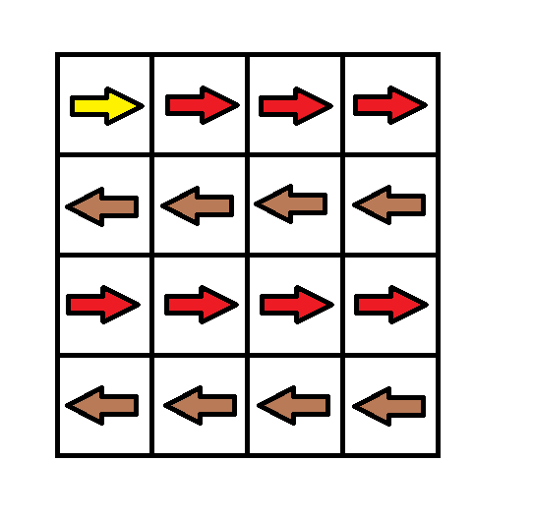

**Input:** grid = [[1,1,1,1],[2,2,2,2],[1,1,1,1],[2,2,2,2]]

**Output:** 3

**Explanation:** You will start at point (0, 0).

The path to (3, 3) is as follows. (0, 0) --> (0, 1) --> (0, 2) --> (0, 3) change the arrow to down with cost = 1 --> (1, 3) --> (1, 2) --> (1, 1) --> (1, 0) change the arrow to down with cost = 1 --> (2, 0) --> (2, 1) --> (2, 2) --> (2, 3) change the arrow to down with cost = 1 --> (3, 3)

The total cost = 3.

**Example 2:**

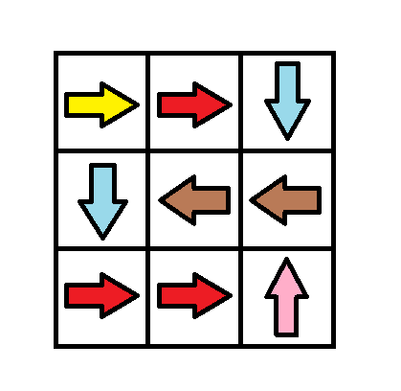

**Input:** grid = [[1,1,3],[3,2,2],[1,1,4]]

**Output:** 0

**Explanation:** You can follow the path from (0, 0) to (2, 2).

**Example 3:**

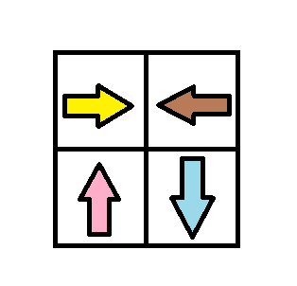

**Input:** grid = [[1,2],[4,3]]

**Output:** 1

**Example 4:**

**Input:** grid = [[2,2,2],[2,2,2]]

**Output:** 3

**Example 5:**

**Input:** grid = [[4]]

**Output:** 0

**Constraints:**

* m == grid.length
* n == grid[i].length
* 1 <= m, n <= 100

class Solution {

public:

    int minCost(vector<vector<int>>& grid) {

        int m = grid.size(), n = grid[0].size();

        deque<pair<int, int>> q{{0, 0}};

        // for the pair, the first element is the cell position, the second is the path cost to this cell

        int dirs[4][2] = {{-1, 0}, {1, 0}, {0, -1}, {0, 1}};

        unordered_set<int> visited;

        int res = 0;

        while(!q.empty())

        {

            auto t = q.front();

            q.pop_front();

            int curi = t.first / n, curj = t.first % n;

            if (visited.insert(t.first).second)

                // If we have never visited this node, then we have the shortest path to this node

                res = t.second;

            if (curi == m-1 && curj == n-1)

                return res;

            for (auto dir: dirs)

            {

                int x = curi + dir[0];

                int y = curj + dir[1];

                int pos = x * n + y;

                if (x<0 || x>=m || y<0 || y>=n || visited.count(pos)) continue;

                int cost;

                if (grid[curi][curj] == 1 && dir[0] == 0 && dir[1] == 1) cost = 0;

                else if (grid[curi][curj] == 2 && dir[0] == 0 && dir[1] == -1) cost = 0;

                else if (grid[curi][curj] == 3 && dir[0] == 1 && dir[1] == 0) cost = 0;

                else if (grid[curi][curj] == 4 && dir[0] == -1 && dir[1] == 0) cost = 0;

                else cost = 1;

                if (cost == 1)

                    q.push_back({pos, t.second + cost});

                else

                    q.push_front({pos, t.second + cost});

            }

        }

        return res;

    }

};

### 1371. Find the Longest Substring Containing Vowels in Even Counts

Medium

Given the string s, return the size of the longest substring containing each vowel an even number of times. That is, 'a', 'e', 'i', 'o', and 'u' must appear an even number of times.

**Example 1:**

**Input:** s = "eleetminicoworoep"

**Output:** 13

**Explanation:** The longest substring is "leetminicowor" which contains two each of the vowels: **e**, **i** and **o** and zero of the vowels: **a** and **u**.

**Example 2:**

**Input:** s = "leetcodeisgreat"

**Output:** 5

**Explanation:** The longest substring is "leetc" which contains two e's.

**Example 3:**

**Input:** s = "bcbcbc"

**Output:** 6

**Explanation:** In this case, the given string "bcbcbc" is the longest because all vowels: **a**, **e**, **i**, **o** and **u** appear zero times.

**Constraints:**

* 1 <= s.length <= 5 x 10^5
* s contains only lowercase English letters.

class Solution {

public:

    int findTheLongestSubstring(string s) {

        unordered_map<int, int> m{{0, -1}};

        int res = 0, n = s.length(), cur = 0;

        for (int i = 0; i < n; i++) {

            cur ^= 1 << string("aeiou").find(s[i]) + 1 >> 1;

            if (!m.count(cur)) m[cur] = i;

            res = max(res, i - m[cur]);

        }

        return res;

    }

};

### 1373. Maximum Sum BST in Binary Tree

Hard

Given a **binary tree** root, the task is to return the maximum sum of all keys of **any** sub-tree which is also a Binary Search Tree (BST).

Assume a BST is defined as follows:

* The left subtree of a node contains only nodes with keys **less than** the node's key.
* The right subtree of a node contains only nodes with keys **greater than** the node's key.
* Both the left and right subtrees must also be binary search trees.

**Example 1:**

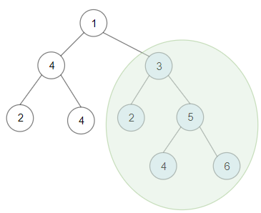

**Input:** root = [1,4,3,2,4,2,5,null,null,null,null,null,null,4,6]

**Output:** 20

**Explanation:** Maximum sum in a valid Binary search tree is obtained in root node with key equal to 3.

**Example 2:**

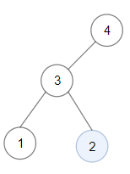

**Input:** root = [4,3,null,1,2]

**Output:** 2

**Explanation:** Maximum sum in a valid Binary search tree is obtained in a single root node with key equal to 2.

**Example 3:**

**Input:** root = [-4,-2,-5]

**Output:** 0

**Explanation:** All values are negatives. Return an empty BST.

**Example 4:**

**Input:** root = [2,1,3]

**Output:** 6

**Example 5:**

**Input:** root = [5,4,8,3,null,6,3]

**Output:** 7

**Constraints:**

* The given binary tree will have between 1 and 40000 nodes.
* Each node's value is between [-4 * 10^4 , 4 * 10^4].

/**

 * Definition for a binary tree node.

 * struct TreeNode {

 *     int val;

 *     TreeNode *left;

 *     TreeNode *right;

 *     TreeNode(int x) : val(x), left(NULL), right(NULL) {}

 * };

 */

class Solution {

public:

    int maxSumBST(TreeNode* root) {

        if (!root) return 0;

        dfs(root);

        return res;

    }

private:

    int res = 0;

    tuple<bool, int, int, int> dfs(TreeNode *p) {

        if (!p->left && !p->right) {

            res = max(res, p->val);

            return make_tuple(true, p->val, p->val, p->val);

        }

        auto l = p->left ? dfs(p->left) : make_tuple(true, p->val, p->val-1, 0);

        auto r = p->right ? dfs(p->right) : make_tuple(true, p->val+1, p->val, 0);

        bool ok = get<0>(l) && get<0>(r);

        if (!ok) return make_tuple(false, 0, 0, 0);

        else if (get<2>(l) >= p->val || p->val >= get<1>(r)) return make_tuple(false, 0, 0, 0);

        else {

            int t = get<3>(l) + get<3>(r) + p->val;

            res = max(res, t);

            return make_tuple(true, get<1>(l), get<2>(r), t);

        }

    }

};

class Solution {

public:

    struct BSTNode {

        bool isBST;

        int mn;

        int mx;

        int sum;

    };

    BSTNode findMaxBST(TreeNode* node, int& res) {

        if (node != nullptr) {

            BSTNode left = findMaxBST(node -> left, res);

            BSTNode right = findMaxBST(node -> right, res);

            bool isBST = (left.isBST and right.isBST and left.mx < node -> val and node -> val < right.mn);

            int sum = node -> val + left.sum + right.sum;

            if (isBST) res = max(res, sum);

            return { isBST, min(node -> val, left.mn), max(node -> val, right.mx) , sum};

        } else {

            return { true, INT_MAX, INT_MIN, 0};

        }

    }

    int maxSumBST(TreeNode* root) {

        int res = 0;

        findMaxBST(root, res);

        return res;

    }

};

### 1375. Bulb Switcher III

Medium

There is a room with n bulbs, numbered from 1 to n, arranged in a row from left to right. Initially, all the bulbs are turned off.

At moment *k* (for *k* from 0 to n - 1), we turn on the light[k] bulb. A bulb **change color to blue** only if it is on and all the previous bulbs (to the left) are turned on too.

Return the number of moments in which **all turned on** bulbs **are blue.**

**Example 1:**

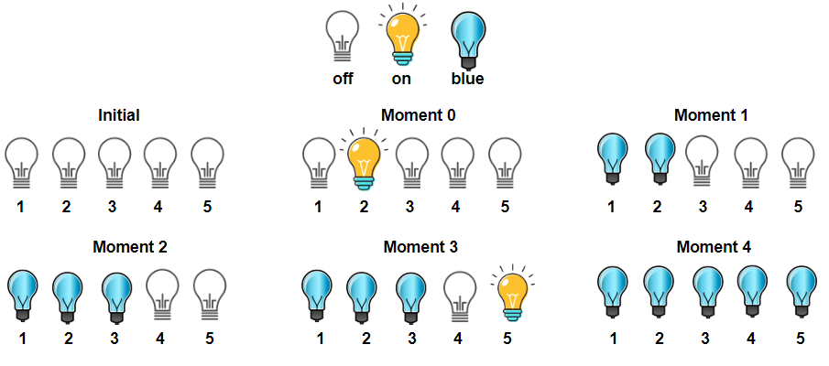

**Input:** light = [2,1,3,5,4]

**Output:** 3

**Explanation:** All bulbs turned on, are blue at the moment 1, 2 and 4.

**Example 2:**

**Input:** light = [3,2,4,1,5]

**Output:** 2

**Explanation:** All bulbs turned on, are blue at the moment 3, and 4 (index-0).

**Example 3:**

**Input:** light = [4,1,2,3]

**Output:** 1

**Explanation:** All bulbs turned on, are blue at the moment 3 (index-0).

Bulb 4th changes to blue at the moment 3.

**Example 4:**

**Input:** light = [2,1,4,3,6,5]

**Output:** 3

**Example 5:**

**Input:** light = [1,2,3,4,5,6]

**Output:** 6

**Constraints:**

* n == light.length
* 1 <= n <= 5 * 10^4
* light is a permutation of  [1, 2, ..., n]

class Solution {

public:

    int numTimesAllBlue(vector<int>& A) {

        int right = 0, res = 0, n = A.size();

        for (int i = 0; i < n; ++i)

            res += (right = max(right, A[i])) == i + 1;

        return res;

    }

};

class Solution {

public:

    int numTimesAllBlue(vector<int>& light) {

        set<int> off;

        int n = light.size();

        for (int i = 1; i <= n; ++i) off.insert(i);

        int res = 0;

        for (int i = 0; i < n; ++i) {

            off.erase(light[i]);

            if (off.empty() || *off.begin() == i+2) ++res;

        }

        return res;

    }

};

### 1383. Maximum Performance of a Team

Hard

There are n engineers numbered from 1 to n and two arrays: speed and efficiency, where speed[i] and efficiency[i] represent the speed and efficiency for the i-th engineer respectively. *Return the maximum****performance****of a team composed of at most k engineers, since the answer can be a huge number, return this modulo 10^9 + 7.*

The **performance** of a team is the sum of their engineers' speeds multiplied by the minimum efficiency among their engineers.

**Example 1:**

**Input:** n = 6, speed = [2,10,3,1,5,8], efficiency = [5,4,3,9,7,2], k = 2

**Output:** 60

**Explanation:**

We have the maximum performance of the team by selecting engineer 2 (with speed=10 and efficiency=4) and engineer 5 (with speed=5 and efficiency=7). That is, performance = (10 + 5) * min(4, 7) = 60.

**Example 2:**

**Input:** n = 6, speed = [2,10,3,1,5,8], efficiency = [5,4,3,9,7,2], k = 3

**Output:** 68

**Explanation:**

This is the same example as the first but k = 3. We can select engineer 1, engineer 2 and engineer 5 to get the maximum performance of the team. That is, performance = (2 + 10 + 5) * min(5, 4, 7) = 68.

**Example 3:**

**Input:** n = 6, speed = [2,10,3,1,5,8], efficiency = [5,4,3,9,7,2], k = 4

**Output:** 72

* 1 <= n <= 10^5
* speed.length == n
* efficiency.length == n
* 1 <= speed[i] <= 10^5
* 1 <= efficiency[i] <= 10^8
* 1 <= k <= n

class Solution {

public:

    int maxPerformance(int n, vector<int>& speed, vector<int>& efficiency, int k) {

        vector<node> v;

        for (int i = 0; i < n; ++i) {

           v.emplace_back(speed[i], efficiency[i]);

        }

        sort(v.begin(), v.end());

        long long res = 0, sum = 0;

        priority_queue<int, vector<int>, greater<int>> pq;

        for (int i = 0; i < n; ++i) {

            sum += v[i].s;

            pq.push(v[i].s);

            res = max(res, sum * v[i].e);

            if (pq.size() == k) {

                sum -= pq.top();

                pq.pop();

            }

        }

        return res % (int)(1e9 + 7);

    }

    struct node{

        node(int s, int e) : s(s), e(e){}

        int s, e;

        bool operator < (const node &rhs) {

            if (e != rhs.e) return e > rhs.e;

            else return s > rhs.e;

        }

    };

};

class Solution {

public:

    int maxPerformance(int n, vector<int>& speed, vector<int>& efficiency, int k) {

        vector<pair<int, int>> ess;

        for (int i = 0; i < n; ++i)

            ess.emplace_back(efficiency[i], speed[i]);

        sort(rbegin(ess), rend(ess));

        long sumS = 0, res = 0;

        priority_queue <int, vector<int>, greater<int>> pq; //min heap

        for(auto& [e, s]: ess){

            pq.emplace(s);

            sumS += s;

            if (pq.size() > k) {

                sumS -= pq.top();

                pq.pop();

            }

            res = max(res, sumS * e);

        }

        return res % (int)(1e9+7);

    }

};

### 1388. Pizza With 3n Slices

Hard

There is a pizza with 3n slices of varying size, you and your friends will take slices of pizza as follows:

* You will pick **any** pizza slice.
* Your friend Alice will pick next slice in anti clockwise direction of your pick.
* Your friend Bob will pick next slice in clockwise direction of your pick.
* Repeat until there are no more slices of pizzas.

Sizes of Pizza slices is represented by circular array slices in clockwise direction.

Return the maximum possible sum of slice sizes which you can have.

**Example 1:**

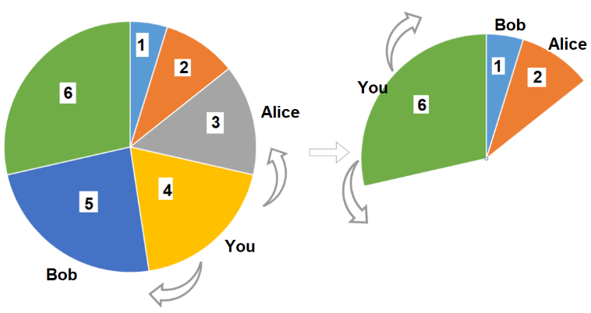

**Input:** slices = [1,2,3,4,5,6]

**Output:** 10

**Explanation:** Pick pizza slice of size 4, Alice and Bob will pick slices with size 3 and 5 respectively. Then Pick slices with size 6, finally Alice and Bob will pick slice of size 2 and 1 respectively. Total = 4 + 6.

**Example 2:**

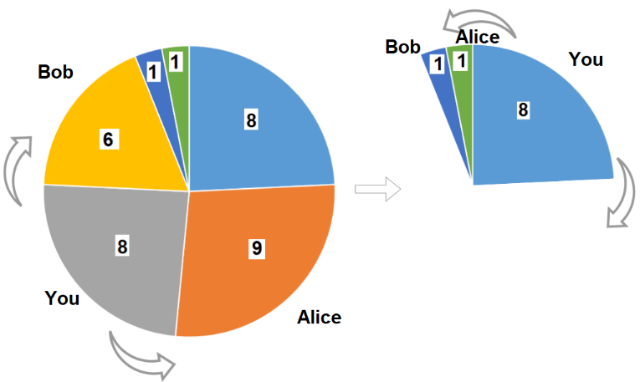

**Input:** slices = [8,9,8,6,1,1]

**Output:** 16

**Output:** Pick pizza slice of size 8 in each turn. If you pick slice with size 9 your partners will pick slices of size 8.

**Example 3:**

**Input:** slices = [4,1,2,5,8,3,1,9,7]

**Output:** 21

**Example 4:**

**Input:** slices = [3,1,2]

**Output:** 3

**Constraints:**

* 1 <= slices.length <= 500
* slices.length % 3 == 0
* 1 <= slices[i] <= 1000

class Solution {

public:

    int maxSizeSlices(vector<int>& slices) {

        int n = (int)slices.size() / 3;

        auto l1 = vector<int>(slices.begin(), slices.end()-1);

        auto l2 = vector<int>(slices.begin()+1, slices.end());

        return max(linear(l1, n), linear(l2, n));

    }

private:

    int linear(vector<int>& slices, int n) {

        vector<vector<int>> eat((int)slices.size()+2, vector<int>(n+1, INT_MIN));

        int res = INT_MIN;

        for (int i=0; i<eat.size(); ++i) eat[i][0] = 0;

        for (int i=2; i<eat.size(); ++i) {

            for (int j=1; j<n+1; ++j)

                eat[i][j] = max(eat[i-1][j], eat[i-2][j-1] + slices[i-2]);

            res = max(eat[i][n], res);

        }

        return res;

    }

};

### 1395. Count Number of Teams

Medium

There are n soldiers standing in a line. Each soldier is assigned a **unique** rating value.

You have to form a team of 3 soldiers amongst them under the following rules:

* Choose 3 soldiers with index (i, j, k) with rating (rating[i], rating[j], rating[k]).
* A team is valid if:  (rating[i] < rating[j] < rating[k]) or (rating[i] > rating[j] > rating[k]) where (0 <= i < j < k < n).

Return the number of teams you can form given the conditions. (soldiers can be part of multiple teams).

**Example 1:**

**Input:** rating = [2,5,3,4,1]

**Output:** 3

**Explanation:** We can form three teams given the conditions. (2,3,4), (5,4,1), (5,3,1).

**Example 2:**

**Input:** rating = [2,1,3]

**Output:** 0

**Explanation:** We can't form any team given the conditions.

**Example 3:**

**Input:** rating = [1,2,3,4]

**Output:** 4

**Constraints:**

* n == rating.length
* 1 <= n <= 200
* 1 <= rating[i] <= 10^5

class Solution {

public:

    int numTeams(vector<int>& rating) {

        int res = 0;

        for (auto i = 1; i < rating.size() - 1; ++i) {

            int less[2] = {}, greater[2] = {};

            for (auto j = 0; j < rating.size(); ++j) {

                if (rating[i] < rating[j])

                    ++less[j > i];

                if (rating[i] > rating[j])

                    ++greater[j > i];

            }

            res += less[0] * greater[1] + greater[0] * less[1];

        }

        return res;

    }

};

class SolutionOfLeetCode315 {

public:

    using pii = pair<int, int>;

    vector<vector<int>> countSmaller(vector<int>& nums) {

        int n = nums.size();

        vector<pii> v(n);

        vector<vector<int>> res(2, vector<int>(n, 0));

        for (int i = 0; i < n; i++)  v[i] = {nums[i], i};

        merge_sort(v.begin(), v.end(), res, true);

        for (int i = 0; i < n; i++)  v[i] = {nums[i], i};

        merge_sort(v.begin(), v.end(), res, false);

        return res;

    }

private:

    void merge_sort(vector<pii>::iterator l, vector<pii>::iterator r,

                    vector<vector<int>> &res, bool IsGreater) {

        if (l+1 < r) {

            auto mid = l + (r-l)/2;

            merge_sort(l, mid, res, IsGreater);

            merge_sort(mid, r, res, IsGreater);

            merge(l, r, res, IsGreater);

        }

    }

    void merge(vector<pii>::iterator l, vector<pii>::iterator r,

               vector<vector<int>> &res, bool IsGreater) {

        int cnt = 0;

        auto mid = l + (r-l)/2, p = l, q = mid;

        while (p < mid || q < r) {

            if (p < mid && q < r) {

                if (q->first >= p->first) {

                    if (!IsGreater) res[1][p->second] += r-q;

                    IsGreater ? ++q : ++p;

                }

                else {

                    if (IsGreater) res[0][p->second] += r-q;

                    IsGreater ? ++p : ++q;

                }

            }

            else if (p < mid) p++;

            else q++;

        }

        if (IsGreater) inplace_merge(l, mid, r, std::greater<>());

        else inplace_merge(l, mid, r, std::less<>());

    }

};

class Solution {

public:

    int numTeams(vector<int>& rating) {

        //preprocess

        class SolutionOfLeetCode315 A;

        auto temp = A.countSmaller(rating);

        auto &t0  = temp[0], t1 = temp[1];

        int n = rating.size(), res = 0;

        vector<int> sorted_rating(rating);

        sort(sorted_rating.begin(), sorted_rating.end());

        for (int i = 1; i < n-1; ++i) {

            int pos = lower_bound(sorted_rating.begin(), sorted_rating.end(), rating[i])

                      - sorted_rating.begin();

            res += t0[i]*(n-1-pos-t1[i]) + t1[i]*(pos-t0[i]);

        }

        return res;

    }

};

### 1397. Find All Good Strings

Hard

Given the strings s1 and s2 of size n, and the string evil. *Return the number of****good****strings*.

A **good** string has size n, it is alphabetically greater than or equal to s1, it is alphabetically smaller than or equal to s2, and it does not contain the string evil as a substring. Since the answer can be a huge number, return this modulo 10^9 + 7.

**Example 1:**

**Input:** n = 2, s1 = "aa", s2 = "da", evil = "b"

**Output:** 51

**Explanation:** There are 25 good strings starting with 'a': "aa","ac","ad",...,"az". Then there are 25 good strings starting with 'c': "ca","cc","cd",...,"cz" and finally there is one good string starting with 'd': "da".

**Example 2:**

**Input:** n = 8, s1 = "leetcode", s2 = "leetgoes", evil = "leet"

**Output:** 0

**Explanation:** All strings greater than or equal to s1 and smaller than or equal to s2 start with the prefix "leet", therefore, there is not any good string.

**Example 3:**

**Input:** n = 2, s1 = "gx", s2 = "gz", evil = "x"

**Output:** 2

**Constraints:**

* s1.length == n
* s2.length == n
* s1 <= s2
* 1 <= n <= 500
* 1 <= evil.length <= 50
* All strings consist of lowercase English letters.

class Solution {

public:

    int dp[501][51][2][2] = {};

    int dfs(const string &s1, const string &s2, const string &evil, int sp, int ep, bool l1, bool l2, const vector<int> &kmp) {

        if (ep == evil.size())

            return 0;

        if (sp == s1.size())

            return 1;

        if (!dp[sp][ep][l1][l2]) {

            for (char ch = (l1 ? s1[sp] : 'a'); ch <= (l2 ? s2[sp] : 'z'); ++ch) {

                auto n_ep = ep;

                while (n_ep > 0 && ch != evil[n_ep])

                    n_ep = kmp[n_ep - 1];

                dp[sp][ep][l1][l2] = (dp[sp][ep][l1][l2] +

                    dfs(s1, s2, evil, sp + 1, ch == evil[n_ep] ? n_ep + 1 : 0,

                        l1 & (ch == s1[sp]), l2 & (ch == s2[sp]), kmp)) % 1000000007;

            }

        }

        return dp[sp][ep][l1][l2];

    }

    int findGoodStrings(int n, string &s1, string &s2, string &evil) {

        vector<int> kmp(evil.size());

        for (auto j = 0, i = 1; i < kmp.size(); ++i) {

            if (evil[i] == evil[j])

                kmp[i] = ++j;

            else if (j > 0) {

                j = kmp[j - 1];

                --i;

            }

        }

        return dfs(s1, s2, evil, 0, 0, true, true, kmp);

    }

};

### 1402. Reducing Dishes

Hard

A chef has collected data on the satisfaction level of his n dishes. Chef can cook any dish in 1 unit of time.

*Like-time coefficient* of a dish is defined as the time taken to cook that dish including previous dishes multiplied by its satisfaction level  i.e.  time[i]*satisfaction[i]

Return the maximum sum of *Like-time coefficient*that the chef can obtain after dishes preparation.

Dishes can be prepared in **any**order and the chef can discard some dishes to get this maximum value.

**Example 1:**

**Input:** satisfaction = [-1,-8,0,5,-9]

**Output:** 14

**Explanation:** After Removing the second and last dish, the maximum total *Like-time coefficient* will be equal to (-1*1 + 0*2 + 5*3 = 14). Each dish is prepared in one unit of time.

**Example 2:**

**Input:** satisfaction = [4,3,2]

**Output:** 20

**Explanation:** Dishes can be prepared in any order, (2*1 + 3*2 + 4*3 = 20)

**Example 3:**

**Input:** satisfaction = [-1,-4,-5]

**Output:** 0

**Explanation:** People don't like the dishes. No dish is prepared.

* n == satisfaction.length
* 1 <= n <= 500
* -10^3 <= satisfaction[i] <= 10^3

class Solution {

public:

    int maxSatisfaction(vector<int>& v) {

        sort(v.begin(), v.end());

        int n = v.size();

        int sum = 0, tmp = 0;

        for (int i = 0; i < n; ++i) {

            tmp += (i+1) * v[i];

            sum += v[i];

        }

        int res = tmp;

        for (int i = 0; i < n && v[i] < 0; ++i) {

            tmp -= sum;

            sum -= v[i];

            res = max(res, tmp);

        }

        return res;

    }

};

class Solution {

public:

    int maxSatisfaction(vector<int>& A) {

        sort(A.begin(), A.end());

        int res = 0, total = 0, n = A.size();

        for (int i = n - 1; i >= 0 && A[i] > -total; --i) {

            total += A[i];

            res += total;

        }

        return res;

    }

};

### 1405. Longest Happy String

Medium

A string is called *happy* if it does not have any of the strings 'aaa', 'bbb' or 'ccc' as a substring.

Given three integers a, b and c, return **any** string s, which satisfies following conditions:

* s is *happy*and longest possible.
* s contains **at most** a occurrences of the letter 'a', **at most** b occurrences of the letter 'b' and **at most** c occurrences of the letter 'c'.
* s will only contain 'a', 'b' and 'c' letters.

If there is no such string s return the empty string "".

**Example 1:**

**Input:** a = 1, b = 1, c = 7

**Output:** "ccaccbcc"

**Explanation:** "ccbccacc" would also be a correct answer.

**Example 2:**

**Input:** a = 2, b = 2, c = 1

**Output:** "aabbc"

**Example 3:**

**Input:** a = 7, b = 1, c = 0

**Output:** "aabaa"

**Explanation:** It's the only correct answer in this case.

**Constraints:**

* 0 <= a, b, c <= 100
* a + b + c > 0

class Solution {

public:

    string longestDiverseString(int a, int b, int c) {

        priority_queue<node> pq;

        if (a) pq.emplace('a', a);

        if (b) pq.emplace('b', b);

        if (c) pq.emplace('c', c);

        string res;

        char pre = ' ';

        while (!pq.empty()) {

            stack<node> stk;

            bool ok = false;

            while (!pq.empty()) {

                auto t = pq.top();

                pq.pop();

                if (pre == t.c) {

                    stk.push(t);

                    continue;

                }

                if (stk.empty() && t.x >= 2) {

                    res += string(2, t.c);

                    t.x -= 2;

                }

                else {

                    res += string(1, t.c);

                    t.x -= 1;

                }

                if (t.x > 0) pq.push(t);

                pre = t.c;

                ok = true;

                break;

            }

            if (!ok) break;

            while (!stk.empty()) {

                pq.push(stk.top());

                stk.pop();

            }

        }

        return res;

    }

    struct node {

        node (char c, int x) : c(c), x(x) {};

        char c;

        int x;

        bool operator < (const node &rhs) const {

            if (x != rhs.x) return x < rhs.x;

            else return c < rhs.c;

        }

    };

};

class Solution {

public:

    string longestDiverseString(int a, int b, int c, char aa = 'a', char bb = 'b', char cc = 'c') {

        if (a < b)

            return longestDiverseString(b, a, c, bb, aa, cc);

        if (b < c)

            return longestDiverseString(a, c, b, aa, cc, bb);

        if (b == 0)

            return string(min(2, a), aa);

        auto use_a = min(2, a), use_b = a - use_a >= b ? 1 : 0;

        return string(use_a, aa) +  string(use_b, bb) +

            longestDiverseString(a - use_a, b - use_b, c, aa, bb, cc);

    }

};

### 1406. Stone Game III

Hard

Alice and Bob continue their games with piles of stones. There are several stones **arranged in a row**, and each stone has an associated value which is an integer given in the array stoneValue.

Alice and Bob take turns, with **Alice** starting first. On each player's turn, that player can take **1, 2 or 3 stones** from the **first** remaining stones in the row.

The score of each player is the sum of values of the stones taken. The score of each player is **0** initially.

The objective of the game is to end with the highest score, and the winner is the player with the highest score and there could be a tie. The game continues until all the stones have been taken.

Assume Alice and Bob **play optimally**.

Return *"Alice"* if Alice will win, *"Bob"* if Bob will win or *"Tie"* if they end the game with the same score.

**Example 1:**

**Input:** values = [1,2,3,7]

**Output:** "Bob"

**Explanation:** Alice will always lose. Her best move will be to take three piles and the score become 6. Now the score of Bob is 7 and Bob wins.

**Example 2:**

**Input:** values = [1,2,3,-9]

**Output:** "Alice"

**Explanation:** Alice must choose all the three piles at the first move to win and leave Bob with negative score.

If Alice chooses one pile her score will be 1 and the next move Bob's score becomes 5. The next move Alice will take the pile with value = -9 and lose.

If Alice chooses two piles her score will be 3 and the next move Bob's score becomes 3. The next move Alice will take the pile with value = -9 and also lose.

Remember that both play optimally so here Alice will choose the scenario that makes her win.

**Example 3:**

**Input:** values = [1,2,3,6]

**Output:** "Tie"

**Explanation:** Alice cannot win this game. She can end the game in a draw if she decided to choose all the first three piles, otherwise she will lose.

**Example 4:**

**Input:** values = [1,2,3,-1,-2,-3,7]

**Output:** "Alice"

**Example 5:**

**Input:** values = [-1,-2,-3]

**Output:** "Tie"

**Constraints:**

* 1 <= values.length <= 50000
* -1000 <= values[i] <= 1000

class Solution {

public:

    string stoneGameIII(vector<int>& A) {

        int n = A.size();

        vector<int> dp(n, -1e9);

        for (int i = n - 1; i >= 0; --i) {

            for (int k = 0, take = 0; k < 3 && i + k < n; ++k) {

                take += A[i + k];

                dp[i] = max(dp[i], take - (i + k + 1 < n ? dp[i + k + 1] : 0));

            }

        }

        if (dp[0] > 0) return "Alice";

        if (dp[0] < 0) return "Bob";

        return "Tie";

    }

};

class Solution {

public:

    string stoneGameIII(vector<int>& A) {

        vector<int> dp(4);

        for (int i = A.size() - 1; i >= 0; --i) {

            dp[i % 4] = -1e9;

            for (int k = 0, take = 0; k < 3 && i + k < A.size(); ++k)

                dp[i % 4] = max(dp[i % 4], (take += A[i + k]) - dp[(i + k + 1) % 4]);

        }

        return dp[0] == 0 ? "Tie" : (dp[0] > 0 ? "Alice" : "Bob");

    }

};

### 1411. Number of Ways to Paint N × 3 Grid

Hard

You have a grid of size n x 3 and you want to paint each cell of the grid with exactly one of the three colours: **Red**, **Yellow** or **Green** while making sure that no two adjacent cells have the same colour (i.e no two cells that share vertical or horizontal sides have the same colour).

You are given n the number of rows of the grid.

Return *the number of ways* you can paint this grid. As the answer may grow large, the answer **must be** computed modulo 10^9 + 7.

**Example 1:**

**Input:** n = 1

**Output:** 12

**Explanation:** There are 12 possible way to paint the grid as shown:

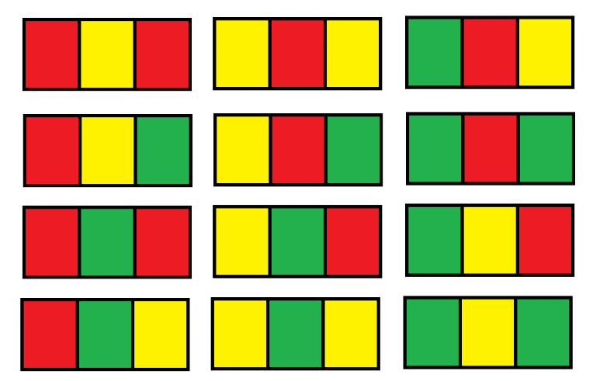

**Example 2:**

**Input:** n = 2

**Output:** 54

**Example 3:**

**Input:** n = 3

**Output:** 246

**Example 4:**

**Input:** n = 7

**Output:** 106494

**Example 5:**

**Input:** n = 5000

**Output:** 30228214

**Constraints:**

* n == grid.length
* grid[i].length == 3
* 1 <= n <= 5000

class Solution {

public:

    int numOfWays(int n) {

        return (int)(6*(dp(0, n) + dp(1, n)) % MOD);

    }

    const long long MOD = 1e9 + 7;

    map<pair<int, int>, long long> mp;

    long long dp(int i, int j) {

        if (j == 1) return 1;

        if (mp.count({i, j})) return mp[{i, j}];

        long long res;

        if (i == 0) res = 3*dp(0, j-1) +2*dp(1, j-1);

        else res = 2*dp(0, j-1) +2*dp(1, j-1);

        return mp[{i, j}] = res % MOD;

    }

};

class Solution {

public:

    int numOfWays(int n) {

        long a121 = 6, a123 = 6, b121, b123, mod = 1e9 + 7;

        for (int i = 1; i < n; ++i) {

            b121 = a121 * 3 + a123 * 2;

            b123 = a121 * 2 + a123 * 2;

            a121 = b121 % mod;

            a123 = b123 % mod;

        }

        return (a121 + a123) % mod;

    }

};

### 1414. Find the Minimum Number of Fibonacci Numbers Whose Sum Is K

Medium

Given the number k, *return the minimum number of Fibonacci numbers whose sum is equal to*k, whether a Fibonacci number could be used multiple times.

The Fibonacci numbers are defined as:

* F1 = 1
* F2 = 1
* Fn = Fn-1 + Fn-2 , for n > 2.

It is guaranteed that for the given constraints we can always find such fibonacci numbers that sum k.

**Example 1:**

**Input:** k = 7

**Output:** 2

**Explanation:** The Fibonacci numbers are: 1, 1, 2, 3, 5, 8, 13, ...

For k = 7 we can use 2 + 5 = 7.

**Example 2:**

**Input:** k = 10

**Output:** 2

**Explanation:** For k = 10 we can use 2 + 8 = 10.

**Example 3:**

**Input:** k = 19

**Output:** 3

**Explanation:** For k = 19 we can use 1 + 5 + 13 = 19.

**Constraints:**

* 1 <= k <= 10^9

class Solution {

public:

    using ll = long long;

    int findMinFibonacciNumbers(int k) {

        while (v.back() < k) {

            v.push_back(v[v.size()-1] + v[v.size()-2]);

        }

        return f(k);

    }

    vector<ll> v{1, 1};

    int f(int k) {

        if (k <= 1) return k;

        int pos = upper_bound(v.begin(), v.end(), k) - v.begin();

        return 1 + f(k-v[pos-1]);

    }

};

class Solution {

public:

    int findMinFibonacciNumbers(int k) {

        if (k < 2) return k;

        int a = 1, b = 1;

        while (b <= k) {

            swap(a, b);

            b += a;

        }

        return 1 + findMinFibonacciNumbers(k - a);

    }

};

### 1415. The k-th Lexicographical String of All Happy Strings of Length n

Medium

A **happy string** is a string that:

* consists only of letters of the set ['a', 'b', 'c'].
* s[i] != s[i + 1] for all values of i from 1 to s.length - 1 (string is 1-indexed).

For example, strings **"abc", "ac", "b"** and **"abcbabcbcb"** are all happy strings and strings **"aa", "baa"** and **"ababbc"** are not happy strings.

Given two integers n and k, consider a list of all happy strings of length n sorted in lexicographical order.

Return *the kth string* of this list or return an **empty string** if there are less than k happy strings of length n.

**Example 1:**

**Input:** n = 1, k = 3

**Output:** "c"

**Explanation:** The list ["a", "b", "c"] contains all happy strings of length 1. The third string is "c".

**Example 2:**

**Input:** n = 1, k = 4

**Output:** ""

**Explanation:** There are only 3 happy strings of length 1.

**Example 3:**

**Input:** n = 3, k = 9

**Output:** "cab"

**Explanation:** There are 12 different happy string of length 3 ["aba", "abc", "aca", "acb", "bab", "bac", "bca", "bcb", "cab", "cac", "cba", "cbc"]. You will find the 9th string = "cab"

**Example 4:**

**Input:** n = 2, k = 7

**Output:** ""

**Example 5:**

**Input:** n = 10, k = 100

**Output:** "abacbabacb"

**Constraints:**

* 1 <= n <= 10
* 1 <= k <= 100

class Solution {

public:

    string getHappyString(int n, int k) {

        auto prem = 1 << (n - 1);

        if (k > 3 * prem)

            return "";

        string s = string(1, 'a' + (k - 1) / prem);

        while (prem > 1) {

            k = (k - 1) % prem + 1;

            prem >>= 1;

            s += (k - 1) / prem == 0 ? 'a' + (s.back() == 'a') : 'b' + (s.back() != 'c');

        }

        return s;

    }

};

class Solution {

public:

    string getHappyString(int n, int k) {

        if (k > 3*(1 << (n-1))) return "";

        --k;

        string s;

        while (1) {

            int t = k / (1 << (n-1));

            k -= t * (1 << (n-1));

            char c;

            if (s == "") c = 'a' + t;

            else if (s.back() == 'a') {

                if (t == 0) c = 'b';

                else c = 'c';

            }

            else if (s.back() == 'b') {

                if (t == 0) c = 'a';

                else c = 'c';

            }

            else if (s.back() == 'c') {

                if (t == 0) c = 'a';

                else c = 'b';

            }

            s += c;

            if (--n == 0) break;

        }

        return s;

    }

};

### 1416. Restore The Array

Hard

A program was supposed to print an array of integers. The program forgot to print whitespaces and the array is printed as a string of digits and all we know is that all integers in the array were in the range [1, k] and there are no leading zeros in the array.

Given the string s and the integer k. There can be multiple ways to restore the array.

Return *the number of possible array* that can be printed as a string s using the mentioned program.

The number of ways could be very large so return it **modulo** 10^9 + 7

**Example 1:**

**Input:** s = "1000", k = 10000

**Output:** 1

**Explanation:** The only possible array is [1000]

**Example 2:**

**Input:** s = "1000", k = 10

**Output:** 0

**Explanation:** There cannot be an array that was printed this way and has all integer >= 1 and <= 10.

**Example 3:**

**Input:** s = "1317", k = 2000

**Output:** 8

**Explanation:** Possible arrays are [1317],[131,7],[13,17],[1,317],[13,1,7],[1,31,7],[1,3,17],[1,3,1,7]

**Example 4:**

**Input:** s = "2020", k = 30

**Output:** 1

**Explanation:** The only possible array is [20,20]. [2020] is invalid because 2020 > 30. [2,020] is ivalid because 020 contains leading zeros.

**Example 5:**

**Input:** s = "1234567890", k = 90

**Output:** 34

**Constraints:**

* 1 <= s.length <= 10^5.
* s consists of only digits and doesn't contain leading zeros.
* 1 <= k <= 10^9.

class Solution {

public:

    int dp[100001] = {};

    int dfs(string &s, int i, int k) {

        if (i == s.size())

            return 1;

        if (s[i] == '0')

            return 0;

        if (!dp[i]) {

            for (long sz = 1, num = 0; i + sz <= s.size(); ++sz) {

                num = num * 10 + s[i + sz - 1] - '0';

                if (num > k)

                    break;

                dp[i] = (dp[i] + dfs(s, i + sz, k)) % 1000000007;

            }

        }

        return dp[i];

    }

    int numberOfArrays(string s, int k) {

        return dfs(s, 0, k);

    }

};

class Solution {

public:

    int numberOfArrays(string s, int k) {

        vector<int> dp(s.size() + 1);

        dp[s.size()] = 1;

        for (int i = s.size() - 1; i >= 0; --i) {

            if (s[i] == '0')

                continue;

            for (long sz = 1, n = 0; i + sz <= s.size(); ++sz) {

                n = n * 10 + s[i + sz - 1] - '0';

                if (n > k)

                    break;

                dp[i] = (dp[i] + dp[i + sz]) % 1000000007;

            }

        }

        return dp[0];

    }

};

### 1420. Build Array Where You Can Find The Maximum Exactly K Comparisons

Hard

Given three integers n, m and k. Consider the following algorithm to find the maximum element of an array of positive integers:

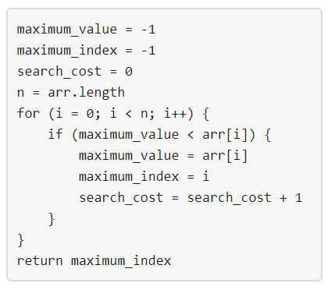

You should build the array arr which has the following properties:

* arr has exactly n integers.
* 1 <= arr[i] <= m where (0 <= i < n).
* After applying the mentioned algorithm to arr, the value search_cost is equal to k.

Return *the number of ways* to build the array arr under the mentioned conditions. As the answer may grow large, the answer **must be** computed modulo 10^9 + 7.

**Example 1:**

**Input:** n = 2, m = 3, k = 1

**Output:** 6

**Explanation:** The possible arrays are [1, 1], [2, 1], [2, 2], [3, 1], [3, 2] [3, 3]

**Example 2:**

**Input:** n = 5, m = 2, k = 3

**Output:** 0

**Explanation:** There are no possible arrays that satisify the mentioned conditions.

**Example 3:**

**Input:** n = 9, m = 1, k = 1

**Output:** 1

**Explanation:** The only possible array is [1, 1, 1, 1, 1, 1, 1, 1, 1]

**Example 4:**

**Input:** n = 50, m = 100, k = 25

**Output:** 34549172

**Explanation:** Don't forget to compute the answer modulo 1000000007

**Example 5:**

**Input:** n = 37, m = 17, k = 7

**Output:** 418930126

**Constraints:**

* 1 <= n <= 50
* 1 <= m <= 100
* 0 <= k <= n

class Solution {

public:

    /* let ways[i][j][k] = # ways to construct an array of length i with max element equal to j and a search cost of k. */

    long long ways[51][101][51];

    const int MOD = 1e9 + 7;

    int numOfArrays(int n, int m, int k) {

        /* There are our base cases. For each index 1 <= j <= m, we require ways[1][j][1] = 1 because the array consisting of only the element j

            has length 1, maximum element j, and it has a search cost of 1. */

        for (int j = 1; j <= m; j++) {

                ways[1][j][1] = 1;

        }

        for (int a = 1; a <= n; a++) {

            for (int b = 1; b <= m; b++) {

                for (int c = 1; c <= k; c++) {

                    long long s = 0;

                    /* In this first case, we can append any element from [1, b] to the end of the array. */

                    s = (s + b * ways[a - 1][b][c]) % MOD;

                   /* In this second case, we can append the element "b" to the end of the array. */

                    for (int x = 1; x < b; x++) {

                        s = (s + ways[a - 1][x][c - 1]) % MOD;

                    }

                    ways[a][b][c] = (ways[a][b][c] + s) % MOD;

                }

            }

        }

        long long ans = 0;

        for (int j = 1; j <= m; j++) {

            ans = (ans + ways[n][j][k]) % MOD;

        }

        return int(ans);

    }

};

### 1423. Maximum Points You Can Obtain from Cards

Medium

There are several cards **arranged in a row**, and each card has an associated number of points The points are given in the integer array cardPoints.

In one step, you can take one card from the beginning or from the end of the row. You have to take exactly k cards.

Your score is the sum of the points of the cards you have taken.

Given the integer array cardPoints and the integer k, return the *maximum score* you can obtain.

**Example 1:**

**Input:** cardPoints = [1,2,3,4,5,6,1], k = 3

**Output:** 12

**Explanation:** After the first step, your score will always be 1. However, choosing the rightmost card first will maximize your total score. The optimal strategy is to take the three cards on the right, giving a final score of 1 + 6 + 5 = 12.

**Example 2:**

**Input:** cardPoints = [2,2,2], k = 2

**Output:** 4

**Explanation:** Regardless of which two cards you take, your score will always be 4.

**Example 3:**

**Input:** cardPoints = [9,7,7,9,7,7,9], k = 7

**Output:** 55

**Explanation:** You have to take all the cards. Your score is the sum of points of all cards.

**Example 4:**

**Input:** cardPoints = [1,1000,1], k = 1

**Output:** 1

**Explanation:** You cannot take the card in the middle. Your best score is 1.

**Example 5:**

**Input:** cardPoints = [1,79,80,1,1,1,200,1], k = 3

**Output:** 202

**Constraints:**

* 1 <= cardPoints.length <= 10^5
* 1 <= cardPoints[i] <= 10^4
* 1 <= k <= cardPoints.length

class Solution {

public:

    int maxScore(vector<int>& P, int k) {

        int sum = 0, res = INT_MAX, S = 0;

        k = P.size()-k;

        for (int i = 0; i < P.size(); ++i) {

            sum += P[i];

            S += P[i];

            if (i >= k) sum -= P[i-k];

            if (i >= k-1) res = min(res, sum);

        }

        return S - res;

        //return helper(P, 0, P.size()-1, k);

    }

private:

    map<pair<int, int>, int> dp;

    int helper(vector<int>& P, int st, int ed, int k) {

        if (k == 0) return 0;

        if (dp.count({st, ed})) return dp[{st, ed}];

        if (st == ed) return P[st];

        int res = 0;

        res = max(P[st] + helper(P, st+1, ed, k-1), P[ed] + helper(P, st, ed-1, k-1));

        return dp[{st, ed}] = res;

    }

};

class Solution {

public:

    int maxScore(vector<int>& cp, int k) {

        // Time Complexity: O(k)

        // Space Complexity: O(1)

        int n(cp.size()), left(0), right(0);

        for (int i = 0; i < k; ++i) left += cp[i];

        int ans(left);

        for (int i = 0; i < k; ++i) {

            left -= cp[k - i - 1];

            right += cp[n - i - 1];

            ans = max(ans, left + right);

        }

        return ans;

    }

};

### 1425. Constrained Subsequence Sum

Hard

Given an integer array nums and an integer k, return the maximum sum of a **non-empty** subsequence of that array such that for every two **consecutive** integers in the subsequence, nums[i] and nums[j], where i < j, the condition j - i <= k is satisfied.

A *subsequence* of an array is obtained by deleting some number of elements (can be zero) from the array, leaving the remaining elements in their original order.

**Example 1:**

**Input:** nums = [10,2,-10,5,20], k = 2

**Output:** 37

**Explanation:** The subsequence is [10, 2, 5, 20].

**Example 2:**

**Input:** nums = [-1,-2,-3], k = 1

**Output:** -1

**Explanation:** The subsequence must be non-empty, so we choose the largest number.

**Example 3:**

**Input:** nums = [10,-2,-10,-5,20], k = 2

**Output:** 23

**Explanation:** The subsequence is [10, -2, -5, 20].

**Constraints:**

* 1 <= k <= nums.length <= 10^5
* -10^4 <= nums[i] <= 10^4

class Solution {

public:

    int constrainedSubsetSum(vector<int>& nums, int k) {

        int n = nums.size();

        vector<int> dp(n);

        int res = INT_MIN;

        deque<int> deq;

        for (int i = 0; i < n; ++i) {

            dp[i] = nums[i];

            if (!deq.empty()) dp[i] = max(dp[i], dp[deq.front()] + nums[i]);

            while (!deq.empty() && dp[deq.back()] < dp[i]) {

                deq.pop_back();

            }

            deq.push_back(i);

            if ((i+1) - deq.front() > k) deq.pop_front();

            res = max(res, dp[i]);

        }

        return res;

    }

};

class Solution {

public:

    int constrainedSubsetSum(vector<int>& A, int k) {

        deque<int> q;

        int res = A[0];

        for (int i = 0; i < A.size(); ++i) {

            A[i] += q.size() ? q.front() : 0;

            res = max(res, A[i]);

            while (q.size() && A[i] > q.back())

                q.pop_back();

            if (A[i] > 0)

                q.push_back(A[i]);

            if (i >= k && q.size() && q.front() == A[i - k])

                q.pop_front();

        }

        return res;

    }

};

### 1434. Number of Ways to Wear Different Hats to Each Other

Hard

There are n people and 40 types of hats labeled from 1 to 40.

Given a list of list of integers hats, where hats[i] is a list of all hats preferred by the i-th person.

Return the number of ways that the n people wear different hats to each other.

Since the answer may be too large, return it modulo 10^9 + 7.

**Example 1:**

**Input:** hats = [[3,4],[4,5],[5]]

**Output:** 1

**Explanation:** There is only one way to choose hats given the conditions.

First person choose hat 3, Second person choose hat 4 and last one hat 5.

**Example 2:**

**Input:** hats = [[3,5,1],[3,5]]

**Output:** 4

**Explanation:** There are 4 ways to choose hats

(3,5), (5,3), (1,3) and (1,5)

**Example 3:**

**Input:** hats = [[1,2,3,4],[1,2,3,4],[1,2,3,4],[1,2,3,4]]

**Output:** 24

**Explanation:** Each person can choose hats labeled from 1 to 4.

Number of Permutations of (1,2,3,4) = 24.

**Example 4:**

**Input:** hats = [[1,2,3],[2,3,5,6],[1,3,7,9],[1,8,9],[2,5,7]]

**Output:** 111

**Constraints:**

* n == hats.length
* 1 <= n <= 10
* 1 <= hats[i].length <= 40
* 1 <= hats[i][j] <= 40
* hats[i] contains a list of **unique** integers.

class Solution {

public:

    int numberWays(vector<vector<int>>& hats) {

        // n: number of persons, 10 at most

        // h: number of hats, 40 at most

        // Time Complexity: O(2^n * h * n)

        // Space Complexity: O(2^n)

        // from the complexity analysis, you can also see why re-organization is critical in passing OJ

        vector<vector<int>> persons(40);

        const int n(hats.size()), mod(1e9 + 7);

        // masks range from 00...0 to 11...1 (n-digit binary number)

        // i-th digit represents whether i-th person has already had a hat

        // Base case: no one has a hat at first

        vector<int> masks(1 << n);

        masks[0] = 1;

        // re-organize, hats -> persons

        for (int i = 0; i < n; ++i)

            for (const int& h: hats[i])

                persons[h - 1].emplace_back(i);

        for (int i = 0; i < 40; ++i)                    // hats

            for (int j = (1 << n) - 1; j >= 0; --j)     // masks

                for (const int& p: persons[i])          // persons

                    // if the current state j implies that p-th person hasn't had a hat yet

                    // we can give the i-th hat to that person, and update the state

                    if ((j & (1 << p)) == 0) {

                        masks[j | (1 << p)] += masks[j];

                        masks[j | (1 << p)] %= mod;

                    }

        // return the state that each person has a hat

        return masks[(1 << n) - 1];

    }

};

### 1438. Longest Continuous Subarray With Absolute Diff Less Than or Equal to Limit

Medium

Given an array of integers nums and an integer limit, return the size of the longest **non-empty** subarray such that the absolute difference between any two elements of this subarray is less than or equal to limit*.*

**Example 1:**

**Input:** nums = [8,2,4,7], limit = 4

**Output:** 2

**Explanation:** All subarrays are:

[8] with maximum absolute diff |8-8| = 0 <= 4.

[8,2] with maximum absolute diff |8-2| = 6 > 4.

[8,2,4] with maximum absolute diff |8-2| = 6 > 4.

[8,2,4,7] with maximum absolute diff |8-2| = 6 > 4.

[2] with maximum absolute diff |2-2| = 0 <= 4.

[2,4] with maximum absolute diff |2-4| = 2 <= 4.

[2,4,7] with maximum absolute diff |2-7| = 5 > 4.

[4] with maximum absolute diff |4-4| = 0 <= 4.

[4,7] with maximum absolute diff |4-7| = 3 <= 4.

[7] with maximum absolute diff |7-7| = 0 <= 4.

Therefore, the size of the longest subarray is 2.

**Example 2:**

**Input:** nums = [10,1,2,4,7,2], limit = 5

**Output:** 4

**Explanation:** The subarray [2,4,7,2] is the longest since the maximum absolute diff is |2-7| = 5 <= 5.

**Example 3:**

**Input:** nums = [4,2,2,2,4,4,2,2], limit = 0

**Output:** 3

**Constraints:**

* 1 <= nums.length <= 10^5
* 1 <= nums[i] <= 10^9
* 0 <= limit <= 10^9

//nlogn

class Solution {

public:

    int longestSubarray(vector<int>& A, int limit) {

        int i = 0, j;

        multiset<int> m;

        for (j = 0; j < A.size(); ++j) {

            m.insert(A[j]);

            if (*m.rbegin() - *m.begin() > limit)

                m.erase(m.find(A[i++]));

        }

        return j - i;

    }

};

//n

class Solution {

public:

    int longestSubarray(vector<int>& A, int limit) {

        deque<int> maxd, mind;

        int i = 0, j;

        for (j = 0; j < A.size(); ++j) {

            while(!maxd.empty() && A[j] > maxd.back()) maxd.pop_back();

            while(!mind.empty() && A[j] < mind.back()) mind.pop_back();

            maxd.push_back(A[j]);

            mind.push_back(A[j]);

            if (maxd.front() - mind.front() > limit) {

                if (maxd.front() == A[i]) maxd.pop_front();

                if (mind.front() == A[i]) mind.pop_front();

                ++i;

            }

        }

        return j - i;

    }

};

### 1439. Find the Kth Smallest Sum of a Matrix With Sorted Rows

Hard

You are given an m * n matrix, mat, and an integer k, which has its rows sorted in non-decreasing order.

You are allowed to choose exactly 1 element from each row to form an array. Return the Kth **smallest** array sum among all possible arrays.

**Example 1:**

**Input:** mat = [[1,3,11],[2,4,6]], k = 5

**Output:** 7

**Explanation:** Choosing one element from each row, the first k smallest sum are:

[1,2], [1,4], [3,2], [3,4], [1,6]. Where the 5th sum is 7.

**Example 2:**

**Input:** mat = [[1,3,11],[2,4,6]], k = 9

**Output:** 17

**Example 3:**

**Input:** mat = [[1,10,10],[1,4,5],[2,3,6]], k = 7

**Output:** 9

**Explanation:** Choosing one element from each row, the first k smallest sum are:

[1,1,2], [1,1,3], [1,4,2], [1,4,3], [1,1,6], [1,5,2], [1,5,3]. Where the 7th sum is 9.

**Example 4:**

**Input:** mat = [[1,1,10],[2,2,9]], k = 7

**Output:** 12

**Constraints:**

* m == mat.length
* n == mat.length[i]
* 1 <= m, n <= 40
* 1 <= k <= min(200, n ^ m)
* 1 <= mat[i][j] <= 5000
* mat[i] is a non decreasing array.

class Solution {

public:

    int kthSmallest(vector<vector<int>>& mat, int k) {

        vector<int> row(mat[0]);

        for(int i = 1; i < mat.size(); ++i) {

            vector<int> nr;  // next row

            for(int j = 0; j < mat[i].size(); ++j)

                for(auto pathSum : row)

                    nr.push_back(mat[i][j] + pathSum); // all possible path ends at [i,j] by far

            sort(nr.begin(), nr.end());

            nr.resize( min(k, int(nr.size())) );

            row=move(nr);

        }

        return row[k-1];

    }

};

class Solution {

public:

    int kthSmallest(vector<vector<int>>& mat, int k) {

        vector<int> ans = {0};

        int maxSize = k + 1;

        for(int i = 0; i < mat.size(); i++){

            // cal

            vector<int> temp;

            for(int j = 0; j < mat[i].size(); j++){

                for(int k = 0; k < ans.size(); k++){

                    temp.push_back(mat[i][j] + ans[k]);

                }

            }

            sort(temp.begin(), temp.end());

            // update answer

            ans.clear();

            int till = min((int)maxSize, (int)temp.size()); // cut Line

            for(int j = 0; j < till; j++){

                ans.push_back(temp[j]);

            }

        }

        return ans[k -1];

    }

};

### 1442. Count Triplets That Can Form Two Arrays of Equal XOR

Medium

Given an array of integers arr.

We want to select three indices i, j and k where (0 <= i < j <= k < arr.length).

Let's define a and b as follows:

* a = arr[i] ^ arr[i + 1] ^ ... ^ arr[j - 1]
* b = arr[j] ^ arr[j + 1] ^ ... ^ arr[k]

Note that **^** denotes the **bitwise-xor** operation.

Return *the number of triplets* (i, j and k) Where a == b.

**Example 1:**

**Input:** arr = [2,3,1,6,7]

**Output:** 4

**Explanation:** The triplets are (0,1,2), (0,2,2), (2,3,4) and (2,4,4)

**Example 2:**

**Input:** arr = [1,1,1,1,1]

**Output:** 10

**Example 3:**

**Input:** arr = [2,3]

**Output:** 0

**Example 4:**

**Input:** arr = [1,3,5,7,9]

**Output:** 3

**Example 5:**

**Input:** arr = [7,11,12,9,5,2,7,17,22]

**Output:** 8

**Constraints:**

* 1 <= arr.length <= 300
* 1 <= arr[i] <= 10^8

class Solution {

public:

    int countTriplets(vector<int>& A) {

        int n = A.size(), res = 0, prefix = 0;

        unordered_map<int, int> count = {{0, 1}}, total;

        for (int i = 0; i < n; ++i) {

            prefix ^= A[i];

            res += count[prefix]++ * i - total[prefix];

            total[prefix] += i + 1;

        }

        return res;

    }

};

### 1444. Number of Ways of Cutting a Pizza

Hard

Given a rectangular pizza represented as a rows x cols matrix containing the following characters: 'A' (an apple) and '.' (empty cell) and given the integer k. You have to cut the pizza into k pieces using k-1 cuts.

For each cut you choose the direction: vertical or horizontal, then you choose a cut position at the cell boundary and cut the pizza into two pieces. If you cut the pizza vertically, give the left part of the pizza to a person. If you cut the pizza horizontally, give the upper part of the pizza to a person. Give the last piece of pizza to the last person.

*Return the number of ways of cutting the pizza such that each piece contains****at least****one apple.*Since the answer can be a huge number, return this modulo 10^9 + 7.

**Example 1:**

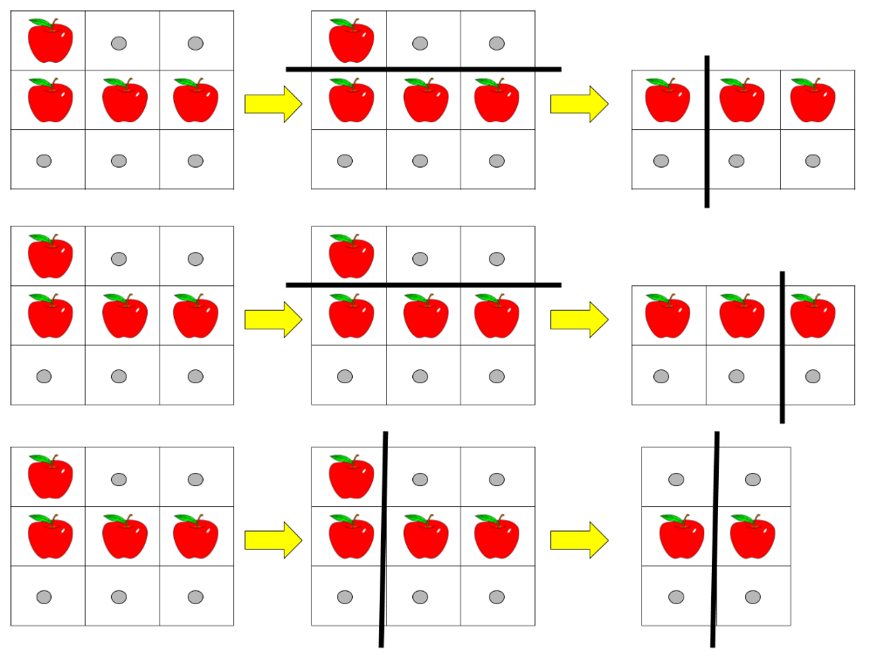

**Input:** pizza = ["A..","AAA","..."], k = 3

**Output:** 3

**Explanation:** The figure above shows the three ways to cut the pizza. Note that pieces must contain at least one apple.

**Example 2:**

**Input:** pizza = ["A..","AA.","..."], k = 3

**Output:** 1

**Example 3:**

**Input:** pizza = ["A..","A..","..."], k = 1

**Output:** 1

**Constraints:**

* 1 <= rows, cols <= 50
* rows == pizza.length
* cols == pizza[i].length
* 1 <= k <= 10
* pizza consists of characters 'A' and '.' only.

class Solution {

    void add(long &a, long &b) { a = (a + b) % ((int) 1e9+7); }

public:

    int ways(vector<string>& A, int K) {

        int M = A.size(), N = A[0].size();

        vector<vector<int>> cnt(M + 1, vector<int>(N + 1));

        for (int i = M - 1; i >= 0; --i) {

            int s = 0;

            for (int j = N - 1; j >= 0; --j) {

                s += A[i][j] == 'A';

                cnt[i][j] = cnt[i + 1][j] + s;

            }

        }

        vector<vector<vector<long>>> dp(M + 1, vector<vector<long>>(N + 1, vector<long>(K + 1)));

        for (int i = M - 1; i >= 0; --i) {

            for (int j = N - 1; j >= 0; --j) {

                dp[i][j][1] = cnt[i][j] > 0;

                for (int k = 2; k <= K; ++k) {

                    for (int t = i + 1; t < M; ++t) {

                        if (cnt[i][j] == cnt[t][j]) continue;

                        if (cnt[t][j] == 0) break;

                        add(dp[i][j][k], dp[t][j][k - 1]);

                    }

                    for (int t = j + 1; t < N; ++t) {

                        if (cnt[i][j] == cnt[i][t]) continue;

                        if (cnt[i][t] == 0) break;

                        add(dp[i][j][k], dp[i][t][k - 1]);

                    }

                }

            }

        }

        return dp[0][0][K];

    }

};

### 1449. Form Largest Integer With Digits That Add up to Target

Hard

Given an array of integers cost and an integer target. Return the **maximum** integer you can paint under the following rules:

* The cost of painting a digit (i+1) is given by cost[i] (0 indexed).
* The total cost used must be equal to target.
* Integer does not have digits 0.

Since the answer may be too large, return it as string.

If there is no way to paint any integer given the condition, return "0".

**Example 1:**

**Input:** cost = [4,3,2,5,6,7,2,5,5], target = 9

**Output:** "7772"

**Explanation:**  The cost to paint the digit '7' is 2, and the digit '2' is 3. Then cost("7772") = 2*3+ 3*1 = 9. You could also paint "977", but "7772" is the largest number.

**Digit cost**

1 -> 4

2 -> 3

3 -> 2

4 -> 5

5 -> 6

6 -> 7

7 -> 2

8 -> 5

9 -> 5

**Example 2:**

**Input:** cost = [7,6,5,5,5,6,8,7,8], target = 12

**Output:** "85"

**Explanation:** The cost to paint the digit '8' is 7, and the digit '5' is 5. Then cost("85") = 7 + 5 = 12.

**Example 3:**

**Input:** cost = [2,4,6,2,4,6,4,4,4], target = 5

**Output:** "0"

**Explanation:** It's not possible to paint any integer with total cost equal to target.

**Example 4:**

**Input:** cost = [6,10,15,40,40,40,40,40,40], target = 47

**Output:** "32211"

**Constraints:**

* cost.length == 9
* 1 <= cost[i] <= 5000
* 1 <= target <= 5000

class Solution {

public:

    unordered_map<int, string> memo;

    string build(const vector<int>& cost, const int& target) {

        if (memo.count(target)) return memo[target];

        string s, t;

        for (int i = 0; i < 9; ++i)

            if (cost[i] <= target) {

                t = build(cost, target - cost[i]);

                if (t != "*") {

                    t = char('1' + i) + t;

                    s = s.length() < t.length() ? t

: s.length() == t.length() && s < t ? t : s;

                }

            }

        return memo[target] = s.empty() ? "*" : s;

    }

    string largestNumber(vector<int>& cost, int target) {

        memo[0] = "";

        string ans = build(cost, target);

        return ans == "*" ? "0" : ans;

    }

};

### 1453. Maximum Number of Darts Inside of a Circular Dartboard

Hard

You have a very large square wall and a circular dartboard placed on the wall. You have been challenged to throw darts into the board blindfolded. Darts thrown at the wall are represented as an array of points on a 2D plane.

Return the maximum number of points that are within or lie on **any** circular dartboard of radius r.

**Example 1:**

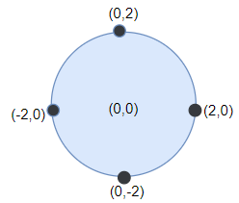

**Input:** points = [[-2,0],[2,0],[0,2],[0,-2]], r = 2

**Output:** 4

**Explanation:** Circle dartboard with center in (0,0) and radius = 2 contain all points.

**Example 2:**

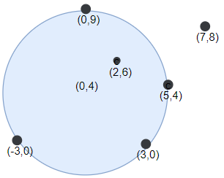

**Input:** points = [[-3,0],[3,0],[2,6],[5,4],[0,9],[7,8]], r = 5

**Output:** 5

**Explanation:** Circle dartboard with center in (0,4) and radius = 5 contain all points except the point (7,8).

**Example 3:**

**Input:** points = [[-2,0],[2,0],[0,2],[0,-2]], r = 1

**Output:** 1

**Example 4:**

**Input:** points = [[1,2],[3,5],[1,-1],[2,3],[4,1],[1,3]], r = 2

**Output:** 4

**Constraints:**

* 1 <= points.length <= 100
* points[i].length == 2
* -10^4 <= points[i][0], points[i][1] <= 10^4
* 1 <= r <= 5000

class Solution {

public:

    const double tol = 1e-6;

    double R;

    struct Point {

        double x, y;

    };

    vector<Point> point;

    double dis(const Point& a, const Point& b) {

        return sqrt((a.x - b.x)*(a.x - b.x) + (a.y - b.y)*(a.y - b.y));

    }

    pair<Point, Point> getCenter(const Point& a, const Point& b) {

        Point mid;

        pair<Point, Point> res;

        mid.x = (a.x + b.x) / 2, mid.y = (a.y + b.y) / 2;

        double theta = atan2(a.y - b.y, b.x - a.x);

        double tmp = dis(a, b) / 2;

        double d = sqrt(R * R - tmp*tmp);

        res.first.x = mid.x - d*sin(theta);

        res.first.y = mid.y - d*cos(theta);

        res.second.x = mid.x + d*sin(theta);

        res.second.y = mid.y + d*cos(theta);

        return res;

    }

    int numPoints(vector<vector<int>>& points, int r) {

        int n = points.size();

        R = (double)r;

        point.resize(n);

        for (int i = 0; i < n; ++i) {

            point[i].x = points[i][0];

            point[i].y = points[i][1];

        }

        int ans = 1;

        for (int i = 0; i < n; i++) {

            for (int j = 0; j < n; j++) {

                if (i == j || dis(point[i], point[j]) - 2 * R > tol)

continue;

                int cnt = 0;

                auto p = getCenter(point[i], point[j]);

                for (int k = 0; k<n; k++) {

                    if (dis(point[k], p.first) - R <= tol)

                        cnt++;

                }

                ans = max(ans, cnt);

                cnt = 0;

                for (int k = 0; k<n; k++) {

                    if (dis(point[k], p.second) - R <= tol)

                        cnt++;

                }

                ans = max(ans, cnt);

            }

        }

        return ans;

    }

};

### 1458. Max Dot Product of Two Subsequences

Hard

Given two arrays nums1 and nums2.

Return the maximum dot product between **non-empty** subsequences of nums1 and nums2 with the same length.

A subsequence of a array is a new array which is formed from the original array by deleting some (can be none) of the characters without disturbing the relative positions of the remaining characters. (ie, [2,3,5] is a subsequence of [1,2,3,4,5] while [1,5,3] is not).

**Example 1:**

**Input:** nums1 = [2,1,-2,5], nums2 = [3,0,-6]

**Output:** 18

**Explanation:** Take subsequence [2,-2] from nums1 and subsequence [3,-6] from nums2.

Their dot product is (2*3 + (-2)*(-6)) = 18.

**Example 2:**

**Input:** nums1 = [3,-2], nums2 = [2,-6,7]

**Output:** 21

**Explanation:** Take subsequence [3] from nums1 and subsequence [7] from nums2.

Their dot product is (3*7) = 21.

**Example 3:**

**Input:** nums1 = [-1,-1], nums2 = [1,1]

**Output:** -1

**Explanation:** Take subsequence [-1] from nums1 and subsequence [1] from nums2.

Their dot product is -1.

**Constraints:**

* 1 <= nums1.length, nums2.length <= 500
* -1000 <= nums1[i], nums2[i] <= 1000

class Solution {

public:

    int maxDotProduct(vector<int>& A, vector<int>& B) {

        int n = A.size(), m = B.size();

        vector<vector<int>> dp(n, vector<int>(m));

        for (int i = 0; i < n; ++i) {

            for (int j = 0; j < m; ++j) {

                dp[i][j] = A[i] * B[j];

                if (i && j) dp[i][j] += max(dp[i - 1][j - 1], 0);

                if (i) dp[i][j] = max(dp[i][j], dp[i - 1][j]);

                if (j) dp[i][j] = max(dp[i][j], dp[i][j - 1]);

            }

        }

        return dp[n - 1][m - 1];

    }

};

### 1462. Course Schedule IV

Medium

There are a total of n courses you have to take, labeled from 0 to n-1.

Some courses may have direct prerequisites, for example, to take course 0 you have first to take course 1, which is expressed as a pair: [1,0]

Given the total number of courses n, a list of direct prerequisite **pairs** and a list of queries **pairs**.

You should answer for each queries[i] whether the course queries[i][0] is a prerequisite of the course queries[i][1] or not.

Return *a list of boolean*, the answers to the given queries.

Please note that if course **a** is a prerequisite of course **b** and course **b** is a prerequisite of course **c**, then, course **a** is a prerequisite of course **c**.

**Example 1:**

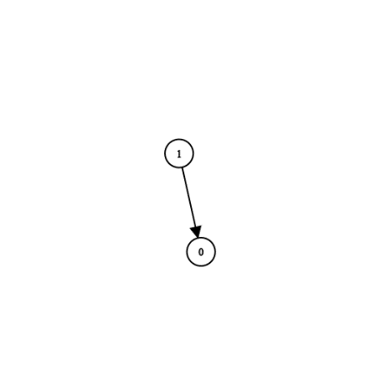

**Input:** n = 2, prerequisites = [[1,0]], queries = [[0,1],[1,0]]

**Output:** [false,true]

**Explanation:** course 0 is not a prerequisite of course 1 but the opposite is true.

**Example 2:**

**Input:** n = 2, prerequisites = [], queries = [[1,0],[0,1]]

**Output:** [false,false]

**Explanation:** There are no prerequisites and each course is independent.

**Example 3:**

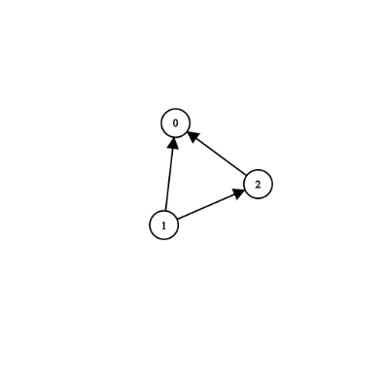

**Input:** n = 3, prerequisites = [[1,2],[1,0],[2,0]], queries = [[1,0],[1,2]]

**Output:** [true,true]

**Example 4:**

**Input:** n = 3, prerequisites = [[1,0],[2,0]], queries = [[0,1],[2,0]]

**Output:** [false,true]

**Example 5:**

**Input:** n = 5, prerequisites = [[0,1],[1,2],[2,3],[3,4]], queries = [[0,4],[4,0],[1,3],[3,0]]

**Output:** [true,false,true,false]

**Constraints:**

* 2 <= n <= 100
* 0 <= prerequisite.length <= (n * (n - 1) / 2)
* 0 <= prerequisite[i][0], prerequisite[i][1] < n
* prerequisite[i][0] != prerequisite[i][1]
* The prerequisites graph has no cycles.
* The prerequisites graph has no repeated edges.
* 1 <= queries.length <= 10^4
* queries[i][0] != queries[i][1]

class Solution {

public:

    vector<bool> checkIfPrerequisite(int n, vector<vector<int>>& prerequisites, vector<vector<int>>& queries) {

        vector<vector<int>> g(n);

        vector<int> indegree(n, 0);

        for(auto v: prerequisites) {

            g[v[0]].emplace_back(v[1]);

            ++indegree[v[1]];

        }

        vector<bitset<100> > cache(n, 0);  // n <= 100

        function<bitset<100>(int)> dfs1462 = [&](int i){

            if(g[i].empty()){bitset<100> b(0); b[i] = true; return b; }  // outdegree[i] == 0

            if(cache[i] != bitset<100>(0)) return cache[i];

            cache[i][i] = true;

            for(int v: g[i])  cache[i] |= dfs1462(v);

            return cache[i];

        };

        for(int i=0; i<n; i++)

            if(indegree[i]==0)

                dfs1462(i);

        vector<bool> res(queries.size(), false);

        int i=0;

        for(auto &q: queries)  res[i++] = bool(cache[q[0]][q[1]]);

        return res;

    }

};

### 1463. Cherry Pickup II

Hard

Given a rows x cols matrix grid representing a field of cherries. Each cell in grid represents the number of cherries that you can collect.

You have two robots that can collect cherries for you, Robot #1 is located at the top-left corner (0,0) , and Robot #2 is located at the top-right corner (0, cols-1) of the grid.

Return the maximum number of cherries collection using both robots  by following the rules below:

* From a cell (i,j), robots can move to cell (i+1, j-1) , (i+1, j) or (i+1, j+1).
* When any robot is passing through a cell, It picks it up all cherries, and the cell becomes an empty cell (0).
* When both robots stay on the same cell, only one of them takes the cherries.
* Both robots cannot move outside of the grid at any moment.
* Both robots should reach the bottom row in the grid.

**Example 1:**

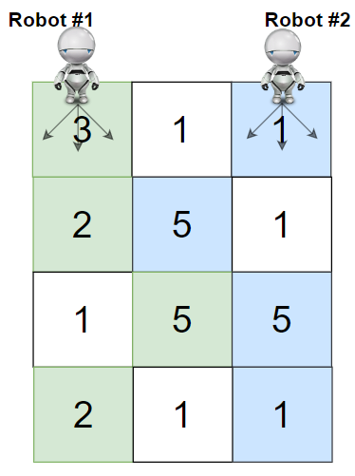

**Input:** grid = [[3,1,1],[2,5,1],[1,5,5],[2,1,1]]

**Output:** 24

**Explanation:** Path of robot #1 and #2 are described in color green and blue respectively.

Cherries taken by Robot #1, (3 + 2 + 5 + 2) = 12.

Cherries taken by Robot #2, (1 + 5 + 5 + 1) = 12.

Total of cherries: 12 + 12 = 24.

**Example 2:**

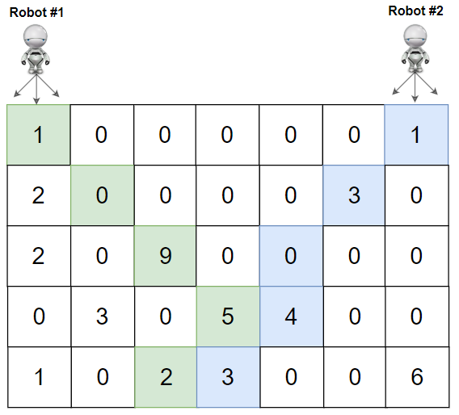

**Input:** grid = [[1,0,0,0,0,0,1],[2,0,0,0,0,3,0],[2,0,9,0,0,0,0],[0,3,0,5,4,0,0],[1,0,2,3,0,0,6]]

**Output:** 28

**Explanation:** Path of robot #1 and #2 are described in color green and blue respectively.

Cherries taken by Robot #1, (1 + 9 + 5 + 2) = 17.

Cherries taken by Robot #2, (1 + 3 + 4 + 3) = 11.

Total of cherries: 17 + 11 = 28.

**Example 3:**

**Input:** grid = [[1,0,0,3],[0,0,0,3],[0,0,3,3],[9,0,3,3]]

**Output:** 22

**Example 4:**

**Input:** grid = [[1,1],[1,1]]

**Output:** 4

**Constraints:**

* rows == grid.length
* cols == grid[i].length
* 2 <= rows, cols <= 70
* 0 <= grid[i][j] <= 100

class Solution {

public:

    int cherryPickup(vector<vector<int>>& grid) {

        int m = grid.size();

        int n = grid[0].size();

        int f[m][n][n];

        int res = 0;

        memset(f, -1, sizeof(f));

        f[0][0][n - 1] = grid[0][0] + grid[0][n-1];

        for (int i = 1; i < m; i++)

            for (int j = 0; j < n; j++)

                for (int k = 0; k < n; k++) {

                    int value = (j == k) ? grid[i][j]

: grid[i][j] + grid[i][k];

                    for (int col1 = j-1; col1 <= j+1; col1++)

                        for (int col2 = k-1; col2 <= k+1; col2++) {

                            if (col1 >= 0 && col1 < n && col2 >= 0

&& col2 < n && f[i-1][col1][col2] >= 0) {

                                f[i][j][k] = max(f[i][j][k],

f[i - 1][col1][col2] + value);

                                if (i == m - 1) res = max(res,

f[i][j][k]);

                            }

                        }

                }

        return res;

    }

};

### 1467. Probability of a Two Boxes Having The Same Number of Distinct Balls

Hard

Given 2n balls of k distinct colors. You will be given an integer array balls of size k where balls[i] is the number of balls of color i.

All the balls will be **shuffled uniformly at random**, then we will distribute the first n balls to the first box and the remaining n balls to the other box (Please read the explanation of the second example carefully).

Please note that the two boxes are considered different. For example, if we have two balls of colors a and b, and two boxes [] and (), then the distribution [a] (b) is considered different than the distribution [b] (a) (Please read the explanation of the first example carefully).

We want to *calculate the probability* that the two boxes have the same number of distinct balls.

**Example 1:**

**Input:** balls = [1,1]

**Output:** 1.00000

**Explanation:** Only 2 ways to divide the balls equally:

- A ball of color 1 to box 1 and a ball of color 2 to box 2

- A ball of color 2 to box 1 and a ball of color 1 to box 2

In both ways, the number of distinct colors in each box is equal. The probability is 2/2 = 1

**Example 2:**

**Input:** balls = [2,1,1]

**Output:** 0.66667

**Explanation:** We have the set of balls [1, 1, 2, 3]

This set of balls will be shuffled randomly and we may have one of the 12 distinct shuffles with equale probability (i.e. 1/12):

[1,1 / 2,3], [1,1 / 3,2], [1,2 / 1,3], [1,2 / 3,1], [1,3 / 1,2], [1,3 / 2,1], [2,1 / 1,3], [2,1 / 3,1], [2,3 / 1,1], [3,1 / 1,2], [3,1 / 2,1], [3,2 / 1,1]

After that we add the first two balls to the first box and the second two balls to the second box.

We can see that 8 of these 12 possible random distributions have the same number of distinct colors of balls in each box.

Probability is 8/12 = 0.66667

**Example 3:**

**Input:** balls = [1,2,1,2]

**Output:** 0.60000

**Explanation:** The set of balls is [1, 2, 2, 3, 4, 4]. It is hard to display all the 180 possible random shuffles of this set but it is easy to check that 108 of them will have the same number of distinct colors in each box.

Probability = 108 / 180 = 0.6

**Example 4:**

**Input:** balls = [3,2,1]

**Output:** 0.30000

**Explanation:** The set of balls is [1, 1, 1, 2, 2, 3]. It is hard to display all the 60 possible random shuffles of this set but it is easy to check that 18 of them will have the same number of distinct colors in each box.

Probability = 18 / 60 = 0.3

**Example 5:**

**Input:** balls = [6,6,6,6,6,6]

**Output:** 0.90327

**Constraints:**

* 1 <= balls.length <= 8
* 1 <= balls[i] <= 6
* sum(balls) is even.
* Answers within 10^-5 of the actual value will be accepted as correct.

class Solution {

public:

    double getProbability(vector<int>& balls) {

        int N = accumulate(balls.begin(), balls.end(), 0), n = N / 2;

        return dfs(0, 0, 0, 0, 0, balls, n);

    }

    double dp[8][50][50][8][8];

    double dfs(int i, int l, int r, int cl, int cr, vector<int> &balls, int n) {

        if (i == balls.size()) {

            return (l == r && cl == cr) ? 1.0 : 0;

        }

        if (dp[i][l][r][cl][cr] != 0) return dp[i][l][r][cl][cr];

        double ret = 0;

        double a = C(2*n - l - r, balls[i]);

        for (int k = 0; k <= balls[i]; ++k) {

            int new_l = l+k, new_r = r+balls[i]-k;

            if (new_l > n) break;

            if (new_r > n) continue;

            int new_cl = cl + (k == 0 ? 0 : 1);

            int new_cr = cr + (k == balls[i] ? 0 : 1);

            double b = C(n - l, k);

            double c = C(n - r, balls[i]-k);

            ret += dfs(i+1, new_l, new_r, new_cl, new_cr, balls, n)

/ a * b * c;

        }

        return dp[i][l][r][cl][cr] = ret;

    }

    double f(int n) {

        if (n == 0) return 1;

        else return n*f(n-1);

    }

    double C(double n, double i) {

        return f(n) / f(i) / f(n-i);

    }

};

### 1477. Find Two Non-overlapping Sub-arrays Each With Target Sum

Medium

Given an array of integers arr and an integer target.

You have to find **two non-overlapping sub-arrays** of arr each with sum equal target. There can be multiple answers so you have to find an answer where the sum of the lengths of the two sub-arrays is **minimum**.

Return *the minimum sum of the lengths* of the two required sub-arrays, or return ***-1*** if you cannot find such two sub-arrays.

**Example 1:**

**Input:** arr = [3,2,2,4,3], target = 3

**Output:** 2

**Explanation:** Only two sub-arrays have sum = 3 ([3] and [3]). The sum of their lengths is 2.

**Example 2:**

**Input:** arr = [7,3,4,7], target = 7

**Output:** 2

**Explanation:** Although we have three non-overlapping sub-arrays of sum = 7 ([7], [3,4] and [7]), but we will choose the first and third sub-arrays as the sum of their lengths is 2.

**Example 3:**

**Input:** arr = [4,3,2,6,2,3,4], target = 6

**Output:** -1

**Explanation:** We have only one sub-array of sum = 6.

**Example 4:**

**Input:** arr = [5,5,4,4,5], target = 3

**Output:** -1

**Explanation:** We cannot find a sub-array of sum = 3.

**Example 5:**

**Input:** arr = [3,1,1,1,5,1,2,1], target = 3

**Output:** 3

**Explanation:** Note that sub-arrays [1,2] and [2,1] cannot be an answer because they overlap.

**Constraints:**

* 1 <= arr.length <= 10^5
* 1 <= arr[i] <= 1000
* 1 <= target <= 10^8

class Solution {

public:

int dp[100005][3];

//if asking for n subarrays, change 3 to n+1

unordered_map<int,int> sm;

// keep track of (prefixsum : index)

    int minSumOfLengths(vector<int>& arr, int tar) {

        int n = arr.size(), cursum = 0;

        sm[0] = 0;

        memset(dp, 127, sizeof(dp));  //initialize to INF

        for (int i = 0; i < 100005; i++) dp[i][0] = 0;

//if we doesn't find a subarray, len = 0

        for (int i = 1; i <= n; i++) {

            int d = -1;

//initialize to -1

            cursum += arr[i-1];

            sm[cursum] = i;

            if (sm.count(cursum - tar)) d = sm[cursum-tar];

            for (int j = 1; j <= 2; j++) {

// if asking for n subarrays, change 2 to n

                dp[i][j] = min(dp[i][j], dp[i-1][j]);

//dp[i][j] must <= dp[i-1][j]

                if (d != -1) dp[i][j] = min(dp[i][j],

dp[d][j-1] + i - d);

            }

        }

        if (dp[n][2] > 1e9) return -1;

// if asking for n subarrays, change 2 to n

        return dp[n][2];

// if asking for n subarrays, change 2 to n

    }

};

### 1478. Allocate Mailboxes

Hard

Given the array houses and an integer k. where houses[i] is the location of the ith house along a street, your task is to allocate k mailboxes in the street.

Return the **minimum** total distance between each house and its nearest mailbox.

The answer is guaranteed to fit in a 32-bit signed integer.

**Example 1:**

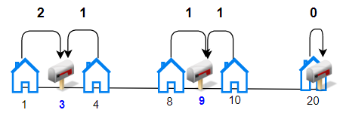

**Input:** houses = [1,4,8,10,20], k = 3

**Output:** 5

**Explanation:** Allocate mailboxes in position 3, 9 and 20.

Minimum total distance from each houses to nearest mailboxes is |3-1| + |4-3| + |9-8| + |10-9| + |20-20| = 5

**Example 2:**

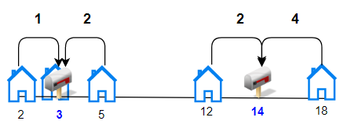

**Input:** houses = [2,3,5,12,18], k = 2

**Output:** 9

**Explanation:** Allocate mailboxes in position 3 and 14.

Minimum total distance from each houses to nearest mailboxes is |2-3| + |3-3| + |5-3| + |12-14| + |18-14| = 9.

**Example 3:**

**Input:** houses = [7,4,6,1], k = 1

**Output:** 8

**Example 4:**

**Input:** houses = [3,6,14,10], k = 4

**Output:** 0

**Constraints:**

* n == houses.length
* 1 <= n <= 100
* 1 <= houses[i] <= 10^4
* 1 <= k <= n
* Array houses contain unique integers.

class Solution {

public:

    int minDistance(vector<int>& A, int K) {

        sort(A.begin(), A.end());

        int n = A.size();

        vector<int> B(n + 1, 0), dp(n, 1e6);

        for (int i = 0; i < n; ++i)

            B[i + 1] = B[i] + A[i];

        for (int k = 1; k <= K; ++k)

            for (int j = n - 1; j > k - 2; --j)

                for (int i = k - 2; i < j; ++i) {

                    int m1 =  (i + j + 1) / 2, m2 = (i + j + 2) / 2;

                    int last = (B[j + 1] - B[m2])-(B[m1 + 1]-B[i + 1]);

                    dp[j] = min(dp[j], (i >= 0 ? dp[i] : 0) + last);

                }

        return dp[n - 1];

    }

};

### 1482. Minimum Number of Days to Make m Bouquets

Medium

Given an integer array bloomDay, an integer m and an integer k.

We need to make m bouquets. To make a bouquet, you need to use k **adjacent flowers** from the garden.

The garden consists of n flowers, the ith flower will bloom in the bloomDay[i] and then can be used in **exactly one** bouquet.

Return *the minimum number of days* you need to wait to be able to make m bouquets from the garden. If it is impossible to make m bouquets return **-1**.

**Example 1:**

**Input:** bloomDay = [1,10,3,10,2], m = 3, k = 1

**Output:** 3

**Explanation:** Let's see what happened in the first three days. x means flower bloomed and _ means flower didn't bloom in the garden.

We need 3 bouquets each should contain 1 flower.

After day 1: [x, _, _, _, _] // we can only make one bouquet.

After day 2: [x, _, _, _, x] // we can only make two bouquets.

After day 3: [x, _, x, _, x] // we can make 3 bouquets. The answer is 3.

**Example 2:**

**Input:** bloomDay = [1,10,3,10,2], m = 3, k = 2

**Output:** -1

**Explanation:** We need 3 bouquets each has 2 flowers, that means we need 6 flowers. We only have 5 flowers so it is impossible to get the needed bouquets and we return -1.

**Example 3:**

**Input:** bloomDay = [7,7,7,7,12,7,7], m = 2, k = 3

**Output:** 12

**Explanation:** We need 2 bouquets each should have 3 flowers.

Here's the garden after the 7 and 12 days:

After day 7: [x, x, x, x, _, x, x]

We can make one bouquet of the first three flowers that bloomed. We cannot make another bouquet from the last three flowers that bloomed because they are not adjacent.

After day 12: [x, x, x, x, x, x, x]

It is obvious that we can make two bouquets in different ways.

**Example 4:**

**Input:** bloomDay = [1000000000,1000000000], m = 1, k = 1

**Output:** 1000000000

**Explanation:** You need to wait 1000000000 days to have a flower ready for a bouquet.

**Example 5:**

**Input:** bloomDay = [1,10,2,9,3,8,4,7,5,6], m = 4, k = 2

**Output:** 9

**Constraints:**

* bloomDay.length == n
* 1 <= n <= 10^5
* 1 <= bloomDay[i] <= 10^9
* 1 <= m <= 10^6
* 1 <= k <= n

class Solution {

public:

    int minDays(vector<int>& v, int m, int k) {

        int n = v.size();

        if (n < m*k) return -1;

        int lo = *min_element(v.begin(), v.end());

        int hi = *max_element(v.begin(), v.end());

        while (lo < hi) {

            int mid = lo + (hi-lo)/2;

            if (check(v, m, k, mid)) hi = mid;

            else lo = mid + 1;

        }

        return hi;

    }

    bool check(vector<int>& v, int m, int k, int day) {

        int sum = 0;

        for (int i : v) {

            if (i <= day) {

                if (++sum == k) {

                    if (--m == 0) return true;

                    sum = 0;

                }

            }

            else sum = 0;

        }

        return false;

    }

};

### 1483. Kth Ancestor of a Tree Node

Hard

You are given a tree with n nodes numbered from 0 to n-1 in the form of a parent array where parent[i] is the parent of node i. The root of the tree is node 0.

Implement the function getKthAncestor(int node, int k) to return the k-th ancestor of the given node. If there is no such ancestor, return -1.

The *k-th ancestor* of a tree node is the k-th node in the path from that node to the root.

**Example:**

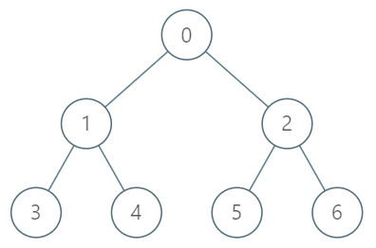

**Input:**

["TreeAncestor","getKthAncestor","getKthAncestor","getKthAncestor"]

[[7,[-1,0,0,1,1,2,2]],[3,1],[5,2],[6,3]]

**Output:**

[null,1,0,-1]

**Explanation:**

TreeAncestor treeAncestor = new TreeAncestor(7, [-1, 0, 0, 1, 1, 2, 2]);

treeAncestor.getKthAncestor(3, 1); // returns 1 which is the parent of 3

treeAncestor.getKthAncestor(5, 2); // returns 0 which is the grandparent of 5

treeAncestor.getKthAncestor(6, 3); // returns -1 because there is no such ancestor

**Constraints:**

* 1 <= k <= n <= 5*10^4
* parent[0] == -1 indicating that 0 is the root node.
* 0 <= parent[i] < n for all 0 < i < n
* 0 <= node < n
* There will be at most 5*10^4 queries.

class TreeAncestor {

public:

    vector<vector<int>>v;

    TreeAncestor(int n, vector<int>& parent) {

        vector<vector<int>> par(n, vector<int>(20));

        for (int i = 0; i < n; i++) par[i][0] = parent[i];

        for (int j = 1; j < 20; j++) {

            for (int i = 0; i < n; i++) {

                if (par[i][j - 1] == -1) par[i][j] = -1;

                else par[i][j] = par[par[i][j - 1]][j - 1];

            }

        }

        swap(v, par);

    }

    int getKthAncestor(int node, int k) {

        for (int i = 0; i < 20; i++) {

            if ((k >> i) & 1) {

                node = v[node][i];

                if (node == -1) return -1;

            }

        }

        return node;

    }

};

### 1488. Avoid Flood in The City

Medium

Your country has an infinite number of lakes. Initially, all the lakes are empty, but when it rains over the nth lake, the nth lake becomes full of water. If it rains over a lake which is **full of water**, there will be a **flood**. Your goal is to avoid the flood in any lake.

Given an integer array rains where:

* rains[i] > 0 means there will be rains over the rains[i] lake.
* rains[i] == 0 means there are no rains this day and you can choose **one lake** this day and **dry it**.

Return *an array ans* where:

* ans.length == rains.length
* ans[i] == -1 if rains[i] > 0.
* ans[i] is the lake you choose to dry in the ith day if rains[i] == 0.

If there are multiple valid answers return **any** of them. If it is impossible to avoid flood return **an empty array**.

Notice that if you chose to dry a full lake, it becomes empty, but if you chose to dry an empty lake, nothing changes. (see example 4)

**Example 1:**

**Input:** rains = [1,2,3,4]

**Output:** [-1,-1,-1,-1]

**Explanation:** After the first day full lakes are [1]

After the second day full lakes are [1,2]

After the third day full lakes are [1,2,3]

After the fourth day full lakes are [1,2,3,4]

There's no day to dry any lake and there is no flood in any lake.

**Example 2:**

**Input:** rains = [1,2,0,0,2,1]

**Output:** [-1,-1,2,1,-1,-1]

**Explanation:** After the first day full lakes are [1]

After the second day full lakes are [1,2]

After the third day, we dry lake 2. Full lakes are [1]

After the fourth day, we dry lake 1. There is no full lakes.

After the fifth day, full lakes are [2].

After the sixth day, full lakes are [1,2].

It is easy that this scenario is flood-free. [-1,-1,1,2,-1,-1] is another acceptable scenario.

**Example 3:**

**Input:** rains = [1,2,0,1,2]

**Output:** []

**Explanation:** After the second day, full lakes are [1,2]. We have to dry one lake in the third day.

After that, it will rain over lakes [1,2]. It's easy to prove that no matter which lake you choose to dry in the 3rd day, the other one will flood.

**Example 4:**

**Input:** rains = [69,0,0,0,69]

**Output:** [-1,69,1,1,-1]

**Explanation:** Any solution on one of the forms [-1,69,x,y,-1], [-1,x,69,y,-1] or [-1,x,y,69,-1] is acceptable where 1 <= x,y <= 10^9

**Example 5:**

**Input:** rains = [10,20,20]

**Output:** []

**Explanation:** It will rain over lake 20 two consecutive days. There is no chance to dry any lake.

**Constraints:**

* 1 <= rains.length <= 10^5

class Solution {

public:

    vector<int> avoidFlood(vector<int>& rains) {

        int n = rains.size();

        vector<int> res(n, -1);

        map<int, int> mp;

        set<int> st;

        for (int i = 0; i < n; ++i) {

            if (rains[i] == 0) st.insert(i);

            else if (mp.count(rains[i])) {

                auto it = st.upper_bound(mp[rains[i]]);

                if (it == st.end()) return {};

                res[*it] = rains[i];

                st.erase(it);

                mp[rains[i]] = i;

            }

            else mp[rains[i]] = i;

        }

        if (st.empty()) return res;

        for (auto it = st.rbegin(); it != st.rend(); ++it) {

            res[*it] = 1;

        }

        return res;

    }

};

### 1489. Find Critical and Pseudo-Critical Edges in Minimum Spanning Tree

Hard

Given a weighted undirected connected graph with n vertices numbered from 0 to n-1, and an array edges where edges[i] = [fromi, toi, weighti] represents a bidirectional and weighted edge between nodes fromi and toi. A minimum spanning tree (MST) is a subset of the edges of the graph that connects all vertices without cycles and with the minimum possible total edge weight.

Find *all the critical and pseudo-critical edges in the minimum spanning tree (MST) of the given graph*. An MST edge whose deletion from the graph would cause the MST weight to increase is called a *critical edge*. A *pseudo-critical edge*, on the other hand, is that which can appear in some MSTs but not all.

Note that you can return the indices of the edges in any order.

**Example 1:**

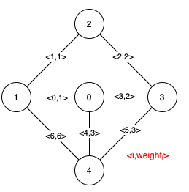

**Input:** n = 5, edges = [[0,1,1],[1,2,1],[2,3,2],[0,3,2],[0,4,3],[3,4,3],[1,4,6]]

**Output:** [[0,1],[2,3,4,5]]

**Explanation:** The figure above describes the graph.

The following figure shows all the possible MSTs:

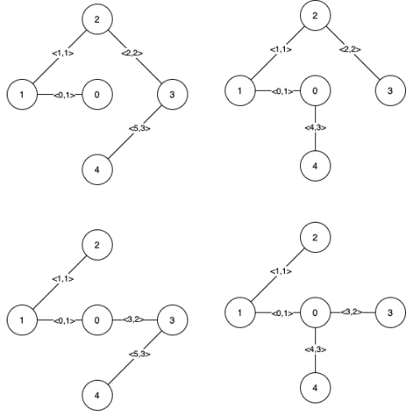

Notice that the two edges 0 and 1 appear in all MSTs, therefore they are critical edges, so we return them in the first list of the output.

The edges 2, 3, 4, and 5 are only part of some MSTs, therefore they are considered pseudo-critical edges. We add them to the second list of the output.

**Example 2:**

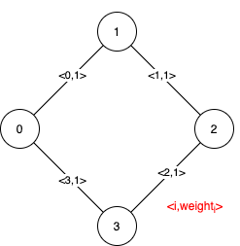

**Input:** n = 4, edges = [[0,1,1],[1,2,1],[2,3,1],[0,3,1]]

**Output:** [[],[0,1,2,3]]

**Explanation:** We can observe that since all 4 edges have equal weight, choosing any 3 edges from the given 4 will yield an MST. Therefore all 4 edges are pseudo-critical.

**Constraints:**

* 2 <= n <= 100
* 1 <= edges.length <= min(200, n * (n - 1) / 2)
* edges[i].length == 3
* 0 <= fromi < toi < n
* 1 <= weighti <= 1000
* All pairs (fromi, toi) are distinct.

class Solution {

public:

    vector<vector<int>> findCriticalAndPseudoCriticalEdges(int n, vector<vector<int>>& edges) {

        for (int i = 0; i < edges.size(); ++i) edges[i].push_back(i);

        sort(edges.begin(), edges.end(),  [](const vector<int> &lhs, const vector<int> &rhs) {return lhs[2] < rhs[2]; });

        int minMST = MST(n, edges, -1, -1);

        vector<vector<int>> res(2);

        for (int i = 0; i < edges.size(); ++i) {

            if (minMST < MST(n, edges, i, -1))

res[0].push_back(edges[i][3]);

            else if (minMST == MST(n, edges, -1, i))

res[1].push_back(edges[i][3]);

        }

        return res;

    }

private:

    int MST(int n, const vector<vector<int>>& edges, int not_use, int must_use) {

        vector<int> fa(n);

        for (int i = 0; i < n; ++i) fa[i] = i;

        int res = 0, cnt = 0;

        if (must_use != -1) {

            fa[edges[must_use][0]] = fa[edges[must_use][1]];

            res += edges[must_use][2];

            cnt = 1;

        }

        for (int i = 0; i < edges.size(); ++i) {

            if (i == not_use || i == must_use) continue;

            const vector<int> &t = edges[i];

            int fax = find(t[0], fa), fay = find(t[1], fa);

            if (fax == fay) continue;

            fa[fax] = fay;

            res += t[2];

            ++cnt;

        }

        return cnt == n-1 ? res : INT_MAX;

    }

    int find(int x, vector<int> &fa) {

        return x == fa[x] ? x : (fa[x] = find(fa[x], fa));

    }

};

### 1494. Parallel Courses II

Hard

Given the integer n representing the number of courses at some university labeled from 1 to n, and the array dependencies where dependencies[i] = [xi, yi]  represents a prerequisite relationship, that is, the course xi must be taken before the course yi.  Also, you are given the integer k.

In one semester you can take **at most** k courses as long as you have taken all the prerequisites for the courses you are taking.

*Return the minimum number of semesters to take all courses*. It is guaranteed that you can take all courses in some way.

**Example 1:**

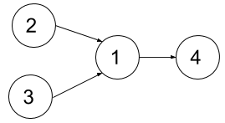

**Input:** n = 4, dependencies = [[2,1],[3,1],[1,4]], k = 2

**Output:** 3

**Explanation:** The figure above represents the given graph. In this case we can take courses 2 and 3 in the first semester, then take course 1 in the second semester and finally take course 4 in the third semester.

**Example 2:**

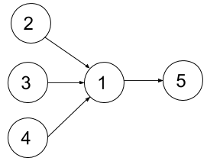

**Input:** n = 5, dependencies = [[2,1],[3,1],[4,1],[1,5]], k = 2

**Output:** 4

**Explanation:** The figure above represents the given graph. In this case one optimal way to take all courses is: take courses 2 and 3 in the first semester and take course 4 in the second semester, then take course 1 in the third semester and finally take course 5 in the fourth semester.

**Example 3:**

**Input:** n = 11, dependencies = [], k = 2

**Output:** 6

**Constraints:**

* 1 <= n <= 15
* 1 <= k <= n
* 0 <= dependencies.length <= n * (n-1) / 2
* dependencies[i].length == 2
* 1 <= xi, yi <= n
* xi != yi
* All prerequisite relationships are distinct, that is, dependencies[i] != dependencies[j].
* The given graph is a directed acyclic graph.

class Solution {

public:

    int minNumberOfSemesters(int n, vector<vector<int>>& dependencies, int k) {

        vector<int> pre(n);

// pre[i]: the bit representation of all dependencies of course i

        for(auto& e : dependencies){

            e[0] -= 1;

            e[1] -= 1;

            pre[e[1]] |= 1 << e[0];

        }

        // i is the bit representation of a combination of courses.

        // dp[i] is the minimum days to complete all the courses

        vector<int> dp(1 << n, n);

        dp[0] = 0;

        for(int i = 0; i < (1 << n); i += 1){

            int ex = 0;

            // find  out ex, the bit representation of the all courses that we can study now

            // since we have i and pre[j], we know course j can be studied if i contains all it's prerequisites ((i & pre[j]) == pre[j])

            for(int j = 0; j < n; j += 1) if((i & pre[j]) == pre[j]) ex |= 1 << j;

            ex &= ~i;

           // enumerate all the bit 1 combinations of ex

           // this is a typical method to enumerate all subsets of a bit representation:

           // for (int i = s; i; i = (i - 1) &ｓ)

            for(int s = ex; s; s = (s - 1) & ex)

if(__builtin_popcount(s) <= k){

                 dp[i | s] = min(dp[i | s], dp[i] + 1);

            }

        }

        return dp.back();

    }

};

### 1498. Number of Subsequences That Satisfy the Given Sum Condition

Medium

Given an array of integers nums and an integer target.

Return the number of **non-empty** subsequences of nums such that the sum of the minimum and maximum element on it is less or equal than target.

Since the answer may be too large, return it modulo 10^9 + 7.

**Example 1:**

**Input:** nums = [3,5,6,7], target = 9

**Output:** 4

**Explanation:** There are 4 subsequences that satisfy the condition.

[3] -> Min value + max value <= target (3 + 3 <= 9)

[3,5] -> (3 + 5 <= 9)

[3,5,6] -> (3 + 6 <= 9)

[3,6] -> (3 + 6 <= 9)

**Example 2:**

**Input:** nums = [3,3,6,8], target = 10

**Output:** 6

**Explanation:** There are 6 subsequences that satisfy the condition. (nums can have repeated numbers).

[3] , [3] , [3,3], [3,6] , [3,6] , [3,3,6]

**Example 3:**

**Input:** nums = [2,3,3,4,6,7], target = 12

**Output:** 61

**Explanation:** There are 63 non-empty subsequences, two of them don't satisfy the condition ([6,7], [7]).

Number of valid subsequences (63 - 2 = 61).

**Example 4:**

**Input:** nums = [5,2,4,1,7,6,8], target = 16

**Output:** 127

**Explanation:** All non-empty subset satisfy the condition (2^7 - 1) = 127

**Constraints:**

* 1 <= nums.length <= 10^5
* 1 <= nums[i] <= 10^6
* 1 <= target <= 10^6

class Solution {

public:

    int numSubseq(vector<int>& A, int target) {

        sort(A.begin(), A.end());

        int res = 0, n = A.size(), l = 0, r = n - 1, mod = 1e9 + 7;

        vector<int> pows(n, 1);

        for (int i = 1 ; i < n ; ++i)

            pows[i] = pows[i - 1] * 2 % mod;

        while (l <= r) {

            if (A[l] + A[r] > target) {

                r--;

            } else {

                res = (res + pows[r - l++]) % mod;

            }

        }

        return res;

    }

};

### 1499. Max Value of Equation

Hard

Given an array points containing the coordinates of points on a 2D plane, sorted by the x-values, where points[i] = [xi, yi] such that xi < xj for all 1 <= i < j <= points.length. You are also given an integer k.

Find the *maximum value of the equation*yi + yj + |xi - xj| where |xi - xj| <= k and 1 <= i < j <= points.length. It is guaranteed that there exists at least one pair of points that satisfy the constraint |xi - xj| <= k.

**Example 1:**

**Input:** points = [[1,3],[2,0],[5,10],[6,-10]], k = 1

**Output:** 4

**Explanation:** The first two points satisfy the condition |xi - xj| <= 1 and if we calculate the equation we get 3 + 0 + |1 - 2| = 4. Third and fourth points also satisfy the condition and give a value of 10 + -10 + |5 - 6| = 1.

No other pairs satisfy the condition, so we return the max of 4 and 1.

**Example 2:**

**Input:** points = [[0,0],[3,0],[9,2]], k = 3

**Output:** 3

**Explanation:** Only the first two points have an absolute difference of 3 or less in the x-values, and give the value of 0 + 0 + |0 - 3| = 3.

**Constraints:**

* 2 <= points.length <= 10^5
* points[i].length == 2
* -10^8 <= points[i][0], points[i][1] <= 10^8
* 0 <= k <= 2 * 10^8
* points[i][0] < points[j][0] for all 1 <= i < j <= points.length
* xi form a strictly increasing sequence.

class Solution {

public:

    int findMaxValueOfEquation(vector<vector<int>>& pts, int k) {

        priority_queue<pair<int, int>> pq; // max-heap

        pq.push({pts[0][1]-pts[0][0],pts[0][0]});

        int ans= INT_MIN;

        for(int i=1;i<pts.size();i++) {

            int sum = pts[i][0]+pts[i][1];

            while(!pq.empty() && pts[i][0]-pq.top().second>k) pq.pop();

            if(!pq.empty())ans = max(ans,sum+pq.top().first);

            pq.push({pts[i][1]-pts[i][0],pts[i][0]});

        }

        return ans;

    }

};

### 1504. Count Submatrices With All Ones

Medium

Given a rows * columns matrix mat of ones and zeros, return how many **submatrices** have all ones.

**Example 1:**

**Input:** mat = [[1,0,1],

  [1,1,0],

  [1,1,0]]

**Output:** 13

**Explanation:**

There are **6** rectangles of side 1x1.

There are **2** rectangles of side 1x2.

There are **3** rectangles of side 2x1.

There is **1** rectangle of side 2x2.

There is **1** rectangle of side 3x1.

Total number of rectangles = 6 + 2 + 3 + 1 + 1 = **13.**

**Example 2:**

**Input:** mat = [[0,1,1,0],

  [0,1,1,1],

  [1,1,1,0]]

**Output:** 24

**Explanation:**

There are **8** rectangles of side 1x1.

There are **5** rectangles of side 1x2.

There are **2** rectangles of side 1x3.

There are **4** rectangles of side 2x1.

There are **2** rectangles of side 2x2.

There are **2** rectangles of side 3x1.

There is **1** rectangle of side 3x2.

Total number of rectangles = 8 + 5 + 2 + 4 + 2 + 2 + 1 = 24**.**

**Example 3:**

**Input:** mat = [[1,1,1,1,1,1]]

**Output:** 21

**Example 4:**

**Input:** mat = [[1,0,1],[0,1,0],[1,0,1]]

**Output:** 5

**Constraints:**

* 1 <= rows <= 150
* 1 <= columns <= 150
* 0 <= mat[i][j] <= 1

class Solution {

public:

    int numSubmat(vector<vector<int>>& mat) {

        int n = mat.size(), m = mat[0].size();

        int res = 0;

        vector<int> h(m, 0);

        for (int i = 0; i < n; ++i) {

            for (int j = 0; j < m; ++j) {

                h[j] = mat[i][j] ? (h[j]+1) : 0;

            }

            res += solve(h);

        }

        return res;

    }

private:

   int solve(const vector<int> &h) {

       vector<int> sum(h.size(), 0);

       stack<int> stk;

       for (int i = 0; i < h.size(); ++i) {

           while (!stk.empty() && h[stk.top()] >= h[i]) stk.pop();

           if (stk.empty()) sum[i] = h[i] * (i + 1);

           else {

               sum[i] = sum[stk.top()] + h[i] * (i - stk.top());

           }

           stk.push(i);

       }

       return accumulate(sum.begin(), sum.end(), 0);

   }

};

### 1505. Minimum Possible Integer After at Most K Adjacent Swaps On Digits

Hard

Given a string num representing **the digits** of a very large integer and an integer k.

You are allowed to swap any two adjacent digits of the integer **at most** k times.

Return *the minimum integer* you can obtain also as a string.

**Example 1:**

https://assets.leetcode.com/uploads/2020/06/17/q4_1.jpg

**Input:** num = "4321", k = 4

**Output:** "1342"

**Explanation:** The steps to obtain the minimum integer from 4321 with 4 adjacent swaps are shown.

**Example 2:**

**Input:** num = "100", k = 1

**Output:** "010"

**Explanation:** It's ok for the output to have leading zeros, but the input is guaranteed not to have any leading zeros.

**Example 3:**

**Input:** num = "36789", k = 1000

**Output:** "36789"

**Explanation:** We can keep the number without any swaps.

**Example 4:**

**Input:** num = "22", k = 22

**Output:** "22"

**Example 5:**

**Input:** num = "9438957234785635408", k = 23

**Output:** "0345989723478563548"

**Constraints:**

* 1 <= num.length <= 30000
* num contains **digits** only and doesn't have **leading zeros**.
* 1 <= k <= 10^9

class Solution {

    vector<pair<int, int>> resort;

    priority_queue<int, vector<int>, greater<int>> nums[10];

    int used[30001], n;

    int getSum(int index)  {

        int sum = 0;

        while (index > 0) {

            sum += used[index];

            index -= index & (-index);

        }

        return sum;

    }

    void updateBIT(int index, int val) {

        while (index <= n) {

         used[index] += val;

         index += index & (-index);

        }

    }

public:

    string minInteger(string num, int k) {

        memset(used, 0, sizeof(used));

        int ctr = 0;

        n = num.size();

        for (int i = 0; i < n; i++)

            nums[num[i] - '0'].push(i + 1);

        string res;

        while (ctr < n && k > 0) {

            for (int i = 0; i <= 9; i++) {

                if (!nums[i].empty()) {

                    int cur = nums[i].top();

                    int holes = getSum(cur - 1);

                    int act = cur - holes;

                    if (act - 1 <= k) {

                        res += ('0' + i);

                        k -= (act - 1);

                        updateBIT(cur, 1);

                        nums[i].pop();

                        break;

                    }

                }

            }

            ctr++;

        }

        for(int i = 0; i <= 9; i++) {

            while (!nums[i].empty()) {

                resort.emplace_back(nums[i].top(), i);

                nums[i].pop();

            }

        }

        sort(resort.begin(), resort.end());

        for (auto &p : resort) {

            res += ('0' + p.second);

        }

        return res;

    }

};

### 1514. Path with Maximum Probability

Medium

You are given an undirected weighted graph of n nodes (0-indexed), represented by an edge list where edges[i] = [a, b] is an undirected edge connecting the nodes a and b with a probability of success of traversing that edge succProb[i].

Given two nodes start and end, find the path with the maximum probability of success to go from start to end and return its success probability.

If there is no path from start to end, **return 0**. Your answer will be accepted if it differs from the correct answer by at most **1e-5**.

**Example 1:**

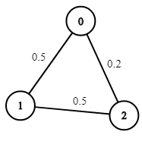

**Input:** n = 3, edges = [[0,1],[1,2],[0,2]], succProb = [0.5,0.5,0.2], start = 0, end = 2

**Output:** 0.25000

**Explanation:** There are two paths from start to end, one having a probability of success = 0.2 and the other has 0.5 * 0.5 = 0.25.

**Example 2:**

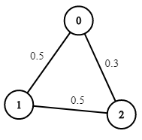

**Input:** n = 3, edges = [[0,1],[1,2],[0,2]], succProb = [0.5,0.5,0.3], start = 0, end = 2

**Output:** 0.30000

**Example 3:**

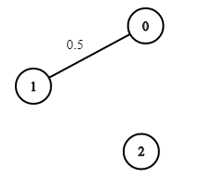

**Input:** n = 3, edges = [[0,1]], succProb = [0.5], start = 0, end = 2

**Output:** 0.00000

**Explanation:** There is no path between 0 and 2.

**Constraints:**

* 2 <= n <= 10^4
* 0 <= start, end < n
* start != end
* 0 <= a, b < n
* a != b
* 0 <= succProb.length == edges.length <= 2*10^4
* 0 <= succProb[i] <= 1
* There is at most one edge between every two nodes.

class Solution {

public:

    double maxProbability(int n, vector<vector<int>>& edges, vector<double>& pro, int start, int end) {

        vector<vector<pair<int, double>>> g(n);

        for(int i=0; i<edges.size(); i++) {

            g[edges[i][0]].push_back({edges[i][1], pro[i]});

            g[edges[i][1]].push_back({edges[i][0], pro[i]});

        }

        vector<int> seen(n, 0);

        priority_queue<pair<double, int>> q;

        q.push({(double)1.0, start});

        vector<double> mx(n, (double)0.0);

        mx[start] = 1.0;

        while(!q.empty()) {

            auto top = q.top();

            q.pop();

            double proba = top.first;

            int node = top.second;

            if(!seen[node]) {

                seen[node]++;

                for(auto &to: g[node]) {

                    if (mx[to.first] < to.second*proba) {

                        mx[to.first] = to.second*proba;

                        q.push({mx[to.first], to.first});

                    }

                }

            }

        }

        return mx[end];

    }

};

### 1515. Best Position for a Service Centre

Hard

A delivery company wants to build a new service centre in a new city. The company knows the positions of all the customers in this city on a 2D-Map and wants to build the new centre in a position such that **the sum of the euclidean distances to all customers is minimum**.

Given an array positions where positions[i] = [xi, yi] is the position of the ith customer on the map, return *the minimum sum of the euclidean distances* to all customers.

In other words, you need to choose the position of the service centre [xcentre, ycentre] such that the following formula is minimized:

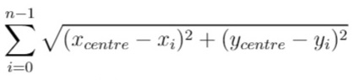

Answers within 10^-5 of the actual value will be accepted.

**Example 1:**

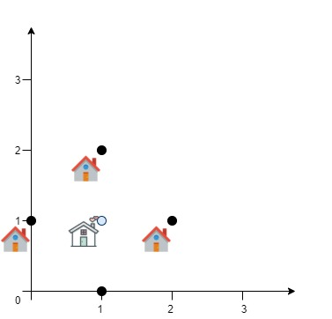

**Input:** positions = [[0,1],[1,0],[1,2],[2,1]]

**Output:** 4.00000

**Explanation:** As shown, you can see that choosing [xcentre, ycentre] = [1, 1] will make the distance to each customer = 1, the sum of all distances is 4 which is the minimum possible we can achieve.

**Example 2:**

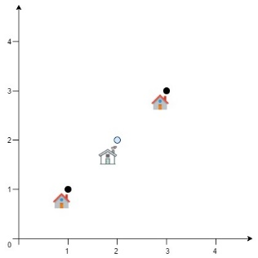

**Input:** positions = [[1,1],[3,3]]

**Output:** 2.82843

**Explanation:** The minimum possible sum of distances = sqrt(2) + sqrt(2) = 2.82843

**Example 3:**

**Input:** positions = [[1,1]]

**Output:** 0.00000

**Example 4:**

**Input:** positions = [[1,1],[0,0],[2,0]]

**Output:** 2.73205

**Explanation:** At the first glance, you may think that locating the centre at [1, 0] will achieve the minimum sum, but locating it at [1, 0] will make the sum of distances = 3.

Try to locate the centre at [1.0, 0.5773502711] you will see that the sum of distances is 2.73205.

Be careful with the precision!

**Example 5:**

**Input:** positions = [[0,1],[3,2],[4,5],[7,6],[8,9],[11,1],[2,12]]

**Output:** 32.94036

**Explanation:** You can use [4.3460852395, 4.9813795505] as the position of the centre.

**Constraints:**

* 1 <= positions.length <= 50
* positions[i].length == 2
* 0 <= positions[i][0], positions[i][1] <= 100

class Solution {

public:

    double getMinDistSum(vector<vector<int>>& pos) {

        double left = 100, bottom = 100, right = 0, top = 0;

        for (auto &p : pos) {

            left = min(left, (double)p[0]);

            bottom = min(bottom, (double)p[1]);

            right = max(right, (double)p[0]);

            top = max(top, (double)p[1]);

        }

        double res = DBL_MAX, res_x = 0, res_y = 0;

        for (double delta = 10; delta >= 0.00001; delta /= 10) {

            for (double x = left; x <= right; x += delta)

                for (double y = bottom; y <= top; y += delta) {

                    double d = 0;

                    for (auto &p : pos)

                        d += sqrt((p[0] - x) * (p[0] - x)

+ (p[1] - y) * (p[1] - y));

                    if (res > d) {

                        res = d;

                        res_x = x;

                        res_y = y;

                    }

                }

            left = res_x - delta;

            bottom = res_y - delta;

            right = res_x + delta * 2;

            top = res_y + delta * 2;

        }

        return res == DBL_MAX ? 0 : res;

    }

};

### 1520. Maximum Number of Non-Overlapping Substrings

Hard

Given a string s of lowercase letters, you need to find the maximum number of **non-empty** substrings of s that meet the following conditions:

1. The substrings do not overlap, that is for any two substrings s[i..j] and s[k..l], either j < k or i > l is true.
2. A substring that contains a certain character c must also contain all occurrences of c.

Find *the maximum number of substrings that meet the above conditions*. If there are multiple solutions with the same number of substrings, *return the one with minimum total length.*It can be shown that there exists a unique solution of minimum total length.

Notice that you can return the substrings in **any** order.

**Example 1:**

**Input:** s = "adefaddaccc"

**Output:** ["e","f","ccc"]

**Explanation:** The following are all the possible substrings that meet the conditions:

[

  "adefaddaccc"

  "adefadda",

  "ef",

  "e",

"f",

  "ccc",

]

If we choose the first string, we cannot choose anything else and we'd get only 1. If we choose "adefadda", we are left with "ccc" which is the only one that doesn't overlap, thus obtaining 2 substrings. Notice also, that it's not optimal to choose "ef" since it can be split into two. Therefore, the optimal way is to choose ["e","f","ccc"] which gives us 3 substrings. No other solution of the same number of substrings exist.

**Example 2:**

**Input:** s = "abbaccd"

**Output:** ["d","bb","cc"]

**Explanation:** Notice that while the set of substrings ["d","abba","cc"] also has length 3, it's considered incorrect since it has larger total length.

**Constraints:**

* 1 <= s.length <= 10^5
* s contains only lowercase English letters.

class Solution {

public:

    vector<string> maxNumOfSubstrings(string s) {

        vector<int> start(26, INT_MAX), end(26, INT_MIN), skip(26, 0);

        vector<string> result;

        for (int i = 0; i < s.size(); ++i) {

            start[s[i] - 'a'] = min(start[s[i] - 'a'], i);

end[s[i] - 'a'] = i;

}

        for (int i = 0; i < 26; ++i)

            for (int j = start[i]; j <= end[i]; ++j)

                if (start[s[j] - 'a'] < start[i]) skip[i] = 1;

                else end[i] = max(end[i], end[s[j] - 'a']);

        for (int i = s.size() - 1, cut = INT_MAX; i >= 0; --i)

            if (i == start[s[i] - 'a'] && end[s[i] - 'a'] < cut

&& !skip[s[i] - 'a'])

                result.push_back(s.substr((cut = i), end[s[i] - 'a']

- i + 1));

        return result;

    }

};

class Solution {

public:

    int checkSubstr(string &s, int i, vector<int> &l, vector<int> &r) {

        int right = r[s[i] - 'a'];

        for (auto j = i; j <= right; ++j) {

            if (l[s[j] - 'a'] < i)

                return -1;

            right = max(right, r[s[j] - 'a']);

        }

        return right;

    }

    vector<string> maxNumOfSubstrings(string s) {

        vector<int> l(26, INT_MAX), r(26, INT_MIN);

        vector<string> res;

        for (int i = 0; i < s.size(); ++i) {

            l[s[i] - 'a'] = min(l[s[i] - 'a'], i);

            r[s[i] - 'a'] = i;

        }

        int right = -1;

        for (int i = 0; i < s.size(); ++i) {

            if (i == l[s[i] - 'a']) {

                int new_right = checkSubstr(s, i, l, r);

                if (new_right != -1) {

                    if (i > right)

                        res.push_back("");

                    right = new_right;

                    res.back() = s.substr(i, right - i + 1);

                }

            }

        }

        return res;

    }

};

### 1521. Find a Value of a Mysterious Function Closest to Target

Hard

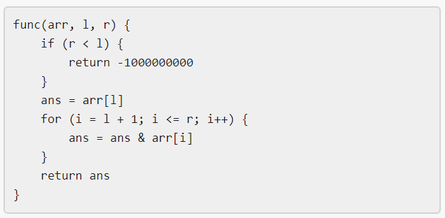

Winston was given the above mysterious function func. He has an integer array arr and an integer target and he wants to find the values l and r that make the value |func(arr, l, r) - target| minimum possible.

Return *the minimum possible value* of |func(arr, l, r) - target|.

Notice that func should be called with the values l and r where 0 <= l, r < arr.length.

**Example 1:**

**Input:** arr = [9,12,3,7,15], target = 5

**Output:** 2

**Explanation:** Calling func with all the pairs of [l,r] = [[0,0],[1,1],[2,2],[3,3],[4,4],[0,1],[1,2],[2,3],[3,4],[0,2],[1,3],[2,4],[0,3],[1,4],[0,4]], Winston got the following results [9,12,3,7,15,8,0,3,7,0,0,3,0,0,0]. The value closest to 5 is 7 and 3, thus the minimum difference is 2.

**Example 2:**

**Input:** arr = [1000000,1000000,1000000], target = 1

**Output:** 999999

**Explanation:** Winston called the func with all possible values of [l,r] and he always got 1000000, thus the min difference is 999999.

**Example 3:**

**Input:** arr = [1,2,4,8,16], target = 0

**Output:** 0

**Constraints:**

* 1 <= arr.length <= 10^5
* 1 <= arr[i] <= 10^6
* 0 <= target <= 10^7

class Solution {

public:

    int closestToTarget(vector<int>& arr, int target) {

        int len = (int)arr.size();

        vector<vector<int> > tab(30);

        for(int i = 0; i < len; i++)

            for(int j = 0; j < 30; j++) if((arr[i] >> j) & 1)

                tab[j].push_back(i);

        vector<int> dp(len);

        int ans = abs(arr[0] - target);

        for(int i = len - 1; i >= 0; i--)

            //In round i, dp[i], dp[i+1]...dp[N-1] is our new sequence of arr[i], arr[i]&arr[i+1],...,arr[i]&...&arr[N-1]

        {

            for(int j = 0; j < 30; j++) if(!((arr[i] >> j) & 1))

                while(!tab[j].empty() && tab[j].back() > i)

                //Find elements whose j'th bit need to be set to zero

                {

                    dp[tab[j].back()] -= 1 << j;

                    tab[j].pop_back();

 //After set this element's j'th bit to zero, we need not consider this bit again

                }

            dp[i] = arr[i];

            //Binary search

            int l = i, r = len;

            while(l < r)

            {

                int m = l + (r - l) / 2;

                if(dp[m] > target) l = m + 1;

                else r = m;

            }

            if(l == len) ans = min(ans, abs(target - dp[l - 1]));

            else if(l == i) ans = min(ans, abs(target - dp[l]));

            else ans = min(ans, min(abs(target - dp[l]), abs(target - dp[l - 1])));

        }

        return ans;

    }

};

class Solution {

public:

    int closestToTarget(vector<int>& arr, int target) {

        int len = (int)arr.size();

        vector<vector<int> > tab(30);

        for(int i = 0; i < len; i++)

            for(int j = 0; j < 30; j++) if((arr[i] >> j) & 1)

                tab[j].push_back(i);

        vector<int> dp(len + 1); dp[len] = arr[0];

        //dummy value to avoid "index out of range"

        int ans = abs(arr[0] - target);

        int l = len - 1;

        for(int i = len - 1; i >= 0; i--)

        {

            for(int j = 0; j < 30; j++) if(!((arr[i] >> j) & 1))

                while(!tab[j].empty() && tab[j].back() > i)

                {

                    dp[tab[j].back()] -= 1 << j;

                    tab[j].pop_back();

                }

            dp[i] = arr[i];

            while(l > i && dp[l] < target) l--;

            //After this line, we have dp[l] >= target, dp[l + 1] < target,

            //or l == i and all elements in this new sequence is smaller than target

            ans = min(ans, min(abs(target - dp[l]), abs(target - dp[l + 1])));

        }

        return ans;

    }

};

### 1526. Minimum Number of Increments on Subarrays to Form a Target Array

Hard

Given an array of positive integers target and an array initial of same size with all zeros.

Return the minimum number of operations to form a target array from initial if you are allowed to do the following operation:

* Choose **any** subarray from initial and increment each value by one.

The answer is guaranteed to fit within the range of a 32-bit signed integer.

**Example 1:**

**Input:** target = [1,2,3,2,1]

**Output:** 3

**Explanation:** We need at least 3 operations to form the target array from the initial array.

[0,0,0,0,0] increment 1 from index 0 to 4 (inclusive).

[1,1,1,1,1] increment 1 from index 1 to 3 (inclusive).

[1,2,2,2,1] increment 1 at index 2.

[1,2,3,2,1] target array is formed.

**Example 2:**

**Input:** target = [3,1,1,2]

**Output:** 4

**Explanation:** (initial)[0,0,0,0] -> [1,1,1,1] -> [1,1,1,2] -> [2,1,1,2] -> [3,1,1,2] (target).

**Example 3:**

**Input:** target = [3,1,5,4,2]

**Output:** 7

**Explanation:** (initial)[0,0,0,0,0] -> [1,1,1,1,1] -> [2,1,1,1,1] -> [3,1,1,1,1]

-> [3,1,2,2,2] -> [3,1,3,3,2] -> [3,1,4,4,2] -> [3,1,5,4,2] (target).

**Example 4:**

**Input:** target = [1,1,1,1]

**Output:** 1

**Constraints:**

* 1 <= target.length <= 10^5
* 1 <= target[i] <= 10^5

class Solution {

public:

    int minNumberOperations(vector<int>& v) {

        int res  = v[0];

        for (int i = 1; i < v.size(); ++i) {

            if (v[i] > v[i-1]) res += v[i] - v[i-1];

        }

        return res;

    }

};

### 1531. String Compression II

Hard

[Run-length encoding](http://en.wikipedia.org/wiki/Run-length_encoding) is a string compression method that works by replacing consecutive identical characters (repeated 2 or more times) with the concatenation of the character and the number marking the count of the characters (length of the run). For example, to compress the string "aabccc" we replace "aa" by "a2" and replace "ccc" by "c3". Thus the compressed string becomes "a2bc3".

Notice that in this problem, we are not adding '1' after single characters.

Given a string s and an integer k. You need to delete **at most** k characters from s such that the run-length encoded version of s has minimum length.

Find the minimum length of the run-length encoded version of s after deleting at most k characters.

**Example 1:**

**Input:** s = "aaabcccd", k = 2

**Output:** 4

**Explanation:** Compressing s without deleting anything will give us "a3bc3d" of length 6. Deleting any of the characters 'a' or 'c' would at most decrease the length of the compressed string to 5, for instance delete 2 'a' then we will have s = "abcccd" which compressed is abc3d. Therefore, the optimal way is to delete 'b' and 'd', then the compressed version of s will be "a3c3" of length 4.

**Example 2:**

**Input:** s = "aabbaa", k = 2

**Output:** 2

**Explanation:** If we delete both 'b' characters, the resulting compressed string would be "a4" of length 2.

**Example 3:**

**Input:** s = "aaaaaaaaaaa", k = 0

**Output:** 3

**Explanation:** Since k is zero, we cannot delete anything. The compressed string is "a11" of length 3.

**Constraints:**

* 1 <= s.length <= 100
* 0 <= k <= s.length
* s contains only lowercase English letters.

class Solution {

public:

    // dp[left][k] means the minimal coding size for substring

    // s[left:] and removing at most k chars

    int getLengthOfOptimalCompression(string s, int k) {

        memset(dp, -1, sizeof(dp));

        return dfs(s, 0, k);

    }

private:

    int dp[101][101];

    int dfs(string &s, int left, int K) {

        if (s.size() - left <= K) return 0;

        if (dp[left][K] >= 0) return dp[left][K];

        int k = K, cnt = 1;

        int res = k ? dfs(s, left + 1, k - 1) : 10000;

        for (int i = left + 1; i <= s.size(); ++i) {

            res = min(res, dfs(s, i, k) + 1 + xs(cnt));

            if (i == s.size()) break;

            if (s[i] == s[left]) ++cnt;

            else if (--k < 0) break;

        }

        return dp[left][K] = res;

    }

    int xs(int x) { return x == 1 ? 0 : x < 10 ? 1 : x < 100 ? 2 : 3; }

};

### 1537. Get the Maximum Score

Hard

You are given two **sorted** arrays of distinct integers nums1 and nums2.

A **validpath** is defined as follows:

* Choose array nums1 or nums2 to traverse (from index-0).
* Traverse the current array from left to right.
* If you are reading any value that is present in nums1 and nums2 you are allowed to change your path to the other array. (Only one repeated value is considered in the valid path).

*Score* is defined as the sum of uniques values in a valid path.

Return the maximum *score* you can obtain of all possible **valid paths**.

Since the answer may be too large, return it modulo 10^9 + 7.

**Example 1:**

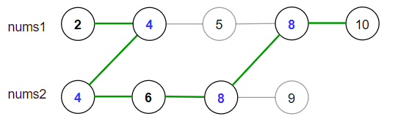

**Input:** nums1 = [2,4,5,8,10], nums2 = [4,6,8,9]

**Output:** 30

**Explanation:** Valid paths:

[2,4,5,8,10], [2,4,5,8,9], [2,4,6,8,9], [2,4,6,8,10], (starting from nums1)

[4,6,8,9], [4,5,8,10], [4,5,8,9], [4,6,8,10] (starting from nums2)

The maximum is obtained with the path in green **[2,4,6,8,10]**.

**Example 2:**

**Input:** nums1 = [1,3,5,7,9], nums2 = [3,5,100]

**Output:** 109

**Explanation:** Maximum sum is obtained with the path **[1,3,5,100]**.

**Example 3:**

**Input:** nums1 = [1,2,3,4,5], nums2 = [6,7,8,9,10]

**Output:** 40

**Explanation:** There are no common elements between nums1 and nums2.

Maximum sum is obtained with the path [6,7,8,9,10].

**Example 4:**

**Input:** nums1 = [1,4,5,8,9,11,19], nums2 = [2,3,4,11,12]

**Output:** 61

**Constraints:**

* 1 <= nums1.length <= 10^5
* 1 <= nums2.length <= 10^5
* 1 <= nums1[i], nums2[i] <= 10^7
* nums1 and nums2 are strictly increasing.

class Solution {

public:

    int maxSum(vector<int>& A, vector<int>& B) {

        int i = 0, j = 0, n = A.size(), m = B.size();

        long a = 0, b = 0, mod = 1e9 + 7;

        while (i < n || j < m) {

            if (i < n && (j == m || A[i] < B[j])) {

                a += A[i++];

            } else if (j < m && (i == n || A[i] > B[j])) {

                b += B[j++];

            } else {

                a = b = max(a, b) + A[i];

                i++, j++;

            }

        }

        return max(a, b) % mod;

    }

};

### 1541. Minimum Insertions to Balance a Parentheses String

Medium

Given a parentheses string s containing only the characters '(' and ')'. A parentheses string is **balanced** if:

* Any left parenthesis '(' must have a corresponding two consecutive right parenthesis '))'.
* Left parenthesis '(' must go before the corresponding two consecutive right parenthesis '))'.

In other words, we treat '(' as openning parenthesis and '))' as closing parenthesis.

For example, "())", "())(())))" and "(())())))" are balanced, ")()", "()))" and "(()))" are not balanced.

You can insert the characters '(' and ')' at any position of the string to balance it if needed.

Return *the minimum number of insertions* needed to make s balanced.

**Example 1:**

**Input:** s = "(()))"

**Output:** 1

**Explanation:** The second '(' has two matching '))', but the first '(' has only ')' matching. We need to to add one more ')' at the end of the string to be "(())))" which is balanced.

**Example 2:**

**Input:** s = "())"

**Output:** 0

**Explanation:** The string is already balanced.

**Example 3:**

**Input:** s = "))())("

**Output:** 3

**Explanation:** Add '(' to match the first '))', Add '))' to match the last '('.

**Example 4:**

**Input:** s = "(((((("

**Output:** 12

**Explanation:** Add 12 ')' to balance the string.

**Example 5:**

**Input:** s = ")))))))"

**Output:** 5

**Explanation:** Add 4 '(' at the beginning of the string and one ')' at the end. The string becomes "(((())))))))".

**Constraints:**

* 1 <= s.length <= 10^5
* s consists of '(' and ')' only.

class Solution {

public:

    int minInsertions(string s) {

        int res = 0, right = 0;

        for (char &c: s) {

            if (c == '(') {

                if (right % 2 > 0) {

                    right--;

                    res++;

                }

                right += 2;

            } else {

                right--;

                if (right < 0) {

                    right += 2;

                    res++;

                }

            }

        }

        return right + res;

    }

};

### 1542. Find Longest Awesome Substring

Hard

Given a string s. An *awesome* substring is a non-empty substring of s such that we can make any number of swaps in order to make it palindrome.

Return the length of the maximum length **awesome substring** of s.

**Example 1:**

**Input:** s = "3242415"

**Output:** 5

**Explanation:** "24241" is the longest awesome substring, we can form the palindrome "24142" with some swaps.

**Example 2:**

**Input:** s = "12345678"

**Output:** 1

**Example 3:**

**Input:** s = "213123"

**Output:** 6

**Explanation:** "213123" is the longest awesome substring, we can form the palindrome "231132" with some swaps.

**Example 4:**

**Input:** s = "00"

**Output:** 2

**Constraints:**

* 1 <= s.length <= 10^5
* s consists only of digits.

class Solution {

public:

    int longestAwesome(string s) {

        vector<int> dp(1024, s.size());

        int res = 0, mask = 0;

        dp[0] = -1;

        for (auto i = 0; i < s.size(); ++i) {

            mask ^= 1 << (s[i] - '0');

            res = max(res, i - dp[mask]);

            for (auto j = 0; j <= 9; ++j)

                res = max(res, i - dp[mask ^ (1 << j)]);

            dp[mask] = min(dp[mask], i);

        }

        return res;

    }

};

### 1546. Maximum Number of NonOverlapping Subarrays With Sum Equals Target

Medium

Given an array nums and an integer target.

Return the maximum number of **non-empty** **non-overlapping** subarrays such that the sum of values in each subarray is equal to target.

**Example 1:**

**Input:** nums = [1,1,1,1,1], target = 2

**Output:** 2

**Explanation:** There are 2 non-overlapping subarrays [**1,1**,1,**1,1**] with sum equals to target(2).

**Example 2:**

**Input:** nums = [-1,3,5,1,4,2,-9], target = 6

**Output:** 2

**Explanation:** There are 3 subarrays with sum equal to 6.

([5,1], [4,2], [3,5,1,4,2,-9]) but only the first 2 are non-overlapping.

**Example 3:**

**Input:** nums = [-2,6,6,3,5,4,1,2,8], target = 10

**Output:** 3

**Example 4:**

**Input:** nums = [0,0,0], target = 0

**Output:** 3

**Constraints:**

* 1 <= nums.length <= 10^5
* -10^4 <= nums[i] <= 10^4
* 0 <= target <= 10^6

class Solution {

public:

    int maxNonOverlapping(vector<int>& nums, int target) {

        int n = nums.size(), res = 0;

        int pre = -1, sum = 0;

        unordered_map<int, int> mp{{0, -1}};

        for (int i = 0; i < n; ++i) {

            sum += nums[i];

            if (mp.count(sum - target)) {

                int p = mp[sum - target];

                if (p >= pre) {

                    ++res;

                    pre = i;

                }

            }

            mp[sum] = i;

        }

        return res;

    }

};

### 1547. Minimum Cost to Cut a Stick

Hard

Given a wooden stick of length n units. The stick is labelled from 0 to n. For example, a stick of length **6** is labelled as follows:

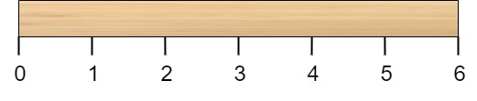

Given an integer array cuts where cuts[i] denotes a position you should perform a cut at.

You should perform the cuts in order, you can change the order of the cuts as you wish.

The cost of one cut is the length of the stick to be cut, the total cost is the sum of costs of all cuts. When you cut a stick, it will be split into two smaller sticks (i.e. the sum of their lengths is the length of the stick before the cut). Please refer to the first example for a better explanation.

Return *the minimum total cost* of the cuts.

**Example 1:**

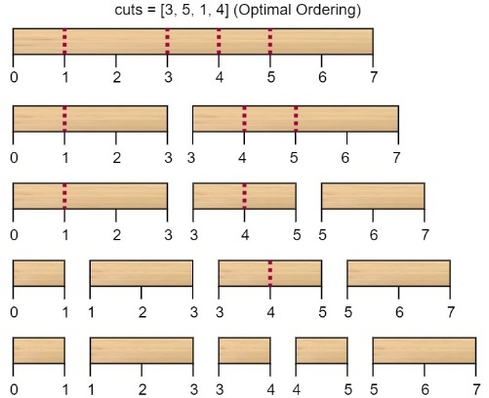

**Input:** n = 7, cuts = [1,3,4,5]

**Output:** 16

**Explanation:** Using cuts order = [1, 3, 4, 5] as in the input leads to the following scenario:

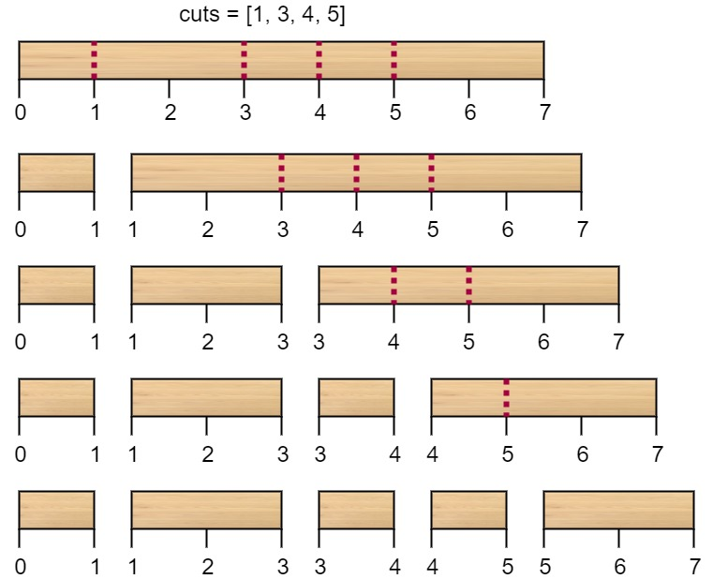

The first cut is done to a rod of length 7 so the cost is 7. The second cut is done to a rod of length 6 (i.e. the second part of the first cut), the third is done to a rod of length 4 and the last cut is to a rod of length 3. The total cost is 7 + 6 + 4 + 3 = 20.

Rearranging the cuts to be [3, 5, 1, 4] for example will lead to a scenario with total cost = 16 (as shown in the example photo 7 + 4 + 3 + 2 = 16).

**Example 2:**

**Input:** n = 9, cuts = [5,6,1,4,2]

**Output:** 22

**Explanation:** If you try the given cuts ordering the cost will be 25.

There are much ordering with total cost <= 25, for example, the order [4, 6, 5, 2, 1] has total cost = 22 which is the minimum possible.

**Constraints:**

* 2 <= n <= 10^6
* 1 <= cuts.length <= min(n - 1, 100)
* 1 <= cuts[i] <= n - 1
* All the integers in cuts array are **distinct**.

class Solution {

public:

    int minCost(int n, vector<int>& A) {

        A.push_back(0);  A.push_back(n);

        sort(A.begin(), A.end());

        int k = A.size();

        vector<vector<int>> dp(k, vector<int>(k, 0));

        for (int d = 2; d < k; ++d) {

            for (int i = 0; i < k - d; ++i) {

                dp[i][i + d] = 1e9;

                for (int m = i + 1; m < i + d; ++m) {

                    dp[i][i + d] = min(dp[i][i + d],

dp[i][m] + dp[m][i + d] + A[i + d] - A[i]);

                }

            }

        }

        return dp[0][k - 1];

    }

};

### 1553. Minimum Number of Days to Eat N Oranges

Hard

There are n oranges in the kitchen and you decided to eat some of these oranges every day as follows:

* Eat one orange.
* If the number of remaining oranges (n) is divisible by 2 then you can eat  n/2 oranges.
* If the number of remaining oranges (n) is divisible by 3 then you can eat  2*(n/3) oranges.

You can only choose one of the actions per day.

Return the minimum number of days to eat n oranges.

**Example 1:**

**Input:** n = 10

**Output:** 4

**Explanation:** You have 10 oranges.

Day 1: Eat 1 orange, 10 - 1 = 9.

Day 2: Eat 6 oranges, 9 - 2*(9/3) = 9 - 6 = 3. (Since 9 is divisible by 3)

Day 3: Eat 2 oranges, 3 - 2*(3/3) = 3 - 2 = 1.

Day 4: Eat the last orange 1 - 1 = 0.

You need at least 4 days to eat the 10 oranges.

**Example 2:**

**Input:** n = 6

**Output:** 3

**Explanation:** You have 6 oranges.

Day 1: Eat 3 oranges, 6 - 6/2 = 6 - 3 = 3. (Since 6 is divisible by 2).

Day 2: Eat 2 oranges, 3 - 2*(3/3) = 3 - 2 = 1. (Since 3 is divisible by 3)

Day 3: Eat the last orange 1 - 1 = 0.

You need at least 3 days to eat the 6 oranges.

**Example 3:**

**Input:** n = 1

**Output:** 1

**Example 4:**

**Input:** n = 56

**Output:** 6

**Constraints:**

* 1 <= n <= 2*10^9

class Solution {

public:

    unordered_map<int, int> dp;

    int minDays(int n) {

        if (n <= 1)  return n;

        if (dp.count(n) == 0)

            dp[n] = 1 + min(n % 2 + minDays(n / 2),

n % 3 + minDays(n / 3));

        return dp[n];

    }

};

**1558. Minimum Numbers of Function Calls to Make Target Array**

Medium

1638Add to ListShare

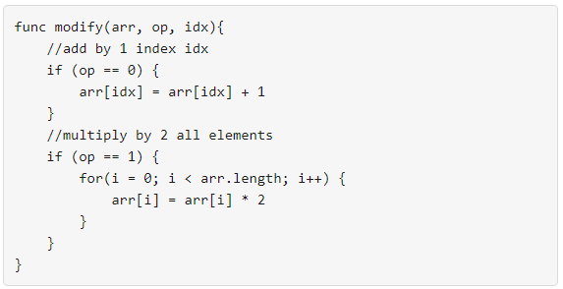

Your task is to form an integer array nums from an initial array of zeros arr that is the same size as nums.

Return the minimum number of function calls to make nums from arr.

The answer is guaranteed to fit in a 32-bit signed integer.

**Example 1:**

**Input:** nums = [1,5]

**Output:** 5

**Explanation:** Increment by 1 (second element): [0, 0] to get [0, 1] (1 operation).

Double all the elements: [0, 1] -> [0, 2] -> [0, 4] (2 operations).

Increment by 1 (both elements) [0, 4] -> [1, 4] -> **[1, 5]** (2 operations).

Total of operations: 1 + 2 + 2 = 5.

**Example 2:**

**Input:** nums = [2,2]

**Output:** 3

**Explanation:** Increment by 1 (both elements) [0, 0] -> [0, 1] -> [1, 1] (2 operations).

Double all the elements: [1, 1] -> **[2, 2]** (1 operation).

Total of operations: 2 + 1 = 3.

**Example 3:**

**Input:** nums = [4,2,5]

**Output:** 6

**Explanation:** (initial)[0,0,0] -> [1,0,0] -> [1,0,1] -> [2,0,2] -> [2,1,2] -> [4,2,4] -> **[4,2,5]**(nums).

**Example 4:**

**Input:** nums = [3,2,2,4]

**Output:** 7

**Example 5:**

**Input:** nums = [2,4,8,16]

**Output:** 8

**Constraints:**

* 1 <= nums.length <= 10^5
* 0 <= nums[i] <= 10^9

class Solution {

public:

    int minOperations(vector<int>& nums) {

        int n = nums.size(), res = 0, B = 0;

        for (auto i : nums) {

            int a = 0, b = 0;

            while (i) {

                if (i % 2 == 0) i /= 2, ++b;

                else --i, ++a;

            }

            res += a;

            B = max(B, b);

        }

        return res + B;

    }

};

### 1559. Detect Cycles in 2D Grid

Hard

Given a 2D array of characters grid of size m x n, you need to find if there exists any cycle consisting of the **same value** in grid.

A cycle is a path of **length 4 or more** in the grid that starts and ends at the same cell. From a given cell, you can move to one of the cells adjacent to it - in one of the four directions (up, down, left, or right), if it has the **same value** of the current cell.

Also, you cannot move to the cell that you visited in your last move. For example, the cycle (1, 1) -> (1, 2) -> (1, 1) is invalid because from (1, 2) we visited (1, 1) which was the last visited cell.

Return true if any cycle of the same value exists in grid, otherwise, return false.

**Example 1:**

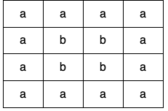

**Input:** grid = [["a","a","a","a"],["a","b","b","a"],["a","b","b","a"],["a","a","a","a"]]

**Output:** true

**Explanation:** There are two valid cycles shown in different colors in the image below:

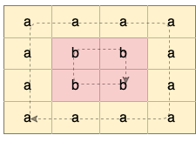

**Example 2:**

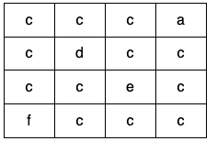

**Input:** grid = [["c","c","c","a"],["c","d","c","c"],["c","c","e","c"],["f","c","c","c"]]

**Output:** true

**Explanation:** There is only one valid cycle highlighted in the image below:

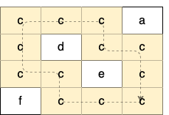

**Example 3:**

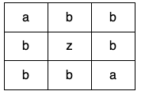

**Input:** grid = [["a","b","b"],["b","z","b"],["b","b","a"]]

**Output:** false

**Constraints:**

* m == grid.length
* n == grid[i].length
* 1 <= m <= 500
* 1 <= n <= 500
* grid consists only of lowercase English letters.

class Solution {

public:

    vector<vector<int>> v;

    bool containsCycle(vector<vector<char>>& grid) {

        int n = grid.size(), m = grid[0].size();

        v.resize(n, vector<int> (m, -1));

        for (int i = 0; i < n; ++i) {

            for (int j = 0; j < m; ++j) {

                if (v[i][j] != -1) continue;

                if (dfs(i, j, n, m, i*m + n, grid)) return true;

            }

        }

        return  false;

    }

    const vector<int> dx{-1,1,0,0};

    const vector<int> dy{0,0,-1,1};

    bool dfs(int i, int j, int n, int m, int cnt, vector<vector<char>>& grid) {

        v[i][j] = ++cnt;

        for (int k = 0; k < 4; ++k) {

            int x = i + dx[k], y = j + dy[k];

            if (x < 0 || y < 0 || x >= n || y >= m) continue;

            if (grid[x][y] != grid[i][j]) continue;

            if (v[x][y] != -1) {

                if (cnt - v[x][y] >= 3) return true;

            }

            else {

                if (dfs(x, y, n, m, cnt, grid)) return true;

            }

        }

        return false;

    }

};

class Solution {

public:

    vector<int> d = {1, 0, -1, 0, 1};

    bool containsCycle(vector<vector<char>>& g) {

        for (int i = 0; i < g.size(); ++i)

            for (int j = 0; j < g[i].size(); ++j) {

                if (g[i][j] >= 'a') {

                    char val = g[i][j];

                    vector<pair<int, int>> q = {{i, j}};

                    while (!q.empty()) {

                        vector<pair<int, int>> q1;

                        for (auto [x, y] : q) {

                            if (g[x][y] < 'a')

                                return true;

                            g[x][y] -= 26;

                            for (auto k = 0; k < 4; ++k) {

                                int dx = x + d[k], dy = y + d[k + 1];

                                if (dx >= 0 && dy >= 0 && dx < g.size()  && dy < g[dx].size()

&& g[dx][dy] == val)

                                    q1.push_back({dx, dy});

                            }

                        }

                        swap(q, q1);

                    }

                }

            }

        return false;

    }

};

### 1562. Find Latest Group of Size M

Medium

Given an array arr that represents a permutation of numbers from 1 to n. You have a binary string of size n that initially has all its bits set to zero.

At each step i (assuming both the binary string and arr are 1-indexed) from 1 to n, the bit at position arr[i] is set to 1. You are given an integer m and you need to find the latest step at which there exists a group of ones of length m. A group of ones is a contiguous substring of 1s such that it cannot be extended in either direction.

Return *the latest step at which there exists a group of ones of length****exactly*** m. *If no such group exists, return* -1.

**Example 1:**

**Input:** arr = [3,5,1,2,4], m = 1

**Output:** 4

**Explanation:**

Step 1: "00100", groups: ["1"]

Step 2: "00101", groups: ["1", "1"]

Step 3: "10101", groups: ["1", "1", "1"]

Step 4: "11101", groups: ["111", "1"]

Step 5: "11111", groups: ["11111"]

The latest step at which there exists a group of size 1 is step 4.

**Example 2:**

**Input:** arr = [3,1,5,4,2], m = 2

**Output:** -1

**Explanation:**

Step 1: "00100", groups: ["1"]

Step 2: "10100", groups: ["1", "1"]

Step 3: "10101", groups: ["1", "1", "1"]

Step 4: "10111", groups: ["1", "111"]

Step 5: "11111", groups: ["11111"]

No group of size 2 exists during any step.

**Example 3:**

**Input:** arr = [1], m = 1

**Output:** 1

**Example 4:**

**Input:** arr = [2,1], m = 2

**Output:** 2

**Constraints:**

* n == arr.length
* 1 <= n <= 10^5
* 1 <= arr[i] <= n
* All integers in arr are **distinct**.
* 1 <= m <= arr.length

class Solution {

public:

    int findLatestStep(vector<int>& A, int m) {

        int res = -1, n = A.size();

        if (n == m) return n;

        vector<int> length(n + 2);

        for (int i = 0; i < n; ++i) {

            int a = A[i], left = length[a - 1], right = length[a + 1];

            length[a - left] = length[a + right] = left + right + 1;

            if (left == m || right == m)

                res = i;

        }

        return res;

    }

};

class Solution {

public:

    int findLatestStep(vector<int>& A, int m) {

        int res = -1, n = A.size();

        vector<int> length(n + 2), count(n + 1);

        for (int i = 0; i < n; ++i) {

            int a = A[i], left = length[a - 1], right = length[a + 1];

            length[a] = length[a - left] = length[a + right]

= left + right + 1;

            count[left]--;

            count[right]--;

            count[length[a]]++;

            if (count[m])

                res = i + 1;

        }

        return res;

    }

};

### 1563. Stone Game V

Hard

There are several stones **arranged in a row**, and each stone has an associated value which is an integer given in the array stoneValue.

In each round of the game, Alice divides the row into **two non-empty rows** (i.e. left row and right row), then Bob calculates the value of each row which is the sum of the values of all the stones in this row. Bob throws away the row which has the maximum value, and Alice's score increases by the value of the remaining row. If the value of the two rows are equal, Bob lets Alice decide which row will be thrown away. The next round starts with the remaining row.

The game ends when there is only **one stone remaining**. Alice's is initially **zero**.

Return *the maximum score that Alice can obtain*.

**Example 1:**

**Input:** stoneValue = [6,2,3,4,5,5]

**Output:** 18

**Explanation:** In the first round, Alice divides the row to [6,2,3], [4,5,5]. The left row has the value 11 and the right row has value 14. Bob throws away the right row and Alice's score is now 11.

In the second round Alice divides the row to [6], [2,3]. This time Bob throws away the left row and Alice's score becomes 16 (11 + 5).

The last round Alice has only one choice to divide the row which is [2], [3]. Bob throws away the right row and Alice's score is now 18 (16 + 2). The game ends because only one stone is remaining in the row.

**Example 2:**

**Input:** stoneValue = [7,7,7,7,7,7,7]

**Output:** 28

**Example 3:**

**Input:** stoneValue = [4]

**Output:** 0

**Constraints:**

* 1 <= stoneValue.length <= 500
* 1 <= stoneValue[i] <= 10^6

class Solution {

public:

    int dp[505][505] = {0};

    vector<int> pre{0};

    int stoneGameV(vector<int>& v) {

        int n = v.size(), res = 0;

        for (auto i : v) pre.push_back(pre.back() + i);

        return solve(1, v.size(), v);

    }

    int solve(int i, int j, vector<int>& v) {

        if (i > j) return 0;

        else if (i == j) return 0;

        else if (dp[i][j] != 0) return dp[i][j];

        int ret = 0;

        for (int k = i; k < j; ++k) {

            int a = pre[k] - pre[i-1];

            int b = pre[j] - pre[k];

            if (a <= b) ret = max(ret, solve(i, k, v) + a);

            if (a >= b) ret = max(ret, solve(k+1, j, v) + b);

        }

        return dp[i][j] = ret;

    }

};

//n*n*logn

class Solution {

    public:

    int getsum(vector<int>& sum, int l, int r) {

        if (l > r) return 0;

        if (l == 0) return sum[r];

        return sum[r] - sum[l - 1];

    }

    int stoneGameV(vector<int>& stoneValue) {

        int n = stoneValue.size();

        vector<int> sum(n, 0);

        for (int i = 0; i < n; ++i) {

            if (i > 0) sum[i] += sum[i - 1];

            sum[i] += stoneValue[i];

        }

        vector<vector<int>> f=vector<vector<int>>(n,vector<int>(n,0));

        vector<vector<int>> lf=vector<vector<int>>(n,vector<int>(n,0));

        vector<vector<int>> rf=vector<vector<int>>(n,vector<int>(n,0));

        for (int i = 0; i < n; ++i) {

            lf[i][i] = rf[i][i] = stoneValue[i];

        }

        for (int i = n - 1; i >= 0; --i) {

        for (int j = i + 1; j < n; ++j) {

            int segsum = getsum(sum, i, j);

            int l = i - 1, r = j;

            while (l < r - 1) {

                int mid = (l + r) / 2;

                int left = getsum(sum, i, mid);

                if (left * 2 <= segsum) l = mid;

                else r = mid;

                if (l >= i) f[i][j] = max(f[i][j], lf[i][l]);

                int rst = l;

                if (getsum(sum, i, l) * 2 < segsum) rst += 2;

                else rst += 1;

                if (rst <= j)

                    f[i][j] = max(f[i][j], rf[rst][j]);

                lf[i][j] = max(lf[i][max(i, j - 1)], f[i][j] + segsum);

                rf[i][j] = max(rf[max(0, i + 1)][j], f[i][j] + segsum);

            }

        }

        return f[0][n - 1];

    }

};

### 1568. Minimum Number of Days to Disconnect Island

Hard

Given a 2D grid consisting of 1s (land) and 0s (water).  An *island* is a maximal 4-directionally (horizontal or vertical) connected group of 1s.

The grid is said to be **connected** if we have **exactly one island**, otherwise is said **disconnected**.

In one day, we are allowed to change **any**single land cell (1) into a water cell (0).

Return *the minimum number of days* to disconnect the grid.

**Example 1:**

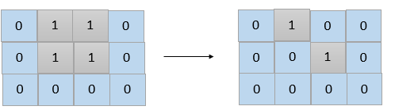

**Input:** grid = [[0,1,1,0],[0,1,1,0],[0,0,0,0]]

**Output:** 2

**Explanation:** We need at least 2 days to get a disconnected grid.

Change land grid[1][1] and grid[0][2] to water and get 2 disconnected island.

**Example 2:**

**Input:** grid = [[1,1]]

**Output:** 2

**Explanation:** Grid of full water is also disconnected ([[1,1]] -> [[0,0]]), 0 islands.

**Example 3:**

**Input:** grid = [[1,0,1,0]]

**Output:** 0

**Example 4:**

**Input:** grid = [[1,1,0,1,1],

  [1,1,1,1,1],

  [1,1,0,1,1],

  [1,1,0,1,1]]

**Output:** 1

**Example 5:**

**Input:** grid = [[1,1,0,1,1],

  [1,1,1,1,1],

  [1,1,0,1,1],

  [1,1,1,1,1]]

**Output:** 2

**Constraints:**

* 1 <= grid.length, grid[i].length <= 30
* grid[i][j] is 0 or 1.

class Solution {

public:

    vector<int> dx = {-1,1,0,0}, dy = {0,0,-1,1};

    int n, m, p = -1;

    vector<pair<int, int>> v;

    int minDays(vector<vector<int>>& grid) {

        n = grid.size(), m = grid[0].size();

        int t = 0, cnt, cnt0;

        for (int i = 0; i < n; ++i) {

            for (int j = 0; j < m; ++j) if (grid[i][j] == 1) {

                ++t;

                cnt = dfs(i, j, grid, -1);

            }

        }

        if (t != 1) return 0;

        if (cnt == 1) return 1;

        for (int i = 0; i < n; ++i) {

            for (int j = 0; j < m; ++j) if (grid[i][j] != 0) {

                grid[i][j] = 0;

                int pp = p == -1?1:-1;

                if (i == v[0].first && j == v[0].second)

                    cnt0 = dfs(v[1].first, v[1].second, grid, pp);

                else cnt0 = dfs(v[0].first, v[0].second, grid, pp);

                if (cnt0 != cnt-1) return 1;

                grid[i][j] = p = pp;

            }

        }

        return 2;

    }

    int dfs(int i, int j, vector<vector<int>>& grid, int p) {

        grid[i][j] = p;

        if (v.size() < 2) v.emplace_back(i, j);

        int res = 1;

        for (int k = 0; k < 4; ++k) {

            int x = i + dx[k], y = j + dy[k];

            if (x < 0 || y < 0 || x >= n || y >= m || grid[x][y] != (p==1?-1:1)) continue;

            res += dfs(x, y, grid, p);

        }

        return res;

    }

};

### 1569. Number of Ways to Reorder Array to Get Same BST

Hard

Given an array nums that represents a permutation of integers from 1 to n. We are going to construct a binary search tree (BST) by inserting the elements of nums in order into an initially empty BST. Find the number of different ways to reorder nums so that the constructed BST is identical to that formed from the original array nums.

For example, given nums = [2,1,3], we will have 2 as the root, 1 as a left child, and 3 as a right child. The array [2,3,1] also yields the same BST but [3,2,1] yields a different BST.

Return *the number of ways to reorder* nums *such that the BST formed is identical to the original BST formed from* nums.

Since the answer may be very large, **return it modulo**10^9 + 7.

**Example 1:**

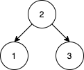

**Input:** nums = [2,1,3]

**Output:** 1

**Explanation:** We can reorder nums to be [2,3,1] which will yield the same BST. There are no other ways to reorder nums which will yield the same BST.

**Example 2:**

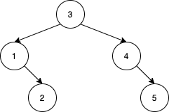

**Input:** nums = [3,4,5,1,2]

**Output:** 5

**Explanation:** The following 5 arrays will yield the same BST:

[3,1,2,4,5]

[3,1,4,2,5]

[3,1,4,5,2]

[3,4,1,2,5]

[3,4,1,5,2]

**Example 3:**

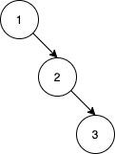

**Input:** nums = [1,2,3]

**Output:** 0

**Explanation:** There are no other orderings of nums that will yield the same BST.

**Example 4:**

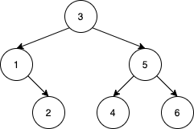

**Input:** nums = [3,1,2,5,4,6]

**Output:** 19

**Example 5:**

**Input:** nums = [9,4,2,1,3,6,5,7,8,14,11,10,12,13,16,15,17,18]

**Output:** 216212978

**Explanation:** The number of ways to reorder nums to get the same BST is 3216212999. Taking this number modulo 10^9 + 7 gives 216212978.

**Constraints:**

* 1 <= nums.length <= 1000
* 1 <= nums[i] <= nums.length
* All integers in nums are **distinct**.

class Solution {

public:

    using ll = long long;

    const ll mod = 1e9 + 7;

    ll dp[1002][1002] = {0};

    int helper(int i, int j) {

        if (i == 0 && j == 0) return 0;

        if (i == 0 || j == 0) return 1;

        if (dp[i][j]) return dp[i][j];

        return dp[i][j] = (helper(i-1, j) + helper(i, j-1)) % mod;

    }

    int numOfWays(vector<int>& nums) {

        return static_cast<int> (dfs(nums) - 1);

    }

    ll dfs(vector<int>& nums) {

        int i = 0, j = nums.size()-1;

        if (i >= j) return 1;

        vector<int> v0, v1;

        for (int k = i+1; k <= j; ++k) {

            if (nums[k] > nums[i]) v0.push_back(nums[k]);

            else v1.push_back(nums[k]);

        }

        ll a = dfs(v0), b = dfs(v1);

        return (a*b % mod) * helper(v0.size(), v1.size()) % mod;

    }

};

### 1574. Shortest Subarray to be Removed to Make Array Sorted

Medium

Given an integer array arr, remove a subarray (can be empty) from arr such that the remaining elements in arr are **non-decreasing**.

A subarray is a contiguous subsequence of the array.

Return *the length of the shortest subarray to remove*.

**Example 1:**

**Input:** arr = [1,2,3,10,4,2,3,5]

**Output:** 3

**Explanation:** The shortest subarray we can remove is [10,4,2] of length 3. The remaining elements after that will be [1,2,3,3,5] which are sorted.

Another correct solution is to remove the subarray [3,10,4].

**Example 2:**

**Input:** arr = [5,4,3,2,1]

**Output:** 4

**Explanation:** Since the array is strictly decreasing, we can only keep a single element. Therefore we need to remove a subarray of length 4, either [5,4,3,2] or [4,3,2,1].

**Example 3:**

**Input:** arr = [1,2,3]

**Output:** 0

**Explanation:** The array is already non-decreasing. We do not need to remove any elements.

**Example 4:**

**Input:** arr = [1]

**Output:** 0

**Constraints:**

* 1 <= arr.length <= 10^5
* 0 <= arr[i] <= 10^9

class Solution {

public:

    int findLengthOfShortestSubarray(vector<int>& n) {

        int sz = n.size(), r = sz - 1;

        for (; r > 0 && n[r - 1] <= n[r]; --r) ;

        auto res = r;

        for (int l = 0; l < r && (l == 0 || n[l - 1] <= n[l]); ++l) {

            while (r < sz && n[r] < n[l])

                ++r;

            res = min(res, r - l - 1);

        }

        return res;

    }

};

### 1575. Count All Possible Routes

Hard

You are given an array of **distinct** positive integers locations where locations[i] represents the position of city i. You are also given integers start, finish and fuel representing the starting city, ending city, and the initial amount of fuel you have, respectively.

At each step, if you are at city i, you can pick any city j such that j != i and 0 <= j < locations.length and move to city j. Moving from city i to city j reduces the amount of fuel you have by |locations[i] - locations[j]|. Please notice that |x| denotes the absolute value of x.

Notice that fuel **cannot** become negative at any point in time, and that you are **allowed** to visit any city more than once (including start and finish).

Return *the count of all possible routes from*start *to* finish.

Since the answer may be too large, return it modulo 10^9 + 7.

**Example 1:**

**Input:** locations = [2,3,6,8,4], start = 1, finish = 3, fuel = 5

**Output:** 4

**Explanation:** The following are all possible routes, each uses 5 units of fuel:

1 -> 3

1 -> 2 -> 3

1 -> 4 -> 3

1 -> 4 -> 2 -> 3

**Example 2:**

**Input:** locations = [4,3,1], start = 1, finish = 0, fuel = 6

**Output:** 5

**Explanation:** The following are all possible routes:

1 -> 0, used fuel = 1

1 -> 2 -> 0, used fuel = 5

1 -> 2 -> 1 -> 0, used fuel = 5

1 -> 0 -> 1 -> 0, used fuel = 3

1 -> 0 -> 1 -> 0 -> 1 -> 0, used fuel = 5

**Example 3:**

**Input:** locations = [5,2,1], start = 0, finish = 2, fuel = 3

**Output:** 0

**Explanation:** It's impossible to get from 0 to 2 using only 3 units of fuel since the shortest route needs 4 units of fuel.

**Example 4:**

**Input:** locations = [2,1,5], start = 0, finish = 0, fuel = 3

**Output:** 2

**Explanation:** There are two possible routes, 0 and 0 -> 1 -> 0.

**Example 5:**

**Input:** locations = [1,2,3], start = 0, finish = 2, fuel = 40

**Output:** 615088286

**Explanation:** The total number of possible routes is 2615088300. Taking this number modulo 10^9 + 7 gives us 615088286.

**Constraints:**

* 2 <= locations.length <= 100
* 1 <= locations[i] <= 10^9
* All integers in locations are **distinct**.
* 0 <= start, finish < locations.length
* 1 <= fuel <= 200

class Solution {

    const int N=1000000007;

public:

    int countRoutes(vector<int>& locations, int start, int finish, int fuel) {

        start=locations[start];

        finish=locations[finish];

        sort(locations.begin(),locations.end());

        start=find(locations.begin(),locations.end(),start)

-locations.begin();

        finish=find(locations.begin(),locations.end(),finish)

-locations.begin();

        int size=locations.size();

        int j,f,d;

        vector<vector<int>> Ldp(size,vector<int>(fuel+1,0));

        vector<vector<int>> Rdp(size,vector<int>(fuel+1,0));

        for(f=1;f<=fuel;f++){

            Ldp[size-1][f]=0;

            Rdp[0][f]=0;

            for(j=0;j<size-1;j++){

                d=locations[j+1]-locations[j];

                if(f>d)

                    Ldp[j][f]=(Rdp[j+1][f-d]+2*Ldp[j+1][f-d]%N)%N;

                else

                    Ldp[j][f]=1*(f==d)*(start==(j+1));

            }

            for(j=1;j<size;j++){

                d=locations[j]-locations[j-1];

                if(f>d)

                    Rdp[j][f]=(Ldp[j-1][f-d]+2*Rdp[j-1][f-d]%N)%N;

                else

                    Rdp[j][f]=1*(f==d)*(start==(j-1));

            }

        }

        int ans=1*(start==finish);

        for(j=1;j<=fuel;j++)

ans=((ans+Ldp[finish][j])%N+Rdp[finish][j])%N;

        return ans;

    }

};

### 1579. Remove Max Number of Edges to Keep Graph Fully Traversable

Hard

Alice and Bob have an undirected graph of n nodes and 3 types of edges:

* Type 1: Can be traversed by Alice only.
* Type 2: Can be traversed by Bob only.
* Type 3: Can by traversed by both Alice and Bob.

Given an array edges where edges[i] = [typei, ui, vi] represents a bidirectional edge of type typei between nodes ui and vi, find the maximum number of edges you can remove so that after removing the edges, the graph can still be fully traversed by both Alice and Bob. The graph is fully traversed by Alice and Bob if starting from any node, they can reach all other nodes.

Return *the maximum number of edges you can remove, or return* -1 *if it's impossible for the graph to be fully traversed by Alice and Bob.*

**Example 1:**

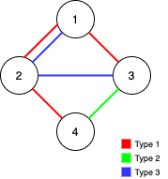

**Input:** n = 4, edges = [[3,1,2],[3,2,3],[1,1,3],[1,2,4],[1,1,2],[2,3,4]]

**Output:** 2

**Explanation:** If we remove the 2 edges [1,1,2] and [1,1,3]. The graph will still be fully traversable by Alice and Bob. Removing any additional edge will not make it so. So the maximum number of edges we can remove is 2.

**Example 2:**

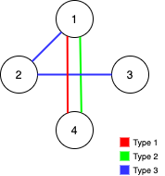

**Input:** n = 4, edges = [[3,1,2],[3,2,3],[1,1,4],[2,1,4]]

**Output:** 0

**Explanation:** Notice that removing any edge will not make the graph fully traversable by Alice and Bob.

**Example 3:**

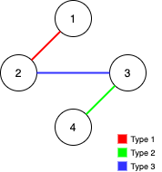

**Input:** n = 4, edges = [[3,2,3],[1,1,2],[2,3,4]]

**Output:** -1

**Explanation:** In the current graph, Alice cannot reach node 4 from the other nodes. Likewise, Bob cannot reach 1. Therefore it's impossible to make the graph fully traversable.

**Constraints:**

* 1 <= n <= 10^5
* 1 <= edges.length <= min(10^5, 3 * n * (n-1) / 2)
* edges[i].length == 3
* 1 <= edges[i][0] <= 3
* 1 <= edges[i][1] < edges[i][2] <= n
* All tuples (typei, ui, vi) are distinct.

class Solution {

public:

    int find(vector<int> &ds, int i) {

        return ds[i] < 0 ? i : ds[i] = find(ds, ds[i]);

    }

    int maxNumEdgesToRemove(int n, vector<vector<int>>& edges) {

        vector<int> ds_both(n + 1, -1);

        int used = 0;

        for (int type = 3; type > 0; --type) {

            auto ds_one = ds_both;

            auto &ds = type == 3 ? ds_both : ds_one;

            for (auto &e : edges)

                if (e[0] == type) {

                    int i = find(ds, e[1]), j = find(ds, e[2]);

                    if (i != j) {

                        ++used;

                        if (ds[j] < ds[i])

                            swap(i, j);

                        ds[i] += ds[j];

                        ds[j] = i;

                    }

                }

            if (type != 3 && ds[find(ds, 1)] != -n)

                return -1;

        }

        return edges.size() - used;

    }

};