1,Commit 提交规范
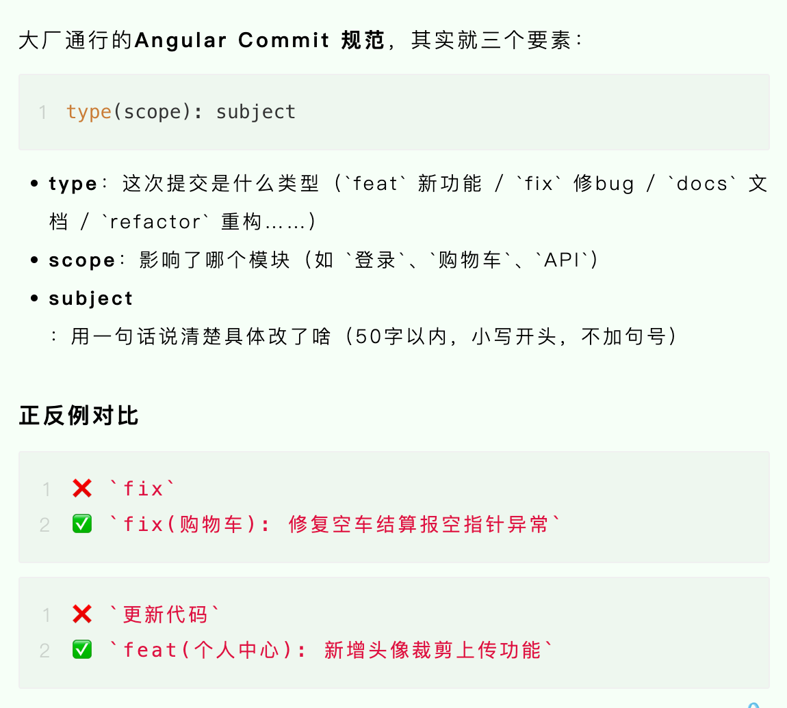
📖 完整规范教程，请参考下面的这个文章（推荐）：
https://mp.weixin.qq.com/s?__biz=MzkyNDY5MDgyNA==&mid=2247491287&idx=1&sn=f3a161028bdecac7bfdfe84f43d9344d&scene=21#wechat_redirect

2,git命令入门
https://mp.weixin.qq.com/s?__biz=MzkyNDY5MDgyNA==&mid=2247491287&idx=1&sn=f3a161028bdecac7bfdfe84f43d9344d&scene=21#wechat_redirect

