**Mid term**

**What is static variable? (什么是静态变量和实例变量)**

**What’s the difference between static variables and**

**instance variables?**

**Static variables:**

» The variables that can be shared by all objects of a class.

» Static variables also called class variables.

**Instance variable:**

» The variables that belong to an object.

» Both static variables and instance variables are sometimes called ***fields*** or ***data members.***

**Differences:**

» Each object has one copy of its instance variables. They are not shared with other objects with the same class type.

**What is the meaning of Inheritance? Please give an example of it.**

Inheritance allows you to define a very general class and then later define mor specialized classes that add some new details to the existing class definition.

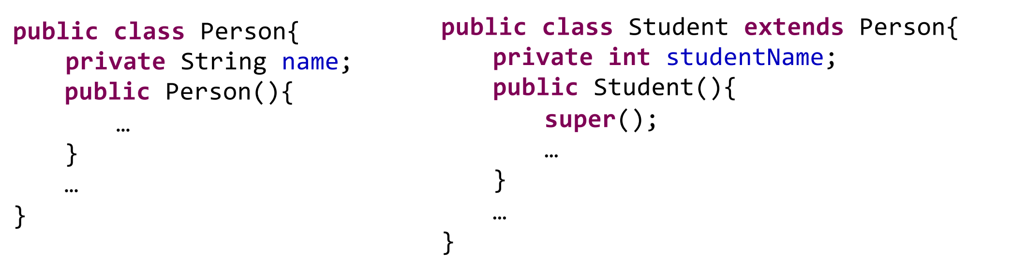

**§ What is the meaning of Polymorphism? Please give an example of it.**

Polymorphism means that a variable of a supertype can refer to a subtype object.

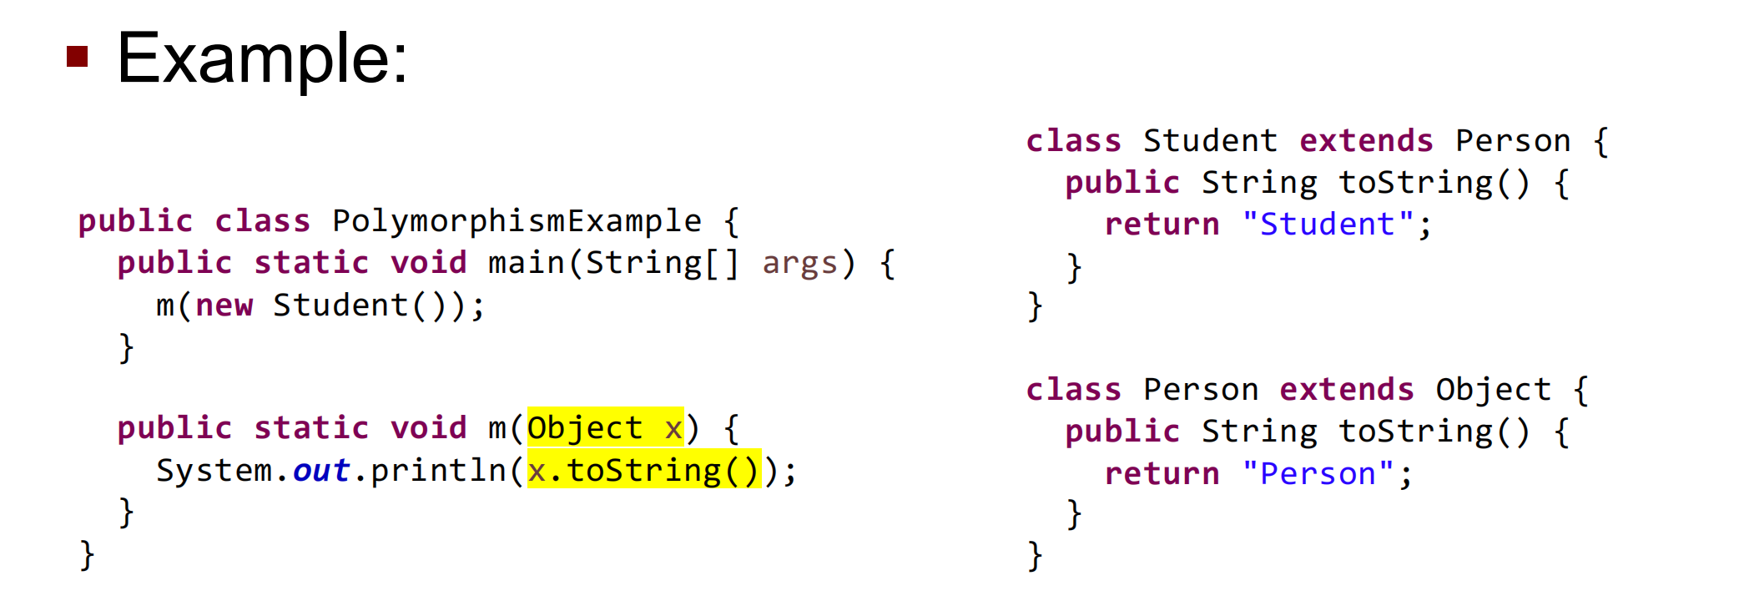

**What is the output of the following code?  
public class ClassExercise {  
 public static void main(String[] args){  
 System.out.println(Integer.parseInt("13"));  
 System.out.println(Integer.parseInt("23",10));  
 System.out.println(Integer.parseInt("33",16));  
 }  
}**

13

23

51

**Please answer “true” or “false” to the following questions? If you answer “false”, please also explain why.**

**Q: A class cannot contain both static and non-static methods.**

False.

§ A Class can contain both static and non-static methods. The static method can be invoked by using the Class name dot method name.

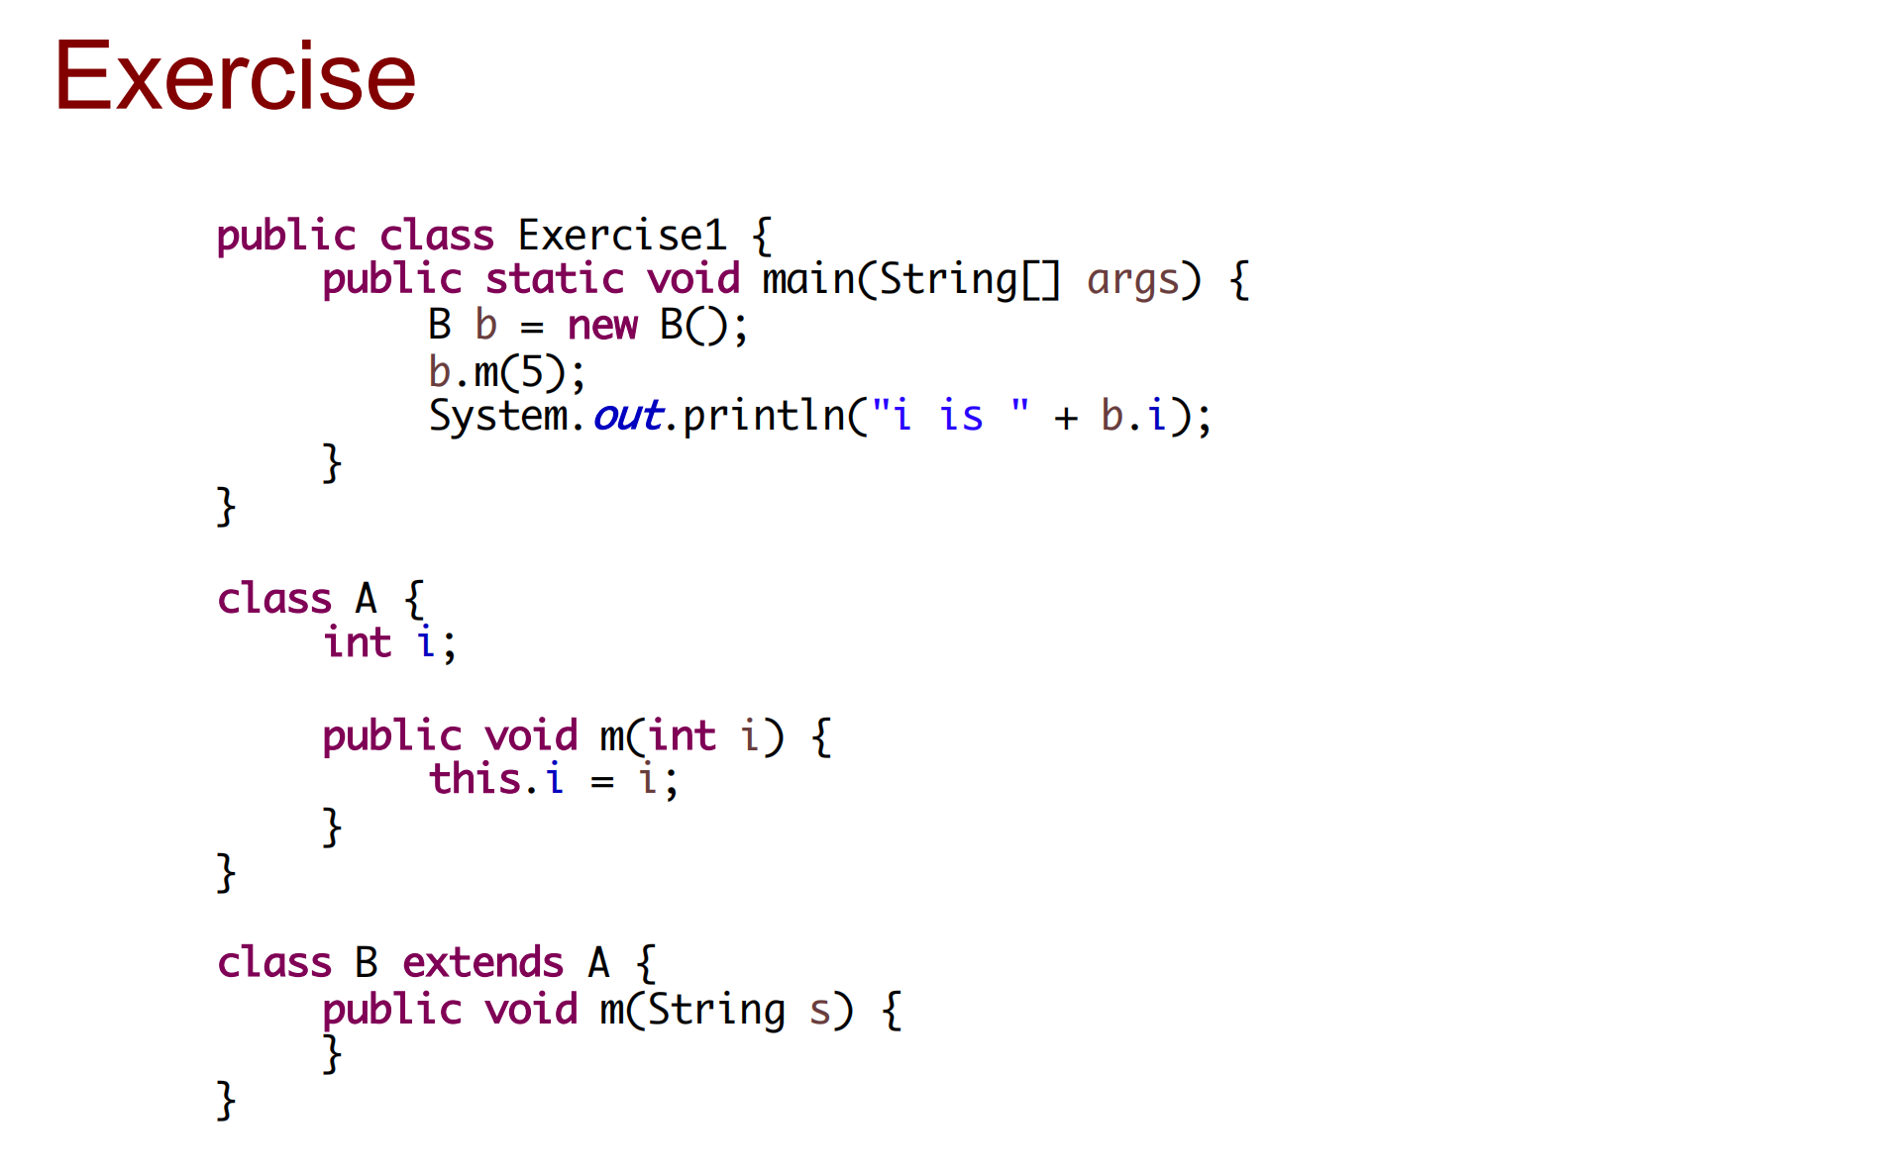

**A. The program has a compilation error, because m is overridden with a different signature in B.**

**B. The program has a compilation error, because b.m(5) cannot be invoked since the method m(int) is hidden in B.**

**C. The program has a runtime error on b.i, because i is not accessible from b.**

**D. The method m is not overridden in B. B inherits the method m from A and defines an overloaded method m in B.**

**Write a method that is passed a String array and returns the longest string (the one with the most characters). If there are multiple String objects that are tied for the longest, return the last such String. Write a main() method to test your method**

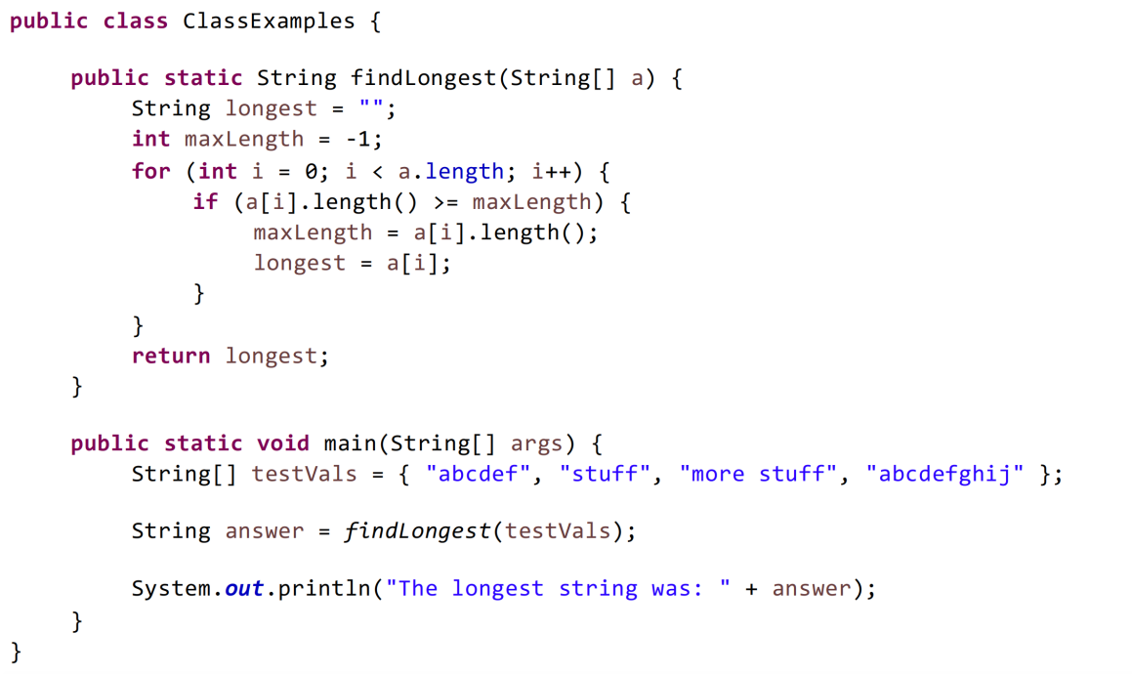

**Write a class that represents a book. Every book should have a name, number of pages, and year published. Include an appropriate constructor and an toString() method. Write a main() method in a separate class to test your book class.**

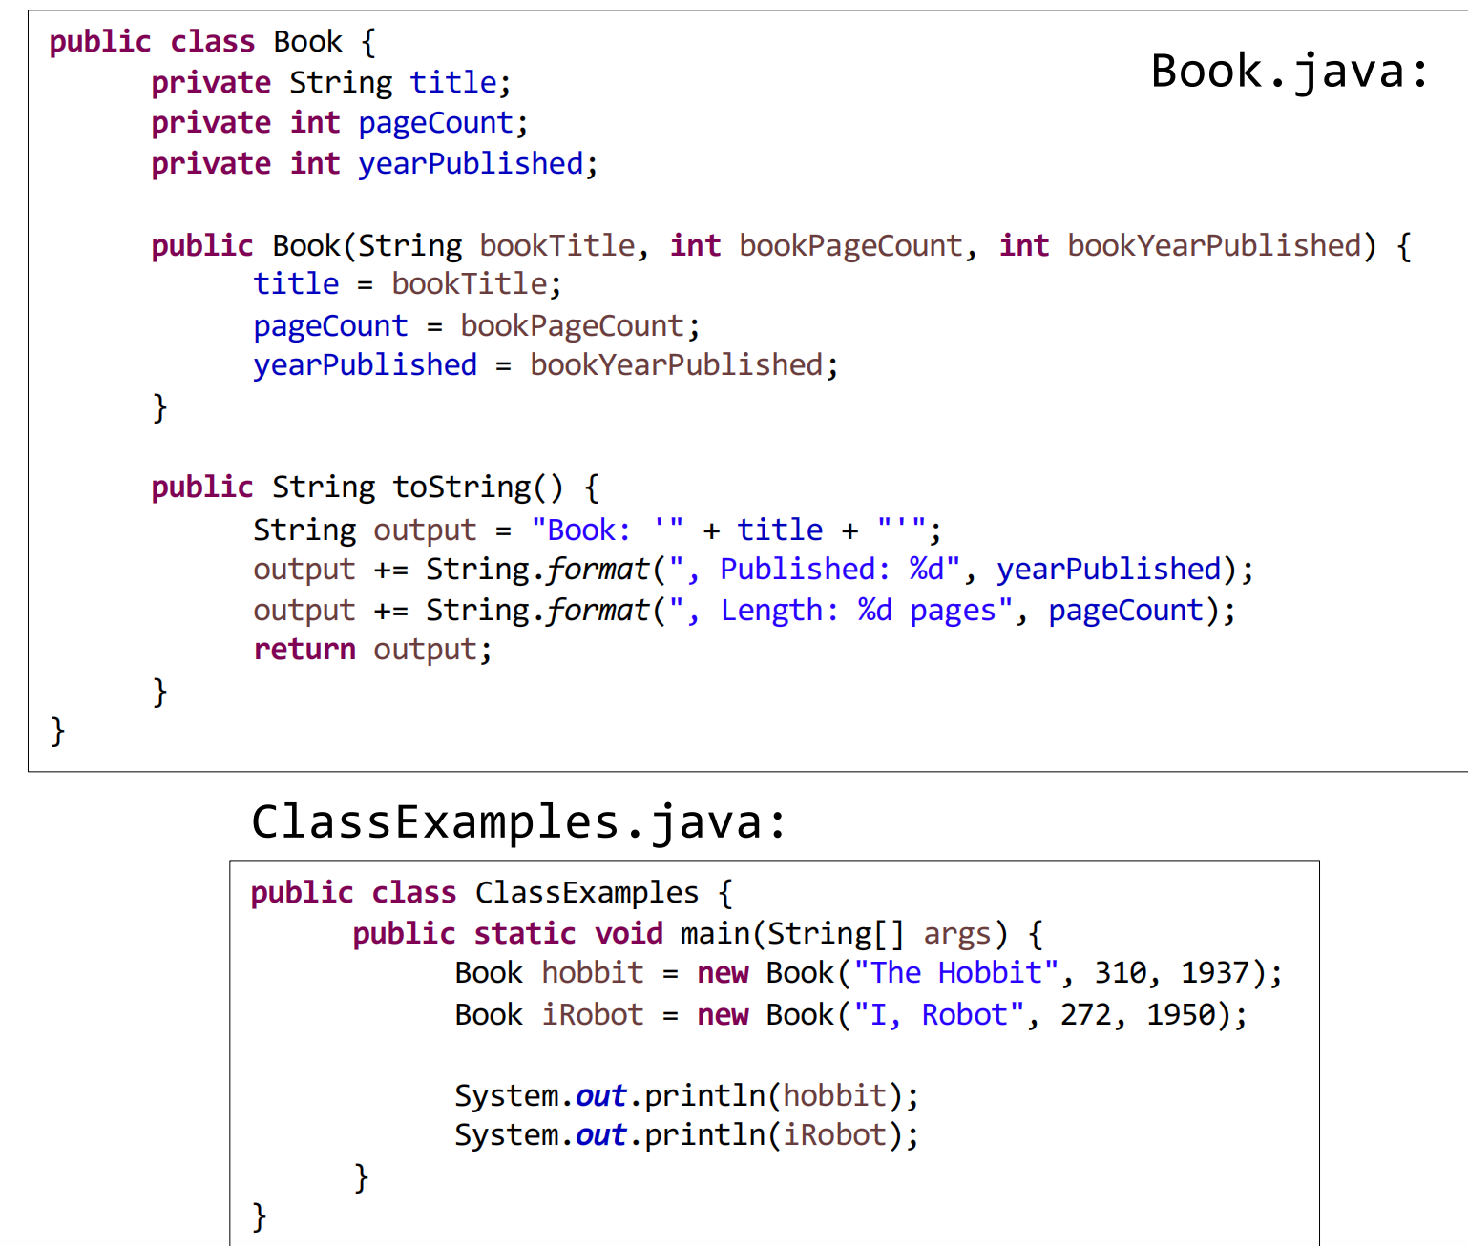

**（写一个星球并测试）Write a class that represents a planet. Every planet has a radius and a distance from the sun. Include an appropriate constructor, a method that lets you set the distance separately, a method that returns the approximate volume of the planet (volume of a sphere is 4πr3/3), and a toString()method. Write a main()method in a separate class to test the planet class.**

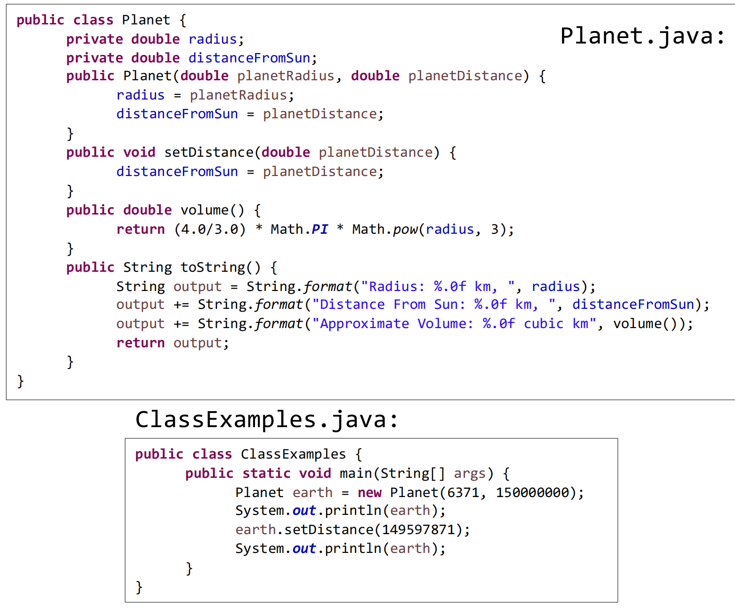

**(创建机器人，具有以下的方法)**

**Create a class Android whose objects have unique data.   
The class has the following attributes:  
»tag: a static integer, begin at 1, change each time an instance   
is created.  
»name: a string that is unique for each instance of this class   
§Android class has the following methods:  
»Android: default constructor that sets name to “Bob”+tag  
»getName: return the name portion of the invoking object  
»isPrime(n): a private static method, return true if n is prime  
»changeTag: a private static method, replace tag with next   
prime number**

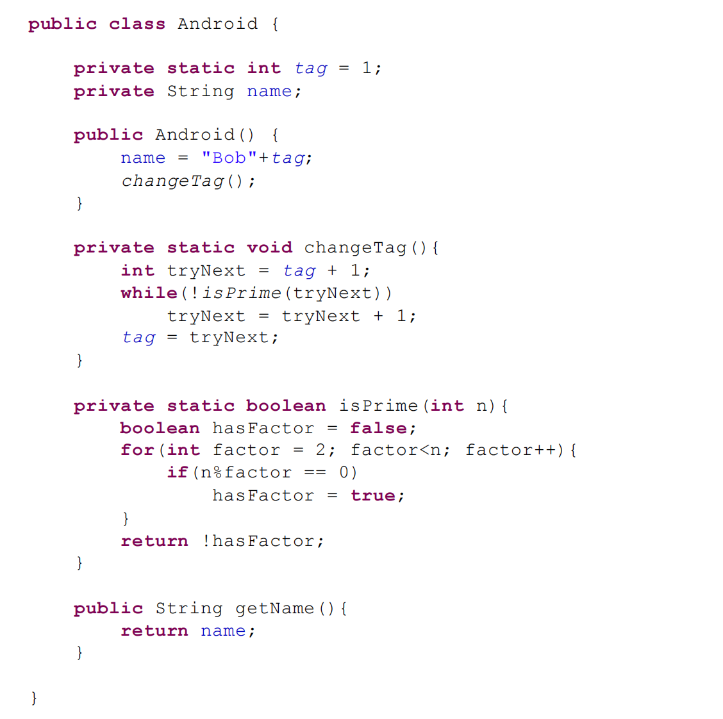

**Continued. Create a program that tests the class Android described above.**

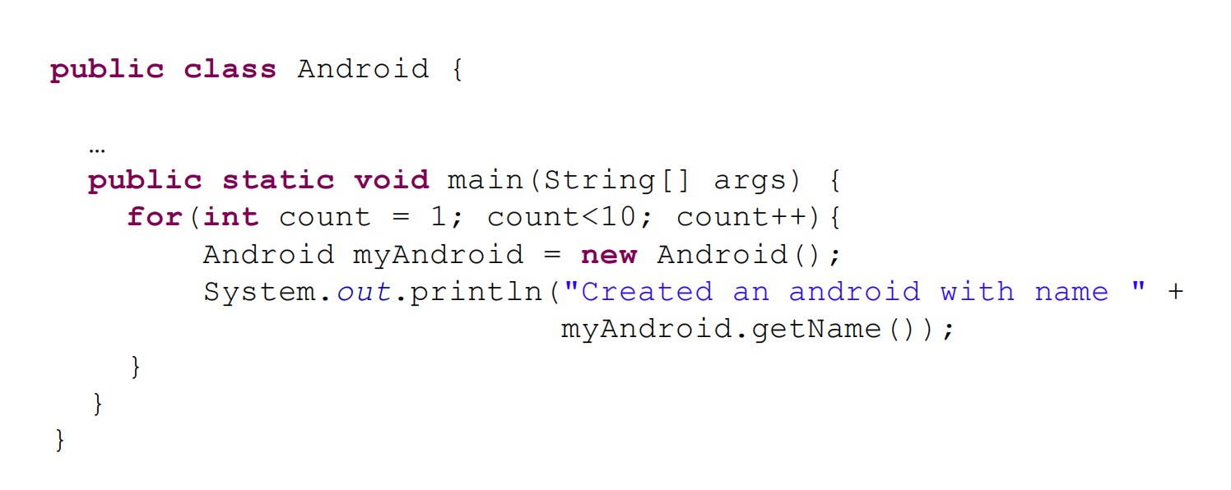

**The following method compiles and executes but does not work as you might hope. What is wrong with it? How do you correct it?   
Exercise**public static int[] copyArray(int[] anArray){  
 int[] temp = new int[anArray.length];  
 temp = anArray;（原因是没有列表把每个值都赋值）  
 return temp;  
}

Because this method can not return the array distinct from given argument.Rather,it returns a reference to the array it is given.to make it true.we should replace “temp=anArray”with

for(int i=0;i<anArray.length;i++)

temp[i]=anArray[i];

}

**Please use ArrayList to contain four greetings and print out all greetings at the end.(创建列表添加信息)**

public class ClassExample {

public static void main(String[] args){  
ArrayList<String> greetings = new ArrayList<String>();

greetings.add("Hello! How are you?");  
greetings.add("Hi man, what's up!");  
greetings.add("Yo! How's going?");  
greetings.add("Hey! How are you doing?");

System.out.println("All greetings");  
System.out.println("");  
for(String s: greetings){  
 System.out.println(s);  
}

}

}