Lab1

Problem description:

Lab1 is to do a method to analyze whether the bank card number is correct or not. The steps are as follows: the first step is to multiply the even-digit number by 2, and if the multiplied by 2 is a two-digit number, add the tens digit and the ones digit, and add Add all the resulting numbers. The second step is to add all the odd digit numbers. The third step is the sum of the data obtained in the first and second steps. The fourth step is to divide the number obtained in the third part by 10. If it is divisible, the bank card number is valid, and if it is not divisible, the bank card number is invalid

Analysis:

In order to achieve the above steps, we need to make several methods to achieve. The first step is to get the sum of each odd number of bits. The method first converts the long type into a character type, and obtains each odd digit, and uses charAt to locate the specific character position and uses the type to convert it into a number, and accumulates each odd digit. The second step is similar to the first step, but there is one more step to add the tens and ones digit of the two-digit number. So we make a method called getDigit() to determine whether it is greater than 10 after multiplying by 2. Then you need to verify that the card number starts with（• 4 for Visa cards ,• 5 for Master cards ,• 37 for American Express cards ,• 6 for Discover cards ) Therefore, it is necessary to verify whether the first few digits are the required numbers, and it is necessary to use a method to compare the input number with the card number, but because it needs to be compared with the first few digits of the card number, it is necessary to create a new method to obtain the first few digits of the bank card number. The specific number of digits should be the same as the number of digits to be compared, and at the same time, in order to obtain this number, it is necessary to make a method to obtain the length of the input number. So a getsize() method is made to achieve it. Because it needs to be converted to a string type to get the length, type conversion is used. The last method is used to confirm whether the card number is reasonable, and the above methods are summarized and assembled in the method of judging the card number is reasonable. The last is verification, call the method in the main function and introduce the scanner to input the card number, and finally judge whether the card number is reasonable.

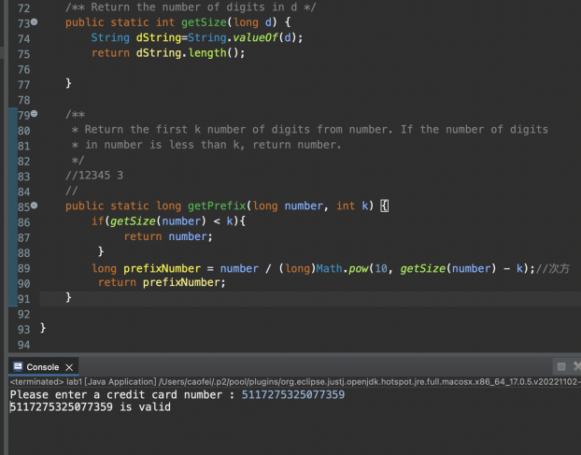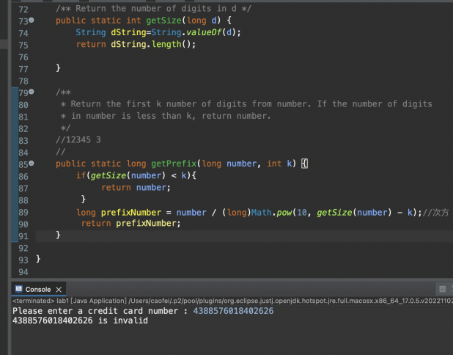

Lab2

Problem description and Analysis:

Lab2 needs to input a row of numbers and judge whether there are four consecutive identical numbers in the sequence. Therefore, in main, the length of the input sequence should be judged first, and then the specific values in the input sequence should be traversed, and a method should be constructed to judge whether have four consecutive identical numbers

