Assignment 1 empno:172217

1.**Display all departments from department table**.

Ans:SELECT DNAME FROM DEPT;

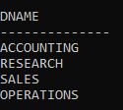

2.Display all employees from employee table.

Ans:SELECT * FROM EMP;

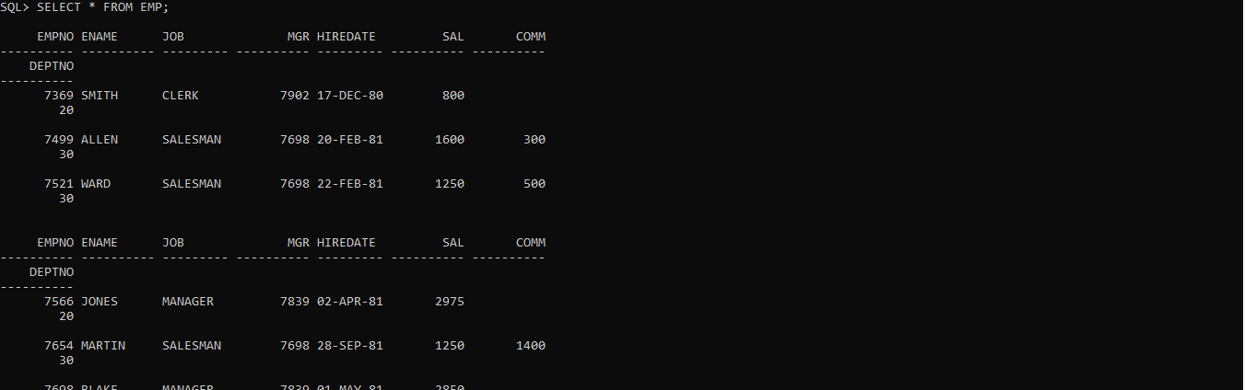

**3.SELECT Employee in Dept 30.**

Ans:SELECT * FROM EMP WHERE DEPTNO =30;

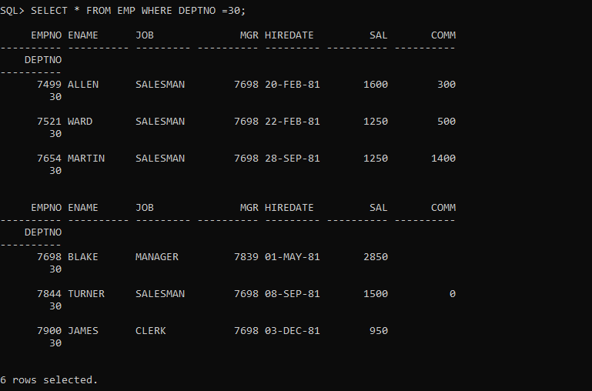

4.List the names,numbers and departmentno of all employees.

Ans:SELECT ENAME,EMPNO,DEPTNO FROM EMP WHERE JOB = 'CLERK';

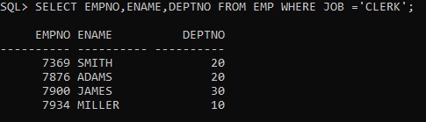

5.Find the depart numbers, and name of the employee of all dept with deptno greater than or equal to 20

Ans:SELECT DEPTNO,ENAME FROM EMP WHERE DEPTNO >=20;

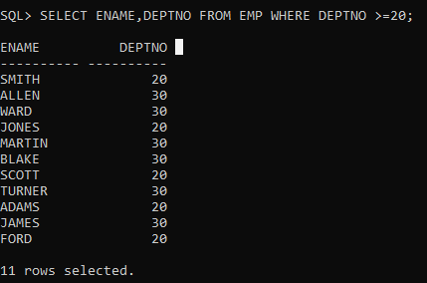

6.Find the Employees whose commission is greater than their salary.

Ans: SELECT * FROM EMP WHERE COMM > SAL;

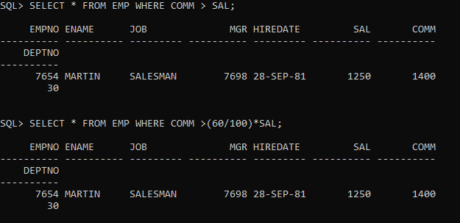

7.Find the employees whose commission is greater than 60% of their salary.

Ans:SELECT FROM EMP WHERE COMM >(60/100)*SAL;



8.Find the employees whose commission is greater than 50% of their salary.

Ans:SELECT FROM EMP WHERE COMM >(50/100)*SAL;

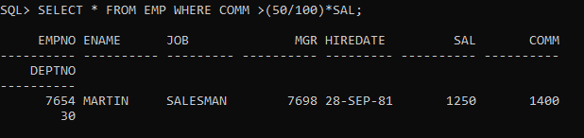

9.Find the name,job,salary of all employees in dept20 who earn more than 2000.

Ans:SELECT ENAME,JOB,SAL FROM EMP WHERE DEPTNO = 20 AND SAL > 2000;

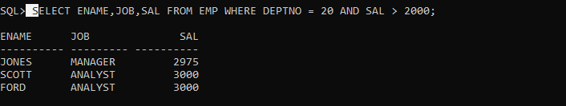

10.Find all salesman in dept30 whose salary is greater than or equal to 1500.

Ans:SELECT * FROM EMP WHERE JOB = 'SALESMAN'AND DEPTNO = 30 AND SAL >=1500;

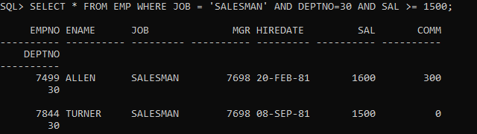

11. Find all the employees whose job is either a president or manager.

**QUERY :**

SELECT * FROM EMP WHERE JOB='MANAGER' OR JOB='PRESIDENT';

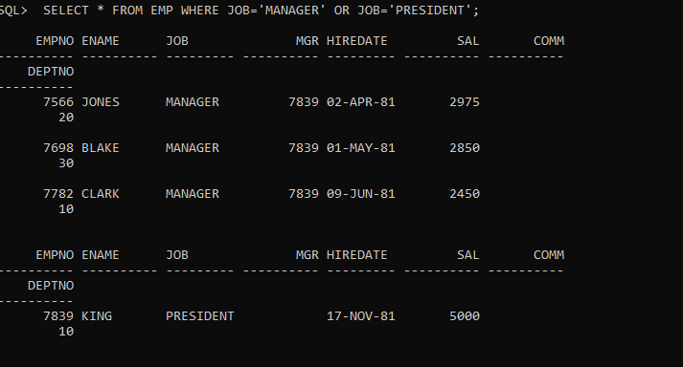

12. Find all managers who are not in dept 30.

**QUERY :**

SELECT * FROM EMP WHERE JOB='MANAGER'AND DEPTNO!=30;

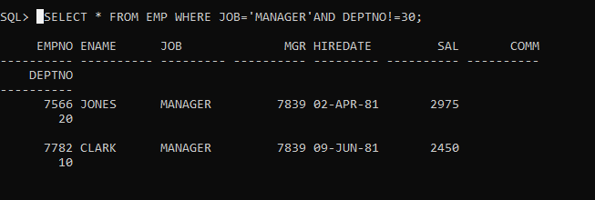

13. Find the details of all managers and clerks in dept 10.

**QUERY :**

SELECT ENAME,JOB,DEPTNO FROM EMP WHERE (JOB='MANAGER' OR JOB='CLERK') AND DEPTNO=10;

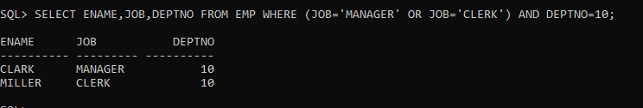

14.Find the details of all manager (in any dept) and all clerks in dept 10

**QUERY :**

SELECT ENAME,JOB,DEPTNO FROM EMP WHERE (JOB='MANAGER') OR (JOB='CLERK' AND DEPTNO=10);

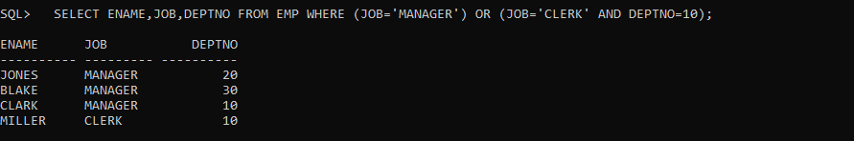

15.Find the details of all managers in dept 10 and all clerks in dept 20.

**QUERY :**

SELECT ENAME,JOB,DEPTNO FROM EMP WHERE (JOB='MANAGER' AND DEPTNO=10 ) OR (JOB='CLERK' AND DEPTNO=20);

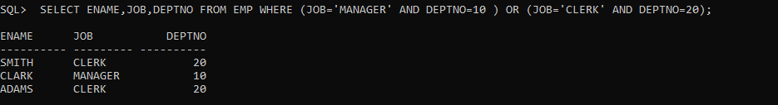

OR

**QUERY :**

SELECT ENAME,JOB,DEPTNO FROM EMP WHERE (JOB='MANAGER' AND DEPTNO=10 ) AND (JOB='CLERK' AND DEPTNO=20);



16.Find all employees who are neither clerks nor manager but whose salary is greater than or equal to Rs. 2000.

**QUERY :**

SELECT * FROM EMP WHERE (JOB!='MANAGER'AND JOB!='CLERK') AND SAL>=2000;

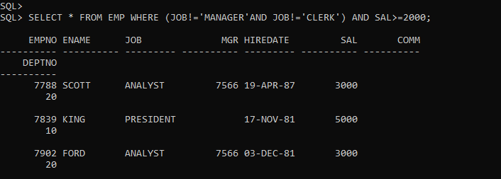

17. Find the employees who earns between Rs. 1200 and Rs.1400.

**QUERY :**

SELECT * FROM EMP WHERE SAL BETWEEN 1200 AND 1400;

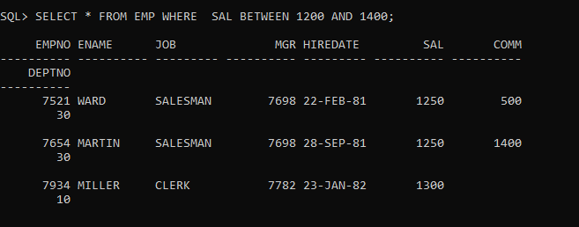

18. Find the employees who are clerks, analysts or salesman.

**QUERY :**

SELECT * FROM EMP WHERE (JOB!='MANAGER'AND JOB!='CLERK') AND SAL>=2000;

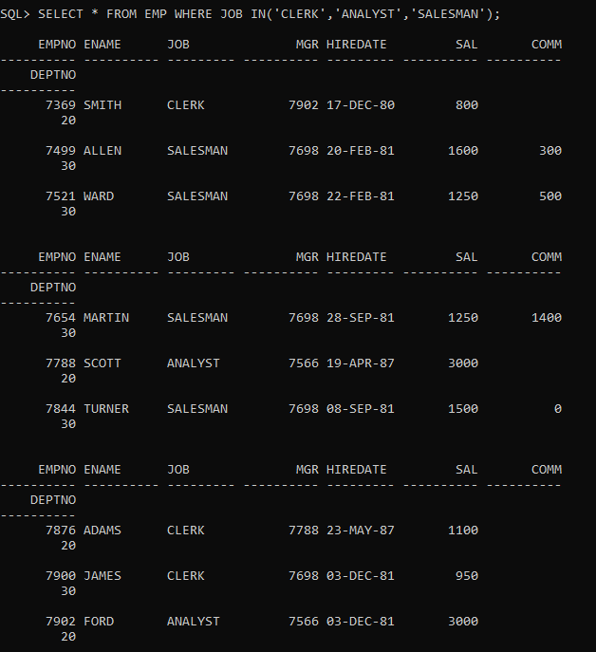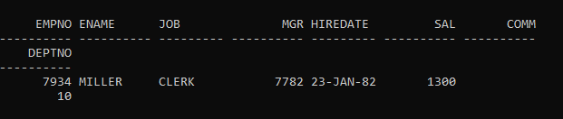

19. Find the employees who are not clerks, analyst or salesman.

**QUERY :**

SELECT * FROM EMP WHERE JOB NOT IN('CLERK','ANALYST','SALESMAN');

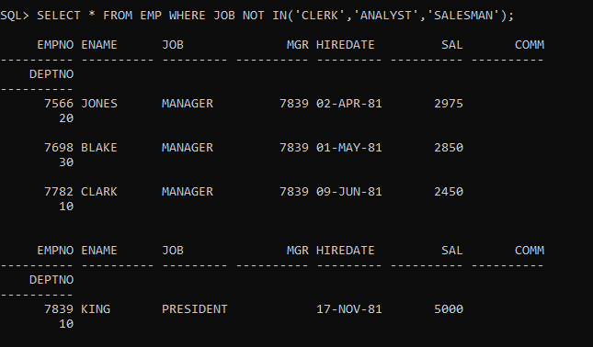

20.Find the employees who do not receive a commission i.e. commission is NULL.

**QUERY :**

SELECT ENAME ,DEPTNO FROM EMP WHERE COMM IS NULL;

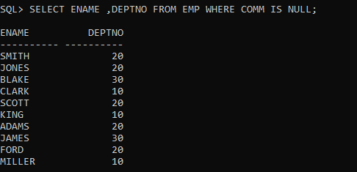

21. Find the employee whose comm ission is Rs. 0.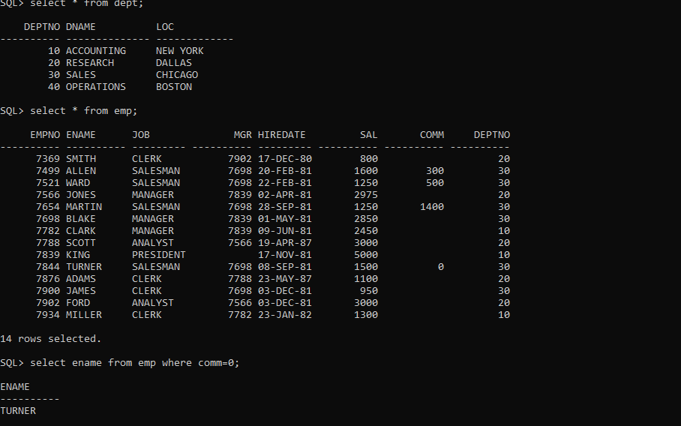

22.Find the different jobs of the employees receiving commission.

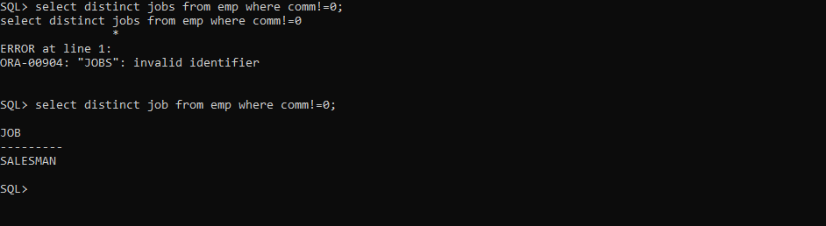

23. Find all employees who do not receive a commission or whose Commission is less than Rs. 100.

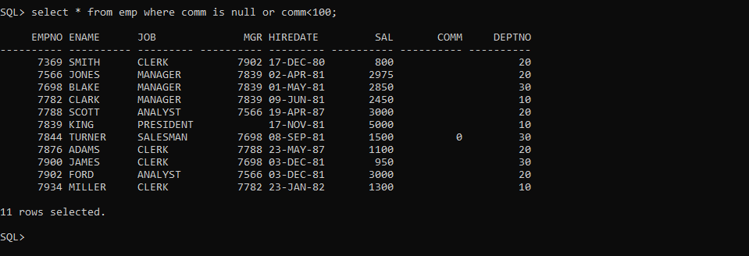

24. The employees who not receiving commission are entailed to Rs. 250, Show the net earnings of all employees. (find about **nvl() )**

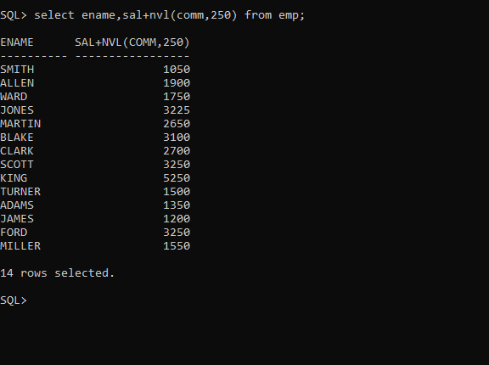

25. Find all employees whose total earnings are greater than Rs. 2000.

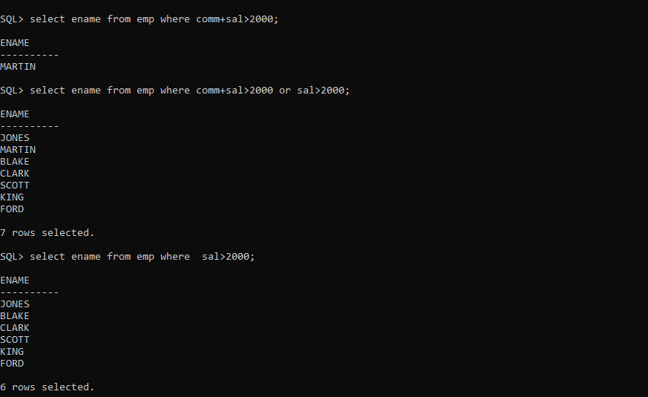

26. Find all employees whose names begin with m.

27.Find all employees whose names end with m.

28.Find all employees whose names contain the letter m.

29.Find the employees whose names are 5 characters long and end with n.

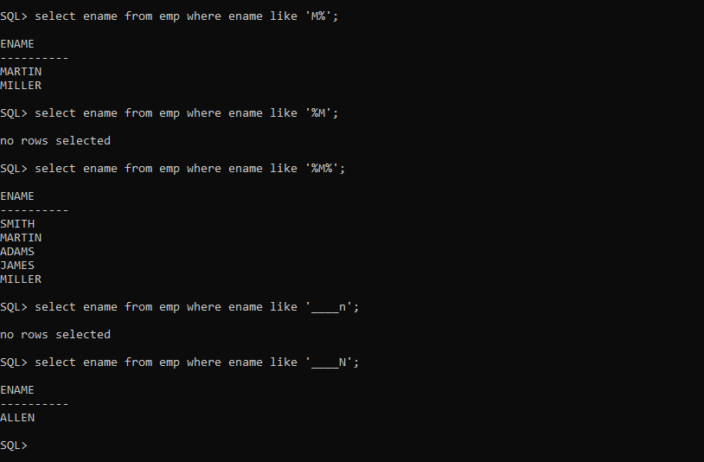

29.Find the employees whose names are 5 characters long and end with n.

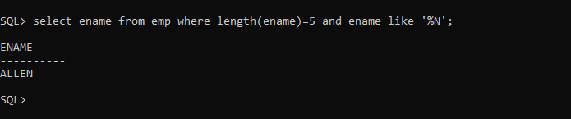

30. Find the employees who have the letter r as the third letter in their name.

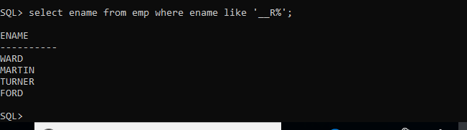

31. Find all employees hired in month of February (of any year).

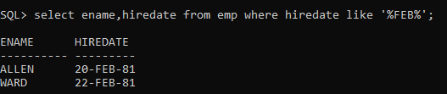

***32. Find all employees who were hired on the last day of the month.***

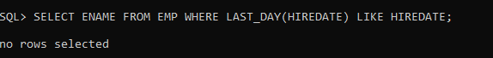

33. Find the employees who were hired more than 12 years ago.

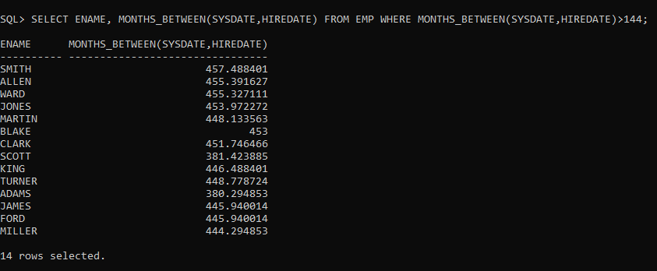

34. Find the managers hired in the year 2007.

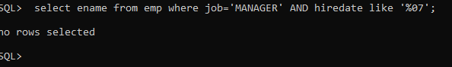

***35. Display the names and the jobs of all employees, separated by ‘,’(comma). For example***

(smith, clerk).

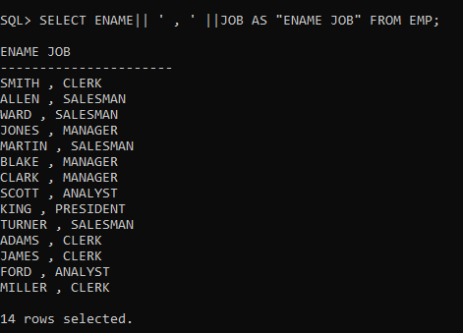

***36. Display the names of all employees with the initial letter only in capitals.***

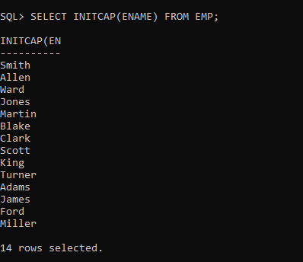

***37. Display the names of all employees, right aligning them to 15 characters.***

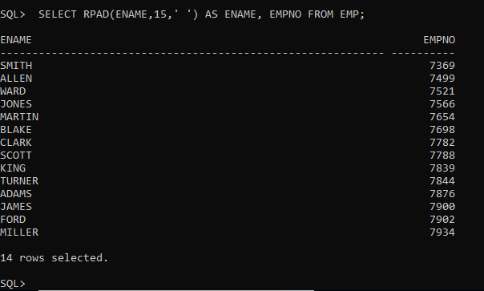

38. Display the names of all employees, padding them to right up-to 15 characters with ‘-‘ (using rpad)

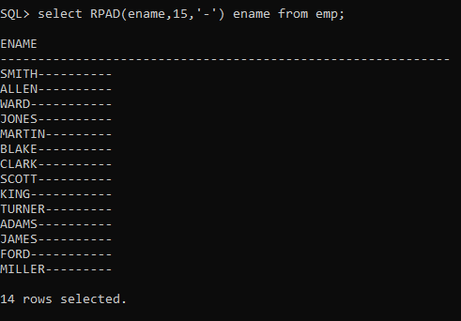

38. Display the names of all employees, padding them to right up-to 15 characters with ‘-‘ (using lpad)

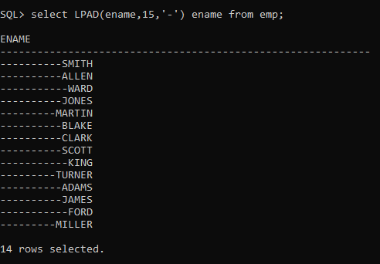

39.Display the length of the name of all employees.

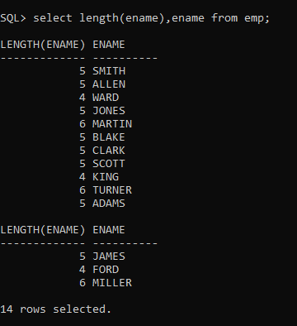

***40. Display the names of all employees centering them with 20 characters.***

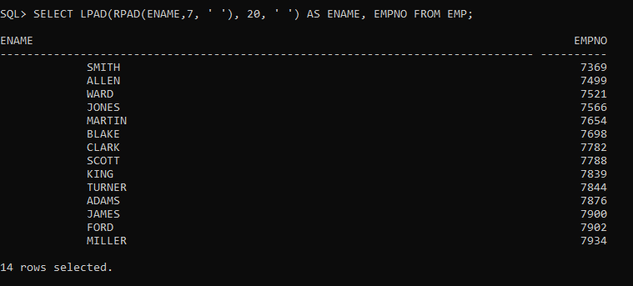

41.Display the names of all employees without any leading 'a'.

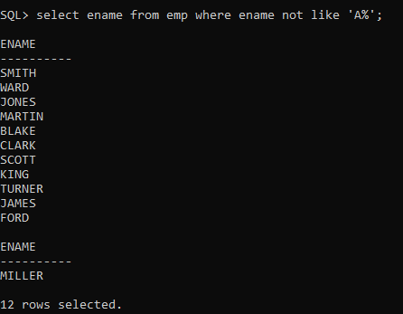

42.Display the names of all employees without any trailing 'r'.

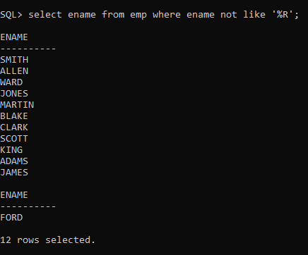

43.Show the first three characters of the names of all employees.

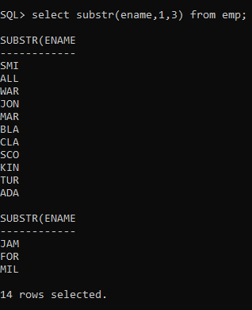

44..Show the last three characters of the names of all employees.

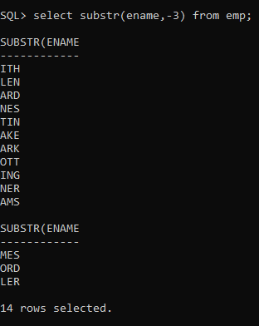

45.Display the names of all employees replacing any 'a' with 'e'.

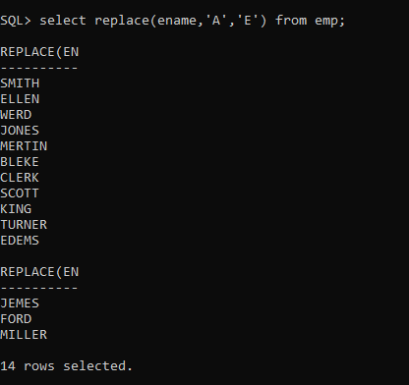

46.Display the names of all employees and the position at which the string 'ar' occurs in the name.

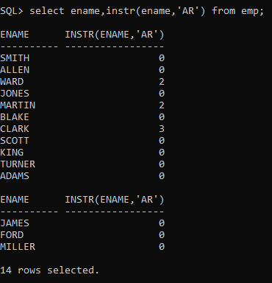

47.Show the salary of all employees rounding it to the nearest Rs. 1000. For example (3790 will be 4000)

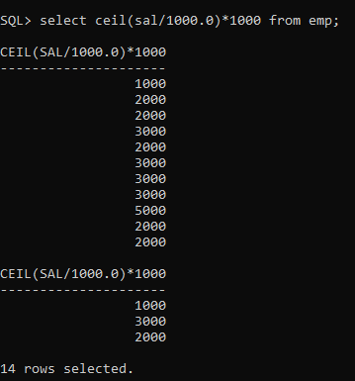

48.Show the daily salary of all employees assuming a month has 30 days.

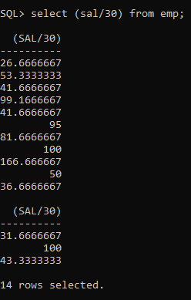

49.Display the name of all employees, and their bonus. Assume each Employee gets a bonus of 20 percent of his salary subject to the Maximum of Rs. 500.

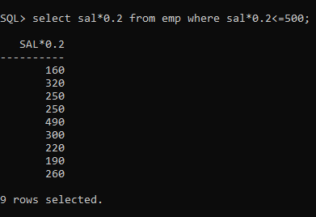

50.Display the name of all employees, and their bonus. Assume each employee gets a bonus of 20 percent of his salary subject to the Maximum of Rs. 200.

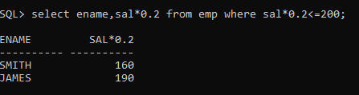

SQL> CREATE TABLE DEPT

2 (

3 DEPTNO NUMERIC(2) CONSTRAINT DEPTNO_DEPT_PK PRIMARY KEY,

4 DNAME VARCHAR(14),

5 LOC VARCHAR(13)

6 );

Table created.

SQL> INSERT INTO DEPT VALUES (10,'ACCOUNTING','NEW YORK');

1 row created.

SQL> INSERT INTO DEPT VALUES (20,'RESEARCH','DALLAS');

1 row created.

SQL> INSERT INTO DEPT VALUES (30,'SALES','CHICAGO');

1 row created.

SQL> INSERT INTO DEPT VALUES (40,'OPERATIONS','BOSTON');

1 row created.

SQL> CREATE TABLE EMP

2 (

3 EMPNO NUMERIC(4) CONSTRAINT EMPNO_EMP_PK PRIMARY KEY,

4 ENAME VARCHAR(10),

5 JOB VARCHAR(9),

6 MGR NUMERIC(4),

7 HIREDATE DATE,

8 SAL NUMERIC(7,2),

9 COMM NUMERIC(7,2),

10 DEPTNO NUMERIC(2) CONSTRAINT DEPTNO_DEPT_FK REFERENCES DEPT(DEPTNO)

11 );

Table created.

SQL> INSERT INTO EMP VALUES (7369,'SMITH','CLERK',7902,'17-DEC-80',800,NULL,20);

1 row created.

SQL> INSERT INTO EMP VALUES (7499,'ALLEN','SALESMAN',7698,'20-FEB-81',1600,300,30);

1 row created.

SQL> INSERT INTO EMP VALUES (7521,'WARD','SALESMAN',7698,'22-FEB-81',1250,500,30);

1 row created.

SQL> INSERT INTO EMP VALUES (7566,'JONES','MANAGER',7839,'02-APR-81',2975,NULL,20);

1 row created.

SQL> INSERT INTO EMP VALUES (7654,'MARTIN','SALESMAN',7698,'28-SEP-81',1250,1400,30);

1 row created.

SQL> INSERT INTO EMP VALUES (7698,'BLAKE','MANAGER',7839,'01-MAY-81',2850,NULL,30);

1 row created.

SQL> INSERT INTO EMP VALUES (7782,'CLARK','MANAGER',7839,'09-JUN-81',2450,NULL,10);

1 row created.

SQL> INSERT INTO EMP VALUES (7788,'SCOTT','ANALYST',7566,'19-APR-87',3000,NULL,20);

1 row created.

SQL> INSERT INTO EMP VALUES (7839,'KING','PRESIDENT',NULL,'17-NOV-81',5000,NULL,10);

1 row created.

SQL> INSERT INTO EMP VALUES (7844,'TURNER','SALESMAN',7698,'08-SEP-81',1500,0,30);

1 row created.

SQL> INSERT INTO EMP VALUES (7876,'ADAMS','CLERK',7788,'23-MAY-87',1100,NULL,20);

1 row created.

SQL> INSERT INTO EMP VALUES (7900,'JAMES','CLERK',7698,'03-DEC-81','950',NULL,30);

1 row created.

SQL> INSERT INTO EMP VALUES (7902,'FORD','ANALYST',7566,'03-DEC-81',3000,NULL,20);

1 row created.

SQL> INSERT INTO EMP VALUES (7934,'MILLER','CLERK',7782,'23-JAN-82',1300,NULL,10);

1 row created.

SQL> commit;

Commit complete.

SQL> select * FROM EMP;

EMPNO ENAME JOB MGR HIREDATE SAL COMM

---------- ---------- --------- ---------- --------- ---------- ----------

DEPTNO

----------

7369 SMITH CLERK 7902 17-DEC-80 800

20

7499 ALLEN SALESMAN 7698 20-FEB-81 1600 300

30

7521 WARD SALESMAN 7698 22-FEB-81 1250 500

30

EMPNO ENAME JOB MGR HIREDATE SAL COMM

---------- ---------- --------- ---------- --------- ---------- ----------

DEPTNO

----------

7566 JONES MANAGER 7839 02-APR-81 2975

20

7654 MARTIN SALESMAN 7698 28-SEP-81 1250 1400

30

7698 BLAKE MANAGER 7839 01-MAY-81 2850

30

EMPNO ENAME JOB MGR HIREDATE SAL COMM

---------- ---------- --------- ---------- --------- ---------- ----------

DEPTNO

----------

7782 CLARK MANAGER 7839 09-JUN-81 2450

10

7788 SCOTT ANALYST 7566 19-APR-87 3000

20

7839 KING PRESIDENT 17-NOV-81 5000

10

EMPNO ENAME JOB MGR HIREDATE SAL COMM

---------- ---------- --------- ---------- --------- ---------- ----------

DEPTNO

----------

7844 TURNER SALESMAN 7698 08-SEP-81 1500 0

30

7876 ADAMS CLERK 7788 23-MAY-87 1100

20

7900 JAMES CLERK 7698 03-DEC-81 950

30

EMPNO ENAME JOB MGR HIREDATE SAL COMM

---------- ---------- --------- ---------- --------- ---------- ----------

DEPTNO

----------

7902 FORD ANALYST 7566 03-DEC-81 3000

20

7934 MILLER CLERK 7782 23-JAN-82 1300

10

14 rows selected.

SQL> SET LINESIZE 180 PAGESIZE 120

SQL> SELECT * FROM EMP;

EMPNO ENAME JOB MGR HIREDATE SAL COMM DEPTNO

---------- ---------- --------- ---------- --------- ---------- ---------- ----------

7369 SMITH CLERK 7902 17-DEC-80 800 20

7499 ALLEN SALESMAN 7698 20-FEB-81 1600 300 30

7521 WARD SALESMAN 7698 22-FEB-81 1250 500 30

7566 JONES MANAGER 7839 02-APR-81 2975 20

7654 MARTIN SALESMAN 7698 28-SEP-81 1250 1400 30

7698 BLAKE MANAGER 7839 01-MAY-81 2850 30

7782 CLARK MANAGER 7839 09-JUN-81 2450 10

7788 SCOTT ANALYST 7566 19-APR-87 3000 20

7839 KING PRESIDENT 17-NOV-81 5000 10

7844 TURNER SALESMAN 7698 08-SEP-81 1500 0 30

7876 ADAMS CLERK 7788 23-MAY-87 1100 20

7900 JAMES CLERK 7698 03-DEC-81 950 30

7902 FORD ANALYST 7566 03-DEC-81 3000 20

7934 MILLER CLERK 7782 23-JAN-82 1300 10

14 rows selected.

SQL> SELECT * FROM DEPT;

DEPTNO DNAME LOC

---------- -------------- -------------

10 ACCOUNTING NEW YORK

20 RESEARCH DALLAS

30 SALES CHICAGO

40 OPERATIONS BOSTON

SQL> SPOOL OFF

SQL> ED

Wrote file afiedt.buf

1* SELECT ENAME,TO_CHAR(HIREDATE,'MONTH') MONTH ,TO_CHAR(HIREDATE,'YEAR') YEAR FROM EMP ORDER BY TO_CHAR(HIREDATE,'MM-YYYY')

SQL> /

ENAME MONTH YEAR

---------- ------------------------------------ ------------------------------------------

MILLER JANUARY NINETEEN EIGHTY-TWO

ALLEN FEBRUARY NINETEEN EIGHTY-ONE

WARD FEBRUARY NINETEEN EIGHTY-ONE

JONES APRIL NINETEEN EIGHTY-ONE

SCOTT APRIL NINETEEN EIGHTY-SEVEN

BLAKE MAY NINETEEN EIGHTY-ONE

ADAMS MAY NINETEEN EIGHTY-SEVEN

CLARK JUNE NINETEEN EIGHTY-ONE

TURNER SEPTEMBER NINETEEN EIGHTY-ONE

MARTIN SEPTEMBER NINETEEN EIGHTY-ONE

KING NOVEMBER NINETEEN EIGHTY-ONE

SMITH DECEMBER NINETEEN EIGHTY

JAMES DECEMBER NINETEEN EIGHTY-ONE

FORD DECEMBER NINETEEN EIGHTY-ONE

14 rows selected.

SQL> ED

Wrote file afiedt.buf

1* SELECT ENAME,TO_CHAR(HIREDATE,'MONTH') MONTH ,TO_CHAR(HIREDATE,'YEAR') YEAR FROM EMP ORDER BY TO_CHAR(HIREDATE,'MM')

SQL> /

ENAME MONTH YEAR

---------- ------------------------------------ ------------------------------------------

MILLER JANUARY NINETEEN EIGHTY-TWO

ALLEN FEBRUARY NINETEEN EIGHTY-ONE

WARD FEBRUARY NINETEEN EIGHTY-ONE

JONES APRIL NINETEEN EIGHTY-ONE

SCOTT APRIL NINETEEN EIGHTY-SEVEN

ADAMS MAY NINETEEN EIGHTY-SEVEN

BLAKE MAY NINETEEN EIGHTY-ONE

CLARK JUNE NINETEEN EIGHTY-ONE

TURNER SEPTEMBER NINETEEN EIGHTY-ONE

MARTIN SEPTEMBER NINETEEN EIGHTY-ONE

KING NOVEMBER NINETEEN EIGHTY-ONE

SMITH DECEMBER NINETEEN EIGHTY

JAMES DECEMBER NINETEEN EIGHTY-ONE

FORD DECEMBER NINETEEN EIGHTY-ONE

14 rows selected.

SQL> SELECT * FROM EMP ORDER BY ENAME;

EMPNO ENAME JOB MGR HIREDATE SAL COMM DEPTNO

---------- ---------- --------- ---------- --------- ---------- ---------- ----------

7876 ADAMS CLERK 7788 23-MAY-87 1100 20

7499 ALLEN SALESMAN 7698 20-FEB-81 1600 300 30

7698 BLAKE MANAGER 7839 01-MAY-81 2850 30

7782 CLARK MANAGER 7839 09-JUN-81 2450 10

7902 FORD ANALYST 7566 03-DEC-81 3000 20

7900 JAMES CLERK 7698 03-DEC-81 950 30

7566 JONES MANAGER 7839 02-APR-81 2975 20

7839 KING PRESIDENT 17-NOV-81 5000 10

7654 MARTIN SALESMAN 7698 28-SEP-81 1250 1400 30

7934 MILLER CLERK 7782 23-JAN-82 1300 10

7788 SCOTT ANALYST 7566 19-APR-87 3000 20

7369 SMITH CLERK 7902 17-DEC-80 800 20

7844 TURNER SALESMAN 7698 08-SEP-81 1500 0 30

7521 WARD SALESMAN 7698 22-FEB-81 1250 500 30

14 rows selected.

SQL> ED

Wrote file afiedt.buf

1* SELECT ENAME FROM EMP ORDER BY HIREDATE

SQL> /

ENAME

----------

SMITH

ALLEN

WARD

JONES

BLAKE

CLARK

TURNER

MARTIN

KING

JAMES

FORD

MILLER

SCOTT

ADAMS

14 rows selected.

SQL> SELECT ENAME,JOB,SAL FROM EMP ORDER BY JOB,SAL;

ENAME JOB SAL

---------- --------- ----------

FORD ANALYST 3000

SCOTT ANALYST 3000

SMITH CLERK 800

JAMES CLERK 950

ADAMS CLERK 1100

MILLER CLERK 1300

CLARK MANAGER 2450

BLAKE MANAGER 2850

JONES MANAGER 2975

KING PRESIDENT 5000

MARTIN SALESMAN 1250

WARD SALESMAN 1250

TURNER SALESMAN 1500

ALLEN SALESMAN 1600

14 rows selected.

SQL> ED

Wrote file afiedt.buf

1* SELECT ENAME,JOB,SAL FROM EMP ORDER BY JOB,SAL DESC

SQL> /

ENAME JOB SAL

---------- --------- ----------

FORD ANALYST 3000

SCOTT ANALYST 3000

MILLER CLERK 1300

ADAMS CLERK 1100

JAMES CLERK 950

SMITH CLERK 800

JONES MANAGER 2975

BLAKE MANAGER 2850

CLARK MANAGER 2450

KING PRESIDENT 5000

ALLEN SALESMAN 1600

TURNER SALESMAN 1500

MARTIN SALESMAN 1250

WARD SALESMAN 1250

14 rows selected.

SQL> ED

Wrote file afiedt.buf

1* SELECT ENAME,JOB,SAL FROM EMP ORDER BY JOB DESC,SAL DESC

SQL> /

ENAME JOB SAL

---------- --------- ----------

ALLEN SALESMAN 1600

TURNER SALESMAN 1500

WARD SALESMAN 1250

MARTIN SALESMAN 1250

KING PRESIDENT 5000

JONES MANAGER 2975

BLAKE MANAGER 2850

CLARK MANAGER 2450

MILLER CLERK 1300

ADAMS CLERK 1100

JAMES CLERK 950

SMITH CLERK 800

FORD ANALYST 3000

SCOTT ANALYST 3000

14 rows selected.

SQL> ED

Wrote file afiedt.buf

1* SELECT ENAME, ROUND(MONTHS_BETWEEN(SYSDATE,HIREDATE)*30)FROM EMP WHERE DEPTNO IN(10,20,30,40)

SQL> /

ENAME ROUND(MONTHS_BETWEEN(SYSDATE,HIREDATE)*30)

---------- ------------------------------------------

SMITH 13725

ALLEN 13662

WARD 13660

JONES 13620

MARTIN 13444

BLAKE 13590

CLARK 13553

SCOTT 11443

KING 13395

TURNER 13464

ADAMS 11409

JAMES 13379

FORD 13379

MILLER 13329

14 rows selected.

SQL> ED

Wrote file afiedt.buf

1* SELECT ENAME, ROUND(MONTHS_BETWEEN(SYSDATE,HIREDATE))FROM EMP WHERE DEPTNO IN(10,20,30,40)

SQL> /

ENAME ROUND(MONTHS_BETWEEN(SYSDATE,HIREDATE))

---------- ---------------------------------------

SMITH 458

ALLEN 455

WARD 455

JONES 454

MARTIN 448

BLAKE 453

CLARK 452

SCOTT 381

KING 447

TURNER 449

ADAMS 380

JAMES 446

FORD 446

MILLER 444

14 rows selected.

SQL> ED

Wrote file afiedt.buf

1* SELECT ENAME,TO_CHAR(TO_DATE(TRUNC(TO_CHAR(MONTHS_BETWEEN(SYSDATE,HIREDATE))),'J'),'JSP'),'MONTHS' ,TO_CHAR(TO_DATE(TRUNC(TO_CHAR(MONTHS_BETWEEN(SYSDATE,HIREDATE)*30)),'J'),'JSP'),'DAYS',TO_CHAR(TO_DATE(TRUNC(TO_CHAR(MONTHS_BETWEEN(SYSDATE,HIREDATE)/12)),'J'),'JSP'),'YEARS' FROM EMP

SQL> /

ENAME TO_CHAR(TO_DATE(TRUNC(TO_CHAR(MONTHS_BETWEEN(SYSDATE,HIREDATE))),'J'),'JSP') 'MONTH TO_CHAR(TO_DATE(TRUNC(TO_CHAR(MONTHS_BETWEEN(SYSDATE,HIREDATE)*30)),'J'),'JSP' 'DAY

---------- ------------------------------------------------------------------------------ ------ ------------------------------------------------------------------------------ ----

TO_CHAR(TO_DATE(TRUNC(TO_CHAR(MONTHS_BETWEEN(SYSDATE,HIREDATE)/12)),'J'),'JSP' 'YEAR

------------------------------------------------------------------------------ -----

SMITH FOUR HUNDRED FIFTY-SEVEN MONTHS THIRTEEN THOUSAND SEVEN HUNDRED TWENTY-FIVE DAYS

THIRTY-EIGHT YEARS

ALLEN FOUR HUNDRED FIFTY-FIVE MONTHS THIRTEEN THOUSAND SIX HUNDRED SIXTY-TWO DAYS

THIRTY-SEVEN YEARS

WARD FOUR HUNDRED FIFTY-FIVE MONTHS THIRTEEN THOUSAND SIX HUNDRED SIXTY DAYS

THIRTY-SEVEN YEARS

JONES FOUR HUNDRED FIFTY-THREE MONTHS THIRTEEN THOUSAND SIX HUNDRED NINETEEN DAYS

THIRTY-SEVEN YEARS

MARTIN FOUR HUNDRED FORTY-EIGHT MONTHS THIRTEEN THOUSAND FOUR HUNDRED FORTY-FOUR DAYS

THIRTY-SEVEN YEARS

BLAKE FOUR HUNDRED FIFTY-THREE MONTHS THIRTEEN THOUSAND FIVE HUNDRED NINETY DAYS

THIRTY-SEVEN YEARS

CLARK FOUR HUNDRED FIFTY-ONE MONTHS THIRTEEN THOUSAND FIVE HUNDRED FIFTY-TWO DAYS

THIRTY-SEVEN YEARS

SCOTT THREE HUNDRED EIGHTY-ONE MONTHS ELEVEN THOUSAND FOUR HUNDRED FORTY-THREE DAYS

THIRTY-ONE YEARS

KING FOUR HUNDRED FORTY-SIX MONTHS THIRTEEN THOUSAND THREE HUNDRED NINETY-FIVE DAYS

THIRTY-SEVEN YEARS

TURNER FOUR HUNDRED FORTY-EIGHT MONTHS THIRTEEN THOUSAND FOUR HUNDRED SIXTY-THREE DAYS

THIRTY-SEVEN YEARS

ADAMS THREE HUNDRED EIGHTY MONTHS ELEVEN THOUSAND FOUR HUNDRED NINE DAYS

THIRTY-ONE YEARS

JAMES FOUR HUNDRED FORTY-FIVE MONTHS THIRTEEN THOUSAND THREE HUNDRED SEVENTY-EIGHT DAYS

THIRTY-SEVEN YEARS

FORD FOUR HUNDRED FORTY-FIVE MONTHS THIRTEEN THOUSAND THREE HUNDRED SEVENTY-EIGHT DAYS

THIRTY-SEVEN YEARS

MILLER FOUR HUNDRED FORTY-FOUR MONTHS THIRTEEN THOUSAND THREE HUNDRED TWENTY-NINE DAYS

THIRTY-SEVEN YEARS

14 rows selected.

SQL> SELECT ENAME ,'JOINED ON THE' , TO_CHAR(TO_DATE(TO_CHAR(HIREDATE,'DD'),'J'),'JSP') AS D,'OF',TO_CHAR(TO_DATE(HIREDATE,'DD-MM-YYYY'),'MONTH')AS YY ,'OF THE YEAR',TO_CHAR(TO_DATE(TO_CHAR(HIREDATE,'YYYY'),'J'),'JSP')FROM EMP;

ENAME 'JOINEDONTHE' D 'O YY 'OFTHEYEAR'

---------- ------------- ------------------------------------------------------------------------------ -- ------------------------------------ -----------

TO_CHAR(TO_DATE(TO_CHAR(HIREDATE,'YYYY'),'J'),'JSP')

------------------------------------------------------------------------------

SMITH JOINED ON THE SEVENTEEN OF DECEMBER OF THE YEAR

ONE THOUSAND NINE HUNDRED EIGHTY

ALLEN JOINED ON THE TWENTY OF FEBRUARY OF THE YEAR

ONE THOUSAND NINE HUNDRED EIGHTY-ONE

WARD JOINED ON THE TWENTY-TWO OF FEBRUARY OF THE YEAR

ONE THOUSAND NINE HUNDRED EIGHTY-ONE

JONES JOINED ON THE TWO OF APRIL OF THE YEAR

ONE THOUSAND NINE HUNDRED EIGHTY-ONE

MARTIN JOINED ON THE TWENTY-EIGHT OF SEPTEMBER OF THE YEAR

ONE THOUSAND NINE HUNDRED EIGHTY-ONE

BLAKE JOINED ON THE ONE OF MAY OF THE YEAR

ONE THOUSAND NINE HUNDRED EIGHTY-ONE

CLARK JOINED ON THE NINE OF JUNE OF THE YEAR

ONE THOUSAND NINE HUNDRED EIGHTY-ONE

SCOTT JOINED ON THE NINETEEN OF APRIL OF THE YEAR

ONE THOUSAND NINE HUNDRED EIGHTY-SEVEN

KING JOINED ON THE SEVENTEEN OF NOVEMBER OF THE YEAR

ONE THOUSAND NINE HUNDRED EIGHTY-ONE

TURNER JOINED ON THE EIGHT OF SEPTEMBER OF THE YEAR

ONE THOUSAND NINE HUNDRED EIGHTY-ONE

ADAMS JOINED ON THE TWENTY-THREE OF MAY OF THE YEAR

ONE THOUSAND NINE HUNDRED EIGHTY-SEVEN

JAMES JOINED ON THE THREE OF DECEMBER OF THE YEAR

ONE THOUSAND NINE HUNDRED EIGHTY-ONE

FORD JOINED ON THE THREE OF DECEMBER OF THE YEAR

ONE THOUSAND NINE HUNDRED EIGHTY-ONE

MILLER JOINED ON THE TWENTY-THREE OF JANUARY OF THE YEAR

ONE THOUSAND NINE HUNDRED EIGHTY-TWO

14 rows selected.

SQL> spool off