**Objective Questions**:

1. What is the total no. of attributes present in the data?

Ans: Total 15 attributes are present in the data.

1. Which columns have inconsistent or missing values, and what is the count of such values?

Ans: There is no such column which has inconsistent or missing values.

1. What is the average daily ticket volume over time?

Ans: Average Daily Ticket Volume is 53.37, calculated by taking pivot table with fetcha attribute in rows and ticket id in values, used average() function over all the values of pivot table and got the answer.

Formula: =AVERAGE($B$14:$B$1840)

1. What is the distribution of ticket categories (e.g., Login Access, System, Software)?

Ans: There are 4 ticket categories, Login Access, Hardware, Software and System.

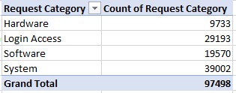

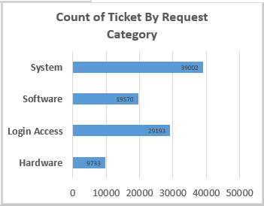

1. How many tickets has each agent handled?

Ans:

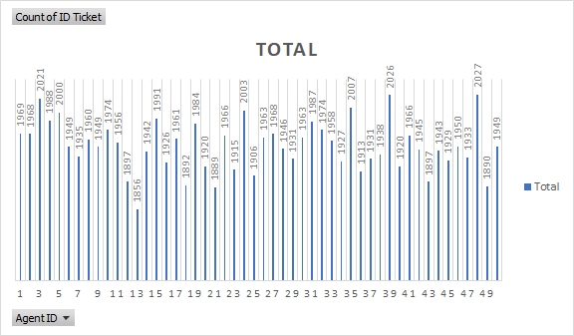

Please refer to this above chart to know the ticket count of 50 Agents.

1. How can you extract the domain from the email addresses in the IT Agents sheet?

Ans: By using the combination of Mid() and FIND() function, we can extract domain name from the mentioned email id.

Ex: =MID(C2, FIND("@", C2) + 1, FIND(".", C2, FIND("@", C2)) - FIND("@", C2) - 1)

With this formula we can extract the domain from email id.

1. How can you find the full name of an agent given their Agent ID?

Ans: We can find full names by using multiple functions such as VLOOKUP, XLOOKUP and FIND MATCH.

→ Please refer to the Lookup Sheet in the excel file. I've extracted the names with Vlookup() and Find & Match Function. As Xlookup is not supported by my excel version, I was not able to extract names through Xlookup function.

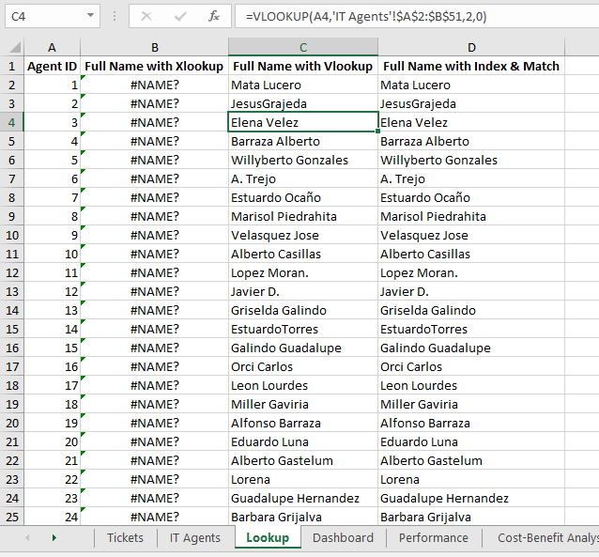

1. What is the count of each issue type (e.g., IT Error, IT Request)?

Ans:

 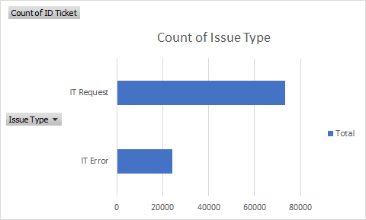

1. What is the daily average resolution time for tickets?

Ans: The daily average resolution time is 4.55 days, calculated through taking the pivot table as fetcha(dates) in rows and resolution time in values. We can calculate the average either through taking average functionality in the pivot table or separately using average() formula over all the values of resolution time.

Formula: =AVERAGE($C$14:$C$1840)

1. How has the volume of tickets changed over time?

Ans:

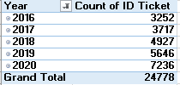

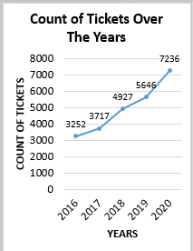

1. What is the average age of the IT agents?

Ans: Average age of IT agents is 39.7, the average age of IT agents got through (a) First, used today function in separate column in IT Agent sheet, used YEARFRAC() function to fetch age of all the IT Agents and at last used Average() function to take average age of all the IT Agents.

Formula: (1) =YEARFRAC(G2,H2)

(2) =AVERAGE('IT Agents'!J2:J51)

1. Is there a correlation between the severity of issues and the resolution time?

Ans: Correlation between Severity and Resolution time is -0.04 which means they both are not correlated to each other.

1. First, use text to column function to separate text from numerical values of Severity Column in the Tickets sheet.
2. Used Formula CORREL() function over all the values of 2 columns, Severity and Resolution Time.

Formula: =CORREL($G$2:$G$97499,$H$2:$H$97499)

1. How many categorical columns are there in the data? [Search about categorical and continuous data, and try to answer this question]

Ans: There are 5 categorical columns in the data,

1. Request Category
2. Issue Type
3. Severity
4. Priority
5. Satisfaction Rate

**Subjective Question:**

1. If there is an investment, should it be used to hire more IT agents, improve training programs, or upgrade ticket management software?

Analysis: Perform a cost-benefit analysis using ticket resolution and satisfaction metrics.

Ans: As per the cost-benefit analysis,

1. The average cost is 4.55.
2. The average Benefit is 4.10

Hence, the cost to benefit is 1.11 which is considered as good. But there are few parameters that we need to consider such as higher resolution time in the hardware category and the need to improve efficiency of the agents. Year by year ticket count is increasing so we need to hire more agents.

**Recommendations:**

1. First priority for investment is Training**:** As seen from data, the IT support team is not performing at its full potential. There is an ample room for training.

Benefit: It needs less investment compared to hiring and implementing new tools.

Cost: Victimization of agents has to be prevented.

1. Second priority for investment is Hiring: Benefit: It may further increase the satisfaction rating and reduce resolution time also. Team can handle further increases in ticket volume. Cost:More investment needs for onboarding a new Employee and still Team may not work at its full potential.
2. Third priority for investment is upgrade Ticket management software: Benefit:It will be an asset for the Team and can handle future issues like surge of tickets. Cost:Huge investment burden.
3. Which agents need additional training based on their performance metrics?

Analysis: Identify agents with the lowest satisfaction ratings and longest resolution times.

Ans. According to the analysis in the pivot table, please check the below agents who have above average resolution time and below average satisfaction rate. Please check the below charts and pivot table:

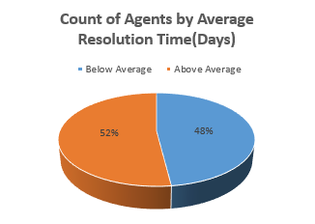 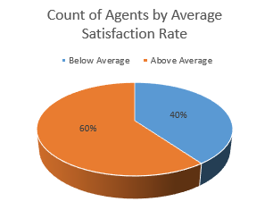

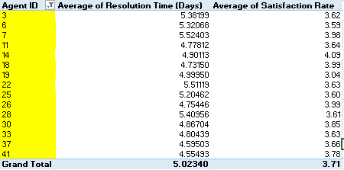

**Insights:**

1. These are the filtered Agent Id’s who are taking more resolution time and they also have less average satisfaction rate then others.

**Recommendations:**

1. As the average resolution time is going above 4.5-5 and if the average satisfaction rate is going below 4 then they should be given first priority in terms of specialized training.
2. Do certain categories of requests have longer resolution times?

Analysis: Analyze the resolution times by request category.

Ans:

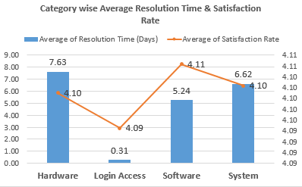

**Insights:**

According to the analysis, the Hardware category has the highest resolution time as compared to other categories because resolving hardware may take some time whereas talking about System Category, It has an average of 6.62 days which is second highest.

1. How effective are the current software tools in managing IT tickets?

Analysis: Evaluate performance metrics before and after the implementation of new tools.

Ans: **Insights:**

* The average Resolution Time is highest in the year 2020 because the count of tickets has increased over the years but if talking about Average satisfaction rate which has also increased over the years that means software tools are effective and working efficiently to manage IT Tickets.

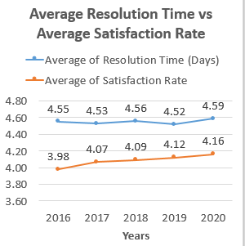

**Recommendations:**

* As said earlier training, hiring or upgrading software tools are solutions in first, second and third priority respectively.

1. How has the performance of the IT support team changed over time (e.g., monthly or quarterly)?

Analysis: Trend analysis using time series charts.

Ans: As per the Analysis, Average number of tickets handled by each agent is 1949.96 and as the number of ticket count increased over the years, the burden on the agent to resolve the issues also increased. Please refer below charts,

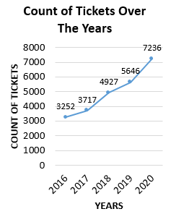 

**Insights:**

1. If trend is analyzed yearly wise: Resolution time is high during 2016, 2018, 2020.
2. Satisfaction rate has increased in 2017 and 2020. Its trend from 2016 is commendable.

Agents are taking more time in resolving higher severity tickets so,

1. There is a need to hire more agents to lower their burden.
2. Specialized training should be given in the age category of 32-36 to increase their satisfaction rate.
3. If we invest more on tech (Hardware, software, etc), do you think it will improve the ticket resolution times and employee satisfaction?

Analysis: Use historical data to project potential improvements.

Ans: Insights:

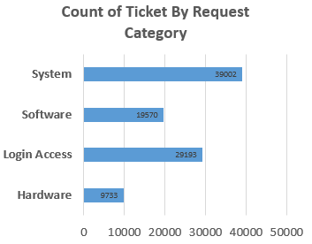 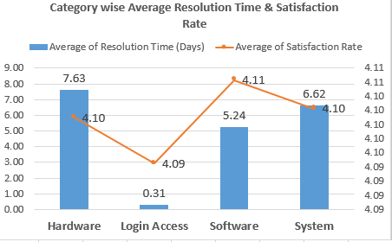

**Recommendations:**

1. System category has the highest number of IT tickets, satisfaction rate is also 4.10 which is a bit less and Resolution Time is 6.62 which is above average so We should invest more into tech.
2. Hardware has the lowest number of ticket count but still highest resolution time and satisfaction rate is less so it would be good to invest in hardware tech.
3. What are the key performance metrics for IT agents, and how can they be improved, do we need to fire any agents?

Analysis: Define and analyse metrics such as average handling time, satisfaction scores, and number of tickets resolved.

Ans:

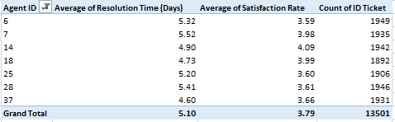

**Insights:**

According to the pivot table analysis, these above shortlisted ID’s have the Above Average Resolution Time, Lowest Average Satisfaction Rate and Lowest Average count of Tickets Handled as compared to other agents out of 50.

**Recommendations:**

1. Firing any agent is not recommended because there is no agent as such, who has no contribution to the team.
2. Data reveals that the team is not working at its full potential, many agents are below average values.

There is ample room for training, hence training of below average agents is recommended to improve both resolution time and satisfaction rate.

1. How do employee demographics (e.g., department, seniority) impact satisfaction and ticket outcomes?

Analysis: Segment analysis using filters and pivot tables.

Ans:

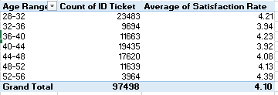

**Insights & Recommendations:**

As per the above analysis of pivot table,

1. Highest number of tickets handled by age category of 28-32 which is 23483, whereas 32-36 has handled only 9694 as being experienced agents and even their satisfaction rating is also less so they need specialized training to brainstorm their ideas and work in an efficient manner.
2. All the age categories, specially 36-40, 40-44, 44-48 and 48-52 which are considered as experienced agents have handled a good number of IT tickets and their satisfaction rate is also good.
3. Identify the trends for IT support operations based on ticket volumes and satisfaction, and mention the peak and stable times?

Analysis: Use pivot tables and charts to identify peak and off-peak hours.

Ans:

Insights:

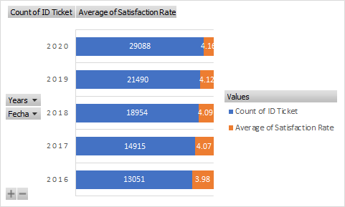

**Insights:**

As per the above analysis, the ticket volume has significantly increased from 2016 to 2020 and the satisfaction rate is also highest in 2020 as compared to other years.

**Recommendations:** As seen from data, satisfaction rating is same for all categories and issue types, so by resolution time metric, focus must be on hardware, system and then software categories’ tickets and in issue type IT request’ tickets should be prioritized.

1. What metrics should be included in the final dashboard to provide a comprehensive view of call center performance and guide investment decisions?

Ans: There are list of parameters can be included in the final dashboard:

1. Average Resolution Time and Average Satisfaction Rate:

These metrics are used to calculate the satisfaction rate and resolution time of agents over the years so that we can analyze the requirements.

1. Average number of Tickets handled by per Agent:

This metric will analyze whether the agent is overburdened or not.

1. Age Wise Satisfaction of Agents:

It will Analyze the satisfaction rate of the agents from different age groups, whether they need specialized training or the technology needs to be upgraded.

1. Resolution Time of High Severity and Higher Priority Tickets:

These metrics will calculate whether the high severity and priority IT tickets are taking more time or less time. If more time then changing the assignment structure in the support team or making specialized teams to focus on high priority and severity tasks.

1. Count of Tickets handled in each category:

This will help to analyze which category is getting more number of IT tickets.

1. Category wise Resolution Time and Satisfaction Rate:

This metric will help whether agents are satisfied with that category and whether they are able to meet the objective by providing solutions on time.

1. Year Wise Ticket Count:

This is helping to analyze that over the years as ticket count has increased so are the agents getting overburdened or not.

These are the number of parameters which can be included in the final dashboard to provide a comprehensive view of call center performance.