FIELD STUDY ON THE IMPACT OF ESL AMONG TAMIL MEDIUM STUDENTS OF XI STANDARD IN GOVT. HR SEC SCHOOL, VALARPURAM

A Field Study Submitted to

GOVERNMENT ARTS AND SCIENCE COLLEGE,
ARAKKONAM – 631 051
In partial fulfillment of the requirements for the degree of
MASTER OF ARTS IN ENGLISH
By
PRIYANKA.P
REG. NO: 35621P02010

Under the Guidance of
Dr. P. SAMUEL, M.A., B.Ed., M. Phil., Ph.D.,
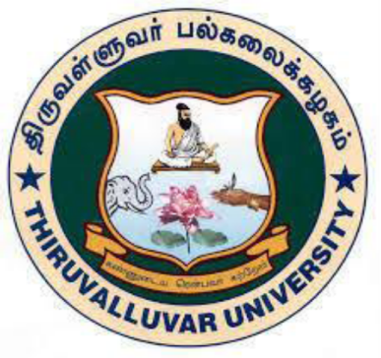

PG DEPARTMENT OF ENGLISH
GOVERNMENT ARTS AND SCIENCE COLLEGE
ARAKKONAM– 631 051
JUNE- 2022

FORM-A
TITLE OF FIELD STUDY : THE IMPACT OF ESL AMONG TAMIL MEDIUM STUDNETS OF XI STANDARD IN GOVT. HR. SEC. SCHOOL, VALARPURAM
LANGUAGE : English
NAME OF THE CANDIDATE : PRIYANKA. P
REG. NO : 35621P02010
AGE : 22
MALE / FEMALE : Female
DEPARTMENT : PG ENGLISH
YEAR / SEMESTER : I/ II
COLLEGE ADDRESS : Government Arts and Science College, Arakkonam – 631 051
RESEARCH SUPREVISOR : Dr.P. SAMUEL, M.A., B.Ed., M.Phil., Ph.D.,

P. PRIYANKA
Govt. Arts and Science College
Arakkonam – 631 051

DECLARATION
I, PRIYANKA.P, hereby declare that the Field Study entitled THE IMPACT OF ESL AMONG TAMIL MEDIUM STUDENTS OF XI STANDARD IN GOVT. HR. SEC. SCHOOL, VALARPURAM is the result of my original and independent research work, carried out under the guidance of Dr. P. SAMUEL, M.A., B.Ed., M.Phil., Ph.D., Assistant Professor & HOD, Government Arts and Science College, Arakkonam and that it has not been submitted for the award of any Degree, Diploma, or Fellowship or any other similar titles of any university or institution previously.

Place : Arakkonam PRIYANKA.P
Date :

DEPARTMENT OF ENGLISH
GOVERNMENT ARTS AND SCIENCE COLLEGE
CERTIFICATE
This is to certify that the Field Study entitled FIELD STUDY ON THE IMPACT OF ESL AMONG TAMIL MEDIUM STUDENTS OF XI STANDARD IN GOVT. HR. SEC. SCHOOL, VALARPURAM is a bonafied work of PRIYANKA.P, Government Arts and Science College, Arakkonam, during the year 2021-2022. It is certified that this Field Study is an original work of the candidate carried out under my supervision.

Signature of the HOD Signature of Research Supervisor
Dr. P. SAMUEL, Dr. P. SAMUEL,
M.A., B.Ed., M.Phil.,Ph.D., M.A., B.Ed., M.Phil., Ph.D.,
Assistant Professor & Head Assistant Professor & Head
Department of English Department of English
Govt. Arts and Science College Govt. Arts and Science College
Arakkonam – 631 501 Arakkonam – 631 501

